Stuff for Tracey – documentation for research on the VS1053 codec line-level IO

RaspberryPi

|  |  |
| --- | --- |
| Links | General code for any microcontroller to use the VS1053 to recording and playback, written in C, [here](http://www.vlsi.fi/en/support/software/microcontrollersoftware.ht) – stopped pursuing because Arduino was showing more progress, so change of plans: have everything work on Arduino, then port it to the pi. |
| Resources | My github has the recording capabilities for a USB input mic and documentation written up upon previous request, [here](https://github.com/tracypham1/SW_roverlink). |

Arduino

|  |  |
| --- | --- |
| Links | No code provided, but describes how to write the VLSI ADMixer plugin to the SD card to decode the audio input and eventually decode and playback, [here](http://www.vsdsp-forum.com/phpbb/viewtopic.php?t=1903). |
|  | To see a forum on using the codec as a music player and voice amplifier, [here](http://www.vsdsp-forum.com/phpbb/viewtopic.php?t=1388). |
|  | For other VLSI solutions plugins for different encoding formats and techniques for manipulating the audio data with individual documents on implementation, [here.](http://www.vlsi.fi/en/support/software/vs10xxplugins.html) |
|  | A project that uses the MAX4466 Electret Mic to record 9 hours activated with a button press, [here](https://www.instructables.com/id/Make-Your-Own-Spy-Bug-Arduino-Voice-Recorder/). |
|  | Specific VS1053 audio input/output, addresses, modes, and registers, [here](https://github.com/CalPlug/VLSI_VS1053B_AudioProcessor_Examples/blob/master/Samples%20and%20Documentation/vs1053audio.pdf). |
| Attachments | “sineTest-works”: edits the example from the Adafruit_VS1053_Library to make sure pins are connected and see how audio is being written to registers for further data transfer investigations, without the SD Card |
|  | “Adafruit_VS1053.h/.cpp”: contains the libraries my .ino files ran because I edited some data member from private to protected for testing purposes, but the one from the internet will work fine, [here](https://github.com/adafruit/Adafruit_VS1053_Library). |
| Still Working | Have played with adafruit blinka and circuit python bundles, seems like a dead end so far. |

As of 07/11/19

1. Customizing the libraries (SD and Adafruit_CS1053) as I go
2. Everything in the admixer-plugin-record.ino because eventually will have that plugin decode input as its encoding it.

Done:

* Adafruit_VS1053_FilePlayer object, musicPlayer is flawless
* The sketch has a sinTest at the beginning to make sure communication with pins is working
* The SD card is readable and prints the directory to prove it

In progress (aka my current headache):

* Play an MP3 file on the SD card
  + playFullFile()
    - calls startPlayingFile()
  + startPlayingFile()
    - track is identified
    - verified to be a MP3 file
    - calls feedBuffer()
  + feedBuffer()
    - does stuff with interrupts
    - changes control flag boolean, feedBufferLock
    - calls feedBuffer_noLock()
  + feedBuffer_noLock()
    - calls playData()
  + playData()
    - reads single value mp3buffer and writes to the register, which should play it, but doesn’t…

For this output:

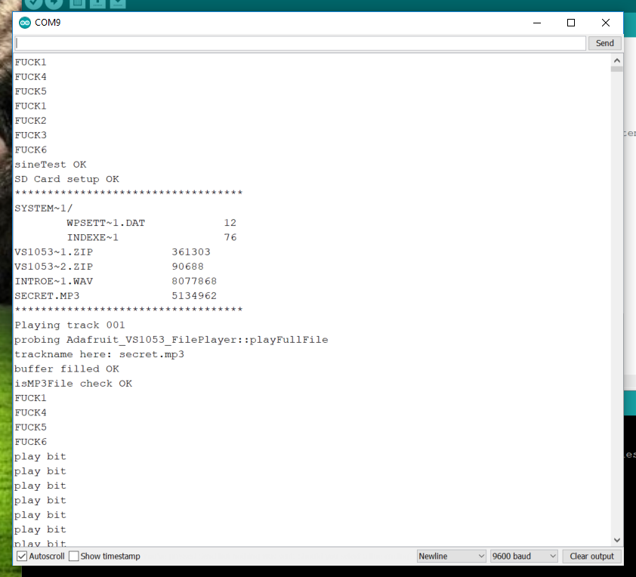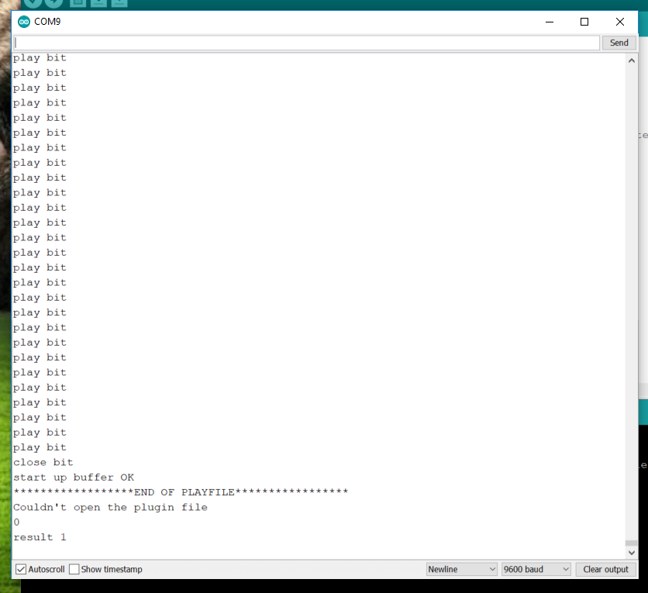

This is what the playFullFile() looks like:

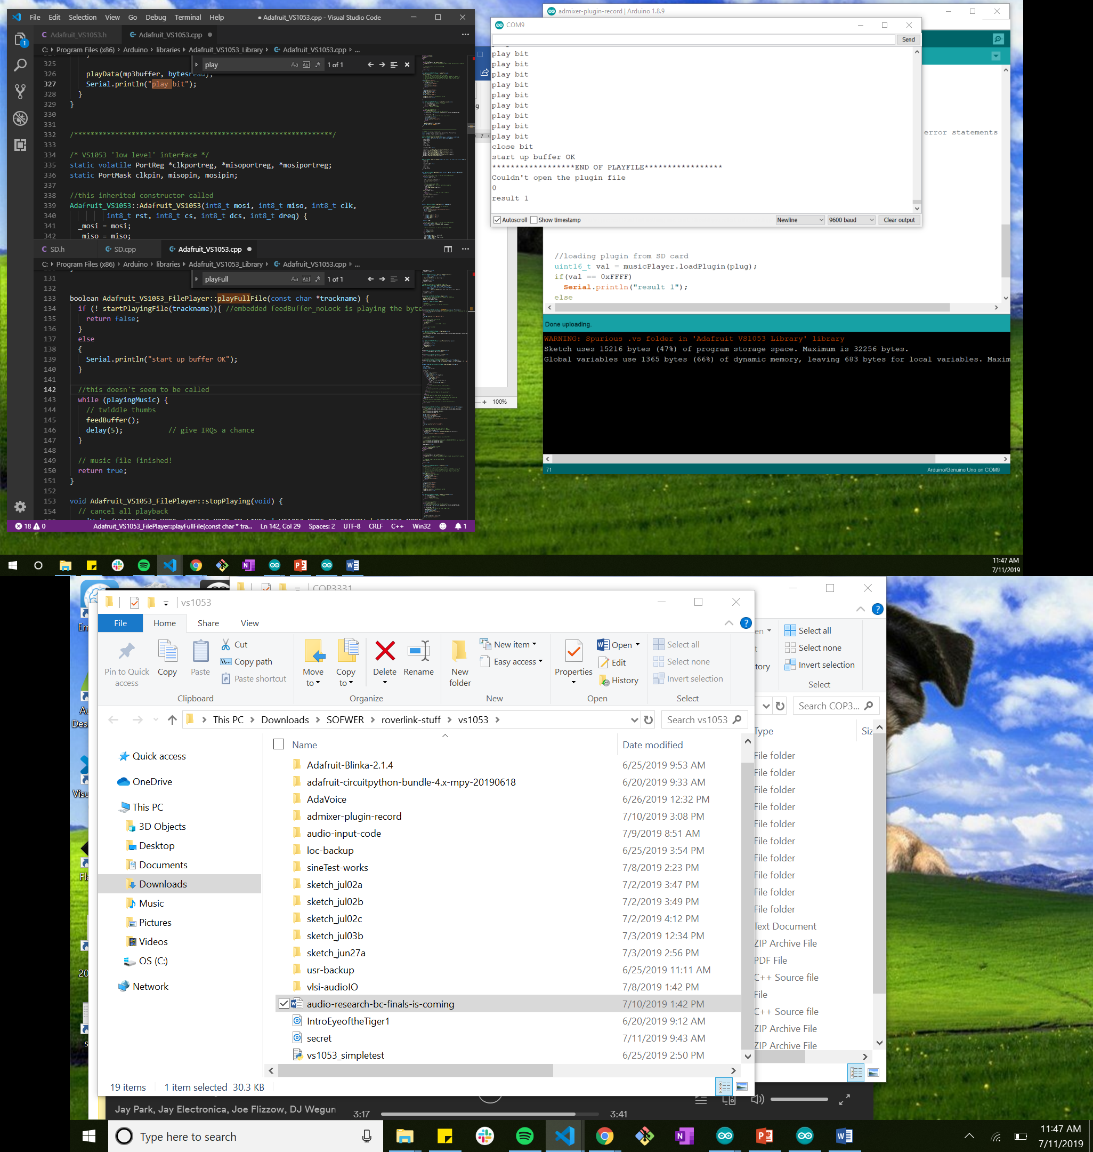

To see each function and call and what not, it can be found in mt edited “Adafruit_VS1053” files

To Do:

* Activate and use plugin to stream audio in real time, in thru MIC out through LOUT/ROUT