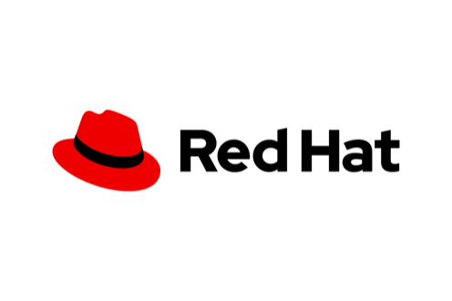



**REPORT**

SAKTI

APPLICATION

DEPENDENCY SCAN RESULT

@%APP%@

2024



CONFIDENTIAL

The information in this document is confidential and intended only for the intended recipient and only in relation to and bound by the terms of the contractual relationship with RedHat Indonesia. This documentation is for the sole purpose of providing information related to review activities and may only be disclosed to individuals with a relevant need to know.

Any entity or person with access to this information is responsible for this confidentiality statement.

No part of this publication may be reproduced or transmitted in any form or by any means for any purpose without the written permission of RedHat Indonesia.

Copyright ©2024 RedHat Indonesia. All rights reserved

# Temuan