SOFIA DELGADO VACA GUZMAN

PRACTICA - ADMINSTRACIÓN DE BASE DE DATOS CON POSGRESQL.- GITHUB
Manejo básico de Github y comándos básicos para la administración de una base de datos en PostgreSQL

GITHUB

Crear un usuario en http://www.github.com - Ingresar y logearse con su cuenta a Github. -Hacer un fork del repositorio: https://github.com/urvog/uasb_DBA

usuario: sofynikita
contraseña: superman22

https://github.com/sofynikita/uasb_DBA

POSTGRESQL

ACTUALIZAR PAQUETES EN UBUNTU
sophia@ninoska:~$ sudo apt-get update
[sudo] password for sophia:
Ign http://extras.ubuntu.com trusty InRelease
Obj http://download.virtualbox.org raring InRelease
Des:1 http://security.ubuntu.com trusty-security InRelease [65,9 kB]
Des:2 http://extras.ubuntu.com trusty Release.gpg [72 B]
Obj http://download.virtualbox.org raring/contrib amd64 Packages
Ign http://bo.archive.ubuntu.com trusty InRelease
Obj http://download.virtualbox.org raring/contrib i386 Packages
Obj http://extras.ubuntu.com trusty Release
Des:3 http://bo.archive.ubuntu.com trusty-updates InRelease [65,9 kB]
Des:4 http://security.ubuntu.com trusty-security/main Sources [112 kB]
Obj http://extras.ubuntu.com trusty/main Sources
Obj http://extras.ubuntu.com trusty/main amd64 Packages
Obj http://bo.archive.ubuntu.com trusty-backports InRelease
Obj http://extras.ubuntu.com trusty/main i386 Packages
Des:5 http://security.ubuntu.com trusty-security/restricted Sources [4.035 B]
Obj http://bo.archive.ubuntu.com trusty Release.gpg
Des:6 http://security.ubuntu.com trusty-security/universe Sources [35,5 kB]
Des:7 http://bo.archive.ubuntu.com trusty-updates/main Sources [273 kB]
Des:8 http://security.ubuntu.com trusty-security/multiverse Sources [2.764 B]
Des:9 http://security.ubuntu.com trusty-security/main amd64 Packages [458 kB]
Des:10 http://bo.archive.ubuntu.com trusty-updates/restricted Sources [5.352 B]
Ign http://download.virtualbox.org raring/contrib Translation-es_BO
Ign http://download.virtualbox.org raring/contrib Translation-es
Des:11 http://bo.archive.ubuntu.com trusty-updates/universe Sources [154 kB]
Ign http://download.virtualbox.org raring/contrib Translation-en
Des:12 http://security.ubuntu.com trusty-security/restricted amd64 Packages [13,0 kB]
Ign http://extras.ubuntu.com trusty/main Translation-es_BO
Ign http://extras.ubuntu.com trusty/main Translation-es
Des:13 http://security.ubuntu.com trusty-security/universe amd64 Packages [126 kB]
Ign http://extras.ubuntu.com trusty/main Translation-en
Des:14 http://bo.archive.ubuntu.com trusty-updates/multiverse Sources [5.928 B]
Des:15 http://security.ubuntu.com trusty-security/multiverse amd64 Packages [4.982 B]
Des:16 http://bo.archive.ubuntu.com trusty-updates/main amd64 Packages [755 kB]
Des:17 http://security.ubuntu.com trusty-security/main i386 Packages [431 kB]
Des:18 http://security.ubuntu.com trusty-security/restricted i386 Packages [12,7 kB]
Des:19 http://security.ubuntu.com trusty-security/universe i386 Packages [126 kB]
Des:20 http://security.ubuntu.com trusty-security/multiverse i386 Packages [5.172 B]
Des:21 http://security.ubuntu.com trusty-security/main Translation-en [251 kB]
Des:22 http://security.ubuntu.com trusty-security/multiverse Translation-en [2.570 B]
Des:23 http://bo.archive.ubuntu.com trusty-updates/restricted amd64 Packages [15,9 kB]
Des:24 http://security.ubuntu.com trusty-security/restricted Translation-en [3.206 B]
Des:25 http://bo.archive.ubuntu.com trusty-updates/universe amd64 Packages [359 kB]
Des:26 http://security.ubuntu.com trusty-security/universe Translation-en [74,7 kB]
Des:27 http://bo.archive.ubuntu.com trusty-updates/multiverse amd64 Packages [13,2 kB]
Des:28 http://bo.archive.ubuntu.com trusty-updates/main i386 Packages [722 kB]
Des:29 http://bo.archive.ubuntu.com trusty-updates/restricted i386 Packages [15,6 kB]
Des:30 http://bo.archive.ubuntu.com trusty-updates/universe i386 Packages [360 kB]
Des:31 http://bo.archive.ubuntu.com trusty-updates/multiverse i386 Packages [13,6 kB]
Des:32 http://bo.archive.ubuntu.com trusty-updates/main Translation-en [377 kB]
Des:33 http://bo.archive.ubuntu.com trusty-updates/multiverse Translation-en [7.227 B]
Des:34 http://bo.archive.ubuntu.com trusty-updates/restricted Translation-en [3.699 B]
Des:35 http://bo.archive.ubuntu.com trusty-updates/universe Translation-en [188 kB]
Obj http://bo.archive.ubuntu.com trusty-backports/main Sources
Obj http://bo.archive.ubuntu.com trusty-backports/restricted Sources
Obj http://bo.archive.ubuntu.com trusty-backports/universe Sources
Obj http://bo.archive.ubuntu.com trusty-backports/multiverse Sources
Obj http://bo.archive.ubuntu.com trusty-backports/main amd64 Packages
Des:36 http://bo.archive.ubuntu.com trusty-backports/restricted amd64 Packages [28 B]
Des:37 http://bo.archive.ubuntu.com trusty-backports/universe amd64 Packages [41,5 kB]
Des:38 http://bo.archive.ubuntu.com trusty-backports/multiverse amd64 Packages [1.571 B]
Obj http://bo.archive.ubuntu.com trusty-backports/main i386 Packages
Obj http://bo.archive.ubuntu.com trusty-backports/restricted i386 Packages
Obj http://bo.archive.ubuntu.com trusty-backports/universe i386 Packages
Obj http://bo.archive.ubuntu.com trusty-backports/multiverse i386 Packages
Obj http://bo.archive.ubuntu.com trusty-backports/main Translation-en
Obj http://bo.archive.ubuntu.com trusty-backports/multiverse Translation-en
Obj http://bo.archive.ubuntu.com trusty-backports/restricted Translation-en
Obj http://bo.archive.ubuntu.com trusty-backports/universe Translation-en
Obj http://bo.archive.ubuntu.com trusty Release
Obj http://bo.archive.ubuntu.com trusty/main Sources
Obj http://bo.archive.ubuntu.com trusty/restricted Sources
Obj http://bo.archive.ubuntu.com trusty/universe Sources
Obj http://bo.archive.ubuntu.com trusty/multiverse Sources
Obj http://bo.archive.ubuntu.com trusty/main amd64 Packages
Obj http://bo.archive.ubuntu.com trusty/restricted amd64 Packages
Obj http://bo.archive.ubuntu.com trusty/universe amd64 Packages
Obj http://bo.archive.ubuntu.com trusty/multiverse amd64 Packages
Obj http://bo.archive.ubuntu.com trusty/main i386 Packages
Obj http://bo.archive.ubuntu.com trusty/restricted i386 Packages
Obj http://bo.archive.ubuntu.com trusty/universe i386 Packages
Obj http://bo.archive.ubuntu.com trusty/multiverse i386 Packages
Obj http://bo.archive.ubuntu.com trusty/main Translation-es
Obj http://bo.archive.ubuntu.com trusty/main Translation-en
Obj http://bo.archive.ubuntu.com trusty/multiverse Translation-es
Obj http://bo.archive.ubuntu.com trusty/multiverse Translation-en
Obj http://bo.archive.ubuntu.com trusty/restricted Translation-es
Obj http://bo.archive.ubuntu.com trusty/restricted Translation-en
Obj http://bo.archive.ubuntu.com trusty/universe Translation-es
Obj http://bo.archive.ubuntu.com trusty/universe Translation-en
Ign http://bo.archive.ubuntu.com trusty/main Translation-es_BO
Ign http://bo.archive.ubuntu.com trusty/multiverse Translation-es_BO
Ign http://bo.archive.ubuntu.com trusty/restricted Translation-es_BO
Ign http://bo.archive.ubuntu.com trusty/universe Translation-es_BO
Descargados 5.106 kB en 1min. 33seg. (54,7 kB/s)
Leyendo lista de paquetes... Hecho

INSTALAR POSGRESQL SERVIDOR Y CLIENTE
sophia@ninoska:~$ sudo apt-get install postgresql postgresql-client
Leyendo lista de paquetes... Hecho
Creando árbol de dependencias
Leyendo la información de estado... Hecho
postgresql ya está en su versión más reciente.
postgresql-client ya está en su versión más reciente.
0 actualizados, 0 se instalarán, 0 para eliminar y 584 no actualizados.

INSTALAR POSGRESQL INTEFAZ GRAFICA
sophia@ninoska:~$ sudo apt-get install pgadmin3
[sudo] password for sophia:
Leyendo lista de paquetes... Hecho
Creando árbol de dependencias
Leyendo la información de estado... Hecho
pgadmin3 ya está en su versión más reciente.
0 actualizados, 0 se instalarán, 0 para eliminar y 584 no actualizados.
sophia@ninoska:~$

INGRESAR AL USUARIO POSGRES QUE SE CREA POR DEFECTO

INICIAR SECION COMO USUARIO POSTGRES
sophia@ninoska:~$ psql -U postgres -W -h localhost
Password for user postgres:
psql (9.3.12)
SSL connection (cipher: DHE-RSA-AES256-GCM-SHA384, bits: 256)
Type "help" for help.
postgres=#

sophia@ninoska:~$ psql -h localhost -d postgres -U admin_user;
Password for user admin_user:
psql (9.3.12)
SSL connection (cipher: DHE-RSA-AES256-GCM-SHA384, bits: 256)
Type "help" for help.
postgres=#

TERMINAR LA SECION Y SALIR A LA TERMINAL O CONSOLA
postgres=# \q
sophia@ninoska:~$

ASIGNAR CONTRASEÑA AL USUARIO POSTGRES QUE SE CREA POR DEFECTO
postgres=#ALTER USER Postgres WITH PASSWORD 'superman22';
ALTER ROLE
postgres=#

Crear un usuario "admin_user" que será el administrador de nuestra base datos.
CREAR USUARIO ADMINISTRADOR
postgres=# CREATE USER admin_user PASSWORD 'superman22';
CREATE ROLE

Otorgarle al usuario "admin_user" los permisos para crear una base de datos y crear usuarios
ASIGNARLE EL ROL DE SUPERUSUARIO A ESE USUARIO ADMINISTRADOR
postgres=# ALTER ROLE admin_user WITH SUPERUSER;
ALTER ROLE
postgres=#

Crear tres usuarios:
uasb_user usuario que realiza solo consultas a los datos
operator_user usuario que realiza operaciones sobre las tablas
test_user usuario que realiza solo consultas a vistas de la base de datos
CREAR USUARIOS CON SUS CONTRASEÑAS
postgres=# CREATE USER uasb_user PASSWORD 'usuario1';
CREATE ROLE
postgres=# CREATE USER operator_user PASSWORD 'operador1';
CREATE ROLE
postgres=# CREATE USER test_user PASSWORD 'tester1';
CREATE ROLE
postgres=#

VER LOS USUARIOS CREADOS
postgres=# \du
List of roles
Role name | Attributes | Member of
---------------+------------------------------------------------+-----------
admin_user | Superuser, Create role, Create DB, Replication+| {}
| Password valid until 2016-10-28 00:00:00-04 |
operator_user | Create DB, Replication +| {}
| Password valid until 2016-04-23 00:00:00-04 |
postgres | Superuser, Create role, Create DB, Replication | {}
test_user | Password valid until 2016-04-23 00:00:00-04 | {}
uasb_user | No inheritance +| {}
| Password valid until 2016-04-23 00:00:00-04 |

postgres=#

OTORGAR PERMISOS A LOS 3 USUARIOS CREADOS

uasb_user usuario que realiza solo consultas a los datos
DESDE SQL EDITOR
grant SELECT on customer_data TO uasb_user;
grant SELECT on invoiceline_data TO uasb_user;
grant SELECT on invoice_data TO uasb_user;
grant SELECT on employee_data TO uasb_user;
grant SELECT on playlisttrack_data TO uasb_user;
grant SELECT on track_data TO uasb_user;
grant SELECT on album_data TO uasb_user;
grant SELECT on genre_data TO uasb_user;
grant SELECT on mediatype_data TO uasb_user;
grant SELECT on playlist_data TO uasb_user;
grant SELECT on artist_data TO uasb_user;

operator_user usuario que realiza operaciones sobre las tablas
DESDE SQL EDITOR
grant SELECT, INSERT, UPDATE, DELETE on invoiceline_data TO operator_user;
grant SELECT, INSERT, UPDATE, DELETE on invoice_data TO operator_user;
grant SELECT, INSERT, UPDATE, DELETE on customer_data TO operator_user;
grant SELECT, INSERT, UPDATE, DELETE on employee_data TO operator_user;
grant SELECT, INSERT, UPDATE, DELETE on playlisttrack_data TO operator_user;
grant SELECT, INSERT, UPDATE, DELETE on track_data TO operator_user;
grant SELECT, INSERT, UPDATE, DELETE on album_data TO operator_user;
grant SELECT, INSERT, UPDATE, DELETE on genre_data TO operator_user;
grant SELECT, INSERT, UPDATE, DELETE on mediatype_data TO operator_user;
grant SELECT, INSERT, UPDATE, DELETE on playlist_data TO operator_user;
grant SELECT, INSERT, UPDATE, DELETE on artist_data TO operator_user;

test_user usuario que realiza solo consultas a vistas de la base de datos
DESDE SQL EDITOR

grant SELECT on vista_top5_genero TO test_user;
grant SELECT on vista_top3clientes_canciones TO test_user;
grant SELECT on vista_top20track_mediatype TO test_user;
grant SELECT on vista_ventasmes_vendor TO test_user;

Crear la base de datos "musicdb" cuyo propietario es el usuario "admin_user", considerar el tipo de codificación de la base de datos.
CREAR UNA BASE DE DATOS
postgres=# CREATE DATABASE musicdb WITH OWNER admin_user;
CREATE DATABASE
postgres=# GRANT ALL PRIVILEGES ON DATABASE musicdb TO admin_user;
GRANT
postgres=#

Asignarle a admin_user propietario de la base de datos musicdb
postgres=# GRANT ALL PRIVILEGES ON DATABASE musicdb to admin_user
postgres-#

ASIGNAR PERMISOS PARA QUE LOS USUARIOS CREADOS SOLO TENGAN ACCESO A LA BASE DE DATOS MUSICDB
PARA ESO TENEMOS QUE QUITAR LOS PRIVILEGIOS DE CONECCION PUBLICA DE LAS BASES DE DATOS CON EL COMANDO REVOKE=REVOCAR ELIMINA LOS PRIVILEGIOS DE ACCESO
postgres=# revoke connect on database postgres from public;
REVOKE
postgres=#

VERIFICANDO
sophia@ninoska:~$ psql -h localhost -d postgres -U uasb_user;
Password for user uasb_user:
psql : FATAL : permission denied for database “postgres”
DETAIL: User does not have CONNECT privilege.
sophia@ninoska:~$

sophia@ninoska:~$ psql -h localhost -d postgres -U operator_user;
Password for user operator_user:
psql : FATAL : permission denied for database “postgres”
DETAIL: User does not have CONNECT privilege.
sophia@ninoska:~$

sophia@ninoska:~$ psql -h localhost -d postgres -U test_user;
Password for user test_user:
psql : FATAL : permission denied for database “postgres”
DETAIL: User does not have CONNECT privilege.
sophia@ninoska:~$

Asignar los permisos para que los usuarios creados sólo tengan acceso a la base de datos "musicdb".
postgres=# GRANT ALL PRIVILEGES ON DATABASE musicdb to uasb_user;
GRANT
postgres=# GRANT ALL PRIVILEGES ON DATABASE musicdb to operator_user;
GRANT
postgres=# GRANT ALL PRIVILEGES ON DATABASE musicdb to test_user;
GRANT
postgres=#

Crear las tablas de acuerdo al Modelo Entidad Relacion proporcionado. Emplear la consola "psql" para realizar este trabajo.

EN LA CONSOLA PSQL QUE SE HABILITA EN LA BASE DE DATOS musicdb CREADA

musicdb=# CREATE TABLE artist_data(ArtistId int, Name varchar(30) );
CREATE TABLE

musicdb=# CREATE TABLE album_data(AlbumId int, Title varchar(90), ArtistId int );
CREATE TABLE

musicdb=# CREATE TABLE playlist_data(PlaylistId int, Name varchar(90));
CREATE TABLE

musicdb=# CREATE TABLE playlisttrack_data(PlaylistId int, TrackId int);
CREATE TABLE

musicdb=# CREATE TABLE mediatype_data(MediaTypeId int, Name varchar(90));
CREATE TABLE

musicdb=# CREATE TABLE genre_data(GennreId int, Name varchar(90));
CREATE TABLE

musicdb=# CREATE TABLE track_data(TrackId int, Name varchar(90), AlbumId int, MediaTypeId int, GenreId int, Composer varchar(90), Milliseconds int, Bytes int, UnitPrice float);
CREATE TABLE

musicdb=# CREATE TABLE invoiceline_data(InvoiceLineId int, InvoiceId int, TrackId int, UnitPrice float, Quantity int);
CREATE TABLE

musicdb=# CREATE TABLE invoice_data(InvoiceID int, CustomerId int, InvoiceDate date, BillingAddress varchar(90), BillingCity varchar(90), BillingState varchar(90), BillingCountry varchar(90), BillingPostalCode varchar(90), Total float);
CREATE TABLE

musicdb=# CREATE TABLE customer_data(CustomerId int, FirstName varchar(50), LastName varchar(50), Company varchar(50), Address varchar(50), City varchar(50), State varchar(50), Country varchar(50), PostalCode varchar(90), Phone int, Fax varchar(60), Email varchar(60), SupportRepId int);
CREATE TABLE

musicdb=# CREATE TABLE employee_data(EmployeeId int, LastName varchar(50), FirstName varchar(50), Title varchar(50), ReportsTo int, BirthDate date, HireDate date, Address varchar(50), City varchar(50), State varchar(50), Country varchar(50), PostalCode varchar(60), Phone int, Fax varchar(60), Email varchar(60));
CREATE TABLE

CONSTRUYENDO LA BASE DE DATOS Y CARGANDO DATOS

Importar los datos a cada tabla de acuerdo a los datos contenidos en la carpeta "RAW CSV" del repositorio de Github. Utilizar la herramienta de "COPY" en Postgres

CLONANDO EL REPOSITORIO
sophia@ninoska:~$ git clone git://github.com/sofynikita/uasb_DBA
Clonar en «uasb_DBA»...
remote: Counting objects: 45, done.
remote: Compressing objects: 100% (30/30), done.
remote: Total 45 (delta 16), reused 43 (delta 15), pack-reused 0
Receiving objects: 100% (45/45), 164.02 KiB | 79.00 KiB/s, done.
Resolving deltas: 100% (16/16), done.
Checking connectivity... hecho.
sophia@ninoska:~$

COPIANDO LOS DATOS A LA BASE DE DATOS

musicdb=# COPY album_data FROM '/home/sophia/Descargas/administrardatos/uasb_DBA-master/RAW_CSV/album_data.csv' delimiter ';' CSV HEADER;
COPY 306
musicdb=#

musicdb=# COPY artist_data FROM '/home/sophia/Descargas/administrardatos/uasb_DBA-master/RAW_CSV/artist_data.csv' delimiter ';' CSV HEADER;
COPY 244
musicdb=#

musicdb=# COPY customer_data FROM '/home/sophia/Descargas/administrardatos/uasb_DBA-master/RAW_CSV/customer_data.csv' delimiter ';' CSV HEADER;
COPY 36
musicdb=#

musicdb=# COPY employee_data FROM '/home/sophia/Descargas/administrardatos/uasb_DBA-master/RAW_CSV/employee_data.csv' delimiter ';' CSV HEADER;
COPY 8
musicdb=#

musicdb=# COPY genre_data FROM '/home/sophia/Descargas/administrardatos/uasb_DBA-master/RAW_CSV/genre_data.csv' delimiter ';' CSV HEADER;
COPY 25

musicdb=# COPY invoice_data FROM '/home/sophia/Descargas/administrardatos/uasb_DBA-master/RAW_CSV/invoice_data.csv' delimiter ';' CSV HEADER;
COPY 251

musicdb=# COPY invoiceline_data FROM '/home/sophia/Descargas/administrardatos/uasb_DBA-master/RAW_CSV/invoiceline_data.csv' delimiter ';' CSV HEADER;
COPY 1107

musicdb=# COPY mediatype_data FROM '/home/sophia/Descargas/administrardatos/uasb_DBA-master/RAW_CSV/mediatype_data.csv' delimiter ';' CSV HEADER;
COPY 5

musicdb=# COPY playlist_data FROM '/home/sophia/Descargas/administrardatos/uasb_DBA-master/RAW_CSV/playlist_data.csv' delimiter ';' CSV HEADER;
COPY 17

musicdb=# COPY playlisttrack_data FROM '/home/sophia/Descargas/administrardatos/uasb_DBA-master/RAW_CSV/playlisttrack_data.csv' delimiter ';' CSV HEADER;
COPY 5941

musicdb=# COPY track_data FROM '/home/sophia/Descargas/administrardatos/uasb_DBA-master/RAW_CSV/track_data.csv' delimiter ';' CSV HEADER;
COPY 2883
musicdb=#

Crear las siguientes vistas usando lenguaje SQL
DESDE LA CONSOLA SQL DE POSTGRESS

Listar el top 5 de las canciones más vendidas por genero

create view vista_top5_genero
as
select a.* from
(
select genre_data.name as genre, track_data.name as track, sum(invoiceline_data.quantity) as quantity, (row_number() over (partition by genre_data.name order by sum(invoiceline_data.quantity) desc)) as ranking
from track_data inner join genre_data on track_data.genreid=genre_data.gennreid
inner join invoiceline_data on track_data.trackid=invoiceline_data.trackid
group by genre, track
order by genre, quantity desc
) as a
where a.ranking <= 5;

select * FROM vista_top5_genero;

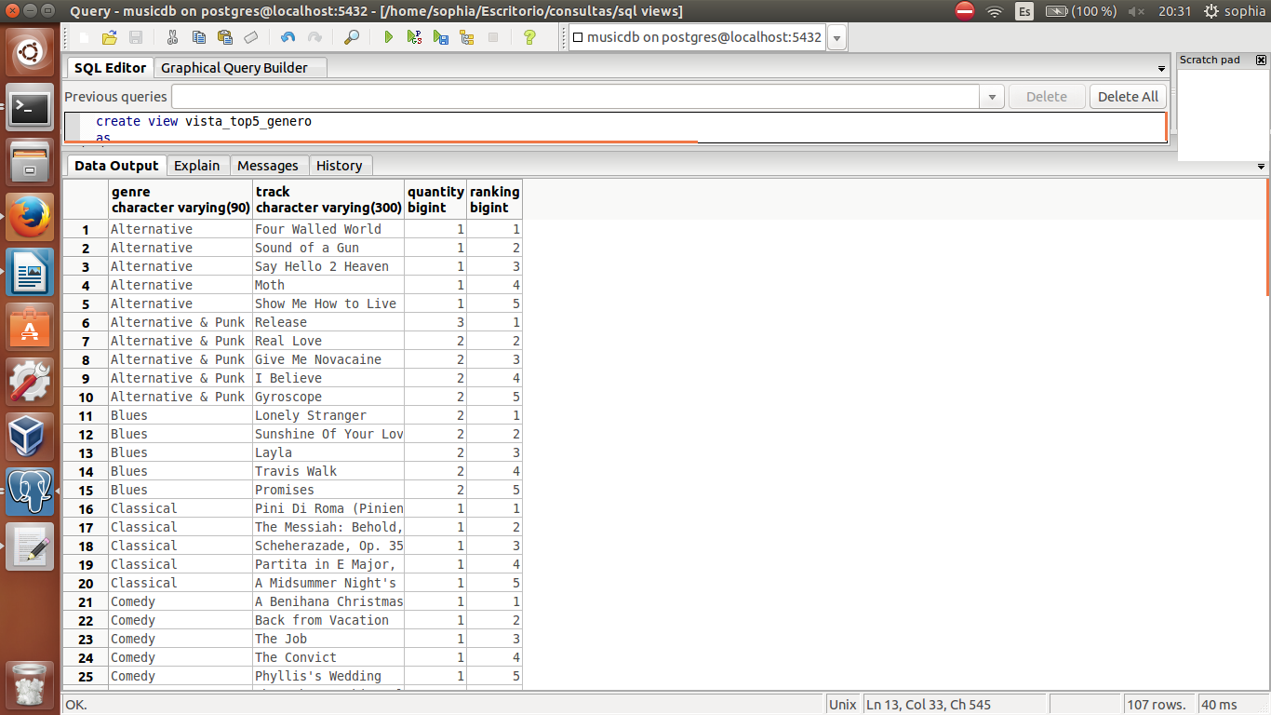

Listar los 3 clientes que han comprado más canciones

create view vista_top3clientes_canciones
as
select customer_data.firstname, customer_data.lastname, customer_data.city,customer_data.country,customer_data.phone, sum(invoiceline_data.quantity) as quantity
from invoiceline_data
inner join invoice_data on invoiceline_data.invoiceid=invoice_data.invoiceid
inner join customer_data on customer_data.customerid=invoice_data.customerid
group by customer_data.firstname,customer_data.lastname, customer_data.city,customer_data.country,customer_data.phone
order by sum(invoiceline_data.quantity) desc
limit 3;

select * FROM vista_top3clientes_canciones;

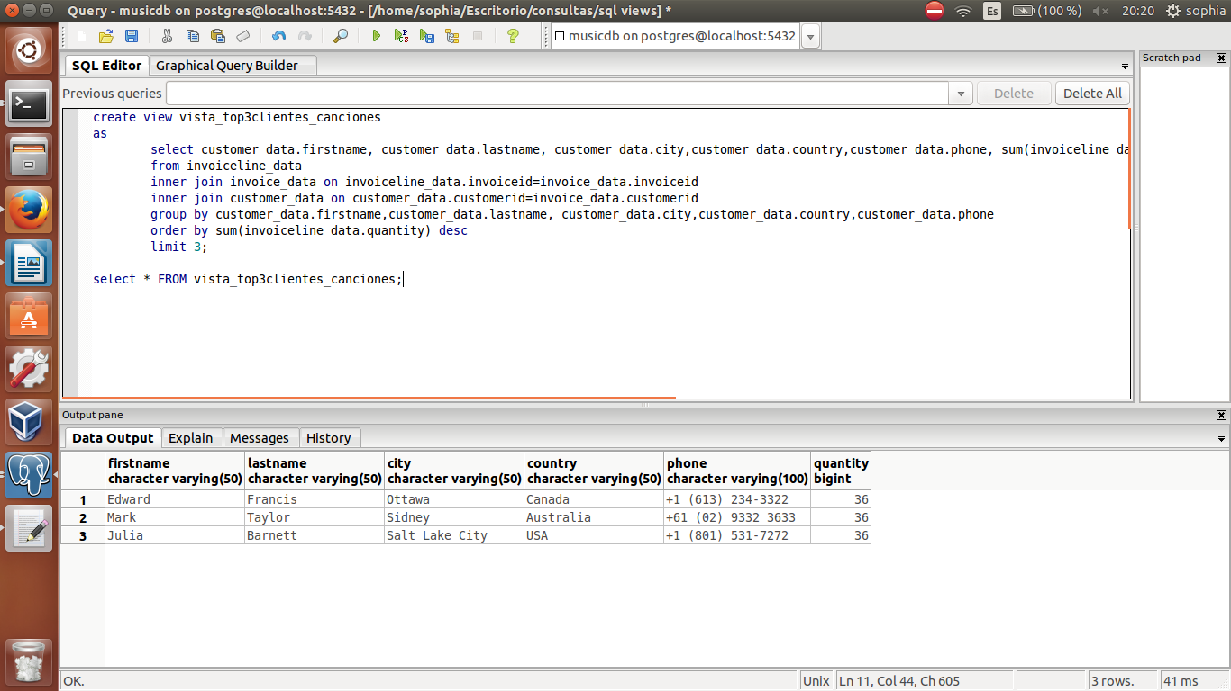

Listar las 20 canciones que tienen mayor duración agrupados por tipo de medio

create view vista_top20track_mediatype
as
select mediatype_data.name as nombre1, track_data.name as nombre2, track_data.milliseconds
from track_data
inner join mediatype_data on mediatype_data.mediatypeid = track_data.mediatypeid
group by mediatype_data.name, track_data.name, track_data.milliseconds
order by track_data.milliseconds desc
limit 20;

select * FROM vista_top20track_mediatype;

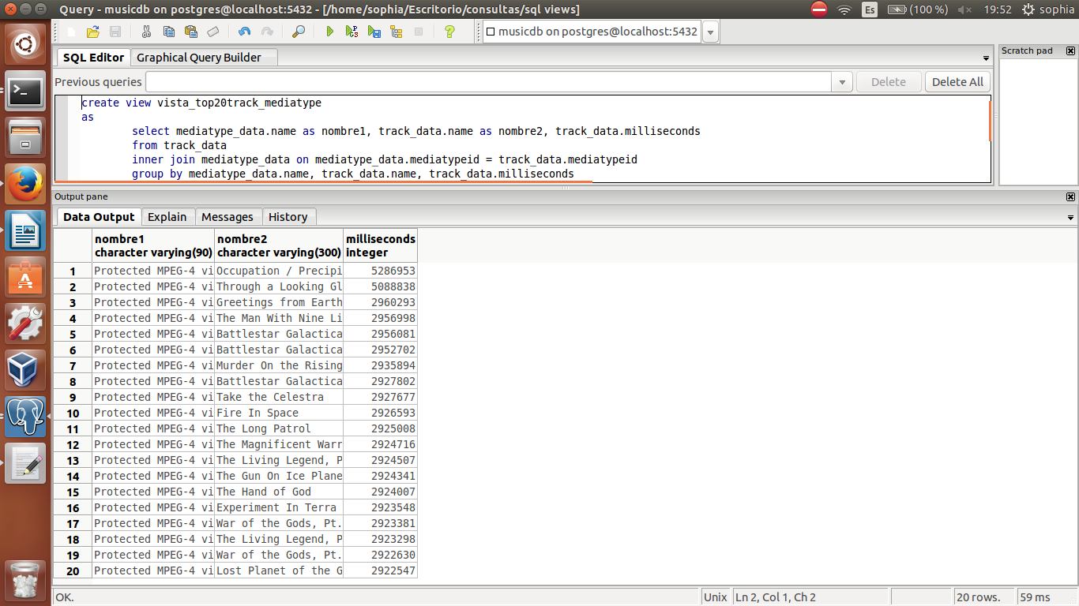

Listar total ventas por mes agrupadas por el vendedor

create view vista_ventasmes_vendor
as
select employee_data.employeeid, employee_data.firstname,extract(year from invoice_data.invoicedate) as year,extract(month from invoice_data.invoicedate) as month,sum(invoice_data.total) as total
from employee_data
inner join customer_data on employee_data.employeeid=customer_data.supportrepid
inner join invoice_data on customer_data.customerid=invoice_data.customerid
group by employee_data.employeeid,employee_data.firstname,extract(year from invoice_data.invoicedate),extract(month from invoice_data.invoicedate)
order by employee_data.firstname,extract(year from invoice_data.invoicedate),extract(month from invoice_data.invoicedate);

select * FROM vista_ventasmes_vendor;

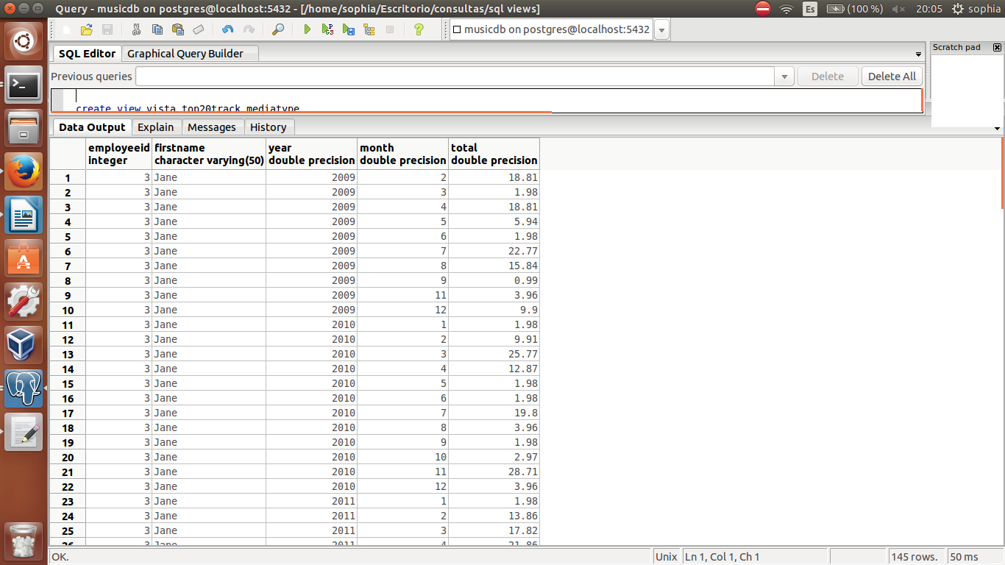
MANTENIMIENTO

Crear dos backups de la base de datos

En formato plano con nombre de archivo "bk_musicdb_usergithub"
DESDE PGADMIN CLICK DERECHO SOBRE LA BASEDATOS Y ELEGIR backup
ELEGIR FORMATO PLAIN para que se pueda leer desde un editor de tesxo O
EN CONSOLA
pg_dump -i -h localhost -p 5433 -U postgres -F p -b -v -f "/home/sofia/uasb_DBA-master/bk_musicdb_usergithub.sql" musicdb

bk_musicdb_usergithub.sql
bk_musicdb_usergithub.plain

En formato Postgresl con el nombre de archivo "bk_musicdb_usergithub"
DESDE PGADMIN CLICK DERECHO SOBRE LA BASEDATOS Y ELEGIR FORMATO BINARIO o EN CONSOLA
pg_dump -i -h localhost -p 5433 -U postgres -F c -b -v -f "/home/sofia/uasb_DBA-master/bk_musicdb_usergithub.backup" musicdb

bk_musicdb_usergithub.postgresql
bk_musicdb_usergithub.backup

Subir ambos "bk_musicdb_usergithub.sql" y "bk_musicdb_usergithub.backkup"archivos backup a su cuenta Github

Subir a Github Realizar backups con la opción -a y -v, explicar la diferencia.

Obtener un repositorio de un compañero y realizar un fork

sofia@quanchi:~/Escritorio$ git clone https://github.com/jboris/uasb_DBA.git
Clonar en «uasb_DBA»...
remote: Counting objects: 56, done.
remote: Total 56 (delta 0), reused 0 (delta 0), pack-reused 56
Unpacking objects: 100% (56/56), done.
Checking connectivity... hecho.
sofia@quanchi:~/Escritorio$

Crear una nueva base de datos con el nombre "musicdb_test" y recuperar todos los datos con los backups obtenidos del repositorio de su compañero.

PARA RESTAURAR restore DESDE PGADMIN Elegir la copia de respaldo de una base de datos
bk_musicdb_usergithub.backup

Proceder con el commando "vacummdb" para la limpieza la base de datos y toda la información generada guardarla en un archivo con nombre "vacumm_music.txt".

DESDE PGADMIN MAINTENANCE

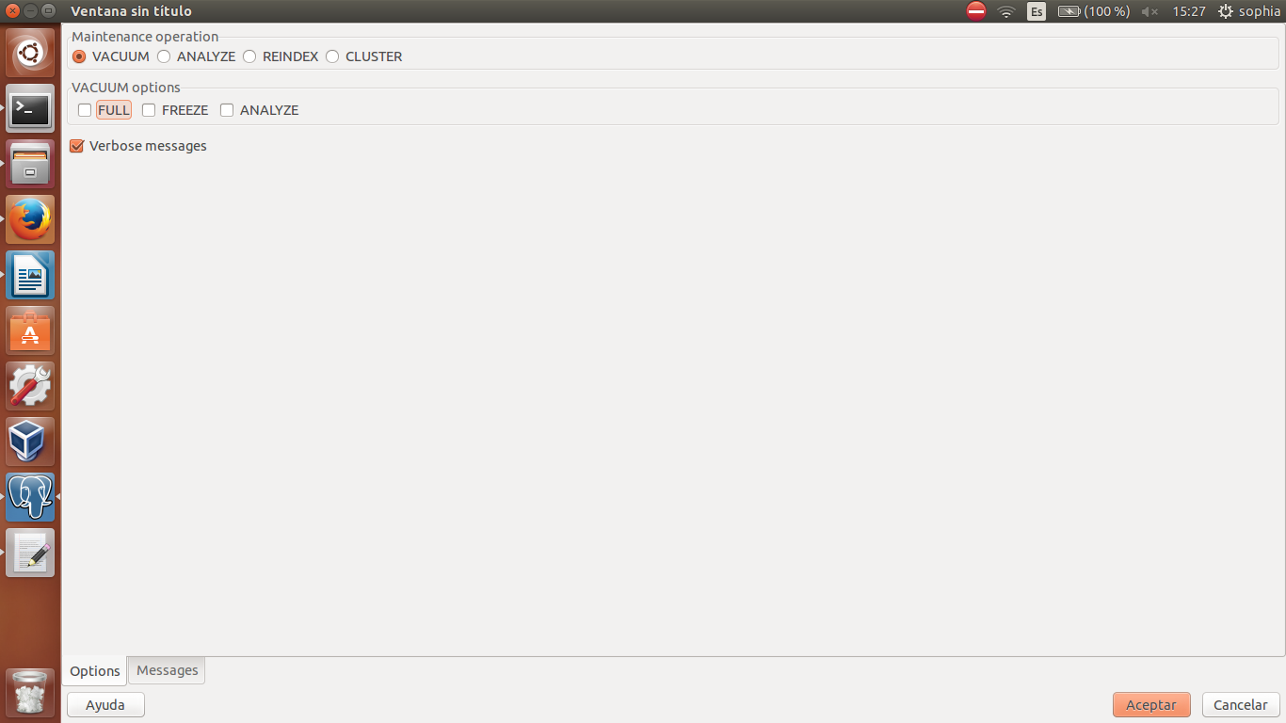

copiarlo en un editor de texto y guardarlo como un archivo.txt

Proceder con el commando "reindexdb" para la reindexación de la base de datos y toda la información generada guardarla en un archivo con el nombre "reindex_music.txt".

DESDE PGADMIN MAINTENANCE

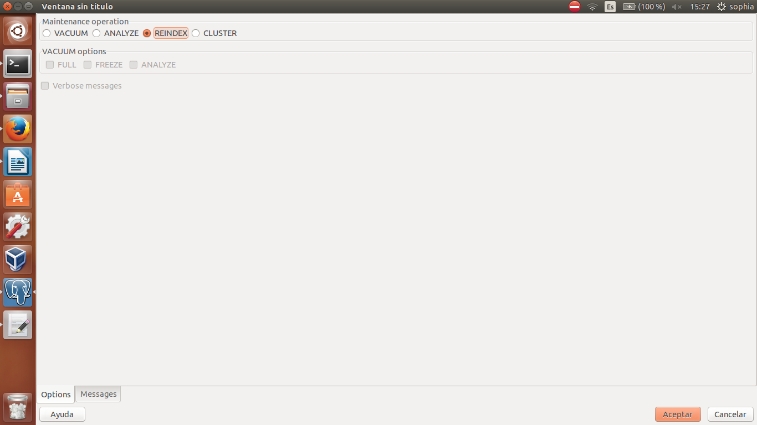

copiarlo en un editor de texto y guardarlo como un archivo.txt

Subir los archivo "vacumm_music.txt" y "reindex_music.txt" al repositorio Github.

Crear un script para generar un backup de la base de datos, el script deberá construir el archivo con el nombre del "archivo + un formato de fecha y hora".

En el editor nano desarrollar el script mensionado y grabar como .sh
scriptbackups.sh

Subir el script.sh a Github.

Subir Utilizar las herramientas .pgpass/cron para construir backups automatizados

Primero se debe instalar crontab

sophia@ninoska:~$ sudo apt-get install crontab
[sudo] password for sophia:
Leyendo lista de paquetes... Hecho
Creando árbol de dependencias
Leyendo la información de estado... Hecho
crontab ya está en su versión más reciente.
0 actualizados, 0 se instalarán, 0 para eliminar y 584 no actualizados.
sophia@ninoska:~$

Luego en el archivo /etc/crontab agregar la siguiente linea

min horas usuario del servidor el script a correr en este caso el que hicimos en el punto anterior

13 22 * * * sofia /home/sofia/Escritorio/scriptbackups.sh

Para que no solicite contraseña se utiliza .pgpass que es un archivo que se crea en la carpeta del usuario que incluye los siguientes datos

hostname:port:database:username:password

localhost:5432:musicdb:admin_user:superman22

CONSOLA

sophia@ninoska:~$ cd /etc/
sophia@ninoska:/etc$ sudo nano crontab
[sudo] password for sophia:

# /etc/crontab: system-wide crontab
# Unlike any other crontab you don't have to run the `crontab'
# command to install the new version when you edit this file
# and files in /etc/cron.d. These files also have username fields,
# that none of the other crontabs do.

SHELL=/bin/sh
PATH=/usr/local/sbin:/usr/local/bin:/sbin:/bin:/usr/sbin:/usr/bin:/home/sofia/$

# m h dom mon dow user command
17 * * * * root cd / && run-parts --report /etc/cron.hourly
25 6 * * * root test -x /usr/sbin/anacron || ( cd / && run-parts --repo$
47 6 * * 7 root test -x /usr/sbin/anacron || ( cd / && run-parts --repo$
52 6 1 * * root test -x /usr/sbin/anacron || ( cd / && run-parts --repo$
13 22 * * * sofia /home/sofia/Escritorio/scriptbackups.sh
#

