LAB ACTION PLAN FOR WEEK 4
MAVEN PROJECT LIFECYCLE & WEB APPLICATIONS
Name: K. TANAY Roll No: 24BD1A665P
Objective:
To enable students to:
- Understand the structure and lifecycle of a Maven project.
- Build and package Java and Web applications using Maven.
- Add dependencies using pom.xml, compile and test using plugins.
- Resolve errors and conflicts arising from dependency mismatches.
- Work with parent and multi-module Maven projects.
- Generate executable JARs and deployable WARs using Maven.
Students must document observations, include screenshots of executions, and answer scenario-based questions after completing the tasks.
1. Understanding Maven Project Structure
Maven standardizes the project structure for both Java and web-based applications:
src/
├── main/
│ ├── java/ → Application source code
│ └── resources/ → Configuration files like config.properties
└── test/
├── java/ → Unit test source code
└── resources/ → Test resources
The compiled files and reports are generated in the target/ directory after a successful build.
2. Steps to Perform Maven Build and Testing
----mvn clean install
- clean: Deletes the previous build (target/ folder)
- install: Builds, tests, and installs the package to local .m2 repository
After execution:
- target/ folder contains compiled .class files and the final .jar or .war
- Artifact is stored in: ~/.m2/repository/groupId/artifactId/version/
In pom.xml: Add a Dependency (e.g., Gson):
<dependency>
<groupId>com.google.code.gson</groupId>
<artifactId>gson</artifactId>
<version>2.10</version>
</dependency>
After running mvn clean install, check:
- Gson JAR is downloaded to .m2/repository/com/google/code/gson/gson/
- If version is wrong or not found → BUILD FAILURE with dependency resolution error.
Creation of Maven Java Project
Step 1. Open Eclipse IDE
└── 1.1. Launch Eclipse workspace
Step 2. Install Maven Plugin (if not installed)
└── 2.1. Go to "Help" in the top menu -> Eclipse Marketplace -> Search "Maven Integration for Eclipse"
Step 3. Create a New Maven Project
└── 3.1. File -> New -> Project... -> Expand "Maven" -> Select "Maven Project" and click "Next"
Step 4. Set Project Configuration -> Workspace location -> Click "Next"
Step 5. Choose Maven Archetype -> org.apache.maven.archetypes -> maven-archetype-quickstart 1.4
Step 6. Define Project Metadata -> Group ID: com.example, Artifact ID: my-maven-project
Step 7. Maven Project Created with src/main/java, src/test/java, pom.xml
Step 8. Update Project Settings -> Right-click project -> Maven -> Update Project...
Step 9. Build and Run Maven Project -> Run As -> Maven clean, Maven install, Maven test
Step 10. Run the application: Right-click on App.java -> Run As -> Java Application -> Output: "Hello Maven with Gson!" displayed.
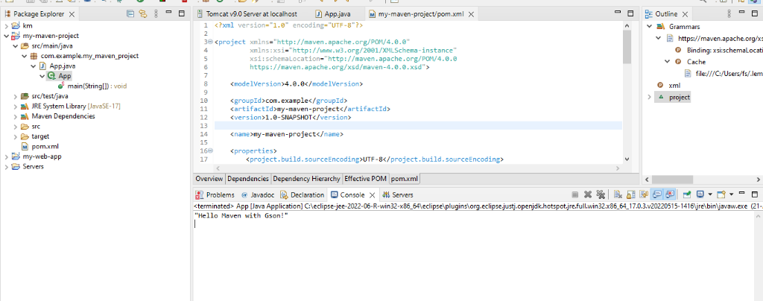
Fig 1: Maven Java Project Execution Output in Eclipse Console ("Hello Maven with Gson!")
Creation of Maven Web Java Project
Step 1: Open Eclipse -> Launch workspace.
Step 2: Create a New Maven Project -> File -> New -> Project -> Maven Project.
Step 3: Choose Maven Archetype -> org.apache.maven.archetypes -> maven-archetype-webapp 1.4.
Step 4: Configure Project -> Group Id: com.example, Artifact Id: my-web-app -> Finish.
Step 5: Add Maven Dependencies for Java Servlet API and JSTL into pom.xml.
Step 6: Configure Tomcat Server in Window -> Show View -> Servers -> Add Tomcat v9.0 server.
Step 7: Build project using mvn clean package.
Step 8: Run application: Right-click index.jsp -> Run As -> Run on Server -> Select Tomcat Server -> Finish.
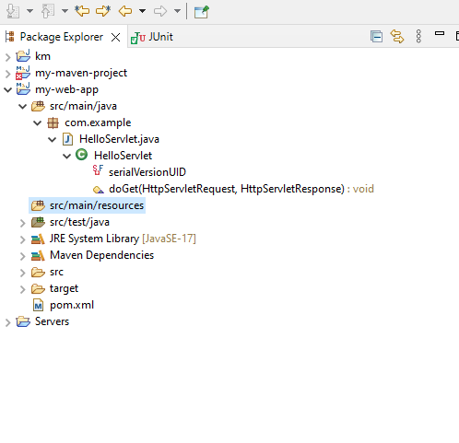
Fig 2: Maven Web Project Structure with HelloServlet.java and WebApp Folder
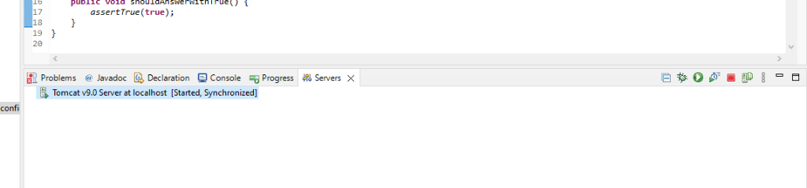
Fig 3: Apache Tomcat Server Running in Eclipse ([Started, Synchronized])
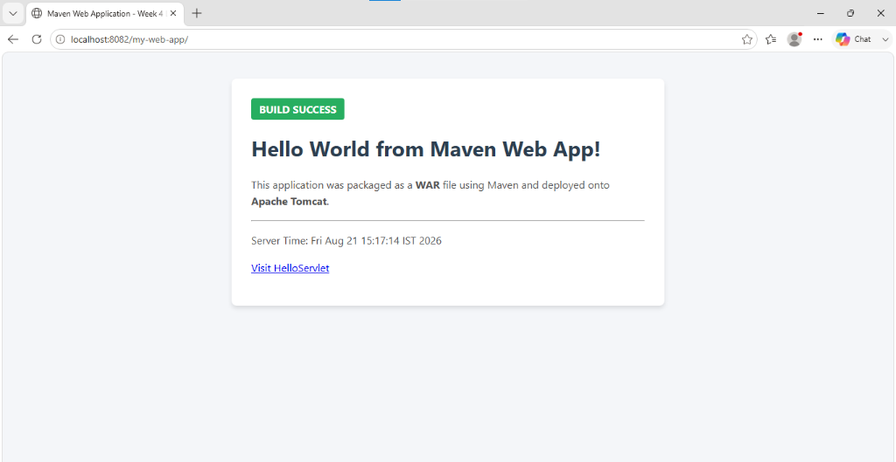
Fig 4: Live Web Application Output in Browser at http://localhost:8082/my-web-app/
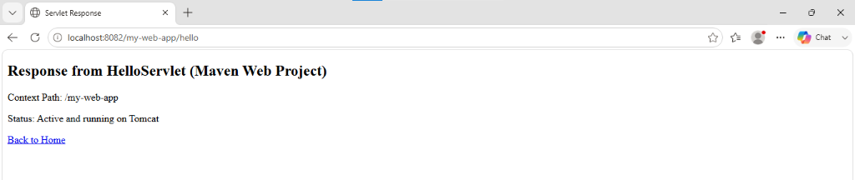
Fig 5: Dynamic Servlet Response from HelloServlet at http://localhost:8082/my-web-app/hello
3. Configure Java Version via Compiler Plugin
In pom.xml:
<plugin>
<groupId>org.apache.maven.plugins</groupId>
<artifactId>maven-compiler-plugin</artifactId>
<version>3.11.0</version>
<configuration>
<source>17</source>
<target>17</target>
</configuration>
</plugin>
Check: Run mvn package, inspect generated JAR: jar tf target/myapp.jar
4. JUnit Testing and Reports
Place test files in src/test/java. Example:
public class AppTest {
@Test
public void testSum() {
assertEquals(5, 2 + 3);
}
}
Run: mvn test
Check:
• target/test-classes/ → compiled test .class files
• target/surefire-reports/ → .txt or .xml test results
If test fails → corresponding log and failure trace shown.
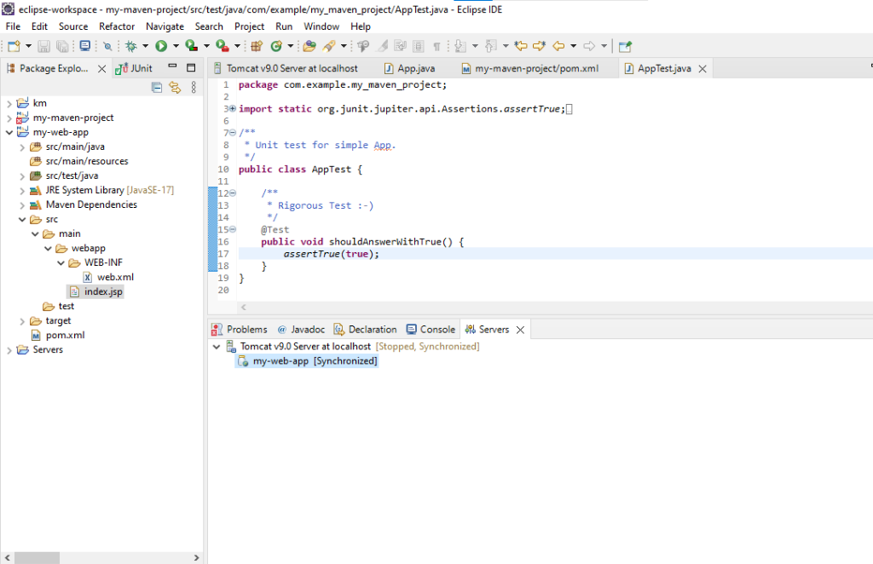
Fig 6: JUnit Test Execution and Directory Verification in Eclipse
5. Handling Errors in pom.xml
- Typos in version numbers or missing repositories cause BUILD FAILURE
- Maven shows precise error in console
- Fix the dependency tag → re-run mvn clean install
6. Adding Resource Files
Put config.properties inside: src/main/resources/config.properties
To read:
InputStream input = getClass().getClassLoader().getResourceAsStream("config.properties");
After build, check target/classes/ → file should exist there.
7. Multi-Module and Parent Projects
Structure:
parent/
├── pom.xml (packaging: pom)
├── core/
│ └── pom.xml
└── web/
└── pom.xml
- Parent pom.xml defines <modules> and common dependencies
- Each submodule builds independently into its target/ directory
8. Executable JARs
Add to pom.xml:
<build>
<plugins>
<plugin>
<groupId>org.apache.maven.plugins</groupId>
<artifactId>maven-jar-plugin</artifactId>
<configuration>
<archive>
<manifest>
<mainClass>com.example.Main</mainClass>
</manifest>
</archive>
</configuration>
</plugin>
</plugins>
</build>
Run:
mvn package
java -jar target/myapp.jar
9. Building a WAR File
Create a Maven web project with structure: src/main/webapp/WEB-INF/web.xml
Add: <packaging>war</packaging>
Command: mvn package
Generates target/mywebapp.war → deploy on Tomcat server.
10. Scenario-Based Questions & Answers
1. If my error is about "Failed to execute goal org.apache.maven.plugins:maven-compiler-plugin:3.8.1:compile", how can I resolve it using Maven terminal?
This error usually occurs because of Java version mismatch, compiler plugin configuration, or compilation errors.
Steps to resolve:
1. First, check the Java version: java --version
2. Check the Maven version: mvn --version
3. Clean the project: mvn clean
4. Run Maven with detailed error information: mvn clean compile -e
5. For complete debug information: mvn clean compile -X
6. Check the pom.xml and configure the maven-compiler-plugin with the correct Java version.
<plugin>
<groupId>org.apache.maven.plugins</groupId>
<artifactId>maven-compiler-plugin</artifactId>
<version>3.8.1</version>
<configuration>
<source>17</source>
<target>17</target>
</configuration>
</plugin>
7. Finally, run: mvn clean install
The exact compilation error shown before [ERROR] -> [Help 1] should also be checked because it usually identifies the actual problem.
2. A dependency you added is not recognized by the compiler. What steps would you take to confirm it is available in .m2 and listed in dependency tree?
If a dependency is not recognized by the compiler, I would check whether Maven has downloaded it correctly and whether it is included in the project's dependency tree.
Step 1: Check the local .m2 repository
Maven stores downloaded dependencies in:
C:\Users\<username>\.m2\repository
I would navigate to the dependency's groupId, artifactId, and version folders and verify that the JAR file is present.
Step 2: Check the dependency tree
Run:
mvn dependency:tree
To check a specific dependency:
mvn dependency:tree -Dincludes=groupId:artifactId
If the dependency appears in the output, Maven has included it in the project's dependency tree.
Step 3: Force Maven to download/update dependencies
If the dependency is missing or corrupted, run:
mvn clean install -U
The -U option forces Maven to check for updated dependencies.
Step 4: Check pom.xml
Make sure the dependency is correctly declared:
<dependency>
<groupId>groupId</groupId>
<artifactId>artifactId</artifactId>
<version>version</version>
</dependency>
Step 5: Rebuild the project
Finally, run:
mvn clean compile
If the dependency is present in .m2, appears in mvn dependency:tree, and is correctly declared in pom.xml, Maven should make it available on the compiler classpath.
3. A teammate sends a .patch file for a bug fix. How would you apply it and include it in your Maven build?
A .patch file usually contains changes to source code.
First, place the patch file in the project directory.
If Git is being used, apply the patch using:
git apply bugfix.patch
Check the changes:
git diff
Then compile and build the project:
mvn clean install
The patch itself does not normally need to be added as a Maven dependency. It modifies the source code, and Maven compiles the modified source during the build.
If the patch contains a new dependency, the required dependency should also be added to pom.xml.
4. You have multiple JUnit test failures and want to rerun only failed tests. How would you approach this?
First, run the tests:
mvn test
Maven stores test reports in:
target/surefire-reports/
For JUnit tests, Maven Surefire Plugin can be configured to rerun failed tests automatically.
Example:
<plugin>
<groupId>org.apache.maven.plugins</groupId>
<artifactId>maven-surefire-plugin</artifactId>
<configuration>
<rerunFailingTestsCount>2</rerunFailingTestsCount>
</configuration>
</plugin>
This configuration reruns a failing test up to two additional times.
Alternatively, identify the failed test classes from the Surefire reports and run only those tests:
mvn -Dtest=TestClassName test
For multiple test classes:
mvn -Dtest=TestClass1,TestClass2 test
5. Your Maven build fails due to "Unsupported class version error." What plugin and configuration would you review?
An unsupported class version error generally means that the Java version used to compile the project is different from the Java version being used to run it.
The first things to check are:
java --version
mvn --version
Then review the maven-compiler-plugin configuration in pom.xml.
Example:
<plugin>
<groupId>org.apache.maven.plugins</groupId>
<artifactId>maven-compiler-plugin</artifactId>
<version>3.8.1</version>
<configuration>
<source>17</source>
<target>17</target>
</configuration>
</plugin>
The source and target Java versions should be compatible with the installed JDK.
After changing the configuration:
mvn clean install
6. You need to change your Java application from a WAR to a standalone JAR. What pom.xml changes are needed?
Change the packaging from:
<packaging>war</packaging>
to:
<packaging>jar</packaging>
If packaging is not specified, Maven uses jar by default.
Remove WAR-specific configuration such as:
<artifactId>maven-war-plugin</artifactId>
If the application needs to be executable, configure a plugin such as the Maven Shade Plugin or Maven Jar Plugin.
Example using Maven Jar Plugin:
<plugin>
<groupId>org.apache.maven.plugins</groupId>
<artifactId>maven-jar-plugin</artifactId>
<configuration>
<archive>
<manifest>
<mainClass>com.example.App</mainClass>
</manifest>
</archive>
</configuration>
</plugin>
Then run:
mvn clean package
The resulting JAR will be generated inside: target/
7. You are required to change the default build output directory from target/ to build_output/. How would you configure it?
Maven uses the project.build.directory property for the build output directory.
Add the following inside pom.xml:
<build>
<directory>build_output</directory>
</build>
After running:
mvn clean package
Maven will generate build files inside build_output/ instead of target/.
8. You want to skip tests during the Maven build. What command would you use?
To skip running tests but still compile the test classes:
mvn package -DskipTests
To skip both test execution and test compilation:
mvn package -Dmaven.test.skip=true
The commonly used command is:
mvn clean install -DskipTests
9. How would you generate a site report with test coverage and dependency analysis for a Maven project?
Maven Site generates documentation and reports for a project.
First, configure the required reporting plugins in pom.xml, such as:
• Maven Surefire Report Plugin
• JaCoCo for test coverage
• Maven Dependency Plugin/Report
Then run:
mvn clean site
The generated site is normally available in: target/site/
The HTML reports can be opened in a browser.
10. How do you build a Java project using Maven, and what files are generated in the target/ folder after running mvn clean install?
The standard Maven build process is:
Step 1: Clean previous build files: mvn clean
Step 2: Compile the source code: mvn compile
Step 3: Run tests: mvn test
Step 4: Package the application: mvn package
Step 5: Install the artifact into the local repository: mvn install
All these stages can be performed using: mvn clean install
After the build, the target/ directory may contain:
target/
├── classes/
├── test-classes/
├── generated-sources/
├── generated-test-sources/
├── maven-status/
├── surefire-reports/
└── project-name-version.jar
For a web application, it may contain: project-name-version.war
11. How does Maven resolve dependency conflicts when two libraries use different versions of the same dependency, and how can you view and manage the dependency tree?
Maven uses a dependency mediation mechanism to resolve conflicts.
A common rule is nearest definition wins. If two dependencies require different versions of the same library, Maven generally selects the version that is closest to the project's dependency in the dependency tree.
To view the dependency tree: mvn dependency:tree
To identify a particular dependency: mvn dependency:tree -Dincludes=groupId:artifactId
If a specific version is required, explicitly declare it in the project's pom.xml:
<dependency>
<groupId>org.example</groupId>
<artifactId>example-library</artifactId>
<version>2.0</version>
</dependency>
You can also exclude an unwanted transitive dependency:
<exclusions>
<exclusion>
<groupId>org.example</groupId>
<artifactId>old-library</artifactId>
</exclusion>
</exclusions>
12. How do you write and run a JUnit test in a Maven project, and where are the compiled test classes and reports stored after running mvn test?
A standard Maven project contains:
src/main/java/ and src/test/java/
Create the Java application class inside src/main/java/
Create the JUnit test class inside src/test/java/
Example:
import static org.junit.jupiter.api.Assertions.assertEquals;
import org.junit.jupiter.api.Test;
public class CalculatorTest {
@Test
void testAddition() {
assertEquals(5, 2 + 3);
}
}
Run the test using: mvn test
Compiled test classes are stored in: target/test-classes/
Test reports are stored in: target/surefire-reports/
13. How can you create an executable JAR with a main method using Maven, and which plugin helps configure this behavior?
An executable JAR must specify the application's main class.
One option is to use the Maven Jar Plugin.
Example:
<plugin>
<groupId>org.apache.maven.plugins</groupId>
<artifactId>maven-jar-plugin</artifactId>
<configuration>
<archive>
<manifest>
<mainClass>com.example.Main</mainClass>
</manifest>
</archive>
</configuration>
</plugin>
Then run: mvn clean package
The JAR will be generated inside target/ and executed using: java -jar target/project-name.jar
For applications with many dependencies, the Maven Shade Plugin is commonly used.
14. How do you install and use a custom third-party JAR file in your Maven project, and how can you confirm it is included in the build and classpath?
Suppose the JAR file is custom-library.jar. Install it into the local Maven repository using:
mvn install:install-file -Dfile=custom-library.jar -DgroupId=com.example -DartifactId=custom-library -Dversion=1.0 -Dpackaging=jar
Then add it to pom.xml:
<dependency>
<groupId>com.example</groupId>
<artifactId>custom-library</artifactId>
<version>1.0</version>
</dependency>
Run: mvn dependency:tree to confirm the custom dependency appears, then build: mvn clean package.
15. How do you create a Maven web project that packages into a WAR file, and what is the standard folder structure?
Set the packaging type in pom.xml: <packaging>war</packaging>
A standard Maven web project has the structure:
project/
├── pom.xml
└── src/
├── main/
│ ├── java/
│ ├── resources/
│ └── webapp/
│ ├── WEB-INF/
│ │ └── web.xml
│ └── index.jsp
└── test/
└── java/
The Java source code is stored in src/main/java/ and web files are stored in src/main/webapp/.
Build using: mvn clean package (WAR file is generated inside target/).
16. What command do you use to build a WAR file in Maven, where is it generated, and how can you deploy it to Apache Tomcat?
First, configure the project with: <packaging>war</packaging>
Build the WAR using: mvn clean package
The WAR file will be generated in: target/ (e.g., target/mywebapp.war)
To deploy it to Apache Tomcat, copy the WAR file into Tomcat's webapps/ directory, then start the Tomcat server.
Tomcat automatically deploys the WAR file and creates the application directory.
17. How do you add JSTL and servlet-api dependencies in a Maven web project, and why should servlet API use provided scope instead of compile?
JSTL can be added as a Maven dependency. For a Jakarta-based application:
<dependency>
<groupId>jakarta.servlet.jsp.jstl</groupId>
<artifactId>jakarta.servlet.jsp.jstl-api</artifactId>
<version>3.0.0</version>
</dependency>
The servlet API can be declared with provided scope:
<dependency>
<groupId>jakarta.servlet</groupId>
<artifactId>jakarta.servlet-api</artifactId>
<version>6.0.0</version>
<scope>provided</scope>
</dependency>
The reason for using provided scope is that the servlet container, such as Apache Tomcat, already provides the Servlet API at runtime. Therefore, Maven should make the API available for compilation but should not package it inside the WAR file to avoid duplicate classes and version conflicts.
18. How do you set up a multi-module Maven web project with separate modules for core logic and web interface, and how are these modules built and connected?
A multi-module project has a parent POM and multiple child modules. Example structure:
my-project/
├── pom.xml
├── core/
│ ├── pom.xml
│ └── src/main/java/
└── web/
├── pom.xml
└── src/main/
├── java/
└── webapp/
The parent pom.xml uses <packaging>pom</packaging> and defines <modules>core, web</modules>.
The core module contains business logic and is packaged as a JAR.
The web module contains the web interface, is packaged as a WAR, and depends on the core module:
<dependency>
<groupId>com.example</groupId>
<artifactId>core</artifactId>
<version>1.0</version>
</dependency>
When the parent project is built using mvn clean install, Maven builds the modules in the correct dependency order.
19. How do you configure a Maven web project, and how does its packaging and execution differ from a traditional WAR-based application?
A Maven web project is configured with <packaging>war</packaging> and standard layout (src/main/java, src/main/resources, src/main/webapp, src/test/java).
Build using mvn clean package -> produces target/application.war.
Difference between JAR and WAR-based applications:
Feature | JAR Application | WAR Application
Packaging | .jar | .war
Main purpose | Standalone Java application | Web application
Execution | Usually java -jar | Deployed to servlet container
Server | Can use embedded server | Usually uses external server
Web files | Not necessarily src/main/webapp | Uses src/main/webapp
Deployment | Run directly | Deploy to Tomcat/other servlet container
Maven packaging | jar | war
A traditional WAR application is deployed to a servlet container such as Tomcat. A standalone JAR application can contain an embedded server and can be started directly using a Java command. The main difference is therefore how the application is packaged, deployed, and executed.
Conclusion
Mastering Maven empowers students to structure projects efficiently, manage complex dependencies, and automate testing and packaging. By practicing real-world scenarios—such as resolving build errors, handling resource files, applying patches, and deploying to servers—students gain valuable hands-on experience aligned with professional software development workflows. Maven not only streamlines builds but also enforces standardization and reusability across projects. Through Maven, students learn efficient project management, dependency control, multi-module integration, and reproducible builds. Understanding Maven's lifecycle, plugin system, and error handling prepares students for professional DevOps and CI/CD workflows. This lab equips students with hands-on experience in packaging, testing, resolving conflicts, and deploying real-world Java and Web applications.

