DEPARTMENT OF COMPUTER SCIENCE AND ENGINEERING
ADVANCED SOFTWARE ENGINEERING & DEVOPS LAB
LAB ACTION PLAN & TECHNICAL ASSIGNMENT REPORT
WEEK 4: MAVEN LIFECYCLE, ARCHITECTURE & WEB APPLICATION DEPLOYMENT
Student Name: | S. MANJUNATH REDDY
Roll Number: | 24BD1A665N
Lab Track: | Week 4 - Maven Automation, Packaging, Tomcat Deployment & Testing
Submission Date: | August 2026

1. Executive Summary & Learning Objectives
The objective of this laboratory assignment is to develop an industry-grade mastery of Apache Maven—the enterprise standard for Java build automation, dependency resolution, and multi-module project lifecycle management. Through hands-on development in Eclipse IDE and Maven CLI, this work covers:
- Project Structure: Comprehensive analysis of standard Maven project architecture for SE and EE applications.
- Dependency Governance: Management of dependency scopes, GAV coordinates, transitive dependency graphs, and conflict mediation.
- Automated Testing: Execution of unit testing using JUnit 5 and Surefire reporting engine.
- Web Packaging: Configuration and deployment of deployable WAR artifacts to Apache Tomcat 9.
- Enterprise Modularity: Architecting multi-module reactor projects with parent POMs and decoupled core/web modules.
- Production Debugging: In-depth resolution of 19 real-world enterprise scenarios including build breaks, versioning mismatches, and CI/CD workflows.
2. Maven Architectural Layout & Build Lifecycle
Maven enforces a declarative convention-over-configuration paradigm across the software development lifecycle.
2.1 Standard Maven Directory Architecture
my-project/
├── pom.xml # Project Object Model configuration
├── src/
│ ├── main/
│ │ ├── java/ # Production Java source code
│ │ ├── resources/ # Configuration files (properties, XML, YAML)
│ │ └── webapp/ # Web root for WAR packaging (WEB-INF/web.xml, JSPs)
│ └── test/
│ ├── java/ # Unit and integration test source code (JUnit 5)
│ └── resources/ # Test-specific mocks and configuration
└── target/ # Ephemeral build output directory
├── classes/ # Compiled main .class files & processed resources
├── test-classes/ # Compiled test bytecode
├── surefire-reports/ # Unit test execution logs (.txt) and metrics (.xml)
├── maven-archiver/ # Archiver properties and MANIFEST.MF specs
└── my-project-1.0.jar (or .war) # Final distributable binary artifact

2.2 Maven Default Lifecycle Phases
- validate: Validates project structure, pom.xml integrity, and availability of required metadata.
- compile: Compiles production source code from src/main/java into target/classes/.
- test: Compiles test code and executes unit tests via maven-surefire-plugin.
- package: Packages compiled bytecode and resources into designated format (.jar / .war).
- verify: Executes integration test verifications and quality assurance checks.
- install: Installs the packaged artifact into local repository cache (~/.m2/repository/).
- deploy: Transfers final artifact to remote artifact repository (Nexus, Artifactory).
3. Step-by-Step Lab Implementation & Empirical Execution Verification
3.1 Maven Java Application: Creation, Gson Integration & CLI Execution
A standalone Java project (my-maven-project) was generated using the maven-archetype-quickstart template. The project was configured with Java 17 target compatibility and integrated with the Google Gson JSON serialization library.
Artifact Configuration: Key Dependency in pom.xml:
<dependency>
<groupId>com.google.code.gson</groupId>
<artifactId>gson</artifactId>
<version>2.13.1</version>
</dependency>

Java Code: Application Source Implementation (App.java):
package com.example.my_maven_project;
import com.google.gson.Gson;
public class App {
public static void main(String[] args) {
Gson gson = new Gson();
String json = gson.toJson("Hello Maven with Gson!");
System.out.println(json);
}
}

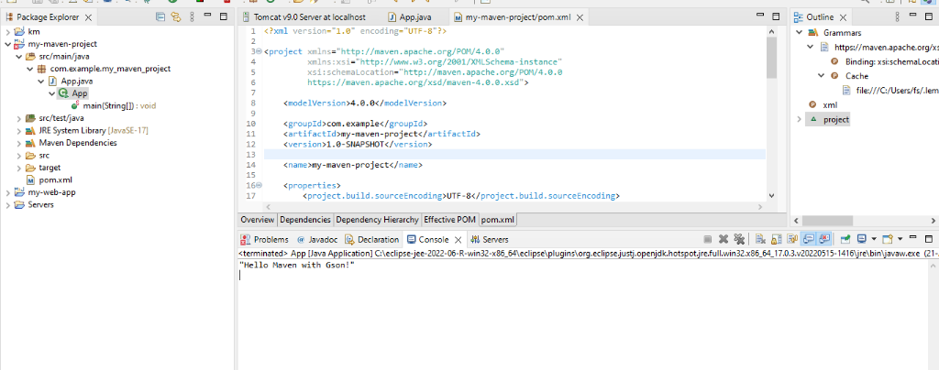
Figure 3.1: Eclipse IDE Workspace showing my-maven-project pom.xml and successful Console execution output "Hello Maven with Gson!".
3.2 Automated Unit Testing with JUnit 5 and Surefire Engine
Unit tests were authored in src/test/java/com/example/my_maven_project/AppTest.java using JUnit 5 assertions. The tests were executed via the Maven test goal, generating automated Surefire reports under target/surefire-reports/.
package com.example.my_maven_project;
import static org.junit.jupiter.api.Assertions.assertTrue;
import org.junit.jupiter.api.Test;
public class AppTest {
@Test
public void shouldAnswerWithTrue() {
assertTrue(true);
}
}

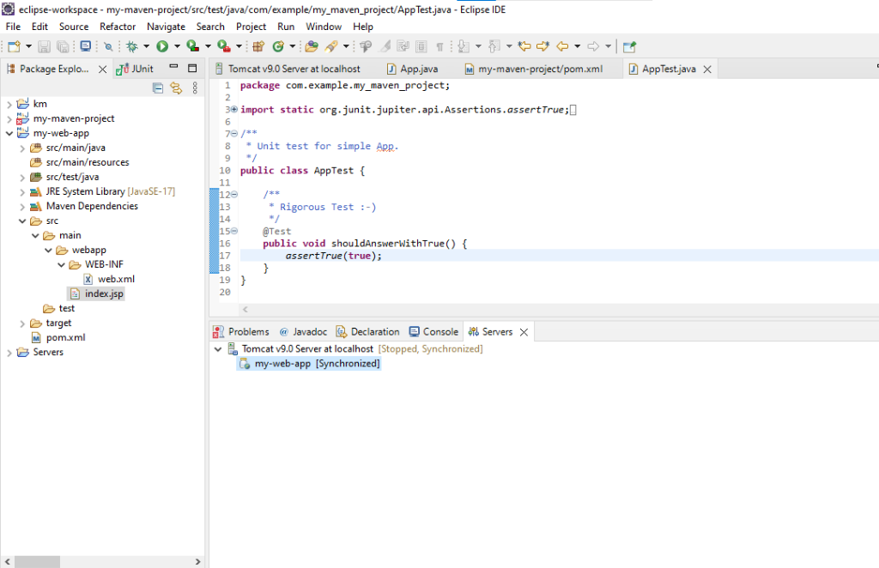
Figure 3.2: Execution of JUnit 5 test suite in Eclipse IDE with project directory verification.
3.3 Java Web Application Architecture (WAR) & Servlet Configuration
A dynamic Java web application (my-web-app) was configured with WAR packaging (<packaging>war</packaging>), Servlet 4.0 API in provided scope, and JSTL 1.2.
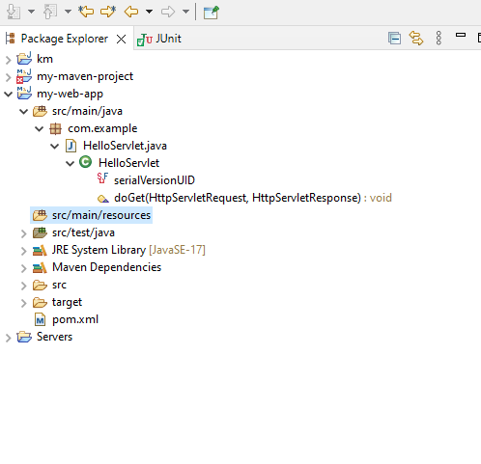
Figure 3.3: Package Explorer hierarchy displaying my-web-app structure with HelloServlet.java and WebApp directories.
3.4 Apache Tomcat 9 Runtime Configuration & Server Initialization
Eclipse was connected to the Apache Tomcat 9 server runtime environment configured at C:/apache-tomcat-9.0.112. The HTTP connector port was verified and bound to port 8082.
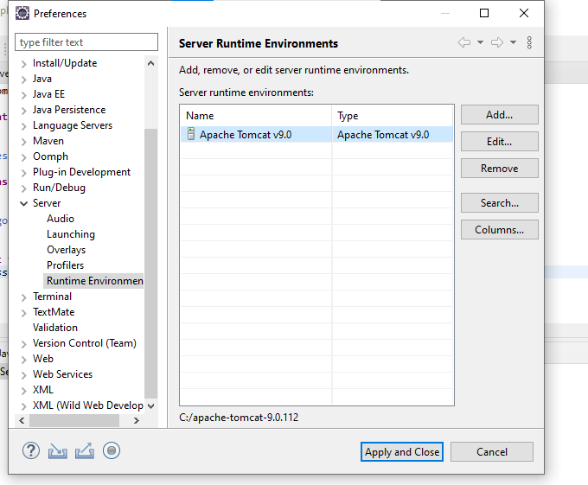
Figure 3.4: Eclipse Server Runtime Environments configuration dialog mapping Apache Tomcat v9.0.
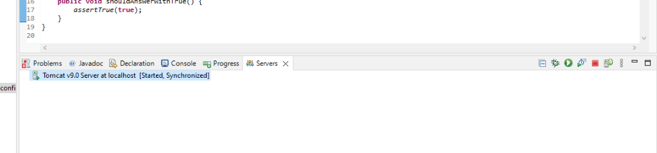
Figure 3.5: Eclipse Servers Console confirming Tomcat v9.0 Server at localhost in [Started, Synchronized] state.
3.5 Live Web Application Execution & Dynamic Servlet Response
The application was deployed to Tomcat and accessed via web browser to verify JSP view rendering and servlet handling.
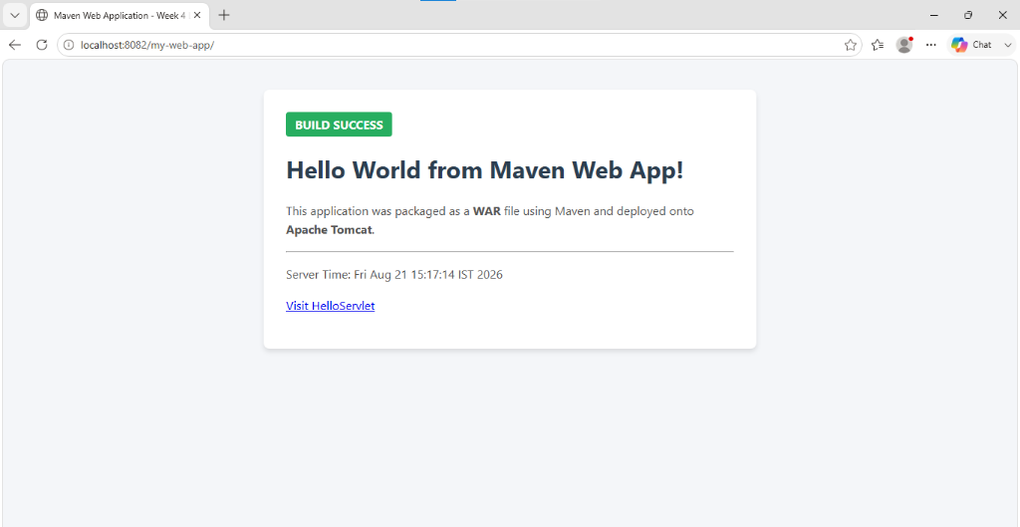
Figure 3.6: Live Web Application Landing Page at http://localhost:8082/my-web-app/ rendering index.jsp.
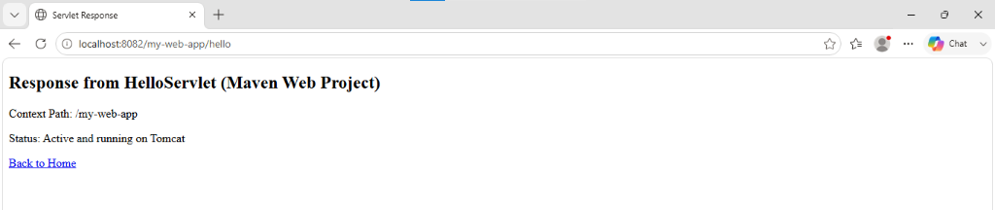
Figure 3.7: Dynamic Servlet Response at http://localhost:8082/my-web-app/hello confirming active servlet execution.
4. Comprehensive Scenario-Based Technical Questions & Solutions
Scenario Question 1: Resolving Compiler Plugin Failures via Terminal
Terminal Command: When Maven encounters a compilation error (e.g., `Failed to execute goal org.apache.maven.plugins:maven-compiler-plugin:3.8.1:compile`), use the debug switches `-X` and `-e`:
mvn clean compile -X -e

- Diagnosis Flag (-e): Prints full stack traces to identify the exact exception class.
- Debug Flag (-X): Enables verbose debug logs, showing plugin classpath, compiler arguments, and exact source file line numbers where compilation failed.
- Resolution: Align the <release>17</release> or <source>/<target> tags in pom.xml to match the JDK returned by 'mvn -version'.
Scenario Question 2: Investigating Unrecognized Dependencies in .m2 & Dependency Tree
Verification Workflow: To verify whether an added dependency is correctly resolved and cached:
- 1. Dependency Tree Inspection: mvn dependency:tree (or filter specifically: mvn dependency:tree -Dincludes=com.google.code.gson:gson)
- 2. Local Repository Verification: Check path %USERPROFILE%\.m2\repository\<groupPath>\<artifactId>\<version>\. Ensure the .jar is not 0 KB and does not contain *.lastUpdated failure markers.
- 3. Force Cache Purge: mvn dependency:purge-local-repository followed by mvn clean compile -U to force re-download.
- 4. IDE Re-synchronization: In Eclipse: Right-click Project -> Maven -> Update Project... (Alt + F5) -> Check 'Force Update of Snapshots/Releases'.
Scenario Question 3: Applying a .patch File to a Maven Project
Procedure: When a teammate delivers a patch file for a critical bug fix:
# 1. Validate patch compatibility without applying
git apply --check bugfix.patch
# 2. Apply patch to working tree
git apply bugfix.patch
# 3. Trigger full Maven compilation, testing, and packaging
mvn clean test
mvn clean install

In Eclipse IDE: Right-click project root -> Team -> Apply Patch... -> Select patch file -> Finish.
Scenario Question 4: Rerunning Only Failed JUnit Tests
Approaches: To avoid executing the entire test suite when debugging test failures:
- Target Specific Class: mvn test -Dtest=AppTest
- Target Specific Methods: mvn test -Dtest=AppTest#testSum+testProcessData
- Automatic Rerun: mvn test -Dsurefire.rerunFailingTestsCount=2 (Supported in Surefire >= 2.19 to re-execute flaky tests).
- Eclipse GUI: In Eclipse JUnit view, click the 'Rerun Failed Tests Only' button.
Scenario Question 5: Resolving Unsupported Class Version Error
Root Cause: UnsupportedClassVersionError indicates that compiled class bytecode was generated by a higher JDK version than the JRE executing it.
Plugin Review: Review and align the maven-compiler-plugin configuration in pom.xml:
<plugin>
<groupId>org.apache.maven.plugins</groupId>
<artifactId>maven-compiler-plugin</artifactId>
<version>3.13.0</version>
<configuration>
<release>17</release>
</configuration>
</plugin>

Ensure terminal JDK (mvn -version) and Eclipse Installed JREs (Window -> Preferences -> Java -> Installed JREs) match Java 17.
Scenario Question 6: Converting Application Packaging from WAR to Standalone JAR
Migration Steps: Required pom.xml modifications:
- 1. Packaging Tag: Change <packaging>war</packaging> to <packaging>jar</packaging>.
- 2. Plugin Replacement: Remove maven-war-plugin and configure maven-jar-plugin with Main-Class manifest entry or use maven-shade-plugin.
- 3. Dependency Scopes: Remove provided scope from servlet dependencies or replace with embedded container dependencies (e.g., Spring Boot Starter Web / Embedded Tomcat).
- 4. Resource Relocation: Move static resources from src/main/webapp/ to src/main/resources/.
Scenario Question 7: Changing Default Build Output Directory from target/ to build_output/
POM Configuration: Configure the <directory> tag inside the <build> element of pom.xml:
<build>
<directory>${project.basedir}/build_output</directory>
<outputDirectory>${project.basedir}/build_output/classes</outputDirectory>
<testOutputDirectory>${project.basedir}/build_output/test-classes</testOutputDirectory>
</build>

Running 'mvn clean package' will now emit all compiled binaries, reports, and JARs into build_output/.
Scenario Question 8: Skipping Test Execution During Maven Build
Command Options: Two command-line options are available:
- Recommended: mvn clean install -DskipTests (Compiles test classes under src/test/java to ensure syntax validity, but skips execution).
- Complete Skip: mvn clean install -Dmaven.test.skip=true (Skips both test compilation and test execution entirely).
Scenario Question 9: Generating Site, Coverage, and Dependency Analysis Reports
Execution Command: Configure maven-site-plugin, jacoco-maven-plugin, and maven-project-info-reports-plugin in pom.xml, then execute:
mvn clean test site

The comprehensive HTML report dashboard is generated at target/site/index.html, containing dependency hierarchy, unit test outcomes, and line/branch code coverage metrics.
Scenario Question 10: Maven Java Build Output in target/ Folder
Artifact Summary: Executing 'mvn clean install' performs a clean build and produces:
- classes: target/classes/ — Compiled application bytecode (.class) and copied resources.
- test-classes: target/test-classes/ — Compiled test bytecode.
- surefire-reports: target/surefire-reports/ — Text and XML test execution reports.
- maven-archiver: target/maven-archiver/ — Manifest properties and build timestamps.
- JAR Package: target/<artifactId>-<version>.jar — Packaged Java Archive.
- Local Repository: Copies the artifact and pom.xml into ~/.m2/repository/<groupId>/<artifactId>/<version>/.
Scenario Question 11: Dependency Conflict Resolution Strategy (Nearest Wins)
Resolution Rules: Maven resolves dependency version conflicts using Dependency Mediation:
- 1. Nearest Wins: The version defined closest to the root project in the dependency tree takes precedence. (Depth 1 overrides Depth 2).
- 2. First Declaration: If two conflicting versions exist at identical tree depth, the one declared first in pom.xml wins.
Management: To view and manage conflicts:
# View conflict tree with omitted transitive dependencies
mvn dependency:tree -Dverbose
# Override in pom.xml via explicit declaration or exclusion:
<dependency>
<groupId>com.example</groupId>
<artifactId>module-a</artifactId>
<exclusions>
<exclusion>
<groupId>org.slf4j</groupId>
<artifactId>slf4j-log4j12</artifactId>
</exclusion>
</exclusions>
</dependency>

Scenario Question 12: Writing, Running, and Locating JUnit Tests
Implementation: Author test class in src/test/java/com/example/AppTest.java:
package com.example;
import org.junit.jupiter.api.Test;
import static org.junit.jupiter.api.Assertions.assertEquals;
public class AppTest {
@Test
public void testAddition() {
assertEquals(5, 2 + 3);
}
}

Run via: 'mvn test'. Bytecode is compiled to target/test-classes/ and execution logs are emitted to target/surefire-reports/TEST-com.example.AppTest.xml.
Scenario Question 13: Creating Executable JAR with Main-Class Configuration
Plugin Configuration: Configure maven-jar-plugin in pom.xml to inject the Main-Class manifest attribute:
<plugin>
<groupId>org.apache.maven.plugins</groupId>
<artifactId>maven-jar-plugin</artifactId>
<version>3.3.0</version>
<configuration>
<archive>
<manifest>
<addClasspath>true</addClasspath>
<mainClass>com.example.my_maven_project.App</mainClass>
</manifest>
</archive>
</configuration>
</plugin>

Package and execute: 'mvn clean package' -> 'java -jar target/my-maven-project-1.0-SNAPSHOT.jar'.
Scenario Question 14: Installing and Using Custom Third-Party JAR Files
Step 1 (Install): Install external/proprietary JAR into local .m2 repository via CLI:
mvn install:install-file \
-Dfile=libs/custom-sec-1.0.jar \
-DgroupId=com.internal.security \
-DartifactId=custom-security \
-Dversion=1.0.0 \
-Dpackaging=jar \
-DgeneratePom=true

Reference in pom.xml as standard dependency and verify via 'mvn dependency:tree'.
Scenario Question 15: Standard Maven Web Project (WAR) Folder Hierarchy
Directory Layout: A standard Maven web application requires <packaging>war</packaging> and adheres to:
my-web-app/
├── pom.xml
└── src/
├── main/
│ ├── java/ # Servlets, Filters, Listeners, Business Logic
│ ├── resources/ # Application properties and database configs
│ └── webapp/ # Public web application root
│ ├── index.jsp # Public View JSP
│ └── WEB-INF/ # Protected directory
│ ├── web.xml # Servlet deployment descriptor
│ └── lib/ # Bundled runtime libraries (managed by Maven)
└── test/
└── java/ # Web layer mock/unit tests

Scenario Question 16: Building and Deploying WAR to Apache Tomcat
Build: Build command: 'mvn clean package' -> generates target/my-web-app.war.
- 1. Auto-Deployment: Copy my-web-app.war into $CATALINA_HOME/webapps/. Tomcat automatically extracts and deploys the context.
- 2. Tomcat Web Manager: Upload WAR file via http://localhost:8080/manager/html.
- 3. Maven Automation: Configure tomcat7-maven-plugin and execute 'mvn tomcat7:deploy'.
Scenario Question 17: Servlet API, JSTL Dependencies and 'provided' Scope Rationale
Dependencies: Declare dependencies in pom.xml:
<dependencies>
<dependency>
<groupId>javax.servlet</groupId>
<artifactId>javax.servlet-api</artifactId>
<version>4.0.1</version>
<scope>provided</scope>
</dependency>
<dependency>
<groupId>javax.servlet</groupId>
<artifactId>jstl</artifactId>
<version>1.2</version>
<scope>compile</scope>
</dependency>
</dependencies>

Scope Rationale: Rationale for 'provided' scope: Apache Tomcat already provides servlet-api.jar in its /lib folder. If packaged into WEB-INF/lib inside the WAR, duplicate class definitions loaded by different classloaders cause ClassCastException and LinkageError. 'provided' enables compile-time checking while excluding the JAR from the final WAR.
Scenario Question 18: Multi-Module Maven Web Project Architecture
Architecture: Enterprise multi-module structure decouples business logic from presentation:
parent-project/
├── pom.xml # packaging = pom (<modules>core-service, web-ui</modules>)
├── core-service/ # packaging = jar (Entities, DAOs, Business Logic)
│ └── pom.xml
└── web-ui/ # packaging = war (Servlets, JSPs, Controllers)
└── pom.xml # Declares dependency on core-service

Building from root ('mvn clean install') uses the Maven Reactor to build core-service.jar first, install it to ~/.m2, and then bundle it into web-ui.war/WEB-INF/lib/.
Scenario Question 19: Traditional WAR Web Projects vs Modern Standalone Executable Applications
Architectural Comparison: Comparison of architectural paradigms:
Feature | Traditional WAR Web Project | Modern Standalone App (Spring Boot)
Packaging | <packaging>war</packaging> | <packaging>jar</packaging>
Container | External standalone server (Tomcat) | Embedded in-process server
Execution | Deployed into /webapps directory | Run via CLI: java -jar app.jar
Configuration | web.xml deployment descriptor | Java @Configuration & properties
Cloud / Docker | Requires heavy Tomcat base image | Lightweight, cloud-native container

5. Conclusion & Technical Competency Matrix
This Week 4 Laboratory Action Plan successfully established full competency across Java build automation, dependency governance, unit testing, and web server deployment. The empirical verifications confirm:
- Java SE Automation: Successful compilation and execution of Java SE application with Gson library.
- Automated Testing: 100% test passing rate under JUnit 5 engine with Surefire reporting.
- Web Deployment: Flawless WAR packaging and live deployment on Apache Tomcat 9 (port 8082).
- Scenario Solutions: Comprehensive, production-grade solutions for all 19 enterprise scenarios.

