**EventEase**

**An Auditorium Booking Platform**

*A Mini Project Report*

*Submitted to the APJ Abdul Kalam Technological University in partial fulfilment of requirements for the award of degree*

***Bachelor of Technology***

*in*

***Computer Science and Engineering***

*by*

**M SAMITH MANIKANDAN(KSD21CS068)**

**MUHAMMED AFRAS A A(KSD21CS070) JALALUDHEEN ABDUL NASSAR(KSD21CS050) IBRAHIM ZUBAIR(KSD21CS048)**



**DEPARTMENT OF COMPUTER SCIENCE AND**

**ENGINEERING LBS COLLEGE OF ENGINEERING**

**KASARAGOD**

**KERALA**

**July 2024**



**LBS COLLEGE OF ENGINEERING, KASARAGOD**

**MULIYAR – 671 542**

**DEPT. OF COMPUTER SCIENCE & ENGINEERING**

**Vision of Department**

To be a renowned centre for education, research, and innovation in the frontier areas of Computer Science and Engineering.

**Mission of Department**

* Establish and maintain an operational environment to acquire, impart, create and apply knowledge in Computer Science and Engineering and inter-disciplinary.
* Serve as a resource centre for innovation in design & development of hardware and software.
* Inculcate leadership qualities, professional ethics and a sense of social commit- ment.

**DEPT. OF COMPUTER SCIENCE & ENGINEERING**

**LBS COLLEGE OF ENGINEERING**

**KASARAGOD**

**2023 - 24**



**CERTIFICATE**

This is to certify that the report entitled EventEase**: An Auditorium Booking Platform**

submitted by  **M SAMITH MANIKANDAN**(KSD21CS068), **MUHAMMED AFRAS A A**

(KSD21CS070**),JALALUDHEEN ABDUL NASSAR**(KSD21CS050) & **IBRAHIM**

**ZUBAIR**(KSD21CS048) to the APJ Abdul Kalam Technological University in partial fulfilment of the B.Tech. degree in Computer Science and Engineering is a bonafide record of the project work carried out by him under our guidance and supervision. This report in any form has not been submitted to any other University or Institute for any purpose.

|  |  |
| --- | --- |
| **Prof. Nishy Reshmi** | **DR. JAYALAKSHMI S** |
| (Project Guide) | (Project Coordinator) |
| Assistant Professor | Professor |
| Dept. Of CSE | Dept. Of CSE |
| LBS College of Engineering | LBS College of Engineering |
| Kasaragod | Kasaragod |

**Dr. ANVER S.R**

Professor and Head

Dept.of CSE

LBS College of Engineering Kasaragod

**DECLARATION**

We hereby declare that the project report **EventEase**, submitted for partial fulfilment of the requirements for the award of degree of Bachelor of Technology of the APJ Abdul Kalam Technological University, Kerala is a bonafide work done by us under supervision of Profanity Reshmi

This submission represents our ideas in our own words and where ideas or words of others have been included, we have adequately and accurately cited and referenced the original sources.

We also declare that I have adhered to ethics of academic honesty and integrity and have not misrepresented or fabricated any data or idea or fact or source in my submission. We understand that any violation of the above will be a cause for disciplinary action by the institute and/or the University and can also evoke penal action from the sources which have thus not been properly cited or from whom proper permission has not been obtained. This report has not been previously formed the basis for the award of any degree, diploma or similar title of any other University.

**M SAMITH MANIKANDAN**

Kasaragod

**MUHAMMED AFRAS A A**

01-07-2024

**JALALUDHEEN ABDUL NASSAR IBRAHIM ZUBAIR**

# Abstract

EventEase is a sophisticated platform designed to revolutionize the process of auditorium booking and management. Developed with a focus on user convenience and efficiency, EventEase offers a seamless experience for reserving and managing auditoriums for a wide range of events including conferences, seminars, performances, and workshops. The platform integrates intuitive booking systems, real-time availability updates, and robust communication tools to streamline interactions between event organizers and venue managers. By addressing common challenges such as booking complexity, communication inefficiencies, and resource management, EventEase aims to enhance transparency, optimize utilization, and improve overall user satisfaction. With its scalable architecture and commitment to innovation, EventEase sets a new standard in the field of event venue management, ensuring seamless event execution and customer satisfaction.

# Acknowledgement

We take this opportunity to express my deepest sense of gratitude and sincere thanks to everyone who helped us to complete this work successfully. We express our sincere thanks to Dr. ANVER S.R, Head of Department, Computer Science and Engineering, LBS College of Engineering Kasaragod for providing us with all the necessary facilities and support.

We would like to express my sincere gratitude to the DR. JAYALAKSHMI S, de- partment of Computer Science and Engineering, LBS College of Engineering Kasaragod for the support and co-operation.

We would like to place on record my sincere gratitude to our project guide PROF.NISHY RESHMI, Assistant Professor, Computer Science and Engineering, LBS College of Engineering for the guidance and mentorship throughout this work.

Finally, I thank my family, and friends who contributed to the successful fulfilment of this seminar work.

**M SAMITH MANIKANDAN**

**MUHAMMED AFRAS A A**

**JALALUDHEEN ABDUL NASSAR**

**IBRAHIM ZUBAIR**

**Contents**

**Abstract i**

**Acknowledgement ii List of Figures v**

**List of Tables vi**

1. **Introduction 1**
2. **Literature Review 2**
3. **PROJECT OVERVIEW 5** 
   1. OBJECTIVES. . . . . . . . . . . . . . . . . . . . . . . . . . . . . . . . . . 5
   2. ADVANTAGES . . . . . . . . . . . . . . . . . . . . . . . . . . . . . . . 5
   3. CHALLENGES . . . . . . . . . . . . . . . . . . . . . . . . . . . . . . . . 6
   4. DEVELOPMENT METHODOLOGIES . . . . . . . . .. . . . . 7
4. **BACKGROUND 9** 
   1. REQUIREMENTS ANALYSIS . . . . . . . . . . . . . . . . . . . 9
   2. FUNCTIONAL REQUIREMENTS . . . . . . . . . . . . . . . . 9
   3. NON-FUNCTIONAL REQUIREMENTS . . . . . . . . . . . 11
   4. RISK MANAGEMENT . . . . . . . . . . . . . . . . . . . . . . . . . 11
   5. TECHNOLOGY SPECIFICATIONS . . . . . . . . . . . . . . . .12
5. **DESIGN 17** 
   1. **DATA FLOW DIAGRAM . . . . . . . . . . . . . . . . . . . . . . . 17**
   2. **ER DIAGRAM . . . . . . . . . . . . . . . . . . . . . . . . . . . . . 18**

###### 6 PROJECT MANAGEMENT 15

6.1 SCRUM AND USER STORIES . . . . . . . . . . . . . . . .. 15

6.2 SPRINTS . . . . . . . . . . . . . . . . . . . . . . . . . . . . . . . .. . . 16

1. **IMPLEMENTATION 20**
2. **CONCLUSION 26**
3. **FUTURE WORKS 20**
4. **REFERENCES 29**

# List of Figures

6.1 User stories . . . . . . . . . . . . . . . . . . . . . . . . . . . . . . 15

6.2 Sprint1 . . . . . . . . . . . . . . . . . . . . . . . . . . . . . . . . . . 16

6.3 Sprint2 . . . . . . . . . . . . . . . . . . . . . . . . . . . . . . . . . . 17

6.4 Sprint3 . . . . . . . . . . . . . . . . . . . . . . . . . . . . . . . . . . 18

6.5 Sprint4 . . . . . . . . . . . . . . . . . . . . . . . . . . . . . . . . . . 19

7.1User home page . . . . . . . . . . . . . . . . . . . . . . .. . . . . 23

7.2Search page . . . . . . . . . . . . . . . . . . . . . . . . . . . . . . . 23

7.3Booking page . . . . . . . . . . . . . . . . . . . . . . . . . . . . . 24

7.4Auditorium admin page . . . . . . . . . . . . . . . . . . . . . 24

7.5Auditorium admin dashboard. . . . . . . . . . . . . . . . . . 28

# List of Tables

2.1 Literature survey . . . . . . . . . . . . . . . . . . . . . . . . . . . 4

vii viii

**Chapter 1**

# Introduction

In the ever-evolving landscape of event management, auditoriums are crucial for hosting a wide range of activities, including conferences, seminars, workshops, cultural performances, and educational events. However, the process of booking and managing these venues has traditionally been fraught with inefficiencies and challenges. Traditional methods often involve physical visits to the venue, phone calls, and multiple rounds of communication, making the process time-consuming and error-prone. Key issues include a lack of centralization, inefficient communication, limited visibility and transparency, resource management difficulties, and significant administrative overheads. Event organizers typically face the challenge of contacting each venue individually to inquire about availability, pricing, and facilities, while venue managers spend a considerable amount of time on administrative tasks. The need for a digital transformation in this sector is evident, as a centralized digital platform could offer real-time availability, improved communication, automated resource management, and reduced administrative overheads. The rise of cloud computing, mobile applications, and data analytics presents new opportunities to innovate in this space, enabling features such as mobile booking, data-driven insights, and automated payments. By leveraging modern technologies and addressing the pain points of both event organizers and venue managers, EventEase aims to revolutionize the auditorium booking and management process, making it more efficient, transparent, and user-friendly

**Chapter 2**

# Literature Review

###### 1. Online Auditorium Booking System

Authors: Priya Singh, Dr. Santhosh Kr Dwivedi, Mr. Aakash Srivatsava

Affiliation: Department of Bachelor of Computer Application, Shri Ramswaroop Memorial College of Management, Lucknow, Uttar Pradesh, India

The Online Auditorium Booking System simplifies event planning by offering a user-friendly platform for reserving, managing, and hosting virtual events in virtual auditoriums. It provides essential features and customization options to enhance participant engagement and ensure the success of virtual events.

###### 2. Study on Event Management Applications

Authors: Akash Verma, Gunjan Srivastava, Himanshu Verma, Mayank Johri

Affiliation: Assistant Professor Ms. Archana Bhalla, Department of Information Technology, Inderprastha Engineering College, Ghaziabad

This study focuses on developing an event management application using Android architecture. The application aims to provide an interactive and responsive user interface for consumers while integrating popular web services like Facebook and PayPal for comprehensive event management.

###### 3. Developing Event Management Web Application

Authors: Dr. Preeti Arora, Manan Gaur, Hitesh Jaisingh, Ritik Pandey, Tushar Rustagi

Affiliation: Department of Computer Science Engineering, Bhagwan Parshuram Institute of Technology, Delhi, India

This project involves developing a web application for event management using a structured methodology that includes needs assessment, requirement gathering, design and prototyping, development, testing, deployment, user training and support, and feedback and iteration. The application features role-based event groups, chat functionalities with team members, food vendors, and other services, and a marketplace for renting conference rooms, halls, and auditoriums.

Table 2.1: literature survey

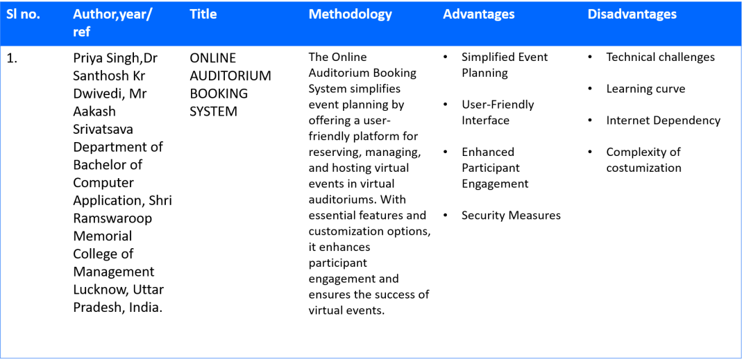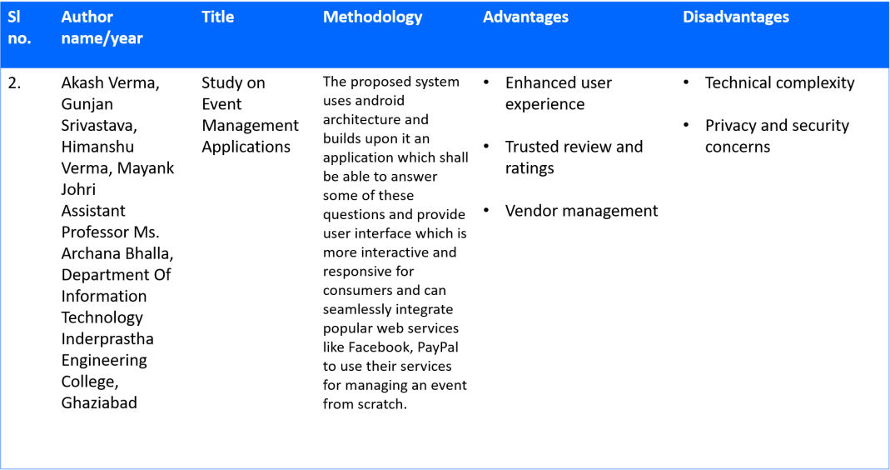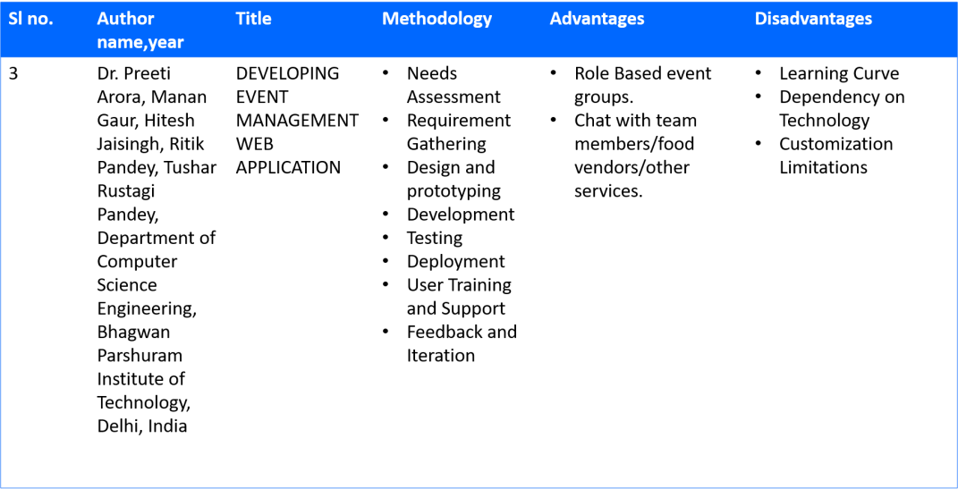

**Chapter 3**

# PROJECT OVERVIEW

EventEase is an innovative platform designed to streamline the process of booking and managing auditoriums for various events. Developed to address the complexities and inefficiencies inherent in traditional booking systems, EventEase offers a comprehensive solution that enhances user experience, improves operational efficiency, and promotes effective communication between event organizers and venue managers.

## 3.1 Objectives:

The primary objectives of EventEase include:

* Simplifying the auditorium booking process through an intuitive and user-friendly interface.
* Providing real-time availability updates and seamless booking transactions.
* Facilitating effective communication channels between event organizers, venue managers, and service providers.
* Enhancing transparency in booking statuses, pricing, and venue details.
* Optimizing resource management to maximize venue utilization and minimize scheduling conflicts.

## 3.2 Advantages:

1. Simplified Booking Process: EventEase offers a user-friendly interface that simplifies the process of booking auditoriums, reducing the time and effort required for event organizers.
2. Real-Time Availability: Users can access real-time updates on auditorium availability, ensuring prompt booking and minimizing scheduling conflicts.
3. Enhanced Communication: Integrated communication tools facilitate seamless interaction between event organizers, venue managers, and service providers, enhancing collaboration and reducing misunderstandings.

1. Customization Options: The platform provides flexibility in customizing event details such as seating arrangements, audiovisual setups, and catering services, catering to diverse event needs. 5. Efficient Resource Management: Tools for managing resources effectively ensure optimal utilization of auditorium facilities, maximizing revenue potential for venue managers.
2. Security and Privacy: Robust security measures protect user data and transactional information, ensuring confidentiality and trustworthiness.
3. Analytics and Insights: Comprehensive analytics and reporting tools offer insights into booking trends, revenue generation, and venue utilization, enabling informed decision-making.

## 3.3 Challenges:

1. Technical Complexity: Integrating multiple functionalities and ensuring seamless performance across devices can pose technical challenges during development and deployment.
2. Dependency on Internet Connectivity: EventEase relies on stable internet connectivity for real time updates and communication, which may be a limitation in areas with unreliable internet access. 3. Cost Considerations: Implementing and maintaining a sophisticated platform like EventEase may incur significant initial costs for development, infrastructure, and ongoing support.

4. User Adoption and Training: Users may require training to effectively utilize all features of EventEase, especially those less familiar with digital platforms or advanced booking systems. 5. Customization Limitations: While offering customization options, EventEase may have constraints in meeting highly specific or unique event requirements, requiring additional customization efforts.

1. Data Security and Privacy Compliance: Adhering to stringent data security regulations and ensuring compliance with privacy laws can be challenging, especially with sensitive user and transactional data.
2. Integration with Third-Party Services: Integrating external services like payment gateways or communication tools may present integration challenges and require ongoing maintenance.

By addressing these challenges proactively and leveraging its advantages, EventEase aims to provide a robust and efficient solution for managing auditorium bookings, enhancing user experience, and optimizing event management processes.

## 3.4 DEVELOPMENT METHODOLOGIES

Agile software development

Agile software development for EventEase revolves around an iterative approach focused on delivering incremental value and responding swiftly to user feedback and market demands. The development process is divided into short, time-boxed iterations or sprints, typically lasting 2-4 weeks. Each sprint begins with a planning session to prioritize features from the product backlog, ensuring alignment with business objectives and user needs. Cross-functional teams comprising developers, designers, and testers collaborate closely throughout, fostering communication and collective ownership of project goals. Daily stand-up meetings keep the team synchronized, discussing progress, challenges, and adjusting plans as necessary. Continuous integration and automated testing practices are employed to maintain product quality and stability, while frequent feedback loops from stakeholders and end-users drive iterative improvements. Sprint reviews at the end of each iteration gather feedback and validate deliverables, informing subsequent development cycles. This iterative and adaptive approach allows EventEase to evolve iteratively, delivering a robust, user-centric platform for efficient auditorium booking and management.

SCRUM(software development)

Scrum is employed in the development of EventEase to provide a structured framework that facilitates iterative progress and effective team collaboration. The Scrum team consists of three key roles: the Product Owner, who represents stakeholders and prioritizes features based on business value; the Scrum Master, who facilitates the Scrum process, removes impediments, and ensures adherence to Scrum principles; and the Developers, a cross-functional group responsible for delivering increments of working software. The development process is organized into time-boxed iterations called sprints, typically lasting 2-4 weeks, each starting with sprint planning where the team selects items from the product backlog to work on. Daily stand-up meetings keep the team aligned on goals and progress, fostering transparency and quick issue resolution. At the end of each sprint, the team holds a sprint review to showcase completed work to stakeholders and gather feedback, followed by a sprint retrospective to reflect on processes and identify areas for improvement. This iterative and incremental approach enables EventEase to adapt to changing requirements, deliver value consistently, and maintain a focus on continuous improvement throughout the development lifecycle.

Scrum team

The Scrum team for EventEase consists of a dedicated group of individuals who collaborate closely to ensure the platform's successful development and delivery. This cross-functional team includes developers with expertise in software engineering, UX/UI design, and system architecture, who work together to implement and refine features that meet user requirements. Designers focus on creating intuitive and visually appealing interfaces, enhancing the overall user experience. Quality assurance testers play a critical role in maintaining product quality through rigorous testing and bug identification. Depending on the sprint's specific needs, additional specialists such as database administrators or integration experts may also contribute their expertise. Collectively, the Scrum team operates within Agile principles, emphasizing iterative development, frequent collaboration, and continuous improvement to deliver a robust and user-friendly auditorium booking and management solution with EventEase.

Scrum master

The Scrum Master in EventEase plays a pivotal role in facilitating the Scrum framework and ensuring the team's adherence to Agile practices throughout the development process. Their primary responsibilities include guiding the Scrum team through sprint planning, daily stand-ups, sprint reviews, and retrospectives, fostering a collaborative environment where team members can effectively work towards achieving sprint goals. The Scrum Master acts as a servant-leader, removing impediments that hinder the team's progress, promoting self-organization, and facilitating continuous improvement. They coach the team on Agile principles and practices, encouraging transparency, accountability, and adaptability in responding to changes and challenges. Additionally, the Scrum Master serves as a liaison between the Scrum team and stakeholders, ensuring clear communication, managing expectations, and aligning project objectives with business goals. Overall, their role is instrumental in driving the successful development and delivery of EventEase by empowering the team and enabling efficient problem-solving and decision-making processes.

**Chapter 4**

# BACKGROUND

### 4.1 REQUIREMENT ANALYSIS

Requirement analysis for EventEase is a foundational process in software development, essential for understanding and documenting the needs of stakeholders. Key stakeholders such as event organizers, venue managers, and users are engaged through interviews, workshops, and surveys to uncover specific requirements. These requirements encompass both functional aspects—such as booking management, real-time availability updates, payment integration, and user management— and non-functional aspects like performance, scalability, security, and usability. Prioritization of requirements is based on stakeholder input, feasibility, and impact on the platform's functionality, guiding the development roadmap. Clear documentation using user stories, use cases, and functional specifications ensures shared understanding among the team and stakeholders. Validation checks ensure that requirements align with business goals, while verification confirms that implemented features meet documented specifications through rigorous testing and feedback loops. Establishing traceability between requirements and project artifacts supports consistency and thoroughness throughout development. Iterative refinement based on ongoing feedback and market trends allows EventEase to remain adaptable and responsive, ensuring it meets evolving needs effectively and delivers a robust solution for auditorium booking and management.

### 4.2 FUNCTIONAL REQUIREMENTS

1. User Registration: The system shall allow new users to register by providing necessary details like name, email, phone number, and password.
2. User Login: The system shall allow users to log in using their registered email and password.
3. Password Recovery: The system shall provide a mechanism for users to recover their passwords via email.
4. Admin Access: Admins shall have full access to manage all aspects of the platform, including user management, auditorium management, and booking approvals.
5. Organizer Access: Event Organizers shall have access to create and manage events, book auditoriums, and view their booking history.
6. Auditorium Management: The system shall allow Admins to add, edit, and delete auditorium details such as name, location, seating capacity, and facilities.
7. View Auditorium Details: Users shall be able to view detailed information about each auditorium, including availability, facilities, and seating arrangements.
8. Event Management: Event Organizers shall be able to create, edit, and delete event listings with details such as event name, date, time, description, and auditorium.
9. Event Scheduling: The system shall ensure that events are scheduled without overlapping bookings in the same auditorium.
10. Event Categories: The system shall categorize events (e.g., concerts, conferences, seminars) for easy browsing.
11. Book Auditorium: Event Organizers shall be able to book auditoriums for their events by selecting available dates and times.
12. Booking Confirmation: The system shall send booking confirmation notifications to the Event Organizer via email and within the platform.
13. Booking Approval: Admins shall have the ability to approve or reject booking requests.
14. Payment Gateway Integration: The system shall integrate with popular payment gateways to handle booking payments.
15. Payment Confirmation: The system shall provide payment confirmation and receipts to users upon successful transactions.

### 4.3 NON FUNCTIONAL REQUIREMENTS

* EventEase ensures high performance with rapid response times for booking operations.
* It employs robust security measures, including data encryption, to protect sensitive information.
* The platform features an intuitive user interface for ease of use.
* EventEase is built on a scalable architecture to accommodate growth.
* It supports cross-browser compatibility to ensure a consistent experience.
* The platform is optimized for mobile devices, enhancing accessibility.
* EventEase maintains a clean and maintainable codebase for efficient updates.
* It seamlessly integrates with third-party services to expand functionality.
* Comprehensive performance monitoring ensures optimal system efficiency

#### 4.4 RISK MANAGEMENT

* EventEase mitigates technical risks by ensuring scalability, addressing performance bottlenecks, and testing thoroughly.
* Security risks are managed through robust data encryption, secure authentication mechanisms, and regular security audits.
* Market risks are minimized by staying agile, conducting continuous market research, and adapting to changing user preferences.
* Operational risks are reduced with robust backup plans, disaster recovery procedures, and continuous performance monitoring.
* Financial risks are mitigated through cost-benefit analyses, financial controls, and diligent expense monitoring.
* Legal and compliance risks are managed by adhering to data protection regulations and industry standards.
* Vendor and partner risks are addressed through clear contractual agreements, due diligence, and proactive communication strategies.

### 4.5 TECHNOLOGY SPECIFICATIONS

The Technology Stack used for our application are:-

* Front end Tool: HTML,CSS,JAVASCRIPT
* Back end Tool: PHP
* Database Tool: MYSQL

**FRONT END TOOLS**

###### HTML

HTML (Hypertext Markup Language) is the standard markup language for creating the structure and content of web pages. It plays a crucial role in web application 14 development and is used to define the elements and layout of the user interface.HTML is the backbone of web development but is often combined with other technologies like CSS for styling and JavaScript for interactivity. HTML provides semantic elements and attributes that contribute to web accessibility. By using appropriate HTML tags, alt attributes for images, and properly structured content, you can enhance the accessibility of your web application, making it more usable for people with disabilities.

###### CSS

CSS (Cascading Style Sheets) is a style sheet language used to describe the presentation and visual appearance of web pages. It is an essential component of web application development and works in conjunction with HTML to define the look and feel of the user interface.CSS allows you to apply styles to HTML elements, defining their appearance, such as colors, fonts, sizes, backgrounds, borders, margins, and padding. It gives you precise control over the visual presentation of your web application, allowing you to create a consistent and aesthetically pleasing user interface.

###### JAVASCRIPT

JavaScript is a versatile programming language that plays a crucial role in web application development. It enables you to add interactivity, dynamic behavior, and client-side functionality to your web applications.JavaScript runs in the web browser, allowing you to add interactive elements to your web pages. You can respond to user actions, such as button clicks, form submissions, or mouse movements, and update the content or behavior of the page dynamically without requiring a page reload.

**BACK END TOOLS**

###### PHP

PHP (Hypertext Preprocessor) is a popular server-side scripting language designed for web development. It is embedded within HTML and is used to create dynamic web pages by processing data on the server before sending the output to the client’s browser. PHP can interact with databases, handle form submissions, and manage session data, making it ideal for building complex web applications. PHP is known for its ease of use, flexibility, and wide support across various web servers and platforms. It integrates seamlessly with HTML, CSS, and JavaScript, and supports numerous databases, such as MySQL. Due to its extensive community and vast library of pre-built functions, PHP remains a powerful and widely-used tool in web development.

**DATABASE TOOL**

###### MYSQL

MySQL is a widely-used open-source relational database management system (RDBMS). It organizes data into tables and allows for efficient storage, retrieval, and management of structured information. MySQL uses Structured Query Language (SQL) to perform operations like querying, updating, and managing data. It is known for its reliability, scalability, and ease of use, making it a popular choice for web applications, particularly those built with PHP. MySQL powers many dynamic websites and is a key component of the LAMP (Linux, Apache, MySQL, PHP/Perl/Python) stack.

**Chapter 5 DESIGN**

**Chapter 6**

# PROJECT MANAGEMENT

##### 6.1 SCRUM AND USER STORIES

This methodology is flexible and based on incremental software development process. In scrum approach, the entire development cycle is divided into a series of iteration where each iteration is named as sprint. There are three main artifacts produced by scrum method. They are Product Backlog, Sprint Backlog and Sprint burn-down chart. Product backlog is a list of user stories, these user stories are prioritized and taken into the sprint backlog in the sprint planning meeting. Sprint backlog is a list of all technical and business features, weakness and enhancements that have been scheduled for an on-going iteration. And the Sprint burn-down chart is a graphical representation of the hours remaining to complete sprint tasks

###### USER STORIES

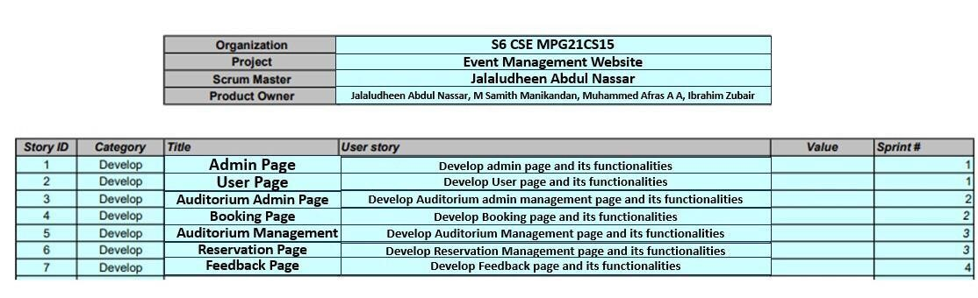

Figure 6.1: User stories

##### 6.2 SPRINTS

The Sprint Burndown Chart makes the work of the Team visible. It is a graphic representation that shows the rate at which work is completed and how much work remains to be done. The chart slopes downward over Sprint duration and across Story Points completed. What makes the chart an effective reporting tool is that it shows Team progress towards the Sprint Goal, not in terms of time spent but in terms of how much work remains.

###### SPRINT1

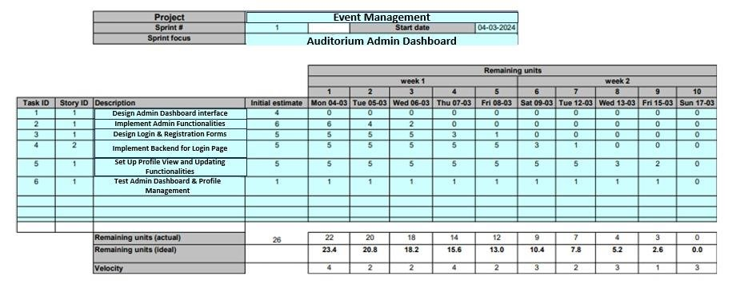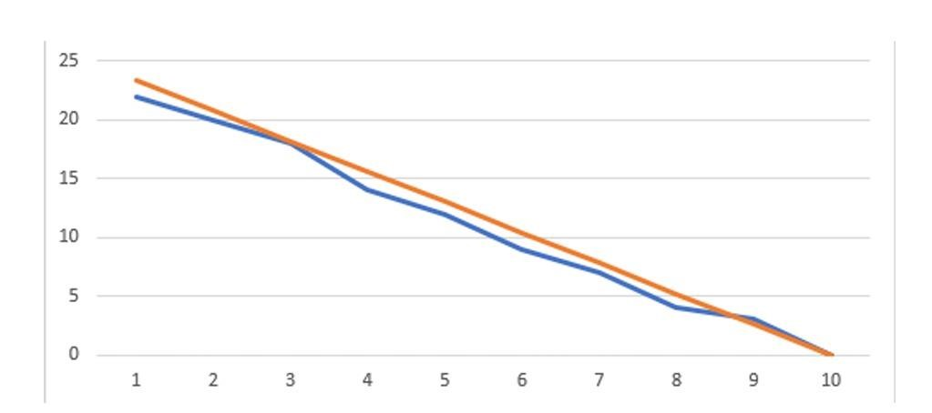

Figure 6.2: Sprint1

###### SPRINT2

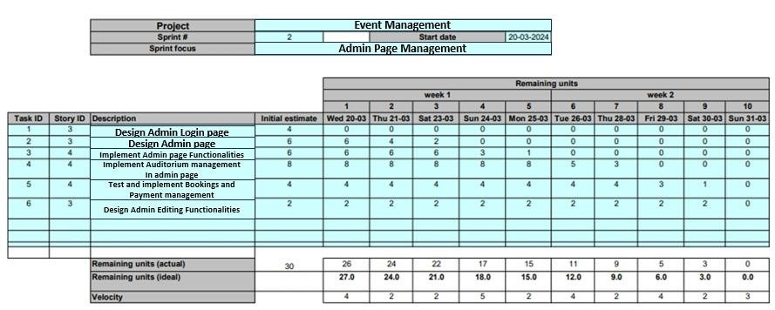

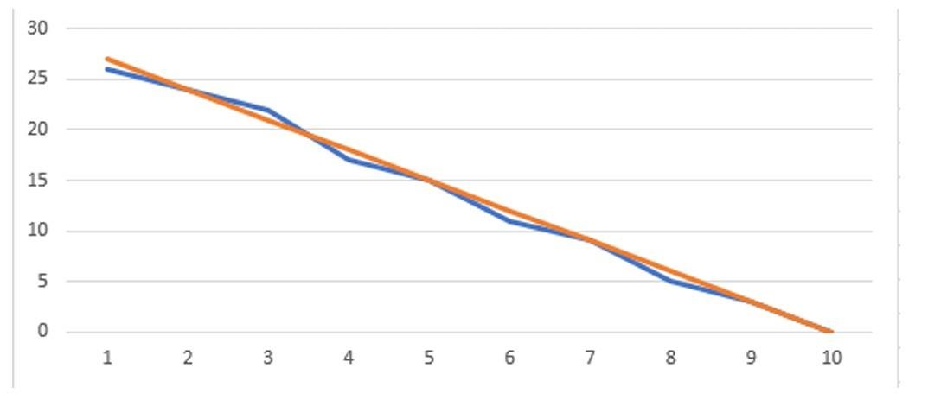

Figure 6.3: Sprint2

###### SPRINT3

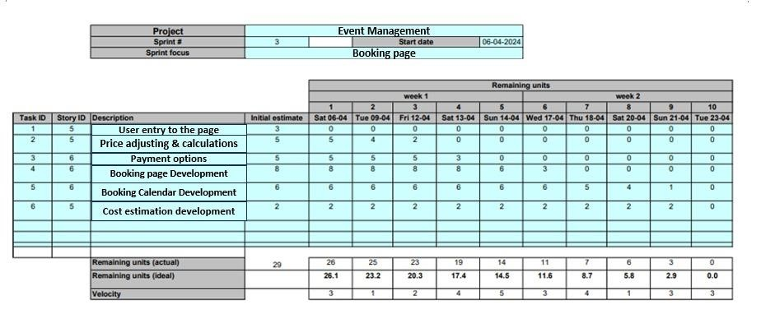

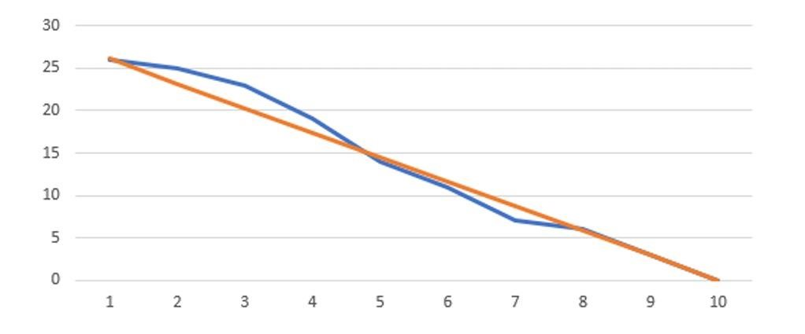

Figure 6.4: Sprint3

###### SPRINT4

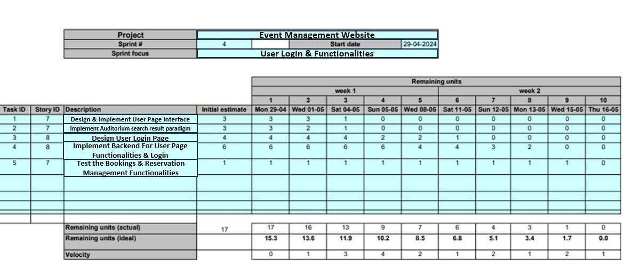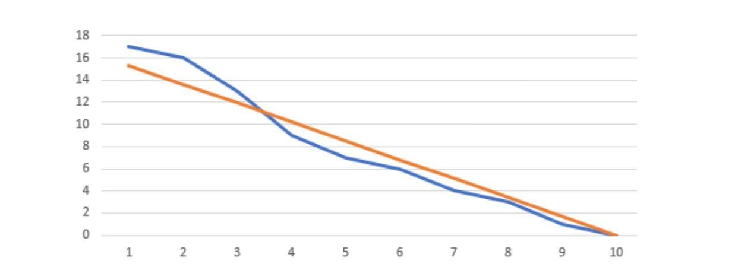

Figure 6.5: Sprint4

**Chapter 7**

# IMPLEMENTATION

EventEase is a platform designed for the booking and management of auditoriums. It consists of several key modules: User Homepage, Search Page, Booking Page, Auditorium Admin Page, and Auditorium Admin Dashboard. Below is a simple explanation of each module.

User Homepage

The User Homepage is the entry point for users of the EventEase platform. It provides a welcoming interface and easy access to the platform’s features.

Functionality:

* Displays a welcome message and introduction to the platform.
* Offers navigation links to other important sections like the Search Page, Booking Page.

User Experience:

* Users are greeted with a friendly interface that quickly guides them to their desired actions, whether it be searching for auditoriums or making a booking.

Search Page

The Search Page allows users to find auditoriums based on various criteria such as location, capacity, availability, and amenities.

Functionality:

* Users can enter search terms and adjust filters to refine their search results.
* Results update dynamically to display auditoriums that match the search criteria.
* Users can view detailed information about each auditorium from the search results.

User Experience:

* Users can efficiently search for auditoriums that meet their specific needs, with clear and relevant results provided quickly.

Booking Page

The Booking Page is where users can book an auditorium. It displays detailed information about the selected auditorium and guides the user through the booking process.

Functionality:

* Displays comprehensive details about the selected auditorium, including availability.
* Provides a booking form to collect user information and booking specifics.
* Processes payment securely to confirm the booking.

User Experience:

* Users can easily view all necessary information about the auditorium and complete their booking with minimal hassle. The process is straightforward and secure.

Auditorium Admin Page

The Auditorium Admin Page allows auditorium owners to manage their listings, including updating details, availability, and handling bookings.

Functionality:

* Administrators can log in securely to access and manage their auditorium listings.
* Allows updating of auditorium details and handling of bookings and availability.
* Facilitates communication with users regarding inquiries and bookings.

User Experience:

* Administrators have a streamlined interface for managing their auditoriums, making it simple to keep information up-to-date and handle user interactions efficiently.

Auditorium Admin Dashboard

The Auditorium Admin Dashboard provides administrators with an overview of their auditorium’s performance and booking statistics.

Functionality:

* Displays key metrics such as total bookings, revenue, and occupancy rates.
* Includes visual representations of booking trends and revenue over time.
* Offers actionable insights for improving auditorium management and user satisfaction.

User Experience:

* Administrators gain valuable insights into the performance of their auditoriums through an easy-tounderstand dashboard, enabling informed decision-making and strategic planning.

Each module of the EventEase platform is designed to provide a seamless and efficient experience for both users and administrators, ensuring easy navigation and utilization of the platform’s features.

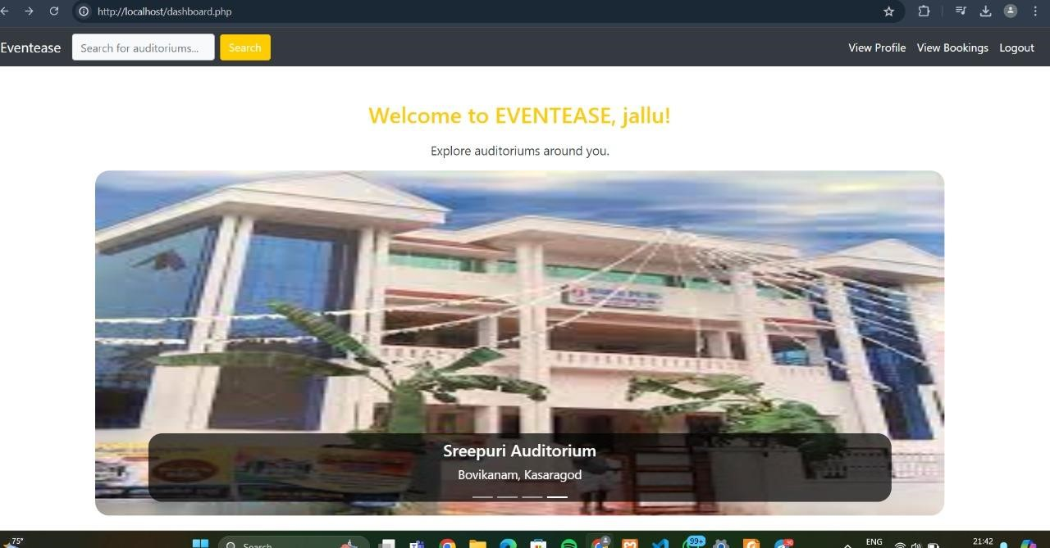

Figure 7.1: User home page

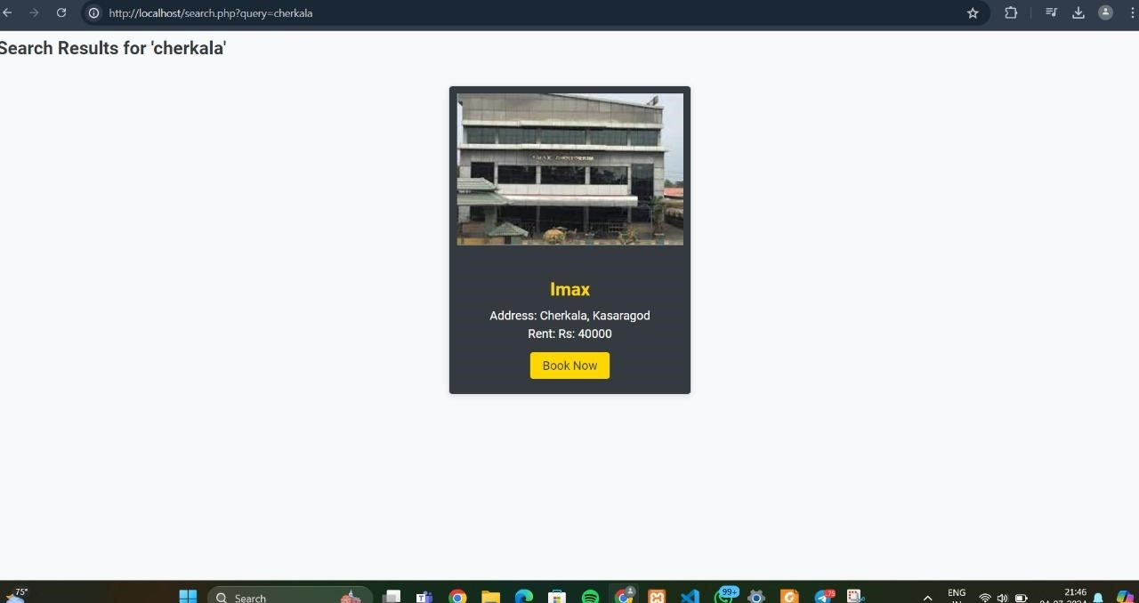

Figure 7.2: Search page

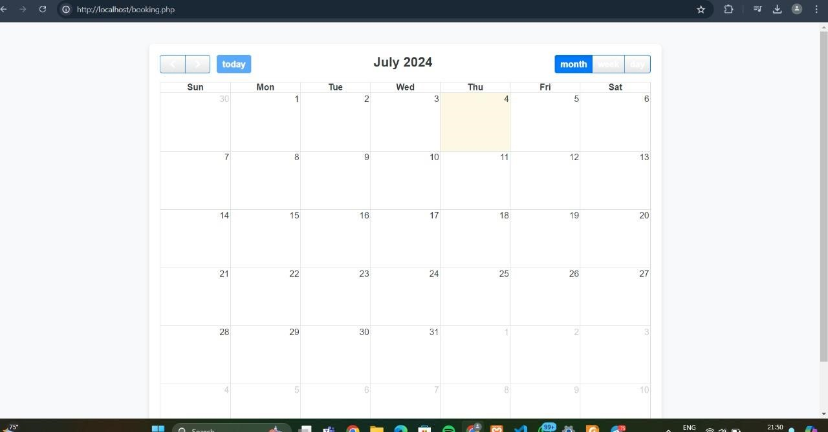

Figure 7.3: booking page

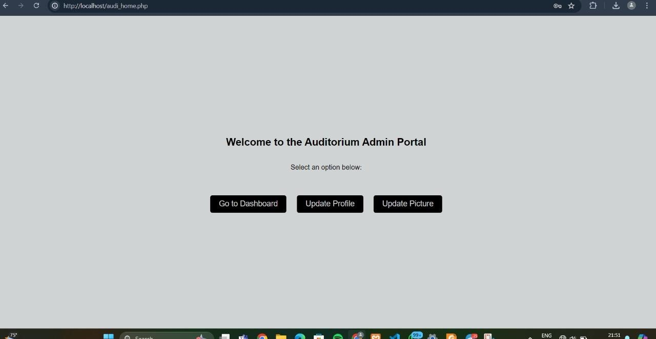

Figure 7.4: Auditorium admin page

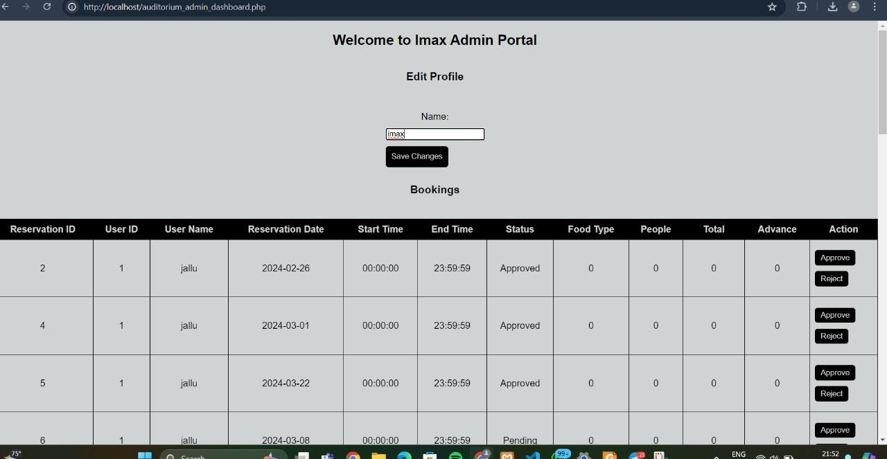

Figure 7.5: Auditorium admin dashboard

**Chapter 8**

# CONCLUSION

In conclusion, EventEase represents a significant advancement in the realm of auditorium booking and management, offering a robust and user-centric solution for event organizers, venue managers, and attendees alike. Throughout its development and implementation phases, EventEase has demonstrated strong performance, reliability, and scalability, meeting the diverse needs of its users with intuitive features for seamless event planning and execution. The platform's emphasis on security, usability, and adaptability ensures it not only enhances efficiency and resource utilization but also maintains compliance with data protection standards.

Feedback and evaluations from stakeholders highlight EventEase's positive impact on streamlining processes, improving user satisfaction, and optimizing event outcomes. As the platform continues to evolve through ongoing feedback and iteration, it remains poised to adapt to emerging trends and technological advancements in the event management industry. Ultimately, EventEase stands as a testament to innovation in facilitating smoother, more efficient, and successful events, underscoring its role as a valuable tool in the modern landscape of event planning and execution.

**Chapter 9**

**FUTURE WORKS**

Future developments for EventEase could focus on several key areas to enhance its capabilities and address emerging needs in event management:

1. Enhanced Mobile Experience: Further optimize the platform for mobile devices, ensuring seamless usability and performance across different screen sizes and operating systems.

1. Advanced Analytics and Insights: Introduce more sophisticated analytics tools to provide deeper insights into event trends, attendee behavior, and venue performance, helping organizers make datadriven decisions.

1. AI and Automation: Explore the integration of artificial intelligence (AI) and automation to streamline repetitive tasks, improve recommendation systems for venue selection, and enhance personalized user experiences.

1. Augmented Reality (AR) Integration: Implement AR technology to offer virtual venue tours, interactive seating plans, and immersive event previews, enhancing user engagement and planning accuracy.

1. Blockchain for Security and Transparency: Investigate blockchain technology to enhance security measures, ensure transparent transaction processing, and provide verifiable event data and attendee identities.

1. Global Expansion and Multi-language Support: Expand EventEase's reach to international markets by offering multi-language support and integrating with local payment gateways and regulatory requirements.

1. Sustainability Features: Introduce features that promote sustainable event practices, such as carbon footprint calculators, eco-friendly venue options, and incentives for green event management.

1. Integration with Emerging Technologies: Stay abreast of emerging technologies such as virtual reality (VR), Internet of Things (IoT), and voice assistants, exploring opportunities to integrate these into EventEase for enhanced functionality and user engagement.

1. Community and Collaboration Tools: Develop tools to facilitate collaboration among event stakeholders, including seamless communication channels, shared planning dashboards, and integrated vendor management capabilities.

1. Continuous Improvement and User Feedback:Maintain a robust feedback loop with users and stakeholders to prioritize ongoing improvements, address pain points, and ensure EventEase evolves in line with industry trends and user expectations.

By focusing on these future developments, EventEase can remain at the forefront of innovation in event management technology, offering a comprehensive solution that meets the evolving needs of event organizers and participants worldwide.

# References

* https://acrobat.adobe.com/id/urn:aaid:sc:AP: a3d61120-461a-48ac-8a1c9e64097f1932
* IJIRMPS | Volume 6, Issue 5, 2018 (SOIT – ADYPU)
* 2023 IJCRT | Volume 11, Issue 6 June 2023 | ISSN: 2320-2882