01/01/2024

TIC AND ITS TECHNOLOGIES REPORT

Réalisé par :

* Taleb Idriss
* Yalaoui Mohamed El Amine
* Maten Anis
* Halimi Anes
* Benayache Ahmed Yacine

**The Content of the Report:**

1. Introduction……………………………………………….…….. 2
2. Introduction to the TIC…………………………………………. 2
   1. Definition of TIC ……………………………………………………….…. 2
   2. The Importance of TIC…………………………………………………….. 3
3. Technologies related to TIC …………………………………… 4
   1. Google services ………………………………………………………….... 4
   2. Microsoft Tools………………………………………………………..…... 7
4. Git and GitHub…………………………………………………. 10
   1. Git……………………………………………………………………….… 10
   2. GitHub…………………………………………………………………….. 10
5. Conclusion ……………………………………………………... 12

# Introduction :

Information and Communication Technologies, or ICT, encompass a broad range of technologies that facilitate the manipulation and transmission of information. From traditional forms like radio and television to modern innovations such as the Internet and mobile communication, ICT plays a pivotal role in shaping how we communicate, access information, and interact with the digital world. As ICT continues to evolve, it brings about transformative changes in various aspects of our daily lives, impacting communication, work, and connectivity on a global scale.

# Introduction to the TIC :

* + 1. Definition of TIC

Information and Communication Technologies (ICT) is a term that encompasses a diverse range of technologies and tools used for the processing, storage, transmission, and presentation of information. It includes both traditional technologies, such as telecommunication networks and broadcasting, and modern digital technologies like computers, the internet, and mobile devices. ICT plays a fundamental role in facilitating communication and information exchange across various platforms and technologies.

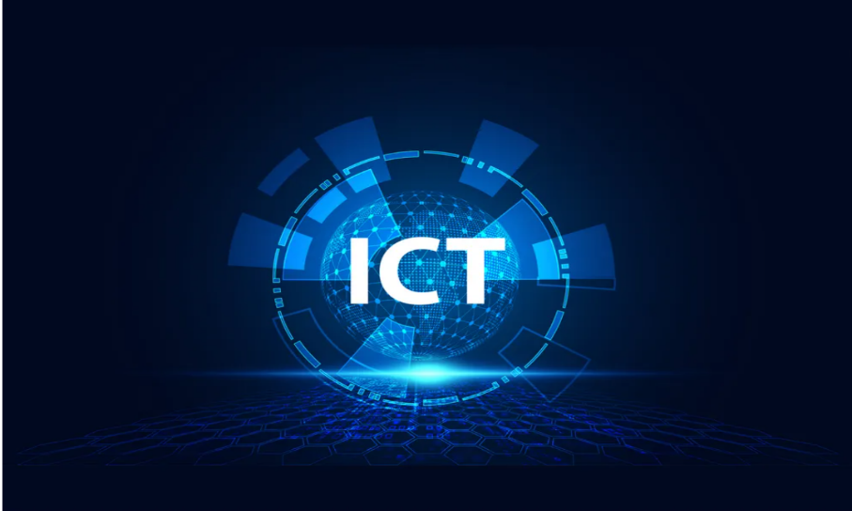

* + 1. The Importance of TIC

**Education:** ICT has transformed education by introducing online learning, e-books, interactive multimedia content, and educational software. It has expanded learning opportunities, making education more accessible to a global audience.

**Communication:** ICT plays a pivotal role in enhancing communication on a global scale. It enables real-time interaction through various channels, including emails, instant messaging, video conferencing, and social media, bringing people and businesses closer regardless of geographical distances.

**Economic Development:** ICT is a key driver of economic development. It fosters entrepreneurship, supports the growth of small and medium-sized enterprises, and contributes to the creation of new business models, thereby stimulating economic progress.

**Access to Information:** ICT provides unprecedented access to information. The internet serves as a vast repository of knowledge, allowing individuals, businesses, and institutions to acquire information rapidly and efficiently. This democratization of information contributes to educational and professional growth.

**Healthcare:** In the healthcare sector, ICT enhances patient care through electronic health records, telemedicine, and health information systems. It improves the efficiency of medical services, leading to better diagnosis, treatment, and overall healthcare outcomes.

# Technologies Related to TIC:

* + 1. Google Services:



Google is a big company on the internet. They help you find stuff with Google Search, store things in Google Drive, make documents in Google Docs, and show videos on YouTube. They also have maps, a video meeting tool called Google Meet, and more. Google's main job is to make information easy to find and use online.

|  |  |
| --- | --- |
| 1. **Google search**   is a tool that helps you find information on the internet. You type in what you're looking for, and it shows you a list of websites, pictures, and other stuff related to your search. It's like a giant index for the web. |  |
| 1. **Google Drive**   Google Drive is like an online folder where you can store and share your documents, pictures, and other files. It's like having your own digital space in the cloud. |  |
| 1. **Google docs**   Google Docs is a way to create and edit documents online. It's like a digital version of a word processor, and you can work on your documents from anywhere with an internet connection. |  |
| 1. **Google Calendar**   Google Calendar helps you organize your schedule and events. It's like a digital planner that you can access from your computer or phone. |  |
| 1. **Google Meet**   Google Meet is a tool for video meetings. It's like a virtual conference room where you can  see and talk to people online. |  |
| 1. **Google Maps**   Google Maps is a digital map that helps you find places, get directions, and explore. It's like a guide for navigating the real world. |  |
| 1. **Google Earth**   Google Earth lets you explore a 3D map of the world. It's like a virtual globe that allows you to zoom in on different places and see them in detail. |  |
| 1. **YouTube**   YouTube is a platform for watching and sharing videos. It's like an online video library with content on almost every topic imaginable. |  |
| 1. **Google ADS**   Google Ads is a platform for businesses to show their ads online. It's like a way for companies to promote their products or services to people using Google's advertising network. |  |

* + 1. Microsoft tools:

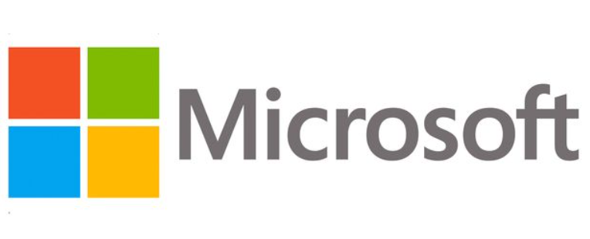

Definition

Microsoft is a big company that makes computer software, tools, and services. They create popular programs like Word, Excel, and PowerPoint for writing, organizing data, and making presentations. Microsoft also develops the Windows operating system for computers. They offer tools for communication, like Outlook and Teams, and cloud services like Azure. Essentially, Microsoft helps people use technology for work, creativity, and more.

|  |  |
| --- | --- |
| 1. **Microsoft Word**   Microsoft Word is a computer tool for writing and making documents. It's like a digital notepad where you can type, format, and make things look good. It helps you create letters, reports, and other written stuff on your computer. |  |
| 1. **Microsoft Excel**   Excel is like a digital sheet of paper where you can organize numbers and make simple charts. It's good for things like budgets and lists. |  |
| 1. **Microsoft PowerPoint**   PowerPoint is a tool for creating slides. It's like a digital board where you can put pictures and words to make presentations. |  |
|  |  |
| 1. **Microsoft Outlook**   Outlook is like a digital mailbox. It helps you send and receive emails, and  Keep your calendar organized. |  |
| 1. **Microsoft Windows**   Windows is like the control center of your computer. It helps you run programs and manage files. | Informatique : quels bénéfices à travailler sous Windows 10 Pro ? |
| 1. **Microsoft Visual Studio Code**   Visual Studio Code is a tool for writing and editing code. It's like a digital notebook for computer programmers, helping them create software. | VSCode 웹개발 초기 세팅 가이드(범용) |

# Git and GitHub:

* + 1. Git:

**Git** is a distributed version control system designed to track changes in source code during software development. It allows multiple developers to collaborate on projects efficiently. Git keeps a complete history of a project, recording changes made to the codebase over time. Developers can work on their copies of the code, make changes independently, and later merge those changes seamlessly. This system helps manage different versions of the code, facilitates collaboration, and provides mechanisms to handle conflicts when changes overlap. Git is widely used in the software development industry and is known for its speed, flexibility, and robust branching and merging capabilities.

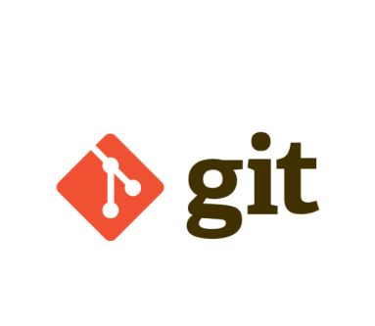

* + 1. GitHub:

GitHub is a web-based platform that utilizes Git for version control and collaborative software development. It provides a centralized hub for developers to host and manage their Git repositories. On GitHub, individuals and teams can store, share, and collaborate on projects, making it easier to track changes, manage contributions, and coordinate work on software development projects. GitHub includes features such as issue tracking, pull requests, and project management tools, enhancing collaboration among developers. It has become a widely adopted platform for open-source and private software development, fostering community involvement and facilitating seamless collaboration across the global development community.



# Conclusion:

In conclusion, Information and Communication Technologies (TIC) have significantly changed the way we live and work. From improved communication to innovative solutions, TIC has made a profound impact. However, challenges like the digital divide and privacy concerns exist. As we move forward, it's crucial to embrace technology responsibly, ensuring accessibility for all and addressing potential risks. TIC's continued evolution promises a future of collaboration and progress, requiring us to balance innovation with ethical considerations for the greater good.