Transporta un sakaru institūts
Отчет по
Лабораторной Работе №6
По курсу Введение в интеллектуальные системы
Тема: Применение МНН для классификации. Регуляризация. Сравнение производительности регрессионного перцептрона и регрессионного дерева принятия решений при решении задач прогнозирования
Студента группы 4701BD
Лаптев Илья

Rīga – 2020

Оглавление
1. Задание 3
2. Код программы 4
MultiLayerRegression.scala код 4
Utility.scala код 7
Data_Akbilgic.scala код 10
RegressionTree.scala код 12
Node.scala код 17
3. Результат работы 19
4. Выводы 23

Задание

Задание:
1) Выбрать и подготовить к работе набор данных “ISTANBUL STOCK EXCHANGE” https://archive.ics.uci.edu/ml/datasets/ISTANBUL+STOCK+EXCHANGE
2) Набор данных содержит наблюдения об изменении 9 биржевых индексов. Выберете любой из индексов в качестве зависимой переменной (y). Остальные 8 индексов будут использоваться в качестве независимых (X).
3) Попарно рассчитайте коэффициент корреляции Пирсона для всех переменных.
4) Реализовать/вызвать алгоритм для обучения модели многослойного перцептрона для решения задачи регрессии (sklearn.neural_network.MLPRegressor или tf.keras.Sequential)
5) Реализовать/вызвать алгоритм для обучения регрессионного дерева принятия решения (sklearn.tree.DecisionTreeRegressor)
6) Обучить алгоритмы на тренировочной выборке и оценить производительность на тестовой.
7) Вывести на экран параметры моделей. Вектор весов (коэффициентов) и свободный член для МНН. Глубина дерева и количество листьев для регрессионного дерева.
8) Рассчитать и вывести на экран среднюю квадратичную ошибку и коэффициент детерминации (R2) для тренировочной и тестовой подвыборок.
9) Изучить как вариация параметров регуляризации (l1, l2) влияют на производительность МНН.
10) Сравнить полученные модели между собой.
Входные данные: ISTANBUL STOCK EXCHANGE

https://archive.ics.uci.edu/ml/datasets/ISTANBUL+STOCK+EXCHANGE

Код программы

MultiLayerRegression.scala код
package com.sogoeslight.task.regression
import com.sogoeslight.task.preparation.Data_Akbilgic
import com.sogoeslight.task.preparation.Data_Akbilgic.{convertedData, ds}
import com.sogoeslight.task.regression.Neuron.{addLayer, calculateOutputsOfLayers}
import com.sogoeslight.task.regression.Utility._
import scala.collection.mutable.ArrayBuffer
object MultiLayerRegression extends App {
lazy val epoch: Int = 1000
lazy val network = new ArrayBuffer[ArrayBuffer[Neuron]]()
lazy val bias = 1
lazy val size: Int = Data_Akbilgic.attributes.length
def pearsonCorrelationCoef(): Unit = {
val data: Array[Array[Double]] = convertedData.clone()
val cols: Array[Array[Double]] = data.transpose
val dsVariables: Array[String] = ds.head
for (x <- dsVariables.indices) {
for (y <- x + 1 until dsVariables.length) {
val couples: Array[(Double, Double)] = cols(x) zip cols(y)
val sum_X: Double = cols(x).sum
val sum_Y: Double = cols(y).sum
val coef: Double = (data.length * couples.map{ case (i, j) => i * j }.sum - sum_X * sum_Y) /
math.sqrt((data.length * cols(x).map(math.pow(_, 2)).sum - math.pow(sum_X, 2)) *
(data.length * cols(y).map(math.pow(_, 2)).sum) - math.pow(sum_Y, 2))
println(s" ${dsVariables(x)} - ${dsVariables(y)} correlation coefficient = $coef")
}
println()
}
println()
}
def trainModel(ds: Array[Array[Double]]): Unit = {
network.addOne(new ArrayBuffer[Neuron](1)) // Activation layer
network.last.addOne(Neuron(network.head.length + bias, sigmoid = true))
for (_ <- 0 to epoch) {
for (row <- ds) {
calculateOutputsOfLayers(network, row)
val ideal: Double = row.last // 0 or 1
val actual: Double = network.last.head.output
var fDerivative: Double = 1 - actual * actual // for tangh
network.last.head.error = (ideal - actual) * fDerivative
for (layerIndex <- network.tail.indices) { // calculate deltas
for ((neuron, index) <- network(layerIndex).zipWithIndex) {
var sum: Double = 0
fDerivative = 1 - neuron.output * neuron.output
for (nextLayer <- network(layerIndex + 1)) {
sum += nextLayer.weights(index) * nextLayer.error
}
neuron.error = fDerivative * sum
}
}
for (layerIndex <- network.indices) { // calculate weight's gradients
for (neuron <- network(layerIndex)) {
if (layerIndex != 0) {
for (weight <- 0 until neuron.weights.length - bias) {
val output: Double = network(layerIndex - 1)(weight).output
neuron.gradients(weight) = output * neuron.error
}
if (bias == 1) {
val output: Double = neuron.weights(neuron.weights.length - bias)
neuron.gradients(neuron.weights.length - bias) = output * neuron.error
}
} else {
for (index <- Data_Akbilgic.attributes.indices) {
neuron.gradients(index) = row(index) * neuron.error
}
neuron.gradients(neuron.gradients.size - 1) = neuron.weights.last * neuron.error
}
}
}
for ((layer, layerIndex) <- network.zipWithIndex) { // recalculate weights
for ((neuron, neuronIndex) <- layer.zipWithIndex) {
for (index <- neuron.weights.indices) { // delta of weight = learning rate * (weight's gradient + previous weight's delta)
var weightsDif: Double = 0
if (layerIndex == 0) weightsDif = rate * neuron.gradients(index) // rate = epsilon, first layer weights difference is 0, so we do not include it in the formula
else weightsDif = rate * (neuron.gradients(index) + network(layerIndex - 1)(neuronIndex).weightsDif(index))
neuron.weightsDif(index) = weightsDif
neuron.weights(index) += weightsDif
}
}
}
}
}
}
lazy val learningAccuracy: Double = testMultiLayerRegressionModel(Data_Akbilgic.learning, network)
lazy val testAccuracy: Double = testMultiLayerRegressionModel(Data_Akbilgic.test, network)
def calculate(showWeights: Boolean): Unit = {
println("Pearson: ")
pearsonCorrelationCoef()
addLayer(network, amountOfNeurons = 3, size, hyperbolicTangent = true)
addLayer(network, amountOfNeurons = 3, size, hyperbolicTangent = true)
trainModel(Data_Akbilgic.learning)
printMultiLayerPerceptroneInfo(labAndMethod = "6 - Multi Layer Perceptrone",
network, learning = learningAccuracy, test = testAccuracy, weights = showWeights)
}
//calculate(showWeights = true)
}

Utility.scala код
package com.sogoeslight.task.regression
import com.sogoeslight.task.preparation.Data.attributes
import com.sogoeslight.task.regression.Neuron.calculateOutputsOfLayers
import scala.collection.mutable.ArrayBuffer
object Utility {
val rate: Double = 0.2 // learning rate (usually -> [0.1, 0.3]) - regulates how much coefs changes each iteration
def iterateWeightCoefs(weights: ArrayBuffer[Double], error: Double, row: Array[Double], prediction: Double, size: Int): Unit = {
for (i <- attributes.indices) { // new weight coefficients
weights(i) += rate * error * prediction * (1 - prediction) * row(i)
}
weights(size) += rate * error * prediction * (1 - prediction)
}
def calculateOutput(row: Array[Double], weights: ArrayBuffer[Double]): Double = {
var output: Double = 0
for (index <- attributes.indices) {
output += row(index) * weights(index)
}
output += weights.last // free term
output
}
// log functions
def sigmoid(output: Double): Double = 1 / (1 + math.exp(-output))
def hyperbolicTangent(output: Double, bias: Int = 1): Double = 2 / (1 + math.exp(-2 * output)) - bias
def testModel(ds: Array[Array[Double]], weights: ArrayBuffer[Double]): Double = {
var accuracy: Double = 0
for (row <- ds) {
val prediction: Double = sigmoid(calculateOutput(row, weights))
if (prediction.round == row.last) accuracy += 1
}
accuracy / ds.length * 100 // in %s
}
def testMultiLayerClassificationModel(ds: Array[Array[Double]], network: ArrayBuffer[ArrayBuffer[Neuron]]): Double = {
var accuracy: Double = 0
for (row <- ds) {
calculateOutputsOfLayers(network, row)
val prediction: Double = network.last(0).output
if (prediction.round == row.last)
accuracy += 1
}
accuracy / ds.length * 100 // in %s
}
def testMultiLayerRegressionModel(ds: Array[Array[Double]], network: ArrayBuffer[ArrayBuffer[Neuron]]): Double = {
var accuracy: Double = 0
val mean: Double = ds.transpose.last.sum / ds.length
val disp: Double = math.sqrt(ds.transpose.last.map(elem => math.pow(elem - mean, 2)).sum / ds.length)
for (row <- ds) {
calculateOutputsOfLayers(network, row)
val prediction: Double = network.last(0).output
if (math.pow(prediction - row.last, 2) >= disp)
accuracy += 1
}
accuracy / ds.length * 100 // in %s
}
def printWeights(network: ArrayBuffer[ArrayBuffer[Neuron]]): Unit = {
println("- Model:")
network.indices
.foreach(layerIndex => network(layerIndex).indices
.foreach(neuronIndex => {
network(layerIndex)(neuronIndex).weights.dropRight(1).indices
.foreach(weightIndex => println(s" Coef (Layer[$layerIndex] Neuron[$neuronIndex] Weight[$weightIndex])" +
s" = ${network(layerIndex)(neuronIndex).weights(weightIndex)}"))
println(s" Free term = ${network(layerIndex)(neuronIndex).weights.last}\n")
}))
}
def printMultiLayerPerceptroneInfo(labAndMethod: String, network: ArrayBuffer[ArrayBuffer[Neuron]], learning: Double, test: Double, weights: Boolean): Unit = {
println(s"\nLAB $labAndMethod\n")
if (weights) printWeights(network)
println(f"- Learning samples accuracy: $learning%.2f%%")
println(f"- Test samples accuracy: $test%.2f%%")
println("\n____________________________________________________________________________________")
}
def printRegressionInfo(labAndMethod: String, weights: ArrayBuffer[Double], learning: Double, test: Double): Unit = {
println(s"\nLAB $labAndMethod\n")
println("- Model:")
for ((coef, index) <- weights.dropRight(1).zipWithIndex) println(s" Coef $index = $coef")
println(" Free term = " + weights.last)
println(f"\n- Learning samples accuracy: $learning%.2f%%")
println(f"- Test samples accuracy: $test%.2f%%")
println("\n____________________________________________________________________________________")
}
}

Data_Akbilgic.scala код
package com.sogoeslight.task.preparation
import com.sogoeslight.task.preparation.Data.datasetRegex
import scala.collection.mutable.ArrayBuffer
import scala.io.{BufferedSource, Source}
import scala.util.Random
object Data_Akbilgic extends App {
final lazy val path_to_data: String = "./src/main/resources/data_akbilgic.csv" // just xlsx saved as csv
final lazy val dataset: BufferedSource = Source.fromFile(path_to_data)
final lazy val initialData: ArrayBuffer[ArrayBuffer[String]] = dataset.getLines()
.map(_.split(datasetRegex).to(ArrayBuffer)).to(ArrayBuffer)
dataset.close()
final lazy val cleanDataset: Array[Array[String]] = {
var dataset: ArrayBuffer[ArrayBuffer[String]] = ArrayBuffer[ArrayBuffer[String]]()
for (row <- initialData) { // removing extra spaces and empty fields
val cleanRow: ArrayBuffer[String] = row.map(_.trim).filter(_.nonEmpty)
if (cleanRow.size == initialData.head.length) dataset += cleanRow
}
dataset.toArray.map(_.toArray)
}
// drop dates
final lazy val ds: Array[Array[String]] = cleanDataset.transpose.drop(1).transpose
final lazy val attributes: Array[String] = ds.head.dropRight(1)
// drop attributes row, convert data to double
final lazy val convertedData1: Array[Array[Double]] = ds.drop(1).map(_.map(_.toDouble))
final lazy val convertedData: Array[Array[Double]] = convertedData1.map(_.map(_ * 1000))
final lazy val shuffledSamples: Array[Array[Double]] = Random.shuffle(convertedData.to(ArrayBuffer).map(_.map(identity))).toArray
final lazy val (learning, test) = shuffledSamples.splitAt(math.ceil(convertedData.length * 0.75).toInt)
final lazy val avg: Double = convertedData.transpose.last.sum / convertedData.length
def prepare(): Unit = {
println("\nLAB 6")
println(s"\n- Rows count: ${cleanDataset.length}")
println(s"- Attribute count: ${attributes.length}")
println(s"\n- Learning samples: ${learning.length}")
println(s"- Test samples: ${test.length}")
println()
}
prepare()
}

RegressionTree.scala код
package com.sogoeslight.task.tree
import com.sogoeslight.task.preparation.Data_Akbilgic._
import scala.collection.mutable.ArrayBuffer
object RegressionTree extends App {
def create(): Unit = {
// values for calculating entropy
val avg: Double = learning.transpose.last.sum / ds.length
val dispTotal: Double = math.sqrt(learning.transpose.last.map(elem => math.pow(elem - avg, 2)).sum / learning.length)
def getDisp(ds: ArrayBuffer[ArrayBuffer[Double]]): Double = math.sqrt(ds.transpose.last.map(elem => math.pow(elem - avg, 2)).sum / ds.length)
val positive: Double = convertedData.count(_.last >= dispTotal)
val negative: Double = convertedData.length - positive
val total: Double = convertedData.length
def log2: Double => Double = (x: Double) => math.log10(x) / math.log10(2.0)
def calcEntropy(pos: Double, neg: Double, total: Double): Double = (pos, neg) match {
case (0, 0) => 0
case (_, 0) | (0, _) => 1
case _ => -1 * (pos / total) * log2(pos / total) - (neg / total) * log2(neg / total)
}
val totalEntropy: Double = calcEntropy(positive, negative, total)
// find averages of each attribute values
def getDelimiters(ds: ArrayBuffer[ArrayBuffer[Double]]): ArrayBuffer[Double] = {
def findOne(ds: ArrayBuffer[ArrayBuffer[Double]]): ArrayBuffer[Double] = {
ds.transpose.map(_.sum / convertedData.length)
}
findOne(ds)
}
def calcInfoGains(ds: ArrayBuffer[ArrayBuffer[Double]]): ArrayBuffer[BigDecimal] = {
val delimiters: ArrayBuffer[Double] = getDelimiters(ds)
val informationGains: ArrayBuffer[BigDecimal] = ArrayBuffer[BigDecimal]()
def countOnes(moreOrLess: ArrayBuffer[ArrayBuffer[Double]]): Double = moreOrLess.count(p => p.last == 1.0)
def countZeroes(moreOrLess: ArrayBuffer[ArrayBuffer[Double]]): Double = moreOrLess.count(p => p.last == 0)
for (index <- 0 to ds(0).size - 2) {
val moreThanDelimiter: ArrayBuffer[ArrayBuffer[Double]] = ds.filter(_ (index) >= delimiters(index))
val attrMoreEntropy: Double = calcEntropy(countOnes(moreThanDelimiter), countZeroes(moreThanDelimiter), moreThanDelimiter.size)
val lessThanDelimiter: ArrayBuffer[ArrayBuffer[Double]] = ds.filter(_ (index) < delimiters(index))
val attrLessEntropy: Double = calcEntropy(countOnes(lessThanDelimiter), countZeroes(lessThanDelimiter), lessThanDelimiter.size)
informationGains += totalEntropy - (moreThanDelimiter.size / total) * attrMoreEntropy - (lessThanDelimiter.size / total) * attrLessEntropy
}
informationGains
}
def getMaxInfoGain(IGs: ArrayBuffer[BigDecimal]): Int = IGs.indexOf(IGs.max)
def splitNode(ds: ArrayBuffer[ArrayBuffer[Double]], bestAttributeIndex: Int, del: Double): (Node, Node) = {
val (leftChild, rightChild) = (Node(), Node())
for (row <- ds) {
val removed: Double = row.remove(bestAttributeIndex)
if (removed >= del) leftChild.dataset += row else rightChild.dataset += row
}
(leftChild, rightChild)
}
def mostCommonClass(ds: ArrayBuffer[ArrayBuffer[Double]]): String = {
val negatives: Int = ds.count(_.last == 0)
val positives: Int = ds.count(_.last == 1)
if (positives > negatives) "1"
else "0"
}
/**
* Main algorithm for decision tree creating
*
* @param ds - dataset
* @param attributeList - list of attributes
* @return Tree
*/
def train(ds: ArrayBuffer[ArrayBuffer[Double]], attributeList: Array[String]): Node = {
val root: Node = Node()
val dsToTrain: ArrayBuffer[ArrayBuffer[Double]] = ds.to(ArrayBuffer).map(_.to(ArrayBuffer))
val attributes: ArrayBuffer[String] = attributeList.to(ArrayBuffer)
root.disp = getDisp(ds)
val classColumn: ArrayBuffer[Double] = dsToTrain.transpose.last
if (attributes.length <= 1) { // check if any attributes left
root.leafAvg = classColumn.sum / ds.length
root.label = s"${root.leafAvg} +- ${root.disp}"
} else {
val bestAttributeIndex = getMaxInfoGain(calcInfoGains(dsToTrain))
root.bestAttributeIndex = Some(bestAttributeIndex)
root.label = attributes(bestAttributeIndex)
root.delimiter = getDelimiters(dsToTrain)(bestAttributeIndex)
root.dataset = dsToTrain
val (left, right) = splitNode(dsToTrain, bestAttributeIndex, root.delimiter)
root.left = left
root.left.dataset = left.dataset
root.right = right
root.right.dataset = right.dataset
val updateAttributesList: ArrayBuffer[String] = attributes -= attributes(bestAttributeIndex)
def newNode(node: Node, attrList: ArrayBuffer[String], isLeft: Boolean): Unit = {
if (node.dataset.isEmpty || attrList.isEmpty) {
node.label = mostCommonClass(node.dataset)
} else {
if (isLeft) root.left = train(root.left.dataset, updateAttributesList.toArray)
else root.right = train(root.right.dataset, updateAttributesList.toArray)
}
}
newNode(left, attributes, isLeft = true)
newNode(right, attributes, isLeft = false)
}
root
}
/**
*
* @param tree tree for testing
* @param ds testing dataset
* @return accuracy in %
*/
def testTree(tree: Node, ds: Array[Array[Double]], isRegression: Boolean = false): Double = {
def check(node: Node, ds: Array[Array[Double]]): Double = {
var correctAnswersCounter: Int = 0
if (!isRegression) {
for (row <- ds) {
val expected: String = row.last.toInt.toString
var testNode: Node = node
while (testNode.bestAttributeIndex.isDefined) {
if (row(testNode.bestAttributeIndex.get) < testNode.delimiter) testNode = testNode.right
else testNode = testNode.left
}
val realValue: String = testNode.label
if (expected == realValue) correctAnswersCounter += 1
}
} else {
for (row <- ds) {
val expected: Double = row.last
var testNode: Node = node
while (testNode.bestAttributeIndex.isDefined) {
if (row(testNode.bestAttributeIndex.get) < testNode.delimiter) testNode = testNode.right
else testNode = testNode.left
}
if (expected <= tree.leafAvg + tree.disp && expected >= tree.leafAvg - tree.disp) correctAnswersCounter += 1
}
}
correctAnswersCounter
}
check(tree, ds) / ds.length * 100
}
def printTreeAndAllTheData(): Unit = {
val tree: Node = train(learning.to(ArrayBuffer).map(_.to(ArrayBuffer)), attributes)
println("\nLAB 6 - Decision Tree\n")
tree.draw()
println()
tree.printDepth()
tree.printAmountOfLeaves()
println("- Metrics: Information gain")
println(f"- Accuracy for test (${test.length} rows) array: ${testTree(tree, test, isRegression = true)}%.2f%%")
println(f"- Accuracy for learning (${learning.length} rows) array: ${testTree(tree, learning, isRegression = true)}%.2f%%")
println("\n____________________________________________________________________________________")
}
printTreeAndAllTheData()
}
}

Node.scala код
package com.sogoeslight.task.tree
import scala.collection.mutable.ArrayBuffer
case class Node(var dataset: ArrayBuffer[ArrayBuffer[Double]] = ArrayBuffer[ArrayBuffer[Double]](),
var attributes: ArrayBuffer[String] = ArrayBuffer[String](),
var bestAttributeIndex: Option[Int] = None,
var delimiter: Double = 0,
var label: String = "",
var left: Node = null,
var right: Node = null,
var disp: Double = 0,
var leafAvg: Double = 0
) {
def printDepth(): Unit = {
println(s"- Tree depth: ${maxDepth(root = this)}")
}
def maxDepth(root: Node): Int = root match {
case null => 0
case _ => math.max(maxDepth(root.left), maxDepth(root.right)) + 1
}
def printAmountOfLeaves(): Unit = {
println(s"- Leaves: ${leaves(root = this)}")
}
def leaves(root: Node): Int = root match {
case null => 0
case node if node.left == null && node.right == null => 1
case _ => leaves(root.right) + leaves(root.left)
}
def draw(): Unit = {
draw(prefix = "", node = this, left = false)
}
def draw(prefix: String, node: Node, left: Boolean): Unit = {
if (node != null) {
if (node.delimiter != 0) {
println(prefix + (
if (left) f"|---- ${node.label}, < ${node.delimiter}%.7f"
else f"\\---- ${node.label}, > ${node.delimiter}%.7f")
)
} else {
println(prefix + (
if (left) f"|---- "
else f"\\---- ")
+ node.label
)
}
draw(prefix + (if (left) "| " else " "), node.left, left = true)
draw(prefix + (if (left) "| " else " "), node.right, left = false)
}
}
}

Результат работы

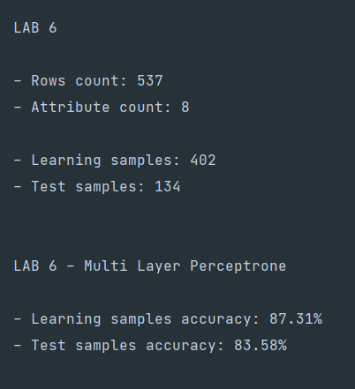
Рис. 1. Вывод информации
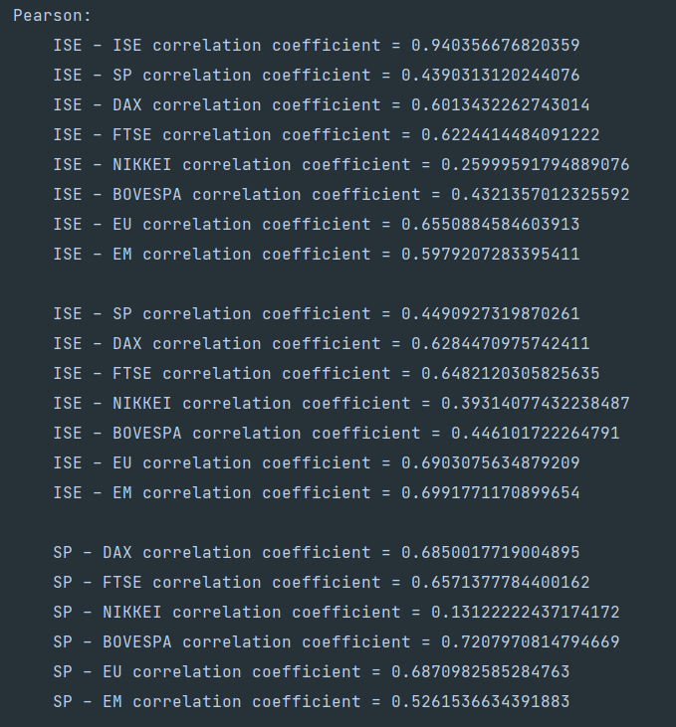
Рис. 2. Вывод информации

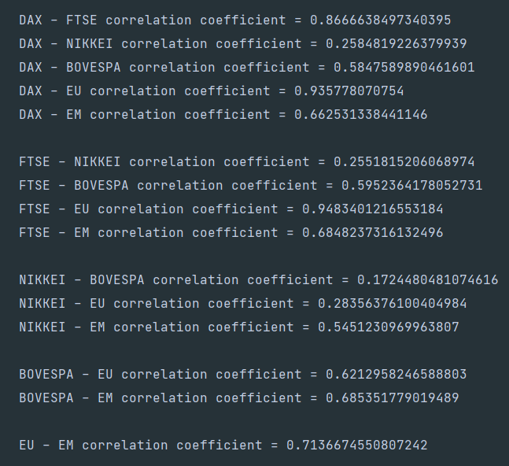
Рис. 3. Вывод информации о коэффициентах корреляции Пирсона

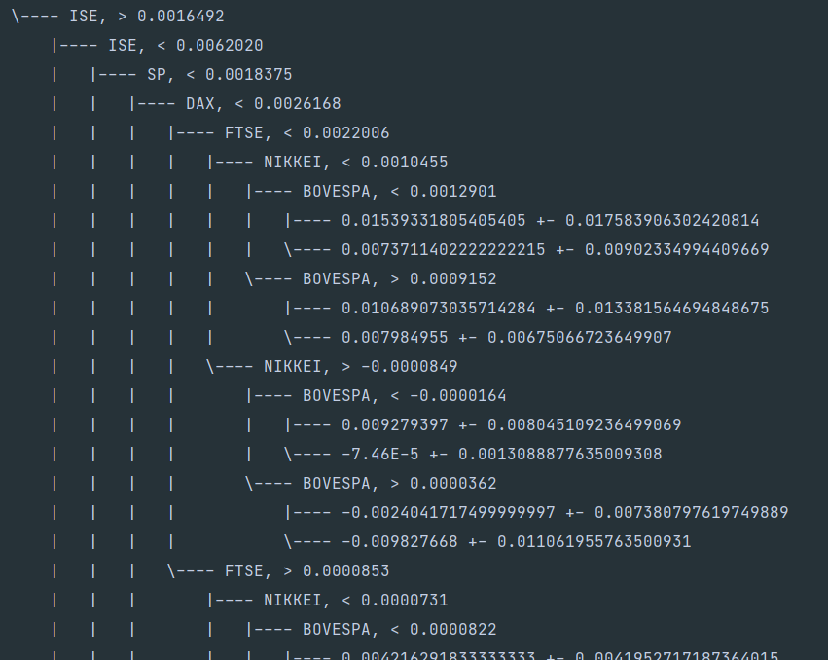
Начало графического отображения дерева (ввиду его очень больших размеров, посчитал нецелесообразным его полную вставку в отчет)
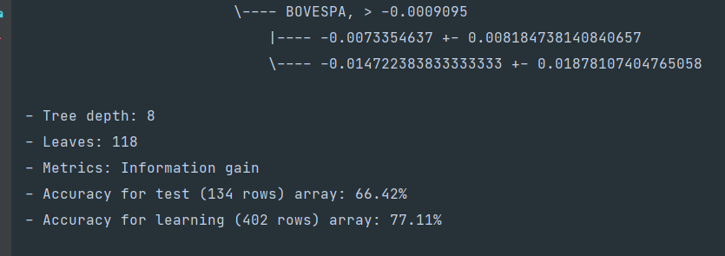
Рис. 5, 6. Вывод информации о регрессионном дереве

Выводы

В ходе лабораторной работы была реализована многослойная нейронная сеть для задач регрессии и регрессионное дерево.
В ходе выполнения работы возникли трудности с реализацией нейросети без использования сторонних библиотек. Также периодически возникали проблемы при работе с очень маленькими числами, при большом числе эпох.
По большому счету, реализация очень схожа с 5 лабораторной работой – принцип остался тот же. Из различий – в качестве функции активации был использован гиперболический тангенс. Предварительно данные были сконвертированы из .xlsx в .csv файл, а также убран 1 столбец с датами. В качестве зависимой переменной был выбран последний столбец. Также попарно были рассчитаны коэффициенты корреляции Пирсона для всех атрибутов (рисунки 2 и 3).
Пиковой точности (рис. 1) получилось добиться при 1000 эпох, с двумя слоями по 3 нейрона. При добавлении большего числа слоёв или еще же большего числа нейронов, точность предсказаний чаще всего падала для обеих тренировочной и тестовой подвыборок. При большем числе эпох, чем 1000, судя по всему, начиналось переобучение нейросети и точность падала.
Регрессионное дерево в реализации также схоже с классификационным деревом, из главных изменений – был немного доработан case class Node, а также функции построения и тестирования непосредственно самого дерева.
Сравнивая полученные модели могу заявить, что регрессионное дерево дает стабильно худшие результаты, чем нейронная сеть. Средняя точность нейросети – 85%, а регрессионного дерева – 72%
В итоге, после выполнения всех лабораторных работ сложилось впечатление, что нейросети – возможно самый универсальный из инструментов. В процессе изучения и реализации алгоритмов стало более ясно, что нейросети эффективны в работе с нелинейными зависимостями и могут очень точно описывать различные наборы данных.
Подытоживая результаты разработки реализации алгоритмов каждой из лабораторных работ и беглого анализа применения фреймворка Apache Spark в Scala проекте, думаю, что в реальной жизни для практического применения реализация своих алгоритмов имеет мало смысла, кроме как образовательного. Более того, проведя быстрое сравнение библиотек для работы с ИИ в Питоне и Скале, я пришел к выводу, что несмотря на большее быстродействие Скалы, для подобных задач я бы всё же использовал Питон и внешние API, а Скалу бы в качестве лучшей мультипарадигмальной Джавы оставил для разработки серверной части микросервисов и приложений. Как мне кажется, это более логично и целесообразно с точки зрения создания программ, использующих алгоритмы AI и ML. Ввиду большей «громоздкости» Скалы, мне кажется, что чем менее критична скорость работы приложения и чем более ограничены ресурсы разработчиков (человеко часы), тем больший смысл имеет использование Питона в реализации таких алгоритмов. Также у Скалы самой по себе выше уровень вхождения. Конкретно же для меня было интересно просто попробовать свои силы в каком-либо отличном от Питона языке и Скала показалась наиболее подходящей для решения подобных задач.
В более удобном виде с моей реализацией всех работ можно ознакомиться здесь:
https://github.com/sogoeslight/AI_Labs (рефакторинг кода, более удобное разделение частей, ликвидация оставшихся дубликатов функций и приведение к более общему виду (использование Generic типов данных для хранения датасетов) в планах на ближайшее свободное время после сессии)

