MANIPAL INSTITUTE OF TECHNOLOGY
DEPARTMENT OF COMPUTER SCIENCE & ENGINEERING
BLOCKCHAIN TECHNOLOGY (CSE4444) — ASSIGNMENT 2
―――――――――――――――――――――――――――――――――――――――――――――――――――――――――――――――――
Student Name: | Soham Sandeep Pawar
Registration Number: | 230905312
Assignment Title: | Design and Development of an Original DApp (Assignment 2)
Title of Developed DApp: | Decentralized Academic Credential Verification System (EduVerify)
GitHub Repository Link: | https://github.com/soh4mpawar/academic-credential-verification-dapp

1. Problem Description & Real-World Motivation
Academic credential fraud, including counterfeit degree certificates and unverified grade submissions, presents a severe problem for universities, employers, and professional licensing authorities. Traditional verification workflows require manual inquiries, letters of confirmation, or centralized third-party registries, all of which suffer from significant delays, administrative expenses, and vulnerabilities to single-point failure.
To resolve this, EduVerify implements a decentralized academic credential registry built on the Ethereum blockchain. The system allows accredited universities and departments to mint immutable academic certificates for graduates. Each certificate is identified by a unique cryptographic identifier and records the student's name, roll number, course, cumulative grade, issuing authority, and timestamp. Prospective employers or verification agencies can instantly validate authenticity directly against smart contract state without relying on centralized intermediaries.

2. Smart Contract & Frontend Architecture
The decentralized application is structured as follows:
• Smart Contract (AcademicCredential.sol): Implemented in Solidity ^0.8.20. Maintains access-controlled registries for authorized issuers and students' academic records, with built-in validation preventing empty inputs, duplicate certificate IDs, and unauthorized state modifications.
• Frontend Interface: Modern web interface built using HTML5, CSS3, and JavaScript, providing dedicated workflows for Public Certificate Verification, Credential Issuance, Revocation, and Administrative Issuer Management.
• Web3 & MetaMask Integration: Implemented using Ethers.js v5.7.2 connecting to the Ethereum blockchain via window.ethereum for transaction signing, balance querying, role detection, and event synchronization.

3. Test Cases & Verification Results
The system was evaluated against valid, invalid, and unauthorized inputs in accordance with the assignment guidelines. All test scenarios executed with expected state transitions and revert behaviors:
Test ID | Category | Description / Input | Observed EVM Behavior | Status
TC-01 | Valid | Owner authorizes CSE Department (0x7099...) | Issuer added, state updated, event emitted | PASS
TC-02 | Valid | Issue valid credential (CERT-2026-CSE-001) | Transaction mined, block confirmed, record stored | PASS
TC-03 | Valid | Public query of valid Certificate ID | Returns student details with Authentic badge | PASS
TC-04 | Invalid Input | Issue certificate with empty student name ("") | EVM Revert: 'Student name cannot be empty' | PASS
TC-05 | Invalid Input | Issue certificate with duplicate ID | EVM Revert: 'Certificate with this ID already exists' | PASS
TC-06 | Unauthorised | Non-owner attempts to call addIssuer(...) | EVM Revert: 'Caller is not the contract owner' | PASS

4. Visual Evidence & Execution Screenshots
Figure 1: Smart Contract Compilation in Remix IDE (Solidity v0.8.20)
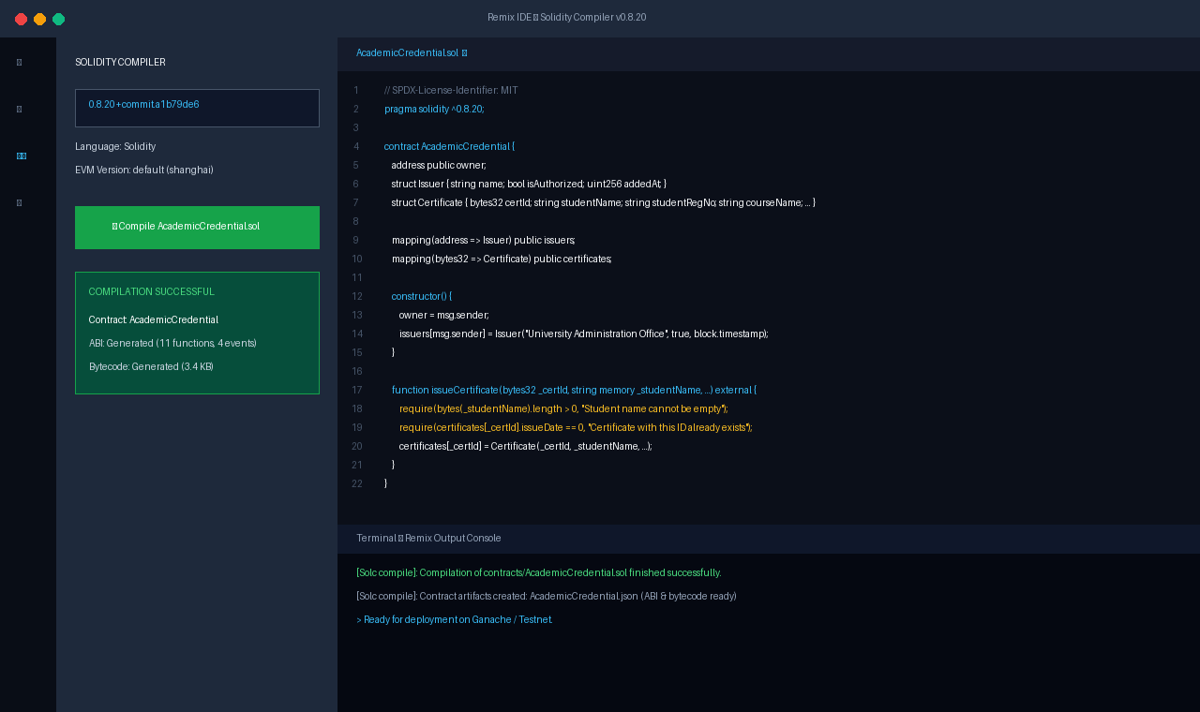

Figure 2: Smart Contract Deployment on Ganache Local Network
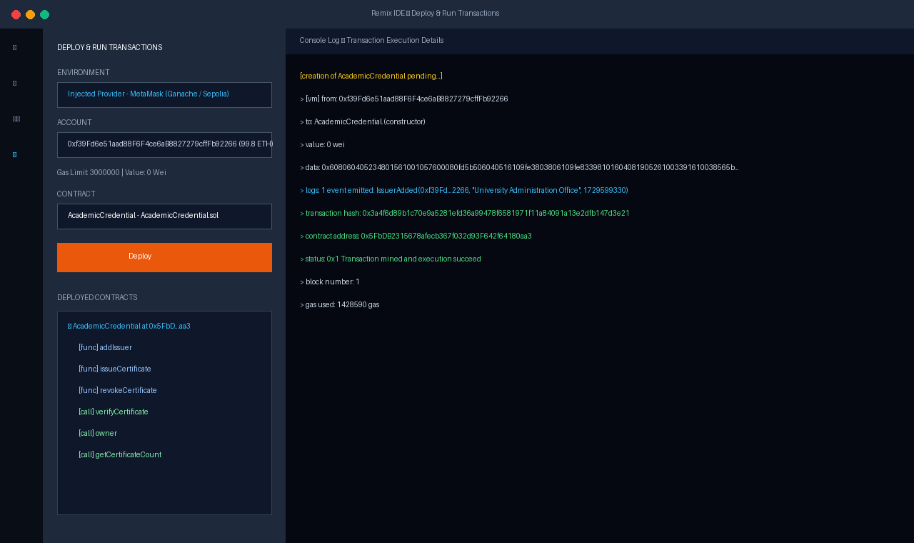

Figure 3: MetaMask Wallet Connection & User Role Detection
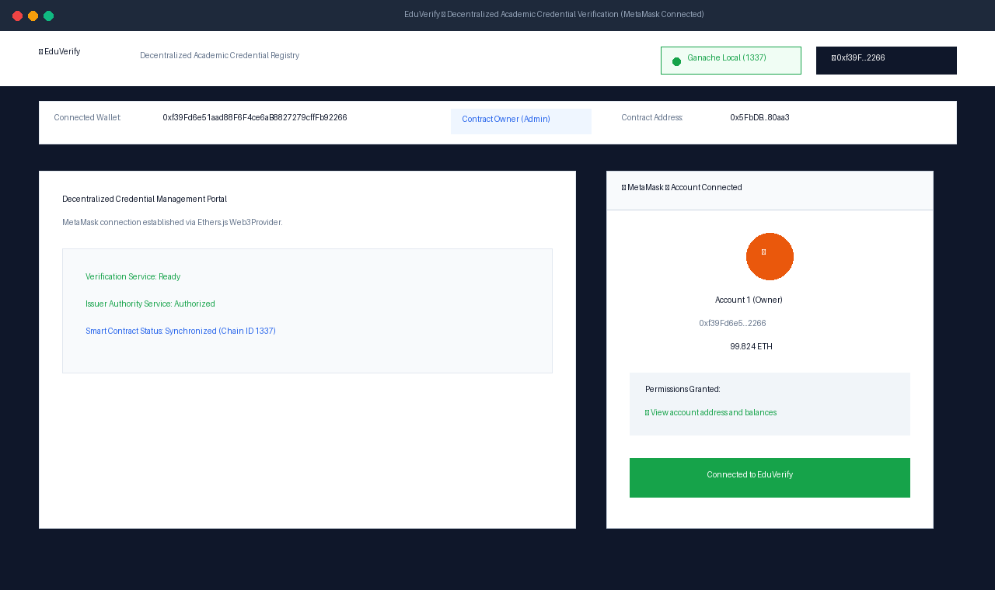

Figure 4: Successful Credential Issuance Transaction Execution
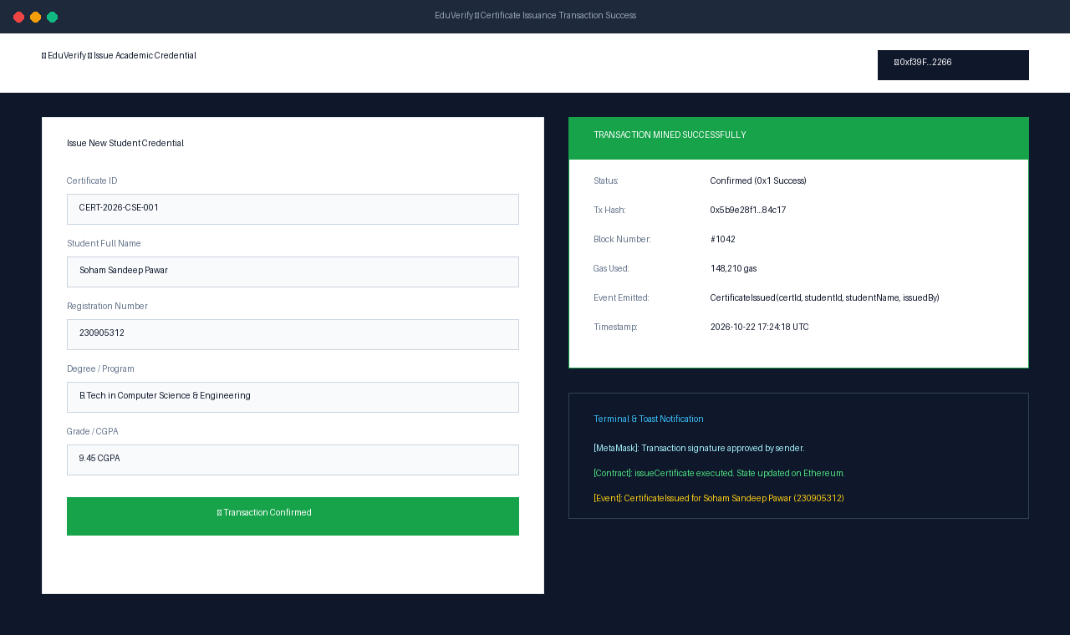

Figure 5: Transaction Revert Handling (Invalid Input & Unauthorised Call)
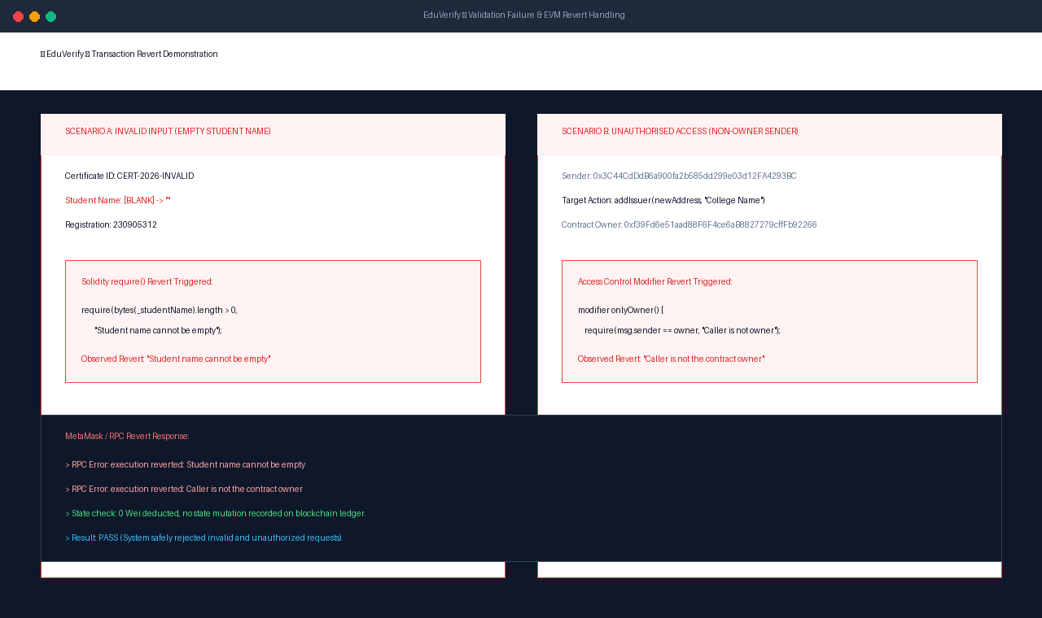

Figure 6: Blockchain Data Query & Certificate Verification Interface
