The Initial Conditions: A Critical Synthesis of Temperament Theories and the Derivation of a Universal Temperament Graph
[Author 1 name], [Author 2 name]
[Affiliations]
Author note. Correspondence concerning this article should be addressed to [corresponding author]. The graph data files and figure-generation code are openly available in the article’s supplementary repository. This article is the fifth in a planned series deriving the Unified Person Graph (UPG), an eight-dimensional network model of psychological functioning. The preceding articles derived the Universal Disorder Graph (psychopathology), the Universal Therapy Graph (treatment), the Universal Developmental Graph (development), and the Universal Personality Graph (personality).

Abstract
Temperament research asks the question the rest of a person-model takes as given: what does the system bring to its first encounter with the world? The field’s classic models — Thomas and Chess’s behavioral styles, Buss and Plomin’s heritable EAS traits, Goldsmith and Campos’s emotion-centered definition, Rothbart’s reactivity and self-regulation, and Kagan’s high- and low-reactive biases — famously failed to converge on a definition at the field’s founding roundtable, yet half a century of evidence has quietly converged beneath their vocabularies. This article critically synthesizes the classic and contemporary temperament theories, their philosophies, logics, measurement traditions, applications, and documented weaknesses, and reviews what the evidence settled: moderate heritability with decisive non-shared environment, a replicated three-dimension consensus structure (negative affectivity, surgency, effortful control), moderate and rising stability of dimensions and person-centered types, and moderated — never deterministic — pathways to psychopathology governed by temperament-by-temperament and temperament-by-environment interactions. From the synthesis we extract seven principles and formalize them as the Universal Temperament Graph (UTempG): a signed, weighted, time-gated graph whose reactive dimensions are downregulated by an effortful-control node (the stratum’s constitutive negative edge), whose goodness-of-fit node makes outcome relational rather than intrinsic, and whose interface nodes couple biology inward and personality, disorder, and caregiving systems outward. Within the Unified Person Graph the UTempG plays the role its title names: it supplies the initial conditions on which the developmental stratum’s time-gated weights operate and from which the personality stratum’s trait hierarchy grows. Falsification conditions, a validation pathway, and limitations are specified.
Keywords: temperament, reactivity, self-regulation, effortful control, behavioral inhibition, goodness of fit, network model, graph theory

1. Introduction
Every stratum of the Unified Person Graph derived so far describes something that happens to, in, or through an already-running system. The developmental article of this series ended by noting that its graph required initial conditions it could not itself supply; the personality article imported a “temperament substrate” node and promised its contents later. This article pays those debts. Temperament — biologically rooted, early-appearing individual differences in emotional reactivity and self-regulation (Fu & Pérez-Edgar, 2015; Rothbart, 2011) — is the person-model’s boundary condition: the profile of biases present before the environment has had time to write anything else, and therefore the stratum every longitudinal claim in the series ultimately conditions on.
The field’s history is unusual among the disciplines this series has reviewed: its founding controversy was staged deliberately. The 1987 roundtable asked the leaders of four research programs what temperament is, and received four partially incompatible answers — behavioral style, heritable early traits, emotional individuality, and constitutionally based reactivity and self-regulation (Goldsmith et al., 1987*). No consensus definition emerged, and Kagan’s categorical program soon added a fifth position (Fu & Pérez-Edgar, 2015; Kagan & Snidman, 1991). Yet, as with the classification wars and therapy-school wars treated earlier in the series, the disagreement proved more lexical than structural: beneath the vocabularies, the programs’ measured constructs map onto a small convergent architecture, their causal claims share a two-process logic of reactivity and regulation, and their outcome claims share a moderated, relational form — the child’s endowment matters as fitted to its context, never alone (Chess & Thomas, 1989; Rettew & McKee, 2005; Rothbart, 2011).
This article, the fifth in the UPG series, treats temperament’s definitional pluralism as a representation problem. We review the theory families critically (Section 3), review what the evidence settled (Section 4), extract the joint requirements as principles (Section 5), and satisfy them with a graph continuous in formalism and axioms with the four strata already derived (Section 6). The review draws on the assembled library — including the field’s central handbook (Zentner & Shiner, 2012), its canonical theory map (Fu & Pérez-Edgar, 2015), and foundational primary sources (Buss & Plomin, 1984; Chess & Thomas, 1989; Kagan & Snidman, 1991; Rothbart, 1981, 2011) — with sources located beyond the library marked by an asterisk in the reference list.

2. Temperament in Brief
Temperament denotes constitutionally based individual differences in reactivity — the arousability of emotional, motor, and attentional systems — and self-regulation, the processes that modulate that arousability (Rothbart, 2011; Rothbart & Derryberry, 1981*). Three structural commitments matter for everything that follows. First, temperament is early but not fixed: its dispositions appear in infancy and show moderate stability that rises with age, yet expression changes with development and context — a bias, not a destiny (Kagan, 2022; Murillo et al., 2024; Rettew & McKee, 2005). Second, temperament is biologically rooted but probabilistically expressed: genetic influence is well established and physiological signatures are documented, but heritability is moderate, non-shared environment is decisive, and no dimension reduces to its substrate (Rettew & McKee, 2005; Spinath & Angleitner, 1998). Third, temperament is consequential only relationally: the same endowment yields adaptation or disorder depending on its fit with environmental demands — the insight Thomas and Chess made canonical as goodness of fit and the modern moderation literature made quantitative (Berdan et al., 2008; Chess & Thomas, 1989; McClowry et al., 2008). Any universal representation must therefore carry a two-process architecture, gate its biological inputs developmentally, and locate risk on interaction edges rather than in nodes — requirements the graph of Section 6 satisfies by construction.

3. The Theories: A Critical Tour
Table 1 compresses the comparative analysis of the five classic research programs plus the neurobiological mapping tradition (Fu & Pérez-Edgar, 2015; Goldsmith et al., 1987*; Zentner & Shiner, 2012). Figure E2 displays the programs’ constructs mapped onto the consensus dimensions. The narrative highlights what each contributes to the extraction of Section 5 and where its documented weaknesses lie.
Table 1. Major temperament research programs: logic, contributions, and documented weaknesses.
Program | Exemplary figures | Core logic of temperament | Chief contribution to the universal architecture | Chief documented weaknesses
Behavioral-style (NYLS) | Thomas; Chess | Temperament is the how of behavior: nine stylistic dimensions, three clinical types, and outcomes determined by goodness of fit | The fit construct; the clinical bridge; the typology | Nine dimensions psychometrically unsupported; style/content boundary blurs; parent-report base
Behavioral-genetic (EAS) | Buss; Plomin | Temperament is the heritable, early-appearing subset of personality: emotionality, activity, sociability | The inheritance criterion; the temperament–personality continuity claim | Criterion excludes regulation; rater contrast effects inflate twin estimates; sociability/shyness unstable across analyses
Emotion-centered | Goldsmith; Campos | Temperament is individual variation in primary-emotion parameters, measurable in expression | Emotion-parameter precision; laboratory measurement (Lab-TAB) | Regulation under-represented; boundary with emotional development contested
Reactivity–regulation | Rothbart; Derryberry | Temperament is constitutionally based reactivity plus the effortful control that modulates it | The two-process architecture; the three-dimension structure; instrument lineage (IBQ→CBQ→EATQ) | Effortful control overlaps executive function; questionnaire-laboratory convergence imperfect
Categorical-biological | Kagan; Snidman | A minority of infants carry discrete high-/low-reactive biases with physiological signatures and asymmetric long-term risk | The bias-not-destiny result; physiological anchoring; developmental psychopathology bridge | Categories versus continua contested; taxonicity unresolved; effect sizes modest at long range
Neurobiological mapping | Gray; Cloninger; Gomez | Temperament dimensions are surface expressions of defined brain motivational systems (BIS/BAS/FFFS; psychobiological model) | The substrate interface; converging adult measurement | Mappings partial; systems revised repeatedly; effortful control outside the reactive systems

3.1 Thomas and Chess: behavioral style and goodness of fit
The New York Longitudinal Study founded modern temperament research against the era’s radical environmentalism, establishing that infants differ from birth in the style of their behavior — nine dimensions including activity, rhythmicity, approach–withdrawal, adaptability, intensity, and mood — and that these differences are neither parent-caused nor outcome-determining (Chess & Thomas, 1989; Thomas & Chess, 1977*). Two exports proved permanent. The clinical typology — easy, difficult, slow-to-warm-up — gave pediatrics and child psychiatry a working vocabulary (Chess & Thomas, 1989). And goodness of fit — the thesis that adaptive outcome is a property of the match between temperament and environmental demands, not of temperament alone — became the field’s most consequential idea, the direct ancestor of today’s temperament-based interventions (McClowry et al., 2008) and, in this article, a node rather than a slogan. The documented weaknesses are psychometric: the nine dimensions do not survive factor analysis, the style/content boundary blurs on inspection, and the parent-interview evidence base carries rater biases the behavioral-genetic literature later quantified (Fu & Pérez-Edgar, 2015; Zentner & Shiner, 2012).

3.2 Buss and Plomin: the inheritance criterion
Buss and Plomin (1975*, 1984) defined temperament by a criterion rather than a content list: temperaments are inherited personality traits appearing in the first two years — emotionality, activity, and sociability, with shyness the developmentally pivotal blend. The program’s contributions are the explicit temperament–personality continuity claim this series formalizes as an interface, and the behavioral-genetic discipline it imported: twin designs, heritability estimation, and, eventually, honest accounting of their limits. Those limits are themselves documented library results: parental ratings of twins show contrast effects — parents exaggerate differences between dizygotic twins, inflating heritability estimates derived from ratings (Spinath & Angleitner, 1998) — and the EAS factor structure replicates only partially across samples, with sociability and shyness resisting clean separation (Boer & Westenberg, 1994). The extraction keeps the criterion’s kernel — biological rootedness as a defining constraint — while assigning its measurement cautions to the validation program.

3.3 Goldsmith and Campos: temperament as emotional individuality
The emotion-centered program defined temperament as individual differences in the experience and expression of the primary emotions, deliberately excluding cognition and confining evidence to measurable expression (Fu & Pérez-Edgar, 2015; Goldsmith et al., 1987*). Its laboratory instrumentation (Lab-TAB) disciplined a field over-reliant on questionnaires, and its emotion-parameter precision — latency, rise time, intensity, recovery — anticipated the state-level resolution the personality stratum later required. Its documented weakness is scope: regulation enters only through expression, and the boundary between temperamental emotionality and emotional development is contested (Fu & Pérez-Edgar, 2015). The extraction keeps its precision as the facet grain of the reactive dimensions.

3.4 Rothbart: reactivity and self-regulation
Rothbart’s model is the field’s central synthesis and the architecture this article generalizes: temperament as constitutionally based individual differences in reactivity — negative affectivity and surgency — and in self-regulation, chiefly effortful control, the capacity to deploy attention and inhibit prepotent responses voluntarily (Rothbart, 2011; Rothbart & Derryberry, 1981*). The program built the field’s instrument lineage from infancy to adulthood (Rothbart, 1981), documented the maturational emergence of effortful control with frontal regulatory networks, and established the model’s developmental signature: regulation modulates reactivity, an inherently signed, inherently time-gated claim (Fu & Pérez-Edgar, 2015). Adult measurement work ties the model to the neurobiological systems of reinforcement sensitivity theory — BIS and FFFS constructs align with negative affectivity, BAS constructs with surgency, while effortful control stands outside the reactive systems as their regulator (Gomez et al., 2016). Documented weaknesses are boundary questions: effortful control overlaps executive function, and questionnaire–laboratory convergence is imperfect (Zentner & Shiner, 2012). The extraction adopts the two-process architecture wholesale; it is the stratum’s spine.

3.5 Kagan: categorical biases and their honest limits
Kagan’s program identified, in roughly a fifth to a third of infants, high-reactive profiles — vigorous motor and distress responses to novelty — that predict behavioral inhibition, and low-reactive profiles predicting its uninhibited complement, each with physiological signatures in limbic and striatal circuitry (Kagan & Snidman, 1991). Longitudinal follow-ups established the program’s twin legacies: the biases are real, physiologically anchored, and predictive of asymmetric risk — high reactivity forecasts anxiety-spectrum outcomes at elevated rates — and yet they are biases, not destinies: most high-reactive infants do not become disordered adults, and trajectories bend with context (Kagan, 2022; Pérez-Edgar et al., 2024). Kagan’s late-career synthesis added a methodological conscience the series adopts: psychological constructs must specify the pattern of measures, the settings, and the population before claims travel (Kagan, 2022). Documented weaknesses: the categorical claim remains contested against dimensional alternatives, and long-range effect sizes are modest (Fu & Pérez-Edgar, 2015; Pérez-Edgar et al., 2024). The extraction keeps types as configurations over dimensions — person-centered profiles, not a rival ontology — which is precisely how the contemporary typology literature now proceeds (Murillo et al., 2024).

3.6 Applied and assessment traditions
An applied lineage descending from Jungian typology treats child temperament styles as a school- and family-facing assessment vocabulary (Callueng & Oakland, 2014), and the intervention literature has converted goodness of fit from metaphor to protocol: temperament-based interventions coach caregivers and teachers to adjust demands to the child’s profile, with self-regulation as the common target (McClowry et al., 2008). The commentary literature stresses the same translational point: temperament is the child’s contribution to development, and services that ignore it misattribute its effects (Calkins, 2012). These traditions supply the graph’s applied validity channel — its constructs must remain measurable and coachable in ordinary settings.

4. What the Evidence Settled

4.1 Etiology: rooted, not fixed
Twin and family studies converge on moderate genetic influence across dimensions and types, with the remaining variance dominated by non-shared environment — and essentially no role for shared environment in most analyses (Murillo et al., 2024; Rettew & McKee, 2005). The same literature documents its own measurement hazards: rating-based heritability estimates are inflated by parental contrast effects (Spinath & Angleitner, 1998). The design consequence: the biological substrate is an input node with childhood-peaked, never absolute, edge weights — and the graph’s provenance must distinguish rating-based from observation-based evidence.

4.2 Structure: three dimensions, configural types
Across instruments and programs, measured constructs organize into negative affectivity, surgency/positive affectivity, and effortful control (Fu & Pérez-Edgar, 2015; Rothbart, 2011) — the mapping Figure E2 makes explicit, with the RST alignment supplying adult convergent validity (Gomez et al., 2016). Person-centered analyses recover interpretable profiles over these dimensions: a large diverse twin cohort identified regulated, average, and reactive-type profiles showing both continuity and lawful change from infancy to adolescence, with genetic and environmental contributions to type membership (Murillo et al., 2024). The design consequence: dimensions are nodes; types are configurations — a derived layer, not competing structure.

4.3 Outcome: moderated pathways, relational risk
Temperament–psychopathology linkage is established but never one-to-one. Negative emotionality and low inhibitory control associate with broad disorder risk; the candidate mechanisms — risk/vulnerability, spectrum, and scar models — remain empirically live, with vulnerability best supported for most conditions (Rettew & McKee, 2005). The pathways are moderated twice over: temperament-by-temperament, as when effortful control buffers the inhibition-to-anxiety route, and temperament-by-environment, as when social preference and perceived acceptance protect high-surgency children against externalizing outcomes (Berdan et al., 2008; Fu & Pérez-Edgar, 2015) — with differential-susceptibility evidence indicating that the most reactive children are most responsive to environmental quality in both directions (Belsky & Pluess, 2009*). Intervention research closes the causal loop: changing the fit changes the outcome (McClowry et al., 2008). The design consequence is the section’s deepest: risk lives on interaction edges — moderation must be a first-class edge type, and fit a node.

4.4 What follows for design
Jointly the verdicts impose six requirements. A universal temperament representation must (1) carry the two-process reactivity–regulation architecture with a signed regulatory edge, (2) organize content as three consensus dimensions with facet subgraphs and types as configurations, (3) gate biological input developmentally and let stability rise with age, (4) locate outcome risk on moderated paths rather than in nodes, (5) carry goodness of fit as a relational node coupling the person to environmental demands, and (6) expose explicit interfaces — biology inward; personality, disorder, development, and caregiving systems outward. No single program satisfies all six; their union, expressed as principles, does.

5. Extraction: The Universal Temperament Framework

5.1 Method of extraction
As in the preceding articles, we extracted the shared architecture by triangulating the field’s comparative sources (Fu & Pérez-Edgar, 2015; Goldsmith et al., 1987*; Zentner & Shiner, 2012) against the primary statements of each program (Section 3) and the adjudicating empirical literatures (Section 4). A principle was admitted if (a) it is asserted or presupposed, under whatever local vocabulary, by at least three of the six programs, and (b) it has empirical support independent of any single program’s paradigm. Seven principles survived both filters.

5.2 The seven principles
Table 2. The seven universal temperament principles: ancestry, evidence, and graph translation.
# | Principle | Statement | Principal ancestry | Independent evidence | Graph translation
1 | Biological rootedness, probabilistic expression | Temperament is constitutionally based but never substrate-determined | Buss & Plomin; Kagan; Rothbart | Moderate heritability, decisive non-shared environment (Murillo et al., 2024; Rettew & McKee, 2005) | Substrate interface node with childhood-peaked gated edges
2 | Reactivity–regulation architecture | Reactive systems and a regulatory system are distinct, interacting processes | Rothbart & Derryberry; Gray | Maturational and neuroimaging dissociations (Fu & Pérez-Edgar, 2015) | Two reactive dimension nodes plus an effortful-control node with signed edges
3 | Dimensional convergence | Measured constructs organize into negative affectivity, surgency, and effortful control | All programs (Figure E2) | Cross-instrument, cross-age recovery (Gomez et al., 2016; Rothbart, 2011) | Three dimension nodes with facet subgraphs
4 | Types as configurations | Person-centered types are profiles over the dimensions, not a rival ontology | Thomas & Chess; Kagan; Murillo | Latent-profile replication with etiological signal (Murillo et al., 2024) | Configural type node derived hierarchically from dimensions
5 | Bias, not destiny | Early dispositions predict asymmetric risk with moderate, rising stability and lawful change | Kagan; NYLS; lifespan evidence | Longitudinal follow-ups (Kagan, 2022; Murillo et al., 2024; Pérez-Edgar et al., 2024) | Age-increasing autoregressive self-loops; modest cascade weights
6 | Relational outcome (goodness of fit) | Adaptive outcome is a property of the temperament–environment match, moderated twice over | Thomas & Chess; intervention research | Fit-based intervention effects; protective-factor moderation (Berdan et al., 2008; McClowry et al., 2008) | Fit node; T×T and T×E moderation edges into the risk channel
7 | Temperament–personality continuity | The dimensions are the developmental cores of the trait hierarchy | Buss & Plomin; Rothbart; Caspi | Longitudinal temperament-to-trait prediction (Caspi et al., 2005*) | Gated cascade edges into the personality interface node
As in the earlier strata, the principles are intersection constraints, not a seventh model. Principle 2 deserves emphasis: the regulatory edge is negative — effortful control subtracts from reactive output — making temperament the stratum where the series’ Axiom 5 (signed superposition) is not an accommodation but the central mechanism.

6. The Universal Temperament Graph

6.1 Formal definition
Let $V$ be the node set published in the accompanying data files: a superordinate temperament node $T$; the genetic/physiological substrate interface; three dimension nodes (negative affectivity, surgency/positive affectivity, effortful control) with their thirteen facet subnodes; the configural-types node with its four canonical profiles; the goodness-of-fit node; the caregiving/demands interface; the maladjustment-risk channel; the personality-trait-layer interface; and three mechanism nodes (temperament-by-temperament moderation, temperament-by-environment moderation, regulatory maturation). Let $W(t)∈R^{|V|×|V|}$ be a signed weighted adjacency matrix indexed by developmental time, inheriting the gating formalism of the developmental stratum: $w_{ij}(t)=g_{ij}(t) {\overset{‾}{w}}_{ij}$. The UTempG is $G(t)=(V,W(t))$, with the edge typology partitioning nonzero entries into hierarchical, cascade, transactional, moderation, and autoregressive types. Figure E1 displays the graph at dimension resolution; every edge carries weight, sign, type, gate class, evidential basis, and primary sources in the data files.
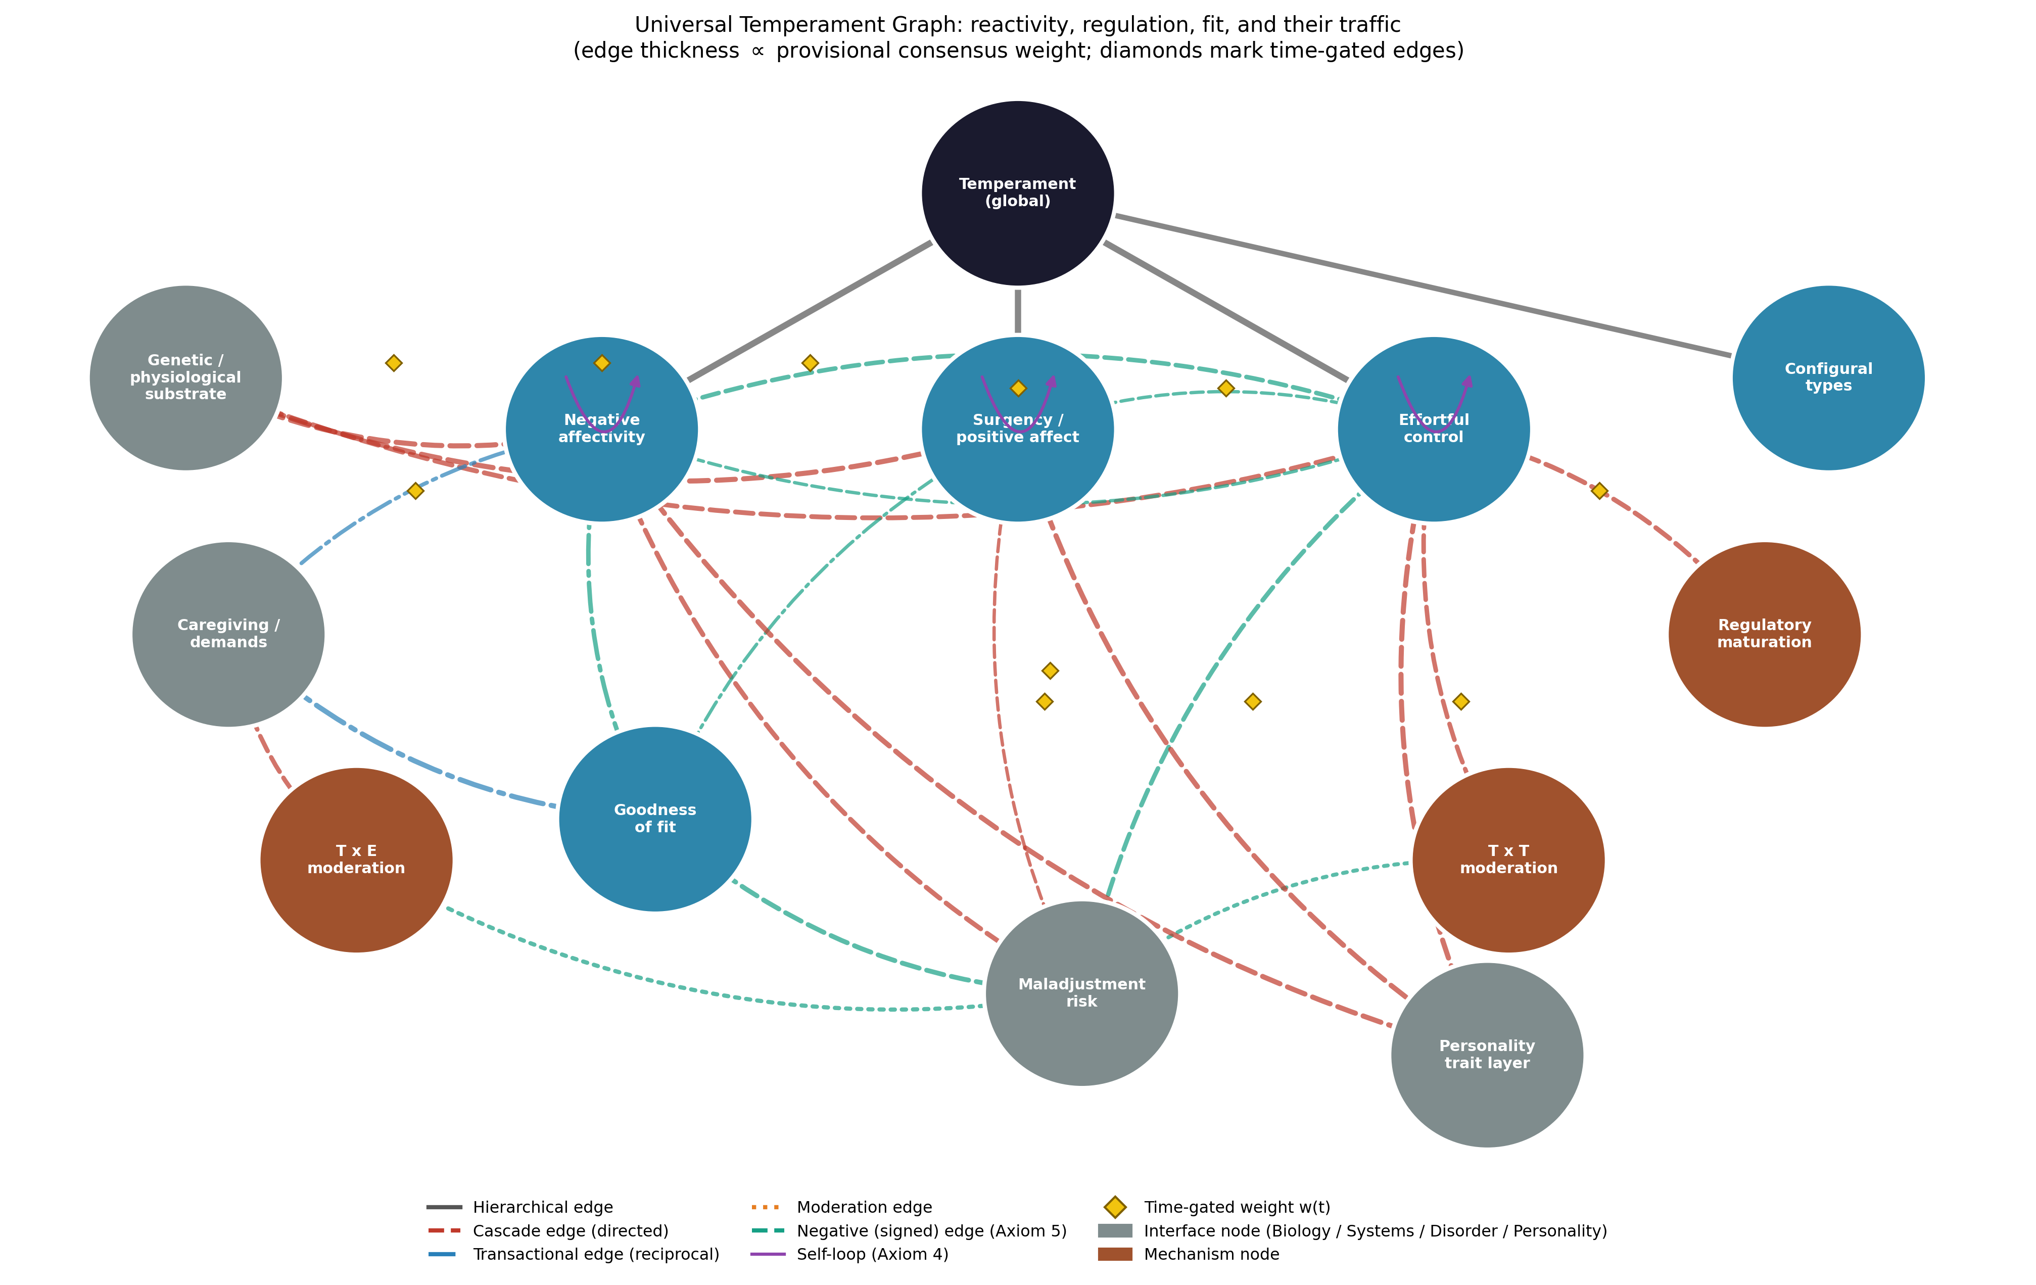
Figure E1. The Universal Temperament Graph: reactivity, regulation, fit, and their traffic. Edge thickness is proportional to provisional consensus weight; diamonds mark time-gated edges; teal edges are negative (Axiom 5); grey nodes are interfaces to the biological substrate and to the Systems, Disorder, and Personality strata.
Three structural features define the stratum. First, the signed regulatory core: effortful control carries negative edges into both reactive dimensions — the graph-theoretic statement of self-regulation — and negative reactivity carries a weaker return edge, since acute distress degrades regulatory deployment (Fu & Pérez-Edgar, 2015; Rothbart, 2011). Second, the gates: substrate edges peak in childhood; the maturation→effortful-control edge opens across childhood and adolescence as frontal networks consolidate; the dimension self-loops are age-increasing, encoding rising stability (Murillo et al., 2024); and the dimension→personality edges run on the infancy-to-adulthood gate, the formal rendering of “developmental core.” Third, the relational risk geometry: no edge runs from a dimension to disorder unconditionally at full weight — the direct cascade weights are deliberately modest, and the heavier traffic routes through fit and the two moderation nodes, implementing the settled finding that temperamental risk is realized or nullified interactively (Belsky & Pluess, 2009*; Berdan et al., 2008; Chess & Thomas, 1989).

6.2 Axiom compliance
Axiom 1 (universal connectivity): every node reaches every other through the dimensional spine and the fit/moderation circuitry. Axiom 2 (non-dismissibility): no node may be deleted in formulating a person — dropping effortful control collapses the model into pure reactivity, dropping fit reinstates the intrinsic-risk error the NYLS refuted (Chess & Thomas, 1989). Axiom 3 (mediated and unmediated influence): negative affectivity reaches maladjustment both directly and through fit — both routes are edges with distinct weights. Axiom 4 (self-influence): the dimension self-loops encode the stability literature at its measured, age-graded magnitude. Axiom 5 (signed superposition): the effortful-control edges are negative, soothability loads negatively within its own dimension, and concurrent influences sum — a child’s risk state is the signed sum of reactive load, regulatory subtraction, and moderated contextual input, which is exactly how the moderation literature models it (Berdan et al., 2008).

6.3 Subgraphs and encapsulation
Each dimension owns an encapsulated facet subgraph, published in the data files at the grain of the Rothbart instrument lineage: fear, anger/frustration, sadness, discomfort, and (negatively loading) soothability under negative affectivity; activity, sociability, approach, and high-intensity pleasure under surgency; attentional focusing, inhibitory control, perceptual sensitivity, and low-intensity pleasure under effortful control (Rothbart, 1981, 2011). The types node owns the four canonical profiles — easy, difficult, slow-to-warm-up, and inhibited/uninhibited — as configural subnodes (Chess & Thomas, 1989; Kagan & Snidman, 1991). Encapsulation carries its standing burden: program-specific vocabulary lives inside subgraphs, so the dimension level commits to no program’s lexicon while remaining translatable into all of them (Figure E2).
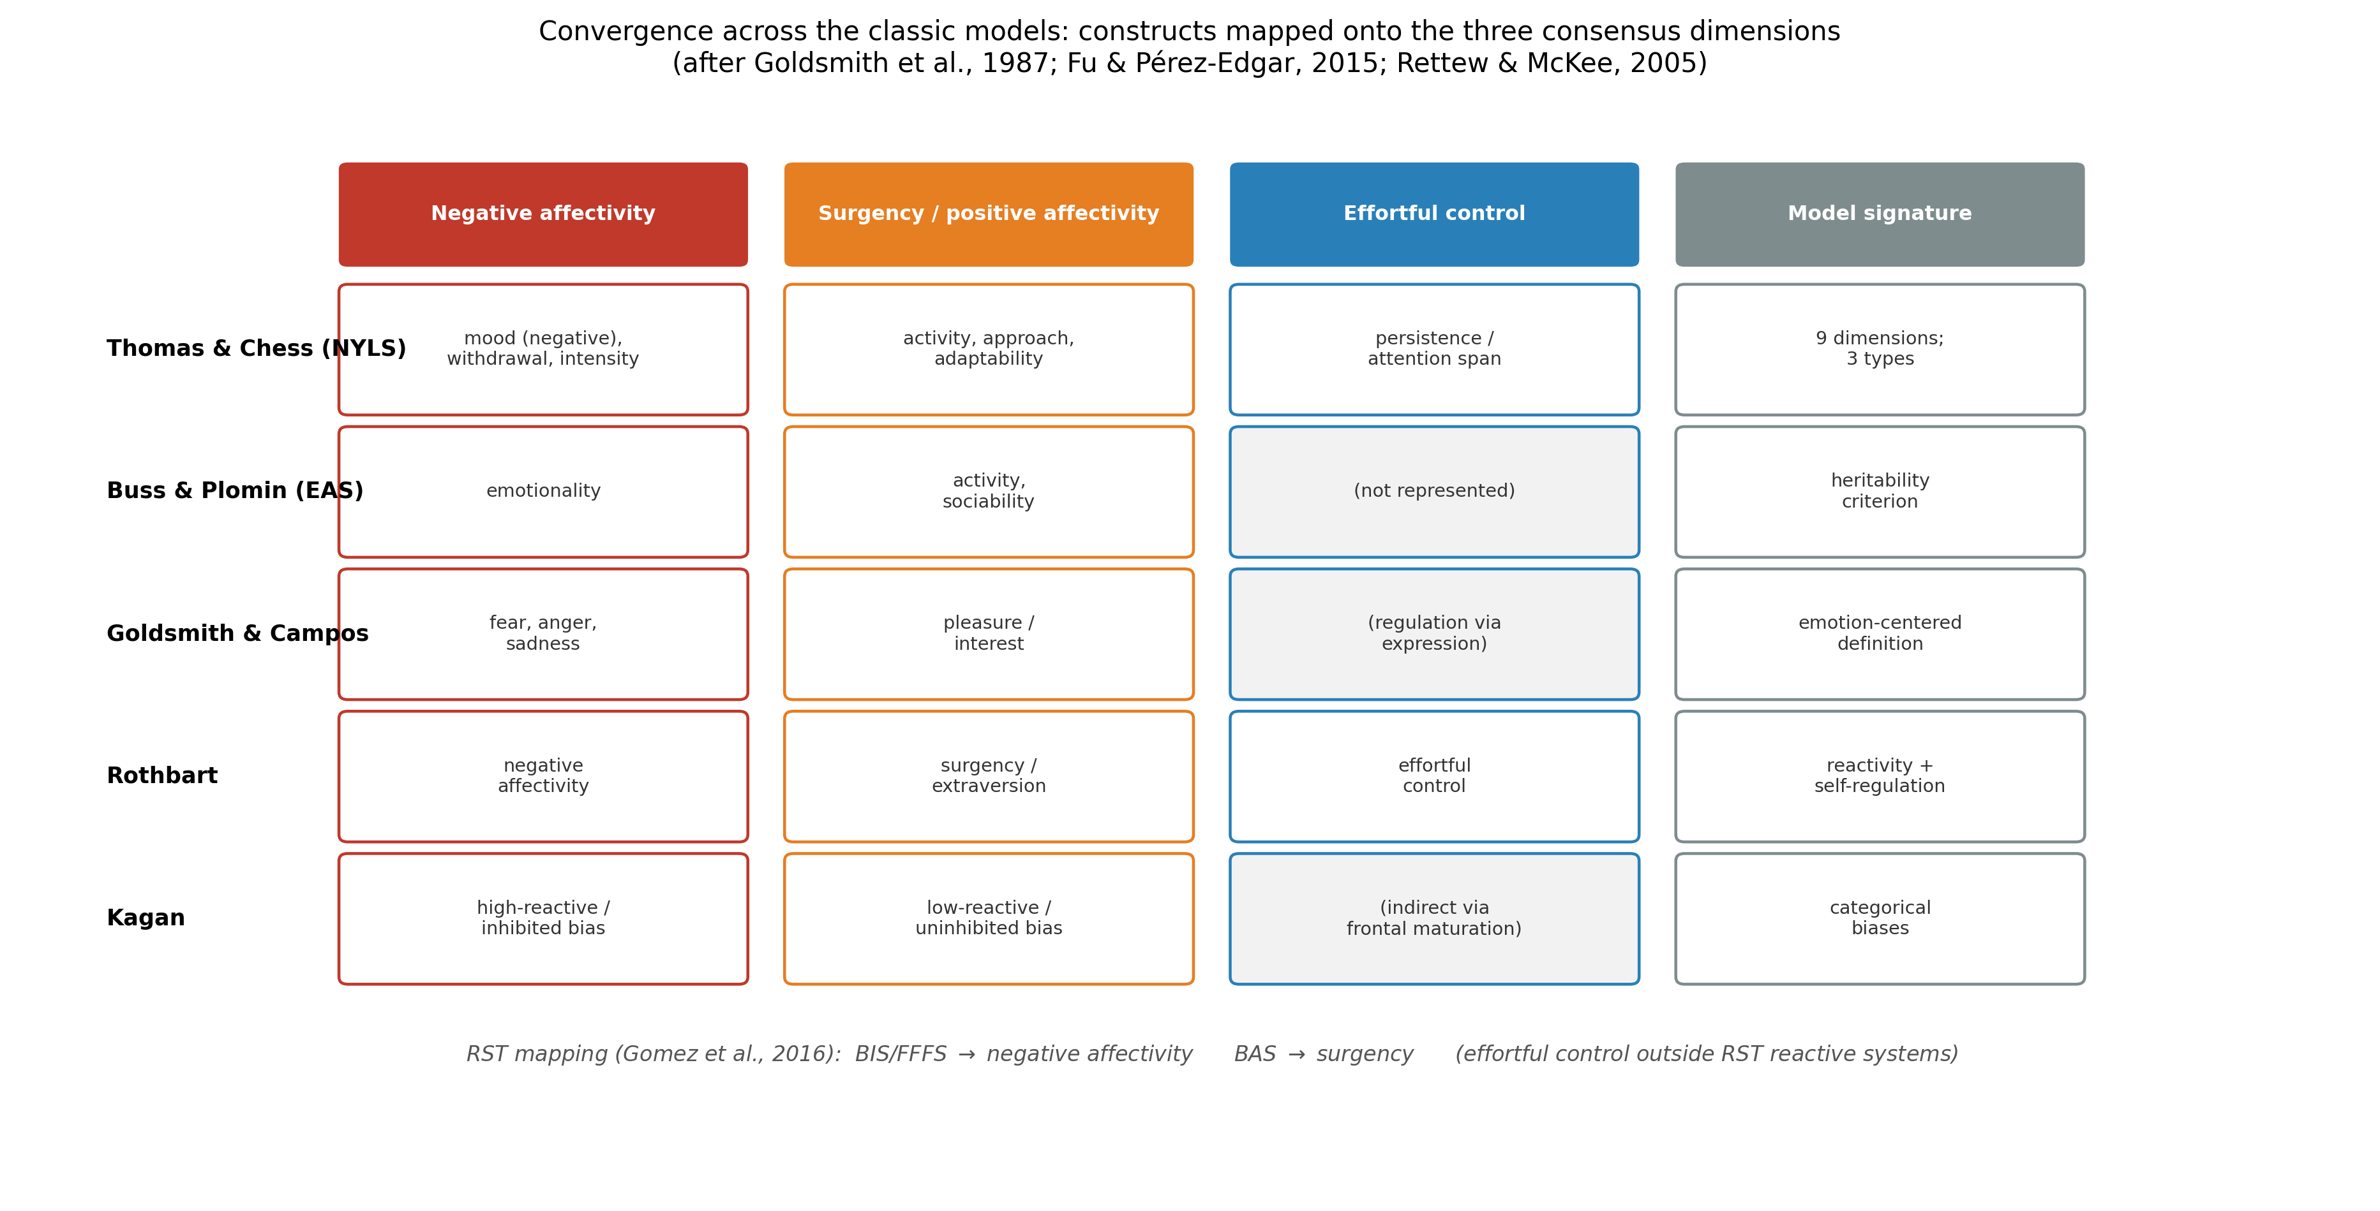
Figure E2. Convergence across the classic models: each program’s constructs mapped onto the three consensus dimensions, with the RST adult mapping below (after Goldsmith et al., 1987; Fu & Pérez-Edgar, 2015; Gomez et al., 2016).

6.4 Goodness of fit as an interaction surface
Figure E3 renders the stratum’s signature claim quantitatively: maladjustment risk as a surface over temperamental load and environmental support. In a low-support environment risk rises steeply with load; in a high-support environment the curve flattens — the geometric form of every result in the moderation literature, from protective peer acceptance (Berdan et al., 2008) to fit-based intervention effects (McClowry et al., 2008) to differential susceptibility’s crossing curves (Belsky & Pluess, 2009*). The surface is generated by the graph’s T×E moderation edges, and it is where the temperament stratum hands the therapy stratum its lever: the UTG’s change-work node cannot rewrite the substrate, but it can move the person along the support axis — which the surface shows is often the larger gradient.
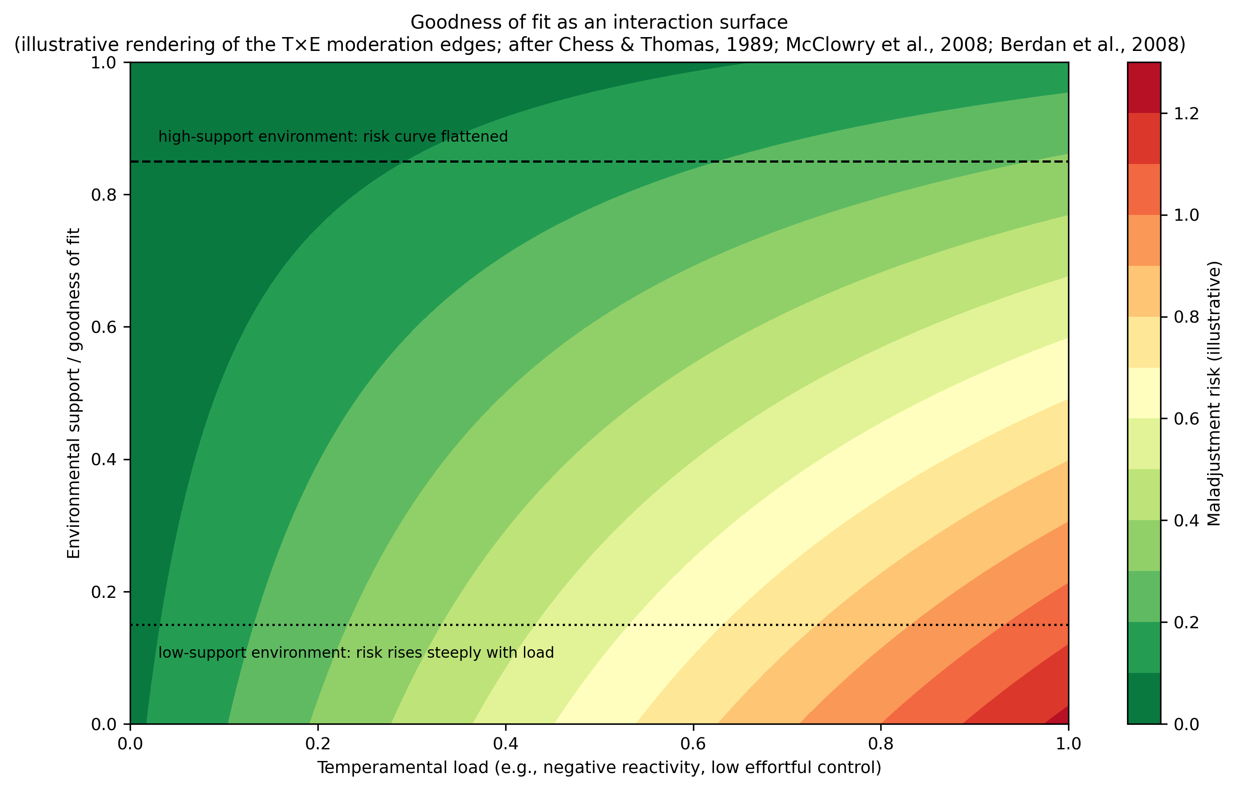
Figure E3. Goodness of fit as an interaction surface: illustrative rendering of the T×E moderation edges (after Chess & Thomas, 1989; McClowry et al., 2008; Berdan et al., 2008).

6.5 Coupling to the other strata
The UTempG’s interfaces close the loop the series opened. Inward, the substrate node imports biology at the only grain the evidence licenses: gated, moderate, probabilistic. Forward to personality, the three dimensions project onto the trait hierarchy as its developmental cores — negative affectivity into neuroticism, surgency into extraversion, effortful control into conscientiousness (Caspi et al., 2005*; Rothbart, 2011) — supplying the initial conditions the personality article’s temperament interface awaited. Through development, every gate in this graph is a UDevG object: the maturation of effortful control is a sensitive-period claim, and the evocative edge from infant negative affectivity to caregiving demands is a transaction the developmental stratum already carries. Toward psychopathology, the maladjustment-risk node is the UDG’s intake: temperamental profiles set person-specific priors on the disorder graph’s node vulnerabilities, in the vulnerability-model form the evidence favors (Rettew & McKee, 2005), with Kagan’s high-reactive bias the worked example — elevated anxiety-spectrum prior, far below unity (Kagan, 2022). Toward treatment, the fit node gives the UTG a structural target: temperament-based intervention is, formally, edge-work on the caregiving→fit coupling (McClowry et al., 2008).

6.6 What the UTempG adds
Against the roundtable’s unresolved pluralism, it replaces definitional dispute with a computable object in which each program survives as the component it got right: NYLS as the fit geometry and typology, EAS as the inheritance constraint and personality continuity, the emotion-centered program as facet grain, Rothbart as the two-process spine, Kagan as configural biases with honest effect sizes, and the neurobiological tradition as the substrate interface. Against dimensional lists, it adds the signed regulatory core and the moderation circuitry — the mechanisms, not just the axes. Against typologies, it derives types rather than asserting them. And against all of them it adds what no temperament model currently possesses: formal continuity with disorder, treatment, development, and personality strata under shared axioms, letting temperament do systemic work — setting initial conditions and priors — instead of standing as one more parallel literature.

6.7 Falsifiability, validation pathway, and limitations
The UTempG makes refutable commitments. Structural: if the three-dimension architecture fails to recover across adequately powered, observation-based (not only rating-based) measurement, or if effortful control proves inseparable from the reactive dimensions, the spine must be revised on record. Signed: the regulatory edges predict that experimentally or developmentally strengthened effortful control reduces expressed negative reactivity; a null or positive coupling would falsify the core. Relational: the fit geometry predicts that matched temperament–environment dyads outperform mismatched dyads at equal temperamental load, and that fit-targeted intervention shifts outcomes without shifting the dimensions themselves — both already partially supported (McClowry et al., 2008) and both cleanly testable. Configural: the types node predicts that person-centered profiles add predictive increment over dimension scores; consistent null increments would demote the node. Validation should proceed from reanalysis of existing longitudinal cohorts (the gates map onto age-moderated stability and heritability coefficients), through multi-method measurement burst designs addressing the rating biases the library itself documents (Spinath & Angleitner, 1998), to prospective fit-intervention trials.
Four limitations bound the contribution. First, the published weights are consensus priors — rated, sourced, versioned, not estimated — and the goodness-of-fit surface is an illustrative rendering of documented moderation, not a fitted response surface. Second, the evidence base over-represents Western samples and parent-report methods; the diverse-cohort literature is growing (Murillo et al., 2024) but cross-cultural facet-level invariance is unestablished. Third, the biological substrate enters as an interface, not a mechanism: gene-to-dimension pathways remain unspecified in the field itself (Rettew & McKee, 2005). Fourth, the categorical–dimensional question is represented, not resolved: the graph carries types as derived configurations, and if taxometric evidence someday favors true categories, the types node’s derivation — though not the graph — would require revision (Kagan, 2022; Pérez-Edgar et al., 2024).

7. Conclusion
Temperament research began with a roundtable that could not agree on what temperament is, and matured into a discipline whose findings agree remarkably on how temperament works: early-appearing, biologically rooted, probabilistically expressed dispositions, organized as reactivity under regulation, stable but bending, and consequential only in relation to the environments they meet. This article extracted that working consensus as seven principles and formalized it as the Universal Temperament Graph: a signed, gated, moderated network whose negative regulatory core makes self-control a mechanism rather than a virtue-word, whose fit node makes risk relational rather than intrinsic, and whose interfaces hand initial conditions to personality, priors to psychopathology, gates to development, and levers to treatment. What you were born with, in this model, is neither a sentence nor a blank slate: it is the initial condition of a lifelong computation — published, revisable, and now formally connected to the strata that compute the rest.

References
Sources marked with an asterisk (*) were located by the authors through supplementary literature searches beyond the assembled source library.
Belsky, J., & Pluess, M. (2009). Beyond diathesis stress: Differential susceptibility to environmental influences. Psychological Bulletin, 135(6), 885–908. https://doi.org/10.1037/a0017376 *
Berdan, L. E., Keane, S. P., & Calkins, S. D. (2008). Temperament and externalizing behavior: Social preference and perceived acceptance as protective factors. Developmental Psychology, 44(4), 957–968. https://doi.org/10.1037/0012-1649.44.4.957
Boer, F., & Westenberg, P. M. (1994). The factor structure of the Buss and Plomin EAS Temperament Survey (parental ratings) in a Dutch sample of elementary school children. Journal of Personality Assessment, 62(3), 524–551. https://doi.org/10.1207/s15327752jpa6203_10
Buss, A. H., & Plomin, R. (1975). A temperament theory of personality development. Wiley-Interscience. *
Buss, A. H., & Plomin, R. (1984). Temperament: Early developing personality traits. Erlbaum.
Calkins, S. D. (2012). Temperament and its impact on child development: Comments on Rothbart, Kagan, Eisenberg, and Schermerhorn and Bates. In R. E. Tremblay, M. Boivin, & R. DeV. Peters (Eds.), Encyclopedia on early childhood development. Centre of Excellence for Early Childhood Development.
Callueng, C., & Oakland, T. (2014). If you do not know the child’s temperament, you do not know the child. Estudos de Psicologia (Campinas), 31(1), 3–13. https://doi.org/10.1590/0103-166X2014000100001
Caspi, A., Roberts, B. W., & Shiner, R. L. (2005). Personality development: Stability and change. Annual Review of Psychology, 56, 453–484. https://doi.org/10.1146/annurev.psych.55.090902.141913 *
Chess, S., & Thomas, A. (1989). Temperament and its functional significance. In S. I. Greenspan & G. H. Pollock (Eds.), The course of life: Vol. 2. Early childhood (pp. 163–227). International Universities Press.
Fu, X., & Pérez-Edgar, K. (2015). Temperament development, theories of. In J. D. Wright (Ed.), International encyclopedia of the social & behavioral sciences (2nd ed., Vol. 24, pp. 191–198). Elsevier. https://doi.org/10.1016/B978-0-08-097086-8.23032-8
Goldsmith, H. H., Buss, A. H., Plomin, R., Rothbart, M. K., Thomas, A., Chess, S., Hinde, R. A., & McCall, R. B. (1987). Roundtable: What is temperament? Four approaches. Child Development, 58(2), 505–529. https://doi.org/10.2307/1130527 *
Gomez, R., Watson, S., & Gomez, A. (2016). Interrelationships of the Rothbart’s temperament model constructs with revised-reinforcement sensitivity theory constructs. Personality and Individual Differences, 99, 118–121. https://doi.org/10.1016/j.paid.2016.04.087
Kagan, J. (2022). Temperamental and theoretical contributions to clinical psychology. Annual Review of Clinical Psychology, 18, 1–18. https://doi.org/10.1146/annurev-clinpsy-081219-115943
Kagan, J., & Snidman, N. (1991). Temperamental factors in human development. American Psychologist, 46(8), 856–862. https://doi.org/10.1037/0003-066X.46.8.856
McClowry, S. G., Rodriguez, E. T., & Koslowitz, R. (2008). Temperament-based intervention: Re-examining goodness of fit. European Journal of Developmental Science, 2(1–2), 120–135.
Murillo, A. S., Clifford, S., Cheng, C. H., Doane, L. D., Davis, M. C., & Lemery-Chalfant, K. (2024). Development of temperament types from infancy to adolescence: Genetic and environmental influences with an economically and racially/ethnically diverse sample. Developmental Psychology, 60(11), 2200–2219. https://doi.org/10.1037/dev0001828
Pérez-Edgar, K., Morrison, F., & Rimm-Kaufman, S. (2024). Revisiting Jerome Kagan and his research legacy: An introduction to a special issue of Developmental Psychology. Developmental Psychology, 60(11), 1949–1957. https://doi.org/10.1037/dev0001885
Rettew, D. C., & McKee, L. (2005). Temperament and its role in developmental psychopathology. Harvard Review of Psychiatry, 13(1), 14–27. https://doi.org/10.1080/10673220590923146
Rothbart, M. K. (1981). Measurement of temperament in infancy. Child Development, 52(2), 569–578. https://doi.org/10.2307/1129176
Rothbart, M. K. (2011). Becoming who we are: Temperament and personality in development. Guilford Press.
Rothbart, M. K., & Derryberry, D. (1981). Development of individual differences in temperament. In M. E. Lamb & A. L. Brown (Eds.), Advances in developmental psychology (Vol. 1, pp. 37–86). Erlbaum. *
Spinath, F. M., & Angleitner, A. (1998). Contrast effects in Buss and Plomin’s EAS questionnaire: A behavioral-genetic study on early developing personality traits assessed through parental ratings. Personality and Individual Differences, 25(5), 947–963. https://doi.org/10.1016/S0191-8869(98)00097-7
Thomas, A., & Chess, S. (1977). Temperament and development. Brunner/Mazel. *
Zentner, M., & Shiner, R. L. (Eds.). (2012). Handbook of temperament. Guilford Press.

