Where You Live: A Critical Synthesis of Systems Theories and the Derivation of a Universal Systems Graph
[Author 1 name], [Author 2 name]
[Affiliations]
Author note. Correspondence concerning this article should be addressed to [corresponding author]. The graph data files and figure-generation code are openly available in the article’s supplementary repository. This article is the eighth in a planned series deriving the Unified Person Graph (UPG), an eight-dimensional network model of psychological functioning. The preceding articles derived the Universal Disorder Graph (psychopathology), Universal Therapy Graph (treatment), Universal Developmental Graph (development), Universal Personality Graph (personality), Universal Temperament Graph (temperament), Universal Needs Graph (needs), and Universal Motivation–Emotion Graph (motivation and emotion).

Abstract
Every stratum derived so far describes something inside the person; this one describes the world the person is inside of. The systems dimension asks where a person lives — in what family, school, workplace, economy, culture, and state — and how those nested environments become causes of psychological functioning rather than mere scenery. Its theories run from the most abstract (von Bertalanffy’s general systems theory, Wiener’s cybernetics, Maturana and Varela’s autopoiesis) through the developmental (Bronfenbrenner’s ecological systems) to the clinical (the Milan and structural–strategic family therapies) and the structural (the social-determinants literature on poverty, inequality, and the state). We critically synthesize these families together with their philosophies, logics, applications, and documented weaknesses. We review what the evidence settled: that the person is an organizationally closed unity structurally coupled to a hierarchy of nested systems; that causation within and between those systems is circular, not linear; that the proximate engines of functioning are the reciprocal interactions of immediate settings; that societal structure is transduced into individual cognition and mental health through identifiable social-determinant pathways — poverty imposing a cognitive load equivalent to roughly thirteen IQ points, persistent early-childhood poverty producing cumulative deficits, food insecurity mediating the poverty–distress link; and that the state, through its economic, legal, and privacy powers, is a genuine mental-health actor. From the synthesis we extract seven principles and formalize them as the Universal Systems Graph (USysG): a signed, weighted, gated graph in which a person-boundary node, structurally coupled to five nested ecological strata (micro-, meso-, exo-, macro-, and chrono-system), receives supporting and thwarting influence through five mechanisms — feedback/circular causality, structural coupling, proximal processes, social-determinant transduction, and leverage points — and couples inward to needs, motivation–emotion, and development, and outward to psychopathology and therapy. Within the Unified Person Graph, the systems stratum supplies the environment layer: the input side that the intrapersonal strata act upon and act within. Falsification conditions, a validation pathway, and limitations are specified.
Keywords: systems theory, ecological systems, autopoiesis, family systems, social determinants of mental health, socioeconomic inequality, network model, graph theory

1. Introduction
Seven strata into the Unified Person Graph, the person is nearly complete as an interior: a temperament, a developmental history, a personality, a set of needs, and a motivation–emotion engine that turns need pressure into wanting, feeling, and doing. But an interior acts somewhere. The motivation–emotion paper closed by naming its own missing term — the situation that its appraisal core evaluates — and deferred it to this stratum. The question the systems dimension answers is the one every prior stratum presupposed and none could formalize alone: where does the person live, and how does where they live get inside them?
For most of the twentieth century, psychology answered “not much, or not measurably.” The discipline’s dominant paradigm studied, in Bronfenbrenner’s (1977) famous indictment, “the strange behavior of children in strange situations with strange adults for the briefest possible periods of time” — the person abstracted from the settings that contain them, the environment present only as a stimulus. The correction came from an unlikely direction: not from within psychology but from a transdisciplinary movement, systems science, that had been arguing since the 1940s that wholes are not the sums of their parts and that the way to understand a complex entity is to model the relations among its components rather than the components in isolation (Laszlo & Krippner, 1998; von Bertalanffy, 1968*). Applied to the person, that argument dissolves the figure-and-ground distinction between an individual and an environment: the person is a system nested within systems, and the boundary between them is not a wall but an interface.
This article, the eighth in the UPG series, treats the environment as the series treats every domain: as a representation problem whose solution is a graph. We review the systems families critically (Section 3), review what the evidence settled — including the mechanisms by which macro-structure becomes individual outcome (Section 4), extract the joint requirements as principles (Section 5), and satisfy them with a single graph continuous in formalism and axioms with the seven strata already derived (Section 6). Per the series convention, the review draws on the assembled library; the two canonical sources located beyond it — von Bertalanffy’s founding statement of general systems theory and Bronfenbrenner’s later addition of the chronosystem — are marked with an asterisk in the reference list.

2. Systems Theories in Brief
Three commitments organize everything that follows. First, a system is a set of interacting components whose relations, not whose parts, define it: each element affects the whole, each is affected by at least one other, and the whole has emergent properties that no part possesses in isolation (Ackoff, in Laszlo & Krippner, 1998). Second, systems are nested and open: a cell sits in a body, a body in a family, a family in a society, a society in a biosphere, and each level exchanges matter, energy, and information with the levels around it, so that reality is “a hierarchy of interconnected systems of higher and lower orders” (Lalande & Baumeister, 2011). Third, causation within and between systems is circular: components are linked by feedback loops through which a system compares its state to a reference value and self-corrects, so that the same event is both cause and effect depending on where one enters the loop (Selvini Palazzoli et al., 1980). The graph of Section 6 carries all three commitments by construction: nested strata, open interfaces, and signed feedback edges.

3. The Theories: A Critical Tour
Table 1 compresses the comparative analysis; Figure H2 maps each theory’s central constructs onto the components the extraction will formalize. The narrative highlights contributions and documented weaknesses.
Table 1. Major systems-theory families: logic, contributions, and documented weaknesses.
Family | Exemplary figures | Core logic | Chief contribution to the universal architecture | Chief documented weaknesses
General systems theory | von Bertalanffy; Boulding; Laszlo | Wholes obey general organizational laws independent of substrate; understand by reduction to dynamics, not to components | The nested hierarchy; emergence; the transdisciplinary claim that one formalism spans levels | Abstraction resists measurement; boundary identification hard for human systems; can become metaphor
Cybernetics | Wiener; Ashby | Systems self-regulate through feedback; information is negative entropy | Feedback/circular causality; homeostasis; the reference-value mechanism | Early versions mechanistic; homeostasis over-predicts stability, under-predicts change
Autopoiesis | Maturana; Varela | Living systems are organizationally closed networks that produce themselves; they are structurally coupled to, not instructed by, their medium | The person as autonomous unity; the boundary; structural coupling without determinism | Dense and contested; the leap from cells to persons/societies is disputed
Ecological systems | Bronfenbrenner | Development is progressive accommodation between person and a nested set of micro-, meso-, exo-, and macro-systems | The concrete nested topology; proximal processes; second-order effects; ecological transitions | Descriptive taxonomy more than mechanism; early versions under-specify weights and dynamics
Family systems / Milan | Selvini Palazzoli; Bateson | The family is a rule-governed system; the symptom serves the system’s homeostasis; the therapist reads circularity and stays neutral | Homeostasis as a systemic disorder prior; circular interviewing; the designated-patient logic | Epistemology outran evidence for decades; risk of blaming families; hard to operationalize
Structural–strategic family therapy | Minuchin; Haley; Szapocznik | Maladaptive, repetitive interaction patterns maintain symptoms; restructure the patterns to change the person | An evidence-based systemic-intervention model; engagement as a systemic problem; measurable outcomes | Effects partly family-structure-specific; manualization tension; less on macro context
Systems thinking for (global) mental health | Jordans; Patel | Mental-health problems are complex, multi-level systems; single interventions miss synergy; find leverage points | Leverage points; causal-loop and system-dynamics tools; the social-determinants bridge | Recent and largely programmatic; few rigorous case studies; boundary of “the system” often arbitrary
Social determinants of mental health | Mani; Shah; Dickerson; Siegel; Fittipaldi | Macro-structural conditions (poverty, inequality, state power) cause individual cognition and mental-health outcomes | The transduction pathways; the state as mental-health actor; quantified effects | Observational designs dominate; causal identification hard; mechanisms still partly open

3.1 General systems theory and cybernetics: the abstract core
The founding move was von Bertalanffy’s (1968)*: against a science that understood things by taking them apart, general systems theory proposed to understand them by the laws of their organization, laws general enough to run “vertically” through physics, biology, psychology, and sociology alike (Laszlo & Krippner, 1998). Its permanent contributions are three — the nested hierarchy of systems, the concept of emergence (the whole has properties no part possesses, and those properties are lost when the system is decomposed), and the methodological principle of reduction to dynamics rather than reduction to components. Cybernetics supplied the missing mechanism: Wiener’s feedback loop, in which information about a system’s output is returned to its input so that the system can compare its state to a reference and self-correct — the thermostat as the minimal case, homeostasis as the biological one, and “information” shown to be formally identical to negative entropy (Lalande & Baumeister, 2011; Selvini Palazzoli et al., 1980). The documented weakness of the abstract core is exactly its abstraction: human systems resist the quantitative boundary-drawing that the theory presumes, and the framework can degrade into metaphor if it is not disciplined by measurement (Laszlo & Krippner, 1998). The extraction keeps the nested hierarchy, emergence, and feedback, and disciplines them by attaching each to a weighted, testable edge.

3.2 Autopoiesis: the person as an autonomous unity
Maturana, Varela, and Uribe (1974) answered a question the abstract theory left open: what distinguishes a living system? Their answer is autopoiesis — a living system is a network of component-producing processes that recursively produces the very network that produces it, thereby realizing itself as a bounded unity in space. Two consequences are load-bearing for a person-model. First, organizational closure with autonomy: the system’s organization is invariant and self-maintained, so the environment can perturb the system but cannot instruct it — the same input yields different effects depending on the unity’s own structure. Second, structural coupling: over recurrent interactions, unity and medium trigger reciprocal structural changes without either determining the other. This is the deepest available answer to the figure–ground problem — it makes the person genuinely embedded in the environment yet genuinely autonomous, neither a billiard ball pushed by stimuli nor a monad sealed against the world. Its documented weakness is difficulty and dispute, especially about extending the concept from cells to persons and societies. The extraction takes structural coupling as the mechanism at the person–environment boundary and autonomy as the reason systemic edges are weighted and gated rather than deterministic.

3.3 Ecological systems theory: the concrete topology
Where general systems theory is abstract, Bronfenbrenner (1977) is concrete, and his taxonomy is the backbone of this stratum’s graph. The ecological environment is “a nested arrangement of structures, each contained within the next”: the microsystem (the immediate settings that contain the person — home, school, workplace, peer group), the mesosystem (the system of microsystems — the interrelations among the settings a person inhabits), the exosystem (settings that do not contain the person but impinge on those that do — a parent’s workplace, local government, media), and the macrosystem (the “blueprints” of a culture — its economic, legal, political, and ideological patterns, carried both as institutions and as belief). His methodological insistence is as important as his taxonomy: the “principal main effects are likely to be interactions,” and the causally decisive phenomena are second-order effects (how a third party modifies a dyad), ecological transitions (shifts in role and setting across the life span), and proximal processes (the enduring reciprocal interactions that are development’s proximate engine). The documented weakness is that the framework is a rich descriptive taxonomy more than a dynamical model — it specifies the levels but not the weights. The extraction adopts the four (later five) nested strata as the graph’s spine, and supplies the weights and dynamics the taxonomy lacks.

3.4 Family systems and the Milan tradition
The clinical systems theories brought the abstraction down into the consulting room. The Milan team (Selvini Palazzoli et al., 1980) treated the family as a rule-governed system whose homeostasis the symptom serves — the designated patient’s behavior stabilizing a system threatened with change, as in their case of a psychotic child whose “return to the family” preserved a sibling from leaving home. Their three guidelines translated systemic epistemology into method: hypothesizing (entering with a systemic hypothesis that organizes the interview), circularity (investigating the family through difference and relationship — asking one member to describe the relationship between two others), and neutrality (allying successively with everyone so as to ally with no one). Their framing of the interview as the introduction of negentropy — information as the reduction of a family’s disorder — is the cybernetic core made clinical. The documented weakness is decades of epistemology outrunning evidence, and a real risk of blaming families; the extraction imports homeostasis as a systemic disorder prior and circular causality as a mechanism, but attaches them to an evidence base rather than to epistemology alone.

3.5 Structural–strategic family therapy: the evidence
That evidence base is largely the achievement of the structural and strategic traditions. Szapocznik and colleagues’ (2012) Brief Strategic Family Therapy operationalized the family-systems claim into a manualized, testable model: maladaptive, rigidly repeated interaction patterns maintain adolescent symptoms, and restructuring those patterns changes the youth — with the signature insight that the same interactional problems that maintain the symptom also obstruct the family’s entry into treatment, making engagement itself a systemic intervention. The systemic therapies now have the empirical backing the Milan tradition initially lacked: Retzlaff and colleagues’ (2013) systematic review of 38 randomized and matched-controlled trials found 33 showing systemic therapy efficacious for internalizing and mixed disorders of childhood and adolescence, with gains stable across follow-ups of up to five years. The documented weakness is that some effects are specific to family structure and context, and that manualization sits in tension with systemic flexibility. The extraction takes the family interaction system as both a disorder prior (when patterns are maladaptive) and a therapy lever (when they are restructured).

3.6 Systems thinking for mental health at scale
The most recent family lifts systems thinking from the family to the service system and the population. Jordans (2025) argues that global mental health, having proven that single task-shifted interventions work, must now ask how interventions “sit in, or influence, a larger system,” deploying system-dynamics tools — causal-loop diagrams, process mapping, stock-and-flow models — and, crucially, the concept of leverage points: places in a complex system where a small, well-placed change produces large, distributed effects. Jason and Bobak (2022) supply the methodological counterpart within community psychology, modeling recovery-home social networks as co-evolving systems in which individual recovery and relationship structure change each other over time. This family also builds the bridge to the next: it insists that mental-health systems must “embrace and address social determinants of mental health.” Its documented weakness is its recency and its largely programmatic character — strong on framework, still thin on rigorous outcome studies. The extraction takes leverage points as a mechanism and the service system as an exosystem node with an outward edge to therapy.

3.7 Social determinants: how structure becomes symptom
The final family answers the question the others raise but do not close: by what concrete mechanism does macro-structure become individual outcome? The evidence is now strong and quantitative. Mani and colleagues (2013) showed experimentally that the condition of poverty impedes cognitive function: inducing financial concerns lowered the cognitive performance of poor participants but not of well-off ones, and the same Indian farmers performed worse before harvest (poor) than after (rich) — an effect the authors size at roughly thirteen IQ-equivalent points, and attribute to scarcity consuming mental bandwidth rather than to stress, nutrition, or effort. Shah and colleagues (2018) traced the attentional mechanism: monetary scarcity captures attention and reshapes the spontaneous contents of thought. Dickerson and Popli (2016), using the UK Millennium Cohort with structural-equation modeling, showed that persistent early-childhood poverty has a cumulative negative effect, leaving persistently poor children roughly twenty percentiles lower on cognitive development by age seven. Nagpaul and colleagues (2021) showed food insecurity mediating the poverty–mental-health link, and Liu and Li (2023) reviewed the biopsychosocial pathways (executive and reward networks, neighborhood effects) by which socioeconomic status shapes cognition across the life span. Above these sits the state: Siegel (2008) argues that the state’s mental-health power extends past its explicit police and parens patriae functions to its role in generating the inequality and the erosions of privacy that themselves undermine mental well-being. The documented weakness of this family is the difficulty of causal identification from largely observational designs — which is exactly why the experimental scarcity studies matter. The extraction renders these pathways as a single social-determinant transduction mechanism carrying signed, developmentally gated edges from macro-structure to the person.

4. What the Evidence Settled

4.1 The person is a coupled unity, not a container
The convergence of autopoiesis and ecological theory settles the stratum’s foundational question: the person is neither sealed off from the environment nor dissolved into it, but an organizationally closed, autonomous unity structurally coupled to a hierarchy of nested systems (Bronfenbrenner, 1977; Maturana et al., 1974). The environment is a genuine cause, but it perturbs rather than instructs, its effects gated by the person’s own structure. Design consequence: a person-boundary node, coupled to the ecological strata through a structural-coupling mechanism, rather than direct environment-to-person determination.

4.2 Causation is circular and mediated
Every systems family, from cybernetics to the Milan school to global-mental-health system dynamics, converges on circular rather than linear causation: components are joined in feedback loops, “the principal main effects are likely to be interactions,” and the decisive influences are second-order — a third party modifying a dyad (Bronfenbrenner, 1977; Selvini Palazzoli et al., 1980). Design consequence: feedback as an explicit mechanism with self-loops, and influence edges that reach the person both directly and through mediating settings — the series’ mediated/unmediated axiom is, in this stratum, the literal content of the theory.

4.3 Structure is transduced into the person, and the transduction is gated by development
The social-determinants evidence settles that macro-structure is not distal background but a proximate cause of cognition and mental health, through identifiable pathways — scarcity and cognitive load, food insecurity, chronic stress — and that the transduction is developmentally gated: persistent poverty in early childhood produces cumulative deficits that later exposure does not (Dickerson & Popli, 2016; Mani et al., 2013; Nagpaul et al., 2021). Design consequence: a social-determinant transduction mechanism carrying negative, developmentally gated edges from the macrosystem to the person, needs, appraisal, and disorder interfaces.

4.4 The state is a mental-health actor
The evidence settles that the largest system in the person’s environment — the state — is a genuine mental-health cause, through its economic policy (which raises or lowers the inequality gradient), its provision of care (parens patriae), and its handling of privacy and liberty (Siegel, 2008; Jordans, 2025). This is the stratum’s explicit answer to the project’s requirement that systemic effects “economic, sociologic, political” be integrated, not gestured at. Design consequence: a state node with signed policy edges to inequality, services, and the person-boundary — the same structure that lets the graph represent both a welfare state’s buffering and a punitive state’s harm.

4.5 What follows for design
Jointly the verdicts impose seven requirements: (1) a nested hierarchy of systems rather than a single “environment”; (2) an autopoietic person-boundary structurally coupled to that hierarchy; (3) circular, feedback-governed causation with self-loops; (4) proximal processes in immediate settings as the proximate engine; (5) social-determinant transduction of macro-structure into the person; (6) the state and economy as explicit macro actors with signed policy edges; and (7) leverage points as the intervention mechanism shared by systemic therapy and systems policy. No single theory satisfies all seven; their union does.

5. Extraction: The Universal Systems Framework

5.1 Method of extraction
As in the preceding articles, we triangulated the field’s integrative statements (Laszlo & Krippner, 1998; von Bertalanffy, 1968*), its concrete developmental taxonomy (Bronfenbrenner, 1977), its clinical operationalizations (Selvini Palazzoli et al., 1980; Szapocznik et al., 2012), and the adjudicating empirical literatures on outcomes and social determinants (Sections 3.5–3.7). A principle was admitted if (a) it is asserted or presupposed by at least three families, and (b) it has support independent of any single family’s paradigm. Seven principles survived.

5.2 The seven principles
Table 2. The seven universal systems principles: ancestry, evidence, and graph translation.
# | Principle | Statement | Principal ancestry | Independent evidence | Graph translation
1 | Nested hierarchy | The environment is a hierarchy of nested systems, each with emergent properties | von Bertalanffy; Bronfenbrenner; Laszlo | Cross-level regularities; ecological main-effects-as-interactions (Bronfenbrenner, 1977) | Five nested strata under one dimension node
2 | Coupled autonomy | The person is an organizationally closed unity structurally coupled to its systems | Maturana & Varela; Bronfenbrenner | Same input, different effect by structure; perturbation not instruction (Maturana et al., 1974) | Person-boundary node + structural-coupling mechanism
3 | Circular causality | Influence is recursive and feedback-governed, not linear | Wiener; Milan school; Jordans | Homeostatic symptom maintenance; causal-loop dynamics (Selvini Palazzoli et al., 1980) | Feedback mechanism with self-loops
4 | Proximal primacy | Immediate-setting reciprocal interactions are the proximate engine | Bronfenbrenner | Second-order effects on development (Bronfenbrenner, 1977) | Proximal-processes mechanism, micro→person
5 | Social-determinant transduction | Macro-structure becomes individual outcome through gated pathways | Mani; Dickerson; Nagpaul; Liu | ~13 IQ-equivalent load; cumulative early-childhood deficits (Mani et al., 2013; Dickerson & Popli, 2016) | Transduction mechanism, signed + dev-gated
6 | State as actor | The state shapes mental health via economy, care, and liberty | Siegel; Jordans | Police/parens patriae + inequality/privacy pathways (Siegel, 2008) | State node with signed policy edges
7 | Leverage | Small, well-placed changes produce large systemic effects | Jordans; systemic therapists | Systemic-therapy efficacy; leverage-point reviews (Retzlaff et al., 2013) | Leverage mechanism, service/therapy edges
The principles are intersection constraints, not a ninth theory. Principle 2 is this stratum’s manifestation of the series’ non-dismissibility axiom applied to the figure–ground problem: one cannot model the person by deleting the environment (the person is coupled to it) or by deleting the person’s autonomy (the environment only perturbs). Principle 5 deserves emphasis: it is what lets the systems graph hand the disorder stratum a genuinely environmental class of priors — poverty, inequality, food insecurity, family dysfunction — distinct from the temperamental, need-based, and motivational-emotional priors the earlier strata supplied.

6. The Universal Systems Graph

6.1 Formal definition
Let $V$ be the node set published in the accompanying data files: a superordinate systems node $SYS$; five nested ecological strata — microsystem, mesosystem, exosystem, macrosystem, and chronosystem — each decomposed into setting-level facets (family, school/work, peers; cross-setting linkages; caregiver economy, services, media, local governance; state, economy, inequality, culture); a person–environment boundary node; five mechanism nodes (feedback/circular causality, structural coupling, proximal processes, social-determinant transduction, leverage points); a person-model interface (the mother node); and five interfaces to the other strata (needs, motivation–emotion/situation, development, psychopathology, therapy). Let $W(t)∈R^{|V|×|V|}$ be a signed weighted adjacency matrix inheriting the series’ gating formalism, $w_{ij}(t)=g_{ij}(t) {\overset{‾}{w}}_{ij}$, with gates here carrying developmental windows (sensitive periods, so that early-childhood poverty weights more heavily than later exposure), situational triggers (life events and ecological transitions), and historical time (cohort and period effects — the chronosystem’s contribution). The USysG is $G(t)=(V,W(t))$; Figure H1 displays it at stratum/mechanism/interface resolution, and every edge carries weight, sign, type, gate class, evidential basis, and primary sources in the data files.
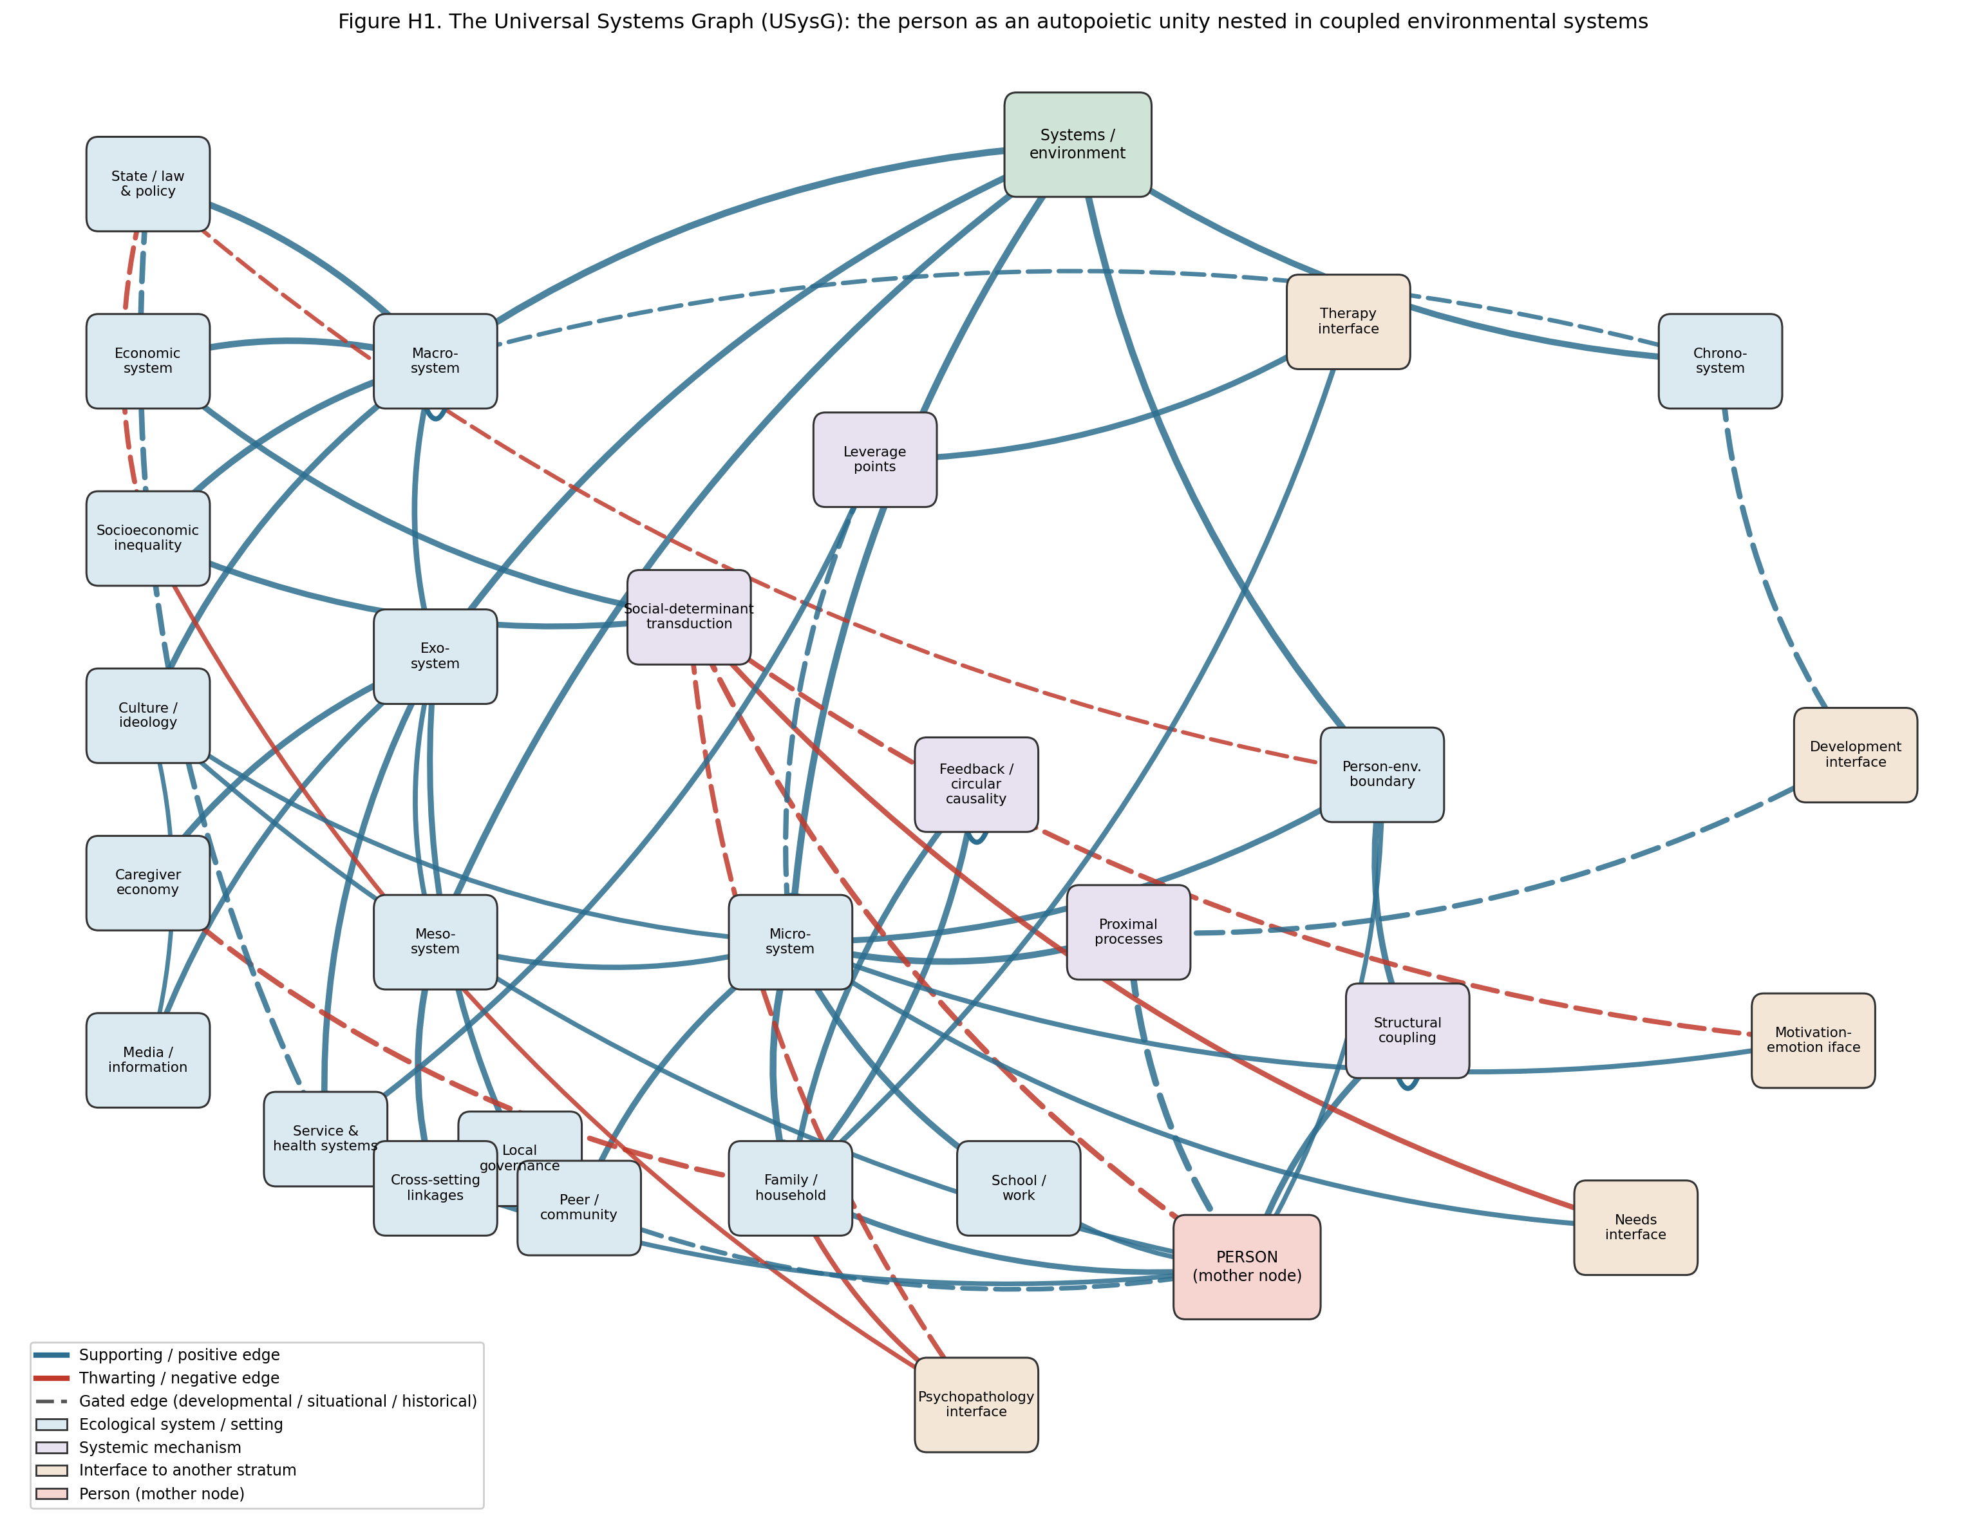
Figure H1. The Universal Systems Graph: the person as an autopoietic unity nested in coupled environmental systems. Five ecological strata (micro-, meso-, exo-, macro-, chrono-) and their facets couple to a person-model interface through five mechanisms; blue edges support and red edges thwart; dashed edges are gated by developmental, situational, or historical clocks; edge thickness is proportional to provisional consensus weight. Concentric topology is shown in Figure H4.
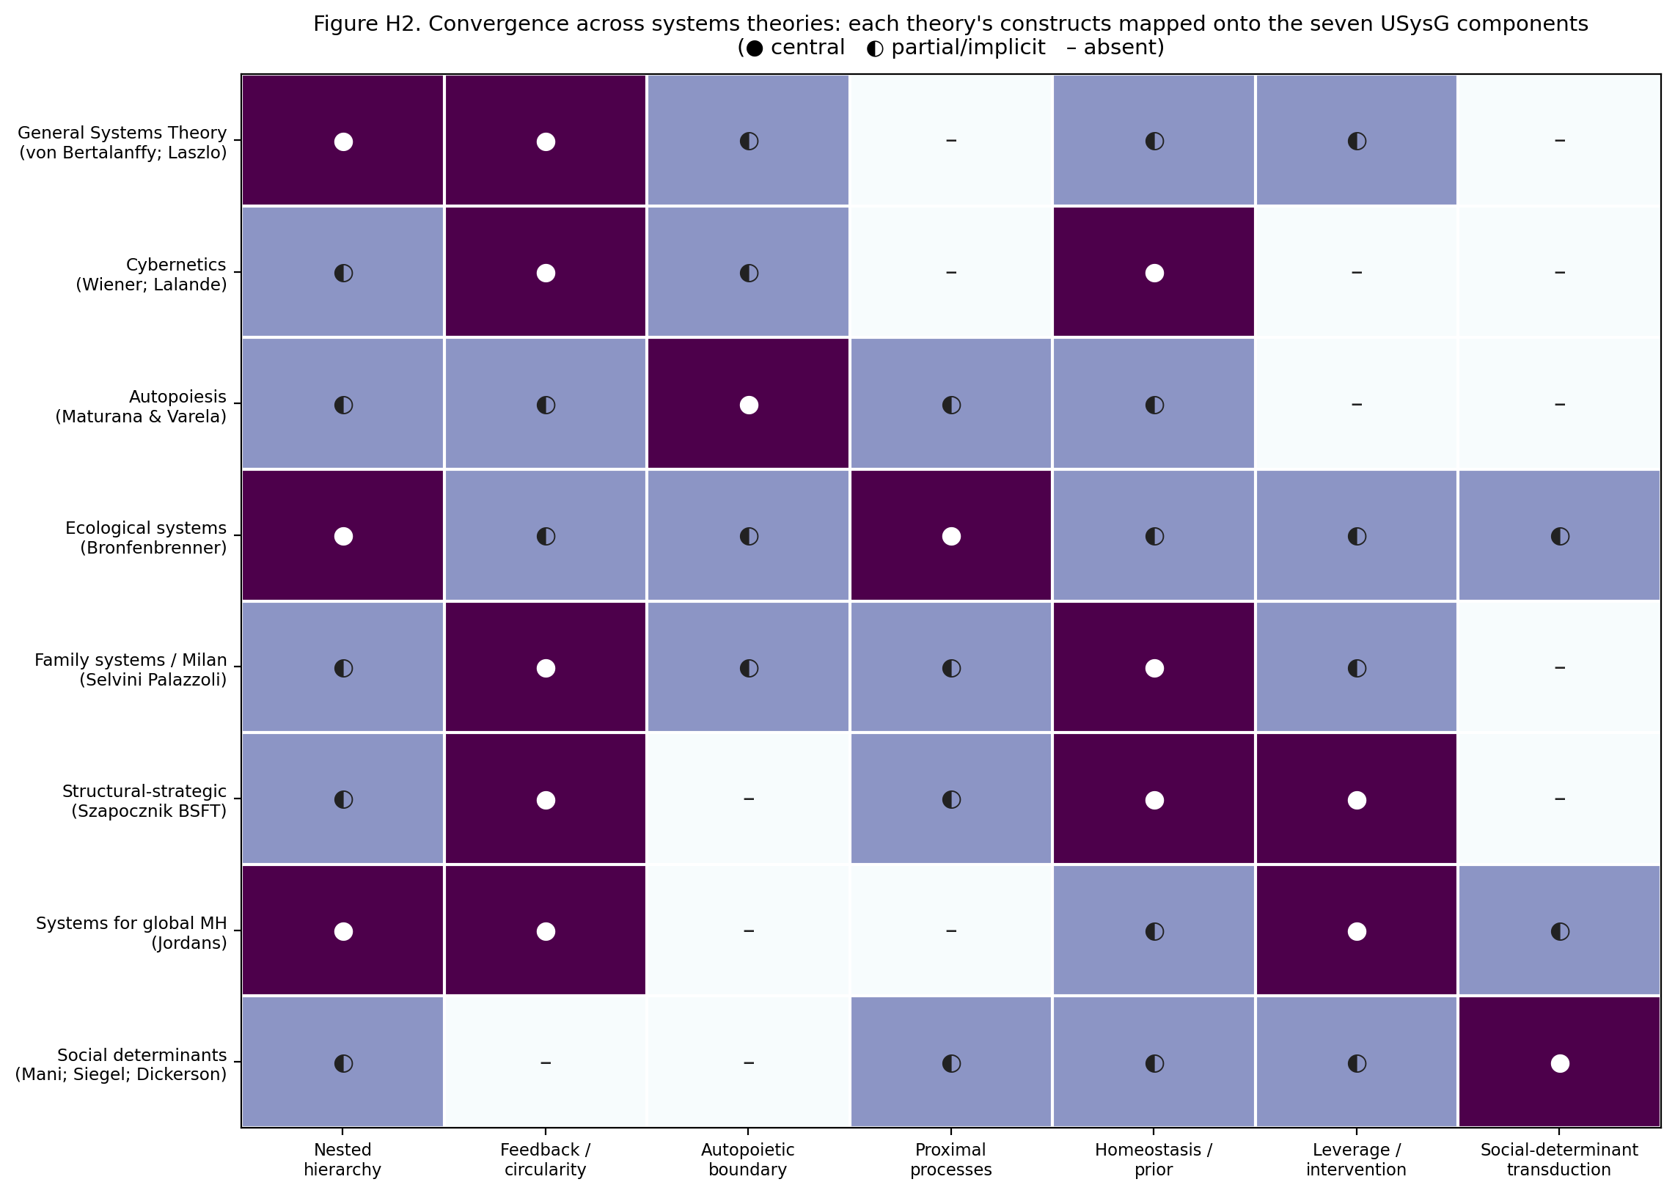
Figure H2. Convergence across systems theories: each theory’s central constructs mapped onto the seven USysG components (nested hierarchy, feedback/circularity, autopoietic boundary, proximal processes, homeostasis/prior, leverage/intervention, social-determinant transduction). Half-filled cells mark constructs that are implicit or partial in the source theory.

6.2 Axiom compliance
Axiom 1 (universal connectivity): every system reaches the person through a stratum, a mechanism, and the boundary; no node is islanded, and the person acts back on the environment through an outward edge, closing the transaction. Axiom 2 (non-dismissibility): neither the environment nor the person’s autonomy may be deleted — a person modeled without systems is a brain in a vat, and systems modeled as determining the person is behaviorism; the stratum’s whole point is coupled autonomy, and both terms are mandatory. Axiom 3 (mediated and unmediated influence): the macrosystem reaches the person both directly (culture supplies cognitive maps) and through mediating settings (macro → exo → meso → micro → person), and the state reaches mental health both directly (privacy, liberty) and through inequality — all routes are edges, and the second-order effect Bronfenbrenner made central is literally a mediated edge. Axiom 4 (self-influence): the graph carries self-loops on feedback (homeostatic self-maintenance: the family system resists change to preserve its steady state), on the macrosystem (structural reproduction: macrosystems reproduce themselves, so persistent poverty compounds), and on structural coupling (autopoietic self-production: the unity continuously regenerates its own organization) — three documented systemic dynamics (Dickerson & Popli, 2016; Maturana et al., 1974; Selvini Palazzoli et al., 1980). Axiom 5 (signed superposition): supporting and thwarting edges sum at the person-boundary, so that a supportive microsystem (a strong family, an accessible recovery home) enters with a positive sign and sums against a depriving macrosystem’s negative one — resilience and its failure become arithmetic rather than exception, and the buffering that a recovery home provides against poverty is the literal cancellation of a negative edge by a positive (Figure H3).

6.3 Subgraphs and encapsulation
Each ecological stratum owns an encapsulated facet subgraph that communicates with the rest of the model only through its stratum (mother) node — the series’ encapsulation rule. The microsystem decomposes into family (the interaction system whose homeostasis and patterns most strongly shape the person), school/work (the achievement setting), and peers/community (the affiliative setting and reservoir of social capital). The exosystem decomposes into caregiver economy, services, media, and local governance — settings that touch the person only through the settings that contain them, the caregiver-economy-to-family edge being the canonical second-order effect. The macrosystem decomposes into state, economy, inequality, and culture. The subgraphs absorb the tradition’s live disputes without destabilizing the stratum level: whether a given family’s homeostasis is pathological is a within-microsystem question, and whether a given culture’s cognitive maps are adaptive is a within-macrosystem question — neither reaches up to threaten the nested architecture. Figure H4 renders the whole as the concentric topology Bronfenbrenner intended: the autopoietic person at the center, the settings that contain them nearest, the societal blueprints outermost, and the chronosystem as the arrow of time along which every ring is redrawn.
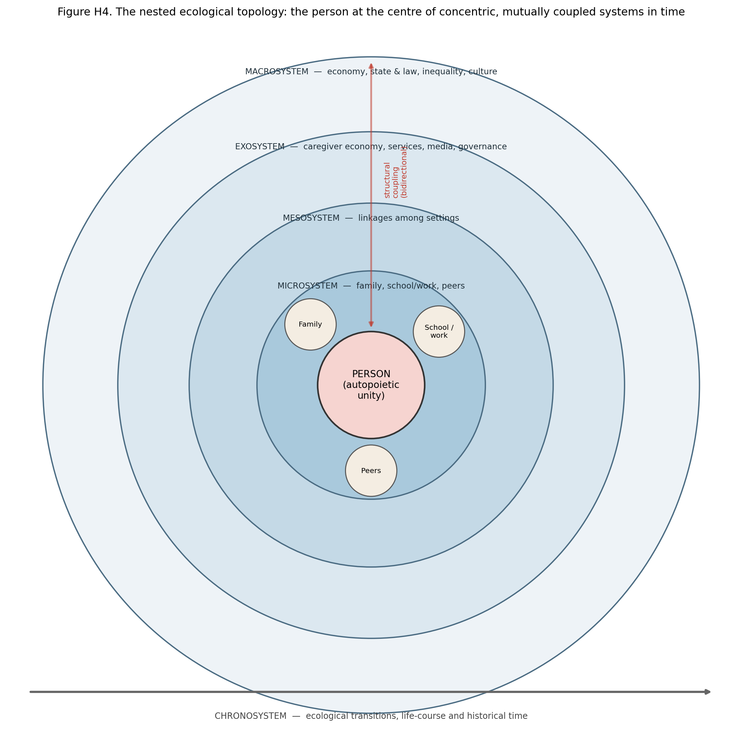
Figure H4. The nested ecological topology: the person as an autopoietic unity at the centre of concentric, mutually coupled systems — microsystem, mesosystem, exosystem, macrosystem — traversed by bidirectional structural coupling and carried through the chronosystem of life-course and historical time. After Bronfenbrenner (1977); person-boundary after Maturana et al. (1974).

6.4 The signature dynamic
Figure H3 renders the stratum’s signature dynamic as an edge-level claim: the social-determinant cascade by which macro-structure becomes individual outcome. State policy sets the inequality gradient; inequality and the economic system drive the transduction mechanism (scarcity, cognitive load, food insecurity, chronic stress); and the mechanism carries negative, developmentally gated edges to cognition (the ~13 IQ-equivalent load, cumulative in early childhood), to appraisal (scarcity capturing attention), to needs (existence and safety frustrated), and to the disorder interface (an environmental prior). The cascade is not deterministic: supportive lower systems enter the person with a positive sign and sum against it, which is the model’s formal statement of resilience (Section 6.2, Axiom 5). The dynamic corresponds to identified, weighted, testable edges in the data files, not to a fitted function.
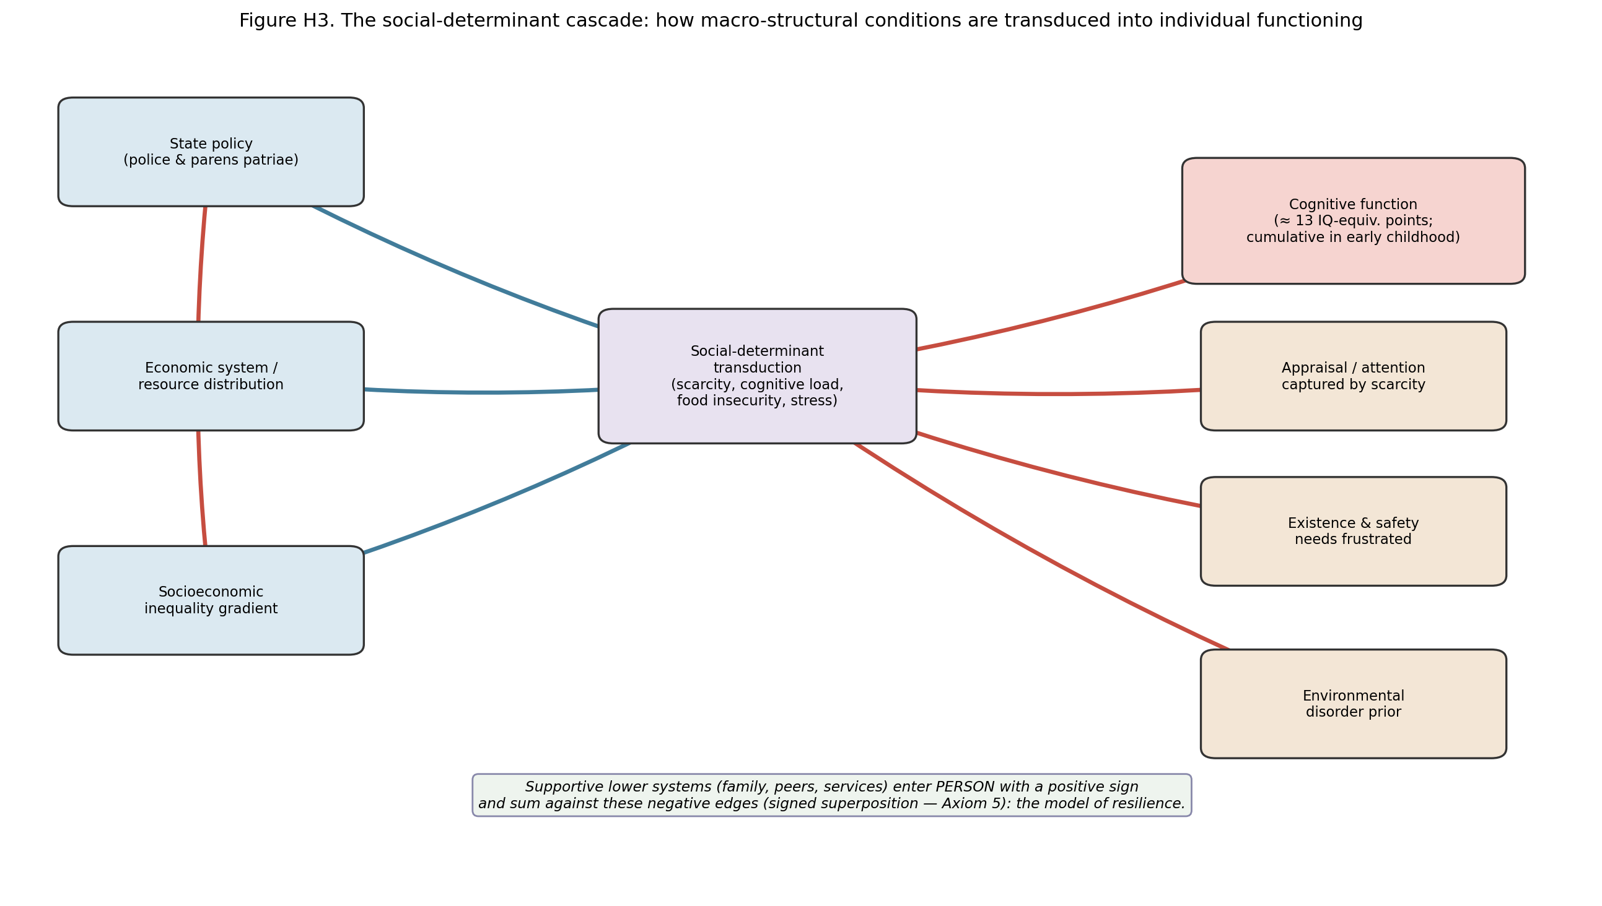
Figure H3. The social-determinant cascade: how macro-structural conditions (state policy, economy, inequality) are transduced through scarcity, cognitive load, food insecurity, and stress into individual cognition, appraisal, needs, and disorder risk. Supportive lower systems sum against these negative edges (signed superposition, Axiom 5).

6.5 Coupling to the other strata
The USysG’s interfaces define the stratum’s systemic role, and they close the loops the earlier papers left open. Inward to needs (Batch F): the environment is the field that satisfies or frustrates the needs — immediate settings supply or withhold the commodities the needs graph requires, and social-determinant deprivation frustrates the existence and safety needs directly, delivering the “environmental supports and thwarts” the needs paper predicted would arrive from this stratum. Inward to motivation–emotion (Batch G): the immediate situation is the appraised stimulus field feeding the valuation core, and scarcity’s capture of appraisal is the systems stratum acting on the motivation–emotion engine — precisely the “situation interface” the motivation–emotion paper deferred to Batch H. Inward to development (Batch C): ecological transitions and proximal processes are the environment’s contribution to development, and the developmental windows that gate this stratum’s edges are the same clocks the developmental graph defined. Outward to psychopathology (Batch A): the systems graph hands the Universal Disorder Graph a fourth and distinctively environmental class of priors — maladaptive family interaction (the designated patient), chronic socioeconomic adversity, inequality, and privacy erosion — alongside the temperamental, need-frustration, and motivational-emotional priors of the earlier strata. Outward to therapy (Batch B): the therapy interface operates through the leverage-points mechanism, and the systems graph makes explicit why the systemic therapies work — they restructure the family interaction system, and they place, at identified leverage points, the small changes that propagate through the whole (Retzlaff et al., 2013; Szapocznik et al., 2012). The person-boundary’s outward edge, finally, makes the coupling genuinely bidirectional: the person’s behavior perturbs the medium it is coupled to, so that the environment the next stratum inherits is partly the person’s own product.

6.6 What the USysG adds
Against a century in which the environment entered psychology as a stimulus or not at all, the USysG replaces “the environment” with a computable object in which each systems family survives as the component it got right: general systems theory as the nested hierarchy and emergence, cybernetics as feedback, autopoiesis as the coupled-autonomous boundary, ecological theory as the concrete topology and proximal processes, the family systems and structural–strategic traditions as the homeostatic prior and the restructuring lever, the global-mental-health family as leverage points, and the social-determinants literature as the transduction pathways and the state-as-actor claim. Against a purely intrapersonal person-model it substitutes one in which poverty, inequality, and the state are edges rather than footnotes — the difference between a model that can represent why the same disorder is more common at the bottom of the socioeconomic gradient and one that cannot. And against all of them it adds what no systems theory currently possesses: formal continuity with temperament, development, personality, needs, motivation–emotion, disorder, and treatment strata under shared axioms, making a person’s poverty, family, and polity traceable paths into a person-model rather than entries in a separate literature.

6.7 Falsifiability, validation pathway, and limitations
The USysG makes refutable commitments. Coupling: Principle 2 predicts that the same environmental perturbation produces structurally different effects across persons, and that no environmental input fully determines an outcome independent of the person’s structure; a demonstration that some environmental exposure determines an outcome invariantly, ignoring person structure, would falsify coupled autonomy (Maturana et al., 1974). Transduction and gating: Principle 5 predicts that manipulating scarcity moves cognition and appraisal (already shown experimentally) and that early-childhood exposure weights more heavily than equivalent later exposure; a finding that poverty’s cognitive effect is timing-invariant would falsify the developmental gate (Dickerson & Popli, 2016; Mani et al., 2013). Mediation: the nested architecture predicts that exosystem effects on the person are mediated by microsystem change; an unmediated exosystem-to-person effect surviving control for the immediate setting would challenge the mediation structure (Bronfenbrenner, 1977). Leverage: Principle 7 predicts that systemic interventions placed at identified leverage points outperform equivalent effort placed elsewhere, and that systemic therapy’s gains track the restructured interaction pattern (Retzlaff et al., 2013). Validation should proceed from reanalysis of existing multi-level cohort datasets (testing the mediation and gating structure), through quasi-experimental exploitation of policy changes (testing the state and inequality edges), to preregistered leverage-point intervention trials.
Four limitations bound the contribution. First, the published weights are consensus priors and the cascade figure is an illustrative structure; the transduction functions and the buffering coefficients await estimation. Second, the social-determinants evidence, though partly experimental, remains largely observational for the macro edges, and causal identification of the state and inequality effects is correspondingly weaker than for the scarcity effect (Siegel, 2008). Third, the evidence base over-represents particular contexts — WEIRD samples for some effects, specific national systems for others — and the cross-cultural generality of the facet structure (which settings count as microsystems, how the family is bounded) is an open empirical question (Fittipaldi et al., 2024). Fourth, the graph deliberately bounds “the environment” at the systems that touch the person; the biosphere, the global economy, and the deep-historical forces that Laszlo’s general evolution theory addresses are represented only through their macrosystem shadow, and a fuller model would extend the hierarchy upward.

7. Conclusion
The person the earlier strata built lives somewhere — in a family with its own homeostasis, a school and a workplace, an economy and a culture, under a state whose policies reach all the way down to the cognitive bandwidth a poor farmer has before harvest. This article extracted the century of systems theory that makes that “somewhere” a cause rather than a backdrop, as seven principles: a nested hierarchy, a coupled-autonomous person, circular causality, proximal primacy, social-determinant transduction, the state as actor, and leverage. The Universal Systems Graph formalizes all seven — a signed, gated network in which the person is an autopoietic unity structurally coupled to five nested systems, poverty and inequality are weighted edges, family dysfunction is a disorder prior, and the reappraisal a therapist teaches meets the leverage point a policy pulls. Within the Unified Person Graph it is the environment layer: the world the interior acts within and acts upon. Seven strata described a person; this one placed that person in a world. What remains is to give the whole assembly its mathematics — the computational and graph-theoretic machinery (Batch I) that lets these eight coupled graphs be composed into one Great Graph, weighted, diagnosed, and computed (Batches J–K).

References
Sources marked with an asterisk (*) were located by the authors through supplementary literature searches beyond the assembled source library.
Bronfenbrenner, U. (1977). Toward an experimental ecology of human development. American Psychologist, 32(7), 513–531. https://doi.org/10.1037/0003-066X.32.7.513
Bronfenbrenner, U. (1979). The ecology of human development: Experiments by nature and design. Harvard University Press. *
Dickerson, A., & Popli, G. K. (2016). Persistent poverty and children’s cognitive development: Evidence from the UK Millennium Cohort Study. Journal of the Royal Statistical Society: Series A (Statistics in Society), 179(2), 535–558. https://doi.org/10.1111/rssa.12128
Fittipaldi, S., Migeot, J., & Ibanez, A. (2024). Socioeconomic disparities harm social cognition. Trends in Cognitive Sciences, 28(5), 386–387. https://doi.org/10.1016/j.tics.2023.12.005
Jason, L. A., & Bobak, T. (2022). Using systems theory to improve intervention outcomes. Professional Psychology: Research and Practice, 53(4), 415–422. https://doi.org/10.1037/pro0000467
Jordans, M. J. D. (2025). Applying systems theory to global mental health. Cambridge Prisms: Global Mental Health, 12, e2. https://doi.org/10.1017/gmh.2024.147
Lalande, D., & Baumeister, R. F. (2011). Systems theories. In Psychology & behavioral health (Salem Press). [Encyclopedia entry].
Laszlo, A., & Krippner, S. (1998). Systems theories: Their origins, foundations, and development. In J. S. Jordan (Ed.), Systems theories and a priori aspects of perception (Ch. 3, pp. 47–74). Elsevier Science.
Liu, C., & Li, X. (2023). The mechanism of socioeconomic status effects on cognition. In Cognitive aging and brain health (Advances in Experimental Medicine and Biology, Vol. 1419, pp. 89–100). Springer. https://doi.org/10.1007/978-981-99-1627-6_7
Mani, A., Mullainathan, S., Shafir, E., & Zhao, J. (2013). Poverty impedes cognitive function. Science, 341(6149), 976–980. https://doi.org/10.1126/science.1238041
Maturana, H. R., Varela, F. G., & Uribe, R. (1974). Autopoiesis: The organization of living systems, its characterization and a model. BioSystems, 5(4), 187–196. https://doi.org/10.1016/0303-2647(74)90031-8
Nagpaul, T., Sidhu, D., & Chen, J. (2021). Food insecurity mediates the relationship between poverty and mental health. Journal of Poverty, 26(3), 233–249. https://doi.org/10.1080/10875549.2021.1910102
Retzlaff, R., von Sydow, K., Beher, S., Haun, M. W., & Schweitzer, J. (2013). The efficacy of systemic therapy for internalizing and other disorders of childhood and adolescence: A systematic review of 38 randomized trials. Family Process, 52(4), 619–652. https://doi.org/10.1111/famp.12041
Shah, A. K., Zhao, J., Mullainathan, S., & Shafir, E. (2018). Money in the mental lives of the poor. Social Cognition, 36(1), 4–19. https://doi.org/10.1521/soco.2018.36.1.4
Selvini Palazzoli, M., Boscolo, L., Cecchin, G., & Prata, G. (1980). Hypothesizing—circularity—neutrality: Three guidelines for the conductor of the session. Family Process, 19(1), 3–12. https://doi.org/10.1111/j.1545-5300.1980.00003.x
Siegel, A. W. (2008). Inequality, privacy, and mental health. International Journal of Law and Psychiatry, 31(2), 150–157. https://doi.org/10.1016/j.ijlp.2008.02.008
Szapocznik, J., Schwartz, S. J., Muir, J. A., & Brown, C. H. (2012). Brief strategic family therapy: An intervention to reduce adolescent risk behavior. Couple and Family Psychology: Research and Practice, 1(2), 134–145. https://doi.org/10.1037/a0029002
von Bertalanffy, L. (1968). General system theory: Foundations, development, applications. George Braziller. *

