The Formal Turn: Computational and Mathematical Psychology and the Mathematical Foundations of the Unified Person Graph
[Author 1 name], [Author 2 name]
[Affiliations]
Author note. Correspondence concerning this article should be addressed to [corresponding author]. The verification code (which reproduces every numerical example in the text), the figure-generation code, and the construct registry are openly available in the article’s supplementary repository. This article is the ninth in a planned series deriving the Unified Person Graph (UPG), an eight-dimensional network model of psychological functioning. The eight preceding substantive articles derived the Universal Disorder Graph (psychopathology), Universal Therapy Graph (treatment), Universal Developmental Graph (development), Universal Personality Graph (personality), Universal Temperament Graph (temperament), Universal Needs Graph (needs), Universal Motivation–Emotion Graph (motivation and emotion), and Universal Systems Graph (systems). Unlike those articles, this one derives no new stratum. It is the methodological keystone: a critical review of computational and mathematical psychology, and the explicit construction of the mathematical toolbox that every prior graph presupposed and the forthcoming synthesis (Batch J) will use to assemble them into one object.

Abstract
Eight strata into the Unified Person Graph, a question has gone unanswered: by what right is any of this mathematics? Every prior article represented a domain of psychology as a signed, weighted, gated graph and manipulated it as if the representation were licensed — but the licence was never issued. This article issues it. We first review the field that makes the licence possible: computational and mathematical psychology, from its 1950s origins in learning theory (Estes; Bush and Mosteller) through its three canonical modes of theory construction (stochastic modeling, the axiomatic method, functional equations), the computational metaphor and its critics, computational psychiatry’s three levels (biophysical, connectionist, algorithmic), the dynamical-systems modeling of psychotherapy (Liebovitch and colleagues; Schiepek and colleagues), the reinforcement-learning and Bayesian reformalization of therapy mechanisms (Moutoussis and colleagues), and the arrival of large language models. We synthesize what the field settled, and what it is still criticized for, relative to traditional verbal-theoretical psychology. We then build the toolbox proper — vectors and the state of a person; matrices as operators and the meaning of signed superposition; the graph Laplacian, its spectrum, and the Fiedler vector; iterated maps, fixed points, Jacobian stability, and bifurcation; Bayesian and reinforcement-learning updates; and the measurement and model-selection theory that keeps the whole enterprise honest — with small, fully reproduced worked examples throughout so that no step is a black box. Finally we discharge the central obligation: we argue, on isomorphism grounds, why a graph is the correct representation for a psychological domain, and why the formal turn yields gains in reliability, cumulativeness, and testability that verbal theory cannot; and we mark, using Gödel’s incompleteness theorems where they genuinely apply and not where they do not, the principled limit that keeps the model open rather than closed. The article is a review and a set of preliminaries; it introduces no graph, but it is the ground on which the eight graphs stand.
Keywords: mathematical psychology, computational psychiatry, network models, spectral graph theory, dynamical systems, reinforcement learning, Bayesian inference, philosophy of measurement

1. Introduction
The series has been performing a sleight of hand. Article after article took a domain of psychology — its disorders, its therapies, its developmental history — and rewrote it as a graph: nodes, signed weighted edges, gates, subgraphs, matrices multiplied and eigenvectors implied. Each article defended its content scrupulously, sourcing every edge. None defended its form. Why a graph and not a list, a taxonomy, a narrative, a regression? Why is a matrix the right container for how shame pulls on sleep? The move from psychology to mathematics was made eight times and justified zero times. This article pays the debt.
It pays it in the only way a debt like this can be paid: by first showing that there exists a mature scientific tradition in which psychology is mathematics — not decorated with statistics, but constituted as formal theory — and then by laying out, in the open, the specific mathematical objects the series has been using, so that a reader can verify that they mean what the series claimed and do what the series needed. This is therefore two things at once. It is a review (Batch I in the project plan: “a brief introduction to computational and mathematical psychology… in comparison to the traditional existing approaches”). And it is a set of mathematical preliminaries — the toolbox that the concluding synthesis will draw on when it composes the eight strata into a single Great Graph, weights its nodes, reads its topography, and turns it into a diagnostic instrument.
The distinction matters for how the article should be read. Sections 2 through 4 are the review: the field, its methods, its results, its documented weaknesses against traditional psychology. Sections 5 and 6 are the construction: the formal objects, each with a worked example small enough to check by hand and reproduced exactly by the accompanying code, followed by the justification of graph representation and an honest account of its formal limits. A reader interested only in the mathematics may begin at Section 5; a reader interested only in the field may stop at Section 4. The series needs both, because a formalism no one has justified is a formalism no reviewer should accept, and a field no one has surveyed is a claim to novelty no one can check.

2. Computational and Mathematical Psychology in Brief
Three terms are often conflated and should be separated. Mathematical psychology is a movement, born in the United States in the 1950s, defined less by its subject matter than by its approach to theory construction: it specifies theories in terms of unobservable formal constructs that predict detailed, replicable features of behavioral data across many settings (Batchelder, 2010). It is not merely “using math in psychology” — psychophysics and psychometrics did that for a century before — but the deliberate program of building psychological theory the way physics builds physical theory, as formal models with derivable consequences (Townsend, 2008). Computational psychology is the narrower thesis, inherited from the cognitive revolution, that mental processes are computations — rule-governed manipulations of symbolic representations — so that a mind can be modeled as, and sometimes literally simulated by, a program (Casey & Moran, 1989). Computational psychiatry is the youngest branch: the application of formal and computational models to mental illness, spanning biophysically detailed circuit models, connectionist network models, and abstract algorithmic models of cognition (Anticevic & Murray, 2018).
What unites them, and what the series inherits, is a single conviction: that the relations among a system’s components — not the components in isolation — are what a theory must capture, and that relations are exactly what mathematics was built to express. Mathematical psychology’s founding insight was that the information sciences that matured during the Second World War — automata theory, cybernetics, information theory, stochastic processes, linear systems theory — supplied constructs precisely fitted to psychological theory (Batchelder, 2010; Townsend, 2008). The founders were interdisciplinary by necessity: Bush a physicist, Mosteller a statistician, Estes a psychologist, Suppes a philosopher, Luce a mathematician (Batchelder, 2010). Their first models were of simple learning (Bush & Mosteller, 1951*; Estes, 1950*), and they predicted not only average learning curves but the trial-by-trial statistics of individual learners — the ambition, present from the start, to model the individual and not merely the group average.

3. The Field: A Critical Tour
Table 1 compresses the comparative analysis; Figure I1 places the branches on the single axis — degree of biophysical detail — along which computational psychiatry organizes itself, and shows the formal objects they share. The narrative highlights each family’s contribution and its documented weaknesses, because a review that only praises is not a review.
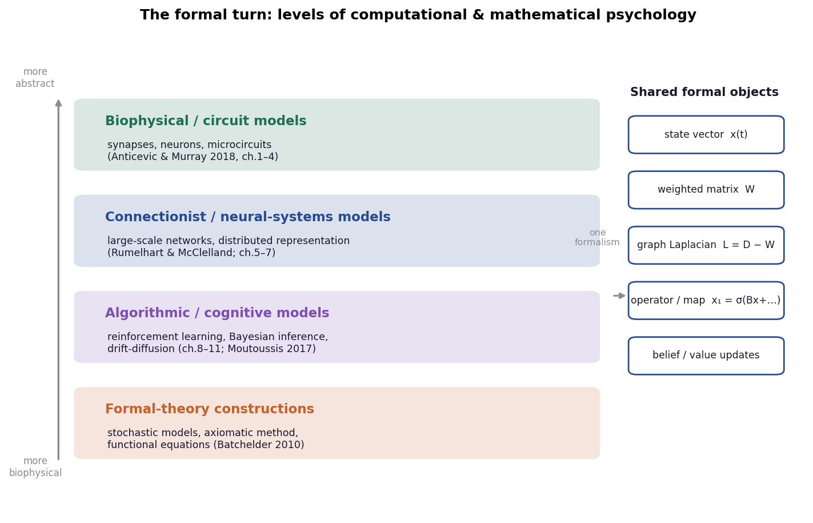
Figure I1. The formal turn, as levels of abstraction. Computational and mathematical psychology arranges its model families along a single axis running from biophysically detailed circuit models to abstract formal-theory constructions; all four levels are expressed through the same small set of formal objects — a state vector, a weighted matrix, the graph Laplacian, an iterated map, and belief/value updates — which are the objects built in Section 5.
Table 1. Families of computational and mathematical psychology: logic, contribution, and documented weaknesses.
Family | Exemplary figures | Core logic | Chief contribution to the universal architecture | Chief documented weaknesses
Mathematical psychology (formal theory) | Estes; Luce; Suppes; Townsend; Batchelder | Specify theory as formal constructs predicting detailed data; three modes — stochastic, axiomatic, functional-equation | The discipline of formal theory itself; measurement foundations; model selection | Narrow topical reach; algebraic axioms lack error theory; field small and shrinking
Computational metaphor / classical cognitivism | Newell; Simon; Fodor; Pylyshyn | Mind is rule-governed symbol manipulation; cognition is computation | Explicitness; the “runnable model” as a test of sufficiency | Symbol grounding (“original meaning”); neglect of body, affect, individual differences
Connectionism / PDP | Rumelhart; McClelland | Cognition emerges from weighted activation across neuron-like units; learning = weight change | The weighted network as a cognitive substrate; graceful degradation; distributed representation | Inscrutability of hidden layers; identifiability; weak on structured/serial reasoning
Computational psychiatry (three levels) | Anticevic; Murray; Huys; Frank; Montague | Bridge levels from synapse to symptom with explicit models; fit parameters to individuals | Multilevel integration; computational phenotyping; simulated treatment | Simple behavioral repertoire; group-level focus; still research-grade
Dynamical-systems modeling of therapy | Liebovitch; Gottman; Schiepek; Aas; Viol | Therapy is a coupled nonlinear dynamical system; outcomes are attractors and phase transitions | Attractors, stability, bifurcation as clinical objects; the “black-hole” endpoint | Influence functions partly speculative; hard to estimate; validation thin
Learning-based / RL & Bayesian therapy | Moutoussis; Dolan; Hauser | Belief updating and reinforcement learning formalize CBT mechanisms | Bayesian belief update; avoidance as blocked extinction; overaccommodation | Reductive risk; parameters hard to identify in real therapy
Computational psychotherapy / NLP | Imel; Steyvers; Atkins; Cioffi | The therapy transcript is data; mine it at scale with topic models and networks | Scaling up process research; graph and network methods on real sessions | Correlational; measurement validity of learned features uncertain
Generative AI / LLMs | Demszky; and the wider field | Language models operate over psychological language at scale | Measurement, generation, simulation of language data; the “trainable agent” horizon | No human-like cognition; bias; opacity; unreliable for autonomous clinical use

3.1 Mathematical psychology and its three modes of theory construction
The most durable bequest of mathematical psychology is not any single model but its taxonomy of how to build one. Batchelder (2010) identifies three modes. Stochastic modeling specifies probabilistic mechanisms with substantive interpretations that predict detailed data patterns; its natural data structure is a participant-by-item random matrix $X=(X_{ij})$, where $X_{ij}$ is participant $i$’s response to item-event $j$ — already a matrix at the foundation of the field. The axiomatic method captures assumptions as formal axioms and derives their joint consequences as theorems, each ideally falsifiable, so that when a prediction fails the failure can be localized to an axiom (Batchelder, 2010). The functional-equations approach postulates constraints on the form of a relationship — invariances under trade-offs or admissible rescalings — and derives the family of all functions satisfying them. The series uses all three: its edges are stochastic quantities awaiting estimation, its five axioms are exactly an axiomatic scaffold, and its insistence that weights be invariant under gauge-like rescaling is a functional-equation constraint.
The documented weaknesses are real and the field states them itself. Mathematical psychology’s topical reach has stayed narrow — memory, choice, psychophysics, decision — and it has struggled to colonize clinical, social, and developmental psychology (Townsend, 2008). Its algebraic axioms often lack an error theory, making it hard to decide whether data satisfy them (Batchelder, 2010). And the field is small and, by Townsend’s (2008) worried account, shrinking, as quantitatively trained psychologists become scarce even while quantitatively trained outsiders — physicists, computer scientists — flood into psychology’s former territory. The series is, in one sense, an attempt to do what Townsend hoped for: bring the formal-theory discipline to bear on the clinical, developmental, and personality domains it never reached.

3.2 The computational metaphor and its critics
The cognitive revolution ran on an analogy: the mind is to the brain as the program is to the computer (Casey & Moran, 1989). The metaphor’s methodological gift was rigor by compulsion — a theory you must implement as a running program cannot hide its gaps, because a program with a gap does not run; the “runnable model” became a criterion of sufficiency (Casey & Moran, 1989). Its permanent liability is the symbol-grounding or “original meaning” problem, sharpened by Searle’s Chinese Room and Fodor’s methodological solipsism: a formal system that manipulates symbols by their shape has, in itself, no account of how those symbols come to mean anything about the world (Casey & Moran, 1989). Connectionism — parallel distributed processing — arrived as the “new wave,” replacing the single-symbol-per-concept assumption with concepts as patterns of activation across weighted networks of neuron-like units, learning by weight adjustment, and exhibiting graceful degradation and automatic generalization (Casey & Moran, 1989). This is the deepest root of the series’ choice of representation: the connectionist claim that psychological content lives in the weights of a network is precisely the claim the eight strata operationalize. But the critics’ point survives the move: a weighted network models relations, not meanings, and the series must therefore keep its nodes tied to measurable, interpretable constructs rather than letting them float as uninterpreted units — a discipline the base framework builds in by insisting that nodes remain “clinically recognizable.”

3.3 Computational psychiatry: three levels of one enterprise
Anticevic and Murray (2018) organize computational psychiatry into three levels, arranged in Figure I1 by biophysical detail. Biophysically based circuit models are constrained by the real physiology of synapses and neurons and are suited to synapse-level hypotheses and pharmacological comparison — able, for instance, to estimate the computational impact of a receptor manipulation in a modeled human circuit that could not be studied in a human. Connectionist / neural-systems models use more abstract units but a systems-level architecture, bridging low-level circuit properties and higher-level behavior, and interfacing naturally with neuroimaging. Algorithmic models formalize the computations underlying cognition — reinforcement learning, Bayesian inference, evidence accumulation — often via normative accounts that define optimal task performance and the constraints that limit it. The volume’s ambition, computational phenotyping, is directly the series’ ambition transposed: fit a model’s parameters to a single patient so those parameters carry diagnostic value, managing the “remarkable heterogeneity” that cuts across DSM categories and motivates dimensional alternatives such as RDoC (Anticevic & Murray, 2018). Érdi and colleagues (2017) supply the complementary dynamical-systems vocabulary — attractors, basins of attraction, multistability, bifurcation, eigenvalues of the linearized system — in which a seizure, or by extension a mood episode, is a phase transition of a high-dimensional dynamical system. The documented weakness is candidly stated in the source: current models capture a very limited behavioral repertoire, focus on group effects, and remain research-grade rather than clinic-ready (Anticevic & Murray, 2018).

3.4 Dynamical-systems models of psychotherapy
Two source models show the formal turn reaching the consulting room. Liebovitch and colleagues (2011) model the therapist–client emotional interaction as two coupled ordinary differential equations,
$$\frac{dT}{dt}=m_{1}T+b_{1}+c_{1}F_{C}(C), \frac{dC}{dt}=m_{2}C+b_{2}+c_{2}F_{T}(T),$$
where $T$ and $C$ are the emotional valences of therapist and client, $m$ are inertias, $b$ the uninfluenced set-points, $c$ the coupling strengths, and $F$ the (piecewise-linear) influence functions. The model’s critical points are the possible endpoints of therapy; one of them is a stable negative–negative state the authors vividly call a “black hole… from which the therapeutic relationship dies” (Liebovitch et al., 2011). Schiepek and colleagues (2016) go further, modeling the client as five coupled nonlinear difference equations in state variables $P$ (problem/symptom severity), $S$ (success/progress), $M$ (motivation), $E$ (emotions), and $I$ (insight), their sixteen connecting functions shaped by four trait-like control parameters — working alliance, mentalization/emotion regulation, resources, self-efficacy — that play, in the language of synergetics, the role of order-inducing control parameters whose slow change triggers discontinuous phase transitions in the fast dynamics. Both models bequeath to the series exactly the objects Section 5.4 formalizes: attractors as clinical states, stability as prognosis, and bifurcation as the mathematics of sudden gains and sudden losses. Both also disclose the weakness the series must respect: the influence functions and control parameters are “somewhat speculative,” empirically constrained but not yet estimated (Liebovitch et al., 2011; Schiepek et al., 2016) — which is why the series labels its own weights consensus priors awaiting estimation.

3.5 The learning-based reformalization: reinforcement learning and Bayesian inference
Moutoussis and colleagues (2017) provide the tightest bridge from computation to therapy mechanism. They recast cognitive-behavioral and mentalization-based therapies in the vocabulary of Bayesian inference and reinforcement learning: a maladaptive belief is a probability distribution over models of the world; a behavioral experiment is a Bayesian update in which disconfirming evidence shifts a prior; avoidance is a control policy that, by keeping the agent out of the feared state, denies the learner the very experience that would extinguish the fear — “avoidance blocks learning”; and overaccommodation is their proposed mechanism of therapy failure, in which a patient attributes therapeutic gains to the therapist rather than updating the underlying self-model, so that improvement does not generalize to real life. These are not metaphors laid over therapy but formal claims with testable parameters, and they hand the series its Section 5.5 tools — belief update and temporal-difference learning — together with a specific, mechanistic set of disorder-and-therapy edges. The complementary empirical wing, computational psychotherapy, treats the session transcript itself as data: Imel and colleagues (2015) use topic models to discover clinically meaningful content in 1,553 transcripts and to classify therapy type with high accuracy, answering Meehl’s decades-old call for a “souped-up mathematics” of the therapy protocol; Cioffi and colleagues (2022), reviewing the field, place graph theory, neural networks, and machine learning at its center. The documented weakness across this family is reductiveness and identifiability — rich clinical processes compressed into a few parameters that may be hard to estimate reliably from real, sparse, noisy clinical data (Moutoussis et al., 2017; Cioffi et al., 2022).

3.6 Generative AI and the trainable agent
The newest family is the one the project’s own axioms invoke. Demszky and colleagues (2023) survey how large language models can transform psychological measurement, experimentation, and practice by operating over language — the medium of all psychology — at unprecedented scale, while warning, emphatically, that these models generate human-like output without human-like thinking or feeling, carry bias, and are opaque in ways that make autonomous clinical use premature. The editorial framing agrees: the promise of language-based mental-health services is real, but “the outputs of current large language models are too unpredictable for this application without human intervention” (Nature Reviews Psychology, 2025). This family matters to the series for a specific reason stated in the project’s own requirements: the end-model should be trainable — axiomatic and consistent enough that an agent instantiated on it would return the same formulation for the same case. Section 6 argues that this is achievable precisely because the model is a formal graph with explicit weights and rules rather than a verbal theory, but Section 6.3 also marks, via Gödel, why “trainable and consistent” must be the target rather than “trainable and complete.”

4. What the Field Settled — and What Traditional Psychology Still Charges Against It
Two conclusions are robust across the sources, and the series rests on both. The first is that relations, formalized, are the proper object of psychological theory: from the participant-by-item matrix at the foundation of mathematical psychology (Batchelder, 2010), through the weighted activation networks of connectionism (Casey & Moran, 1989), to the coupled differential equations of psychotherapy dynamics (Liebovitch et al., 2011; Schiepek et al., 2016) and the symptom networks of computational psychiatry (Anticevic & Murray, 2018), the field converges on the view that psychological phenomena are patterns of interaction best written as matrices, graphs, and the operators that act on them. The second is that formalization pays in cumulativeness and testability: a formal model exposes its assumptions, localizes its failures, forces sufficiency, and can be compared quantitatively against rivals with explicit protection against overfitting (Batchelder, 2010; Townsend, 2008).
The charges from traditional, verbal-theoretical psychology are equally documented, and a publishable synthesis must answer rather than ignore them. The first charge is over-idealization: a model precise enough to run may be too simple to be true, capturing “little decisions just to get the program to run” that are psychologically uninteresting (Casey & Moran, 1989). The second is neglect of the person: early computational models were “theories of pure reason,” slighting the body, emotion, motivation, and individual differences (Casey & Moran, 1989) — the very domains the series’ temperament, needs, motivation–emotion, and personality strata were built to restore. The third is identifiability and reliability: distinct models can predict the same data (Townsend, 2008), and person-specific network estimates can be unstable in realistic clinical sampling (base framework). The fourth is scope: the field has historically modeled narrow laboratory tasks, not whole persons across the lifespan and the full range of typical and atypical functioning. The series’ entire design is a response to these four charges — restoring the person by giving affect, need, and temperament their own strata; controlling identifiability by fixing structure from theory and sourcing every weight; and extending scope from a task to a person by composing eight domains into one object. Whether that response succeeds is the burden of Batch J’s validity analysis; this article’s burden is only to show that the tools the response uses are sound.

5. The Toolbox: Mathematical Preliminaries with Worked Examples
We now build, in the open, the machinery the series has used and the synthesis will use. Each construct is defined, motivated by a modeling need, and illustrated with a worked example small enough to check by hand; the accompanying code reproduces every number printed here. Figure I4 maps the tools onto the needs. Notation follows the base framework and the earlier strata: a person’s psychology is a graph $G=(V,W)$ with node set $V$ and a signed, weighted, possibly time-gated adjacency matrix $W$.
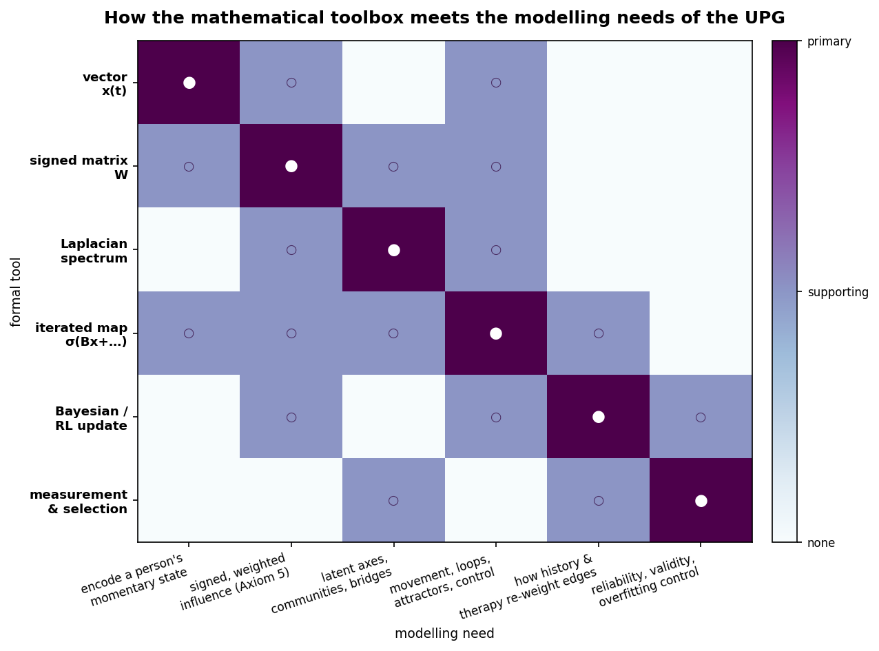
Figure I4. How the mathematical toolbox meets the modelling needs of the Unified Person Graph. Each formal tool (rows) is matched to the modelling needs it serves (columns); filled markers denote the primary tool for a need, open markers a supporting role. The near-diagonal structure shows that the six tools of Section 5 are collectively sufficient — and individually necessary — for the operations the eight strata and the forthcoming synthesis require.

5.1 Vectors: the state of a person
The most basic object is the state vector. If a person’s psychology is described by $n$ nodes — symptoms, traits, needs, affects, settings — then their momentary condition is a point
$$x(t)∈R^{n}, x(t)_{i}=\text{current intensity/activation of node }i.$$
A vector is not a list; it is a location in an $n$-dimensional space, and that is exactly what a psychological state is — a position, from which one can measure distance to another state, direction of movement, and speed. The clinical questions “where is this person?” and “which way are they moving, and how fast?” become $x(t)$, the difference $Δx(t)=x(t)−x(t−1)$, and its norm $∥Δx(t)∥_{2}$ (base framework). The whole series depends on this first move: the moment a person’s condition is a vector, every operation of linear algebra becomes available to psychology.

5.2 Matrices as operators, and the meaning of signed superposition
A matrix is a machine that turns vectors into vectors. The weighted adjacency matrix $W$ is the machine that turns the current state into the influence each node currently exerts on every other. Entry $W_{ij}$ is the signed weight of the edge from node $j$ to node $i$: positive if $j$ reinforces $i$, negative if $j$ weakens it — the sign that lets a single formalism carry both risk and protection (the series’ Axiom 5, signed superposition). The net drive arriving at each node is the matrix–vector product $Wx(t)$, and its $i$-th component,
(Wx)i=j​Wij xj,
is exactly the axiom’s content: the influences converging on a node sum, with reinforcing and weakening inputs adding and subtracting through the connecting edges.
Worked example. Take three nodes — rumination, insomnia, and (protective) social contact — with
$$W=\left(\begin{matrix}0 & 0.6 & −0.4 \\ 0.5 & 0 & −0.3 \\ −0.2 & −0.1 & 0\end{matrix}\right), x=\left(\begin{matrix}0.8 \\ 0.6 \\ 0.3\end{matrix}\right).$$
Then $Wx=(0.24, 0.31, −0.22)^{⊤}$. Rumination receives a net positive drive of $0.24$: insomnia contributes $W_{12}x_{2}=0.6×0.6=+0.36$, while social contact subtracts $W_{13}x_{3}=−0.4×0.3=−0.12$. This is what a clinician means by “rumination is being pushed by poor sleep and only partly buffered by social contact” — now an arithmetic fact, not a turn of phrase. Every “pulling edge” report in the series is one term $W_{ij}x_{j}$ of such a sum.

5.3 Graph theory: the Laplacian, its spectrum, and the Fiedler vector
Given a symmetric weight matrix $W$ (couplings, taken undirected for this purpose), define the degree matrix D=diag​(j​Wij) and the graph Laplacian
$$L=D−W.$$
The Laplacian is the central object of spectral graph theory because its eigenvalues and eigenvectors encode the graph’s global shape. Its smallest eigenvalue is always $λ_{1}=0$ (with the constant eigenvector); the second-smallest, $λ_{2}$, is Fiedler’s algebraic connectivity, which is zero if and only if the graph splits into disconnected pieces, and whose eigenvector $v_{2}$ — the Fiedler vector — gives each node a coordinate whose sign sorts the graph into its two most natural communities and whose magnitude measures distance from the boundary between them (Fiedler, 1973*; von Luxburg, 2007*). The first few nonzero eigenvectors together give a low-dimensional embedding $ϕ(i)=(v_{2}(i),v_{3}(i),…)$ that preserves local structure (Belkin & Niyogi, 2003*). In the series these are not clustering coordinates but learned clinical axes: the deep dimensions along which a domain’s nodes actually organize, recovered from the edges rather than imposed by a theorist.
Worked example. Consider six nodes in two loosely-joined triangles — $\{n_{1},n_{2},n_{3}\}$ and $\{n_{4},n_{5},n_{6}\}$ — with strong within-triangle weights ($0.7$–$0.9$) and a single weak bridge $W_{34}=0.2$ (Figure I2a). Computing $L=D−W$ and its spectrum gives eigenvalues $(0, 0.119, 2.227, 2.372, 2.573, 2.709)$. The near-zero gap $λ_{2}=0.119$ correctly signals a graph that is almost two graphs. The Fiedler vector is
$$v_{2}=(−0.428, −0.431, −0.362, +0.364, +0.426, +0.431),$$
whose sign cleanly partitions the two communities (Figure I2b), and whose smallest-magnitude entries, $|v_{2}(n_{3})|=0.362$ and $|v_{2}(n_{4})|=0.364$, correctly identify the two bridge nodes sitting on the fault line. This is the exact mechanism by which the series proposes to find a person’s deepest axes of psychopathology and the bridge symptoms that connect syndromes — and it is fully reproducible arithmetic, not intuition. (For degree-heterogeneous graphs the normalized Laplacian $L_{\text{sym}}=I−D^{−1/2}WD^{−1/2}$ is preferred, for reasons the base framework details; on this example it yields the same partition.)
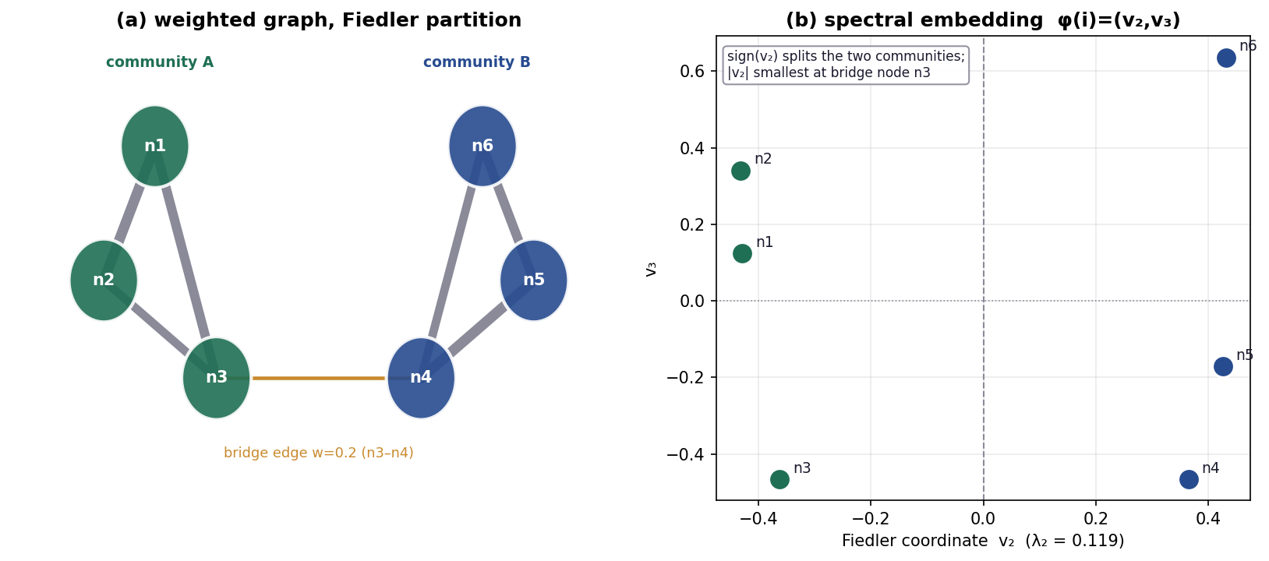
Figure I2. A worked spectral example. (a) A six-node weighted graph of two loosely-joined communities with a single weak bridge edge (n3–n4, $w=0.2$); node colour shows the sign of the Fiedler coordinate. (b) The spectral embedding $ϕ(i)=(v_{2},v_{3})$: the sign of the Fiedler vector $v_{2}$ (associated with $λ_{2}=0.119$) partitions the two communities, while the smallest $|v_{2}|$ values fall on the bridge nodes. All numbers are reproduced by the verification code.

5.4 Dynamical systems: movement, attractors, stability, and bifurcation
A person is not static, so the state must evolve. The series writes the update as an iterated map,
$$x(t+1)=σ​(B x(t)+C c(t)+G u(t)+ε(t)),$$
where $B$ is the temporal influence operator (who pulls whom, over one step), $c$ is context, $u$ is intervention or endogenous control, $σ$ is either the identity (linear regime) or a saturating nonlinearity such as $\text{tanh}$ (bounded states), and $ε$ is noise (base framework; Schiepek et al., 2016). Three notions govern such a system. A fixed point (attractor) is a state that reproduces itself, $x^{⋆}=σ(Bx^{⋆}+…)$ — the formal home of the claim that a disorder can be a self-maintaining state rather than a symptom count (Hopfield, 1982*; base framework). Its stability is read from the Jacobian: for a linear map the Jacobian is $B$ itself, and the fixed point is locally attracting exactly when the spectral radius $ρ(B)<1$ (Érdi et al., 2017). A bifurcation is a qualitative change in the number or stability of fixed points as a control parameter crosses a critical value — the mathematics of a phase transition, and hence of sudden clinical change (Schiepek et al., 2016; Érdi et al., 2017).
Worked example (stable state). Let
$$B=\left(\begin{matrix}0.5 & 0.4 \\ 0.3 & 0.2\end{matrix}\right), b=\left(\begin{matrix}0.1 \\ 0.2\end{matrix}\right),$$
with $σ=\text{identity}$, so $x(t+1)=Bx(t)+b$. The fixed point is $x^{⋆}=(I−B)^{−1}b=(0.571, 0.464)^{⊤}$. The eigenvalues of $B$ are $(0.727, −0.028)$, so $ρ(B)=0.727<1$ and the point is stable; iterating from any start converges to it (Figure I3a), which the code confirms numerically. This is a well-regulated coupling: perturbations decay.
Worked example (bifurcation into a disorder). Now let a symmetric self-maintaining loop have gain $g$, with dynamics $x^{⋆}=\text{tanh}(g x^{⋆})$. For $g≤1$ the only fixed point is $x^{⋆}=0$ (the healthy, quiescent state), and it is stable. As $g$ crosses the critical value $g=1$, that point loses stability and two new stable fixed points appear symmetrically — a pitchfork bifurcation (Figure I3b). The interpretation is exact and clinically pointed: when a reinforcing loop’s gain crosses a threshold, a system that previously always returned to baseline acquires two self-sustaining “disorder” attractors it can fall into and stay in. This is Borsboom’s alternative-stable-states hypothesis (Borsboom, 2017*) rendered as a bifurcation, and it is why the series treats disorders as basins to be exited by controlled transition rather than as tallies to be reduced.
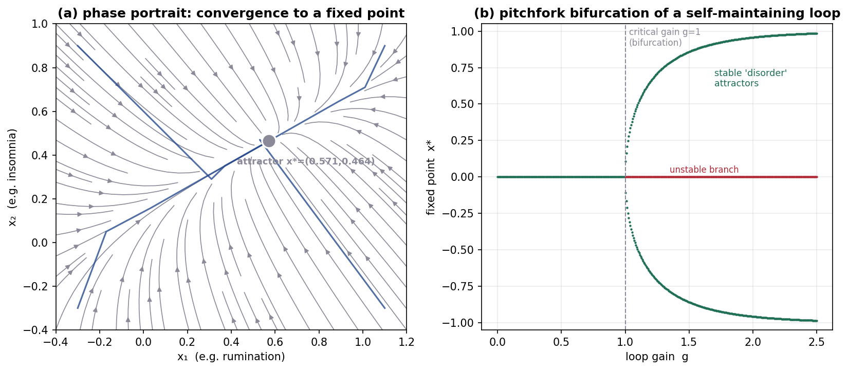
Figure I3. Dynamical-systems tools. (a) Phase portrait of the stable linear system $x(t+1)=Bx(t)+b$ with $ρ(B)=0.727<1$: trajectories from any starting point converge to the single attractor $x^{⋆}=(0.571,0.464)$. (b) Pitchfork bifurcation of a self-maintaining loop $x^{⋆}=\text{tanh}(g x^{⋆})$: below the critical gain $g=1$ only the quiescent state is stable; above it, two stable “disorder” attractors appear (green) while the baseline becomes unstable (red) — self-maintaining psychopathology as a phase transition.

5.5 Bayesian inference and reinforcement learning: how beliefs and values change
Two more tools formalize how a person learns — and therefore how development writes the weights and how therapy rewrites them. Bayesian updating revises a belief (a probability distribution) in light of evidence: posterior $∝$ likelihood $×$ prior (Moutoussis et al., 2017). Modeling a maladaptive belief as a Beta distribution makes a behavioral experiment computable.
Worked example. A socially anxious patient holds the strong prior that coffee-shop patrons are well-dressed and judgmental — encode it as $\text{Beta}(8,2)$, mean $\text{Pr}(\text{mocked})=0.80$. She then observes 20 patrons, none of whom mock her (20 disconfirming events), updating to $\text{Beta}(8,22)$, mean $0.27$ — a belief shift of $0.53$ from a single hour of evidence. The behavioral experiment is not persuasion; it is arithmetic on a posterior.
Reinforcement learning revises the value of a state through prediction error. The temporal-difference rule is
$$V(s)←V(s)+α(r+γV(s′)−V(s)),$$
with learning rate $α$ and discount $γ$ (Moutoussis et al., 2017; Sutton & Barto, 2018*).
Worked example (exposure vs. avoidance). A feared state $s_{2}$ carries a cached value of $−0.8$ from prior avoidance learning. Under exposure with response prevention ($α=0.3$, $γ=0.9$), the patient repeatedly visits $s_{2}$ and finds it safe; the value climbs $−0.8→−0.56→−0.39→−0.27→−0.19→−0.13→−0.09$ across six trials — extinction, as an explicit trajectory. Under continued avoidance, the agent never enters $s_{2}$, no prediction error is ever generated, and the value stays pinned at $−0.8$: “avoidance blocks learning” (Moutoussis et al., 2017), now visibly because an unvisited state is an unupdated one. These two rules are how the series’ developmental stratum sets the other strata’s weights and how its therapy stratum changes them.

5.6 Measurement and model selection: keeping the formalism honest
A formalism can be precise and still be nonsense if its numbers do not measure anything or if it fits noise. Two guardrails from mathematical psychology apply. Measurement theory asks what transformations a scale admits and which statements about it are meaningful — invariant under those admissible transformations (Townsend, 2008; Batchelder, 2010); the series’ weights, defined on a signed $[−1,1]$ scale with a stated interpretation, must respect this, and claims about them must be invariant under the scale’s admissible rescalings. Model selection guards against overfitting by penalizing not only the number of free parameters but the functional flexibility of the model, so that a model is not credited for fitting unmodeled noise (Batchelder, 2010). This is why the series fixes graph structure from theory and sources every weight, rather than freely estimating a dense matrix that could fit anything: a model that can fit anything explains nothing, and the discipline of consensus priors is the series’ overfitting control.

6. Why a Graph? The Justification, and Its Formal Limit

6.1 The isomorphism argument
The debt named in Section 1 can now be paid. The justification for representing a psychological domain as a signed, weighted, gated graph is neither aesthetic nor merely convenient; it is an isomorphism claim. A representation is adequate to a subject when the structure of the representation matches the structure of the subject — when the operations one can perform on the representation correspond to real relations in the thing represented (Casey & Moran, 1989; Townsend, 2008). The empirical sciences of the mind have converged, from independent directions, on a single description of that structure: psychological phenomena are (i) many interacting components, (ii) whose interactions are directed and signed — some reinforcing, some inhibiting, (iii) weighted by strength, (iv) time-varying as development and situation change them, and (v) productive of emergent, self-maintaining states no single component contains. This is not one theory’s picture; it is the shared finding of connectionism (weighted activation networks; Casey & Moran, 1989), symptom-network psychiatry and its alternative stable states (Borsboom, 2017*), dynamical-systems psychotherapy (attractors and bifurcations; Liebovitch et al., 2011; Schiepek et al., 2016), and computational psychiatry (Anticevic & Murray, 2018).
Now observe: a signed, weighted, time-gated graph is the mathematical object whose structure is exactly those five properties and no more. Its nodes are the many components; its signed weights are the directed reinforcing/inhibiting interactions; its edge magnitudes are the strengths; its gates $w_{ij}(t)=g_{ij}(t) {\overset{‾}{w}}_{ij}$ are the time-variation; and its attractors are the emergent self-maintaining states. The match is one-to-one. That is what licenses the representation: not that graphs are useful, but that a graph has precisely the structure the phenomenon has been independently shown to have. A list cannot represent directed influence; a taxonomy cannot represent signed superposition; a single regression cannot represent self-maintaining loops; a narrative cannot be eigendecomposed to reveal latent axes. The graph can, because the graph is the isomorph. This is also why the series can claim to “model the actual phenomena rather than making reality fit the model” (project requirement 15): the formalism was chosen to have the phenomenon’s structure, not the reverse.

6.2 The reliability and validity dividend
Beyond isomorphism, the formal turn buys measurable epistemic goods that verbal theory cannot, and these preview Batch J’s validity analysis. Because the representation is explicit, it is reproducible: every node and edge is published with its weight, sign, type, gate, and source, so any group can re-derive the model and any critic can locate a disagreement in a specific edge rather than in a cloud of prose (project requirements 17, 21). Because it is formal, it is falsifiable in the axiomatic sense: a failed prediction can be traced to an axiom or an edge (Batchelder, 2010). Because it is quantitative, rival versions can be compared with explicit overfitting control (Batchelder, 2010). And because it is computable, it is trainable: an agent instantiated on the model — the project’s stated aspiration — will, given the same case and the same rules, return the same formulation, because the formulation is the output of a fixed function on the inputs, not an act of interpretation. Verbal theories possess none of these properties reliably; two clinicians sharing a verbal theory routinely disagree, and neither their theory nor their disagreement is re-derivable. The series’ central methodological wager is that these dividends are worth the cost of idealization the critics name (Section 4) — a wager the field’s own trajectory, from verbal schools toward formal models, has already largely endorsed (Townsend, 2008).

6.3 The formal limit: what Gödel does and does not license
Honesty about a formal model requires marking where formalization itself reaches a principled limit, and here Gödel’s incompleteness theorems apply — but only if used precisely rather than as decoration. Gödel (1931*) proved that any consistent formal system rich enough to express elementary arithmetic contains true statements it cannot prove, and cannot prove its own consistency from within. The theorems are about formal axiomatic systems of a certain expressive power; they are not a general license to invoke “incompleteness” wherever a theory is incomplete in the ordinary sense, and the series does not so misuse them.
Where the analogy is genuine is this. The project asks for a model that is at once complete (models “all the actual phenomena”), consistent (non-contradictory across its axioms), and closed enough to be trainable (an agent returns fixed answers). Gödel’s result is the reason these three cannot be maximized simultaneously by a single fixed axiomatization: a formal system expressive enough to represent a self-modeling agent — a person who models themselves, and whose “human will” the base framework represents as an endogenous control input the system generates about itself — cannot be both consistent and complete about its own states. The correct design response, which the series adopts, is to prioritize consistency and openness over completeness: fix a consistent axiom set (the five axioms), keep the model explicitly revisable (every edge versioned and re-derivable), and treat the model as a system that generates hypotheses about a person rather than a closed oracle that decides them. This is not a defect patched over; it is a principled boundary that tells the model what kind of object to be — a consistent, open, extensible formal system rather than a complete and therefore either inconsistent or non-terminating one. The practical corollary matches the base framework’s own stance: model outputs are decision support under uncertainty, not automated discovery of hidden clinical truth. Used this way, Gödel does real work in the architecture; used any more strongly, it would be exactly the forced ornament the project warned against, and we decline that use.

7. Conclusion
This article introduced no graph, and that was the point. Eight strata had been built on a formalism whose warrant had never been stated; the ninth states it. We reviewed the field in which psychology is constituted as formal theory — its origins, its three modes of theory construction, the computational metaphor and its discontents, the three levels of computational psychiatry, the dynamical and learning-based models of therapy, and the arrival of language models — and we recorded both what it settled and what it is still charged with, so that the series’ novelty and its answers to critics stand on a surveyed field rather than an assumed one. We then built the toolbox in the open: vectors as states, matrices as the operators of signed superposition, the Laplacian and its Fiedler vector as the finder of latent axes and bridges, iterated maps with their attractors and bifurcations as the mathematics of self-maintaining disorder and sudden change, Bayesian and reinforcement-learning updates as the mechanisms by which history writes and therapy rewrites the weights, and measurement and model-selection theory as the guardrails — each with a worked example reproduced exactly by the accompanying code, so that nothing in the machinery is a black box. Finally we discharged the debt: a graph is not a convenient picture of a psychological domain but its structural isomorph, which is what licenses the whole series; the formal turn buys reproducibility, falsifiability, comparability, and trainability that verbal theory cannot; and Gödel’s theorems, used precisely, mark why the resulting model must be consistent and open rather than complete and closed. The tools are now on the table and shown to be sound. The next article picks them up and does the thing they were sharpened for: it composes the eight strata into one Great Graph, weights its nodes and edges, reads its topography, and turns it into an instrument.

References
Anticevic, A., & Murray, J. D. (Eds.). (2018). Computational psychiatry: Mathematical modeling of mental illness. Academic Press.
Batchelder, W. H. (2010). Mathematical psychology. WIREs Cognitive Science, 1(5), 759–765.
Belkin, M., & Niyogi, P. (2003). Laplacian eigenmaps for dimensionality reduction and data representation. Neural Computation, 15(6), 1373–1396. *
Borsboom, D. (2017). A network theory of mental disorders. World Psychiatry, 16(1), 5–13. *
Bush, R. R., & Mosteller, F. (1951). A mathematical model for simple learning. Psychological Review, 58(5), 313–323. *
Casey, G., & Moran, A. P. (1989). The computational metaphor and cognitive psychology. The Irish Journal of Psychology, 10(2), 143–161.
Cioffi, V., Mosca, L. L., Moretto, E., Ragozzino, O., Stanzione, R., Bottone, M., Maldonato, N. M., Muzii, B., & Sperandeo, R. (2022). Computational methods in psychotherapy: A scoping review. International Journal of Environmental Research and Public Health, 19(19), 12358.
Demszky, D., Yang, D., Yeager, D. S., Bryan, C. J., Clapper, M., Chandhok, S., Eichstaedt, J. C., Hecht, C., Jamieson, J., Johnson, M., Jones, M., Krettek-Cobb, D., Lai, L., JonesMitchell, N., Ong, D. C., Dweck, C. S., Gross, J. J., & Pennebaker, J. W. (2023). Using large language models in psychology. Nature Reviews Psychology, 2(11), 688–701.
Érdi, P., Sen Bhattacharya, B., & Cochran, A. L. (Eds.). (2017). Computational neurology and psychiatry. Springer.
Estes, W. K. (1950). Toward a statistical theory of learning. Psychological Review, 57(2), 94–107. *
Fiedler, M. (1973). Algebraic connectivity of graphs. Czechoslovak Mathematical Journal, 23(2), 298–305. *
Gödel, K. (1931). Über formal unentscheidbare Sätze der Principia Mathematica und verwandter Systeme I. Monatshefte für Mathematik und Physik, 38, 173–198. *
Gu, S., Pasqualetti, F., Cieslak, M., Telesford, Q. K., Yu, A. B., Kahn, A. E., Medaglia, J. D., Vettel, J. M., Miller, M. B., Grafton, S. T., & Bassett, D. S. (2015). Controllability of structural brain networks. Nature Communications, 6, 8414. *
Hopfield, J. J. (1982). Neural networks and physical systems with emergent collective computational abilities. Proceedings of the National Academy of Sciences, 79(8), 2554–2558. *
Imel, Z. E., Steyvers, M., & Atkins, D. C. (2015). Computational psychotherapy research: Scaling up the evaluation of patient–provider interactions. Psychotherapy, 52(1), 19–30.
Liebovitch, L. S., Peluso, P. R., Norman, M. D., Su, J., & Gottman, J. M. (2011). Mathematical model of the dynamics of psychotherapy. Cognitive Neurodynamics, 5(3), 265–275.
Liu, Y.-Y., Slotine, J.-J., & Barabási, A.-L. (2011). Controllability of complex networks. Nature, 473(7346), 167–173. *
Moutoussis, M., Shahar, N., Hauser, T. U., & Dolan, R. J. (2017). Computation in psychotherapy, or how computational psychiatry can aid learning-based psychological therapies. Computational Psychiatry, 2, 50–73.
Nature Reviews Psychology. (2025). Generative AI in psychology [Editorial]. Nature Reviews Psychology, 4(2), 69.
Schiepek, G., Aas, B., & Viol, K. (2016). The mathematics of psychotherapy: A nonlinear model of change dynamics. Nonlinear Dynamics, Psychology, and Life Sciences, 20(3), 369–399.
Smith, P., Liu, Y., Townsend, J. T., & van Zandt, T. (2020). Mathematical psychology. Oxford Bibliographies in Psychology. Oxford University Press.
Strang, G. (2016). Introduction to linear algebra (5th ed.). Wellesley-Cambridge Press. *
Sutton, R. S., & Barto, A. G. (2018). Reinforcement learning: An introduction (2nd ed.). MIT Press. *
Townsend, J. T. (2008). Mathematical psychology: Prospects for the 21st century: A guest editorial. Journal of Mathematical Psychology, 52(5), 269–280.
von Luxburg, U. (2007). A tutorial on spectral clustering. Statistics and Computing, 17(4), 395–416. *

