The Architecture of Individuality: A Critical Synthesis of Personality Theories and the Derivation of a Universal Personality Graph
[Author 1 name], [Author 2 name]
[Affiliations]
Author note. Correspondence concerning this article should be addressed to [corresponding author]. The graph data files and figure-generation code are openly available in the article’s supplementary repository. This article is the fourth in a planned series deriving the Unified Person Graph (UPG), an eight-dimensional network model of psychological functioning. The first article derived the Universal Disorder Graph (psychopathology); the second, the Universal Therapy Graph (treatment); the third, the Universal Developmental Graph (development).

Abstract
Personality psychology answers the question every other stratum of a person-model presupposes: who is the system all of this is happening to? Its history, like that of the disciplines already treated in this series, is a museum of partially incompatible grand theories — psychoanalytic, neo-analytic, trait-factor, biological, behaviorist, social-cognitive, humanistic, and dynamic-integrative — each documented, each incomplete, and none formally composable with models of psychopathology, treatment, or development. This article critically synthesizes the major personality theories and theorists, their philosophies, logics, applications, strengths, and documented weaknesses, and reviews what half a century of evidence settled: the five-factor consensus on trait structure, the interactionist resolution of the person–situation debate, the twin facts of high rank-order stability and lifelong change, and the process mechanisms by which traits produce consequential outcomes. From the synthesis we extract seven principles on which the traditions converge — hierarchical trait structure, traits as state distributions, the three-layer architecture of traits/adaptations/narrative, person–situation transaction, outside-the-skin mediation, stability with lifelong change, and cybernetic organization — and formalize them as the Universal Personality Graph (UPerG): a signed, weighted, time-gated graph whose trait layer encapsulates the Big Five with their thirty facets, whose adaptation and narrative layers carry the contextualized and storied person, and whose process nodes give the trait–outcome literature explicit edge-level representation. The UPerG satisfies the series’ five axioms, inherits the time-gated weight of the developmental stratum, and specifies its couplings: temperament supplies its initial conditions, development sets its weights, and its trait layer parameterizes vulnerability in the disorder graph and responsiveness in the therapy graph. Falsification conditions, a validation pathway, and limitations are specified.
Keywords: personality psychology, personality theory, Big Five, five-factor model, traits, characteristic adaptations, narrative identity, network model, graph theory

1. Introduction
Every stratum of a person-model derived so far in this series has presupposed a bearer. The disorder graph describes states that become self-maintaining in someone; the therapy graph describes a controller acting on someone; the developmental graph describes how someone was assembled. Personality psychology is the discipline whose object is the someone: the organized, enduring, individual pattern of functioning that makes the same situation a different experience for different people (Corr & Matthews, 2009; Schultz & Schultz, 2017). Its question — who are you? — is therefore not one question among eight but the frame within which the other seven are asked.
The field’s inheritance repeats the pattern this series has now documented three times. Personality psychology began with grand theories of the whole person — psychoanalytic, humanistic, behaviorist — then retreated, under empirical pressure, to taxonomic programs and narrow-scope models that explain specific phenomena well and the whole person not at all (Fajkowska & DeYoung, 2015). The grand theories still organize the textbooks (Feist et al., 2018; Schultz & Schultz, 2017), the taxonomies organize the journals, and the two barely speak. Yet the field itself has diagnosed this condition: the editors of the discipline’s own special issue on integration write that personality psychology needs integrative frameworks to restore its original identity as “the study of the whole person,” and that such integration requires metatheory — explicit statement of what any adequate theory must contain (Fajkowska & DeYoung, 2015). That is precisely the method of this series.
This article, the fourth in the Unified Person Graph (UPG) series, treats personality’s theory wars as the earlier articles treated the classification, therapy-school, and developmental-theory wars: as a representation problem. We review the theory families critically (Section 3), review what the evidence settled (Section 4), extract what the traditions jointly require as principles (Section 5), and satisfy the requirements with a graph continuous in formalism and axioms with the Universal Disorder Graph (UDG), Universal Therapy Graph (UTG), and Universal Developmental Graph (UDevG) already derived (Section 6). The review draws on the canonical comparative sources of the assembled library (Corr & Matthews, 2009; Feist et al., 2018; Patel, 2025; Schultz & Schultz, 2017) and the primary literature, with sources located beyond the library marked by an asterisk in the reference list.

2. Personality Psychology in Brief
Personality psychology studies the individual’s characteristic and relatively enduring patterns of thought, feeling, motivation, and behavior — the “ABCDs” of affect, behavior, cognition, and desire organized over time and across situations (Corr & Matthews, 2009; Wilt & Revelle, 2019). Three structural commitments matter for everything that follows. First, the field operates simultaneously on two agendas that must ultimately meet: description (what are the dimensions on which people differ, and how is individuality structured?) and explanation (what processes produce, maintain, and express those differences?) — with its taxonomic successes concentrated in the first agenda and its theoretical debts concentrated in the second (Fajkowska & DeYoung, 2015; Hampson, 2012). Second, personality is consequential: traits predict health, longevity, relationship, occupational, and societal outcomes at magnitudes comparable to socioeconomic status and cognitive ability (Ozer & Benet-Martínez, 2006*; Roberts et al., 2007*), which is why applied literatures from personnel selection (Rumsey, 2020) to public-health decision-making (Yan et al., 2023) and education (Al Shalabi & Salmani Nodoushan, 2009) consume its constructs. Third, personality is both stable and developing: rank orderings are highly consistent and increasingly so with age, while mean levels change across the whole lifespan (Atherton et al., 2022; Caspi et al., 2005*; Roberts & DelVecchio, 2000*). Any universal representation must therefore carry structure and process together, route traits to outcomes through explicit mechanisms, and remain continuous with the developmental stratum that produced it — requirements the graph of Section 6 satisfies by construction.

3. The Theories: A Critical Tour
Table 1 compresses the comparative analysis of the eight theory families that structure the field’s history (Feist et al., 2018; Patel, 2025; Schultz & Schultz, 2017). The narrative highlights what each family contributes to the extraction of Section 5 and where its documented weaknesses lie.
Table 1. Major personality theory families: logic, contributions, and documented weaknesses.
Family | Exemplary figures | Core logic of personality | Chief contribution to the universal architecture | Chief documented weaknesses
Psychoanalytic | Freud | Personality as a dynamic system of conflicting intrapsychic forces, largely unconscious, forged early | The person as an energized system of interacting subsystems; early structure carried forward | Constructs resist measurement; unfalsifiable in classical form; evidence base clinical and retrospective
Neo-analytic / psychosocial | Jung; Adler; Horney; Erikson | Social, cultural, and lifespan forces reshape the dynamic system; strivings and self-processes central | Goal-striving, social embeddedness, lifespan identity work | Same measurement debts as psychoanalysis, partially repaid; fragmented into schools
Trait / factor | Allport; Cattell; Eysenck; Costa & McCrae; Goldberg | Individuality is structured by a small hierarchy of continuous dispositions | The Big Five consensus taxonomy; the facet hierarchy; measurement discipline | Descriptive, not explanatory; process-silent; risk of circularity if traits both name and explain behavior
Biological / genetic / evolutionary | Eysenck; behavioral genetics; evolutionary psychology | Traits are rooted in neurobiological systems under substantial genetic influence, shaped by selection | Heritability constraints; the temperament interface; distal function of dispositions | Mechanistic gap between genome and trait; evolutionary accounts often post hoc
Behaviorist | Skinner | “Personality” is a summary of reinforcement history; consistency lives in the environment | Parsimony discipline; the environment’s causal share; the technology of behavior change | Eliminates the person the field is charged with explaining; cannot carry stable individual structure
Social-cognitive | Bandura; Rotter; Mischel; Kelly | Personality is a system of learned expectancies, competencies, construals, and self-regulatory capacities in reciprocal interaction with situations | Reciprocal determinism; self-efficacy; if–then signatures; the person as construer | Underweights temperament and structure; taxonomically agnostic; constructs proliferate
Humanistic | Maslow; Rogers | Personality is an actualizing process; the self-concept and its congruence with experience are central | Agency, subjective experience, and growth as non-negotiable model contents; the therapeutic interface | Measurement thin; culture-bound ideals; growth claims hard to falsify
Dynamic-integrative | Mischel & Shoda; Fleeson; McAdams; DeYoung | Personality is a multi-level dynamic system: stable distributions of states, contextualized adaptations, narrative identity, cybernetic control | The three-layer architecture; traits as state densities; the cybernetic loop; explicit integration | Young; data-hungry; integration risks eclecticism without a formal spine

3.1 Psychoanalytic theory
Freud’s claim survives translation better than his content: personality is a system — energized, layered, mostly non-conscious, internally conflicted, and assembled early (Freud, 1923/1961*; Schultz & Schultz, 2017). The tradition’s applications built the modern therapeutic professions, and its developmental arm was treated in the previous article. Its documented weaknesses are the classical ones — constructs that resist operationalization, elastic predictions, and an evidence base of retrospective clinical inference (Patel, 2025; Schultz & Schultz, 2017). What the extraction keeps is the systemhood: any adequate model must represent interacting subsystems whose traffic is not fully available to report — which is one reason the universal model measures structure by multiple channels rather than by introspection alone.

3.2 Neo-analytic and psychosocial theories
Jung’s typology seeded the introversion–extraversion dimension that every later taxonomy retained; Adler relocated the engine of personality from libido to goal-directed striving and social interest; Horney respecified anxiety as relational and cultural; and Erikson extended identity work across the lifespan (Feist et al., 2018; Schultz & Schultz, 2017). The family’s applications persist in typological assessment (with well-documented psychometric reservations), in strivings research, and in the identity literature the narrative layer of Section 6 formalizes. Its weaknesses are inherited: partial operationalization and school fragmentation (Schultz & Schultz, 2017). The extraction keeps two commitments — goal-striving as a first-class personality content and identity as constructed over developmental time — both of which receive nodes, not metaphors, in the graph.

3.3 Trait and factor theories
The trait tradition is the field’s taxonomic spine. Allport (1937)* established traits as the natural unit of individuality; Cattell industrialized factor analysis to compress the lexicon; Eysenck bound a small factor set to biology; and the lexical and questionnaire programs converged, across instruments, samples, and languages, on five broad factors — neuroticism, extraversion, openness, agreeableness, conscientiousness — each decomposable into facets, with the thirty-facet NEO specification the de facto standard (Costa & McCrae, 1992*; Goldberg, 1990*; Sangwan, 2023; Schultz & Schultz, 2017). Above the five, two metatraits — stability and plasticity — organize the domains’ shared variance (DeYoung, 2015*; Digman, 1997*); beside them, a six-factor alternative adds honesty–humility (Ashton & Lee, 2007*). The tradition’s applications dominate assessment, selection (Rumsey, 2020), and prediction (Ozer & Benet-Martínez, 2006*). Its documented weakness is equally consensual: trait models describe the structure of individual differences but are silent about process — they say what varies, not how the variation works (Fajkowska & DeYoung, 2015; Hampson, 2012; Patel, 2025). The extraction keeps the hierarchy as the trait layer’s internal structure and assigns the process burden elsewhere in the graph.

3.4 Biological, genetic, and evolutionary approaches
Behavioral-genetic meta-analysis places the heritability of the broad traits near forty percent, with the remainder overwhelmingly non-shared environment (Vukasović & Bratko, 2015*) — jointly refuting both pure environmentalism and genetic determinism. Eysenck’s arousal theory, Gray’s reinforcement-sensitivity revision, and their successors give the biological level real explanatory content, and evolutionary accounts supply distal function (Corr & Matthews, 2009). The documented weaknesses are the mechanistic gap — no gene-to-trait pathway is fully specified — and the post hoc character of many adaptive stories (Corr & Matthews, 2009; Patel, 2025). For the universal architecture the bequest is an interface: the biological substrate enters the personality graph as the temperament node whose stratum (Batch E of this series) supplies the trait layer’s initial conditions, time-gated exactly as the developmental article specified.

3.5 Behaviorist and social-cognitive theories
Skinner’s radical position — that “personality” is a summary term for reinforcement history — could not carry stable individual structure, but its parsimony discipline permanently raised the field’s evidential standards (Schultz & Schultz, 2017). The social-cognitive succession restored the person without abandoning the discipline: Rotter’s expectancies, Kelly’s (1955)* personal constructs, Bandura’s (1977)* reciprocal determinism and self-efficacy, and Mischel’s construal-based critique of trait consistency (Mischel, 1968*). Mischel and Shoda’s (1995)* cognitive-affective system theory converted the critique into a model: stable if–then signatures — situation-contingent behavioral profiles — are themselves the personality structure, generated by a network of interacting cognitive-affective units. The family’s applications run from therapy to education and organizational behavior. Its weaknesses mirror the trait tradition’s inversely: process-rich but taxonomically agnostic, underweighting temperament and structure (Corr & Matthews, 2009). The extraction keeps reciprocal determinism as the transaction principle, if–then signatures as an adaptation-layer node, and construal as the reactive-process node.

3.6 Humanistic theories
Maslow (1954)* and Rogers (1961)* re-centered the field on agency, subjective experience, and growth: personality as an actualizing process, with the self-concept’s congruence or incongruence with experience as its central dynamic. The clinical export — unconditional positive regard, empathy, genuineness — was absorbed into the alliance core of the therapy graph derived earlier in this series. The documented weaknesses are thin measurement and culture-bound ideals of the actualized person (Patel, 2025; Schultz & Schultz, 2017). The extraction keeps the commitment the series’ axioms of origin already require — the model must not override human authenticity and freedom — and implements it structurally: the goal and self-concept nodes belong to the person’s own control loop, so the model represents agency rather than explaining it away.

3.7 Dynamic and integrative theories
The youngest family answers the field’s self-diagnosed need for integration (Fajkowska & DeYoung, 2015). Fleeson (2001)* dissolved the person–situation dichotomy at the level of data: a trait is a density distribution of momentary states — individuals differ enormously within themselves across hours, yet their state distributions are stable and distinctive, making structure and process two views of one object; whole trait theory adds the explanatory half explicitly (Fleeson & Jayawickreme, 2015*). McAdams and Pals (2006)* supplied the architecture: dispositional traits, characteristic adaptations, and integrative life narratives as three distinct, irreducible layers of personality, with culture differentially penetrating each. DeYoung’s (2015)* Cybernetic Big Five Theory supplied the engine: personality as a hierarchy of parameters in a goal-directed control system, cycling through goal activation, action, and feedback. Experience-sampling work grounds the layer traffic empirically — traits predict the contexts people frequent, and traits and contexts jointly shape momentary affect (Wilt & Revelle, 2019). The family’s weaknesses are youth and appetite: it is data-hungry, and integration without a formal spine risks eclecticism (Fajkowska & DeYoung, 2015). Supplying that spine is precisely what Section 6 is for.

3.8 The applied literatures as evidence of convergence
A tour of the applied literatures shows the field’s constructs converging in practice ahead of its theories. Selection research integrates traits with vocational interests as complementary predictors (Rumsey, 2020); public-health work targets Big Five profiles in community decision-making (Yan et al., 2023); educational research links Eysenckian and factor traits to language-learning behavior (Al Shalabi & Salmani Nodoushan, 2009). In each case the working model is the same: a trait hierarchy, expressed through context-dependent processes, producing measurable outcomes — the exact skeleton the extraction below makes explicit.

4. What the Evidence Settled

4.1 Structure: the five-factor consensus
The Big Five is the closest thing differential psychology has to a settled result: five broad factors, recoverable across instruments, informant types, languages, and decades, each decomposed into replicable facets (Costa & McCrae, 1992*; Goldberg, 1990*; Sangwan, 2023). The consensus is bounded, not absolute — the six-factor HEXACO alternative captures honesty–humility variance the five compress (Ashton & Lee, 2007*), and the metatraits above the five are structure too (Digman, 1997*) — but the disagreements are family quarrels within a hierarchical model, not challenges to it. The design consequence: the universal graph’s trait layer must be a hierarchy — metatraits, domains, facets — published at facet resolution, since facets outpredict domains for specific outcomes (Ozer & Benet-Martínez, 2006*).

4.2 Persons and situations: the interactionist resolution
Mischel’s (1968)* demonstration that cross-situational behavioral consistency rarely exceeded r = .30 launched the field’s defining crisis. Its resolution is now textbook: aggregated across occasions, traits predict behavior strongly; within occasions, situations dominate; and the residue of the debate is a set of documented interaction mechanisms — people select situations, evoke responses, and construe stimuli in trait-consistent ways (Buss, 1987*; Hampson, 2012; Mischel & Shoda, 1995*). Experience-sampling data close the loop: traits predict the frequency of trait-consistent contexts and activities, and both traits and contexts carry main effects on momentary affect (Wilt & Revelle, 2019). The design consequence: persons and situations must both be nodes, connected in both directions through named process nodes — selection, evocation, reactivity — rather than compressed into a person-only or situation-only model.

4.3 Stability and change: both, lawfully
Longitudinal meta-analysis establishes that rank-order stability is moderate in childhood, rises through adulthood, and plateaus late — the cumulative-continuity principle (Roberts & DelVecchio, 2000*; Caspi et al., 2005*). Mean levels meanwhile change lawfully across the whole lifespan, with maturational trends toward greater agreeableness, conscientiousness, and emotional stability through adulthood (Roberts et al., 2006*). The generalizability of the specific trajectories is an open frontier: a preregistered twelve-year study of Mexican-origin adults found high rank-order stability (rs = .66–.80) alongside small linear mean-level declines in all five traits, with divergences from the canonical curves partly attributable to acquiescence bias — mean-level change vanished once time-varying acquiescence was modeled (Atherton et al., 2022). Change, moreover, is corresponsive: life experiences deepen precisely the traits that selected those experiences (Caspi et al., 2005*), and repeated states can consolidate bottom-up into trait change (Fleeson & Jayawickreme, 2015*). The design consequences: trait self-loops whose weight increases with age; a transactional return edge from outcomes to traits; and a state-to-trait consolidation edge — stability and change as two parameterizations of the same loops, not opposed doctrines.

4.4 Processes: how traits get outside the skin
The predictive power of traits (Ozer & Benet-Martínez, 2006*; Roberts et al., 2007*) demanded an account of mechanism, and the process literature supplied its taxonomy: moderating (reactive) processes, in which trait-dependent construal and reactivity make the same situation different events for different people, and mediating (instrumental) processes, in which traits produce outcomes through intervening behaviors — conscientiousness reaching longevity through health behaviors is the paradigm case (Hampson, 2012). These mechanisms operate at every timescale from event-sampling to lifespan cohorts (Hampson, 2012). The design consequence is the deepest of the four: the trait–outcome literature is edge literature. Moderation and mediation are statements about paths, and only a graph carries paths as first-class, testable objects.

4.5 What follows for design
Jointly the verdicts impose six requirements. A universal personality representation must (1) carry the trait hierarchy at facet resolution, (2) represent structure and process as views of one object — trait nodes coupled to state distributions, (3) distinguish decontextualized traits from contextualized adaptations from narrative identity, (4) route person–situation traffic bidirectionally through named mechanisms, (5) route trait–outcome prediction through explicit mediating and moderating paths, and (6) parameterize stability and change on the same edges, time-gated as the developmental stratum prescribes. No family satisfies all six; their union, expressed as principles, does.

5. Extraction: The Universal Personality Framework

5.1 Method of extraction
As in the preceding articles, we extracted the shared architecture by triangulating the comparative textbook literature (Feist et al., 2018; Patel, 2025; Schultz & Schultz, 2017), the field’s own integrative metatheory (Fajkowska & DeYoung, 2015), the handbook literature (Corr & Matthews, 2009), and the adjudicating empirical reviews of Section 4. A principle was admitted if (a) it is asserted or presupposed, under whatever local vocabulary, by at least three of the eight theory families, and (b) it has empirical support independent of any single family’s paradigm. Seven principles survived both filters.

5.2 The seven principles
Table 2. The seven universal personality principles: ancestry, evidence, and graph translation.
# | Principle | Statement | Principal ancestry | Independent evidence | Graph translation
1 | Hierarchical trait structure | Individuality is organized as facets within domains within metatraits | Allport; Cattell; Eysenck; Costa & McCrae | Cross-instrument, cross-language replication (Goldberg, 1990*) | Encapsulated trait-layer subgraph: metatraits → Big Five → 30 facets
2 | Traits as state distributions | A trait is a stable, distinctive density distribution of momentary states | Fleeson; Wilt & Revelle | Experience-sampling designs (Fleeson, 2001*; Wilt & Revelle, 2019) | Trait→state edges; states as a first-class node
3 | Three-layer architecture | Traits, characteristic adaptations, and narrative identity are distinct, irreducible layers | McAdams & Pals; McCrae & Costa; Erikson | Differential stability, contextuality, and culture-penetration of the layers (McAdams & Pals, 2006*) | Three level-1 nodes, each owning a subgraph
4 | Person–situation transaction | People select, evoke, and construe their situations; situations shape the person | Bandura; Buss; Mischel & Shoda | Selection/evocation and if–then signature evidence (Buss, 1987*; Mischel & Shoda, 1995*) | Bidirectional person⇄context paths through named process nodes
5 | Outside-the-skin mediation | Traits produce outcomes through moderating and mediating mechanisms | Hampson; social-cognitive tradition | Process studies across timescales (Hampson, 2012) | Explicit trait→mechanism→outcome paths; signed edges
6 | Stability with lifelong change | Rank-order stability rises with age while mean levels change lawfully; experience feeds back corresponsively | Roberts; Caspi; Atherton; Fleeson & Jayawickreme | Longitudinal meta-analyses and cohort studies (Roberts & DelVecchio, 2000*; Atherton et al., 2022) | Age-gated autoregressive self-loops; outcome→trait and state→trait return edges
7 | Cybernetic organization | Personality functions as a goal-directed control system with feedback | DeYoung; Adler; Bandura; humanistic tradition | Goal-regulation and self-efficacy literatures (Bandura, 1977*; DeYoung, 2015*) | Goal→action→outcome→comparison feedback cycle
Two remarks prevent misreading. First, as in the developmental article, the principles are intersection constraints, not a ninth theory. Second, principles 2 and 6 jointly dissolve the field’s oldest false dichotomy: a graph whose trait nodes emit state distributions and whose self-loops are age-gated is simultaneously a structure model and a process model — which is what the integrative movement said an adequate framework must be (Fajkowska & DeYoung, 2015).

6. The Universal Personality Graph

6.1 Formal definition
Let $V$ be the node set published in the accompanying data files: a superordinate personality node $P$; the three layer nodes (dispositional traits, characteristic adaptations, narrative identity); the momentary-states, situations, and consequential-outcomes nodes; the temperament interface node; five process nodes (selection, evocation, reactive processes, instrumental mediation, cybernetic goal loop); and the subgraph nodes of Section 6.3 — including all thirty NEO facets. Let $W(t)∈R^{|V|×|V|}$ be a signed weighted adjacency matrix indexed by developmental time, inheriting the time-gated weight of the developmental stratum: $w_{ij}(t)=g_{ij}(t) {\overset{‾}{w}}_{ij}$. The UPerG is $G(t)=(V,W(t))$, with the edge typology partitioning nonzero entries into hierarchical edges (system → layers → domains → facets), cascade edges (directed influence: traits→adaptations, traits→states, mechanisms→outcomes), transactional edges (reciprocal pairs: narrative⇄adaptations, contexts⇄adaptations, outcomes⇄traits), feedback edges (outcome→goal-comparison; state→trait consolidation), and autoregressive self-loops. Figure D1 displays the graph at layer resolution; every edge carries its provisional consensus weight, sign, type, gate class, evidential basis, and primary sources in the data files.
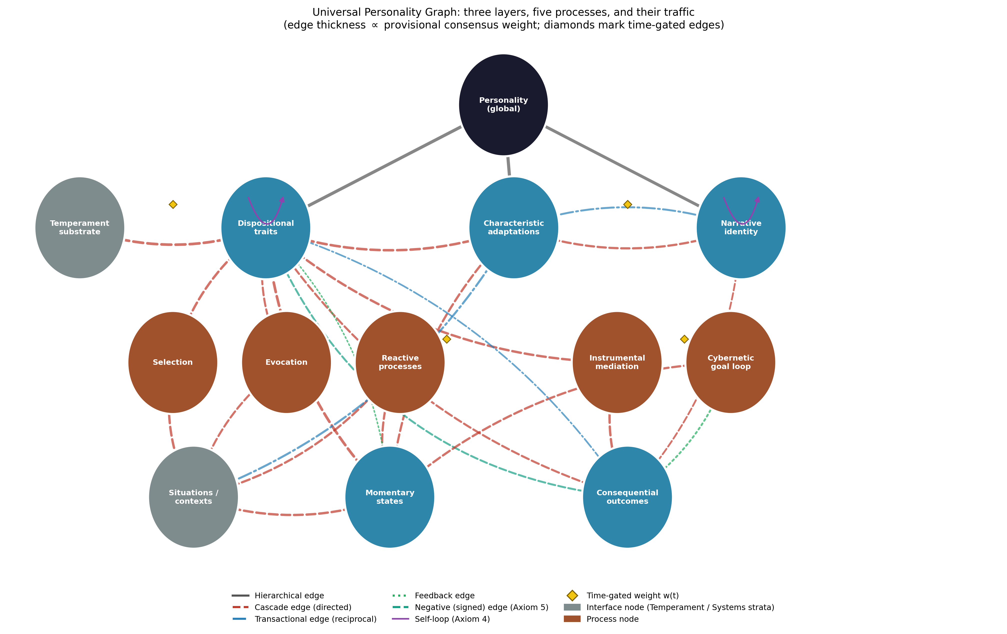
Figure D1. The Universal Personality Graph: three layers, five processes, and their traffic. Edge thickness is proportional to provisional consensus weight; diamonds mark time-gated edges; grey nodes are interfaces to the Temperament and Systems strata.
Three gates carry the developmental findings directly. The temperament→trait edge is childhood-peaked: the substrate’s influence on the emerging trait hierarchy is strongest early, per the developmental stratum. The trait self-loop is age-increasing: cumulative continuity is a gate whose gain rises over the lifespan (Atherton et al., 2022; Roberts & DelVecchio, 2000*). And the adaptation→narrative edge opens in adolescence, when identity work begins in earnest (McAdams & Pals, 2006*).

6.2 Axiom compliance
Axiom 1 (universal connectivity): every node reaches every other through the layer spine and the process paths. Axiom 2 (non-dismissibility): no layer may be deleted in the formulation of a person — a commitment with content, since trait-only description discards the contextualized and storied person, and narrative-only description discards the best-validated predictive structure in the discipline (McAdams & Pals, 2006*; Ozer & Benet-Martínez, 2006*). Axiom 3 (mediated and unmediated influence): traits reach outcomes both directly and through mediating behaviors — the moderation/mediation distinction of the process literature is precisely the distinction between edge and path (Hampson, 2012). Axiom 4 (self-influence): the trait self-loop encodes cumulative continuity; the narrative self-loop encodes the story’s selection of confirming episodes. Axiom 5 (signed superposition): the neuroticism→outcomes edge is negative while the conscientiousness→outcomes edge is positive, and concurrent influences on any node sum — which is how the graph represents, for one person, protective and risk dispositions operating at once.

6.3 Subgraphs and encapsulation
Each layer node owns an encapsulated subgraph communicating with the rest of the graph only through its mother node. The trait subgraph (Figure D2) is the richest and most standardized in the entire UPG series: two metatraits (stability, plasticity) organizing five domains, each decomposed into its six NEO facets — the thirty-facet resolution the series’ axioms of origin anticipated — with neuroticism loading negatively on stability, the subgraph’s internal signed edge (Costa & McCrae, 1992*; DeYoung, 2015*; Digman, 1997*). The adaptation subgraph carries goals and motives, values and beliefs, self-concept and schemas, and if–then behavioral signatures (McAdams & Pals, 2006*; Mischel & Shoda, 1995*). The narrative subgraph carries life-story themes and redemption/contamination sequences (McAdams & Pals, 2006*). Encapsulation does the same work here as in the earlier strata: school-specific detail lives inside the subgraphs, so the layer level commits to no school’s vocabulary.
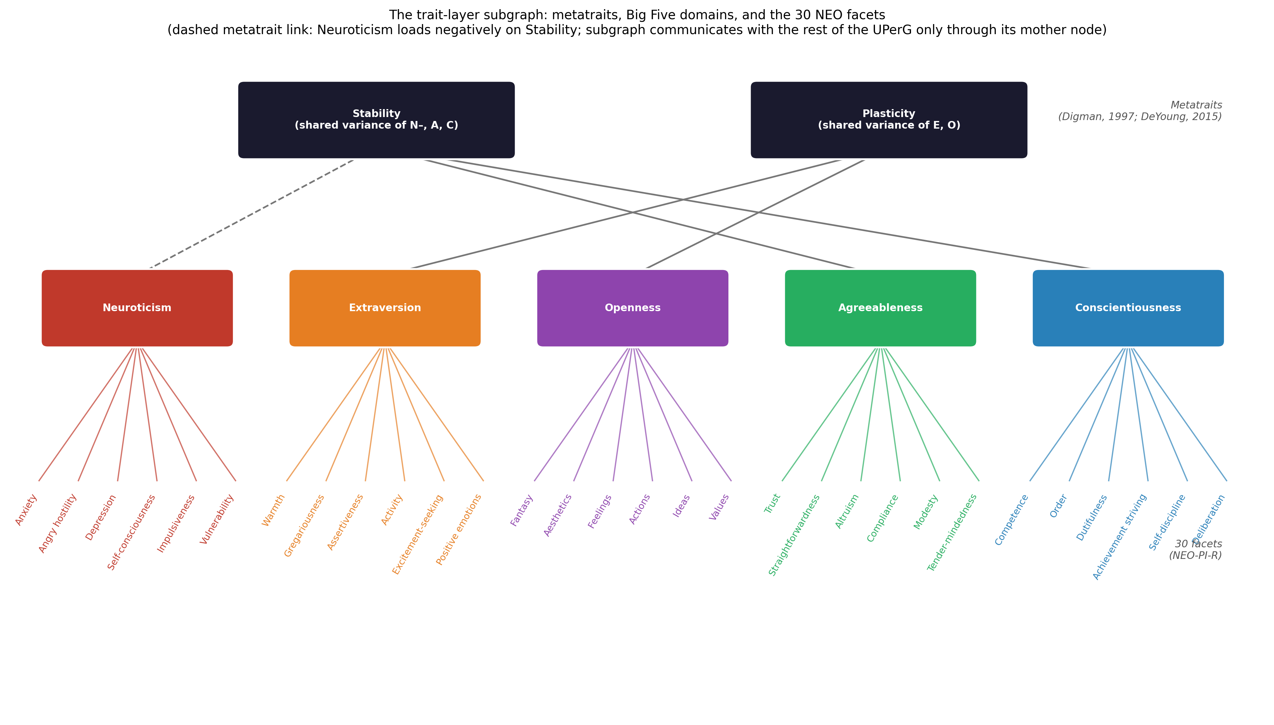
Figure D2. The trait-layer subgraph: metatraits, Big Five domains, and the 30 NEO facets. The dashed link marks neuroticism’s negative loading on stability. The subgraph communicates with the rest of the UPerG only through its mother node.

6.4 Processes as edges: the outside-the-skin circuit
Figure D3 renders the graph’s central circuit: a trait reaches consequential outcomes along two documented outbound channels — selection/evocation of contexts, and instrumental mediation through behaviors — while states register the joint main effects of dispositions and contexts (Hampson, 2012; Wilt & Revelle, 2019). Two return routes close the circuit: the corresponsive edge, by which life outcomes deepen the traits that produced them (Caspi et al., 2005*), and the consolidation edge, by which repeated states densify into trait change (Fleeson & Jayawickreme, 2015*). The circuit is the paper’s answer to the trait tradition’s oldest criticism: description becomes explanation when the paths are explicit, weighted, and independently testable.
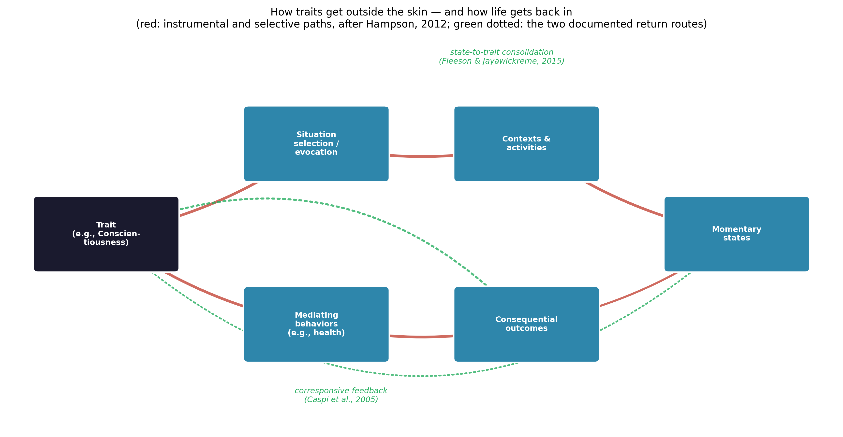
Figure D3. How traits get outside the skin — and how life gets back in. Red: instrumental and selective outbound paths (after Hampson, 2012); green dotted: the two documented return routes.

6.5 Coupling to the other strata
The UPerG specifies its interfaces exactly. Downward, the temperament node imports the biological substrate: the temperament stratum (Batch E) supplies initial conditions for the trait hierarchy, childhood-gated as the developmental article prescribes. Backward, the UDevG is the process by which every weight in this graph was set: the personality graph is, formally, a time-slice of the developmental graph’s output — which is why the two share the gating formalism. Toward psychopathology, the trait layer parameterizes vulnerability: neuroticism’s documented coupling to internalizing disorder is an edge from this graph into the UDG’s node states (Kotov et al., 2010*), giving the disorder stratum person-specific priors rather than population defaults. Toward treatment, traits and adaptations condition the UTG’s controller — treatment selection and responsiveness are moderated by exactly the structures this graph carries, and the client’s goal nodes are the “control input from within” the therapy article identified as the model’s guarantee of authenticity. These couplings honor the axioms of origin: the person’s goals, values, and narrative are nodes the person authors, not parameters imposed — individuality is the model’s content, not its noise.

6.6 What the UPerG adds
Against the textbook museum, it replaces juxtaposed schools with a computable object in which each family survives as the component it got right: psychoanalysis as layered systemhood, the neo-analytics as goal-striving and identity, trait theory as the hierarchical spine, biology as the temperament interface, behaviorism as environmental causal share, social-cognitivism as transaction and construal, humanism as the agency constraint, and the integrative movement as the architecture itself. Against the trait paradigm alone, it adds process: every predictive claim is a path, not a correlation. Against process models alone, it adds the settled taxonomy at facet resolution. Against the three-layer framework it formalizes, it adds edges, weights, signs, gates, and provenance — turning an organizing metaphor into a testable object. And against all of them it adds continuity: the same axioms, edge semantics, and gating formalism as the disorder, therapy, and developmental strata, which is what will allow the eight-dimensional composition the series is building toward.

6.7 Falsifiability, validation pathway, and limitations
The UPerG makes refutable commitments. Structural: if facet-level measurement fails to recover the published hierarchy in adequately powered samples, or if a replicable major dimension (e.g., honesty–humility) resists placement, the trait subgraph must be revised on record. Process: the mediation edges predict that controlling the mediating behaviors attenuates trait–outcome associations — a direct, testable implication (Hampson, 2012); the selection edges predict trait-consistent context frequencies of the kind experience-sampling already documents (Wilt & Revelle, 2019). Dynamic: the age-increasing self-loop gate predicts rising rank-order stability with age and predicts that interventions on traits are more efficient earlier; the corresponsive and consolidation return edges predict that sustained state and environment change produces measurable trait change, and its absence would falsify them. Validation should proceed from published-cohort reanalysis (the gates map onto age-moderated stability coefficients) to experience-sampling estimation of the trait→state and context→state weights, to intervention designs targeting the mediating behaviors.
Four limitations bound the contribution. First, the published weights are consensus priors — rated, sourced, versioned, not yet estimated; the facet-level edge weights in particular are structural placeholders awaiting item-level estimation. Second, the extraction privileges the Western, English-language literature; the Big Five’s cross-cultural recovery is extensive but not universal at facet grain, and the narrative layer is the most culture-penetrated of the three (McAdams & Pals, 2006*) — the graph’s cultural generalizability is an empirical program, aided by evidence that stability findings replicate while specific mean-level trajectories may not (Atherton et al., 2022). Third, the biological channel enters only as an interface; its content belongs to the temperament stratum. Fourth, the graph models normal-range individuality; its coupling to disordered functioning is carried by the UDG interface rather than duplicated here, so maladaptive-trait taxonomies are represented at the coupling, not as a second trait layer.

7. Conclusion
Personality psychology diagnosed its own condition: a field that once asked about the whole person, retreated into excellent fragments, and now seeks integration with explicit metatheoretical standards. This article took the diagnosis as a specification. The critical tour showed each theory family carrying a real property of individuality in a notation the others could not read; the evidence review showed the field’s central disputes — structure versus process, person versus situation, stability versus change — resolved not by winners but by both, lawfully, in interaction; and the extraction compressed the convergence into seven principles. The Universal Personality Graph implements all seven: a three-layer, facet-resolved, process-explicit, time-gated, signed graph, satisfying the series’ five axioms, importing its initial conditions from temperament, its weights from development, and exporting person-specific parameters to the disorder and therapy strata. Who you are, in this model, is not a score or a story alone: it is a published, revisable network — the stratum of the Unified Person Graph that makes every other stratum someone’s.

References
Sources marked with an asterisk (*) were located by the authors through supplementary literature searches beyond the assembled source library.
Al Shalabi, M. F., & Salmani Nodoushan, M. A. (2009). Personality theory and TESOL. i-manager’s Journal on Educational Psychology, 3(1), 14–22.
Allport, G. W. (1937). Personality: A psychological interpretation. Henry Holt. *
Ashton, M. C., & Lee, K. (2007). Empirical, theoretical, and practical advantages of the HEXACO model of personality structure. Personality and Social Psychology Review, 11(2), 150–166. https://doi.org/10.1177/1088868306294907 *
Atherton, O. E., Sutin, A. R., Terracciano, A., & Robins, R. W. (2022). Stability and change in the Big Five personality traits: Findings from a longitudinal study of Mexican-origin adults. Journal of Personality and Social Psychology, 122(2), 337–350. https://doi.org/10.1037/pspp0000385
Bandura, A. (1977). Social learning theory. Prentice-Hall. *
Buss, D. M. (1987). Selection, evocation, and manipulation. Journal of Personality and Social Psychology, 53(6), 1214–1221. https://doi.org/10.1037/0022-3514.53.6.1214 *
Caspi, A., Roberts, B. W., & Shiner, R. L. (2005). Personality development: Stability and change. Annual Review of Psychology, 56, 453–484. https://doi.org/10.1146/annurev.psych.55.090902.141913 *
Corr, P. J., & Matthews, G. (Eds.). (2009). The Cambridge handbook of personality psychology. Cambridge University Press.
Costa, P. T., Jr., & McCrae, R. R. (1992). Revised NEO Personality Inventory (NEO-PI-R) and NEO Five-Factor Inventory (NEO-FFI) professional manual. Psychological Assessment Resources. *
DeYoung, C. G. (2015). Cybernetic Big Five Theory. Journal of Research in Personality, 56, 33–58. https://doi.org/10.1016/j.jrp.2014.07.004 *
Digman, J. M. (1997). Higher-order factors of the Big Five. Journal of Personality and Social Psychology, 73(6), 1246–1256. https://doi.org/10.1037/0022-3514.73.6.1246 *
Fajkowska, M., & DeYoung, C. G. (2015). Introduction to the special issue on integrative theories of personality. Journal of Research in Personality, 56, 1–3. https://doi.org/10.1016/j.jrp.2015.04.001
Feist, J., Feist, G. J., & Roberts, T.-A. (2018). Theories of personality (9th ed.). McGraw-Hill Education.
Fleeson, W. (2001). Toward a structure- and process-integrated view of personality: Traits as density distributions of states. Journal of Personality and Social Psychology, 80(6), 1011–1027. https://doi.org/10.1037/0022-3514.80.6.1011 *
Fleeson, W., & Jayawickreme, E. (2015). Whole trait theory. Journal of Research in Personality, 56, 82–92. https://doi.org/10.1016/j.jrp.2014.10.009 *
Freud, S. (1961). The ego and the id. In J. Strachey (Ed. & Trans.), The standard edition of the complete psychological works of Sigmund Freud (Vol. 19, pp. 1–66). Hogarth Press. (Original work published 1923) *
Goldberg, L. R. (1990). An alternative “description of personality”: The Big-Five factor structure. Journal of Personality and Social Psychology, 59(6), 1216–1229. https://doi.org/10.1037/0022-3514.59.6.1216 *
Hampson, S. E. (2012). Personality processes: Mechanisms by which personality traits “get outside the skin.” Annual Review of Psychology, 63, 315–339. https://doi.org/10.1146/annurev-psych-120710-100419
Kelly, G. A. (1955). The psychology of personal constructs. Norton. *
Kotov, R., Gamez, W., Schmidt, F., & Watson, D. (2010). Linking “big” personality traits to anxiety, depressive, and substance use disorders: A meta-analysis. Psychological Bulletin, 136(5), 768–821. https://doi.org/10.1037/a0020327 *
Maslow, A. H. (1954). Motivation and personality. Harper & Row. *
McAdams, D. P., & Pals, J. L. (2006). A new Big Five: Fundamental principles for an integrative science of personality. American Psychologist, 61(3), 204–217. https://doi.org/10.1037/0003-066X.61.3.204 *
McCrae, R. R., & Costa, P. T., Jr. (2008). The five-factor theory of personality. In O. P. John, R. W. Robins, & L. A. Pervin (Eds.), Handbook of personality: Theory and research (3rd ed., pp. 159–181). Guilford Press. *
Mischel, W. (1968). Personality and assessment. Wiley. *
Mischel, W., & Shoda, Y. (1995). A cognitive-affective system theory of personality: Reconceptualizing situations, dispositions, dynamics, and invariance in personality structure. Psychological Review, 102(2), 246–268. https://doi.org/10.1037/0033-295X.102.2.246 *
Ozer, D. J., & Benet-Martínez, V. (2006). Personality and the prediction of consequential outcomes. Annual Review of Psychology, 57, 401–421. https://doi.org/10.1146/annurev.psych.57.102904.190127 *
Patel, P. (2025). The evolution of personality theories: A journey through key theoretical frameworks. Horizons of Holistic Education, 12(1), 71–84.
Roberts, B. W., & DelVecchio, W. F. (2000). The rank-order consistency of personality traits from childhood to old age: A quantitative review of longitudinal studies. Psychological Bulletin, 126(1), 3–25. https://doi.org/10.1037/0033-2909.126.1.3 *
Roberts, B. W., Kuncel, N. R., Shiner, R., Caspi, A., & Goldberg, L. R. (2007). The power of personality: The comparative validity of personality traits, socioeconomic status, and cognitive ability for predicting important life outcomes. Perspectives on Psychological Science, 2(4), 313–345. https://doi.org/10.1111/j.1745-6916.2007.00047.x *
Roberts, B. W., Walton, K. E., & Viechtbauer, W. (2006). Patterns of mean-level change in personality traits across the life course: A meta-analysis of longitudinal studies. Psychological Bulletin, 132(1), 1–25. https://doi.org/10.1037/0033-2909.132.1.1 *
Rogers, C. R. (1961). On becoming a person: A therapist’s view of psychotherapy. Houghton Mifflin. *
Rumsey, M. G. (2020). Personality and interests for selection: Theoretical perspectives. Military Psychology, 32(1), 7–23. https://doi.org/10.1080/08995605.2019.1652478
Sangwan, N. (2023). Exploring the Big Five theory: Unveiling the dynamics and dimensions of personality. SSHA, 1(2), 73–77. https://doi.org/10.60081/SSHA.1.2.2023.73-77
Schultz, D. P., & Schultz, S. E. (2017). Theories of personality (11th ed.). Cengage Learning.
Vukasović, T., & Bratko, D. (2015). Heritability of personality: A meta-analysis of behavior genetic studies. Psychological Bulletin, 141(4), 769–785. https://doi.org/10.1037/bul0000017 *
Wilt, J., & Revelle, W. (2019). The Big Five, everyday contexts and activities, and affective experience. Personality and Individual Differences, 136, 140–147. https://doi.org/10.1016/j.paid.2017.12.032
Yan, M., Zhang, J., Ge, P., & Wu, Y. (2023). Personality theory: New factors to incorporate in public decision-making in communities. Health Care Science, 2(3), 198–203. https://doi.org/10.1002/hcs2.43

