**MongoDB Sharding**

Step 1

Creating directories

# Config Server

mkdir C:\data\cfg1, C:\data\cfg2, C:\data\cfg3

# Shard Servers (2 shards, 3 nodes each)

mkdir C:\data\shard1_1, C:\data\shard1_2, C:\data\shard1_3

mkdir C:\data\shard2_1, C:\data\shard2_2, C:\data\shard2_3

# Mongos router

mkdir C:\data\mongos

Step 2

Start Config Server Replica Set

Server 1

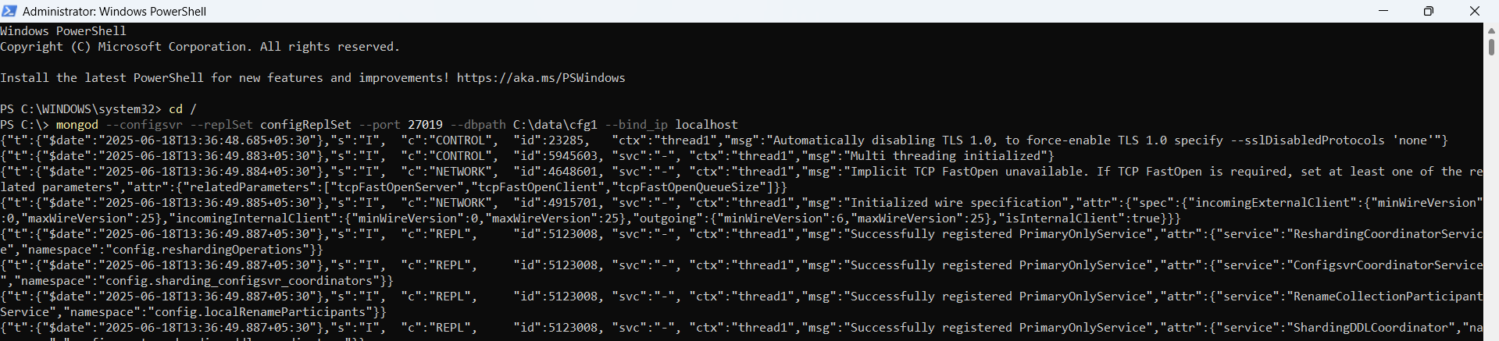

Server 2

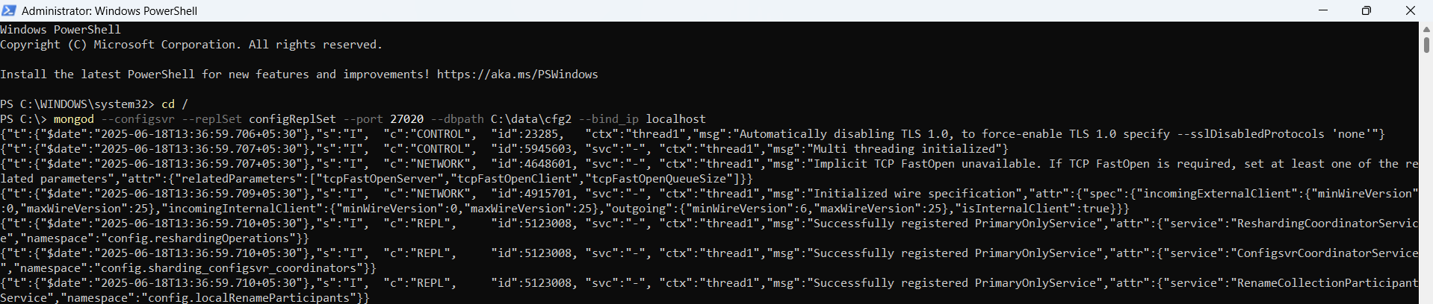

Server 3

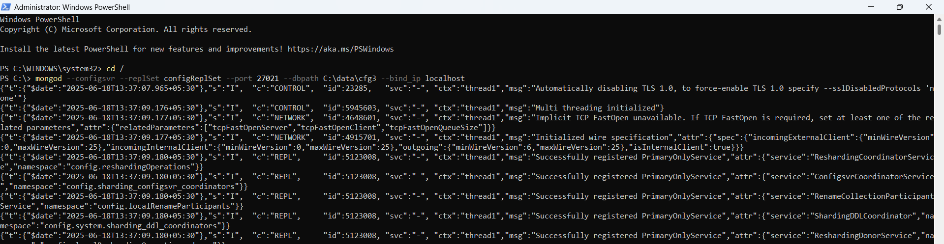

Initialize the config replica set:

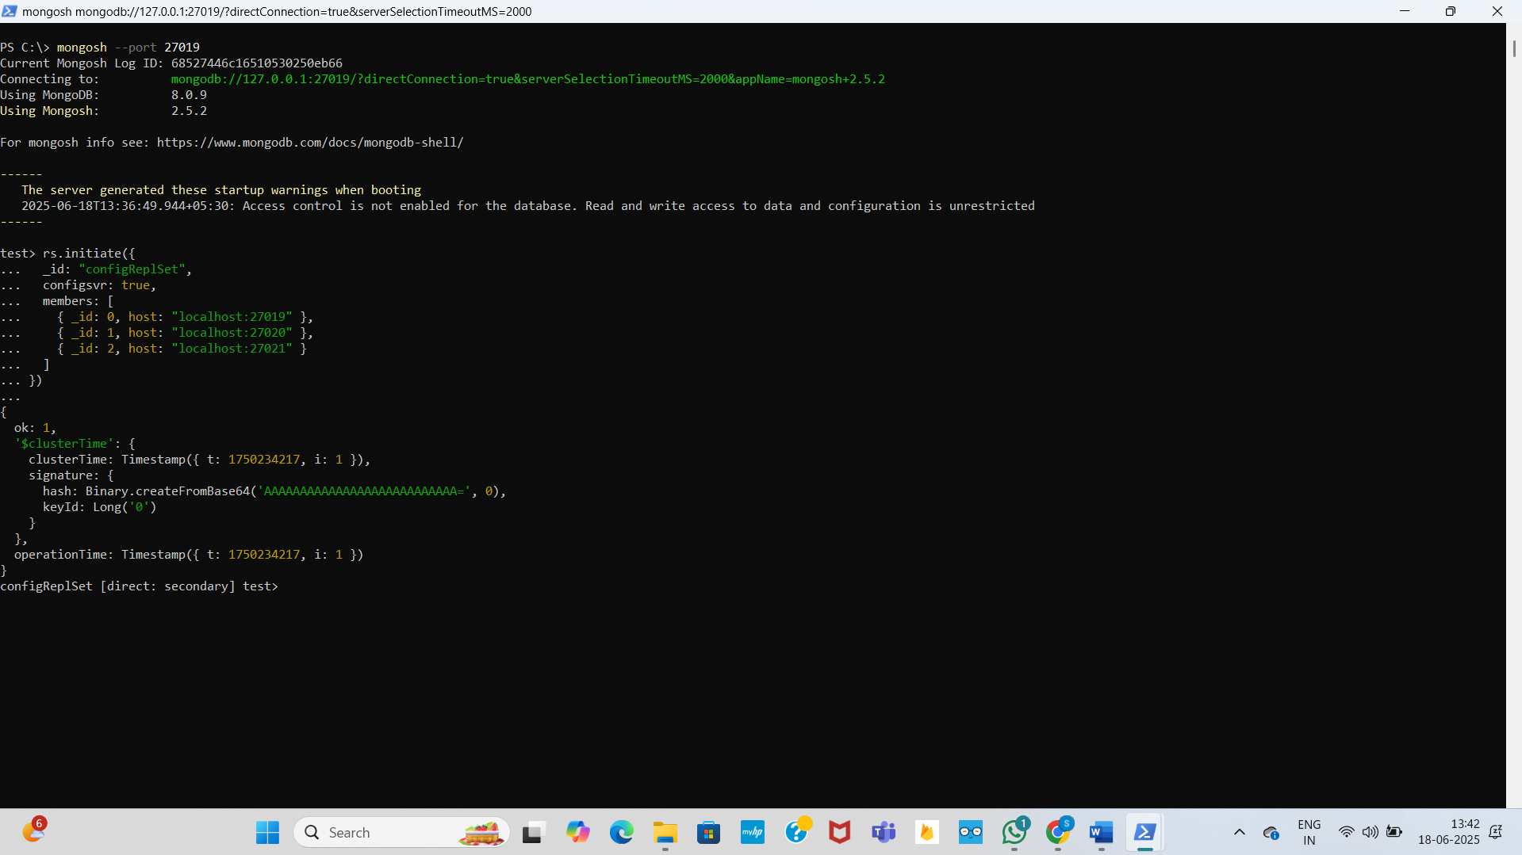

Step 3: Start Shard Replica Sets

# Shard1 Node1

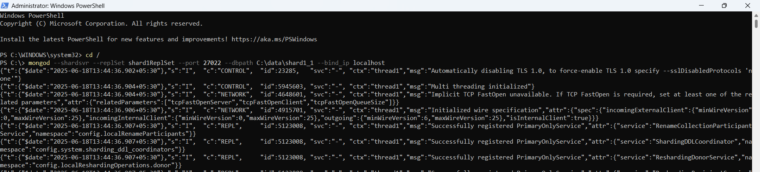

# Shard1 Node2

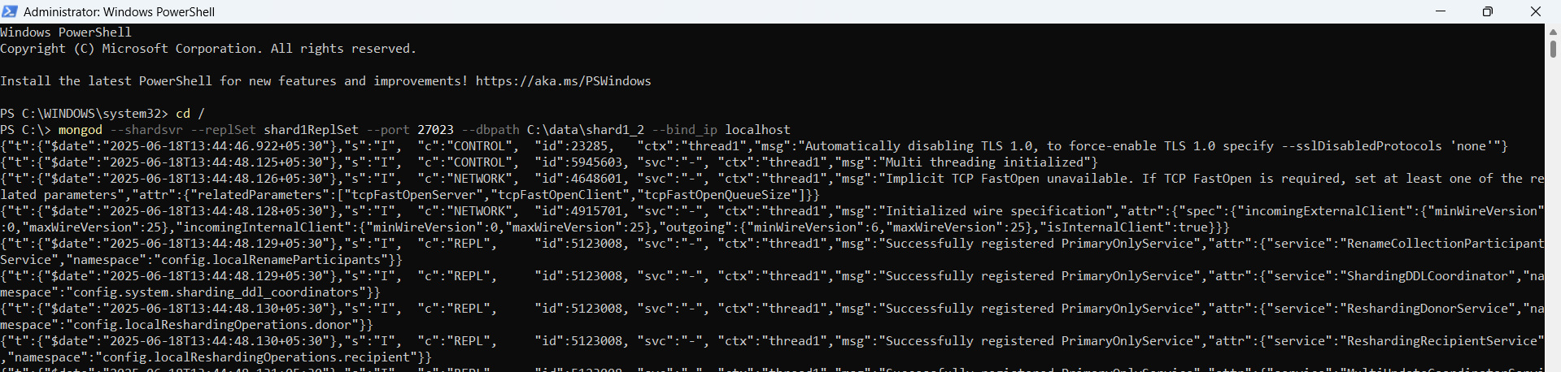

# Shard1 Node3

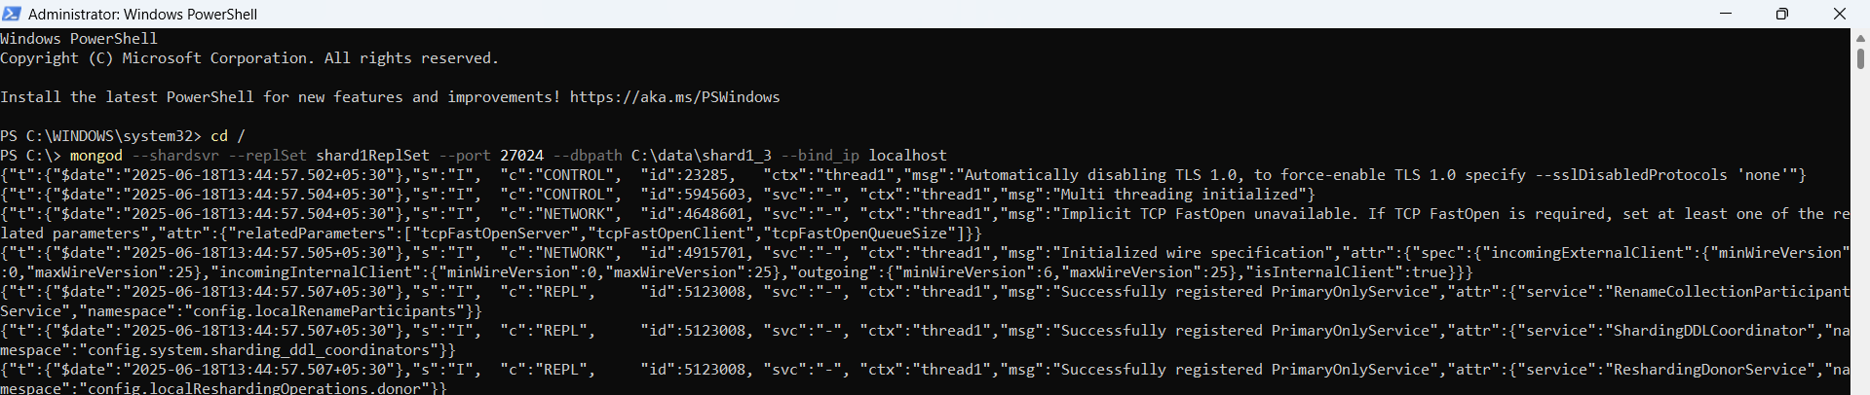

Initialize Shard 1:

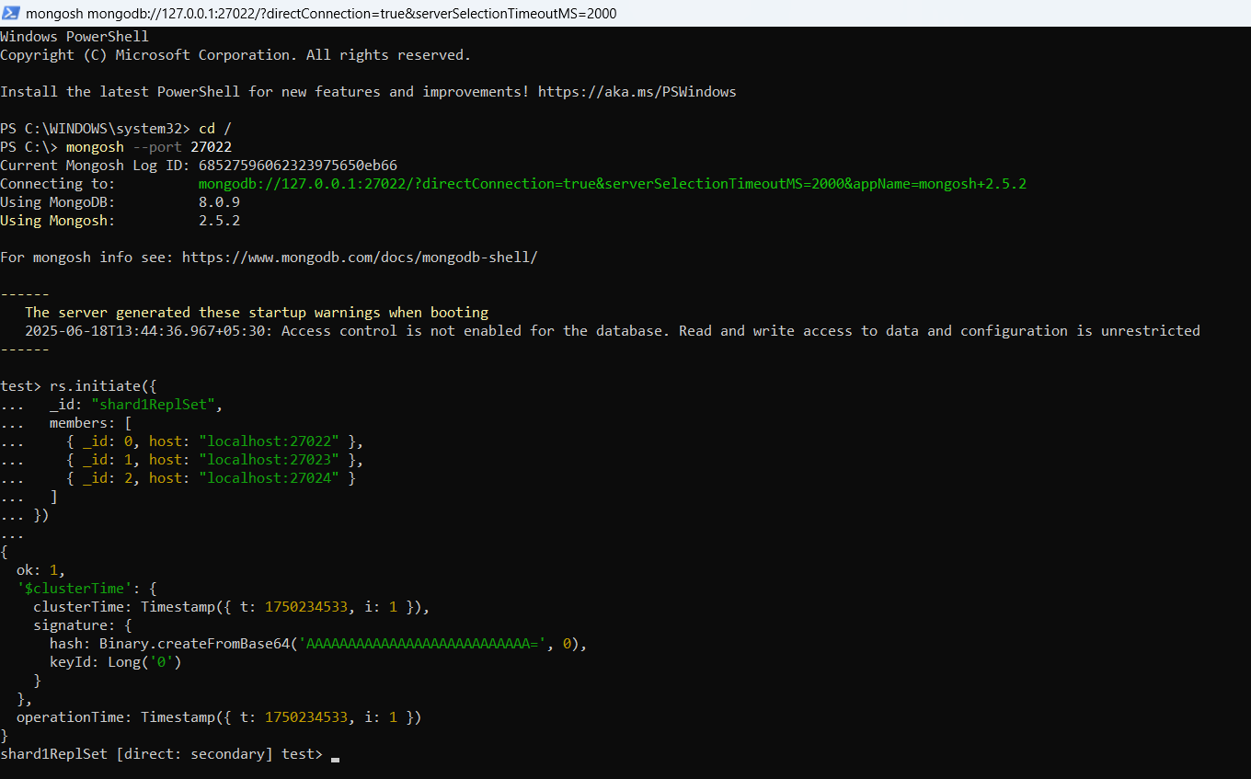

Shard 2

# Shard2 Node1

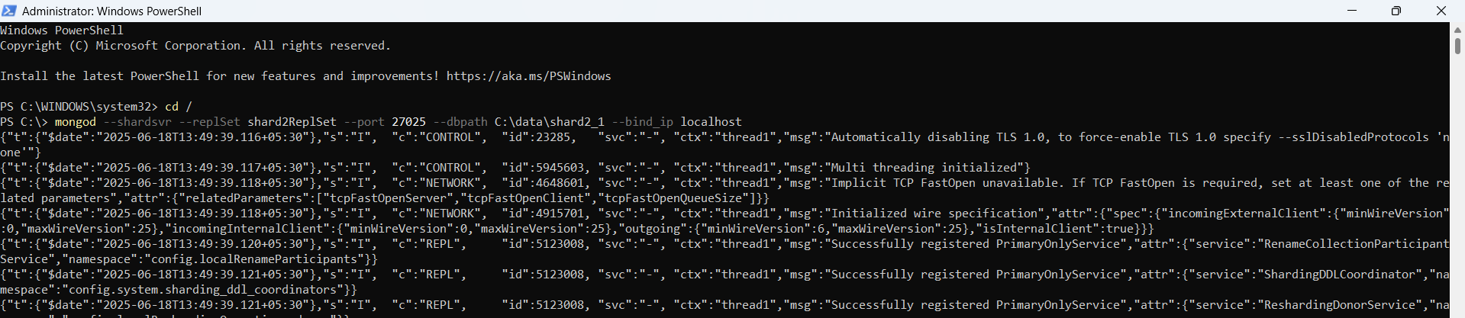

# Shard2 Node2

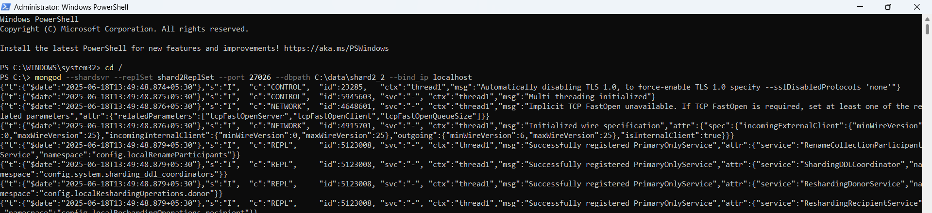

# Shard2 Node3

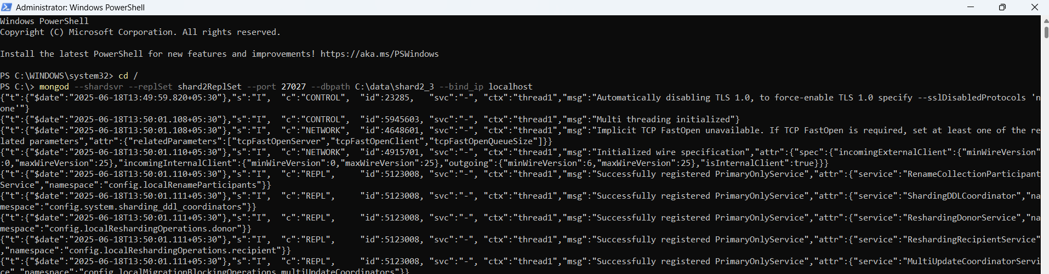

Initialize Shard 2:

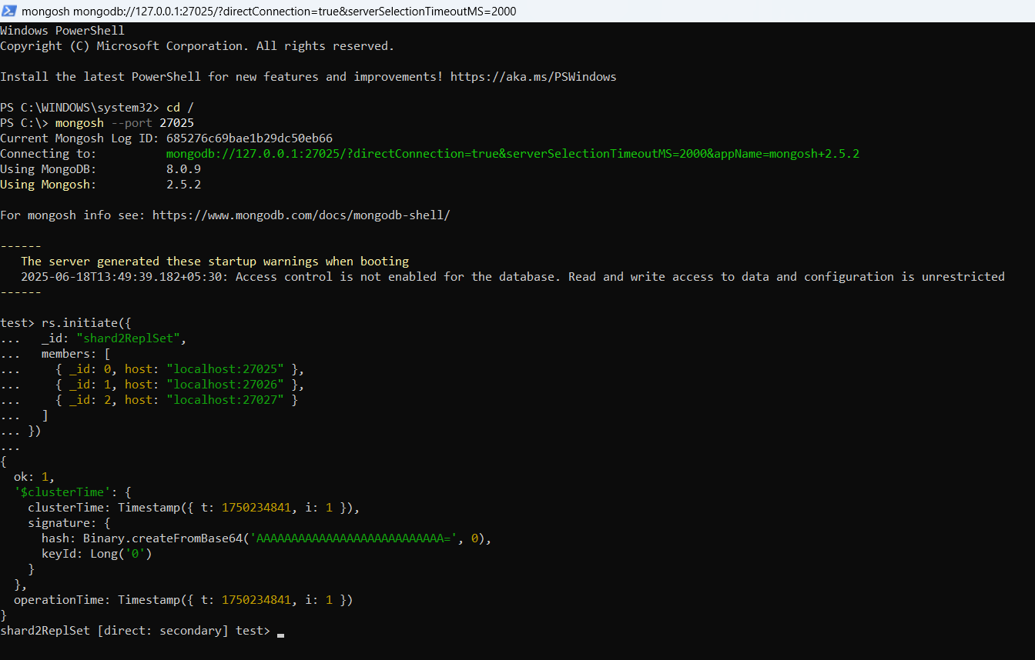

Step 4: Start Mongos Query Router

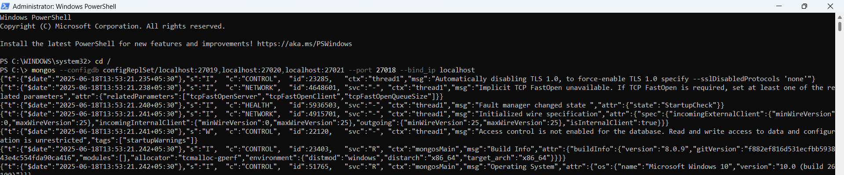

Step 5: Configure Sharding

Connect to mongos:

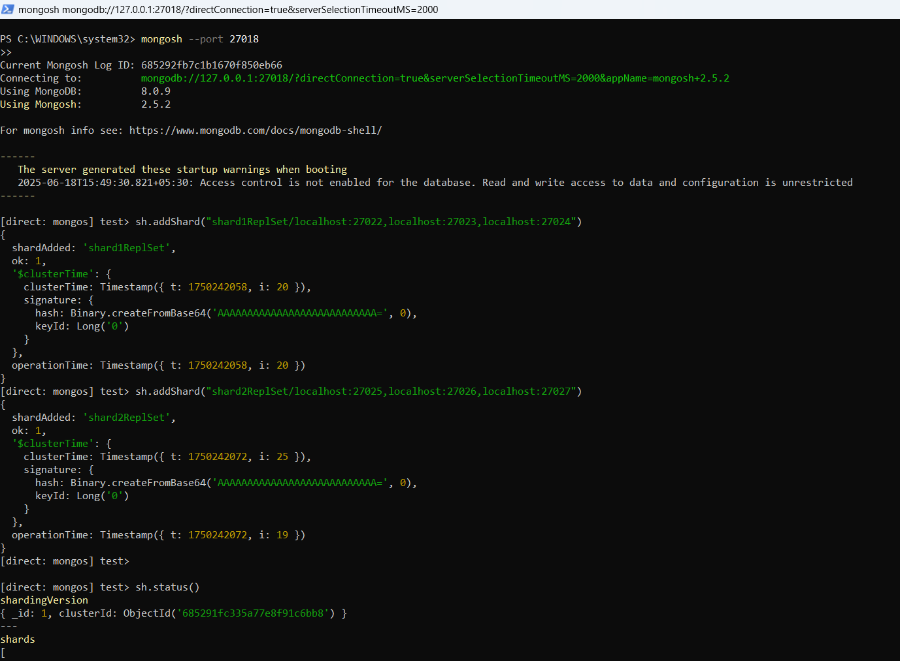

Step 6: Enable Sharding for a Database and Collection

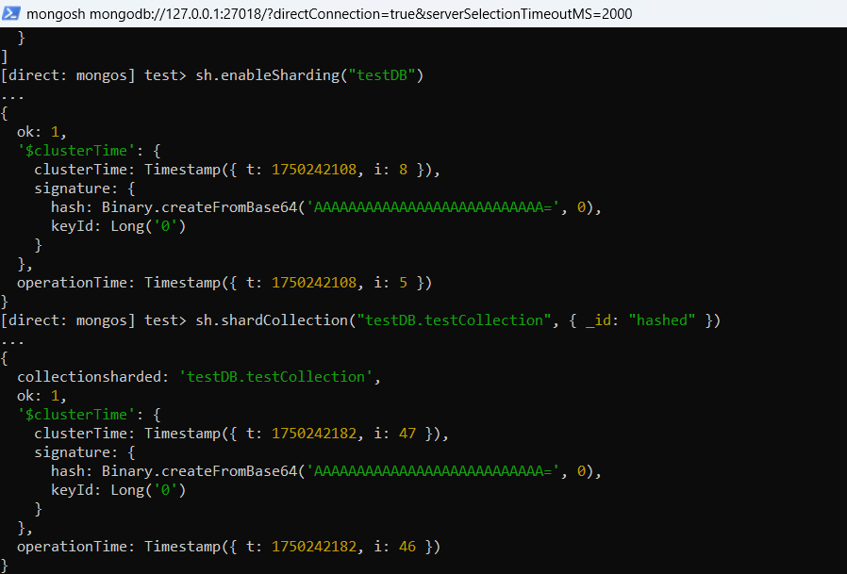

Step 7: Verify Sharding Status

