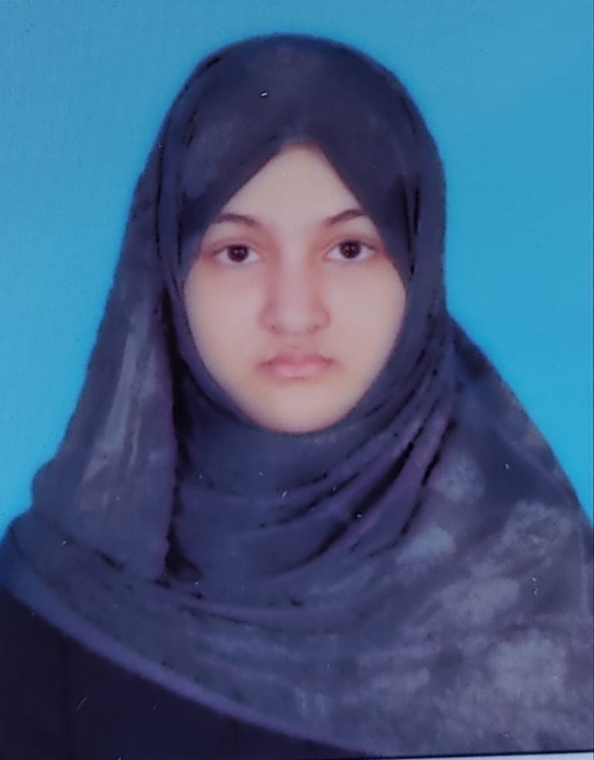**SOHA BEGUM**

**COMPUTER SCIENCE ENGINEERING**

**Contact No: +91 8639373630**

**E-mail: sohabegum54@gmail.com**

**OBJECTIVE:**

Motivated and detail-oriented Computer Science Engineering student with a strong foundation in programming, data structures, and web development. Passionate about algorithms, emerging technologies, and innovative computing solutions. Eager to apply and expand my knowledge by contributing to meaningful research and development projects while continuously enhancing my academic and technical skills.

**ACADEMIC QUALIFICATION:**

|  |  |  |  |  |
| --- | --- | --- | --- | --- |
| S.NO | COURSE NAME | UNIVERSITY/SCHOOL | CGPA | YEAR OF PASS |
| 1 | Bachelor of Technology in Computer Science | Rajiv Gandhi University of Knowledge Technologies | Top 20% | Pursuing |
| 2 | PUC (Pre-University Course) | Rajiv Gandhi University of Knowledge Technologies | 9.75 | 2023 |
| 3 | SSC | Kakatiya Olympiad School | 10 | 2021 |

SEMESTER-WISE SGPA:

|  |  |  |
| --- | --- | --- |
| S.NO | SEMESTER | SGPA |
| 1 | E1-SEM1 | 9.81 |
| 2 | E1-SEM2 | 8.88 |
| 3 | E2 | PURSUING |

**TECHNICAL SKILLS:**

* Programming languages: C, Python,Java,mysql
* Web Development: HTML, CSS,Javascript,PHP

**ACADEMIC ACHIEVEMENTS:**

* All India rank 100 in Science Olympiad-NSTSE
* State rank 10 in Math Olympiad-CHUKKA LAKSHMI BAI OLYMPIAD TEST
* Class Representative for an entire semester
* Top 20% in B.Tech(cse) at RGUKT
* secured 872 state rank in Engineering Stream and 281 state rank in Agriculture Stream in polycet
* Received a memento for appreciation in Essay writing competition Organised by our university on the occasion of Women’s day.

**SOFT SKILLS:**

* Leadership skills
* Teamwork
* Interpersonal skills
* Quick learner

**HOBBIES:**

* Chess
* Coding
* Learning a new language

**EXTRACURRICULAR ACTIVITIES:**

* Participated in college level technical quizzes,Essay competitions
* Volunteered for an event specifically for faculty on the occasion of Teachers day
* participated in coding contest conducted by our university code club

**PERSONAL PROFILE :**

Name : Soha Begum

Father Name : Shaik Mahaboob Ali

Mother Name : Kanees Begum

Date of Birth : 28-07-2006

Nationality : Indian

Gender : Female

Siblings : 2

**LANGUAGES KNOWN:** Telugu, Hindi, English, Urdu

**Certified courses:**

* Data Structures in C – Great Learning Academy,2024
* Frontend Development – oneroadmap,june 14,2025

**DECLARATION :**

I hereby declare that all the above information is true to the best of my knowledge and belief.

**DATE: 17-06-2025**

**PLACE: NIZAMABAD (SOHA BEGUM)**