SVKM's NMIMS
Mukesh Patel School of Technology Management & Engineering
Academic Year 2026–2027

Mobile Application Development
MINI PROJECT REPORT
SafeWalk
An offline-first personal-safety app that uses fuzzy logic to detect risky walks and alert trusted contacts

Programme / Batch:
B.Tech AI – Batch 1

Submitted by
Sr. | Name of the Student | Roll No. | SAP ID
1 | Soha Chand | I007 | 70122400036
2 | Atharv Dixit | I013 | 70122400069
3 | Ojaswi Gondalia | I019 | 70122400044

Faculty: Leena Nadkar
Date of Submission: 21/10/2026
GitHub Repository: https://github.com/sohachand/SafeWalk

Table of Contents

Abstract
Walking alone at night, through unfamiliar streets or after a late class or shift, is a daily source of anxiety for students and young professionals, and most existing safety apps only help after the person presses a button. SafeWalk is an Android app (Java) that watches a walk in the background and estimates a risk score from three signals: how long the user has been stationary, how far they have strayed from the planned route, and how late it is. The score comes from a Mamdani fuzzy-inference engine written from scratch (10 rules, centroid defuzzification) and is shown with a plain-English explanation of why. When risk becomes high the app asks “Are you safe?” and, if there is no answer, alerts the user’s trusted contacts by SMS with a live-location link; a shake-to-SOS, siren and strobe, fake call, arrive-by timer and emergency helpline screen add manual safeguards. Android features used include Activities and Intents, GPS (LocationManager), the accelerometer, SMS and dialer intents, SharedPreferences storage, custom Views, and Firebase Authentication with Cloud Firestore for optional sync and live sharing. The result is a working 20+ screen application tested on a Pixel 8 emulator (API 37).

1. Problem Statement

1.1 Background
Women, students, night-shift workers and people travelling alone regularly walk home after dark. Walking home is rarely an emergency until, suddenly, it is. A person who is being followed, who has lost their way, or who has fallen or been stopped is often unable to unlock a phone, open an app and press a panic button. In India, the Ministry of Home Affairs’ ERSS (dial 112) and several state apps exist, but they are all reactive: they begin only when the user acts. A typical example: a student leaves a library at 10:45 pm, takes an unfamiliar shortcut, and stops for several minutes because she is lost. Nobody knows, and she is not in a state to call for help. SafeWalk is designed for exactly this gap: it notices that something is off and acts before the user has to.

1.2 Target Users and Their Needs
User type | Need / pain point | How the app helps
Students / young women walking home at night | Fear of unsafe routes; cannot easily reach the phone in a threatening situation | Monitors the walk automatically, raises the risk tier and alerts contacts if the user does not respond
Parents / friends (trusted circle) | Do not know whether the person has reached safely | Receive an SMS with battery level and a map link, and can follow the walk live with a 6-digit code
Night-shift and gig workers | Long solo commutes through isolated stretches | Arrive-by timer, route-deviation detection and one-tap Emergency screen with helplines
Anyone in immediate danger | Needs to attract attention or escape a situation fast | Shake-to-SOS, loud siren with flashlight strobe, and a fake incoming call

1.3 Objectives
- Estimate walking risk automatically in real time from stationary time, route deviation and time of night using a fuzzy-logic engine, and show the reason for each score.
- Alert trusted contacts by SMS (with GPS link and battery level) and let them follow the walk live, with escalation when the user does not confirm they are safe.
- Provide instant manual safeguards: shake/button SOS, siren with strobe, fake call, arrive-by timer and an Emergency page with Call 112 and national helplines.
- Keep a history of walks (risk timeline and GPS trail) and simple safety insights, stored locally and synced to the cloud when the user signs in.
- Work offline-first: every safety feature must function without an internet connection or an account.

1.4 Scope
In scope: Sign-up/login (optional), onboarding and permissions, trusted-circle management, walk setup, live fuzzy risk monitoring, “Are you safe?” escalation, SMS alert, manual SOS (shake), siren/strobe, fake call, arrive-by timer, Emergency Help screen, live walk sharing, walk history with timeline and trail, insights, sensitivity settings, Firebase sync.
Out of scope / limitations: The app does not call the police automatically (it opens the dialer or SMS app so the user stays in control); it uses straight-line deviation rather than turn-by-turn routing; SMS is sent through the user’s SMS app (the user must press Send); stationary detection depends on GPS accuracy; live sharing needs an internet connection; no iOS version.

1.5 Originality
Most safety apps are SOS buttons with a contact list. SafeWalk’s own idea is to make the app decide: a hand-built Mamdani fuzzy-inference engine (fuzzification, 10 IF-THEN rules, min/max inference and centroid defuzzification) turns three vague human notions (“been still for a while”, “a bit off route”, “quite late”) into a 0–100 risk score, and the live screen explains which rule produced it. This goes well beyond the lab exercises, which covered layouts, intents, menus and local storage. Other original elements are the arrive-by timer with an automatic “Are you safe?” prompt, a colour-coded GPS trail replay of each walk, a personal safety score, and sensitivity presets (Relaxed / Standard / Cautious) that shift the fuzzy set boundaries.

2. Technical Explanation

2.1 Development Environment
IDE | Android Studio Quail 1 | 2026.1.1 Patch 2 (macOS)
Language | Java
Build (AGP / Gradle) | AGP 9.2.1, Kotlin-DSL Gradle files with a version catalog (libs.versions.toml)
compileSdk / minSdk / targetSdk | 36 / 24 / 36
Tested on | Pixel 8 emulator, Android API 37.1
Other libraries | Material Components 1.14.0, AppCompat 1.8.0, ConstraintLayout 2.2.2, Firebase BoM 35.0.1 (Authentication, Cloud Firestore), google-services plugin

2.2 Android Components Used
Component | Where it is used in the app | Purpose
Activities & Intents (explicit / implicit) | 20+ activities (Splash → Onboarding → Home …); explicit intents between screens, ACTION_SENDTO (SMS), ACTION_DIAL (112 and helplines), ACTION_VIEW (Google Maps) | Navigation, passing walk/contact data via extras, handing off SMS, calls and maps to the system apps
Layouts (Constraint / Linear) & Views | 25 XML layouts using ConstraintLayout, LinearLayout, ScrollView, MaterialCardView; custom Views RiskTimelineView, TrailView, ScoreRingView | Responsive screens and custom-drawn charts (risk timeline, GPS trail, safety-score ring)
Spinner / AlertDialog / Toast | Arrive-by timer chooser, “Are you safe?” dialog, Nearby Help dialog, sensitivity choice, Toast messages | Quick choices, confirmations and short feedback
Custom list (adapter) | Recent walks and history lists built from item_walk_history.xml; trusted contacts from item_trusted_contact.xml | Display repeating records with styled rows
Local storage (SharedPreferences + JSON) | SessionStore, TrustedCircleStore, WalkHistoryStore (JSON arrays) | Offline storage of login state, contacts and walk records instead of SQLite
Sensors (accelerometer) | ActiveWalkActivity via SensorManager | Shake-to-SOS detection
Location (GPS) | ActiveWalkActivity via LocationManager | Stationary time, route deviation, trail points, live location
Runtime permissions | PermissionsSetupActivity, PermissionsManagementActivity | Location, contacts and audio permissions requested with explanation
Handler / Timers / CountDownTimer | ActiveWalkActivity risk tick (5 s), arrive-by timer, 20 s response countdown | Periodic risk evaluation and escalation
Audio & camera flash | SirenStrobe (ToneGenerator + CameraManager torch) | Siren and strobe to attract attention
SmsManager (automatic SMS) | AlertSentActivity | Sends the alert text to trusted contacts without opening the messaging app
Firebase Authentication & Cloud Firestore | cloud/FirebaseGate, CloudSync, LiveShare; SignUpLoginActivity, FollowWalkActivity | Optional account, cloud backup of walks, live location sharing by code
Components not used in this app: ListView/BaseAdapter menus, SQLite and file (TXT/CSV) handling and Camera/Gallery were not required; local data is kept in SharedPreferences JSON stores and in Firebase Firestore.

2.3 Screen Flow
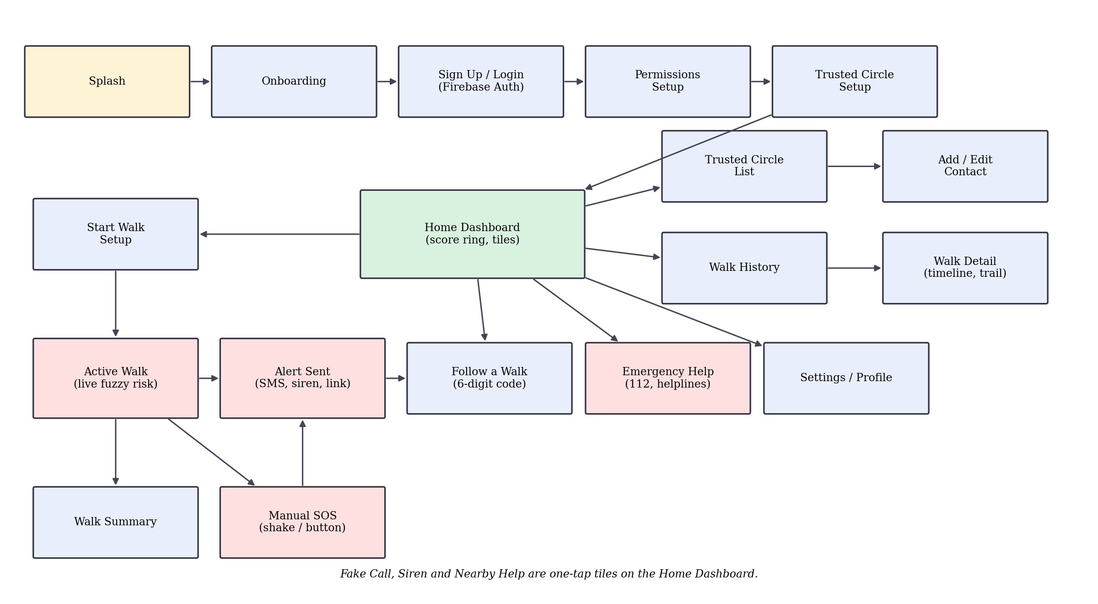
Figure 1: Screen flow of the app

2.4 Database Design
The app has no SQLite database. Data is stored as JSON in three SharedPreferences files and mirrored to Cloud Firestore when the user is signed in. The main record, WalkRecord (stored in safewalk_walk_history and in Firestore at users/{uid}/walks/{walkId}), has the following fields. Live sharing uses a second Firestore collection, live/{code}, with fields such as ownerUid, tier, risk, lat/lng and updatedAt; security rules allow only the owner to write or delete a live document.
Column | Data type | Constraint | Description
id | String (UUID) | Primary key | Unique id of the walk
fromLabel / toLabel | String | — | Start and destination names
startTimeMillis / endTimeMillis | long | — | Walk start and end timestamps
peakRisk | double | 0–100 | Highest fuzzy risk score reached
finalTier | String | LOW / MEDIUM / HIGH | Risk tier at the end of the walk
triggers | List<String> | — | Events such as alerts or SOS that occurred
timeline | List<RiskPoint> | — | Per-tick risk, stationary minutes, deviation, plus optional lat/lng for trail
Other stores: safewalk_session (login state, name, sensitivity) and safewalk_trusted_circle (contact name, phone, relation).

2.5 Project Structure
Package com.example.project is organised by feature (Figure 2):
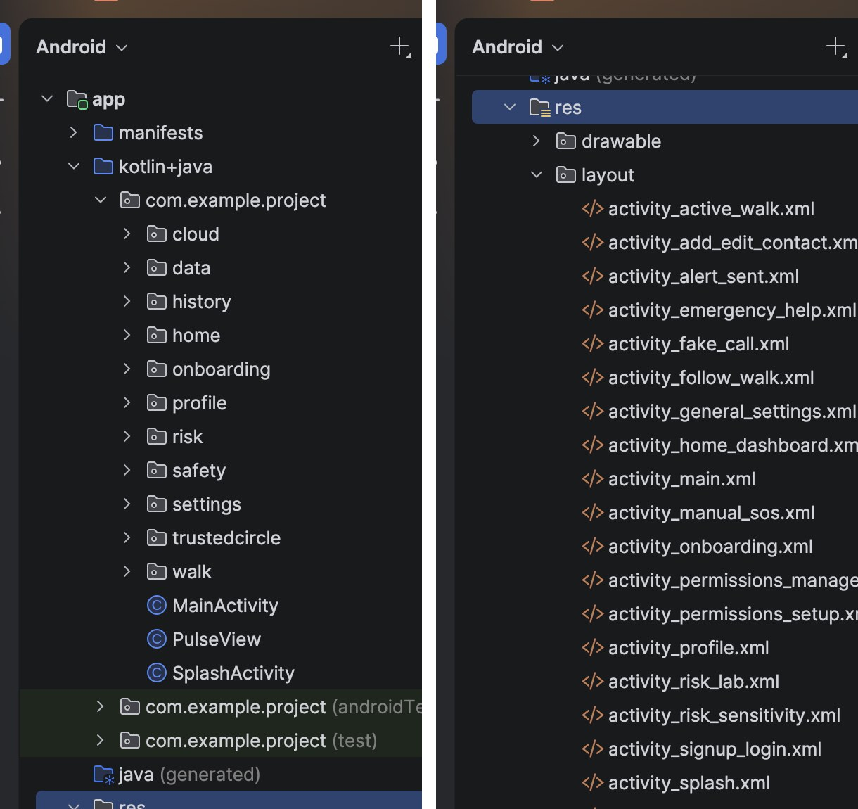
Figure 2: Android Studio Project panel – feature packages under java and layout files under res
- risk/FuzzyRiskEngine – Mamdani fuzzy inference: membership functions, 10-rule base, centroid defuzzification, tier thresholds (LOW <30, MEDIUM <65, HIGH ≥65).
- walk/ActiveWalkActivity, StartWalkSetupActivity, FollowWalkActivity – walk setup, live monitoring loop, “Are you safe?” escalation, arrive-by timer, followers’ live view.
- safety/AlertSentActivity, ManualSosActivity, EmergencyHelpActivity, FakeCallActivity, SirenStrobe – alerting, SOS, helplines, fake call, siren and strobe.
- home/HomeDashboardActivity, ScoreRingView – dashboard, safety score and insights, nearby-help dialog.
- history/WalkHistoryActivity, WalkDetailActivity, WalkSummaryActivity, RiskTimelineView, TrailView – past walks, risk chart and GPS trail.
- onboarding/* and profile/* – splash, onboarding, sign-up/login, permissions, trusted-circle setup, profile.
- trustedcircle/* and settings/* – contact list and editor, general settings, sensitivity, permission management.
- data/* – SessionStore, TrustedCircleStore, WalkHistoryStore, WalkRecord, RiskPoint, TrustedContact (local persistence models).
- cloud/* – FirebaseGate (safe availability check), CloudSync (walk upload/pull), LiveShare (live location documents).

3. Self-Learning / New Concepts
The following tools and concepts were learned from documentation and self-study and used beyond the lab syllabus:
New concept / tool | Source (docs / video / article link) | Where used in the app | What you learned
Fuzzy logic / Mamdani inference | Zadeh, “Fuzzy sets”; MATLAB Fuzzy Logic Toolbox documentation (mathworks.com) | risk/FuzzyRiskEngine.java | Triangular, trapezoid and shoulder membership functions; min-AND rules; max aggregation; centroid defuzzification; shifting set boundaries (not readings) to implement sensitivity
Firebase Authentication & Cloud Firestore | firebase.google.com/docs/auth/android, /docs/firestore | cloud/*, SignUpLoginActivity, FollowWalkActivity | Email/password auth, document model, snapshot listeners, security rules (owner-only writes), offline-first design with a runtime gate when Firebase is absent
Sensors (SensorManager accelerometer) | developer.android.com/develop/sensors-and-location/sensors | ActiveWalkActivity | Register/unregister listeners, shake detection from acceleration magnitude
Location (LocationManager) | developer.android.com/develop/sensors-and-location/location | ActiveWalkActivity | Requesting updates, distance calculations, route deviation and stationary detection
Custom Views (Canvas) | developer.android.com/develop/ui/views/layout/custom-views | RiskTimelineView, TrailView, ScoreRingView | onDraw, Paint, Path, drawArc; colour-coding values by risk
ToneGenerator & CameraManager torch | developer.android.com (ToneGenerator, CameraManager.setTorchMode) | SirenStrobe.java | Looping alarm tone on the alarm stream and flashing the torch without opening the camera
Gradle version catalog & conditional plugin | docs.gradle.org / developer.android.com/build | libs.versions.toml, app/build.gradle.kts | Central dependency versions; applying google-services only when google-services.json exists
Git & GitHub | git-scm.com/doc | Project repository | Commits, .gitignore for secrets (google-services.json), pushing to GitHub

4. The Application

4.1 Features
Sr. | Feature | Status (Working / Partial)
1 | Sign-up / login with Firebase (or continue without account) | Working
2 | Onboarding, permissions request and trusted-circle setup | Working
3 | Trusted circle management (add / edit / delete contacts) | Working
4 | Plan a walk (from / to, sensitivity) and start live monitoring | Working
5 | Fuzzy risk engine with live score, tier banner and “why this score” explanation | Working
6 | Risk timeline chart and GPS trail replay per walk | Working
7 | “Are you safe?” prompt and automatic escalation to SOS | Working
8 | SMS alert with battery and map link; Manual SOS by button and shake-to-SOS during a walk | Working (user confirms Send in SMS app)
9 | Siren with flashlight strobe; fake incoming call | Working
10 | Arrive-by timer (1–60 min) | Working
11 | Emergency Help: Call 112 and national helplines; Nearby help (police, hospital, pharmacy, petrol pump) | Working
12 | Live walk sharing and Follow a Walk by 6-digit code | Working (needs internet and Firebase)
13 | Walk history, safety score ring and insights | Working
14 | Cloud backup/sync of walks | Working (needs sign-in)
15 | Risk Lab: interactive fuzzy-engine simulator with live membership-function charts | Working
16 | Automatic SMS alert to trusted contacts (SmsManager) with fallback to the messaging app | Working on a real device with SMS permission
17 | Route deviation using real routing / geofences | Partial (straight-line distance only)

4.2 Screenshots of the Working App
Screenshots taken from screen recordings of the app running on a real Android phone. Each caption says what the user does on that screen.
Screenshot | Screenshot
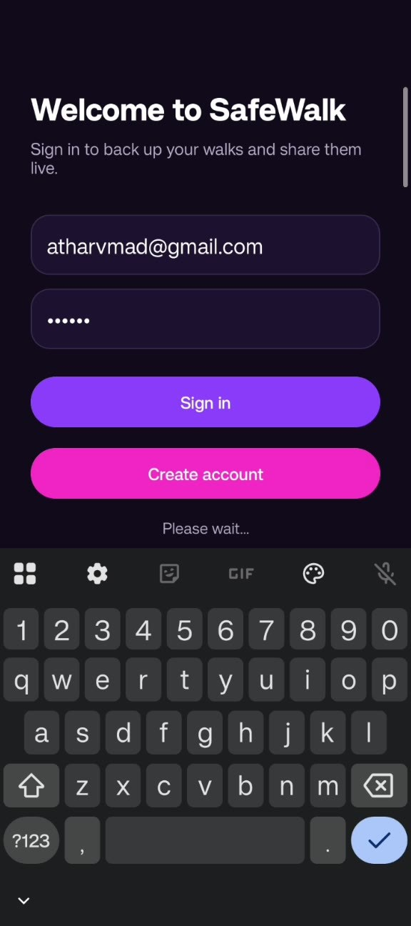 | 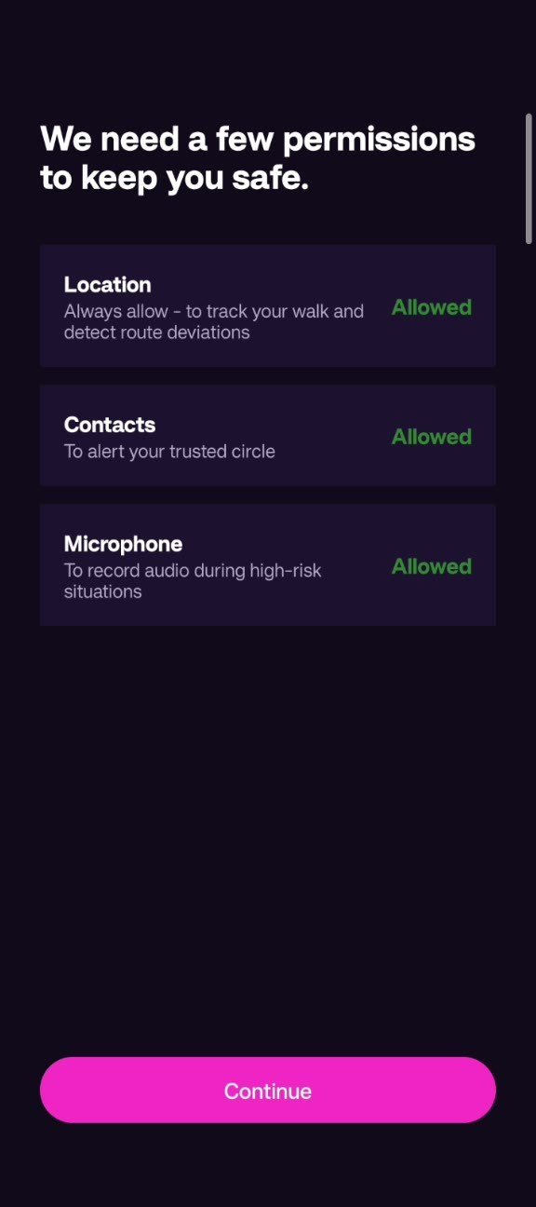
Figure 3: Sign-in / create account screen | Figure 4: Permissions setup (Location, Contacts, Microphone)
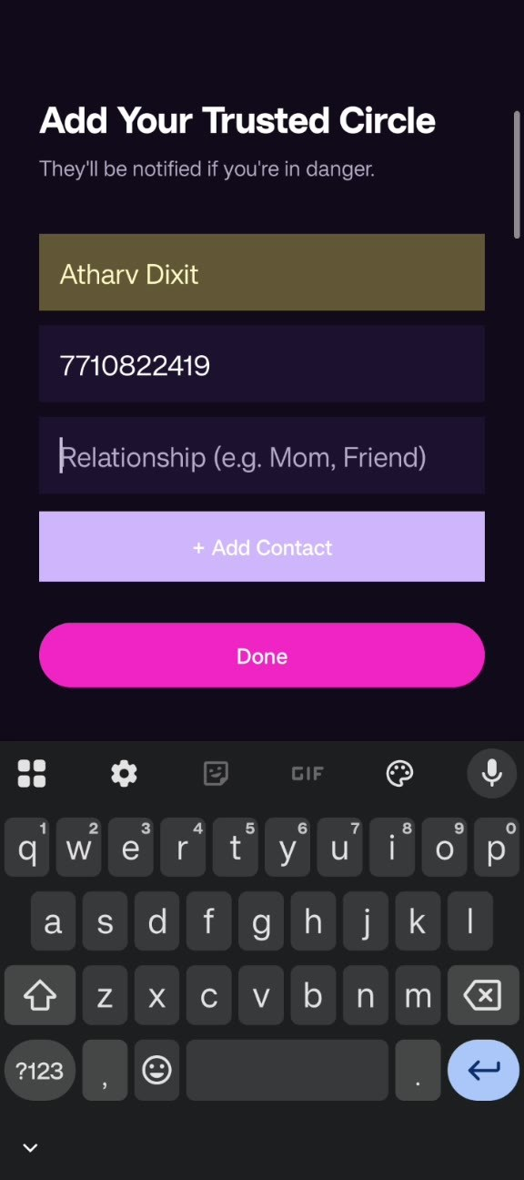 | 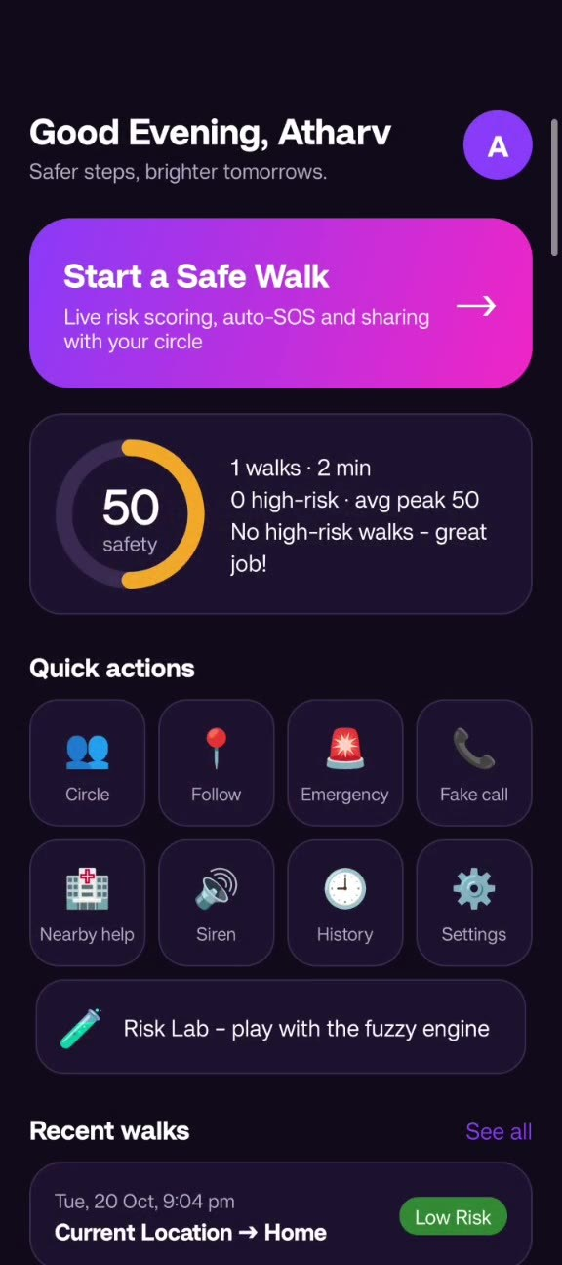
Figure 5: Trusted circle setup | Figure 6: Home Dashboard with safety score and quick actions
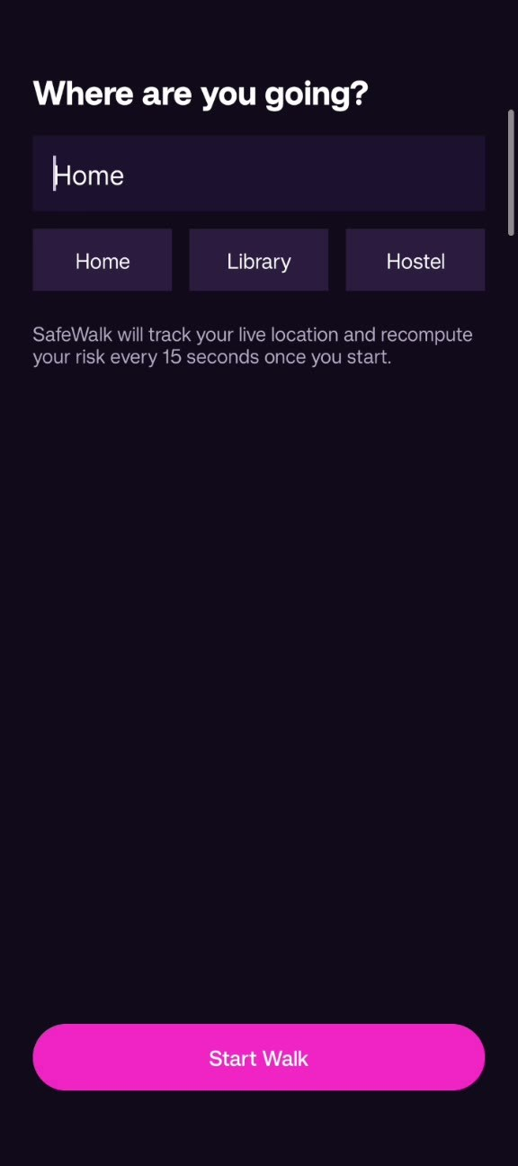 | 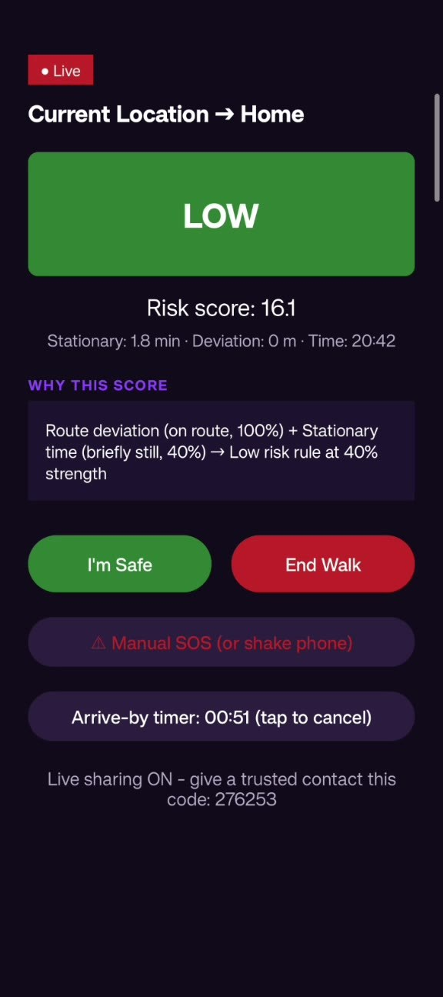
Figure 7: Start Walk: choose a destination | Figure 8: Active Walk with LOW risk and rule explanation
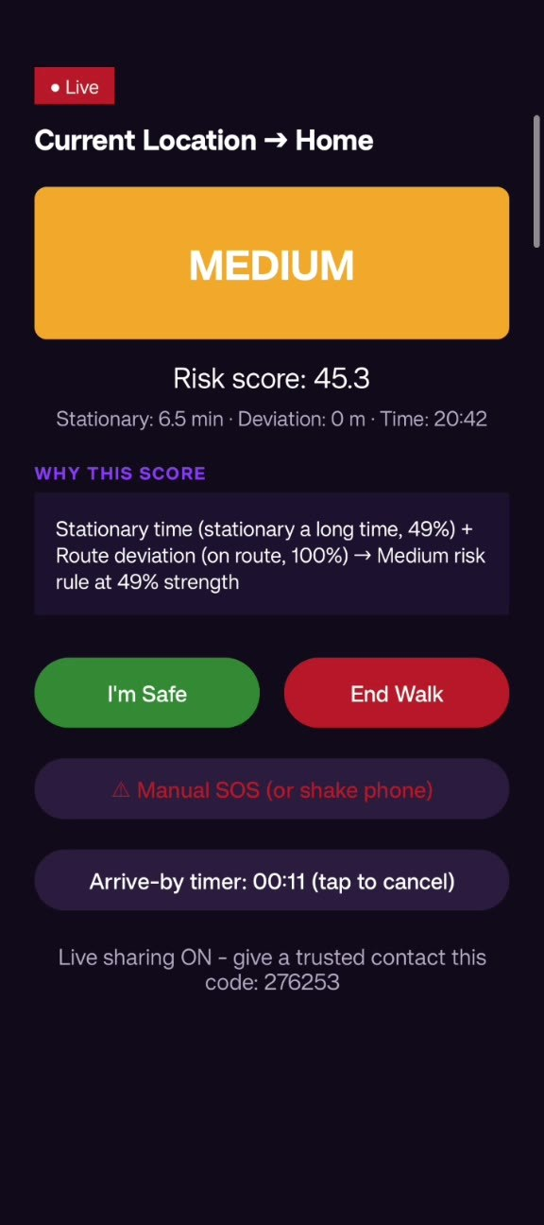 | 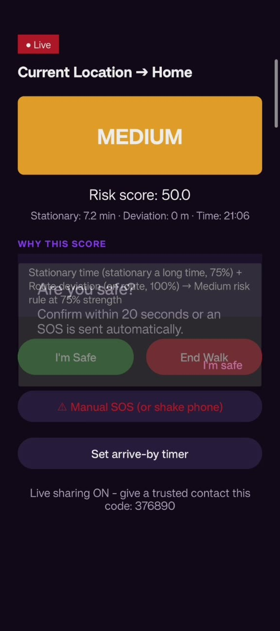
Figure 9: Active Walk with MEDIUM risk | Figure 10: “Are you safe?” confirmation prompt
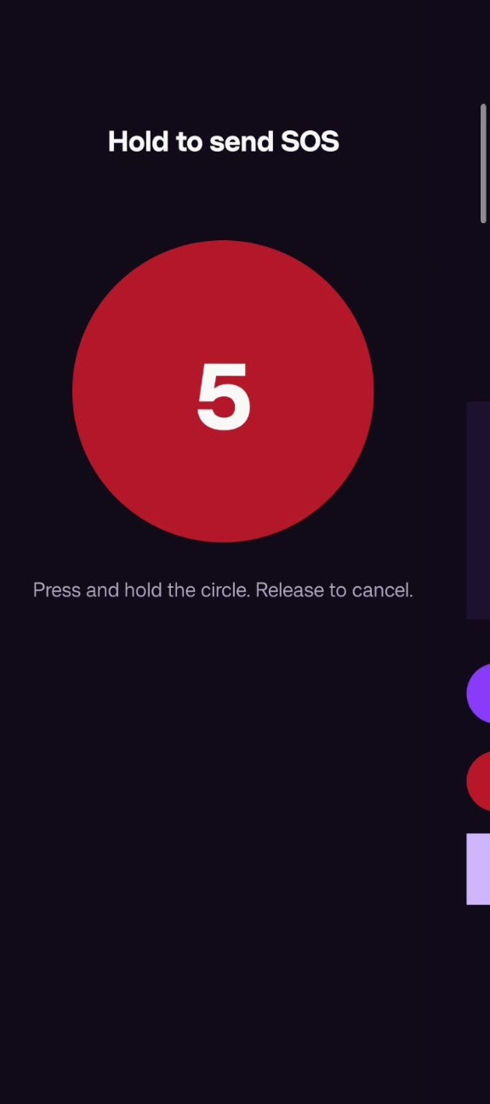 | 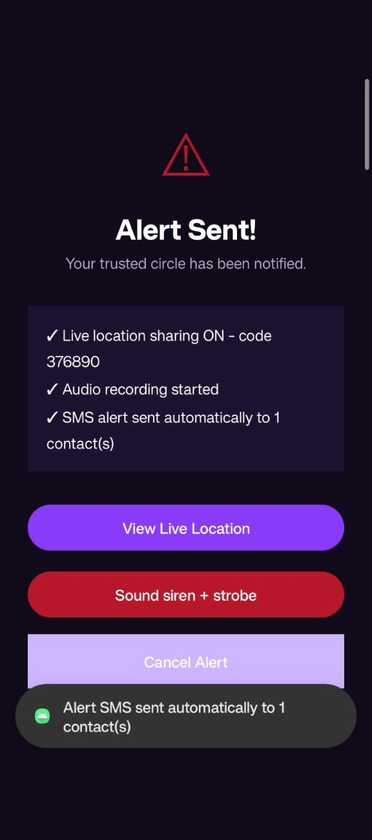
Figure 11: Hold-to-send Manual SOS | Figure 12: Alert Sent: live code and automatic SMS
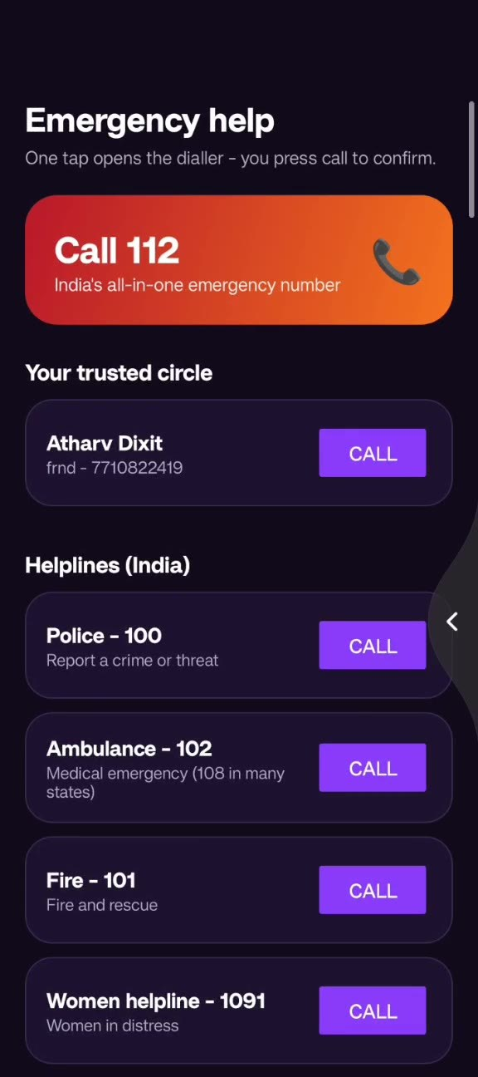 | 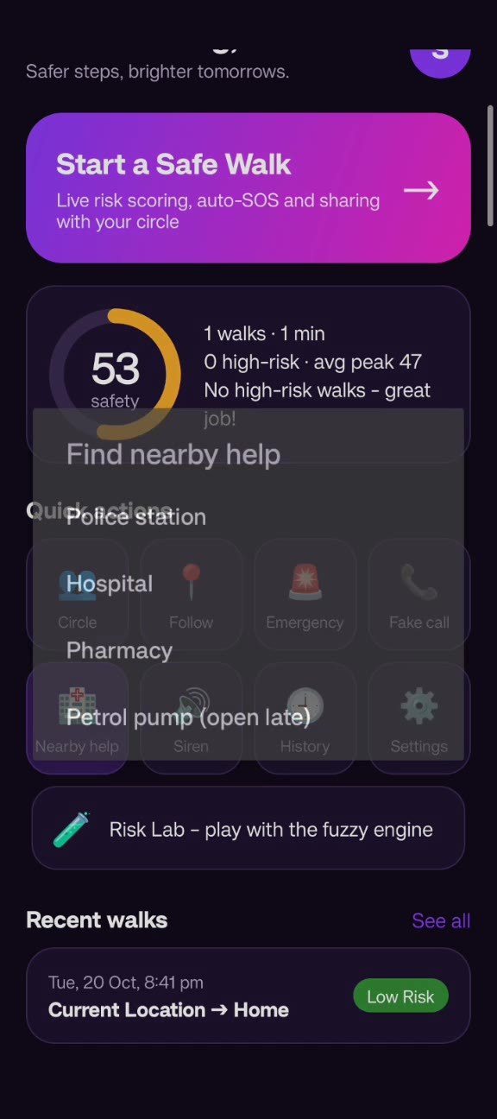
Figure 13: Emergency Help: Call 112 and helplines | Figure 14: Nearby help options
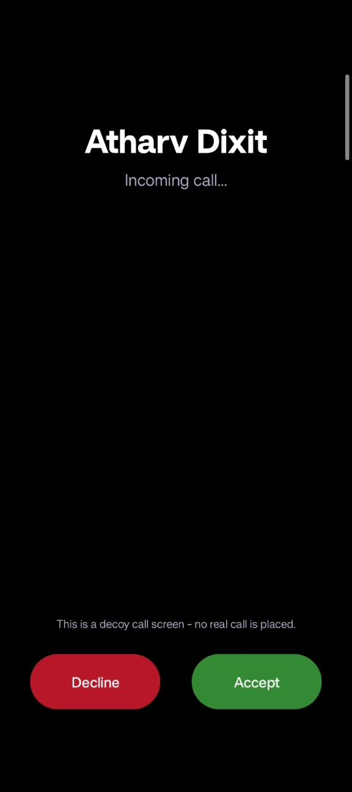 | 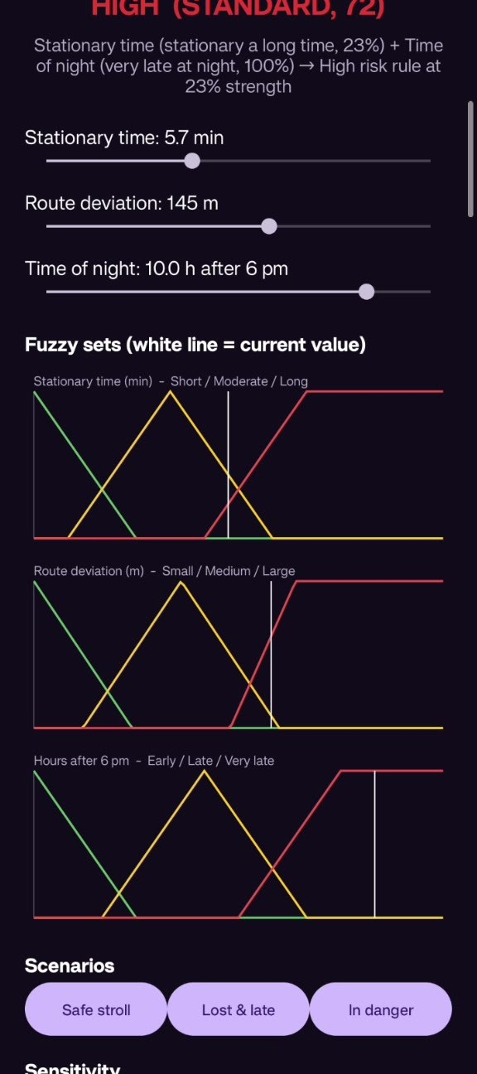
Figure 15: Fake call screen | Figure 16: Risk Lab with fuzzy-set charts
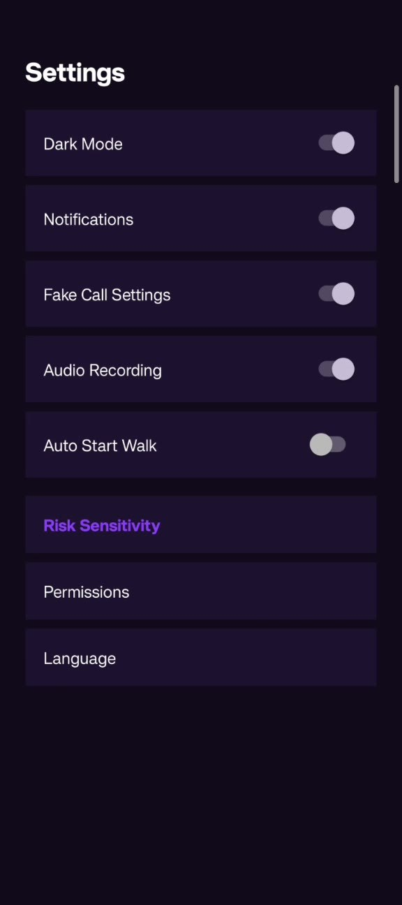 | 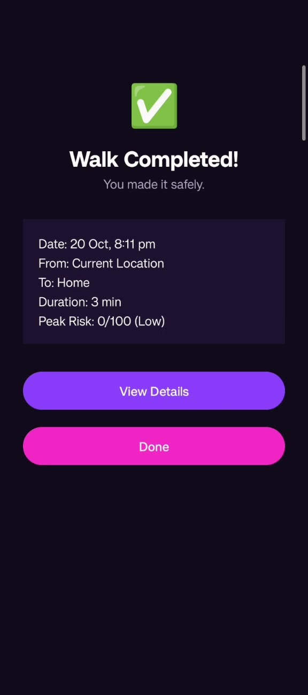
Figure 17: Settings | Figure 18: Walk Completed summary

4.3 Key Code Snippets
Three key snippets (shortened) with explanation.
Snippet 1 – Fuzzification and rule evaluation (FuzzyRiskEngine.java)
public static double triangular(double x, double a, double b, double c) {
if (x == b) return 1.0; // peak (also handles a == b spikes)
if (x <= a || x >= c) return 0.0;
if (x <= b) return (x - a) / (b - a);
return (c - x) / (c - b);
}
degrees.put("Long", rightShoulder(minutes, 5 * scale, 8 * scale));
// rule: IF stationary is Long AND night is VeryLate THEN risk is High
double strength = Math.min(deg1, deg2); // fuzzy AND
Fuzzification turns raw readings into degrees of membership. Each rule takes the minimum of its two antecedents (fuzzy AND). The scale variable shifts the set boundaries so the Cautious preset (0.75) escalates sooner and Relaxed (1.25) later, without altering the real sensor values.
Snippet 2 – Centroid defuzzification (FuzzyRiskEngine.java)
double numerator = 0.0, denominator = 0.0;
for (int x = 0; x <= 100; x++) {
double mu = 0.0;
for (FiredRule fr : fired) {
if (fr.strength <= 0.0) continue;
mu = Math.max(mu, Math.min(fr.strength, outputMembership(fr.output, x)));
}
numerator += x * mu; denominator += mu;
}
double risk = denominator > 0.0 ? numerator / denominator : 0.0;
This is Mamdani inference: each fired rule clips its output set, the clipped sets are combined with max, and the centroid of the combined area gives one crisp score from 0 to 100. The tier is then LOW below 30, MEDIUM below 65 and HIGH otherwise.
Snippet 3 – Alert intents (AlertSentActivity / EmergencyHelpActivity)
Intent sms = new Intent(Intent.ACTION_SENDTO, Uri.parse("smsto:" + phone));
sms.putExtra("sms_body", message + statusSuffix()); // battery % + maps link
startActivity(sms);
Intent call = new Intent(Intent.ACTION_DIAL, Uri.parse("tel:112"));
startActivity(call); // dialer opens; the user stays in control
Implicit intents hand SMS and calls to system apps, so SafeWalk needs no SEND_SMS or CALL_PHONE permission. statusSuffix() appends the battery level and a Google Maps link to the last known location so contacts can find the user quickly.

4.4 Testing
Test case | Input / Action | Expected result | Actual result | Pass / Fail
TC1 – Engine, nominal walk | Stationary 0 min, deviation 0 m, 0 h after 6 pm | Low risk, LOW tier | Score 13.0 → LOW | Pass
TC2 – Medium case | Stationary 4 min, deviation 90 m, 5 h after 6 pm | MEDIUM tier | Score 50.0 → MEDIUM | Pass
TC3 – Severe case | Stationary 10 min, deviation 200 m, 10 h after 6 pm | HIGH tier | Score 87.0 → HIGH | Pass
TC4 – Sensitivity | Stationary 4 min, deviation 90 m, 5 h; Cautious | Higher score than Standard | 59.1 vs 50.0 | Pass
TC5 – Daytime walk | Walk at 2 pm | Time treated as not late (clamped to 0) | Early set = 1, no late-night boost | Pass
TC6 – Login without account | Tap “Continue without an account” | Opens app in offline mode | [verify on device] | [ ]
TC7 – Shake SOS | Shake the device during a walk | Manual SOS screen then Alert Sent | [verify on device] | [ ]
TC8 – SMS alert | Trigger SOS with SEND_SMS allowed | SMS sent automatically to the trusted contact | Alert Sent showed “SMS alert sent automatically to 1 contact(s)” | Pass
TC9 – Live follow | Start walk, enter 6-digit code in Follow a walk | Follower sees tier and location updates | Without a GPS fix, record was not created; fixed to publish tier without location, retest | Fixed, retest
TC10 – Permission denied | Deny SMS permission on a real phone | App explains and does not crash | “App was denied access to SMS” shown; walk continued normally | Pass

4.5 Design and Usability Standards Followed
- Consistent colours and drawables (rounded cards, pills, ripple tiles) and Material3 theme; app_name and labels in strings.xml.
- Input validation on sign-up and contact forms (empty or invalid email, short password, invalid phone) with clear messages.
- ConstraintLayout/ScrollView screens that adapt to different sizes; large touch targets for emergency actions.
- App icon and name set; safety features work offline, and a runtime FirebaseGate prevents crashes when the cloud is unavailable.
- Safety-first UX: dangerous actions never occur silently; the user is asked first and can cancel.

5. Individual Contribution
Name & Roll No. | Screens / modules built | Other work (testing, report, design) | GitHub commits (count)
Soha Chand, I007 | Fuzzy risk engine, Active Walk monitoring and escalation, Alert Sent, Risk Lab, Firebase integration, GitHub repository | Project lead, integration, report | 3 (all commits to date, pushed from the team repository owner's account)
Atharv Dixit, I013 | Sign-up/login, permissions, trusted circle, profile and settings screens | Testing on a real Android phone, demo video recording | 0 (work was pushed through the shared repository by the owner)
Ojaswi Gondalia, I019 | Emergency Help, fake call, siren and strobe, walk history and trail views | UI testing, screenshots, documentation | 0 (work was pushed through the shared repository by the owner)

5.1 Challenges Faced and How We Solved Them
Problem / error | Who solved it | Solution
App built but Gradle sync/build failed after adding Firebase | Team | Added the Firebase BoM, Auth and Firestore dependencies in the version catalog and applied google-services only if google-services.json exists
Risk score showed LOW when the user was stationary at the start of a walk | Team | Fixed triangular() so a value exactly at the peak (a == b spike sets) returns 1.0 before the bounds check
Daytime walks scored as if late at night | Team | hoursSince6pmFromClock now clamps hours outside the 6 pm–6 am window to 0 instead of wrapping
Compile error: cannot resolve SECONDS_IN_MILLIS | Team | Used DateUtils.SECOND_IN_MILLIS
JSON crash risk when saving GPS points without a fix | Team | RiskPoint stores lat/lng only when hasLocation() is true because JSONObject.put(NaN) throws
git push failed with “Bad CPU type in executable” | Team | Used the system /usr/bin/git instead of the Intel build in /usr/local/bin

5.2 Teamwork
We are a team of three. Work was divided by module (see the table above): one member owned the risk engine and walk monitoring, one the account and onboarding flow plus real-device testing, and one the emergency tools and history views. We met in person and on WhatsApp to agree interfaces, shared the project through a single GitHub repository (all commits were pushed from one team member's account), and tested each other's screens on an emulator and a Samsung phone before the final build.

6. Conclusion and Future Scope

6.1 Conclusion
The objectives in Section 1.3 were achieved: SafeWalk estimates risk automatically with a fuzzy-logic engine, explains the result, alerts trusted contacts and offers manual safeguards, and works offline with optional cloud sync. We learned how to model uncertainty with fuzzy sets, to design offline-first apps, to use Firebase Auth/Firestore with security rules, to build custom Views, and to handle sensors, location and permissions responsibly.

6.2 Future Scope
- Real route-aware deviation using the Directions API and geofenced safe zones.
- Background foreground-service monitoring so walks continue with the screen off.
- Automatic SMS without user confirmation (with the right permissions) and push notifications to followers.
- Duress PIN, audio/video evidence capture, and a wearable companion.
- Learn personal thresholds from walk history (adaptive fuzzy sets), plus Hindi and regional-language support.

6.3 Demo / Viva Preparation
1) Log in and show the Home Dashboard. 2) Start a walk (time is sped up 8x for the demo) and let the risk rise from LOW to HIGH, showing the live explanation. 3) Show the “Are you safe?” prompt and the Alert Sent screen (SMS with map link, siren, live code). 4) Follow the walk from the Follow a Walk screen using the 6-digit code. 5) Open Walk History to show the timeline and GPS trail, and finish with the Emergency Help screen.

7. References
[1] Android Developers, “Sensors overview”, developer.android.com, accessed 2026.
[2] Android Developers, “Location and context”, developer.android.com, accessed 2026.
[3] Android Developers, “Create custom view components”, developer.android.com, accessed 2026.
[4] Android Developers, “Common intents (SMS, dial, maps)”, developer.android.com, accessed 2026.
[5] Firebase, “Get started with Authentication on Android” and “Cloud Firestore”, firebase.google.com/docs, accessed 2026.
[6] L. A. Zadeh, “Fuzzy sets”, Information and Control, 1965; E. H. Mamdani, “Application of fuzzy algorithms for control of simple dynamic plant”, Proc. IEE, 1974.
[7] MathWorks, “Fuzzy inference process”, mathworks.com, accessed 2026.
[8] Gradle, “Version catalogs”, docs.gradle.org, accessed 2026.
[9] AI tool used: Claude (Anthropic) assisted with code review, Firebase setup guidance and drafting this report; all code was built, run and checked by the student.

Appendix
Item | Link
GitHub repository | https://github.com/sohachand/SafeWalk
APK (Drive link) | https://drive.google.com/file/d/1Q3yvka0O6BzlQ0Lcax23MI0wuTTGSb74/view?usp=sharing
Demo video (3.5 min) | https://drive.google.com/file/d/11g_fvWuoiHjmCRGtabqKJRRQziLjTrya/view?usp=sharing

Declaration
We declare that this report and the application are our own work. Sources and tools we used are acknowledged in the References.
Name | Roll No. | Signature
Team | [Roll No.]

