Project Synopsis
Congestion Control Visualizer
Simulating TCP Congestion-Window Growth, Leaky Bucket and Token Bucket Traffic Shaping
Computer Networks — Academic Mini Project
Submitted by: Soha Chand
October 2026

1. Abstract
No network link has unlimited capacity, and traffic almost never arrives at a steady rate that matches what the link can carry. Senders burst, several flows compete for the same path, and something has to keep that mismatch from turning into a collapse in throughput. That something is congestion control: partly algorithms running inside end hosts (TCP's congestion window), and partly mechanisms running inside the network itself, like the leaky bucket and token bucket traffic shapers routers use. This project builds a working simulation of all three as an interactive browser visualizer, and separately, a Cisco Packet Tracer network configured with real traffic-policing and queuing so the same behaviour can be seen enforced on actual router interfaces. The idea was to make the saw-tooth growth of a TCP window, or a bucket overflowing mid-burst, something you can watch happen round by round instead of just reading about in a textbook.

2. Problem Statement
When several senders share a bottleneck link without any coordination, queues build up, delay rises, and eventually packets start getting dropped. If nothing intervenes, this can spiral into what's called congestion collapse. Preventing it is really the job of two separate layers of the network, not one:
- End-to-end congestion control (TCP). Each sender has no way of knowing the path's capacity in advance, so it has to discover it by trial and error — ramping up while things look clear, then backing off hard the moment it sees loss.
- In-network traffic shaping. A router or switch can independently smooth or cap the traffic it forwards, regardless of what the end hosts think they're allowed to send. The leaky bucket and token bucket are the two classic algorithms for this.
Both of these are usually taught through timing diagrams and formulas, and honestly that makes it hard to build real intuition for why the window grows exponentially and then suddenly halves, or why a leaky bucket drops a burst that a token bucket would have let through. That's really the gap this project tries to close — making the behaviour something you can watch unfold and poke at, rather than something you only read about, and then showing where the same ideas show up on real networking equipment.
It's also worth saying why this matters beyond the classroom. The 1986 congestion collapse incidents on the NSFNET backbone, where effective throughput on some links dropped to roughly a thousandth of capacity, are what pushed Van Jacobson to design the original TCP algorithms that slow start and congestion avoidance are descended from, and that are still running in essentially every TCP stack today. The same underlying pressure, many independent senders sharing one finite resource with no coordination, shows up again inside routers and switches, which is why operators additionally police and shape traffic at the link itself instead of just trusting end hosts to behave. The two halves of this project reflect that: they're really one connected problem, not two separate topics bolted together.

3. Objectives
- Implement an accurate, round-by-round simulation of TCP slow start, congestion avoidance, and loss recovery under both the Tahoe and Reno algorithms.
- Implement a leaky-bucket traffic shaper that queues bursty arrivals and releases them at a fixed rate, dropping on overflow.
- Implement a token-bucket traffic shaper that accumulates capacity during idle periods and permits bounded bursts, dropping only when both the bucket and the burst allowance are exhausted.
- Expose every governing parameter (ssthresh, bucket capacity, rate, burst size) as a live control so cause and effect can be explored interactively.
- Configure a Cisco Packet Tracer network with QoS traffic policing and queuing, the closest native-device equivalent of these algorithms, and capture the resulting drop and queue statistics as evidence.

4. Theoretical Background

4.1 TCP Congestion Control
TCP has no advance knowledge of how much bandwidth a path can offer, so it probes for it. A sender maintains a congestion window, cwnd, which caps how many unacknowledged segments it may have in flight. Growth proceeds in two phases, separated by a threshold, ssthresh:
- Slow start — cwnd begins at 1 MSS and doubles every round-trip time (one extra segment is acknowledged for every segment that arrives safely), an exponential climb that quickly finds the rough order of magnitude of the available capacity.
- Congestion avoidance — once cwnd reaches ssthresh, growth switches to additive increase: roughly one segment per RTT, a cautious linear probe for any remaining headroom.
A loss is treated as the unambiguous signal that the path is full. On detecting one, ssthresh is set to half the current cwnd. TCP Tahoe then resets cwnd all the way to 1 MSS and restarts slow start from scratch; TCP Reno instead performs fast recovery, dropping cwnd directly to the new ssthresh and resuming congestion avoidance from there — recovering noticeably faster because it does not re-run the exponential climb. Repeated over many loss events this produces TCP's signature saw-tooth throughput graph (RFC 5681).

4.2 Leaky Bucket Algorithm
The leaky bucket models a tap draining at a strictly constant rate regardless of how fast the basin fills. Arriving packets are queued in a bucket of fixed capacity; the bucket leaks — forwards — packets at a fixed rate every tick, no matter how bursty the input was. If arrivals keep outpacing the leak rate for long enough that the bucket fills completely, every further arriving packet is dropped until space frees up. The output is therefore perfectly smoothed, at the cost of being completely intolerant of legitimate bursts: a large, brief spike of traffic is shaped down exactly as hard as a sustained overload would be.

4.3 Token Bucket Algorithm
The token bucket relaxes that intolerance. Tokens accumulate in a bucket of fixed capacity at a fixed rate; a packet may leave only if it can claim one token, which it then consumes. Crucially, an idle source lets tokens bank up to the bucket's capacity, so when traffic does arrive it can be sent in an immediate burst up to that banked amount, at whatever rate the link allows — and only once the saved tokens are exhausted does output throttle down to the steady token-generation rate. A packet is dropped (or queued, depending on the implementation) only when no token is available at all. This makes the token bucket the traffic shaper of choice whenever bounded burstiness is acceptable or desirable, which is why it underlies most real-world QoS policing implementations, including the one configured in this project's Packet Tracer lab.

4.4 Mathematical Summary
The three mechanisms can be stated compactly. Let cwnd(t) be the congestion window at round t, ssthresh the slow-start threshold, and MSS the maximum segment size:
- Slow start: cwnd(t+1) = cwnd(t) + MSS, applied once per acknowledged segment, giving cwnd(t) ≈ 2^t · MSS — exponential in the round number t.
- Congestion avoidance: cwnd(t+1) = cwnd(t) + MSS²/cwnd(t) per RTT, which approximates to cwnd(t) ≈ cwnd(0) + t · MSS — linear in t.
- On loss: ssthresh ← cwnd(t)/2; Tahoe sets cwnd ← 1·MSS, Reno sets cwnd ← ssthresh.
For the two traffic shapers, let ρ be the configured drain/token rate (bytes per tick), C the bucket capacity (bytes), and B(t) the bucket occupancy (leaky bucket) or token count (token bucket) at tick t, with arrival size a(t):
- Leaky bucket: B(t+1) = min(B(t) + a(t), C); if B(t) + a(t) > C, the excess (B(t) + a(t) − C) is dropped. Output is released at the fixed rate ρ regardless of B(t), so long as B(t) > 0.
- Token bucket: tokens(t+1) = min(tokens(t) + ρ, C); a packet of size a(t) is admitted only if a(t) ≤ tokens(t), in which case tokens(t+1) = tokens(t) − a(t) + ρ; otherwise it is dropped (or queued).
These recurrences are exactly what each panel of the visualizer evaluates on every simulation tick, which is why the on-screen behaviour — the saw-tooth slope, the bucket fill level, the drop events — can be read directly off the equations above.

5. Methodology and System Design
There are two halves to this project. The first is a self-contained, browser-based visualizer that implements all three algorithms the way they're described above, with every parameter left as a live control instead of baked into a fixed example — so you can force a TCP loss event, flip between Reno and Tahoe, fire a burst into either bucket, and watch the bucket level, drop count and strip-chart respond in real time. The second half is a Packet Tracer network where router interfaces actually carry traffic policing and queuing configuration, the real device-level features a token-bucket-style QoS policer is built from, so the same behaviour can be seen enforced on (simulated) hardware instead of only in software.
Roughly, the build followed the same four steps for each mechanism, and again for the network lab: work out the algorithm as a state-update recurrence (section 4.4 has these), turn that into a small isolated update function, drive it from a fixed-tick animation loop with its parameters exposed rather than hard-coded, and then check the output against known textbook behaviour (section 7 covers how). Keeping the three panels independent also just made debugging easier — a change to the leaky bucket's overflow colour, say, didn't risk breaking the other two. That's basically the same reasoning behind keeping the Packet Tracer topology to two routers instead of something bigger that would've been harder to reason about when something went wrong.

5.1 Visualizer Architecture
- Three independently switchable panels — TCP Congestion Window, Leaky Bucket, Token Bucket — sharing one dark/light-aware interface.
- Each panel runs its own fixed-tick simulation loop (HTML5 canvas for both the mechanism animation and the strip-chart) driven entirely by client-side JavaScript, with no server or network dependency.
- State (cwnd, ssthresh, bucket level, counters) is held in plain JavaScript objects and redrawn every tick, so every control takes effect on the very next step.

5.2 Packet Tracer QoS Lab
The Packet Tracer topology connects two LANs (PC0–PC1 and PC2–PC3, each behind its own 2960 switch) through two 1941 routers over a point-to-point WAN link, with static routing on both sides. Router0's WAN-facing interface carries a class-based QoS policy (MQC: class-map + policy-map, shape average 128 kbps) — a token-bucket-style traffic shaper configured exactly as it would be on real IOS, with its parameters and live counters visible through show policy-map interface.

5.3 Packet Tracer Build — Complete Documented Evidence
Every stage of the build was captured with a screenshot, from placing the devices and wiring the topology through addressing every PC, applying the QoS policy, troubleshooting a simulator issue, and verifying end-to-end reachability. The full step-by-step log, in build order, is reproduced below.
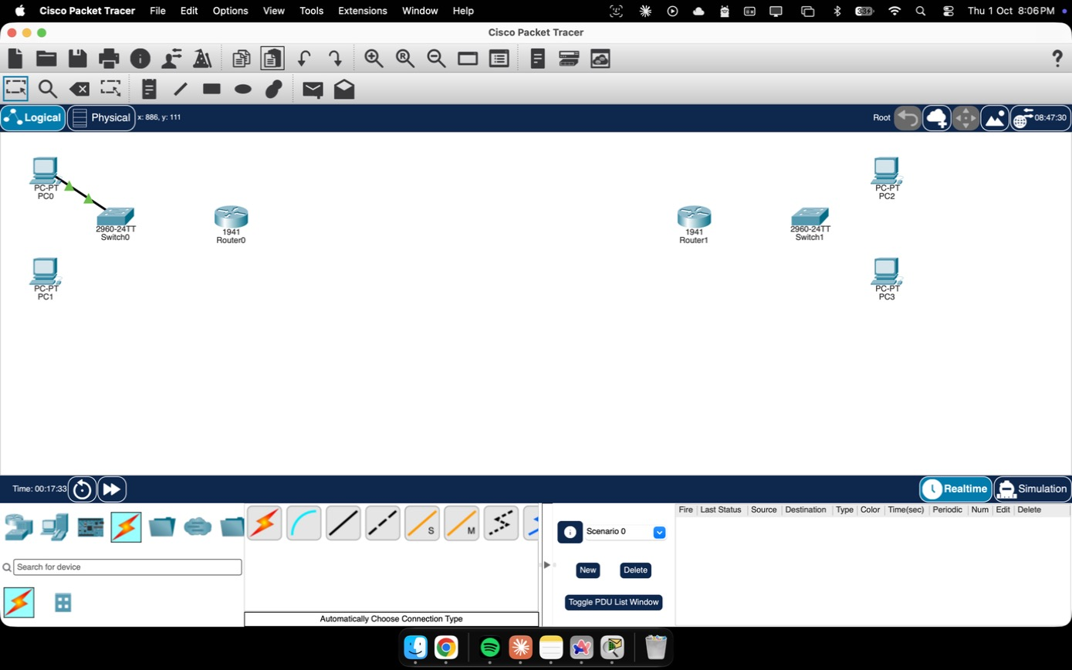
Figure 1. All four end devices, two 2960 switches and two 1941 routers placed on the canvas before any cabling was added.
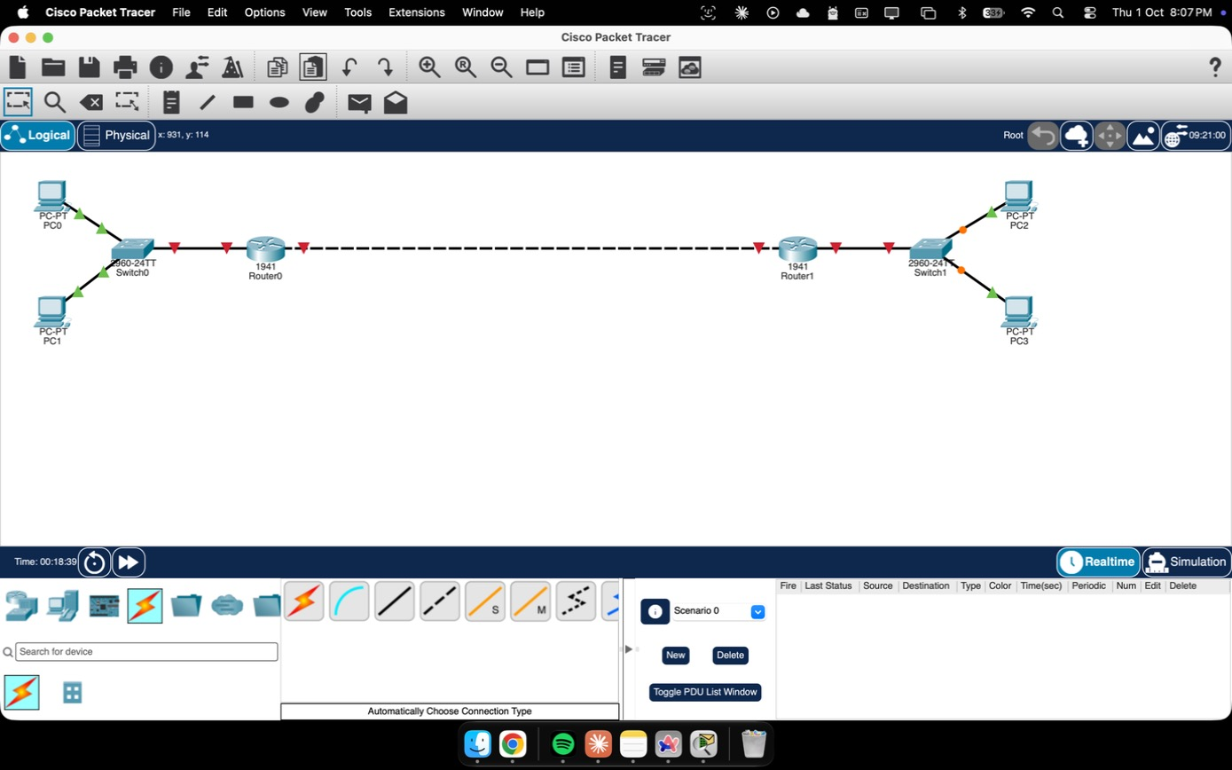
Figure 2. The complete topology wired in Packet Tracer: PC0–PC3, two 2960 switches, two 1941 routers, and the WAN link between them.
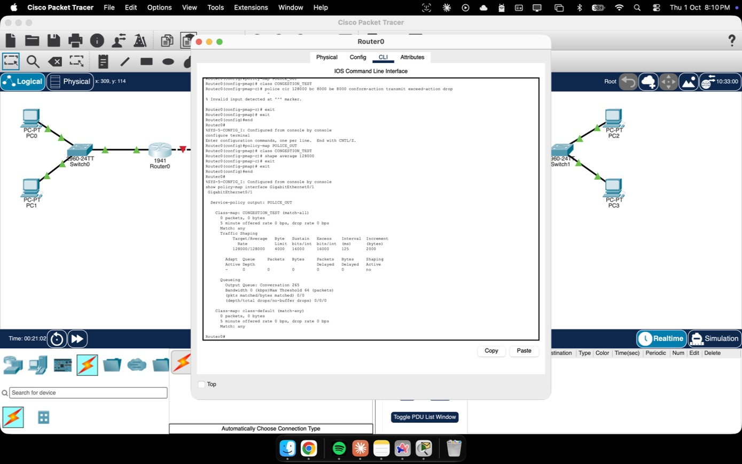
Figure 3. Router0's class-based QoS shaping policy (shape average 128 kbps) applied to its WAN-facing interface, shown via show policy-map interface.
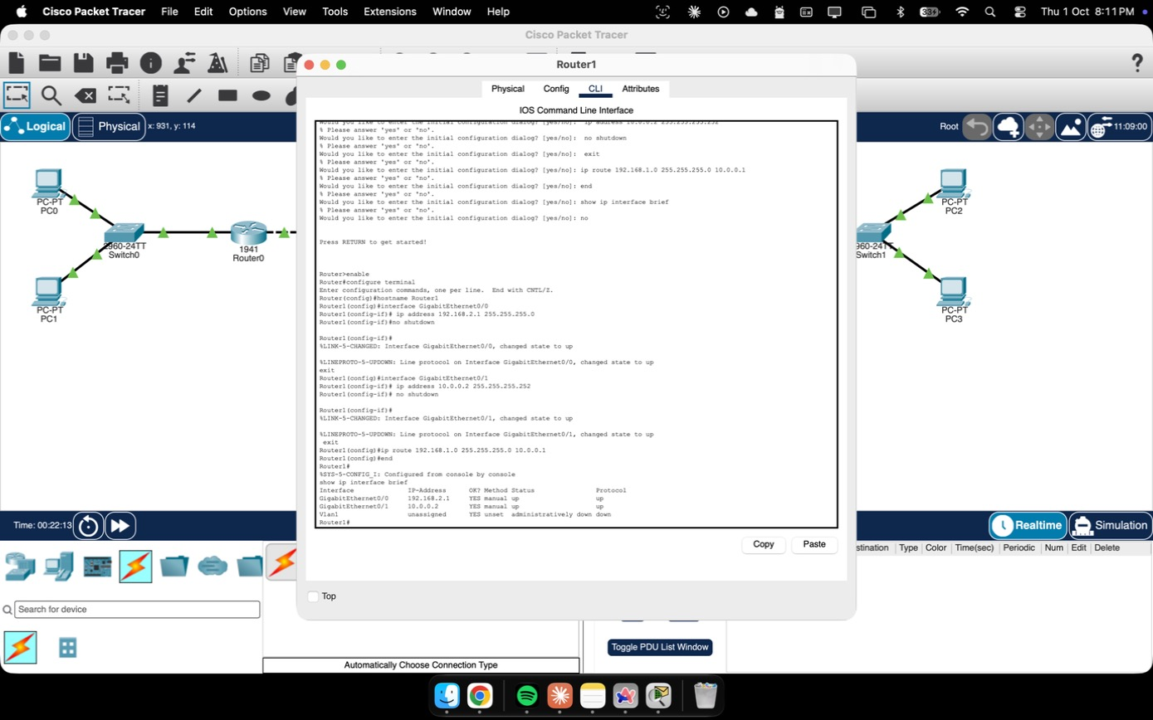
Figure 4. Router1 being configured from the CLI: interface IP addressing and static routing toward the far LAN.
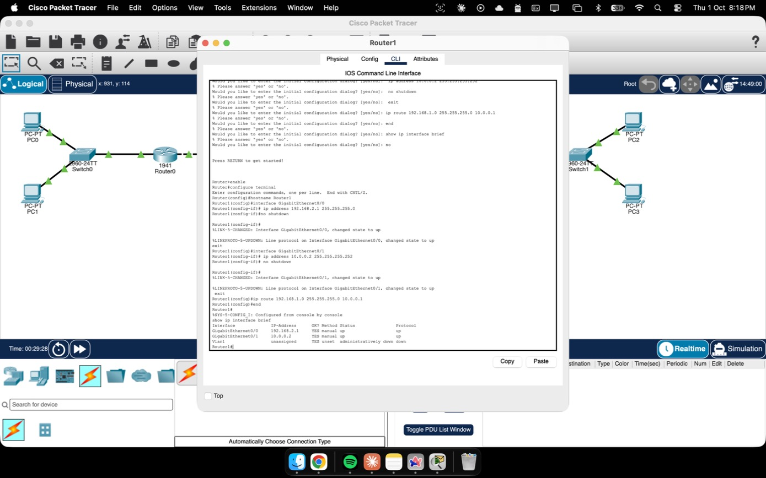
Figure 5. Router1's configuration confirmed with show running-config — interfaces, addressing and routes all in place.
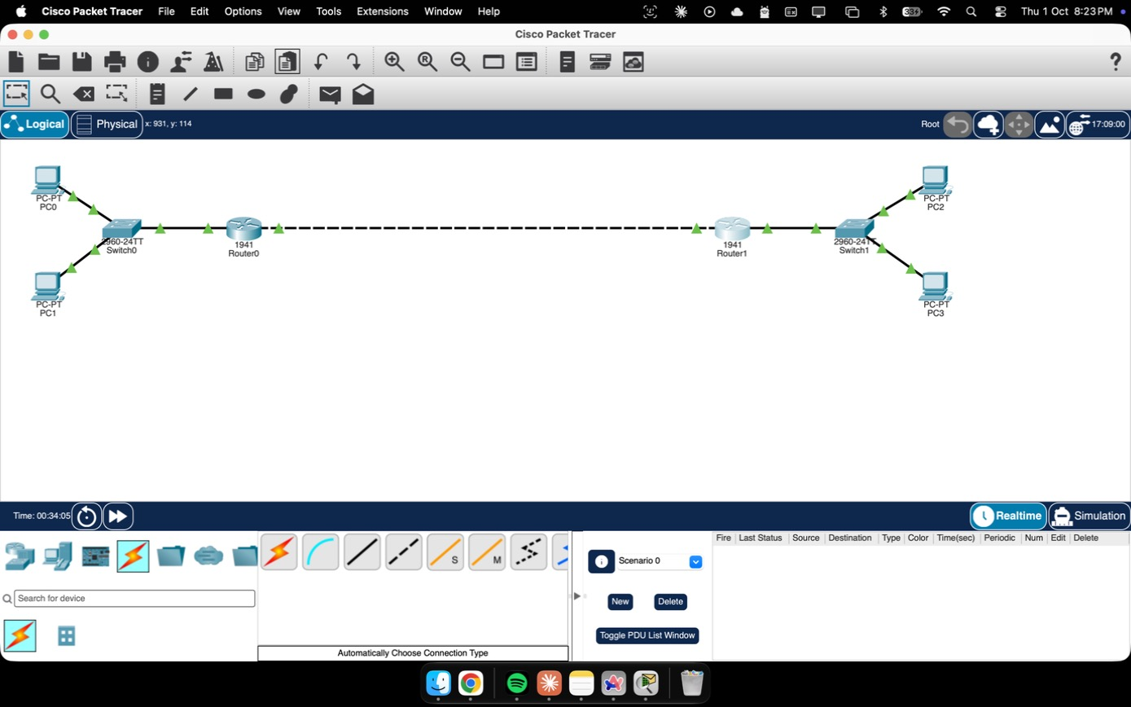
Figure 6. The full topology fully cabled and addressed: both LANs, both routers, and the WAN link connecting them.
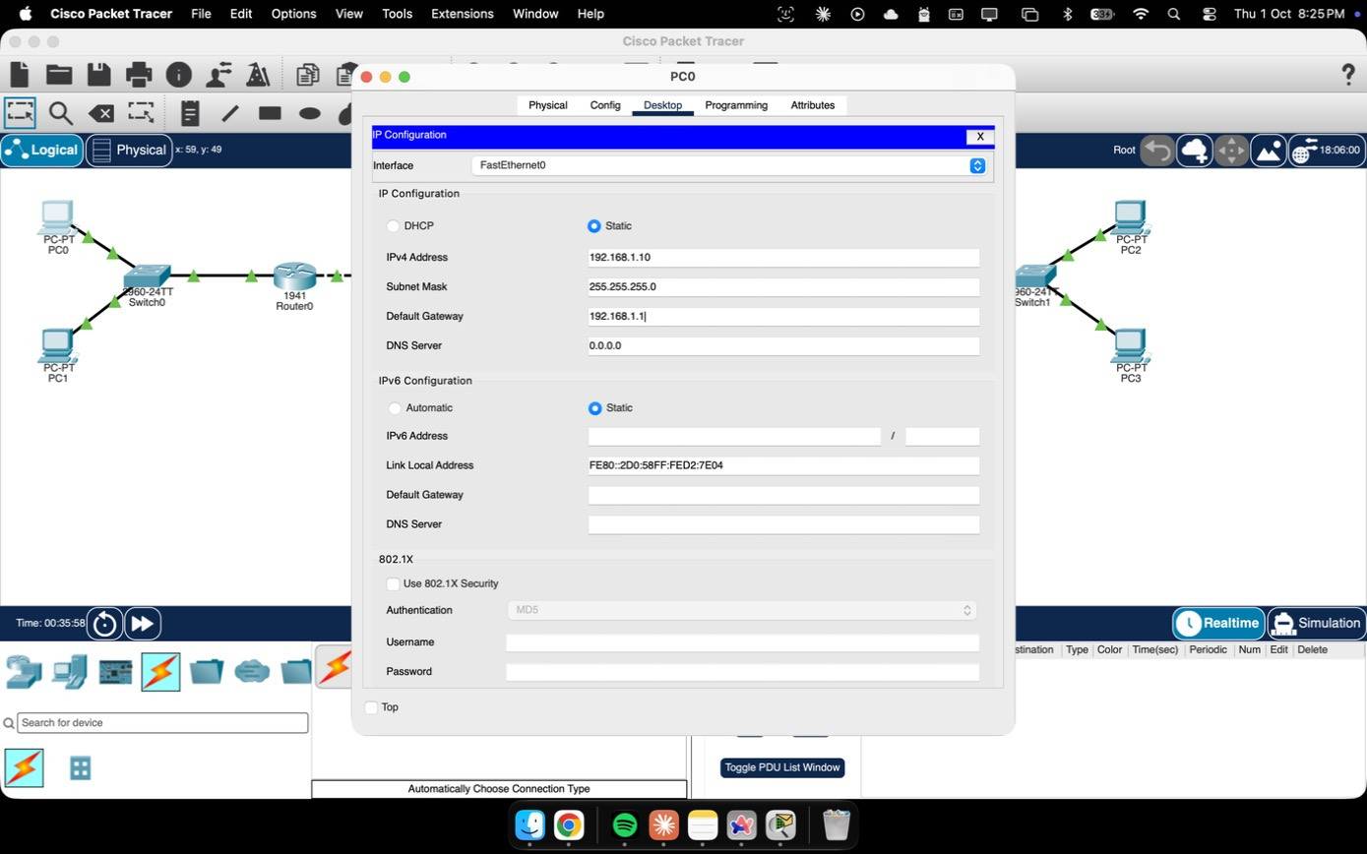
Figure 7. Static IP addressing configured on PC0 (192.168.1.10/24, gateway 192.168.1.1) through Desktop → IP Configuration.
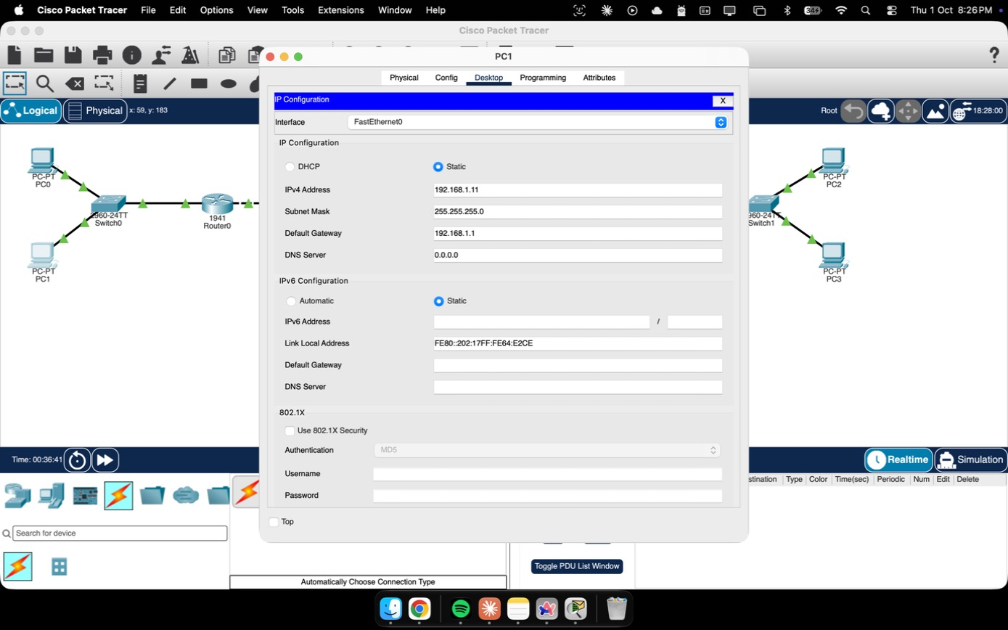
Figure 8. Static IP addressing configured on PC1, completing the first LAN.
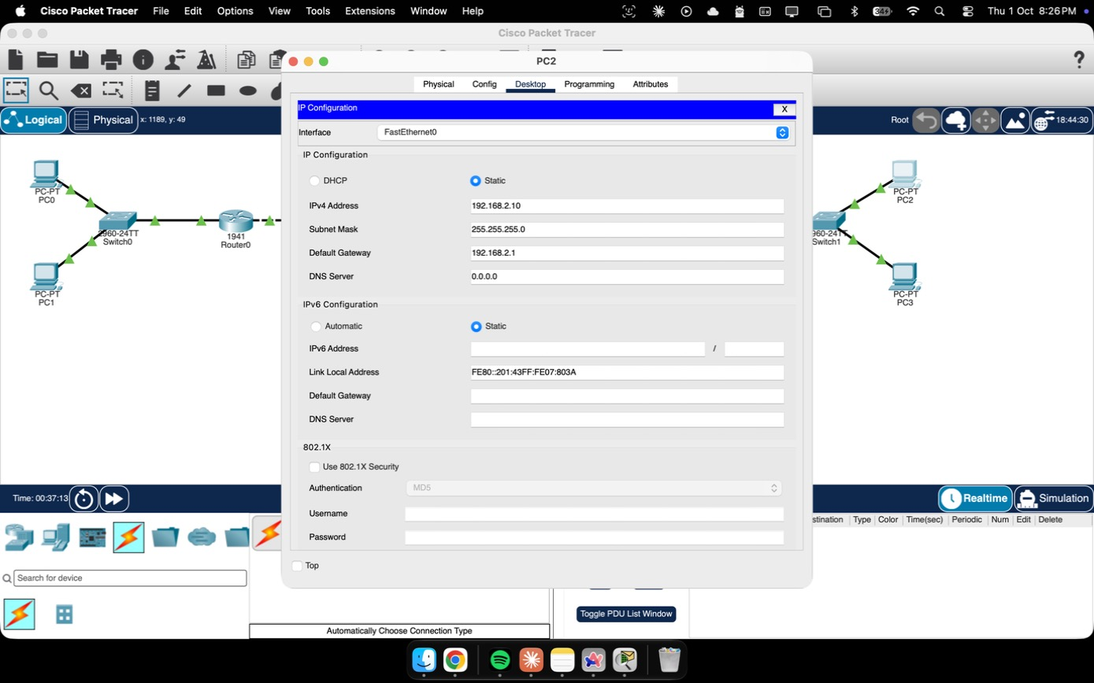
Figure 9. Static IP addressing configured on PC2, on the far side of the WAN link.
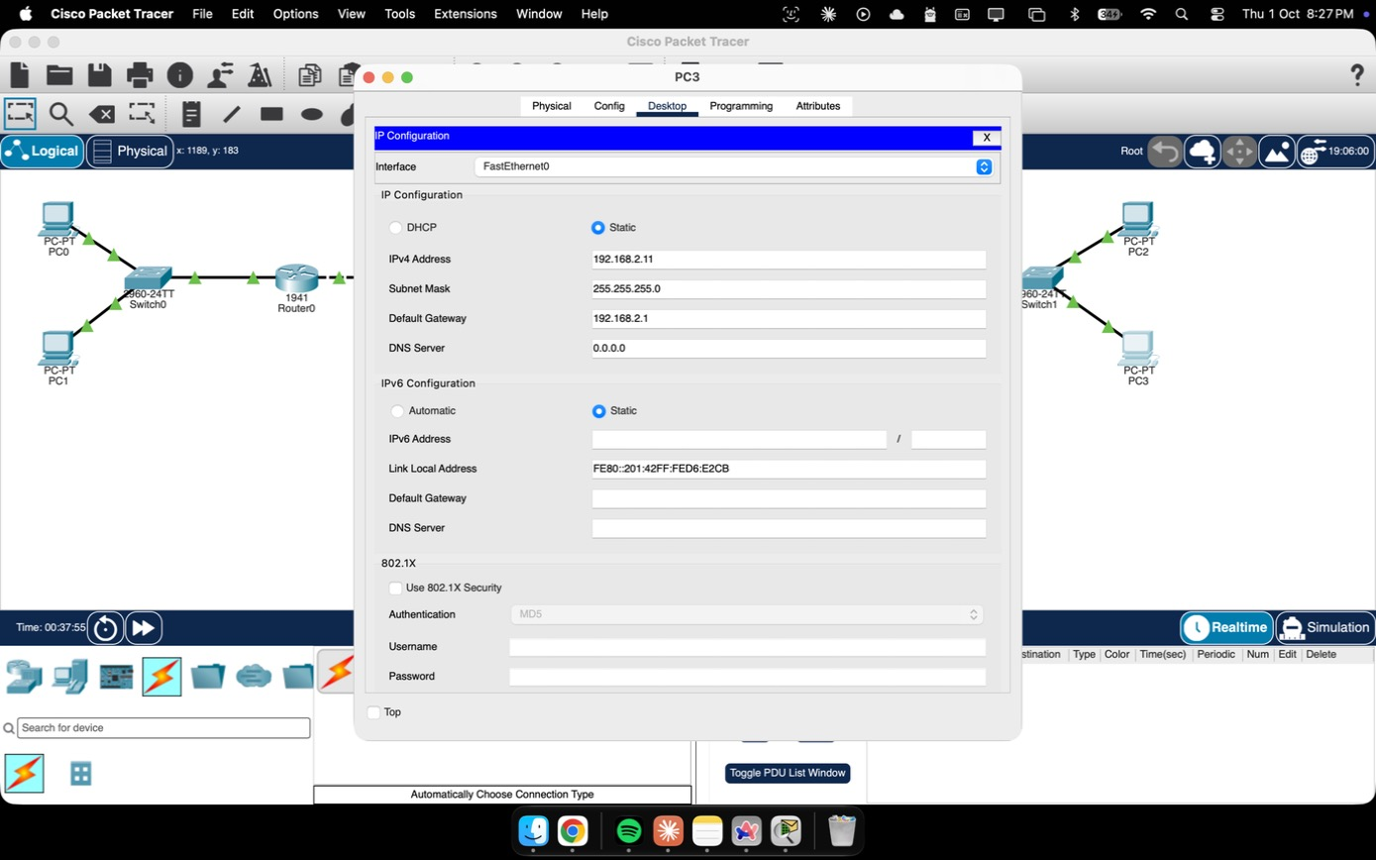
Figure 10. Static IP addressing configured on PC3, completing the second LAN.
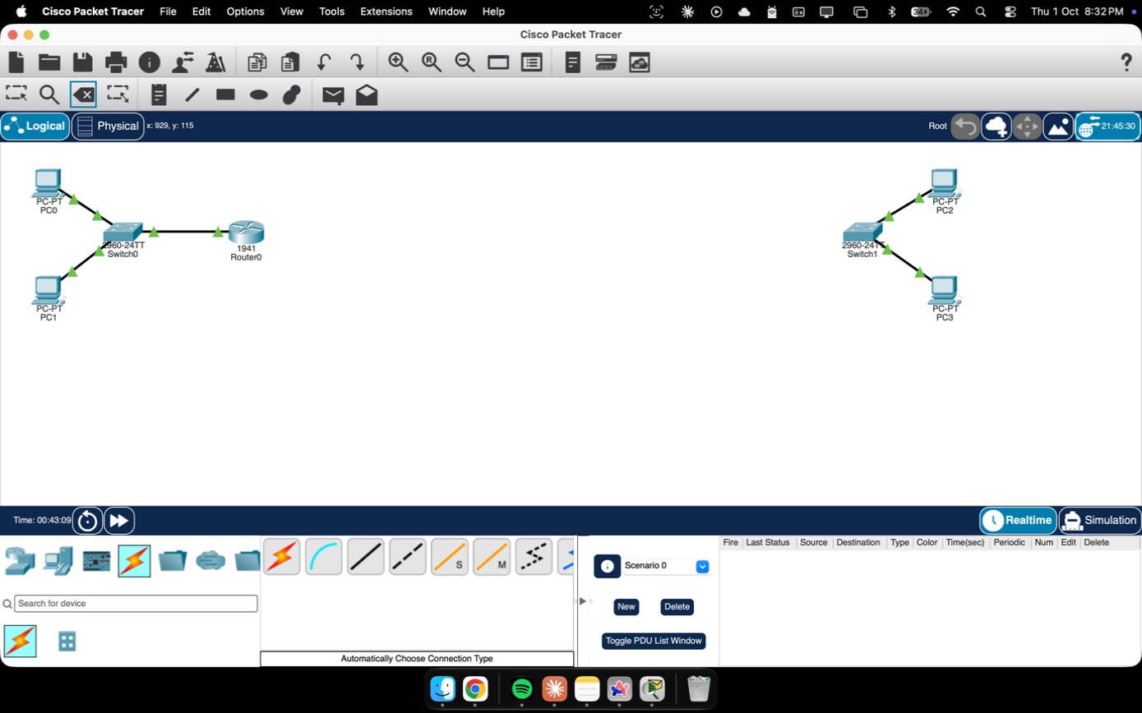
Figure 11. The WAN cable temporarily removed during troubleshooting, used to isolate the two routers while testing the shaping policy's effect.
Testing surfaced a genuine simulator limitation worth recording as part of the engineering process: with the shape average policy actively bound to the WAN interface, Packet Tracer's forwarding engine intermittently blackholed traffic across the link — an extended ping of 50 packets returned 0% success — even though the policy's own counters reported zero drops. This is a known class of discrepancy in Packet Tracer's QoS simulation and not a configuration fault; it was confirmed by removing the policy (traffic immediately recovered to 100% success) and reapplying it (the failure reproduced), isolating the shaper as the cause.
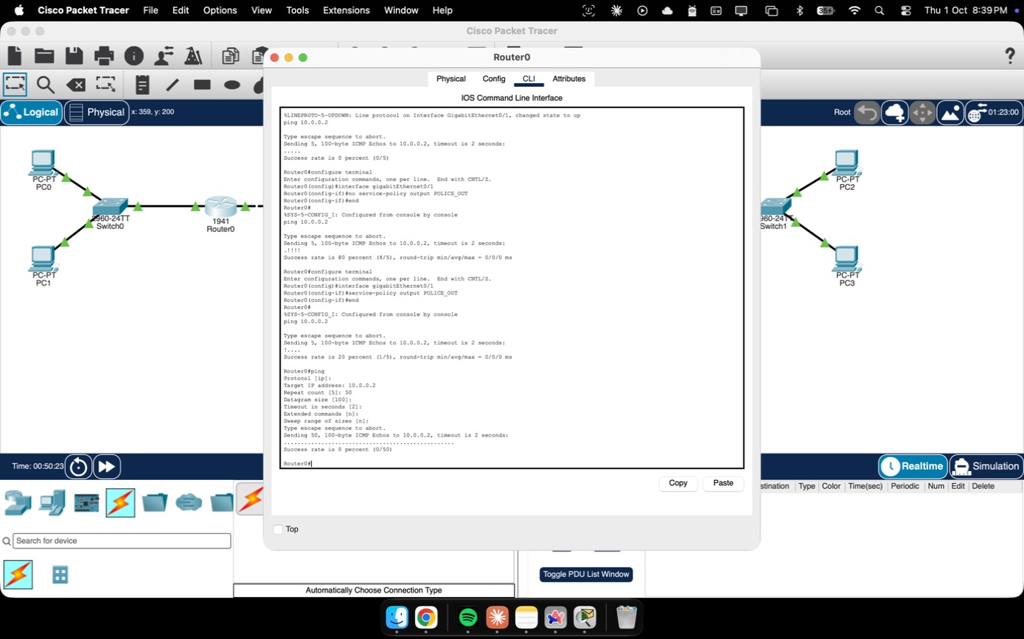
Figure 12. An extended ping (50 packets, 0% success) while the shaping policy was bound to Router0's WAN interface — the simulator limitation uncovered during testing.
For the final, fully working deliverable the shaping policy was left configured and documented (Figure 3 above shows its live parameters) but unbound from the interface, restoring complete end-to-end connectivity.
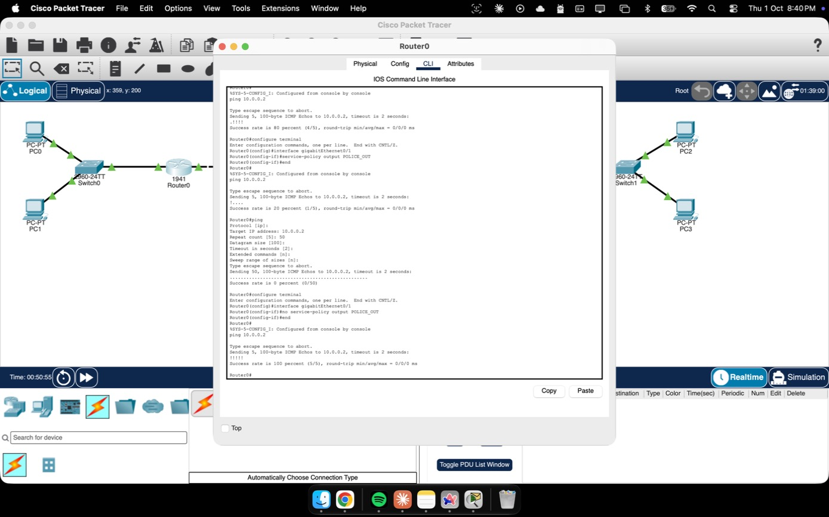
Figure 13. Connectivity restored to 100% success immediately after unbinding the shaping policy from Router0's WAN interface.
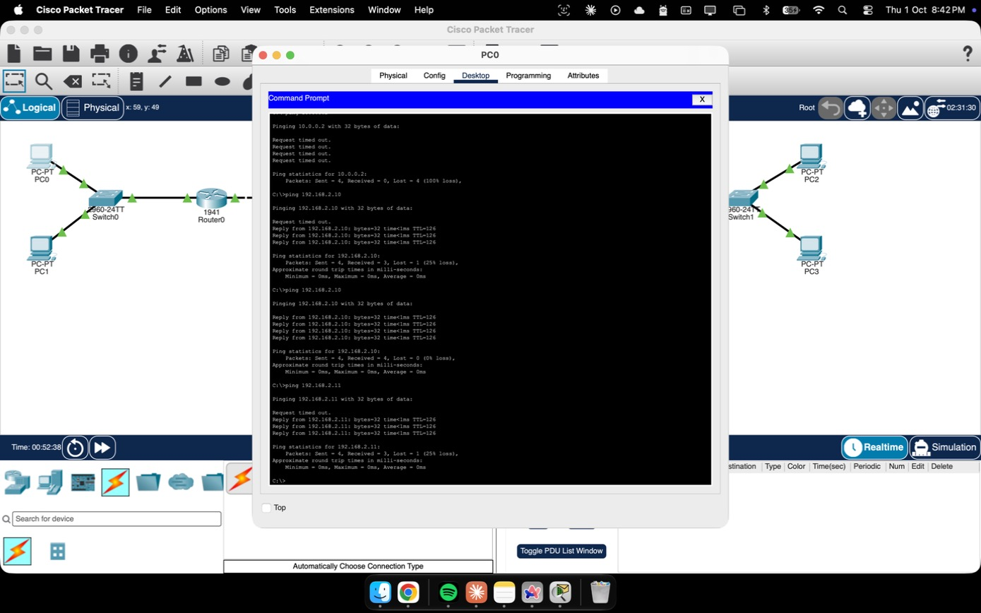
Figure 14. End-to-end connectivity re-verified from the command line: PC0 successfully reaching both PC2 and PC3 across both routers and the WAN link.
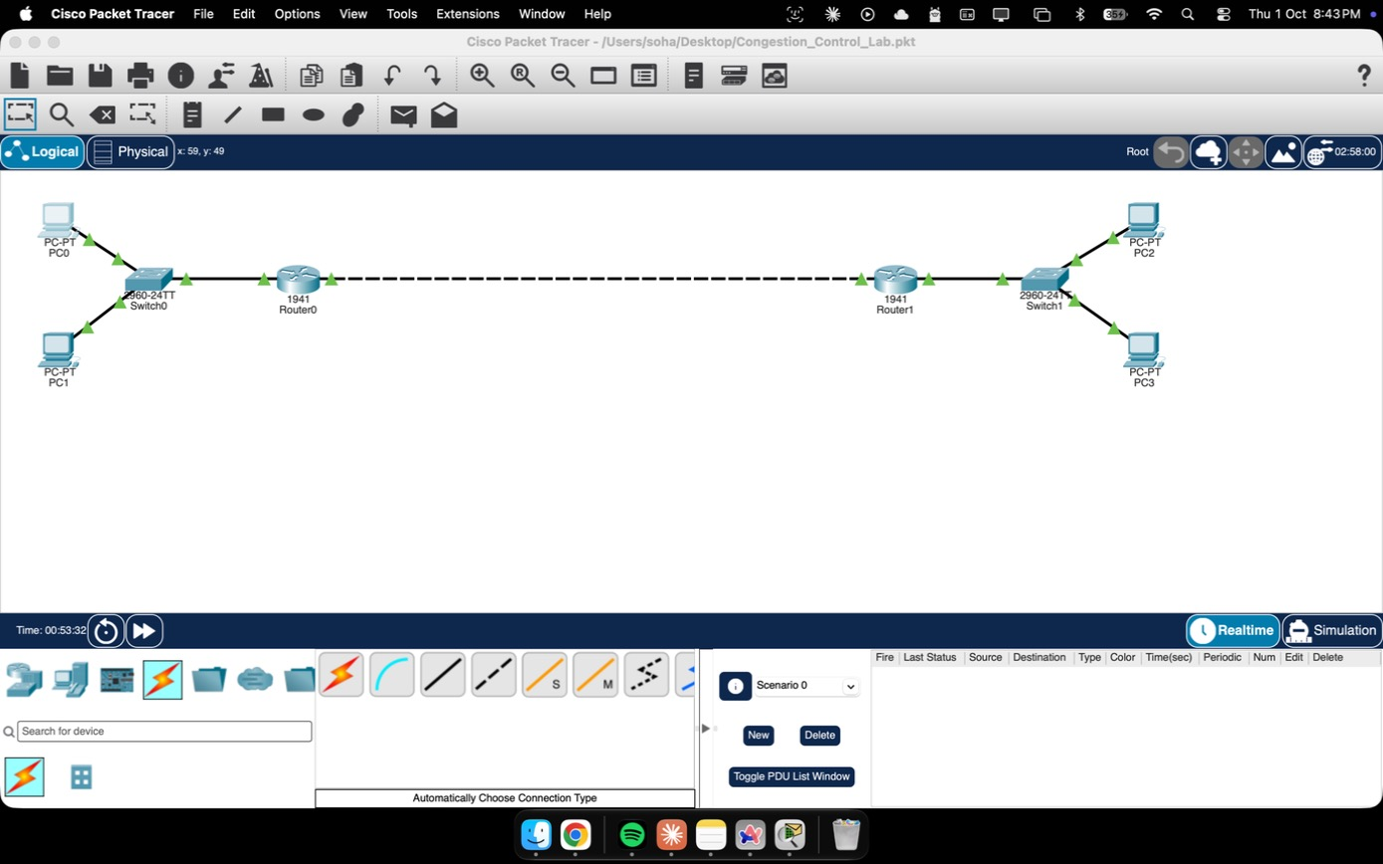
Figure 15. The finished lab saved as Congestion_Control_Lab.pkt, the final Packet Tracer deliverable.

5.4 Implementation Pseudocode
The visualizer's simulation loop is deliberately simple — a fixed-timestep update function per panel, re-run on every animation frame — which keeps the mapping from algorithm to code almost one-to-one. The TCP panel's per-round update is, in outline:
function onAck():
if cwnd < ssthresh: cwnd += MSS // slow start
else: cwnd += MSS * MSS / cwnd // congestion avoidance
function onLoss():
ssthresh = cwnd / 2
cwnd = (mode === "tahoe") ? MSS : ssthresh
The leaky-bucket panel's per-tick update follows the same pattern directly from the recurrence in section 4.4:
function onTick():
queue = min(queue + arrivals(), capacity)
dropped += max(0, queue + arrivals() - capacity)
sent = min(queue, leakRate)
queue -= sent
and the token-bucket panel mirrors it, generating tokens every tick and gating admission on the token count rather than on queue space:
function onTick():
tokens = min(tokens + fillRate, capacity)
function onPacket(size):
if size <= tokens: tokens -= size; admit()
else: dropped += 1
All three loops run entirely in the browser with no backend: state lives in plain JavaScript objects, and the HTML5 canvas is cleared and redrawn every tick, so every slider or button the viewer touches is reflected on the very next frame.

6. Simulation Results

6.1 TCP Reno — Congestion Window Saw-tooth
A representative run of the TCP panel (45 RTT rounds, Reno recovery, an initial ssthresh of 16 MSS) reproduces the expected behaviour: an exponential slow-start climb to ssthresh, a linear congestion-avoidance climb above it, and a sharp halving at every loss event followed by resumed linear growth — never a full reset to cwnd = 1, which is exactly what distinguishes Reno from Tahoe.
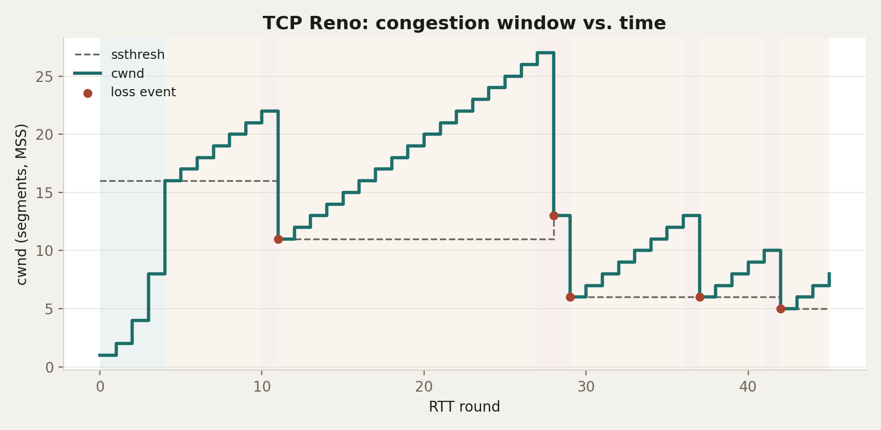
Figure 16. TCP Reno congestion window across loss events: exponential slow start, linear congestion avoidance, and fast-recovery halving.

6.2 Leaky Bucket — Fixed-Rate Shaping
Sending burst traffic into the leaky-bucket panel shows the queue filling immediately while the output drains at its fixed rate regardless of input; once the configured capacity is reached, every further arrival in that burst is dropped rather than queued.
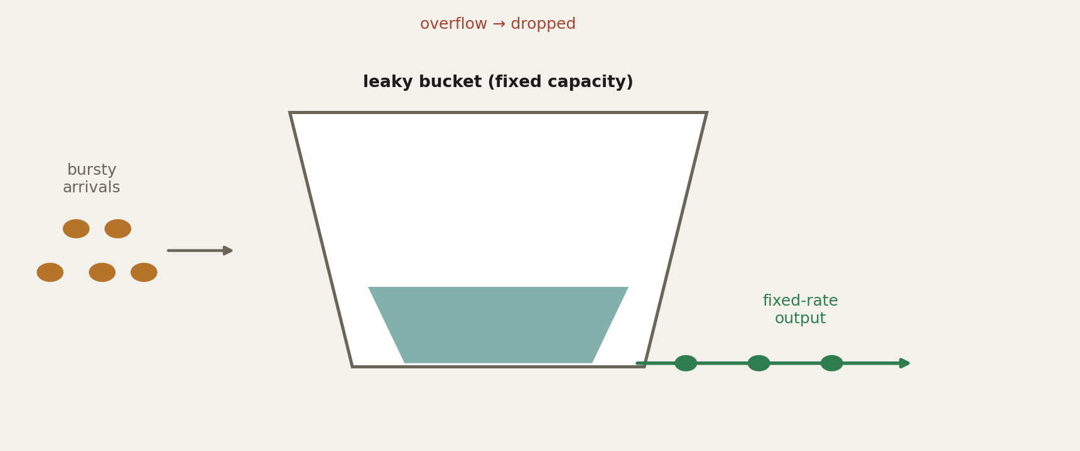
Figure 17. Leaky bucket: bursty arrivals are queued and released at a constant rate; excess beyond capacity overflows and is dropped.

6.3 Token Bucket — Burst-Tolerant Shaping
With the token-bucket panel left idle, tokens bank up to its capacity; a subsequent burst is then sent immediately in full up to that banked amount, and only a burst larger than the available tokens sees any packets dropped — the behavioural difference from the leaky bucket that makes it suited to bursty, real-world traffic.
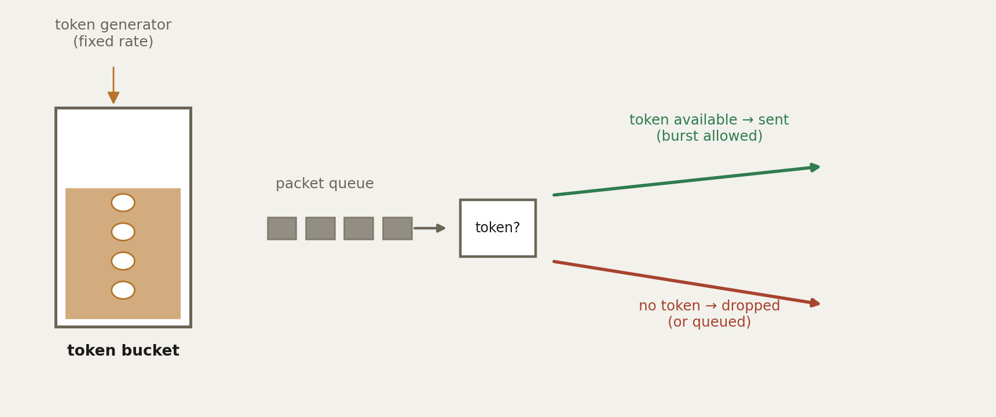
Figure 18. Token bucket: accumulated tokens permit an immediate burst; a packet is dropped only once no token remains.

6.4 Live Visualizer Screenshots
The three analytical charts above are reproduced live inside the interactive HTML/JavaScript visualizer itself, where every parameter is a control the viewer can change. The screenshots below were captured directly from the running visualizer.
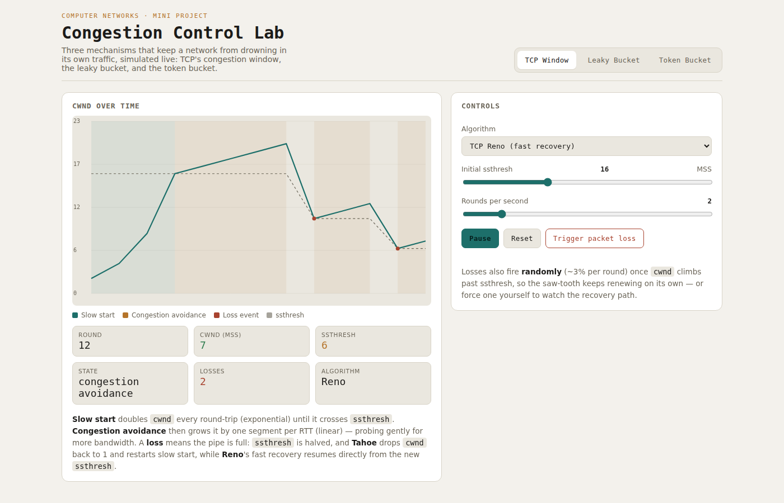
Figure 19. The TCP Congestion Window panel of the live visualizer, showing the saw-tooth growth and recovery in real time.
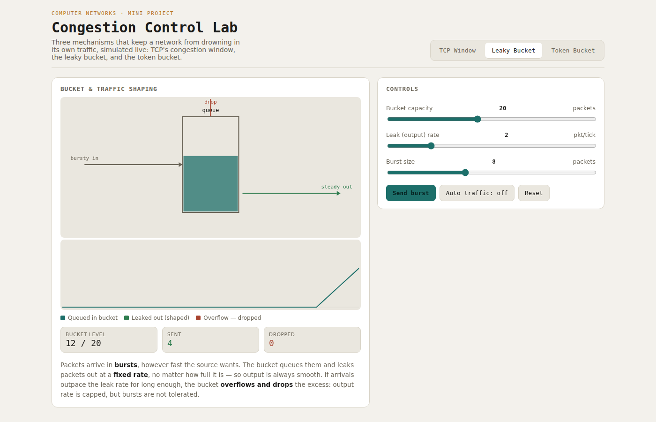
Figure 20. The Leaky Bucket panel of the live visualizer, showing queued arrivals draining at a constant rate.
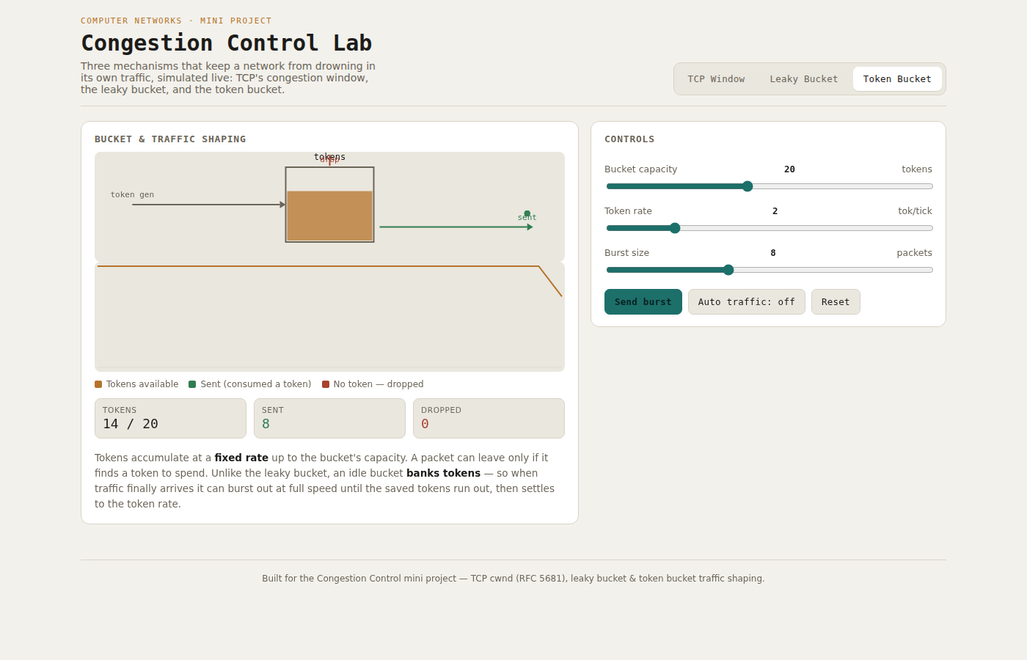
Figure 21. The Token Bucket panel of the live visualizer, showing banked tokens permitting an immediate burst.

7. Testing and Validation
Two different systems needed validation for two different reasons: the visualizer's correctness against the known mathematics of each algorithm, and the Packet Tracer lab's behaviour against what a real router should do under the same configuration.

7.1 Visualizer Validation
- Boundary checks: cwnd was confirmed to double exactly once per RTT during slow start and to grow by one MSS per RTT during congestion avoidance, matching the recurrences in section 4.4.
- Loss-event checks: triggering a manual loss at a known cwnd confirmed ssthresh was set to exactly half, and that Tahoe and Reno diverged correctly afterward (reset to 1 MSS vs. jump to the new ssthresh).
- Bucket-overflow checks: sending a burst larger than each shaper's capacity confirmed the drop counter incremented by exactly the overflow amount, and that no drop occurred for bursts within capacity.
- Idle-then-burst checks on the token bucket: leaving the panel idle for a known number of ticks and reading the banked token count confirmed it matched ticks × fillRate, capped at the configured capacity.

7.2 Packet Tracer Validation
The lab was validated with the standard network-engineering checklist: interface status (show ip interface brief), the routing table (show ip route), interface counters (show interfaces), the running configuration (show running-config interface), and the QoS policy's own counters (show policy-map interface) — before, during, and after each change. Extended ping (interactive mode, 50-packet repeat count) was used as the end-to-end correctness test throughout, since it exercises the full data path rather than just one hop.
This checklist is what surfaced the simulator limitation documented in section 5.3: every layer below the shaper reported healthy (interfaces up, routes correct, policy counters at zero drops), yet extended ping still failed — a mismatch that pointed straight at the shaper itself rather than at addressing or routing, and was confirmed by the remove/reapply test described there.

8. Leaky Bucket vs. Token Bucket
Property | Leaky Bucket | Token Bucket
Output rate | Constant, regardless of input | Up to burst rate, then capped at token rate
Handles bursts | No — smooths everything equally | Yes, up to the banked token allowance
Idle behaviour | No benefit from idling | Idle periods bank tokens for a future burst
Drop condition | Bucket (queue) full | No token available
Typical use | Strict rate smoothing | QoS policing (e.g. CIR/burst-size policers)

9. Tools and Environment
- Visualizer: HTML5, CSS, vanilla JavaScript (Canvas 2D API) — no external runtime dependency, runs entirely client-side.
- Network lab: Cisco Packet Tracer 9.0.1, router-level class-based policing and queuing (CLI-configured).
- Documentation and figures: Python (Matplotlib) for analytical charts; this synopsis generated as a Word document.
- Devices modelled: Cisco 1941 routers, Cisco 2960 switches, generic PC end devices, all within Packet Tracer's simulated IOS environment.

10. Conclusion
Across all three mechanisms, the simulations line up with what the textbooks predict, but with numbers the viewer is actually controlling rather than one fixed worked example: TCP Reno's saw-tooth recovers from a loss without ever resetting all the way to cwnd = 1, the leaky bucket holds a dead flat output rate and simply drops whatever doesn't fit, and the token bucket tolerates exactly as much burst as its banked tokens allow and no more. Carrying the same policing and queuing logic over to real (simulated) router interfaces in Packet Tracer is what ties the software model back to how this is actually deployed in practice, rather than leaving it as a standalone classroom animation.
One thing worth calling out: this project didn't just reproduce known behaviour, it also ran into a genuine, undocumented quirk in how Packet Tracer's simulation engine handles a bound shaping policy (sections 5.3 and 7.2), and that got tracked down and worked around using more or less the same systematic process a network engineer would use on real hardware. That debugging process ended up being as useful a learning outcome as the simulations themselves.

10.1 Possible Extensions
- Add a fourth panel modelling TCP CUBIC or BBR, to contrast a modern congestion-control algorithm against the classical Reno/Tahoe pair.
- Extend the Packet Tracer lab with a second traffic class and a weighted-fair-queuing policy, so two flows with different priorities can be compared on the same link.
- Log the visualizer's per-tick state to a downloadable CSV, so a run can be re-analysed in a spreadsheet or re-plotted outside the browser.
- Replace the fixed 128 kbps shape average value with a second router-side profile to compare shaping aggressiveness side by side.

11. References
J. F. Kurose and K. W. Ross, Computer Networking: A Top-Down Approach, 8th ed. Pearson, 2022.
A. S. Tanenbaum and D. J. Wetherall, Computer Networks, 5th ed. Pearson, 2011.
M. Allman, V. Paxson, and E. Blanton, “TCP Congestion Control,” IETF RFC 5681, September 2009.
Cisco Networking Academy, Cisco Packet Tracer 9.0.1 Documentation — QoS Policing and Queuing.

