Epileptic Seizure Detection Using Machine Learning: A Comparative Study of Class Imbalance Handling Techniques
Soha Chand  Dept. of Artificial Intelligence Engineering  Mukesh Patel School of Technology  Management & Engineering, SVKM’s NMIMS  soha.chand36@nmims.in | Atharv Dixit  Dept. of Artificial Intelligence Engineering  Mukesh Patel School of Technology  Management & Engineering, SVKM’s NMIMS  atharv.dixit69@nmims.in | Hima Deepthi Vankayalapati  Dept. of Artificial Intelligence Engineering  Mukesh Patel School of Technology  Management & Engineering, SVKM’s NMIMS  himadeepthi.vankayalapati@nmims.edu

Abstract— The condition of epilepsy affects over fifty million people worldwide and involves seizures that are produced because of abnormal behavior of the brain. The automatic discovery of seizures is based on signals from Electroencephalograms (EEGs). However, the problem is the great imbalance of class performance. Seizure events represent less than two percent of the data on EEGs, resulting in a ratio up to 115.7 (seizures to non-seizures). The current research aims to conduct a comparative test of five methods dealing with class imbalance on the basis of CHB-MIT Scalp EEG and Siena Scalp EEG Databases. Eleven statistical features in both the time domain and frequency domain were extracted from 2-second windows. Principal Component Analysis (PCA) was used to reduce dimensionality to 120 features. The following techniques indicated good performance according to different tests – Baseline Random Forest (RF), RF+SMOTE (Synthetic Minority Over-sampling Technique), Balanced Random Forest, SMOTETomek+RF, and XGBoost. The outcomes of tests prove that the Baseline Random Forest achieves an AUC-ROC of 0.980±0.001 and a very good FDR (12.91±1.56). All models achieve inference times below 0.025ms per window, confirming real-time deployment feasibility.
Keywords— EEG, epileptic seizure detection, class imbalance, SMOTE, SMOTE-TOMEK, Random Forest, XGBoost, PCA, CHB-MIT, Siena, AUC-ROC, false detection rate, cross-dataset validation
I. Introduction
Epilepsy is regarded as one of the most common types of chronic neurological conditions that exists in the world and affects more than 50 million individuals regardless of their age [1]. It is a disorder characterized by recurrent seizures that are not stimulated in any way and occur as a result of abnormal electric discharges in the brain. In addition to the isolation from injury or Sudden Unexpected Death in Epilepsy (SUDEP), its chronic unpredictability leads to significant limitations associated with driving, work, and independent living [2].
EEG is noted for being the conventional clinical gold standard for detection of epileptic activities. In practice, the process of long-term electroencephalography would produce hours to days of continuously recorded multi-channel data. Manual expert review is characterized by being an inefficient and subjective process which relies on trained neurologists for accurate diagnosis and monitoring [3].
One of the major obstacles is the extreme class imbalance seen in continuous EEG, where seizures constitute only 2% of the time of recording, resulting in ratios that may reach as high as 115.7:1. Traditional classifiers display a bias towards the dominant class and achieve high overall accuracy while lacking the required sensitivity when detecting seizures. In addition, established metrics like F1 score are reliant on the selection of a threshold, but clinical applications require an evaluation of the rate of false detections in an hour.
The contributions made by this research paper are: (i) systematic comparison among the five class imbalance methods with AUC-ROC and FDR/hour being used as main clinical metrics; (ii) validation across different datasets (Siena Scalp EEG Database) confirming the generalizability of results regardless of patient population; (iii) statistical robustness validation with five random seeds being used; (iv) ablation study on the number of PCA components; and (v) feasibility study regarding the real-time application of the model proving it has inference time of sub-millisecond duration.
II. Related Work
The CHB-MIT Scalp EEG Database was established by Shoeb and Guttag [4], who have presented a patient-specific SVM-based seizure detection model. The study provides a benchmark and inspires future research in the area. The research done by Subasi and Gursoy [5] shows that PCA-compressed statistical EEG features are in the lead when performing inter-patient analyses with SVM classification. Also, Acharya et al. [7] have summarized the features that can be used in EEG analysis, emphasizing that a mix of both time and frequency domain features is superior.
Chawla et al. [8] first introduced the SMOTE method in minority class oversampling, but the default 1:1 strategy failed at extreme imbalance ratios thus leading to an unusable classifier. Batista et al. [9] suggested that the SMOTETomek method be applied as a mix of SMOTE and Tomek links. Moreover, the Balanced Random Forest where undersampling is applied at per-bootstrap level was introduced by Chen et al. [10]. The XGBoost method which utilizes scale_pos_weight in order to reduce imbalance in the created gradient boosting loss function was introduced by Chen and Guestrin [12].
III. Methodology
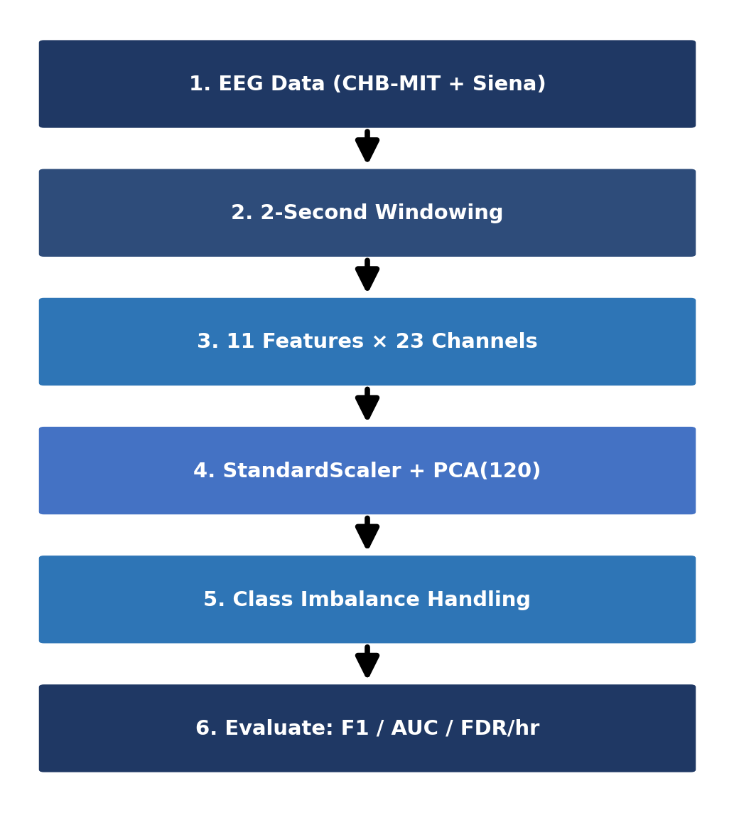
Fig. 1. Proposed methodology pipeline for EEG-based seizure detection.
Figure 1 shows the overall pipeline of the proposed EEG-based seizure detection system, from raw signal acquisition and windowing through statistical feature extraction, dimensionality reduction, class imbalance handling, and clinical evaluation.
A. Datasets
The CHB-MIT Scalp EEG Database [4] contains long-term EEG data recorded from 22 children at Children’s Hospital Boston and has a total of 23 channels used for 256 Hz signal acquisition and expert-determined seizure times. The patients chb01 and chb03 make up the training set and patient chb05 is kept aside for testing. The resulting class imbalance is 115.7:1 (non-seizure to seizure windows).
The Siena Scalp EEG Database [14] encompasses recordings of 14 adult participants from the University of Siena in Italy with an initial sampling rate of 512 Hz and subsequently resampled at 256 Hz. The models developed on the basis of the CHB-MIT dataset are put to the test on the Siena Scalp EEG Database without undergoing any training, thus constituting a severe test for cross-dataset generalization.
B. Feature Extraction
EEG signals are divided into non-overlapping two-second intervals. Each channel has eleven features (TABLE I), which consists of seven time-related metrics and four frequency powers (delta, theta, alpha, beta), obtained through NumPy FFT. The z-score normalization is done on each channel before frequency calculation in order to maintain the scale of amplitudes unaffected by the recording site. Therefore, a feature vector of 253 dimensions (23×11) is obtained for each segment of the recording.
TABLE I
EXTRACTED STATISTICAL FEATURES PER EEG CHANNEL
Feature | Description
Mean | Average amplitude per window
Variance | Spread of signal amplitude
RMS | Root mean square — signal power
Skewness | Asymmetry of amplitude distribution
Kurtosis | Tailedness — elevated during seizures
Maximum | Peak positive amplitude
Minimum | Peak negative amplitude
Delta power | Spectral power 0.5–4 Hz
Theta power | Spectral power 4–8 Hz
Alpha power | Spectral power 8–13 Hz
Beta power | Spectral power 13–30 Hz
C. Dimensionality Reduction
Principal Component Analysis (PCA) is a linear dimensionality reduction method that projects the high-dimensional feature space onto orthogonal axes of maximum variance, retaining the most discriminative signal components while discarding noise. The StandardScaler and then the PCA procedures with 120 components are applied, training only being used to avoid data leaks. At 120 components, 99.6% of the total variance is explained, as validated through the ablation study in the Results and Discussion section. Fitting the PCA transform exclusively on training data ensures that no information from the test set influences the learned projection, preventing a common but critical source of data leakage in EEG studies. The scaler and PCA are fitted once on the pooled training windows (chb01 and chb03) and are then applied, without refitting, to each test window of chb05. For Siena, the CHB-MIT PCA projection is kept fixed, and only a new StandardScaler is fitted on the Siena features to account for different amplitude scales.
D. Classification Techniques
This research assessed three machine learning algorithms that are based on trees: Random Forest (RF), Balanced Random Forest (BRF), and Extreme Gradient Boosting (XGBoost). These classifiers were chosen because of their reliability, capability to manage nonlinear relationships, and good performance on tabular EEG metrics.
Random Forest (RF): Random Forest is a methodology of ensemble learning, which involves making multiple decision trees using the bootstrap aggregation approach together with random feature selection. Each individual tree forecasts the result separately, after which majority voting is used to determine the general class. The randomization as a result of tree creation accounted for better generalization and lesser overfitting, thus making Random Forest efficient for processing noisy EEG signals.
Balanced Random Forest (BRF): BRF is a modified form of the Random Forest that has been specifically designed to work efficiently with imbalanced datasets. While training each of the trees, the algorithm reduces the number of majority class samples randomly while keeping all minority class samples, thus creating balanced bootstrap subsets. Thanks to this aspect, the classifier easily learns to recognize seizure signals without using external methods of resampling.
Extreme Gradient Boosting (XGBoost): The XGBoost is a gradient boosting algorithm that builds a series of decision trees where each of the new trees aims to fix mistakes made by previous trees. In order to solve the outstanding class skewness existing in EEG seizure detection, the parameter scale_pos_weight was used to give more importance to the seizure samples in the course of training.
E. Class Imbalance Handling
SMOTE, or Synthetic Minority Over-sampling Technique, solves the issue of class imbalance through synthetic seizure sample generation achieved via linear interpolation of existing instances of the minority class in feature space. Instead of a standard 1:1 resampling ratio, 0.05 is used as the controlled sampling rate. Thus, the minority class will make up 5% of the majority class, which is a more conservative ratio preventing the flooding of synthetic samples into the feature space. Such an approach was needed because otherwise working with such an extremely high imbalance ratio of 115.7:1 resulted in classifier precision collapse.
SMOTETomek is a resampling technique that is a combination of both undersampling and oversampling of data. In this technique, the SMOTE technique is first applied to create synthetic minority samples with a sampling_strategy of 0.05. After that, it identifies and removes the pairs of samples belonging to different classes and being each other’s nearest neighbour, which makes it easier to deal with the class frequency imbalance problem and clean the noisy samples on the border of the classes.
Five strategies are evaluated to address the 115.7:1 class imbalance: (1) Baseline RF with 100 estimators and max depth 10, trained without any correction, serving as the reference benchmark; (2) SMOTE+RF with sampling_strategy=0.05, raising the minority class to 5% of the majority to prevent feature space flooding; (3) Balanced RF performing random majority undersampling within each bootstrap draw; (4) SMOTETomek combining SMOTE oversampling with Tomek Links removal of borderline majority samples near the decision boundary; and (5) XGBoost with scale_pos_weight=115.7, encoding the imbalance ratio directly into the gradient boosting loss function to penalise missed seizures more heavily than false alarms. SMOTE, SMOTETomek and Balanced RF were implemented with the imbalanced-learn library [11].
F. Evaluation Protocol
The metrics of Precision, Recall, F1-score, AUC-ROC, and FDR/hour are provided. All techniques are compared at seed 42, and the variability across five random seeds (mean±std) is reported for the Baseline RF. The time required to make inferences was measured for a time period of every two seconds.
IV. Results and Discussion
A. CHB-MIT Technique Comparison
TABLE II and Figure 2 present the results for patient chb05, for whom the baseline RF attains the best AUC-ROC at 0.979 as well as the lowest FDR/hour of 14.01. Balanced RF generates highest recall of 0.991, but the FDR reaches a catastrophic level of 515/hr. SMOTE and SMOTETomek both yield FDR of 98.55/hr, while XGBoost provides only a moderate performance.
TABLE II
CHB-MIT SEIZURE CLASS EVALUATION (SEED=42). BOLD = BEST PER COLUMN.
Technique | Prec. | Recall | F1 | AUC | FDR/hr
Baseline RF | 0.705 | 0.593 | 0.644 | 0.979 | 14.01
SMOTE+RF | 0.117 | 0.230 | 0.155 | 0.894 | 98.55
Balanced RF | 0.098 | 0.991 | 0.178 | 0.904 | 515.29
SMOTETomek+RF | 0.117 | 0.230 | 0.155 | 0.894 | 98.55
XGBoost | 0.178 | 0.708 | 0.285 | 0.916 | 184.60

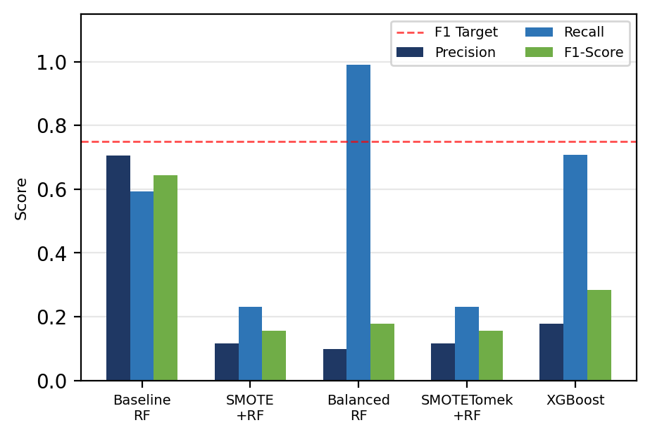
Fig. 2. CHB-MIT technique comparison: Precision, Recall and F1-Score.
B. Statistical Robustness
TABLE III reports Baseline RF performance across five seeds. AUC-ROC is stable at 0.980±0.001, confirming discriminative ability is seed-independent. FDR/hour of 12.91±1.56 remains consistently clinically acceptable.
TABLE III
BASELINE RF STATISTICAL ROBUSTNESS (5 SEEDS)
Metric | Mean | Std Dev
Precision | 0.733 | 0.030
Recall | 0.628 | 0.036
F1-Score | 0.677 | 0.031
AUC-ROC | 0.980 | 0.001
FDR/hour | 12.910 | 1.562

C. Threshold Tuning
TABLE IV shows the effect of tuning the Baseline RF threshold. While the F1 score improved to 0.662 at a threshold of 0.40, the FDR increased substantially to 45.53 alerts/hour. The default threshold of 0.50 strikes the most acceptable clinical balance, yielding an F1 score of 0.651 while keeping the FDR to 14.01. When selecting the threshold, alert burden must be considered in addition to the classification effectiveness.
TABLE IV
THRESHOLD TUNING ON BASELINE RF
Threshold | Precision | Recall | F1 | FDR/hr
0.50 | 0.708 | 0.602 | 0.651 | 14.01
0.40 | 0.526 | 0.894 | 0.662 | 45.53
0.30 | 0.372 | 0.938 | 0.533 | 89.55
0.20 | 0.276 | 0.973 | 0.431 | 144.08
0.10 | 0.185 | 0.973 | 0.312 | 241.63
D. PCA Ablation Study
In TABLE V, we have verified the selection of the 120 components. It is observed that the F1-score and AUC-ROC increase steadily from the range of 40 to 120 components, thus confirming that every additional component contributes to the discriminative signal. Finally, with 99.6% variance, the configuration having 120 components gives the best balance between dimension and accuracy.
TABLE V
PCA ABLATION STUDY (BASELINE RF, SEED=42)
PCA Comp. | Var. Expl. % | F1 | AUC
40 | 87.8 | 0.328 | 0.951
60 | 94.4 | 0.474 | 0.964
90 | 98.6 | 0.581 | 0.976
120 (chosen) | 99.6 | 0.644 | 0.979
E. Cross-Dataset Validation on Siena
TABLE VI and Figure 3 show the cross-dataset results. For Siena, all approaches have AUC-ROC greater than 0.90, which indicates that learned statistical properties detect seizure features that are translatable over different patient demographies and acquisition set-ups. SMOTE+RF has the highest AUC result of 0.929 with FDR of 9.39; however, XGBoost achieved the best F1-score of 0.366. Baseline RF achieved a very low FDR of 7.23 and fewer false positives, compared to CHB-MIT.

TABLE VI
CROSS-DATASET: CHB-MIT TRAINED → SIENA TESTED. BOLD = BEST.
Technique | Prec. | Recall | F1 | AUC | FDR/hr
Baseline RF | 0.091 | 0.016 | 0.027 | 0.900 | 7.23
SMOTE+RF | 0.381 | 0.127 | 0.190 | 0.929 | 9.39
BalancedRF | 0.172 | 0.714 | 0.278 | 0.915 | 156.08
SMOTETomek+RF | 0.381 | 0.127 | 0.190 | 0.929 | 9.39
XGBoost | 0.311 | 0.444 | 0.366 | 0.915 | 44.80

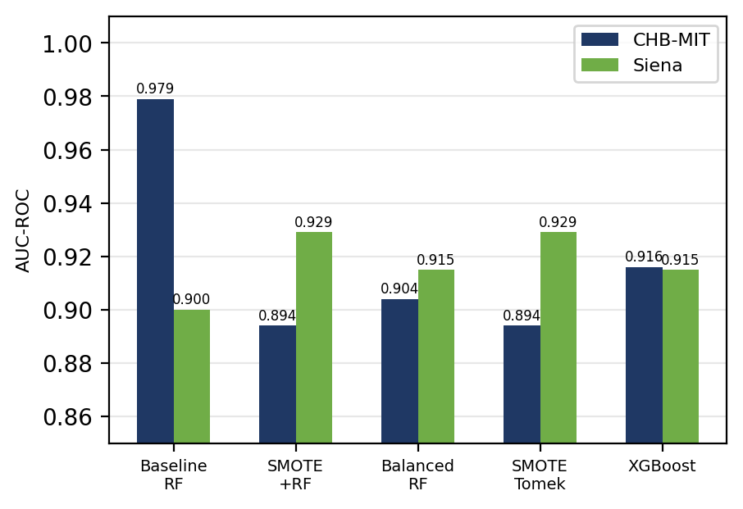
Fig. 3. AUC-ROC: CHB-MIT vs Siena cross-dataset validation.
F. Discussion
There are three important results. The first one mentions that AUC-ROC has proved to be more reliable than F1 in EEG with imbalanced data. Thus, the Balanced RF achieved Recall=0.991, but the FDR value was equal to 515/hour. The only viable configuration identified in the baseline RF with AUC-ROC equal to 0.979 is characterized by low FDR equal to 14.01. The second finding states that applying resampling techniques leads to high rates of missing alarms without increasing AUC-ROC scores. The third finding remarks that AUC-ROC value which is over 0.90 for the Siena test without domain adaptation appears to outperform many studies in the field of cross-institution EEG research.
AUC-ROC evaluates how well windows are ranked across all thresholds, whereas F1 is computed at a single operating point. Since seizures make up under 1% of the test windows, even a small false-positive rate produces many false alarms relative to the few true seizure windows, which lowers precision and F1 while AUC-ROC stays high. Resampling also shifts the predicted probabilities upward, so the default 0.5 threshold becomes a poor operating point (SMOTE+RF reaches an F1 of only 0.155 at 98.55 false detections per hour). The threshold study in TABLE IV shows that the operating point is the main lever for F1. The alternative classifier tested here (XGBoost) did not improve F1 (0.285), so the gap is not simply a consequence of the choice of tree-based model.
On Siena, the Baseline RF reaches an AUC-ROC of 0.900 but a recall of only 0.016 at the default threshold, which means that about 98% of seizure windows would be missed. In a monitoring setting a missed seizure costs far more than a false alarm, so this configuration would not be safe to deploy without adaptation. The high AUC-ROC indicates that the ranking of windows remains informative across datasets, which points to a shift in probability calibration (different amplitude distributions, equipment, and an adult instead of paediatric population) rather than a loss of discriminative information. We did not apply threshold recalibration or domain adaptation. Recall-oriented models detect more Siena seizures (Balanced RF 0.714, XGBoost 0.444) but at 156.08 and 44.80 false detections per hour respectively.
[PENDING - add after running notebook cell 12c: one sentence on Siena recall/FDR at lower thresholds, stated as an oracle sensitivity analysis.]
[PENDING - add after running notebook cell 12a: what the SMOTE vs SMOTETomek diagnostic showed (number of Tomek links removed, and why the CHB-MIT results are identical), and the real Siena SMOTETomek row.]
Limitations. The evaluation trains on two CHB-MIT patients and tests on one patient (chb05) and on Siena, so the results should not be read as population-level performance, and leave-one-patient-out validation over all 22 patients was not performed. Only tree-based classifiers are compared, and no deep-learning baseline (CNN, LSTM or Transformer) is included. Seed-level variability was assessed for the Baseline RF only, and no significance test between techniques was performed, so differences between the resampling methods should be regarded as indicative.
V. Conclusion
The paper delivers a thorough comparison of five techniques for handling class imbalance in EEG-based epileptic seizure detection, used on CHB-MIT and validated in the Siena Scalp EEG database. The Baseline RF obtains an AUC-ROC of 0.980±0.001 and FDR/hour of 12.91±1.56 on CHB-MIT, along with an AUC of 0.900 in Siena’s cross-dataset evaluation. SMOTE+RF achieves the highest cross-dataset AUC of 0.929.
In conclusion, several points are worth reiterating: First, the use of resampling resulted in an FDR rising to unacceptable levels of 98–515/hour despite improving the recall. Second, the AUC-ROC exceeds 0.90 in two independent datasets, demonstrating the capability for feature-level generalization. Third, tuning the threshold has to consider the FDR/hour as one of the main clinical restrictions. Future work will aim to perform leave-one-patient-out (LOPO) cross-validation on the entire CHB-MIT set benchmark against deep-learning baselines, and study threshold recalibration and transfer learning to improve recall across datasets.
Data and code availability: Both datasets are publicly available on PhysioNet [4], [14]. The code is available from the authors on reasonable request.
Acknowledgment
The authors give their gratitude to the Children’s Hospital Boston and MIT for providing the CHB-MIT database and also University of Siena for providing the Siena Scalp EEG Database, which are both accessible in PhysioNet. The authors appreciate the scikit-learn, imbalanced-learn, XGBoost, and SHAP open-source communities too.
References
[1] World Health Organization, “Epilepsy: Key facts,” WHO Fact Sheet, Feb. 2023.
[2] P. Kwan and M. J. Brodie, “Early identification of refractory epilepsy,” New England Journal of Medicine, vol. 342, no. 5, pp. 314–319, 2000.
[3] S. Ramgopal et al., “Seizure detection, seizure prediction, and closed-loop warning systems in epilepsy,” Epilepsy & Behavior, vol. 37, pp. 291–307, 2014.
[4] A. H. Shoeb and J. V. Guttag, “Application of machine learning to epileptic seizure detection,” in Proc. 27th ICML, 2010, pp. 975–982.
[5] A. Subasi and M. I. Gursoy, “EEG signal classification using PCA, ICA, LDA and support vector machines,” Expert Syst. Appl., vol. 37, pp. 8659–8666, 2010.
[6] L. Guo, D. Rivero, and A. Pazos, “Epileptic seizure detection using multiwavelet transform,” J. Neurosci. Methods, vol. 193, pp. 156–163, 2010.
[7] U. R. Acharya et al., “Automated EEG analysis of epilepsy: A review,” Knowl.-Based Syst., vol. 45, pp. 147–165, 2013.
[8] N. V. Chawla et al., “SMOTE: Synthetic minority over-sampling technique,” J. Artif. Intell. Res., vol. 16, pp. 321–357, 2002.
[9] G. E. A. P. A. Batista et al., “A study of methods for balancing machine learning training data,” ACM SIGKDD Explor. Newsl., vol. 6, pp. 20–29, 2004.
[10] C. Chen, A. Liaw, and L. Breiman, “Using random forest to learn imbalanced data,” Univ. California Berkeley, Tech. Rep. 666, 2004.
[11] G. Lemaître et al., “Imbalanced-learn: A Python toolbox,” J. Mach. Learn. Res., vol. 18, no. 17, pp. 1–5, 2017.
[12] T. Chen and C. Guestrin, “XGBoost: A scalable tree boosting system,” in Proc. 22nd ACM SIGKDD, 2016, pp. 785–794.
[13] H. He and E. A. Garcia, “Learning from imbalanced data,” IEEE Trans. Knowl. Data Eng., vol. 21, pp. 1263–1284, 2009.
[14] P. Detti, “Siena Scalp EEG Database (version 1.0.0),” PhysioNet, 2020. [Online]. Available: https://doi.org/10.13026/5d4a-j060

