Epileptic Seizure Detection Using Machine Learning: A Comparative Study of Class Imbalance Handling Techniques
Soha Chand  Dept. of Artificial Intelligence Engineering  Mukesh Patel School of Technology  Management & Engineering, SVKM’s NMIMS  soha.chand36@nmims.in | Atharv Dixit  Dept. of Artificial Intelligence Engineering  Mukesh Patel School of Technology  Management & Engineering, SVKM’s NMIMS  atharv.dixit69@nmims.in | Hima Deepthi Vankayalapati  Dept. of Artificial Intelligence Engineering  Mukesh Patel School of Technology  Management & Engineering, SVKM’s NMIMS  himadeepthi.vankayalapati@nmims.edu

Abstract—The condition of epilepsy affects over fifty million people worldwide and involves seizures produced by abnormal brain activity. Automatic seizure detection is based on electroencephalogram (EEG) signals, but the problem is highly imbalanced: seizure windows make up about one percent of the EEG windows used here, giving a training imbalance of 115.7:1 (non-seizure to seizure). This study compares five approaches for handling class imbalance on the CHB-MIT Scalp EEG Database (training on two patients, testing on a third) and in an exploratory cross-dataset test on a subset of the Siena Scalp EEG Database. Eleven time-domain and frequency-domain features per channel were extracted from 2-second windows and reduced to 120 components with Principal Component Analysis (PCA), fitted on training data only. The techniques are Baseline Random Forest (RF), SMOTE+RF, Balanced RF, SMOTETomek+RF and XGBoost. Over five random seeds, the Baseline RF gave the best results on the held-out patient (AUC-ROC 0.984±0.001, F1 0.575±0.034, FDR 26.0±3.5 per hour), while resampling and cost-sensitive methods increased false alarms without improving AUC-ROC. Generalisation was limited: on Siena the AUC-ROC was 0.78–0.89 and the Baseline RF detected no seizure windows at the default threshold, and a leave-one-patient-out test over three patients showed large differences between patients. Inference takes about 0.01 ms per window.
Keywords— EEG, epileptic seizure detection, class imbalance, SMOTE, SMOTE-TOMEK, Random Forest, XGBoost, PCA, CHB-MIT, Siena, AUC-ROC, false detection rate, cross-dataset validation
I. Introduction
Epilepsy is regarded as one of the most common types of chronic neurological conditions that exists in the world and affects more than 50 million individuals regardless of their age [1]. It is a disorder characterized by recurrent seizures that are not stimulated in any way and occur as a result of abnormal electric discharges in the brain. In addition to the isolation from injury or Sudden Unexpected Death in Epilepsy (SUDEP), its chronic unpredictability leads to significant limitations associated with driving, work, and independent living [2].
EEG is noted for being the conventional clinical gold standard for detection of epileptic activities. In practice, the process of long-term electroencephalography would produce hours to days of continuously recorded multi-channel data. Manual expert review is characterized by being an inefficient and subjective process which relies on trained neurologists for accurate diagnosis and monitoring [3].
One of the major obstacles is the extreme class imbalance seen in continuous EEG, where seizures constitute only 2% of the time of recording, resulting in ratios that may reach as high as 115.7:1. Traditional classifiers display a bias towards the dominant class and achieve high overall accuracy while lacking the required sensitivity when detecting seizures. In addition, established metrics like F1 score are reliant on the selection of a threshold, but clinical applications require an evaluation of the rate of false detections in an hour.
The contributions made by this research paper are: (i) a systematic comparison of five class imbalance methods with AUC-ROC and FDR/hour as the main clinical metrics; (ii) statistical validation of all five techniques over five random seeds with paired significance tests; (iii) an ablation of the number of PCA components and a comparison with no PCA; (iv) an exploratory cross-dataset test on a subset of the Siena Scalp EEG Database, with threshold-sensitivity and unsupervised domain-adaptation analyses, which shows that generalisation is limited; (v) a leave-one-patient-out evaluation over the three available CHB-MIT patients and comparison with 1D-CNN and MLP baselines; and (vi) a real-time feasibility check with inference times of about 0.01 ms per window.
II. Related Work
The CHB-MIT Scalp EEG Database was established by Shoeb and Guttag [4], who have presented a patient-specific SVM-based seizure detection model. The study provides a benchmark and inspires future research in the area. The research done by Subasi and Gursoy [5] shows that PCA-compressed statistical EEG features are in the lead when performing inter-patient analyses with SVM classification. Also, Acharya et al. [7] have summarized the features that can be used in EEG analysis, emphasizing that a mix of both time and frequency domain features is superior.
Chawla et al. [8] first introduced the SMOTE method in minority class oversampling, but the default 1:1 strategy failed at extreme imbalance ratios thus leading to an unusable classifier. Batista et al. [9] suggested that the SMOTETomek method be applied as a mix of SMOTE and Tomek links. Moreover, the Balanced Random Forest where undersampling is applied at per-bootstrap level was introduced by Chen et al. [10]. The XGBoost method which utilizes scale_pos_weight in order to reduce imbalance in the created gradient boosting loss function was introduced by Chen and Guestrin [12].
III. Methodology
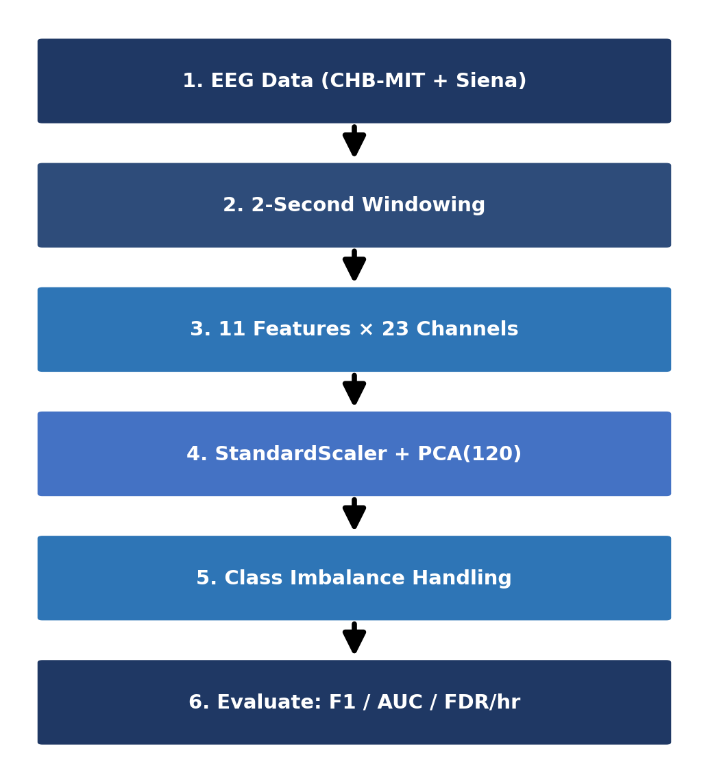
Fig. 1. Proposed methodology pipeline for EEG-based seizure detection.
Figure 1 shows the overall pipeline of the proposed EEG-based seizure detection system, from raw signal acquisition and windowing through statistical feature extraction, dimensionality reduction, class imbalance handling, and clinical evaluation.
A. Datasets
The CHB-MIT Scalp EEG Database [4] contains long-term EEG data recorded from 22 children at Children’s Hospital Boston, with 23 channels sampled at 256 Hz and expert-annotated seizure times. Only three patients were available for this study. Patients chb01 and chb03 form the training set (21,588 windows, 185 of them seizure windows, a ratio of 115.7:1) and patient chb05 is held out for testing (3,598 windows, 113 seizure windows, 3.1%).
The Siena Scalp EEG Database [14] contains recordings of 14 adult patients from the University of Siena in Italy, originally sampled at 512 Hz and resampled to 256 Hz. Only the recordings that could be read completely were used, which gives a subset of 2,491 two-second windows, 63 of them seizure windows. The models trained on CHB-MIT are tested on this subset without retraining, as an exploratory cross-dataset test.
B. Feature Extraction
EEG signals are divided into non-overlapping two-second windows. Each channel has eleven features (TABLE I), which consist of seven time-domain metrics and four frequency band powers (delta, theta, alpha, beta), obtained through the NumPy FFT. The Siena signals were z-score normalised per channel before feature extraction to reduce amplitude differences between recording systems; the CHB-MIT signals were used at their recorded amplitude. A feature vector of 253 dimensions (23×11) is obtained for each CHB-MIT window.
TABLE I
EXTRACTED STATISTICAL FEATURES PER EEG CHANNEL
Feature | Description
Mean | Average amplitude per window
Variance | Spread of signal amplitude
RMS | Root mean square — signal power
Skewness | Asymmetry of amplitude distribution
Kurtosis | Tailedness — elevated during seizures
Maximum | Peak positive amplitude
Minimum | Peak negative amplitude
Delta power | Spectral power 0.5–4 Hz
Theta power | Spectral power 4–8 Hz
Alpha power | Spectral power 8–13 Hz
Beta power | Spectral power 13–30 Hz
C. Dimensionality Reduction
Principal Component Analysis (PCA) is a linear dimensionality reduction method that projects the feature space onto orthogonal axes of maximum variance. A StandardScaler followed by PCA with 120 components is fitted on the training windows (chb01 and chb03) only and then applied unchanged to the test patient, so that no statistics from the test set influence the learned projection. At 120 components, 98.2% of the total variance is explained (TABLE V). For Siena, a new StandardScaler is fitted on the Siena features and the CHB-MIT PCA projection is applied unchanged.
D. Classification Techniques
This research assessed three machine learning algorithms that are based on trees: Random Forest (RF), Balanced Random Forest (BRF), and Extreme Gradient Boosting (XGBoost). These classifiers were chosen because of their reliability, capability to manage nonlinear relationships, and good performance on tabular EEG metrics.
Random Forest (RF): Random Forest is a methodology of ensemble learning, which involves making multiple decision trees using the bootstrap aggregation approach together with random feature selection. Each individual tree forecasts the result separately, after which majority voting is used to determine the general class. The randomization as a result of tree creation accounted for better generalization and lesser overfitting, thus making Random Forest efficient for processing noisy EEG signals.
Balanced Random Forest (BRF): BRF is a modified form of the Random Forest that has been specifically designed to work efficiently with imbalanced datasets. While training each of the trees, the algorithm reduces the number of majority class samples randomly while keeping all minority class samples, thus creating balanced bootstrap subsets. Thanks to this aspect, the classifier easily learns to recognize seizure signals without using external methods of resampling.
Extreme Gradient Boosting (XGBoost): The XGBoost is a gradient boosting algorithm that builds a series of decision trees where each of the new trees aims to fix mistakes made by previous trees. In order to solve the outstanding class skewness existing in EEG seizure detection, the parameter scale_pos_weight was used to give more importance to the seizure samples in the course of training.
E. Class Imbalance Handling
SMOTE, or Synthetic Minority Over-sampling Technique, solves the issue of class imbalance through synthetic seizure sample generation achieved via linear interpolation of existing instances of the minority class in feature space. Instead of a standard 1:1 resampling ratio, 0.05 is used as the controlled sampling rate. Thus, the minority class will make up 5% of the majority class, which is a more conservative ratio preventing the flooding of synthetic samples into the feature space. Such an approach was needed because otherwise working with such an extremely high imbalance ratio of 115.7:1 resulted in classifier precision collapse.
SMOTETomek is a resampling technique that is a combination of both undersampling and oversampling of data. In this technique, the SMOTE technique is first applied to create synthetic minority samples with a sampling_strategy of 0.05. After that, it identifies and removes the pairs of samples belonging to different classes and being each other’s nearest neighbour, which makes it easier to deal with the class frequency imbalance problem and clean the noisy samples on the border of the classes.
Five strategies are evaluated to address the 115.7:1 class imbalance: (1) Baseline RF with 100 estimators and max depth 10, trained without any correction, serving as the reference benchmark; (2) SMOTE+RF with sampling_strategy=0.05, raising the minority class to 5% of the majority to prevent feature space flooding; (3) Balanced RF performing random majority undersampling within each bootstrap draw; (4) SMOTETomek combining SMOTE oversampling with Tomek Links removal of borderline majority samples near the decision boundary; and (5) XGBoost with scale_pos_weight=115.7, encoding the imbalance ratio directly into the gradient boosting loss function to penalise missed seizures more heavily than false alarms. SMOTE, SMOTETomek and Balanced RF were implemented with the imbalanced-learn library [11].
F. Evaluation Protocol
The metrics of Precision, Recall, F1-score, AUC-ROC and FDR/hour are reported. FDR/hour is the number of false-positive windows divided by the test duration in hours. Every technique was trained and evaluated with five random seeds (42, 123, 456, 789 and 999), and the results are given as mean±std (population standard deviation). Each technique is compared with the Baseline RF using a paired t-test across the seeds. Inference time was measured per two-second window.
IV. Results and Discussion
A. CHB-MIT Technique Comparison
TABLE II and Figure 2 present the results for patient chb05 (seed 42), for whom the Baseline RF attains the best AUC-ROC (0.983), the best F1-score (0.543) and the lowest FDR/hour (28.02). Balanced RF has the highest recall (1.000), but its FDR reaches 501.78/hour. SMOTE+RF and SMOTETomek+RF give identical results (F1 0.278, FDR 64.54/hour), because no Tomek links were removed after SMOTE, so the SMOTETomek training set is identical to the SMOTE training set. XGBoost has a high recall (0.850) but low precision (F1 0.292, FDR 224.62/hour).
TABLE II
CHB-MIT SEIZURE CLASS EVALUATION (SEED=42). BOLD = BEST PER COLUMN.
Technique | Prec. | Recall | F1 | AUC | FDR/hr
Baseline RF | 0.529 | 0.558 | 0.543 | 0.983 | 28.02
SMOTE+RF | 0.232 | 0.345 | 0.278 | 0.952 | 64.54
BalancedRF | 0.101 | 1.000 | 0.184 | 0.897 | 501.78
SMOTETomek+RF | 0.232 | 0.345 | 0.278 | 0.952 | 64.54
XGBoost | 0.176 | 0.850 | 0.292 | 0.925 | 224.62

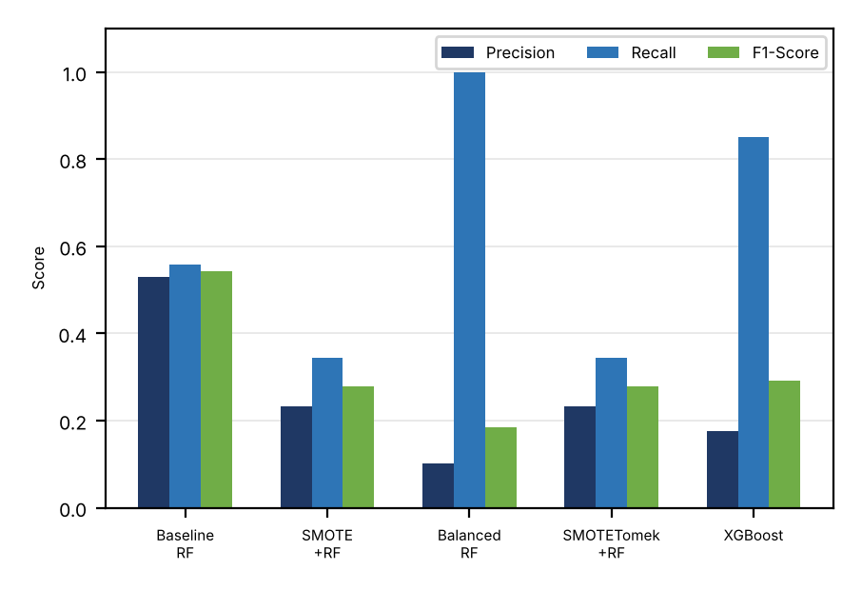
Fig. 2. CHB-MIT technique comparison: Precision, Recall and F1-Score.
B. Statistical Robustness
TABLE III reports the mean±std of F1-score, AUC-ROC and FDR/hour over five seeds for all five techniques. The Baseline RF has the highest AUC-ROC (0.984±0.001), the highest F1-score (0.575±0.034) and the lowest FDR/hour (26.0±3.5). Paired t-tests against the Baseline RF give p < 0.001 for F1-score, AUC-ROC and FDR/hour for every other technique. SMOTETomek+RF yields the same values as SMOTE+RF. With five seeds the smallest possible p-value of the Wilcoxon signed-rank test is 0.0625, so the paired t-test is reported. The seeds change only the model randomness on a fixed patient split.
TABLE III
STATISTICAL ROBUSTNESS OF ALL TECHNIQUES (MEAN±STD, 5 SEEDS)
Technique | F1 | AUC | FDR/hr
Baseline RF | 0.575±0.034 | 0.984±0.001 | 26.0±3.5
SMOTE+RF | 0.223±0.043 | 0.943±0.006 | 70.0±3.8
BalancedRF | 0.186±0.008 | 0.895±0.009 | 496.4±25.5
SMOTETomek+RF | 0.223±0.043 | 0.943±0.006 | 70.0±3.8
XGBoost | 0.281±0.013 | 0.925±0.007 | 218.6±8.2

C. Threshold Tuning
TABLE IV shows the effect of tuning the Baseline RF threshold. The F1-score improved from 0.549 at the default threshold of 0.50 to 0.628 at 0.40 (recall 0.920), but the FDR rose from 28.02 to 57.03 alerts/hour. Lower thresholds raise the recall to 1.000 at about 410 alerts/hour. The alert burden must therefore be considered together with classification effectiveness. A window whose predicted probability equals the threshold is counted as a seizure, so the row for 0.50 differs slightly from TABLE II.
TABLE IV
THRESHOLD TUNING ON BASELINE RF
Threshold | Precision | Recall | F1 | FDR/hr
0.50 | 0.533 | 0.566 | 0.549 | 28.02
0.40 | 0.477 | 0.920 | 0.628 | 57.03
0.30 | 0.319 | 0.982 | 0.482 | 118.57
0.20 | 0.203 | 0.991 | 0.337 | 219.62
0.10 | 0.121 | 1.000 | 0.216 | 409.73
D. PCA Ablation Study
In TABLE V, the F1-score and AUC-ROC increase from 40 to 90 components, and the AUC-ROC increases further to 0.983 at 120 components. The F1-score at the default threshold is slightly higher at 90 components (0.576) than at 120 (0.543), a difference of about one seed standard deviation (0.034 in TABLE III), so we do not claim that either is clearly better. We use 120 components throughout, which retain 98.2% of the variance. Without PCA (all 253 standardised features), the RF obtains F1 0.279, AUC-ROC 0.954 and FDR 60.5/hour, which is worse than with PCA; XGBoost obtains F1 0.350, AUC-ROC 0.946 and FDR 120.6/hour without PCA, compared with 0.292, 0.925 and 224.6 with PCA.
TABLE V
PCA ABLATION STUDY (BASELINE RF, SEED=42)
PCA Comp. | Var. Expl. % | F1 | AUC
40 | 85.3 | 0.417 | 0.957
60 | 91.2 | 0.478 | 0.970
90 | 95.9 | 0.576 | 0.978
120 | 98.2 | 0.543 | 0.983
E. Cross-Dataset Validation on Siena
TABLE VI and Figure 3 show the cross-dataset results on the Siena subset (2,491 windows, 63 seizure windows). AUC-ROC is lower than on CHB-MIT, between 0.782 and 0.887. At the default threshold the Baseline RF, SMOTE+RF and SMOTETomek+RF do not detect any seizure window (recall 0; their FDR of 0 only reflects that no alarms were raised). Balanced RF obtained the best F1-score (0.206) and recall (0.254), and XGBoost the best AUC-ROC (0.887) and precision (0.292) with a lower FDR (12.28/hour). The SMOTETomek+RF row equals the SMOTE+RF row, as on CHB-MIT.

TABLE VI
CROSS-DATASET: CHB-MIT TRAINED → SIENA TESTED. BOLD = BEST.
Technique | Prec. | Recall | F1 | AUC | FDR/hr
Baseline RF | 0.000 | 0.000 | 0.000 | 0.782 | 0.00
SMOTE+RF | 0.000 | 0.000 | 0.000 | 0.841 | 0.00
BalancedRF | 0.174 | 0.254 | 0.206 | 0.883 | 54.92
SMOTETomek+RF | 0.000 | 0.000 | 0.000 | 0.841 | 0.00
XGBoost | 0.292 | 0.111 | 0.161 | 0.887 | 12.28

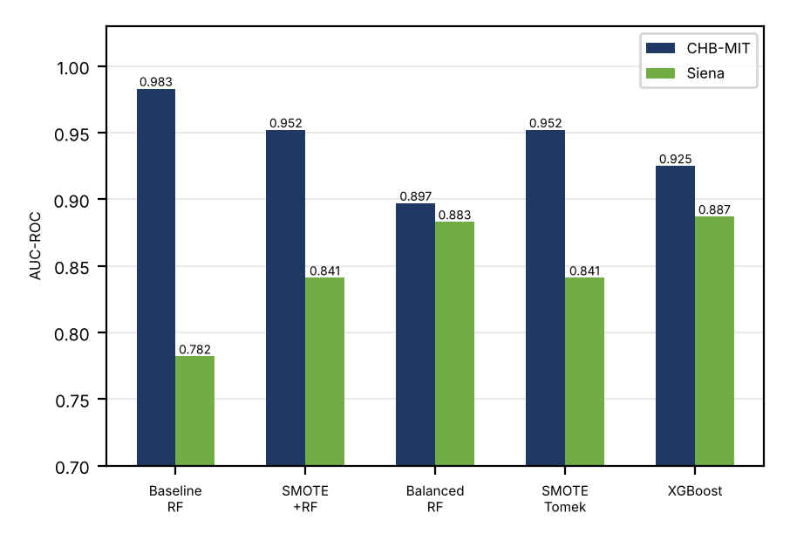
Fig. 3. AUC-ROC: CHB-MIT vs Siena cross-dataset validation.
F. Patient-Level, Deep-Learning and Domain-Adaptation Analyses
To examine patient-to-patient variability, each of the three available CHB-MIT patients was held out in turn, with the scaler and PCA refitted on the other two. TABLE VII gives the mean±std over the three held-out patients. The mean F1-score is low and varies strongly between patients (Baseline RF 0.194±0.247, from 0.000 on chb01 to 0.543 on chb05), while the AUC-ROC stays between 0.93 and 0.95 for all techniques. XGBoost has the highest mean F1 (0.234±0.043) and AUC-ROC (0.952±0.019), so the advantage of the Baseline RF seen on chb05 does not hold across patients. With only three patients these results are indicative, not statistically conclusive.
TABLE VII
LEAVE-ONE-PATIENT-OUT OVER THE THREE AVAILABLE PATIENTS (MEAN±STD)
Technique | F1 | AUC | FDR/hr
Baseline RF | 0.194±0.247 | 0.937±0.038 | 25.2±18.0
SMOTE+RF | 0.114±0.117 | 0.935±0.021 | 29.9±26.0
BalancedRF | 0.187±0.030 | 0.930±0.024 | 245.8±184.5
SMOTETomek+RF | 0.124±0.112 | 0.936±0.022 | 27.1±27.0
XGBoost | 0.234±0.043 | 0.952±0.019 | 82.9±100.3
A 1D-CNN and an MLP with positive-class weighting (pos_weight = 115.7) were trained on the same 120 PCA features (five seeds). On chb05 they reached F1 0.148±0.014 (AUC-ROC 0.937±0.091, FDR 613±71/hour) and 0.239±0.064 (AUC-ROC 0.924±0.016, FDR 353±101/hour), which is below the Baseline RF (F1 0.575, FDR 26.0/hour). On Siena the CNN had a recall of 0.454±0.064 but F1 only 0.171±0.004 and AUC-ROC 0.839±0.002, and the MLP had F1 0.103±0.068 and AUC-ROC 0.615±0.070. We also applied CORAL, an unsupervised alignment of the Siena features to the CHB-MIT training features that uses no Siena labels. It changed the AUC-ROC by at most 0.015 and left the recall of the tree models near zero (for example SMOTE+RF recall 0.016, AUC-ROC 0.841 to 0.856; XGBoost F1 0.161 to 0.132), so it did not remove the cross-dataset shift. These networks are small and untuned, so they should not be read as a limit of deep learning.
G. Discussion
There are three main results. First, AUC-ROC is more informative than F1 for imbalanced EEG data. Balanced RF reached a recall of 1.000, but with 501.78 false alarms per hour. On the held-out patient the uncorrected Baseline RF is the best configuration (AUC-ROC 0.983, FDR 28.02/hour). Second, resampling and cost-sensitive learning increased the false-alarm rate without improving AUC-ROC (0.895–0.952 compared with 0.983 for the baseline). Third, this result does not carry over unchanged to other patients or datasets: on Siena the AUC-ROC fell to 0.782–0.887, and in the leave-one-patient-out test the ranking of the techniques changed, so conclusions drawn from a single test patient should be treated with caution.
AUC-ROC evaluates how well windows are ranked across all thresholds, whereas F1 is computed at one operating point. Since seizures make up about 3% of the test windows, even a small false-positive rate produces many false alarms relative to the few seizure windows, which lowers precision and F1 while AUC-ROC stays high. The threshold study in TABLE IV shows that the operating point matters: with the same classifier, F1 rose from 0.549 to 0.628 when the threshold was lowered from 0.50 to 0.40. XGBoost, a different classifier with cost-sensitive weighting, did not improve F1 (0.281±0.013), so the gap is not simply a consequence of the choice of RF.
On Siena, the Baseline RF reaches an AUC-ROC of 0.782 but detects no seizure windows at the default threshold, which means that every seizure window would be missed; the same holds for SMOTE+RF and SMOTETomek+RF. In a monitoring setting a missed seizure costs far more than a false alarm, so these configurations would not be safe to deploy. Lowering the threshold on Siena raises the Baseline RF recall to 0.254 at a threshold of 0.05 (73.7 false detections per hour) and 0.397 at 0.02 (F1 0.195, 121.4 per hour). SMOTE+RF reaches a recall of 0.603 at 0.02 (F1 0.234, 161.9 per hour), and XGBoost has the best F1 of 0.275 at 0.05 (recall 0.302, 40.5 per hour). This is an oracle analysis, since the threshold was chosen using the Siena labels, so it is an upper bound and not a deployable calibration method. Even at the best threshold the F1-score stays below 0.28, and CORAL alignment (above) did not close the gap. Likely causes are differences in population (adults instead of children), recording equipment and montage, the small number of training patients, and the fact that z-score normalisation was applied to Siena only; we did not isolate their individual effects.
Limitations. The models are trained on two CHB-MIT patients and tested on one patient (chb05) and, in the leave-one-patient-out test, on the three available patients; leave-one-patient-out validation over all 22 patients was not possible. The Siena evaluation uses only the recordings that could be read completely (63 seizure windows), so its estimates are noisy. FDR/hour is computed from window-level predictions, without event-level evaluation or post-processing. The deep-learning baselines are small and untuned, and the seed analysis varies only the random seed on a fixed split, so it does not capture variability between patients.
V. Conclusion
The paper presents a comparison of five techniques for handling class imbalance in EEG-based epileptic seizure detection on CHB-MIT, with an exploratory cross-dataset test on a subset of Siena. On the held-out patient the Baseline RF obtained an AUC-ROC of 0.984±0.001 and an FDR of 26.0±3.5/hour over five seeds, whereas SMOTE, SMOTETomek, Balanced RF and XGBoost raised the false-alarm rate. Generalisation was limited: on Siena the AUC-ROC was 0.782–0.887 with no detected seizure windows for the Baseline RF at the default threshold, and a three-patient leave-one-patient-out test showed large differences between patients.
In conclusion: first, resampling and cost-sensitive techniques raised the FDR from 28 to between 65 and 502/hour on the held-out patient, and only Balanced RF and XGBoost improved the recall. Second, the ranking quality (AUC-ROC) transferred partly across datasets, but the default operating point did not, and neither an oracle threshold nor CORAL alignment made the models reliable on Siena. Third, threshold selection has to consider FDR/hour as a clinical constraint. Future work will perform leave-one-patient-out cross-validation on all 22 CHB-MIT patients, event-based evaluation, and better-tuned deep models, and will study calibration and transfer learning with a small amount of target-site data.
Data and code availability: Both datasets are publicly available on PhysioNet [4], [14]. The code is available from the authors on reasonable request.
Acknowledgment
The authors give their gratitude to the Children’s Hospital Boston and MIT for providing the CHB-MIT database and also University of Siena for providing the Siena Scalp EEG Database, which are both accessible in PhysioNet. The authors appreciate the scikit-learn, imbalanced-learn, XGBoost, and SHAP open-source communities too.
References
[1] World Health Organization, “Epilepsy: Key facts,” WHO Fact Sheet, Feb. 2023.
[2] P. Kwan and M. J. Brodie, “Early identification of refractory epilepsy,” New England Journal of Medicine, vol. 342, no. 5, pp. 314–319, 2000.
[3] S. Ramgopal et al., “Seizure detection, seizure prediction, and closed-loop warning systems in epilepsy,” Epilepsy & Behavior, vol. 37, pp. 291–307, 2014.
[4] A. H. Shoeb and J. V. Guttag, “Application of machine learning to epileptic seizure detection,” in Proc. 27th ICML, 2010, pp. 975–982.
[5] A. Subasi and M. I. Gursoy, “EEG signal classification using PCA, ICA, LDA and support vector machines,” Expert Syst. Appl., vol. 37, pp. 8659–8666, 2010.
[6] L. Guo, D. Rivero, and A. Pazos, “Epileptic seizure detection using multiwavelet transform,” J. Neurosci. Methods, vol. 193, pp. 156–163, 2010.
[7] U. R. Acharya et al., “Automated EEG analysis of epilepsy: A review,” Knowl.-Based Syst., vol. 45, pp. 147–165, 2013.
[8] N. V. Chawla et al., “SMOTE: Synthetic minority over-sampling technique,” J. Artif. Intell. Res., vol. 16, pp. 321–357, 2002.
[9] G. E. A. P. A. Batista et al., “A study of methods for balancing machine learning training data,” ACM SIGKDD Explor. Newsl., vol. 6, pp. 20–29, 2004.
[10] C. Chen, A. Liaw, and L. Breiman, “Using random forest to learn imbalanced data,” Univ. California Berkeley, Tech. Rep. 666, 2004.
[11] G. Lemaître et al., “Imbalanced-learn: A Python toolbox,” J. Mach. Learn. Res., vol. 18, no. 17, pp. 1–5, 2017.
[12] T. Chen and C. Guestrin, “XGBoost: A scalable tree boosting system,” in Proc. 22nd ACM SIGKDD, 2016, pp. 785–794.
[13] H. He and E. A. Garcia, “Learning from imbalanced data,” IEEE Trans. Knowl. Data Eng., vol. 21, pp. 1263–1284, 2009.
[14] P. Detti, “Siena Scalp EEG Database (version 1.0.0),” PhysioNet, 2020. [Online]. Available: https://doi.org/10.13026/5d4a-j060

