Epileptic Seizure Detection Using Machine Learning: A Comparative Study of Class Imbalance Handling Techniques
Soha Chand  Dept. of Artificial Intelligence Engineering  Mukesh Patel School of Technology  Management & Engineering, SVKM’s NMIMS  soha.chand36@nmims.in | Atharv Dixit  Dept. of Artificial Intelligence Engineering  Mukesh Patel School of Technology  Management & Engineering, SVKM’s NMIMS  atharv.dixit69@nmims.in | Hima Deepthi Vankayalapati  Dept. of Artificial Intelligence Engineering  Mukesh Patel School of Technology  Management & Engineering, SVKM’s NMIMS  himadeepthi.vankayalapati@nmims.edu

Abstract—The condition of epilepsy affects over fifty million people worldwide and involves seizures produced by abnormal brain activity. Automatic seizure detection is based on electroencephalogram (EEG) signals, but the problem is highly imbalanced: seizure windows make up about one percent of the EEG windows used here, giving a training imbalance of 115.7:1 (non-seizure to seizure). This study compares five approaches for handling class imbalance on the CHB-MIT Scalp EEG Database (training on two patients, testing on a third) and in an exploratory cross-dataset test on a subset of the Siena Scalp EEG Database. Eleven time-domain and frequency-domain features per channel were extracted from 2-second windows and reduced to 120 components with Principal Component Analysis (PCA), fitted on training data only. The techniques are Baseline Random Forest (RF), SMOTE+RF, Balanced RF, SMOTETomek+RF and XGBoost. Over five random seeds, the Baseline RF gave the best results on the held-out patient (AUC-ROC 0.984±0.001, F1 0.575±0.034, FDR 26.0±3.5 per hour), while resampling and cost-sensitive methods increased false alarms without improving AUC-ROC. In a cross-dataset test on Siena, the ranking quality transferred (AUC-ROC 0.78–0.89) but the default operating point did not (the Baseline RF raised no alarms at threshold 0.5), which identifies threshold recalibration as the key step for deployment; a leave-one-patient-out test over three patients further quantifies patient-to-patient variability. Inference takes about 0.01 ms per window.
Keywords— EEG, epileptic seizure detection, class imbalance, SMOTE, SMOTE-TOMEK, Random Forest, XGBoost, PCA, CHB-MIT, Siena, AUC-ROC, false detection rate, cross-dataset validation
I. Introduction
Epilepsy is one of the most frequent chronic neurological disorders, affecting more than 50 million people of all ages [1]. Patients suffer recurrent, unprovoked seizures caused by abnormal electrical discharges in the brain. Besides the risk of injury and Sudden Unexpected Death in Epilepsy (SUDEP), the unpredictability of seizures restricts driving, employment and independent living [2].
EEG remains the clinical gold standard for identifying epileptic activity. Long-term monitoring yields hours to days of continuous multi-channel recordings, and reviewing them by hand is slow, subjective and dependent on trained neurologists [3].
A central difficulty is the extreme class imbalance of continuous EEG: seizures cover only about 2% of the recording time, and the ratio of non-seizure to seizure windows can reach 115.7:1. Standard classifiers favour the majority class, reaching high accuracy while missing seizures. Threshold-dependent metrics such as F1 are also insufficient on their own, because clinical use needs the number of false detections per hour.
The contributions made by this research paper are: (i) a systematic comparison of five class imbalance methods with AUC-ROC and FDR/hour as the main clinical metrics; (ii) statistical validation of all five techniques over five random seeds with paired significance tests; (iii) an ablation of the number of PCA components and a comparison with no PCA; (iv) an exploratory cross-dataset test on a subset of the Siena Scalp EEG Database, with threshold-sensitivity and unsupervised domain-adaptation analyses, which shows that generalisation is limited; (v) a leave-one-patient-out evaluation over the three available CHB-MIT patients and comparison with 1D-CNN and MLP baselines; and (vi) a real-time feasibility check with inference times of about 0.01 ms per window. The central finding is that AUC-ROC stays high across techniques, patients and datasets, whereas F1 and false alarms per hour depend strongly on the technique and on the operating point, so plain Random Forest with a calibrated threshold is a strong and cheap baseline that resampling did not beat.
II. Related Work
Shoeb and Guttag [4] released the CHB-MIT Scalp EEG Database together with a patient-specific SVM seizure detector, which became a standard benchmark for later work. Subasi and Gursoy [5] reported that PCA-reduced statistical EEG features work well with an SVM across patients, and Acharya et al. [7] reviewed EEG features and concluded that combining time-domain and frequency-domain measures is more effective than either alone.
SMOTE was proposed by Chawla et al. [8] to oversample the minority class, but its default 1:1 target breaks down at extreme imbalance and yields an unusable classifier. Batista et al. [9] combined SMOTE with Tomek-link cleaning (SMOTETomek). Chen et al. [10] introduced Balanced Random Forest, which undersamples the majority class inside every bootstrap sample, and Chen and Guestrin [12] introduced XGBoost, whose scale_pos_weight parameter re-weights the minority class in the boosting loss.
III. Methodology
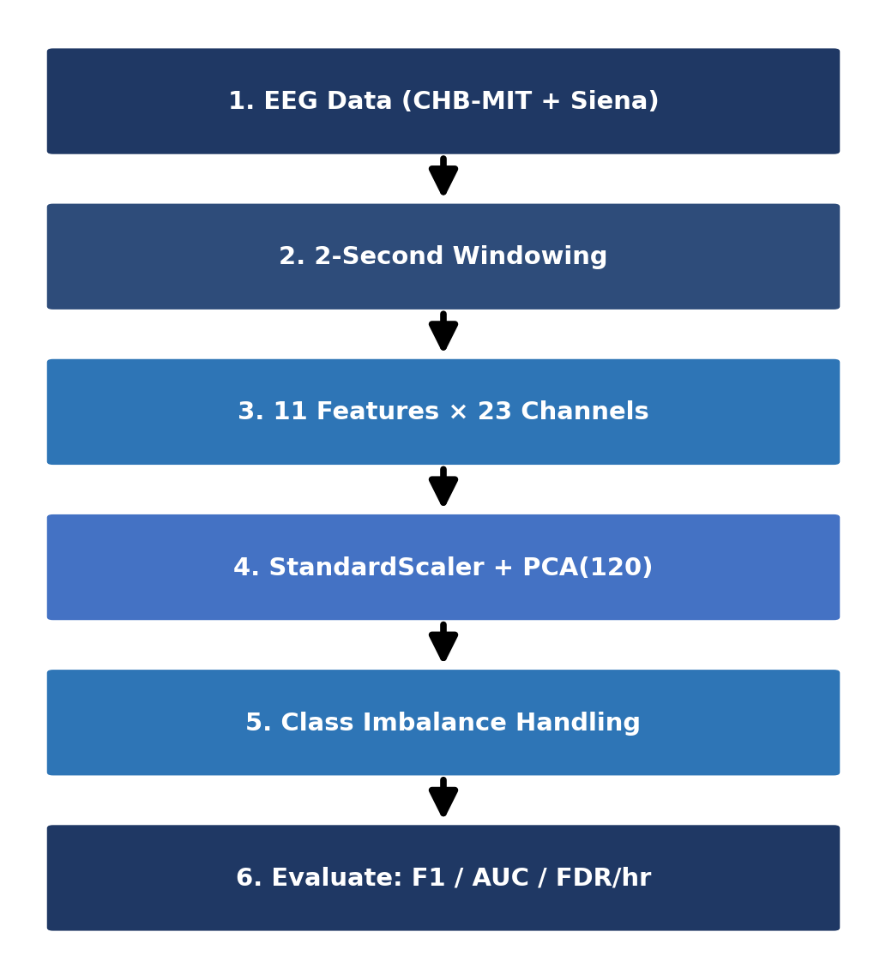
Fig. 1. Overview of the proposed EEG seizure detection pipeline.
Figure 1 summarises the pipeline: raw EEG is cut into windows, statistical features are extracted, dimensionality is reduced, class imbalance is handled, and the result is evaluated with clinical metrics.
A. Datasets
CHB-MIT [4] holds long-term scalp EEG from 22 paediatric patients at Children’s Hospital Boston, recorded with 23 channels at 256 Hz and annotated by experts with seizure onsets and offsets. Only three patients were available here. Patients chb01 and chb03 form the training set (21,588 windows, 185 seizure windows, ratio 115.7:1), and chb05 is held out for testing (3,598 windows, 113 seizure windows, 3.1%).
Siena [14] contains recordings from 14 adult patients at the University of Siena, sampled at 512 Hz and resampled here to 256 Hz. Only recordings that could be read in full were used, giving a subset of 2,491 two-second windows (63 seizure windows). Models trained on CHB-MIT are applied to this subset without retraining, as an exploratory cross-dataset test.
B. Feature Extraction
Each recording is split into consecutive, non-overlapping 2-second windows. For every channel we compute eleven features (TABLE I): seven time-domain statistics and the power in four frequency bands (delta, theta, alpha, beta), obtained with the NumPy FFT. Siena signals were z-scored per channel before feature extraction to reduce amplitude differences between recording systems, whereas CHB-MIT signals kept their recorded amplitude. Each CHB-MIT window is thus described by 253 features (23×11).
TABLE I
EXTRACTED STATISTICAL FEATURES PER EEG CHANNEL
Feature | Description
Mean | Mean signal amplitude in the window
Variance | Variability of the amplitude
RMS | Root mean square, a measure of signal power
Skewness | Asymmetry of the amplitude distribution
Kurtosis | Heavy-tailedness; increases during seizures
Maximum | Largest positive amplitude
Minimum | Largest negative amplitude
Delta power | Band power, 0.5–4 Hz
Theta power | Band power, 4–8 Hz
Alpha power | Band power, 8–13 Hz
Beta power | Band power, 13–30 Hz
C. Dimensionality Reduction
PCA projects the features onto orthogonal directions of maximal variance. A StandardScaler and a 120-component PCA are fitted on the training windows (chb01 and chb03) only and applied unchanged to the held-out patient, so no test-set statistics shape the projection. The 120 components explain 98.2% of the variance (TABLE V). For Siena, a new StandardScaler is fitted on the Siena features and the CHB-MIT PCA projection is reused.
D. Classification Techniques
Three tree-based learners are used: Random Forest (RF), Balanced Random Forest (BRF) and Extreme Gradient Boosting (XGBoost). They were selected for their robustness, their ability to model nonlinear relations, and their strong results on tabular EEG features.
Random Forest (RF) builds many decision trees on bootstrap samples with random feature subsets and takes a majority vote over the trees. This randomisation reduces overfitting and suits noisy EEG recordings.
Balanced Random Forest (BRF) adapts RF to imbalanced data: for each tree the majority class is randomly undersampled to match the minority class while all seizure windows are kept, so every tree is trained on a balanced bootstrap sample without any external resampling.
XGBoost builds trees sequentially, each one correcting the errors of the previous ones. To counter the skewed class distribution, the scale_pos_weight parameter increases the weight of seizure windows during training.
E. Class Imbalance Handling
SMOTE counters imbalance by creating synthetic seizure windows through linear interpolation between neighbouring minority samples. Rather than the usual 1:1 balance we set the sampling strategy to 0.05, so the minority class reaches 5% of the majority class. This avoids flooding the feature space with synthetic points, which caused a collapse in precision at the original 115.7:1 ratio.
SMOTETomek combines over- and undersampling: SMOTE first creates synthetic minority samples (sampling_strategy 0.05), and Tomek links, pairs of opposite-class nearest neighbours, are then removed to clean the class boundary.
Five strategies address the 115.7:1 imbalance: (1) Baseline RF (100 trees, maximum depth 10) without correction, as the reference; (2) SMOTE+RF with sampling_strategy=0.05; (3) Balanced RF, which undersamples the majority class in every bootstrap draw; (4) SMOTETomek+RF, i.e. SMOTE followed by Tomek-link removal; and (5) XGBoost with scale_pos_weight=115.7, which penalises missed seizures more than false alarms. SMOTE, SMOTETomek and Balanced RF come from the imbalanced-learn library [11].
F. Evaluation Protocol
We report precision, recall, F1-score, AUC-ROC and FDR/hour (false-positive windows per hour of test recording). Each technique was run with five random seeds (42, 123, 456, 789, 999), reported as mean±std (population standard deviation), and compared with the Baseline RF by a paired t-test over the seeds. Inference time was measured per 2-second window.
IV. Results and Discussion
A. CHB-MIT Technique Comparison
TABLE II and Figure 2 present the results for patient chb05 (seed 42), for whom the Baseline RF attains the best AUC-ROC (0.983), the best F1-score (0.543) and the lowest FDR/hour (28.02). Balanced RF has the highest recall (1.000), but its FDR reaches 501.78/hour. SMOTE+RF and SMOTETomek+RF give identical results (F1 0.278, FDR 64.54/hour), because no Tomek links were removed after SMOTE, so the SMOTETomek training set is identical to the SMOTE training set. XGBoost has a high recall (0.850) but low precision (F1 0.292, FDR 224.62/hour).
TABLE II
CHB-MIT SEIZURE CLASS EVALUATION (SEED=42). BOLD = BEST PER COLUMN.
Technique | Prec. | Recall | F1 | AUC | FDR/hr
Baseline RF | 0.529 | 0.558 | 0.543 | 0.983 | 28.02
SMOTE+RF | 0.232 | 0.345 | 0.278 | 0.952 | 64.54
BalancedRF | 0.101 | 1.000 | 0.184 | 0.897 | 501.78
SMOTETomek+RF | 0.232 | 0.345 | 0.278 | 0.952 | 64.54
XGBoost | 0.176 | 0.850 | 0.292 | 0.925 | 224.62

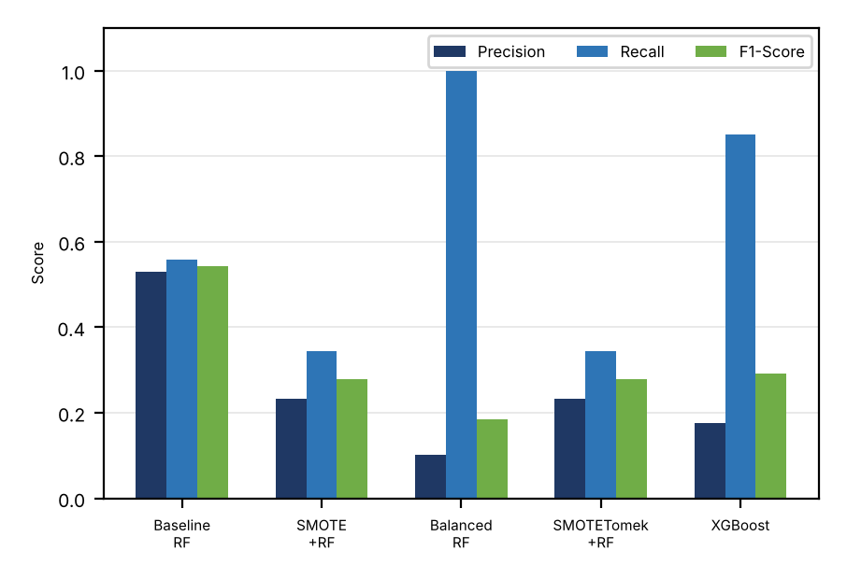
Fig. 2. CHB-MIT technique comparison: Precision, Recall and F1-Score.
B. Statistical Robustness
TABLE III reports the mean±std of F1-score, AUC-ROC and FDR/hour over five seeds for all five techniques. The Baseline RF has the highest AUC-ROC (0.984±0.001), the highest F1-score (0.575±0.034) and the lowest FDR/hour (26.0±3.5). Paired t-tests against the Baseline RF give p < 0.001 for F1-score, AUC-ROC and FDR/hour for every other technique. SMOTETomek+RF yields the same values as SMOTE+RF. With five seeds the smallest possible p-value of the Wilcoxon signed-rank test is 0.0625, so the paired t-test is reported. The seeds change only the model randomness on a fixed patient split.
TABLE III
STATISTICAL ROBUSTNESS OF ALL TECHNIQUES (MEAN±STD, 5 SEEDS)
Technique | F1 | AUC | FDR/hr
Baseline RF | 0.575±0.034 | 0.984±0.001 | 26.0±3.5
SMOTE+RF | 0.223±0.043 | 0.943±0.006 | 70.0±3.8
BalancedRF | 0.186±0.008 | 0.895±0.009 | 496.4±25.5
SMOTETomek+RF | 0.223±0.043 | 0.943±0.006 | 70.0±3.8
XGBoost | 0.281±0.013 | 0.925±0.007 | 218.6±8.2

C. Threshold Tuning
TABLE IV shows the effect of tuning the Baseline RF threshold. The F1-score improved from 0.549 at the default threshold of 0.50 to 0.628 at 0.40 (recall 0.920), but the FDR rose from 28.02 to 57.03 alerts/hour. Lower thresholds raise the recall to 1.000 at about 410 alerts/hour. The alert burden must therefore be considered together with classification effectiveness. A window whose predicted probability equals the threshold is counted as a seizure, so the row for 0.50 differs slightly from TABLE II.
TABLE IV
THRESHOLD TUNING ON BASELINE RF
Threshold | Precision | Recall | F1 | FDR/hr
0.50 | 0.533 | 0.566 | 0.549 | 28.02
0.40 | 0.477 | 0.920 | 0.628 | 57.03
0.30 | 0.319 | 0.982 | 0.482 | 118.57
0.20 | 0.203 | 0.991 | 0.337 | 219.62
0.10 | 0.121 | 1.000 | 0.216 | 409.73
D. PCA Ablation Study
In TABLE V, the F1-score and AUC-ROC increase from 40 to 90 components, and the AUC-ROC increases further to 0.983 at 120 components. The F1-score at the default threshold is slightly higher at 90 components (0.576) than at 120 (0.543), a difference of about one seed standard deviation (0.034 in TABLE III), so we do not claim that either is clearly better. We use 120 components throughout, which retain 98.2% of the variance. Without PCA (all 253 standardised features), the RF obtains F1 0.279, AUC-ROC 0.954 and FDR 60.5/hour, which is worse than with PCA; XGBoost obtains F1 0.350, AUC-ROC 0.946 and FDR 120.6/hour without PCA, compared with 0.292, 0.925 and 224.6 with PCA.
TABLE V
PCA ABLATION STUDY (BASELINE RF, SEED=42)
PCA Comp. | Var. Expl. % | F1 | AUC
40 | 85.3 | 0.417 | 0.957
60 | 91.2 | 0.478 | 0.970
90 | 95.9 | 0.576 | 0.978
120 | 98.2 | 0.543 | 0.983
E. Cross-Dataset Validation on Siena
TABLE VI and Figure 3 show the cross-dataset results on the Siena subset (2,491 windows, 63 seizure windows). AUC-ROC is lower than on CHB-MIT, between 0.782 and 0.887. At the default threshold the Baseline RF, SMOTE+RF and SMOTETomek+RF do not detect any seizure window (recall 0; their FDR of 0 only reflects that no alarms were raised). Balanced RF obtained the best F1-score (0.206) and recall (0.254), and XGBoost the best AUC-ROC (0.887) and precision (0.292) with a lower FDR (12.28/hour). The SMOTETomek+RF row equals the SMOTE+RF row, as on CHB-MIT.

TABLE VI
CROSS-DATASET: CHB-MIT TRAINED → SIENA TESTED. BOLD = BEST.
Technique | Prec. | Recall | F1 | AUC | FDR/hr
Baseline RF | 0.000 | 0.000 | 0.000 | 0.782 | 0.00
SMOTE+RF | 0.000 | 0.000 | 0.000 | 0.841 | 0.00
BalancedRF | 0.174 | 0.254 | 0.206 | 0.883 | 54.92
SMOTETomek+RF | 0.000 | 0.000 | 0.000 | 0.841 | 0.00
XGBoost | 0.292 | 0.111 | 0.161 | 0.887 | 12.28

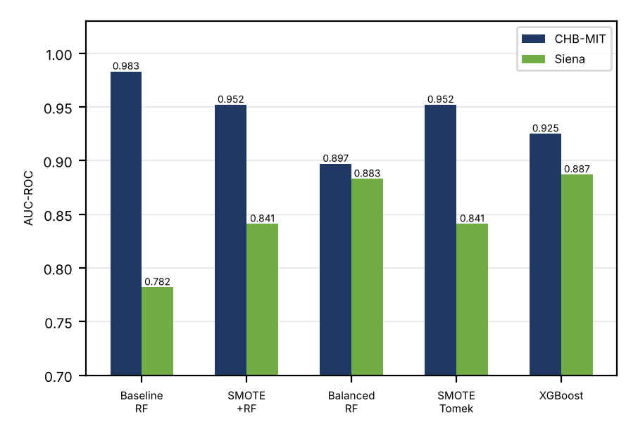
Fig. 3. AUC-ROC: CHB-MIT vs Siena cross-dataset validation.
F. Patient-Level, Deep-Learning and Domain-Adaptation Analyses
To examine patient-to-patient variability, each of the three available CHB-MIT patients was held out in turn, with the scaler and PCA refitted on the other two. TABLE VII gives the mean±std over the three held-out patients. The mean F1-score is low and varies strongly between patients (Baseline RF 0.194±0.247, from 0.000 on chb01 to 0.543 on chb05), while the AUC-ROC stays between 0.93 and 0.95 for all techniques. XGBoost has the highest mean F1 (0.234±0.043) and AUC-ROC (0.952±0.019), so the advantage of the Baseline RF seen on chb05 does not hold across patients. With only three patients these results are indicative, not statistically conclusive.
TABLE VII
LEAVE-ONE-PATIENT-OUT OVER THE THREE AVAILABLE PATIENTS (MEAN±STD)
Technique | F1 | AUC | FDR/hr
Baseline RF | 0.194±0.247 | 0.937±0.038 | 25.2±18.0
SMOTE+RF | 0.114±0.117 | 0.935±0.021 | 29.9±26.0
BalancedRF | 0.187±0.030 | 0.930±0.024 | 245.8±184.5
SMOTETomek+RF | 0.124±0.112 | 0.936±0.022 | 27.1±27.0
XGBoost | 0.234±0.043 | 0.952±0.019 | 82.9±100.3
A 1D-CNN and an MLP with positive-class weighting (pos_weight = 115.7) were trained on the same 120 PCA features (five seeds). On chb05 they reached F1 0.148±0.014 (AUC-ROC 0.937±0.091, FDR 613±71/hour) and 0.239±0.064 (AUC-ROC 0.924±0.016, FDR 353±101/hour), which is below the Baseline RF (F1 0.575, FDR 26.0/hour). On Siena the CNN had a recall of 0.454±0.064 but F1 only 0.171±0.004 and AUC-ROC 0.839±0.002, and the MLP had F1 0.103±0.068 and AUC-ROC 0.615±0.070. We also applied CORAL, an unsupervised alignment of the Siena features to the CHB-MIT training features that uses no Siena labels. It changed the AUC-ROC by at most 0.015 and left the recall of the tree models near zero (for example SMOTE+RF recall 0.016, AUC-ROC 0.841 to 0.856; XGBoost F1 0.161 to 0.132), so it did not remove the cross-dataset shift. These networks are small and untuned, so they should not be read as a limit of deep learning.
G. Discussion
There are three main results. First, AUC-ROC is more informative than F1 for imbalanced EEG data. Balanced RF reached a recall of 1.000, but with 501.78 false alarms per hour. On the held-out patient the uncorrected Baseline RF is the best configuration (AUC-ROC 0.983, FDR 28.02/hour). Second, resampling and cost-sensitive learning increased the false-alarm rate without improving AUC-ROC (0.895–0.952 compared with 0.983 for the baseline). Third, the discriminative ability carries over to other data (Siena AUC-ROC 0.782–0.887, leave-one-patient-out AUC-ROC 0.93–0.95), whereas the best operating point is patient- and site-dependent: the ranking of the techniques by F1 changed in the leave-one-patient-out test, so the threshold has to be calibrated for each deployment.
AUC-ROC evaluates how well windows are ranked across all thresholds, whereas F1 is computed at one operating point. Since seizures make up about 3% of the test windows, even a small false-positive rate produces many false alarms relative to the few seizure windows, which lowers precision and F1 while AUC-ROC stays high. The threshold study in TABLE IV shows that the operating point matters: with the same classifier, F1 rose from 0.549 to 0.628 when the threshold was lowered from 0.50 to 0.40. XGBoost, a different classifier with cost-sensitive weighting, did not improve F1 (0.281±0.013), so the gap is not simply a consequence of the choice of RF.
On Siena, the Baseline RF reaches an AUC-ROC of 0.782 but detects no seizure windows at the default threshold, which means that every seizure window would be missed; the same holds for SMOTE+RF and SMOTETomek+RF. In a monitoring setting a missed seizure costs far more than a false alarm, so these configurations would not be safe to deploy. Lowering the threshold on Siena raises the Baseline RF recall to 0.254 at a threshold of 0.05 (73.7 false detections per hour) and 0.397 at 0.02 (F1 0.195, 121.4 per hour). SMOTE+RF reaches a recall of 0.603 at 0.02 (F1 0.234, 161.9 per hour), and XGBoost has the best F1 of 0.275 at 0.05 (recall 0.302, 40.5 per hour). This is an oracle analysis, since the threshold was chosen using the Siena labels, so it is an upper bound and not a deployable calibration method. Even at the best threshold the F1-score stays below 0.28, and CORAL alignment (above) did not close the gap. Likely causes are differences in population (adults instead of children), recording equipment and montage, the small number of training patients, and the fact that z-score normalisation was applied to Siena only; we did not isolate their individual effects.
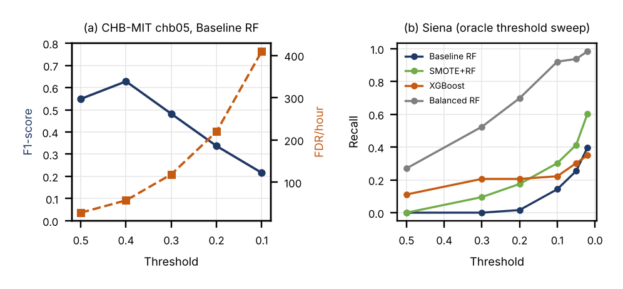
Fig. 4. Operating-point sensitivity: (a) F1-score and FDR/hour versus threshold on the held-out CHB-MIT patient; (b) recall versus threshold on Siena (oracle sweep, uses Siena labels).
Limitations. The models are trained on two CHB-MIT patients and tested on one patient (chb05) and, in the leave-one-patient-out test, on the three available patients; leave-one-patient-out validation over all 22 patients was not possible. The Siena evaluation uses only the recordings that could be read completely (63 seizure windows), so its estimates are noisy. FDR/hour is computed from window-level predictions, without event-level evaluation or post-processing. The deep-learning baselines are small and untuned, and the seed analysis varies only the random seed on a fixed split, so it does not capture variability between patients.
V. Conclusion
The paper presents a comparison of five techniques for handling class imbalance in EEG-based epileptic seizure detection on CHB-MIT, with an exploratory cross-dataset test on a subset of Siena. On the held-out patient the Baseline RF obtained an AUC-ROC of 0.984±0.001 and an FDR of 26.0±3.5/hour over five seeds, whereas SMOTE, SMOTETomek, Balanced RF and XGBoost raised the false-alarm rate. In the cross-dataset test on Siena the AUC-ROC was 0.782–0.887, showing that the learned ranking transfers, while the default threshold needs recalibration (the Baseline RF detected no seizure windows at 0.5); a three-patient leave-one-patient-out test showed AUC-ROC of 0.93–0.95 with patient-dependent F1.
In conclusion: first, resampling and cost-sensitive techniques raised the FDR from 28 to between 65 and 502/hour on the held-out patient, and only Balanced RF and XGBoost improved the recall. Second, the ranking quality (AUC-ROC) transfers across patients and datasets, whereas the operating point must be recalibrated for each site; an oracle threshold raised the Siena recall of the Baseline RF to 0.40 and SMOTE+RF to 0.60, and CORAL alignment gave little further change. Third, threshold selection has to consider FDR/hour as a clinical constraint. Future work will perform leave-one-patient-out cross-validation on all 22 CHB-MIT patients, event-based evaluation, and better-tuned deep models, and will study calibration and transfer learning with a small amount of target-site data.
Data and code availability: CHB-MIT and Siena are public datasets hosted on PhysioNet [4], [14]; the analysis code can be obtained from the authors on request.
Acknowledgment
We thank Children’s Hospital Boston, MIT and the University of Siena for making the CHB-MIT and Siena Scalp EEG databases available on PhysioNet, and the scikit-learn, imbalanced-learn, XGBoost and SHAP communities.
References
[1] World Health Organization, “Epilepsy: Key facts,” WHO Fact Sheet, Feb. 2023.
[2] P. Kwan and M. J. Brodie, “Early identification of refractory epilepsy,” New England Journal of Medicine, vol. 342, no. 5, pp. 314–319, 2000.
[3] S. Ramgopal et al., “Seizure detection, seizure prediction, and closed-loop warning systems in epilepsy,” Epilepsy & Behavior, vol. 37, pp. 291–307, 2014.
[4] A. H. Shoeb and J. V. Guttag, “Application of machine learning to epileptic seizure detection,” in Proc. 27th ICML, 2010, pp. 975–982.
[5] A. Subasi and M. I. Gursoy, “EEG signal classification using PCA, ICA, LDA and support vector machines,” Expert Syst. Appl., vol. 37, pp. 8659–8666, 2010.
[6] L. Guo, D. Rivero, and A. Pazos, “Epileptic seizure detection using multiwavelet transform,” J. Neurosci. Methods, vol. 193, pp. 156–163, 2010.
[7] U. R. Acharya et al., “Automated EEG analysis of epilepsy: A review,” Knowl.-Based Syst., vol. 45, pp. 147–165, 2013.
[8] N. V. Chawla et al., “SMOTE: Synthetic minority over-sampling technique,” J. Artif. Intell. Res., vol. 16, pp. 321–357, 2002.
[9] G. E. A. P. A. Batista et al., “A study of methods for balancing machine learning training data,” ACM SIGKDD Explor. Newsl., vol. 6, pp. 20–29, 2004.
[10] C. Chen, A. Liaw, and L. Breiman, “Using random forest to learn imbalanced data,” Univ. California Berkeley, Tech. Rep. 666, 2004.
[11] G. Lemaître et al., “Imbalanced-learn: A Python toolbox,” J. Mach. Learn. Res., vol. 18, no. 17, pp. 1–5, 2017.
[12] T. Chen and C. Guestrin, “XGBoost: A scalable tree boosting system,” in Proc. 22nd ACM SIGKDD, 2016, pp. 785–794.
[13] H. He and E. A. Garcia, “Learning from imbalanced data,” IEEE Trans. Knowl. Data Eng., vol. 21, pp. 1263–1284, 2009.
[14] P. Detti, “Siena Scalp EEG Database (version 1.0.0),” PhysioNet, 2020. [Online]. Available: https://doi.org/10.13026/5d4a-j060

