Epileptic Seizure Detection Using Machine Learning: A Comparative Study of Class Imbalance Handling Techniques
Soha Chand  Dept. of Artificial Intelligence Engineering  Mukesh Patel School of Technology  Management & Engineering, SVKM’s NMIMS  soha.chand36@nmims.in | Atharv Dixit  Dept. of Artificial Intelligence Engineering  Mukesh Patel School of Technology  Management & Engineering, SVKM’s NMIMS  atharv.dixit69@nmims.in | Hima Deepthi Vankayalapati  Dept. of Artificial Intelligence Engineering  Mukesh Patel School of Technology  Management & Engineering, SVKM’s NMIMS  himadeepthi.vankayalapati@nmims.edu

Abstract—Epilepsy affects over fifty million people worldwide, and automatic seizure detection from electroencephalogram (EEG) signals is hampered by severe class imbalance: seizure windows make up only 0.65% of the windows used here (about 153:1). This study compares class imbalance techniques on the CHB-MIT Scalp EEG Database with leave-one-patient-out validation over 22 patients (809,187 two-second windows), using eleven features per channel, PCA fitted on the training patients only, and paired significance tests. The techniques are a Baseline Random Forest (RF), SMOTE+RF, Balanced RF and XGBoost, plus temporal smoothing of the window probabilities; SMOTETomek, which equalled SMOTE, was evaluated only in a preliminary two-patient study. No resampling or cost-sensitive technique improved AUC-ROC (0.802–0.810) or F1 (0.095–0.107) over the plain RF; they moved the operating point instead. At the default threshold the Baseline RF and SMOTE+RF raised no true alarm in 15 and 13 of the 22 patients, whereas Balanced RF and XGBoost reached a recall of about 0.5 at roughly 180 false alarms per hour. Temporal smoothing, with parameters chosen on training patients only, was the only change that significantly improved AUC-ROC (0.802 to 0.829; 19 of 22 patients; Wilcoxon p < 0.001). In an exploratory cross-dataset test on a subset of the Siena Scalp EEG Database, the ranking quality transferred (AUC-ROC 0.78–0.89) but the default operating point did not.
Keywords— EEG, epileptic seizure detection, class imbalance, SMOTE, SMOTE-TOMEK, Random Forest, XGBoost, PCA, CHB-MIT, Siena, AUC-ROC, false detection rate, cross-dataset validation, temporal smoothing, leave-one-patient-out
I. Introduction
Epilepsy is one of the most frequent chronic neurological disorders, affecting more than 50 million people of all ages [1]. Patients suffer recurrent, unprovoked seizures caused by abnormal electrical discharges in the brain. Besides the risk of injury and Sudden Unexpected Death in Epilepsy (SUDEP), the unpredictability of seizures restricts driving, employment and independent living [2].
EEG remains the clinical gold standard for identifying epileptic activity. Long-term monitoring yields hours to days of continuous multi-channel recordings, and reviewing them by hand is slow, subjective and dependent on trained neurologists [3].
A central difficulty is the extreme class imbalance of continuous EEG: seizures are rare, and in the data used here they make up only 0.65% of the windows (a ratio of non-seizure to seizure windows of about 153:1). Standard classifiers favour the majority class, reaching high accuracy while missing seizures. Threshold-dependent metrics such as F1 are also insufficient on their own, because clinical use needs the number of false detections per hour.
The contributions of this paper are: (i) a comparison of class imbalance methods (SMOTE, SMOTETomek, Balanced Random Forest and cost-sensitive XGBoost) against a plain Random Forest, with AUC-ROC and FDR/hour as the main clinical metrics, by leave-one-patient-out validation over 22 CHB-MIT patients with paired Wilcoxon and t-tests; (ii) a temporal smoothing step whose parameters are chosen on training patients only; (iii) a preliminary two-patient study with five random seeds, threshold tuning and a PCA ablation; (iv) an exploratory cross-dataset test on a subset of the Siena Scalp EEG Database, with threshold-sensitivity and domain-adaptation analyses; and (v) 1D-CNN and MLP baselines and a real-time feasibility check (about 0.01 ms per window). The central finding is that, across patients, no resampling or cost-sensitive technique improved AUC-ROC or F1 over a plain Random Forest, because they only move the operating point between missed seizures and false alarms, whereas temporal smoothing was the only step that improved AUC-ROC significantly.
II. Related Work
Shoeb and Guttag [4] released the CHB-MIT Scalp EEG Database together with a patient-specific SVM seizure detector, which became a standard benchmark for later work. Subasi and Gursoy [5] reported that PCA-reduced statistical EEG features work well with an SVM across patients, and Acharya et al. [7] reviewed EEG features and concluded that combining time-domain and frequency-domain measures is more effective than either alone.
SMOTE was proposed by Chawla et al. [8] to oversample the minority class, but its default 1:1 target breaks down at extreme imbalance and yields an unusable classifier. Batista et al. [9] combined SMOTE with Tomek-link cleaning (SMOTETomek). Chen et al. [10] introduced Balanced Random Forest, which undersamples the majority class inside every bootstrap sample, and Chen and Guestrin [12] introduced XGBoost, whose scale_pos_weight parameter re-weights the minority class in the boosting loss.
III. Methodology
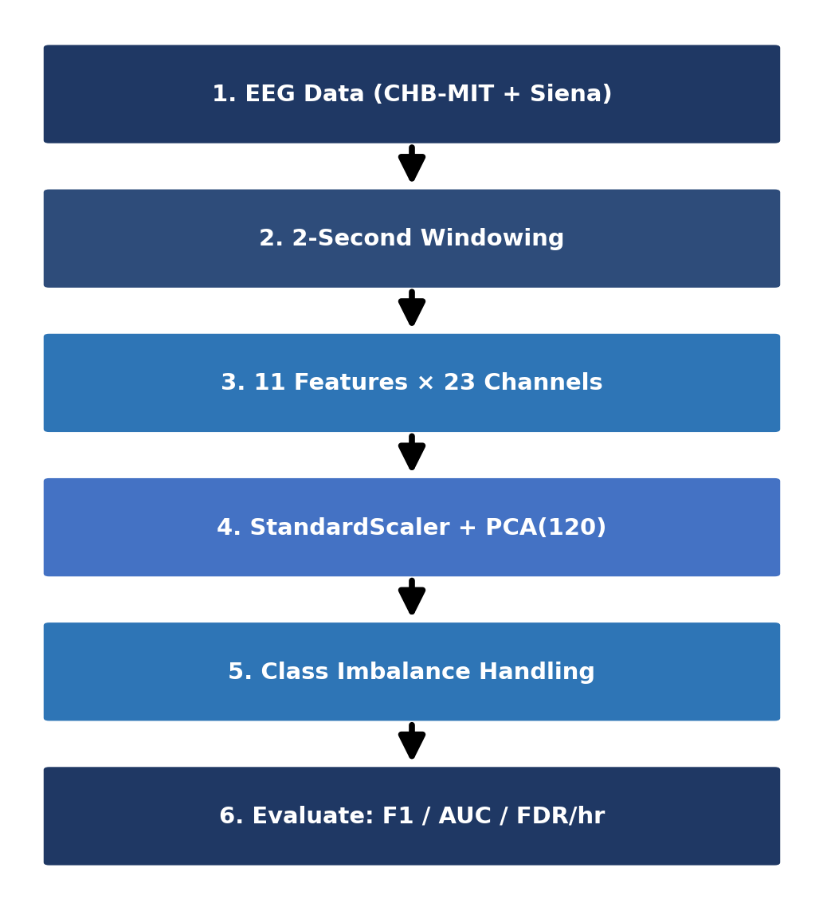
Fig. 1. Overview of the proposed EEG seizure detection pipeline.
Figure 1 summarises the pipeline: raw EEG is cut into windows, statistical features are extracted, dimensionality is reduced, class imbalance is handled, and the result is evaluated with clinical metrics.
A. Datasets
CHB-MIT [4] holds long-term scalp EEG from paediatric patients at Children’s Hospital Boston, recorded at 256 Hz and annotated by experts with seizure onsets and offsets. The main evaluation uses 22 cases (chb01–chb20, chb22 and chb23). Case chb21 is a later recording of the same subject as chb01 and was excluded, so that no subject appears in both training and test data, and chb24 was not used. For each patient, all usable files that contain a seizure and up to eight evenly spaced seizure-free files were used (files lacking the common channels were skipped). This gives 809,187 two-second windows (about 450 hours), of which 5,250 (0.65%) are seizure windows; the number of windows per patient ranges from 16,679 to 104,207, and the number of seizure windows from 45 to 1,005. A preliminary two-patient study was run first, with chb01 and chb03 as training set (21,588 windows, 185 seizure windows, ratio 115.7:1) and chb05 as test patient (3,598 windows, 113 seizure windows, 3.1%).
Siena [14] contains recordings from 14 adult patients at the University of Siena, sampled at 512 Hz and resampled here to 256 Hz. Only recordings that could be read in full were used, giving a subset of 2,491 two-second windows (63 seizure windows). Models trained on CHB-MIT are applied to this subset without retraining, as an exploratory cross-dataset test.
B. Feature Extraction
Each recording is split into consecutive, non-overlapping 2-second windows. For every channel we compute eleven features (TABLE I): seven time-domain statistics and the power in four frequency bands (delta, theta, alpha, beta), obtained with the NumPy FFT. Siena signals were z-scored per channel before feature extraction to reduce amplitude differences between recording systems, whereas CHB-MIT signals kept their recorded amplitude. The 22-patient evaluation uses the 18 bipolar channels present in every file (198 features per window); the preliminary two-patient study used all 23 channels (253 features).
TABLE I
EXTRACTED STATISTICAL FEATURES PER EEG CHANNEL
Feature | Description
Mean | Mean signal amplitude in the window
Variance | Variability of the amplitude
RMS | Root mean square, a measure of signal power
Skewness | Asymmetry of the amplitude distribution
Kurtosis | Heavy-tailedness; increases during seizures
Maximum | Largest positive amplitude
Minimum | Largest negative amplitude
Delta power | Band power, 0.5–4 Hz
Theta power | Band power, 4–8 Hz
Alpha power | Band power, 8–13 Hz
Beta power | Band power, 13–30 Hz
C. Dimensionality Reduction
PCA projects the features onto orthogonal directions of maximal variance. A StandardScaler and a 120-component PCA are fitted on the training windows only (on the 21 training patients in the leave-one-patient-out evaluation, and on chb01 and chb03 in the two-patient study) and applied unchanged to the held-out patient, so no test-set statistics shape the projection. In the two-patient study the 120 components explain 98.2% of the variance (Section IV-D). For Siena, a new StandardScaler is fitted on the Siena features and the CHB-MIT PCA projection is reused.
D. Classification Techniques
Three tree-based learners are used. Random Forest (RF) averages many decision trees trained on bootstrap samples with random feature subsets, which reduces overfitting on noisy EEG. Balanced Random Forest (BRF) undersamples the majority class in the bootstrap sample of every tree while keeping all seizure windows, so each tree sees a balanced sample without external resampling. XGBoost builds trees sequentially, each correcting the errors of the previous ones, and its scale_pos_weight parameter increases the weight of seizure windows. They were chosen for their robustness, their ability to model nonlinear relations and their strong results on tabular EEG features.
E. Class Imbalance Handling
SMOTE counters imbalance by creating synthetic seizure windows through linear interpolation between neighbouring minority samples. Rather than the usual 1:1 balance we set the sampling strategy to 0.05, so the minority class reaches 5% of the majority class. This avoids flooding the feature space with synthetic points, which caused a collapse in precision at the original 115.7:1 ratio.
SMOTETomek combines over- and undersampling: SMOTE first creates synthetic minority samples (sampling_strategy 0.05), and Tomek links, pairs of opposite-class nearest neighbours, are then removed to clean the class boundary.
Five strategies address the imbalance: (1) Baseline RF (maximum depth 10) without correction, as the reference; (2) SMOTE+RF with sampling_strategy=0.05; (3) Balanced RF, which undersamples the majority class in every bootstrap draw; (4) SMOTETomek+RF, i.e. SMOTE followed by Tomek-link removal; and (5) XGBoost with scale_pos_weight set to the training imbalance ratio, which penalises missed seizures more than false alarms. The forests have 100 trees in the two-patient study and 50 in the leave-one-patient-out evaluation, and XGBoost uses 150 and 100 boosting rounds respectively, to fit the computing budget. The imbalance ratio is 115.7:1 in the two-patient study and 40:1 in the leave-one-patient-out evaluation (after the common undersampling described in Section III-G). SMOTETomek+RF removed no samples in the two-patient study and was therefore not rerun in the 22-patient evaluation. SMOTE, SMOTETomek and Balanced RF come from the imbalanced-learn library [11].
F. Temporal Smoothing
A seizure lasts longer than one two-second window, so isolated window-level alarms are unlikely to be seizures. We therefore average the Baseline RF probabilities of consecutive windows within a recording with a moving average of k windows and then apply a threshold τ. The pair (k, τ), with k ∈ {1, 3, 5, 7, 9, 15} windows (2–30 s) and τ ∈ {0.05, 0.10, 0.15, 0.20, 0.30, 0.40, 0.50, 0.60}, is chosen to maximise the mean F1 over four inner leave-one-training-patient-out folds (20-tree forests), so the held-out patient is never used for the choice. This configuration is called Baseline RF + smoothing.
G. Evaluation Protocol
We report precision, recall, F1-score, AUC-ROC and FDR/hour (false-positive windows per hour of test recording, computed on the windows of the selected files). In the main evaluation each of the 22 patients is held out in turn: the scaler, PCA and all classifiers are fitted on the other 21 patients, and the held-out patient is neither subsampled nor used for any choice. To limit computation, the training negatives are randomly undersampled to 40 per seizure window (the same subset for all techniques) before the scaler and PCA are fitted. Results are given as mean±std (population standard deviation) over the 22 held-out patients at threshold 0.5 and compared with the Baseline RF by the Wilcoxon signed-rank test and the paired t-test across patients. The preliminary two-patient study instead uses five random seeds (42, 123, 456, 789, 999) on the fixed split and a paired t-test over the seeds. Inference time was measured per 2-second window.
IV. Results and Discussion
A. Leave-One-Patient-Out over 22 CHB-MIT Patients
TABLE II gives the mean±std over the 22 held-out patients and TABLE III the paired tests against the Baseline RF. The AUC-ROC of the four classifiers is almost identical (0.802 to 0.810) and no difference is significant (Wilcoxon p ≥ 0.77). The F1-score is low for all of them (0.095–0.107), also without significant differences from the Baseline RF (p > 0.10), and varies strongly between patients (std 0.19 for the Baseline RF). The techniques differ in their operating point at threshold 0.5. The Baseline RF and SMOTE+RF are conservative: they detect no seizure window in 15 and 13 of the 22 patients (mean recall 0.069 and 0.088, mean FDR 2.1 and 3.2/hour). Balanced RF and XGBoost detect part of the seizures in every patient (mean recall 0.521 and 0.487) but raise 184 and 174 false alarms per hour on average, more than the Baseline RF in all 22 patients (p < 0.001), which is not usable in practice. SMOTE+RF raises the false-alarm rate slightly (Wilcoxon p = 0.015, higher in 13 and lower in 3 patients; t-test p = 0.076) without improving F1 or AUC-ROC. After Bonferroni correction for the 12 Wilcoxon tests in TABLE III (α = 0.004), only the FDR differences of Balanced RF and XGBoost and the AUC-ROC gain of temporal smoothing remain significant.
TABLE II
LEAVE-ONE-PATIENT-OUT OVER 22 CHB-MIT PATIENTS (MEAN±STD OVER PATIENTS). BOLD = BEST MEAN.
Technique | Prec. | Recall | F1 | AUC | FDR/hr
Baseline RF | 0.24±0.38 | 0.07±0.14 | 0.10±0.19 | 0.80±0.19 | 2.1±7.7
SMOTE+RF | 0.22±0.34 | 0.09±0.17 | 0.11±0.19 | 0.80±0.18 | 3.2±9.1
BalancedRF | 0.06±0.08 | 0.52±0.34 | 0.10±0.12 | 0.81±0.16 | 184±180
XGBoost | 0.06±0.07 | 0.49±0.31 | 0.10±0.11 | 0.81±0.14 | 174±174
Baseline RF + smoothing | 0.29±0.40 | 0.24±0.31 | 0.17±0.24 | 0.83±0.20 | 20.8±60.2
TABLE III
PAIRED TESTS AGAINST BASELINE RF OVER 22 PATIENTS: WILCOXON p / PAIRED t-TEST p
Technique | F1 | AUC | FDR/hr
SMOTE+RF | 0.110 / 0.350 | 0.924 / 0.633 | 0.015 / 0.076
BalancedRF | 0.198 / 0.950 | 0.775 / 0.370 | <0.001 / <0.001
XGBoost | 0.222 / 0.948 | 0.899 / 0.727 | <0.001 / <0.001
+ smoothing | 0.075 / 0.084 | <0.001 / 0.006 | 0.069 / 0.161
Temporal smoothing is the only modification that helps. With the length and threshold chosen on the training patients (k = 15 windows in 11 patients, 9 in seven and 7 in four; thresholds 0.05–0.4), the mean AUC-ROC rises from 0.802 to 0.829 (median 0.883 to 0.954) and improves in 19 of 22 patients (Wilcoxon p < 0.001, t-test p = 0.006). The mean F1 rises from 0.098 to 0.170 (p = 0.075 and 0.084), which is suggestive but not significant, and the mean recall rises from 0.069 to 0.236 at a mean precision of 0.287. In chb01, for example, the Baseline RF has an AUC-ROC of 0.963 but detects nothing at 0.5, whereas smoothing reaches F1 0.658 (precision 0.728, recall 0.601, 3.7 false alarms per hour). Smoothing does not help every patient: the false-alarm rate is higher in 8 of 22 patients (mean 20.8, median 0.0 per hour) and very high in chb04 (287/hour), and the selected k often lies at the upper end of the search grid, so longer windows were not explored. Fig. 2 shows that performance is patient-dependent: the AUC-ROC of the Baseline RF is 0.90 or higher in 11 patients but below 0.5 in three (chb06, chb12 and chb13), and it stays below 0.65 for every technique in these three.

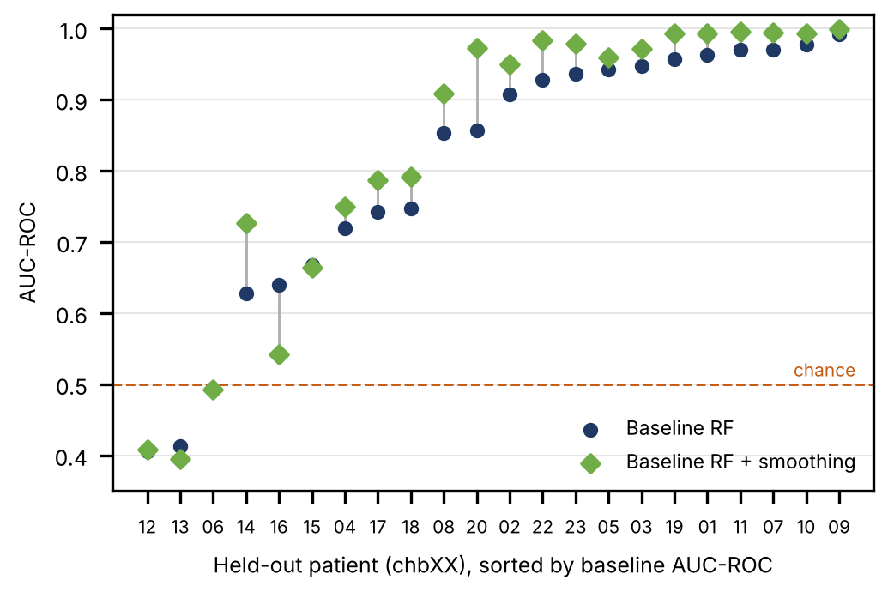
Fig. 2. Per-patient AUC-ROC in leave-one-patient-out validation for the Baseline RF and the Baseline RF with temporal smoothing (a line joins the two values of one patient).
B. Two-Patient Study: Statistical Robustness
In the preliminary two-patient study (training on chb01 and chb03, test on chb05), TABLE IV reports the mean±std of F1-score, AUC-ROC and FDR/hour over five seeds. On this patient the Baseline RF has the highest AUC-ROC (0.984±0.001), the highest F1-score (0.575±0.034) and the lowest FDR/hour (26.0±3.5), and paired t-tests give p < 0.001 against every other technique for all three metrics. Balanced RF reaches a recall of 1.000 but at 501.8 false alarms/hour (seed 42), and SMOTETomek+RF equals SMOTE+RF because no Tomek links were removed after SMOTE. With five seeds the smallest possible p-value of the Wilcoxon test is 0.0625, so the t-test is reported; the seeds change only the model randomness on a fixed split. This ranking does not carry over to the 22-patient evaluation, where the techniques do not differ in F1 or AUC-ROC (TABLE II); chb05 is a patient on which the baseline does well (AUC-ROC 0.94 and F1 0.54 in that evaluation).
TABLE IV
TWO-PATIENT STUDY (CHB-MIT, TEST ON chb05): MEAN±STD OVER 5 SEEDS
Technique | F1 | AUC | FDR/hr
Baseline RF | 0.575±0.034 | 0.984±0.001 | 26.0±3.5
SMOTE+RF | 0.223±0.043 | 0.943±0.006 | 70.0±3.8
BalancedRF | 0.186±0.008 | 0.895±0.009 | 496.4±25.5
SMOTETomek+RF | 0.223±0.043 | 0.943±0.006 | 70.0±3.8
XGBoost | 0.281±0.013 | 0.925±0.007 | 218.6±8.2

C. Threshold Tuning
Fig. 3(a) shows the effect of tuning the Baseline RF threshold on chb05 in the two-patient study. The F1-score improved from 0.549 at the default threshold of 0.50 to 0.628 at 0.40 (recall 0.920), but the FDR rose from 28.02 to 57.03 alerts/hour. Lower thresholds raise the recall to 0.982 at 0.30 (118.6 alerts/hour) and to 1.000 at 0.10 (409.7 alerts/hour). The alert burden must therefore be considered together with classification effectiveness. A window whose predicted probability equals the threshold is counted as a seizure, so the row for 0.50 differs slightly from the seed-42 F1 of 0.543.
D. PCA Ablation Study
With 40, 60, 90 and 120 PCA components (explaining 85.3%, 91.2%, 95.9% and 98.2% of the variance), the F1-score is 0.417, 0.478, 0.576 and 0.543 and the AUC-ROC 0.957, 0.970, 0.978 and 0.983 for the Baseline RF on chb05 (seed 42), so both increase from 40 to 90 components and the AUC-ROC increases further at 120. The F1-score at the default threshold is slightly higher at 90 components (0.576) than at 120 (0.543), a difference of about one seed standard deviation (0.034 in TABLE IV), so we do not claim that either is clearly better. We use 120 components throughout, which retain 98.2% of the variance in the two-patient study. Without PCA (all 253 standardised features), the RF obtains F1 0.279, AUC-ROC 0.954 and FDR 60.5/hour, which is worse than with PCA; XGBoost obtains F1 0.350, AUC-ROC 0.946 and FDR 120.6/hour without PCA, compared with 0.292, 0.925 and 224.6 with PCA.
E. Cross-Dataset Validation on Siena
TABLE V shows the cross-dataset results on the Siena subset (2,491 windows, 63 seizure windows) for the models trained in the two-patient study. AUC-ROC is lower than on CHB-MIT, between 0.782 and 0.887. At the default threshold the Baseline RF, SMOTE+RF and SMOTETomek+RF do not detect any seizure window (recall 0; their FDR of 0 only reflects that no alarms were raised). Balanced RF obtained the best F1-score (0.206) and recall (0.254), and XGBoost the best AUC-ROC (0.887) and precision (0.292) with a lower FDR (12.28/hour). The SMOTETomek+RF row equals the SMOTE+RF row, as on CHB-MIT.

TABLE V
CROSS-DATASET: CHB-MIT TRAINED → SIENA TESTED. BOLD = BEST.
Technique | Prec. | Recall | F1 | AUC | FDR/hr
Baseline RF | 0.000 | 0.000 | 0.000 | 0.782 | 0.00
SMOTE+RF | 0.000 | 0.000 | 0.000 | 0.841 | 0.00
BalancedRF | 0.174 | 0.254 | 0.206 | 0.883 | 54.92
SMOTETomek+RF | 0.000 | 0.000 | 0.000 | 0.841 | 0.00
XGBoost | 0.292 | 0.111 | 0.161 | 0.887 | 12.28

F. Deep-Learning and Domain-Adaptation Analyses
In the two-patient setting, a 1D-CNN and an MLP with positive-class weighting (pos_weight = 115.7) were trained on the same 120 PCA features (five seeds). On chb05 they reached F1 0.148±0.014 (AUC-ROC 0.937±0.091, FDR 613±71/hour) and 0.239±0.064 (AUC-ROC 0.924±0.016, FDR 353±101/hour), which is below the Baseline RF (F1 0.575, FDR 26.0/hour). On Siena the CNN had a recall of 0.454±0.064 but F1 only 0.171±0.004 and AUC-ROC 0.839±0.002, and the MLP had F1 0.103±0.068 and AUC-ROC 0.615±0.070. We also applied CORAL, an unsupervised alignment of the Siena features to the CHB-MIT training features that uses no Siena labels. It changed the AUC-ROC by at most 0.015 and left the recall of the tree models near zero (for example SMOTE+RF recall 0.016, AUC-ROC 0.841 to 0.856; XGBoost F1 0.161 to 0.132), so it did not remove the cross-dataset shift. These networks are small and untuned, so they should not be read as a limit of deep learning.
G. Discussion
There are four main results. First, across 22 held-out patients no resampling or cost-sensitive technique improved on a plain Random Forest in AUC-ROC (0.802–0.810) or F1 (0.095–0.107), and the differences are far smaller than the spread between patients (std of AUC-ROC 0.14–0.19). Second, what the techniques change is the operating point. At threshold 0.5 the Baseline RF and SMOTE+RF are silent in most patients, whereas Balanced RF and XGBoost find about half of the seizure windows at roughly 180 false alarms per hour; neither extreme is clinically useful, and the advantage of the Baseline RF seen on chb05 did not generalise. Third, using the temporal context is more effective than rebalancing the training data: smoothing the probabilities of neighbouring windows raised AUC-ROC in 19 of 22 patients (0.802 to 0.829, p < 0.001) and F1 from 0.098 to 0.170. Fourth, performance varies strongly between patients: the Baseline RF reaches an AUC-ROC of 0.90 or higher in 11 of 22 patients but below 0.5 in three, so whether the features generalise to the patient matters more than the choice of imbalance technique.
AUC-ROC evaluates how well windows are ranked across all thresholds, whereas F1 is computed at one operating point, and with seizure windows at 0.65% of the data even a small false-positive rate produces many false alarms relative to the few seizure windows. The threshold study on chb05 (Fig. 3(a)) shows that the operating point matters: with the same classifier, F1 rose from 0.549 to 0.628 when the threshold was lowered from 0.50 to 0.40. In the 22-patient results the same effect appears in reverse: in chb01 the Baseline RF has an AUC-ROC of 0.963 but detects no seizure at 0.5. Resampling and class weighting mainly shift the predicted probabilities, that is, the operating point, which is consistent with AUC-ROC staying unchanged, whereas smoothing adds information from neighbouring windows. The validation design also matters: the leave-one-patient-out F1 (0.10–0.17) is far below the F1 of 0.575 on chb05, which shows how optimistic a single favourable split can be.
On Siena, the Baseline RF reaches an AUC-ROC of 0.782 but detects no seizure window at the default threshold, as do SMOTE+RF and SMOTETomek+RF, so every seizure would be missed and these configurations would not be safe to deploy. Lowering the threshold raises the Baseline RF recall to 0.254 at 0.05 (73.7 false detections per hour) and 0.397 at 0.02 (F1 0.195, 121.4 per hour); SMOTE+RF reaches 0.603 at 0.02 (F1 0.234, 161.9 per hour), and XGBoost has the best F1 of 0.275 at 0.05 (recall 0.302, 40.5 per hour). This is an oracle analysis, since the threshold was chosen with the Siena labels, so it is an upper bound and not a deployable calibration. CORAL alignment did not close the gap. Likely causes are differences in population (adults instead of children), recording equipment and montage, the small number of training patients, and the z-score normalisation applied to Siena only; we did not isolate their effects.
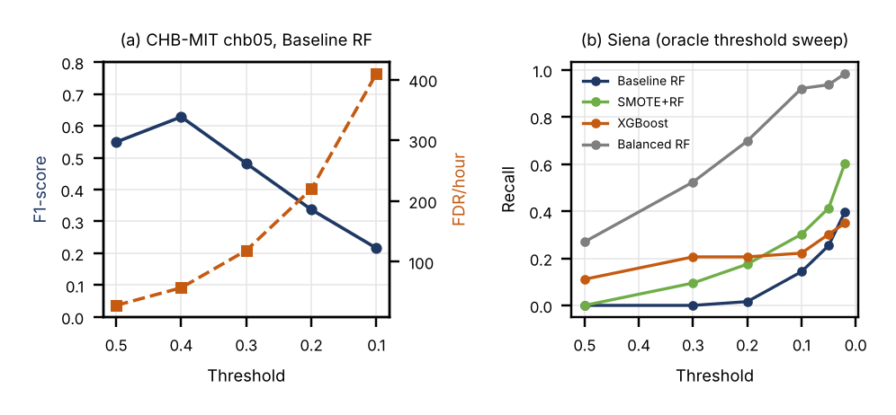
Fig. 3. Operating-point sensitivity: (a) F1-score and FDR/hour versus threshold on the held-out CHB-MIT patient; (b) recall versus threshold on Siena (oracle sweep, uses Siena labels).
Limitations. The main evaluation covers 22 CHB-MIT patients, but only a subset of each recording was used (the seizure files and at most eight seizure-free files per patient), so FDR/hour is computed on these windows and is not a false-alarm rate for continuous monitoring. To keep the run time manageable, the training negatives were undersampled to 40 per seizure window, the forests and boosting were smaller than in the two-patient study, and the smoothing parameters were chosen with four inner folds and 20-tree forests; SMOTETomek was not rerun, and no hyper-parameters were tuned. Smoothing was applied to the Baseline RF only, its chosen length often lies at the edge of the search grid, and the evaluation is still window-based rather than event-based. Three patients (chb06, chb12 and chb13) have an AUC-ROC at or below chance for the Baseline RF, and we did not investigate why. The Siena evaluation uses only the recordings that could be read completely (63 seizure windows), so its estimates are noisy. The deep-learning baselines are small and untuned, and the seed analysis of the two-patient study varies only the random seed.
V. Conclusion
This paper compared class imbalance handling techniques for EEG-based seizure detection on CHB-MIT with leave-one-patient-out validation over 22 patients, a preliminary two-patient study and an exploratory cross-dataset test on a subset of Siena. Across the 22 held-out patients, SMOTE, Balanced RF and cost-sensitive XGBoost did not improve AUC-ROC (0.802–0.810) or F1 (0.095–0.107) over a plain Random Forest. They only moved the operating point, from no detection in 15 and 13 patients (Baseline RF and SMOTE+RF) to about 180 false alarms per hour (Balanced RF and XGBoost). Temporal smoothing of the window probabilities, with parameters chosen on training patients only, was the only step that significantly improved AUC-ROC (0.802 to 0.829, better in 19 of 22 patients, p < 0.001) and raised the mean F1 from 0.098 to 0.170. In the cross-dataset test on Siena the AUC-ROC was 0.782–0.887, showing that the learned ranking transfers while the default threshold needs recalibration.
In conclusion: first, the benefit of the Baseline RF seen for a single patient did not hold across patients, so imbalance techniques should be judged with patient-independent validation before conclusions are drawn. Second, a plain Random Forest with temporal smoothing is a strong and cheap baseline that the resampling techniques did not beat. Third, AUC-ROC is high for most but not all patients (below 0.5 for chb06, chb12 and chb13), and the operating point must be set with FDR/hour as a clinical constraint; an oracle threshold on Siena raised the Baseline RF recall to 0.40 and SMOTE+RF to 0.60, which is an upper bound and not a deployable calibration. Future work will add event-level evaluation on the full recordings, tuned deep models, patient-specific calibration, and an analysis of the patients for whom every technique fails.
Data and code availability: CHB-MIT and Siena are public datasets hosted on PhysioNet [4], [14]; the analysis code can be obtained from the authors on request.
Acknowledgment
We thank Children’s Hospital Boston, MIT and the University of Siena for making the CHB-MIT and Siena Scalp EEG databases available on PhysioNet, and the scikit-learn, imbalanced-learn, XGBoost and SHAP communities.
References
[1] World Health Organization, “Epilepsy: Key facts,” WHO Fact Sheet, Feb. 2023.
[2] P. Kwan and M. J. Brodie, “Early identification of refractory epilepsy,” New England Journal of Medicine, vol. 342, no. 5, pp. 314–319, 2000.
[3] S. Ramgopal et al., “Seizure detection, seizure prediction, and closed-loop warning systems in epilepsy,” Epilepsy & Behavior, vol. 37, pp. 291–307, 2014.
[4] A. H. Shoeb and J. V. Guttag, “Application of machine learning to epileptic seizure detection,” in Proc. 27th ICML, 2010, pp. 975–982.
[5] A. Subasi and M. I. Gursoy, “EEG signal classification using PCA, ICA, LDA and support vector machines,” Expert Syst. Appl., vol. 37, pp. 8659–8666, 2010.
[6] L. Guo, D. Rivero, and A. Pazos, “Epileptic seizure detection using multiwavelet transform,” J. Neurosci. Methods, vol. 193, pp. 156–163, 2010.
[7] U. R. Acharya et al., “Automated EEG analysis of epilepsy: A review,” Knowl.-Based Syst., vol. 45, pp. 147–165, 2013.
[8] N. V. Chawla et al., “SMOTE: Synthetic minority over-sampling technique,” J. Artif. Intell. Res., vol. 16, pp. 321–357, 2002.
[9] G. E. A. P. A. Batista et al., “A study of methods for balancing machine learning training data,” ACM SIGKDD Explor. Newsl., vol. 6, pp. 20–29, 2004.
[10] C. Chen, A. Liaw, and L. Breiman, “Using random forest to learn imbalanced data,” Univ. California Berkeley, Tech. Rep. 666, 2004.
[11] G. Lemaître et al., “Imbalanced-learn: A Python toolbox,” J. Mach. Learn. Res., vol. 18, no. 17, pp. 1–5, 2017.
[12] T. Chen and C. Guestrin, “XGBoost: A scalable tree boosting system,” in Proc. 22nd ACM SIGKDD, 2016, pp. 785–794.
[13] H. He and E. A. Garcia, “Learning from imbalanced data,” IEEE Trans. Knowl. Data Eng., vol. 21, pp. 1263–1284, 2009.
[14] P. Detti, “Siena Scalp EEG Database (version 1.0.0),” PhysioNet, 2020. [Online]. Available: https://doi.org/10.13026/5d4a-j060

