Epileptic Seizure Detection Using Machine Learning: A Comparative Study of Class Imbalance Handling Techniques
Soha Chand  Dept. of Artificial Intelligence Engineering  Mukesh Patel School of Technology  Management & Engineering, SVKM’s NMIMS  soha.chand36@nmims.in | Atharv Dixit  Dept. of Artificial Intelligence Engineering  Mukesh Patel School of Technology  Management & Engineering, SVKM’s NMIMS  atharv.dixit69@nmims.in | Hima Deepthi Vankayalapati  Dept. of Artificial Intelligence Engineering  Mukesh Patel School of Technology  Management & Engineering, SVKM’s NMIMS  himadeepthi.vankayalapati@nmims.edu

Abstract—Epilepsy affects over fifty million people worldwide, and automatic seizure detection from electroencephalogram (EEG) signals is hampered by severe class imbalance: seizure windows make up only 0.65% of the windows used here (about 153:1). This study compares class imbalance techniques on the CHB-MIT Scalp EEG Database with leave-one-patient-out validation over 22 patients (809,187 two-second windows), using eleven features per channel, PCA fitted on the training patients only, and paired significance tests. The techniques are a Baseline Random Forest (RF), SMOTE+RF, Balanced RF and XGBoost; SMOTETomek, which equalled SMOTE, was evaluated only in a preliminary two-patient study. No resampling or cost-sensitive technique improved AUC-ROC (0.802–0.810) or F1 (0.095–0.107) over the plain RF; they moved the operating point instead. Per-patient feature normalisation, the context of neighbouring windows and temporal smoothing raised the mean AUC-ROC to 0.891 (better in all 22 patients; Wilcoxon p < 0.001) and the F1 from 0.098 to 0.283 when the statistics came from whole recordings, and to 0.868 and 0.177 when they came from a 30-minute seizure-free baseline only. With alarm post-processing, 46% (76 of 164) and 32% (52 of 164) of the seizures were detected at about 0.7 false alarms per hour. On 8 Siena subjects the AUC-ROC rose from 0.585 to 0.771 (0.665 with the baseline only), but only 2 and 5 of 14 seizures were detected.
Keywords— EEG, epileptic seizure detection, class imbalance, SMOTE, SMOTE-TOMEK, Random Forest, XGBoost, PCA, CHB-MIT, Siena, AUC-ROC, false detection rate, cross-dataset validation, temporal smoothing, leave-one-patient-out
I. Introduction
Epilepsy is one of the most frequent chronic neurological disorders, affecting more than 50 million people of all ages [1]. Besides the risk of injury and Sudden Unexpected Death in Epilepsy (SUDEP), the unpredictability of seizures restricts driving, employment and independent living [2].
EEG remains the clinical gold standard for identifying epileptic activity, but reviewing days of continuous multi-channel recordings by hand is slow and subjective [3].
A central difficulty is the extreme class imbalance of continuous EEG: seizures are rare, and in the data used here they make up only 0.65% of the windows (a ratio of non-seizure to seizure windows of about 153:1). Standard classifiers favour the majority class, reaching high accuracy while missing seizures. Threshold-dependent metrics such as F1 are also insufficient on their own, because clinical use needs the number of false detections per hour.
The contributions of this paper are: (i) a comparison of class imbalance methods (SMOTE, SMOTETomek, Balanced Random Forest and cost-sensitive XGBoost) against a plain Random Forest, with AUC-ROC and FDR/hour as the main clinical metrics, by leave-one-patient-out validation over 22 CHB-MIT patients with paired Wilcoxon and t-tests; (ii) per-patient feature normalisation (from whole recordings or from a seizure-free baseline), temporal context features, temporal smoothing and alarm post-processing, with parameters chosen without the held-out patient and with window-level and event-level results; (iii) a preliminary two-patient study with five random seeds, threshold tuning and a PCA ablation; (iv) an exploratory cross-dataset test of the models trained on 22 patients on 8 Siena subjects, with an oracle threshold analysis; and (v) 1D-CNN and MLP baselines and a real-time feasibility check (about 0.01 ms per window). The central finding is that, across patients, no resampling or cost-sensitive technique improved AUC-ROC or F1 over a plain Random Forest, whereas handling patient variability and temporal context did, although the resulting seizure detection is still far from clinical requirements.
II. Related Work
Shoeb and Guttag [4] released the CHB-MIT Scalp EEG Database together with a patient-specific SVM detector, which became a standard benchmark. Subasi and Gursoy [5] reported that PCA-reduced statistical EEG features work well with an SVM, and Acharya et al. [7] concluded that combining time- and frequency-domain features is more effective than either alone.
SMOTE was proposed by Chawla et al. [8] to oversample the minority class, but its default 1:1 target breaks down at extreme imbalance. Batista et al. [9] combined SMOTE with Tomek-link cleaning (SMOTETomek). Chen et al. [10] introduced Balanced Random Forest, which undersamples the majority class in every bootstrap sample, and Chen and Guestrin [12] XGBoost, whose scale_pos_weight parameter re-weights the minority class.
III. Methodology
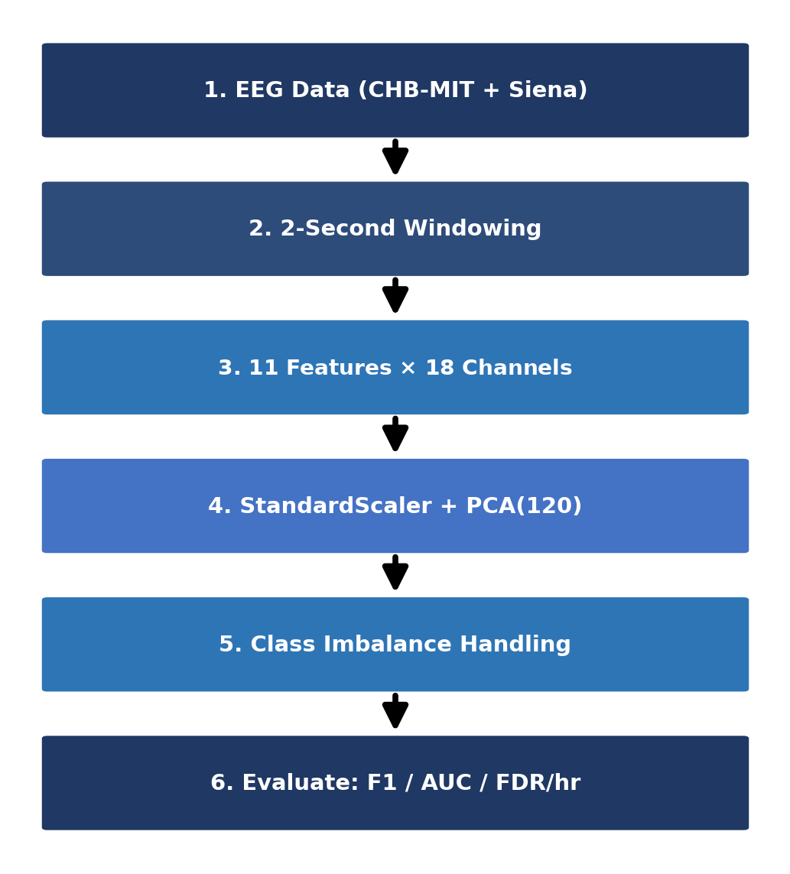
Fig. 1. Overview of the proposed EEG seizure detection pipeline.
Fig. 1 summarises the pipeline.
A. Datasets
CHB-MIT [4] holds long-term scalp EEG from paediatric patients at Children’s Hospital Boston, recorded at 256 Hz and annotated by experts with seizure onsets and offsets. The main evaluation uses 22 cases (chb01–chb20, chb22 and chb23). Case chb21 is a later recording of the same subject as chb01 and was excluded, so that no subject appears in both training and test data, and chb24 was not used. For each patient, all usable files that contain a seizure and up to eight evenly spaced seizure-free files were used (files lacking the common channels were skipped). This gives 809,187 two-second windows (about 450 hours), of which 5,250 (0.65%) are seizure windows. A preliminary two-patient study was run first, with chb01 and chb03 as training set (21,588 windows, 185 seizure windows, ratio 115.7:1) and chb05 as test patient (3,598 windows, 113 seizure windows, 3.1%).
Siena [14] contains recordings from 14 adult patients at the University of Siena, sampled at 512 Hz and resampled here to 256 Hz. Only subjects whose annotation list and recording files could be retrieved were used, with at most two seizure recordings per subject, giving a subset of 8 subjects with 79,860 two-second windows (464 seizure windows, 0.58%). Because Siena uses a monopolar montage, the same 18 bipolar channels as in CHB-MIT were computed by subtracting electrodes. Models trained on all 22 CHB-MIT patients are applied to this subset without retraining, as an exploratory cross-dataset test.
B. Feature Extraction
Each recording is split into consecutive, non-overlapping 2-second windows. For every channel we compute eleven features (TABLE I): seven time-domain statistics and the power in four frequency bands (delta, theta, alpha, beta), obtained with the NumPy FFT. The 22-patient evaluation uses the 18 bipolar channels present in every file (198 features per window); the preliminary two-patient study used all 23 channels (253 features).
TABLE I
EXTRACTED STATISTICAL FEATURES PER EEG CHANNEL
Feature | Description
Mean | Mean signal amplitude in the window
Variance | Variability of the amplitude
RMS | Root mean square, a measure of signal power
Skewness | Asymmetry of the amplitude distribution
Kurtosis | Heavy-tailedness; increases during seizures
Maximum | Largest positive amplitude
Minimum | Largest negative amplitude
Delta power | Band power, 0.5–4 Hz
Theta power | Band power, 4–8 Hz
Alpha power | Band power, 8–13 Hz
Beta power | Band power, 13–30 Hz
C. Dimensionality Reduction
PCA projects the features onto orthogonal directions of maximal variance. A StandardScaler and a 120-component PCA are fitted on the training windows only (on the 21 training patients in the leave-one-patient-out evaluation, and on chb01 and chb03 in the two-patient study) and applied unchanged to the held-out patient, so no test-set statistics shape the projection. In the two-patient study the 120 components explain 98.2% of the variance (Section IV-D). For Siena, the CHB-MIT PCA projection is reused, after standardising the Siena features with a StandardScaler fitted on them (raw-feature pipeline) or after the per-subject normalisation of Section III-G (improved pipeline).
D. Classification Techniques
Three tree-based learners are used. Random Forest (RF) averages many decision trees trained on bootstrap samples with random feature subsets, which reduces overfitting on noisy EEG. Balanced Random Forest (BRF) undersamples the majority class in the bootstrap sample of every tree while keeping all seizure windows, so each tree sees a balanced sample without external resampling. XGBoost builds trees sequentially, each correcting the errors of the previous ones, and its scale_pos_weight parameter increases the weight of seizure windows. They were chosen for their robustness, their ability to model nonlinear relations and their strong results on tabular EEG features.
E. Class Imbalance Handling
SMOTE counters imbalance by creating synthetic seizure windows through linear interpolation between neighbouring minority samples. Rather than the usual 1:1 balance we set the sampling strategy to 0.05, so the minority class reaches 5% of the majority class. This avoids flooding the feature space with synthetic points, which caused a collapse in precision at the original 115.7:1 ratio.
SMOTETomek combines over- and undersampling: SMOTE first creates synthetic minority samples (sampling_strategy 0.05), and Tomek links, pairs of opposite-class nearest neighbours, are then removed to clean the class boundary.
Five strategies address the imbalance: (1) Baseline RF (maximum depth 10) without correction, as the reference; (2) SMOTE+RF with sampling_strategy=0.05; (3) Balanced RF; (4) SMOTETomek+RF, i.e. SMOTE followed by Tomek-link removal; and (5) XGBoost with scale_pos_weight set to the training imbalance ratio. The forests have 100 trees in the two-patient study and 50 in the leave-one-patient-out evaluation, and XGBoost uses 150 and 100 boosting rounds, to fit the computing budget. The imbalance ratio is 115.7:1 in the two-patient study and 40:1 in the leave-one-patient-out evaluation (after the common undersampling of Section III-H). SMOTETomek+RF removed no samples in the two-patient study and was therefore not rerun in the 22-patient evaluation. SMOTE, SMOTETomek and Balanced RF come from imbalanced-learn [11].
F. Temporal Smoothing
A seizure lasts longer than one two-second window, so isolated window-level alarms are unlikely to be seizures. We therefore average the Baseline RF probabilities of consecutive windows within a recording with a moving average of k windows and then apply a threshold τ. The pair (k, τ), with k ∈ {1, 3, 5, 7, 9, 15} windows (2–30 s) and τ ∈ {0.05, 0.10, 0.15, 0.20, 0.30, 0.40, 0.50, 0.60}, is chosen to maximise the mean F1 over four inner leave-one-training-patient-out folds (20-tree forests), so the held-out patient is never used for the choice. This configuration is called Baseline RF + smoothing.
G. Patient Normalisation and Temporal Context
Patient variability is a main obstacle for patient-independent detection, so we added label-free steps. First, each feature is transformed with sign(x)·log(1+|x|) and then centred and scaled for each patient with the median and interquartile range of that patient. These statistics come either from all selected recordings of the patient (whole-recording variant), which include its seizure files, or only from the first 900 windows (30 min) of its seizure-free recordings (baseline-period variant), which stands for a seizure-free baseline recording. Second, the 120 PCA scores of a window are concatenated with their moving average over five windows (10 s) within the same recording, giving 240 inputs. The 40:1 undersampling, the 50-tree Random Forest and the smoothing selection (now on the 240 inputs) are unchanged, and the imbalance techniques were not rerun on these inputs. Third, alarms are post-processed: windows above a threshold τ form alarms, alarms shorter than m windows are dropped, and alarms closer than g windows are merged. (τ, m, g) is chosen from τ ∈ {0.1, …, 0.5}, m ∈ {1, 2, 3, 5} and g ∈ {0, 5, 10, 20} to maximise event sensitivity minus 0.1 times the false alarms per hour on the out-of-fold probabilities of the other 21 patients. For Siena, each subject is normalised in the same way, and the smoothing parameters are the most frequent k and the median τ of the 22 leave-one-patient-out runs.
H. Evaluation Protocol
We report precision, recall, F1-score, AUC-ROC and FDR/hour (false-positive windows per hour of test recording, computed on the windows of the selected files). In the main evaluation each of the 22 patients is held out in turn: the scaler, PCA and all classifiers are fitted on the other 21 patients, and the held-out patient is neither subsampled nor used for any choice. To limit computation, the training negatives are randomly undersampled to 40 per seizure window (the same subset for all techniques) before the scaler and PCA are fitted. Results are given as mean±std (population standard deviation) over the 22 held-out patients at threshold 0.5 and compared with the Baseline RF by the Wilcoxon signed-rank test and the paired t-test across patients. The preliminary two-patient study instead uses five random seeds (42, 123, 456, 789, 999) on the fixed split and a paired t-test over the seeds. For event-level results, a seizure counts as detected if at least one alarm (a run of consecutive positive windows) falls inside it, and a false alarm is an alarm without any seizure window. Inference time was measured per 2-second window.
IV. Results and Discussion
A. Leave-One-Patient-Out over 22 CHB-MIT Patients
TABLE II gives the mean±std over the 22 held-out patients and TABLE III the paired tests against the Baseline RF. The AUC-ROC of the four classifiers is almost identical (0.802 to 0.810) and no difference is significant (Wilcoxon p ≥ 0.77). The F1-score is low for all of them (0.095–0.107), also without significant differences from the Baseline RF (p > 0.10), and varies strongly between patients (std 0.19 for the Baseline RF). The techniques differ in their operating point at threshold 0.5. The Baseline RF and SMOTE+RF are conservative: they detect no seizure window in 15 and 13 of the 22 patients (mean recall 0.069 and 0.088, mean FDR 2.1 and 3.2/hour). Balanced RF and XGBoost detect part of the seizures in every patient (mean recall 0.521 and 0.487) but raise 184 and 174 false alarms per hour on average, more than the Baseline RF in all 22 patients (p < 0.001), which is not usable in practice. SMOTE+RF raises the false-alarm rate slightly (Wilcoxon p = 0.015, higher in 13 and lower in 3 patients; t-test p = 0.076) without improving F1 or AUC-ROC. After Bonferroni correction for the 24 Wilcoxon tests in TABLE III (α = 0.0021), the significant results are the FDR differences of Balanced RF and XGBoost, the AUC-ROC gains of temporal smoothing and of the four normalised variants, and the F1 gain of the full pipeline (p = 0.0019); the F1 gain with context only (p = 0.0029) narrowly misses it.
TABLE II
LEAVE-ONE-PATIENT-OUT OVER 22 CHB-MIT PATIENTS (MEAN±STD OVER PATIENTS). BOLD = BEST MEAN.
Technique | Prec. | Recall | F1 | AUC | FDR/hr
Baseline RF | 0.24±0.38 | 0.07±0.14 | 0.10±0.19 | 0.80±0.19 | 2.1±7.7
SMOTE+RF | 0.22±0.34 | 0.09±0.17 | 0.11±0.19 | 0.80±0.18 | 3.2±9.1
BalancedRF | 0.06±0.08 | 0.52±0.34 | 0.10±0.12 | 0.81±0.16 | 184±180
XGBoost | 0.06±0.07 | 0.49±0.31 | 0.10±0.11 | 0.81±0.14 | 174±174
Baseline RF + smoothing | 0.29±0.40 | 0.24±0.31 | 0.17±0.24 | 0.83±0.20 | 20.8±60.2
RF + patient norm | 0.38±0.44 | 0.10±0.17 | 0.14±0.21 | 0.86±0.15 | 1.9±6.0
RF + norm + context | 0.44±0.44 | 0.18±0.24 | 0.22±0.27 | 0.88±0.14 | 3.3±9.6
RF + norm + ctx + smoothing | 0.43±0.44 | 0.28±0.33 | 0.28±0.34 | 0.89±0.15 | 5.9±14.2
RF + base. norm + ctx + smooth. | 0.24±0.35 | 0.32±0.39 | 0.18±0.28 | 0.87±0.16 | 45.9±111.8
TABLE III
PAIRED TESTS AGAINST BASELINE RF (RAW), 22 PATIENTS: WILCOXON p / t-TEST p. BOLD = SIGNIFICANT AFTER BONFERRONI.
Technique | F1 | AUC | FDR/hr
SMOTE+RF | 0.110 / 0.350 | 0.924 / 0.633 | 0.015 / 0.076
BalancedRF | 0.198 / 0.950 | 0.775 / 0.370 | <0.001 / <0.001
XGBoost | 0.222 / 0.948 | 0.899 / 0.727 | <0.001 / <0.001
+ smoothing | 0.075 / 0.084 | <0.001 / 0.006 | 0.069 / 0.161
+ patient norm | 0.041 / 0.036 | <0.001 / <0.001 | 0.795 / 0.689
+ norm + context | 0.003 / 0.005 | <0.001 / <0.001 | 0.054 / 0.042
+ ctx + smoothing | 0.002 / 0.005 | <0.001 / <0.001 | 0.005 / 0.138
+ baseline-period | 0.177 / 0.247 | <0.001 / <0.001 | 0.006 / 0.089
Temporal smoothing of the raw-feature Baseline RF, with the length and threshold chosen on the training patients (k = 15 windows in 11 patients, 9 in seven and 7 in four; thresholds 0.05–0.4), raises the mean AUC-ROC from 0.802 to 0.829 (median 0.883 to 0.954; better in 19 of 22 patients; Wilcoxon p < 0.001, t-test p = 0.006) and the mean F1 from 0.098 to 0.170 (p = 0.075 and 0.084, not significant). In chb01, for example, the Baseline RF has an AUC-ROC of 0.963 but detects nothing at 0.5, whereas smoothing reaches F1 0.658 (precision 0.728, recall 0.601, 3.7 false alarms per hour). Smoothing does not help every patient: the false-alarm rate is higher in 8 of 22 patients (mean 20.8, median 0.0 per hour) and very high in chb04 (287/hour). Fig. 2 shows that performance is patient-dependent: the AUC-ROC of the raw Baseline RF is 0.90 or higher in 11 patients but below 0.5 in three (chb06, chb12 and chb13), and it stays below 0.65 for every raw-feature technique in these three.
Patient normalisation and temporal context are the changes that help most. Normalising the features of each patient raised the mean AUC-ROC from 0.802 to 0.856 (better in 21 of 22 patients), adding the context of neighbouring windows to 0.882 (better in all 22) and smoothing to 0.891 (better in all 22; Wilcoxon p < 0.001 in each case). The mean F1 rose from 0.098 to 0.138, 0.217 and 0.283 (Wilcoxon p = 0.041, 0.003 and 0.002), and the mean recall from 0.069 to 0.281 at a mean precision of 0.43. The false-alarm rate also rose, from 2.1 to 5.9 per hour (lower than the Baseline RF in only 5 of 22 patients). These numbers use whole-recording statistics, which include the seizure files of the patient, so they are optimistic.
At event level, the full pipeline detected 45 of 164 seizures (27.4%) at a mean of 0.41 false alarms per hour (median 0.13), against 36 and 40 for the two simpler variants, and none in nine patients (chb02, chb06, chb12, chb14–chb18 and chb20; chb12 alone has 27 seizures). Alarm post-processing raised this to 76 of 164 (46.3%) at 0.73 false alarms per hour (median 0.49), with at least one seizure detected in 19 of 22 patients; τ = 0.2, m = 5 and g = 20 were chosen for all 22 patients. Because the choice uses the out-of-fold predictions of models that had seen the held-out patient, it is mildly optimistic. Event-level values exist only for the new models and, like FDR/hour, refer to the selected recordings.
With the baseline-period normalisation, which uses no seizure windows, the mean AUC-ROC is 0.868 (better than the raw Baseline RF in 19 of 22 patients; Wilcoxon p < 0.001), but the mean F1 is 0.177 (p = 0.18) and the window-level FDR 45.9/hour. It detects 51 of 164 seizures at 0.93 false alarms per hour, and 52 of 164 (31.7%) at 0.70 per hour with post-processing, with at least one seizure detected in 15 of 22 patients. This is the more realistic estimate, and the whole-recording results above are an upper bound.

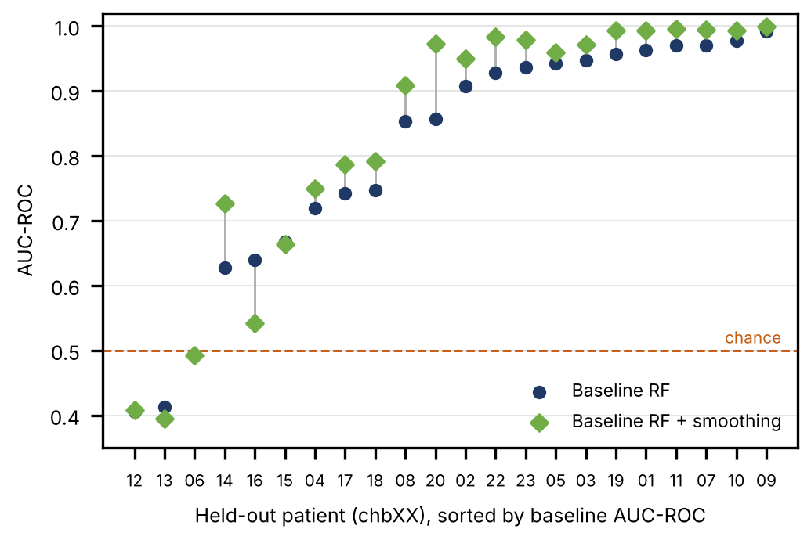
Fig. 2. Per-patient AUC-ROC in leave-one-patient-out validation for the Baseline RF and the Baseline RF with temporal smoothing, both on the raw features (a line joins the two values of one patient).
B. Two-Patient Study: Statistical Robustness
In the preliminary two-patient study (training on chb01 and chb03, test on chb05), TABLE IV reports the mean±std over five seeds. On this patient the Baseline RF has the highest AUC-ROC (0.984±0.001) and F1-score (0.575±0.034) and the lowest FDR/hour (26.0±3.5), with paired t-tests p < 0.001 against every other technique (with five seeds the Wilcoxon p-value cannot go below 0.0625). Balanced RF reaches a recall of 1.000 but at 501.8 false alarms/hour (seed 42), and SMOTETomek+RF equals SMOTE+RF because no Tomek links were removed. The seeds change only the model randomness on a fixed split, and this ranking does not carry over to the 22-patient evaluation (TABLE II); chb05 is a patient on which the baseline does well (AUC-ROC 0.94 and F1 0.54 in that evaluation).
TABLE IV
TWO-PATIENT STUDY (CHB-MIT, TEST ON chb05): MEAN±STD OVER 5 SEEDS
Technique | F1 | AUC | FDR/hr
Baseline RF | 0.575±0.034 | 0.984±0.001 | 26.0±3.5
SMOTE+RF | 0.223±0.043 | 0.943±0.006 | 70.0±3.8
BalancedRF | 0.186±0.008 | 0.895±0.009 | 496.4±25.5
SMOTETomek+RF | 0.223±0.043 | 0.943±0.006 | 70.0±3.8
XGBoost | 0.281±0.013 | 0.925±0.007 | 218.6±8.2

C. Threshold Tuning
Tuning the Baseline RF threshold on chb05 in the two-patient study improved the F1-score from 0.549 at the default threshold of 0.50 to 0.628 at 0.40 (recall 0.920), but the FDR rose from 28.02 to 57.03 alerts/hour; at 0.10 the recall reaches 1.000 at 409.7 alerts/hour. The alert burden must therefore be considered together with classification effectiveness. A window whose probability equals the threshold counts as a seizure, so 0.549 differs slightly from the seed-42 F1 of 0.543.
D. PCA Ablation Study
With 40, 60, 90 and 120 PCA components (explaining 85.3%, 91.2%, 95.9% and 98.2% of the variance), the Baseline RF on chb05 (seed 42) reaches an F1-score of 0.417, 0.478, 0.576 and 0.543 and an AUC-ROC of 0.957, 0.970, 0.978 and 0.983. The F1 difference between 90 and 120 components is about one seed standard deviation (0.034 in TABLE IV), so we do not claim that either is better and use 120 throughout. Without PCA (all 253 standardised features) the RF obtains F1 0.279, AUC-ROC 0.954 and FDR 60.5/hour, and XGBoost F1 0.350, AUC-ROC 0.946 and FDR 120.6/hour, compared with 0.292, 0.925 and 224.6 for XGBoost with PCA.
E. Cross-Dataset Validation on Siena
TABLE V shows the result of training on all 22 CHB-MIT patients and testing on the 8 Siena subjects. With the raw features the transfer largely failed: the AUC-ROC of the four classifiers lies between 0.468 and 0.585, and that of XGBoost (0.468) is below chance. At threshold 0.5 the Baseline RF, SMOTE+RF and SMOTETomek+RF detect no seizure window, whereas Balanced RF and XGBoost detect 22.2% and 12.3% of the seizure windows at 178 and 214 false detections per hour. Smoothing the Baseline RF (k = 15, τ = 0.05, chosen on CHB-MIT) gave an AUC-ROC of 0.642 and an F1 of 0.069. Normalising each Siena subject (Section III-G) raised the AUC-ROC to 0.749, to 0.759 with temporal context and to 0.771 with smoothing (k = 15, τ = 0.4, taken from the CHB-MIT runs). The F1 of the best configuration is only 0.096 (precision 0.159, recall 0.069), and it detects 2 of the 14 seizures at 0.36 false alarms per hour (1 and 2 of 14 for the two simpler variants). With the baseline-period normalisation (k = 15, τ = 0.2) the AUC-ROC is lower, 0.665, and the F1 0.035, but 5 of 14 seizures are detected at 5.3 false alarms per hour (3.3 with post-processing). The ranking is thus clearly better than with the raw features, but the detector is not usable. The SMOTETomek+RF row equals the SMOTE+RF row, as on CHB-MIT.

TABLE V
CROSS-DATASET: 22 CHB-MIT PATIENTS → SIENA (8 SUBJECTS). BOLD = BEST (FDR NOT MARKED).
Technique | Prec. | Recall | F1 | AUC | FDR/hr
Baseline RF | 0.000 | 0.000 | 0.000 | 0.585 | 0.05
SMOTE+RF | 0.000 | 0.000 | 0.000 | 0.578 | 0.18
BalancedRF | 0.013 | 0.222 | 0.024 | 0.584 | 178.29
SMOTETomek+RF | 0.000 | 0.000 | 0.000 | 0.578 | 0.18
XGBoost | 0.006 | 0.123 | 0.011 | 0.468 | 213.56
Baseline RF + smoothing | 0.043 | 0.179 | 0.069 | 0.642 | 41.90
RF + subject norm | 0.048 | 0.002 | 0.004 | 0.749 | 0.45
RF + norm + context | 0.048 | 0.011 | 0.018 | 0.759 | 2.25
RF + norm + ctx + smoothing | 0.159 | 0.069 | 0.096 | 0.771 | 3.81
RF + base. norm + ctx + smooth. | 0.019 | 0.293 | 0.035 | 0.665 | 161.83

F. Deep-Learning Baselines
In the two-patient setting, a 1D-CNN and an MLP with positive-class weighting (pos_weight = 115.7) were trained on the same 120 PCA features (five seeds). On chb05 they reached F1 0.148±0.014 (AUC-ROC 0.937±0.091, FDR 613±71/hour) and 0.239±0.064 (AUC-ROC 0.924±0.016, FDR 353±101/hour), below the Baseline RF (F1 0.575, FDR 26.0/hour). These networks are small, untuned and not evaluated on 22 patients, so they are not a limit of deep learning.
G. Discussion
There are five main results. First, across 22 held-out patients no resampling or cost-sensitive technique improved on a plain Random Forest in AUC-ROC (0.802–0.810) or F1 (0.095–0.107), and the differences are far smaller than the spread between patients (std of AUC-ROC 0.14–0.19). Second, what the techniques change is the operating point. At threshold 0.5 the Baseline RF and SMOTE+RF are silent in most patients, whereas Balanced RF and XGBoost find about half of the seizure windows at roughly 180 false alarms per hour; neither extreme is clinically useful, and the advantage of the Baseline RF seen on chb05 did not generalise. Third, handling the patient variability and the temporal context was more effective than rebalancing the training data: per-patient normalisation, neighbouring-window context and smoothing raised the mean AUC-ROC from 0.802 to 0.891 and the mean F1 from 0.098 to 0.283 with whole-recording statistics, and to 0.868 and 0.177 with statistics from a 30-minute seizure-free baseline only, at the price of a higher false-alarm rate. Fourth, this is still not clinically sufficient: with post-processing, 46% and 32% of the seizures were detected at about 0.7 false alarms per hour, and none in 3 and 7 patients respectively. Fifth, performance varies strongly between patients: with the raw features the Baseline RF reaches an AUC-ROC of 0.90 or higher in 11 of 22 patients but below 0.5 in three, so whether the features generalise to the patient matters more than the choice of imbalance technique.
AUC-ROC evaluates how well windows are ranked across all thresholds, whereas F1 is computed at one operating point, and with seizure windows at 0.65% of the data even a small false-positive rate produces many false alarms. The threshold study on chb05 shows that the operating point matters: F1 rose from 0.549 to 0.628 when the threshold was lowered from 0.50 to 0.40, and in chb01 the Baseline RF has an AUC-ROC of 0.963 but detects no seizure at 0.5. The validation design also matters: the leave-one-patient-out F1 (0.10–0.28) is far below the F1 of 0.575 on chb05, which shows how optimistic a single favourable split can be.
On Siena the raw-feature models did not transfer (AUC-ROC 0.47–0.59, 0.64 with smoothing). An oracle threshold, chosen with the Siena labels and therefore only an upper bound, gave the raw Baseline RF an F1 of at most 0.082 (precision 0.058, recall 0.136, 22.9 false detections per hour), and XGBoost reaches a recall of 0.989 at 0.02 only with a precision of 0.006 and 1,764 false detections per hour, so it flags nearly every window. Normalising each Siena subject was the most effective step (AUC-ROC 0.585 to 0.749), and context and smoothing added up to 0.771, but only 2 of 14 seizures are detected (5 of 14 with the baseline-only normalisation, at 5.3 false alarms per hour). Likely causes of the remaining gap are the difference in population (adults instead of children), recording equipment and montage, the small number of Siena subjects and the limited number of training patients; we did not isolate their effects.
Limitations. Only a subset of each CHB-MIT recording was used (the seizure files and at most eight seizure-free files per patient), so FDR/hour and the event-level false alarms are not rates for continuous monitoring. The training negatives were undersampled to 40 per seizure window, the models were smaller than in the two-patient study, the smoothing parameters were chosen with four inner folds and 20-tree forests, SMOTETomek was not rerun and no hyper-parameters were tuned. The whole-recording normalisation includes the seizure files of a patient in its statistics and is an upper bound; the baseline-period variant takes its seizure-free recordings from the annotations; the post-processing parameters are chosen on out-of-fold predictions of models that had seen the held-out patient; the imbalance techniques were not rerun on the normalised inputs; and event-level values exist only for the new models. Three patients (chb06, chb12 and chb13) have an AUC-ROC at or below chance for the raw Baseline RF, which we did not investigate. The Siena evaluation uses only the 8 subjects whose files could be retrieved and at most two seizure recordings per subject, so it is a single, noisy test of one dataset pair, and its threshold sweep uses the Siena labels. The deep-learning baselines are small and untuned.
V. Conclusion
This paper compared class imbalance handling techniques for EEG-based seizure detection on CHB-MIT with leave-one-patient-out validation over 22 patients, a preliminary two-patient study and an exploratory test on 8 Siena subjects. SMOTE, Balanced RF and cost-sensitive XGBoost did not improve AUC-ROC (0.802–0.810) or F1 (0.095–0.107) over a plain Random Forest; they only moved the operating point, from no detection in 15 and 13 patients to about 180 false alarms per hour. Per-patient normalisation, neighbouring-window context and temporal smoothing raised the mean AUC-ROC to 0.891 (whole-recording statistics) or 0.868 (30-minute seizure-free baseline), and with alarm post-processing 76 (46%) or 52 (32%) of 164 seizures were detected at about 0.7 false alarms per hour. On Siena the AUC-ROC rose from 0.585 to 0.771 (0.665 with the baseline only), but only 2 or 5 of 14 seizures were detected.
In conclusion: first, the benefit of the Baseline RF seen for a single patient did not hold across patients, so imbalance techniques should be judged with patient-independent validation before conclusions are drawn. Second, patient variability and temporal context mattered more than resampling: normalising the features of each patient, adding neighbouring windows and smoothing the probabilities of a plain Random Forest improved AUC-ROC in every patient. Third, the operating point must be set with FDR/hour as a clinical constraint, and detection remains insufficient (32–46% of the seizures in the patient-independent setting, 2–5 of 14 on Siena). Future work will select the baseline recording without annotations, evaluate on the full recordings, retrain the imbalance techniques on the new inputs, tune deep models, add patient-specific calibration, and analyse the patients for whom every technique fails.
Data and code availability: CHB-MIT and Siena are public datasets hosted on PhysioNet [4], [14]; the analysis code can be obtained from the authors on request.
Acknowledgment
We thank Children’s Hospital Boston, MIT and the University of Siena for making the CHB-MIT and Siena Scalp EEG databases available on PhysioNet, and the scikit-learn, imbalanced-learn, XGBoost and SHAP communities.
References
[1] World Health Organization, “Epilepsy: Key facts,” WHO Fact Sheet, Feb. 2023.
[2] P. Kwan and M. J. Brodie, “Early identification of refractory epilepsy,” New England Journal of Medicine, vol. 342, no. 5, pp. 314–319, 2000.
[3] S. Ramgopal et al., “Seizure detection, seizure prediction, and closed-loop warning systems in epilepsy,” Epilepsy & Behavior, vol. 37, pp. 291–307, 2014.
[4] A. H. Shoeb and J. V. Guttag, “Application of machine learning to epileptic seizure detection,” in Proc. 27th ICML, 2010, pp. 975–982.
[5] A. Subasi and M. I. Gursoy, “EEG signal classification using PCA, ICA, LDA and support vector machines,” Expert Syst. Appl., vol. 37, pp. 8659–8666, 2010.
[6] L. Guo, D. Rivero, and A. Pazos, “Epileptic seizure detection using multiwavelet transform,” J. Neurosci. Methods, vol. 193, pp. 156–163, 2010.
[7] U. R. Acharya et al., “Automated EEG analysis of epilepsy: A review,” Knowl.-Based Syst., vol. 45, pp. 147–165, 2013.
[8] N. V. Chawla et al., “SMOTE: Synthetic minority over-sampling technique,” J. Artif. Intell. Res., vol. 16, pp. 321–357, 2002.
[9] G. E. A. P. A. Batista et al., “A study of methods for balancing machine learning training data,” ACM SIGKDD Explor. Newsl., vol. 6, pp. 20–29, 2004.
[10] C. Chen, A. Liaw, and L. Breiman, “Using random forest to learn imbalanced data,” Univ. California Berkeley, Tech. Rep. 666, 2004.
[11] G. Lemaître et al., “Imbalanced-learn: A Python toolbox,” J. Mach. Learn. Res., vol. 18, no. 17, pp. 1–5, 2017.
[12] T. Chen and C. Guestrin, “XGBoost: A scalable tree boosting system,” in Proc. 22nd ACM SIGKDD, 2016, pp. 785–794.
[13] H. He and E. A. Garcia, “Learning from imbalanced data,” IEEE Trans. Knowl. Data Eng., vol. 21, pp. 1263–1284, 2009.
[14] P. Detti, “Siena Scalp EEG Database (version 1.0.0),” PhysioNet, 2020. [Online]. Available: https://doi.org/10.13026/5d4a-j060

