Deep Learning-Guided Nanorobotic Targeting for Precision Oncology: A Comparative Simulation Framework

Ojaswi Gondalia
B.Tech Artificial Intelligence
SVKM’s NMIMS Mukesh Patel School of Technology Management & Engineering
Mumbai, India
ojaswigondalia@gmail.com
Soha Chand
B.Tech Artificial Intelligence
SVKM’s NMIMS Mukesh Patel School of Technology Management & Engineering
Mumbai, India
[email address]
Atharv Dixit
B.Tech Artificial Intelligence
SVKM’s NMIMS Mukesh Patel School of Technology Management & Engineering
Mumbai, India
[email address]

Abstract—Nanorobotic drug delivery can concentrate therapy on tumor tissue only if the robot knows where the tumor is. This paper presents a framework that turns brain MRI into navigation targets for simulated nanobots and compares targeting strategies on them. A 2D U-Net trained from scratch on the LGG brain MRI dataset segments low-grade gliomas with a mean Dice coefficient of 0.773 and a pooled pixel F1 of 0.697 on 22 held-out patients, and detects tumor in 20 of them. The tumor centroid on each slice is stacked into a 3D waypoint path. On every detected validation patient, a static strategy that aims at the mean centroid travels 46.4 voxels on average but stops 5.98 voxels from the nearest segmented tumor point, while dynamic slice-by-slice tracking travels 186.3 voxels and always ends on tumor tissue. Two browser simulators extend the study: an obstacle-aware potential-field strategy that keeps a 5.1 to 5.2 voxel clearance from simulated critical structures that the other strategies enter, and a 3D multi-agent treatment simulation in which 50 drug-carrying nanobots clear a 140-cell tumor in about 170 simulated seconds, with healthy-cell avoidance reducing collateral damage from about 6 of 55 healthy cells to none.
Keywords—nanorobotics, U-Net, brain tumor segmentation, low-grade glioma, path planning, artificial potential field, drug delivery simulation

Introduction
Micro- and nanorobots are being developed as carriers that move actively through tissue and release drugs close to tumor cells, rather than relying on passive accumulation alone [1], [2]. Recent preclinical work shows the potential: urease-powered nanobots increased radionuclide accumulation in mouse bladder tumors and reduced tumor size by about 90% [3], a DNA-origami robot that exposes a cytotoxic ligand pattern only in the acidic tumor environment reduced breast-tumor growth in mice by about 70% [4], magnetically driven carbon nanotubes acted as intracellular scalpels against chemoresistant glioblastoma [5], and pH-responsive DNA nanorobots have been reported to cross the blood–brain barrier and release doxorubicin in glioma [6]. Reviews of the field point to control, navigation and targeting as open problems on the path to clinical use [7], [8].
Navigation needs a target. Brain MRI shows the tumor slice by slice, but manual outlining is slow, so imaging is rarely converted into coordinates that a navigation controller could use. This work connects the two steps in software:
- A U-Net segments the tumor on every MRI slice of a patient.
- The centroid of each slice’s predicted tumor becomes a waypoint, and the waypoints ordered by slice index form a 3D target path that is exported per patient.
- Simulated nanobots navigate to that target with three strategies (static, dynamic and obstacle-aware), and a multi-agent treatment simulation models drug delivery to individual cancer cells.
The contributions are an end-to-end, reproducible pipeline from MRI to navigation targets, a quantitative comparison of targeting strategies on 20 real validation patients, a corrected pixel-level evaluation that avoids a common averaging error, and two interactive browser simulators released with the code. The work is a simulation study: it does not model a physical robot, propulsion, blood flow or tissue mechanics.

Related Work

Medical nanorobots for cancer therapy
Reviews from 2022 to 2025 describe how micro/nanorobots are propelled by chemical fuels, magnetic, acoustic, optical or electric fields and biological motors, and how this motility can deepen tumor penetration compared with passive targeting [1], [2], [8]. Swarms of microrobots have been studied for tumors of the brain, lung, liver, gastrointestinal tract and bladder [8]. In vivo results include enzyme-propelled radionuclide carriers for bladder cancer [3], a tumor-microenvironment-triggered DNA robotic switch [4], magnetic nanosurgery of glioblastoma [5] and acid-triggered DNA nanorobots for glioma [6]. A 2023 systematic review of 52 studies identifies biocompatibility, propulsion, cost and regulation as the main barriers [7].

Navigation and path planning for micro/nanorobots
Path planning for microrobots in vessels has used graph search: A* on a vessel skeleton followed by gradient-descent smoothing keeps a robot near the vessel center line [9]. An analytic-geometry global planner combined with rule-based and learned local controllers has been used to avoid moving obstacles in vessel-like environments in real time [10]. Reinforcement learning has been applied to chemotactic navigation of a multi-link microrobot [11] and, with a model-based approach, to steering ultrasound-driven microrobots with collision avoidance [12]. The obstacle-aware strategy in this paper uses the classical artificial potential field [13], which needs no training and suits a first comparison.

Deep learning for brain tumor segmentation
U-Net [14] and its variants dominate MRI brain tumor segmentation; a 2024 review notes that higher accuracy usually comes with more complex architectures [15]. The LGG dataset used here was assembled by Buda et al. [16] from The Cancer Imaging Archive [17]. Dice-based losses address the class imbalance between small tumors and large backgrounds [18]. Unlike most segmentation studies, this work evaluates the segmentation by what it enables downstream: the quality of the navigation target.

Dataset and Preprocessing
The LGG MRI Segmentation dataset [19] contains 110 low-grade glioma patients and 3,929 axial slices. Each slice is a 256 × 256 .tif image whose three channels hold pre-contrast, FLAIR and post-contrast sequences, with a single-channel binary mask of the FLAIR abnormality. A tumor spans only part of each patient’s slice stack, so most masks are empty.
The data are split by patient, 80/20, with scikit-learn’s train_test_split and random seed 42, so that near-identical neighbouring slices of one patient never appear in both sets (Table I). Each slice is converted from BGR to RGB, resized to 256 × 256 and scaled to [0, 1]; masks are resized and binarised at 127.
- Patient-Level Data Split
Split | Patients | Slices
Training | 88 | 3,151
Validation | 22 | 778
Total | 110 | 3,929

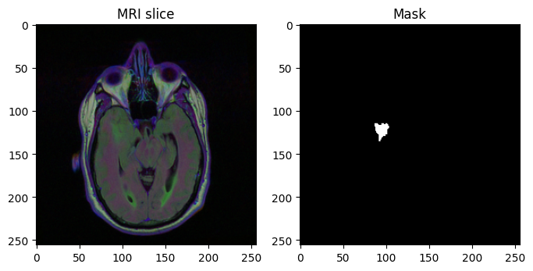
- A training slice (three MRI channels shown as RGB) and its ground-truth tumor mask.

Methodology

System overview
Fig. 2 shows the pipeline. MRI slices pass through the U-Net; the thresholded masks give one centroid per tumor slice; the ordered centroids form a 3D target path that is saved as JSON per patient; and the navigation stage consumes that file, in the notebook and in two browser simulators.
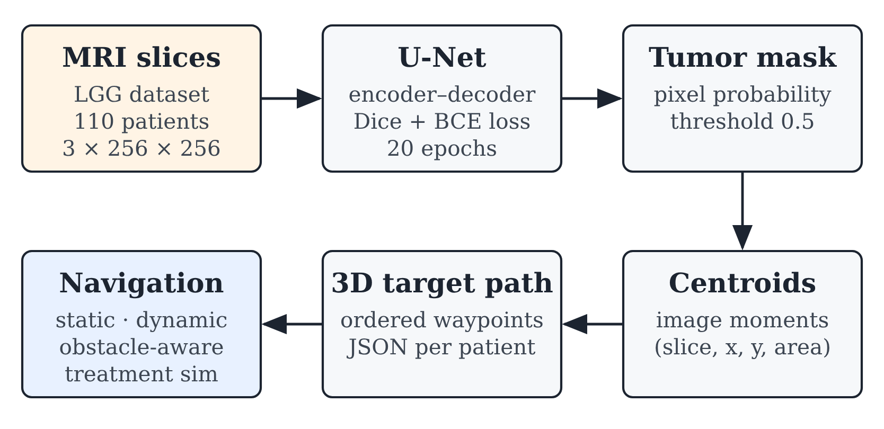
- End-to-end pipeline from MRI slices to nanobot navigation.

U-Net architecture
The network follows the original U-Net [14]. Four encoder levels each apply two 3 × 3 convolutions with batch normalisation and ReLU, then 2 × 2 max pooling, with 64, 128, 256 and 512 channels and a 1,024-channel bottleneck. Four decoder levels upsample with 2 × 2 transposed convolutions and concatenate the matching encoder features through skip connections, which preserve boundary detail. A 1 × 1 convolution and a sigmoid give a per-pixel tumor probability. The model has no pretrained weights.

Loss function and training
Tumor pixels are a small fraction of each slice, so binary cross-entropy (BCE) alone is dominated by background. The loss adds a soft Dice term [18], where p is the predicted probability, g the ground-truth mask and ε = 10⁻⁶:
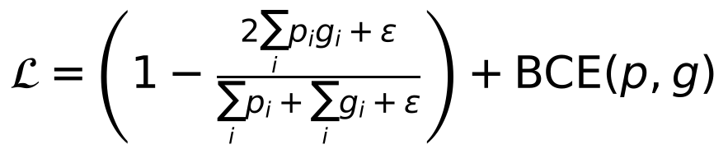 (1)
Training uses Adam [20] with learning rate 1 × 10⁻⁴, batch size 16 and 20 epochs on a Kaggle NVIDIA Tesla T4 GPU (about 3 minutes per epoch). No data augmentation is used.

Centroid extraction and 3D target
Each predicted mask is thresholded at 0.5 into a binary image B, and the image moments of B give the tumor centre on that slice:
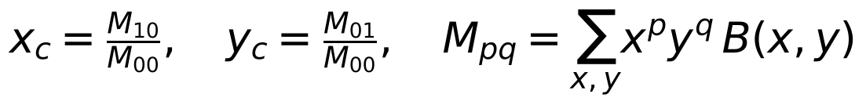 (2)
A slice with M₀₀ = 0 gives no waypoint. Slices are sorted by numeric index, and each detected slice contributes a waypoint (z, x, y, area), with z the slice index. The ordered waypoints c₁ … cₙ form the tumor path, and their mean t̄ is the static target. Coordinates are in voxels, treating one pixel and one slice as one unit.

Navigation strategies
All strategies start at slice 0, image centre (128, 128), and move a fixed step s = 1.5 voxels per iteration toward the current goal t:
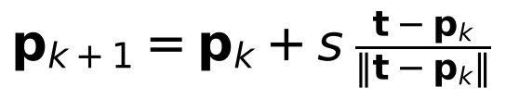 (3)
Static target pursues the mean centroid t̄ until within 1 voxel (at most 200 steps). Dynamic tracking pursues each waypoint in slice order and advances once within 1 voxel (Algorithm 1). Obstacle-aware navigation adds an artificial potential field [13]: each obstacle o within an influence radius ρ = 16 voxels repels the robot with strength k = 10, and the repulsion is scaled by a fade factor f so that it vanishes near the waypoint. Without the fade, the field trapped the robot in a local minimum beside the last obstacle in early tests.
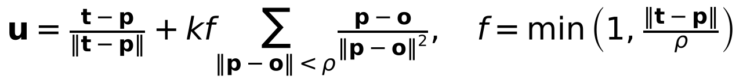 (4)
Algorithm 1: Dynamic tracking
Input: start p0, waypoints c1..cn, step s
p <- p0; path <- [p]
for i = 1 to n do
for k = 1 to 100 do
d <- ||ci - p||
if d < s then p <- ci
else p <- p + s (ci - p) / d
append p to path
if d < 1 then break
return path

Three simulated critical structures (spheres of radius 6 voxels) are placed at 30%, 50% and 70% of the segment from the entry point to the first waypoint, offset by 2 voxels perpendicular to it so that the repulsion does not cancel on the axis. They stand in for anatomy such as vessels or ventricles and are not segmented from the MRI.

Optimisation method
No metaheuristic optimiser (such as particle swarm optimisation, genetic algorithms or ant colony optimisation) is used in this work. Network weights are learned by gradient descent with Adam; navigation is deterministic pursuit with a potential field; and the navigation parameters (s, ρ, k, stopping distances) were set by hand and kept fixed for all patients. Tuning them with a metaheuristic such as particle swarm optimisation [21] is left as future work (Section IX).

Multi-agent 3D treatment simulation
A second browser simulator models treatment at the cell level. A tumor of cancer cells (procedural by default, or built from a patient’s exported centroids with one cell cluster per segmented slice, sized by tumor area) sits in tissue with blood vessels and 55 healthy cells. Nanobots are released from an injection port one every 0.35 s. Each bot is a finite-state agent (Fig. 3) that searches for the nearest unclaimed cancer cell within its detection radius (or the nearest overall), steers toward a stand-off point beside it, and releases drug in doses. Steering combines attraction to the goal, separation from other bots and, when enabled, repulsion from healthy cells. A cell is destroyed when its health reaches zero. Empty bots return to the port to refill and recharge; bots whose battery reaches zero stop. Table II lists the parameters.
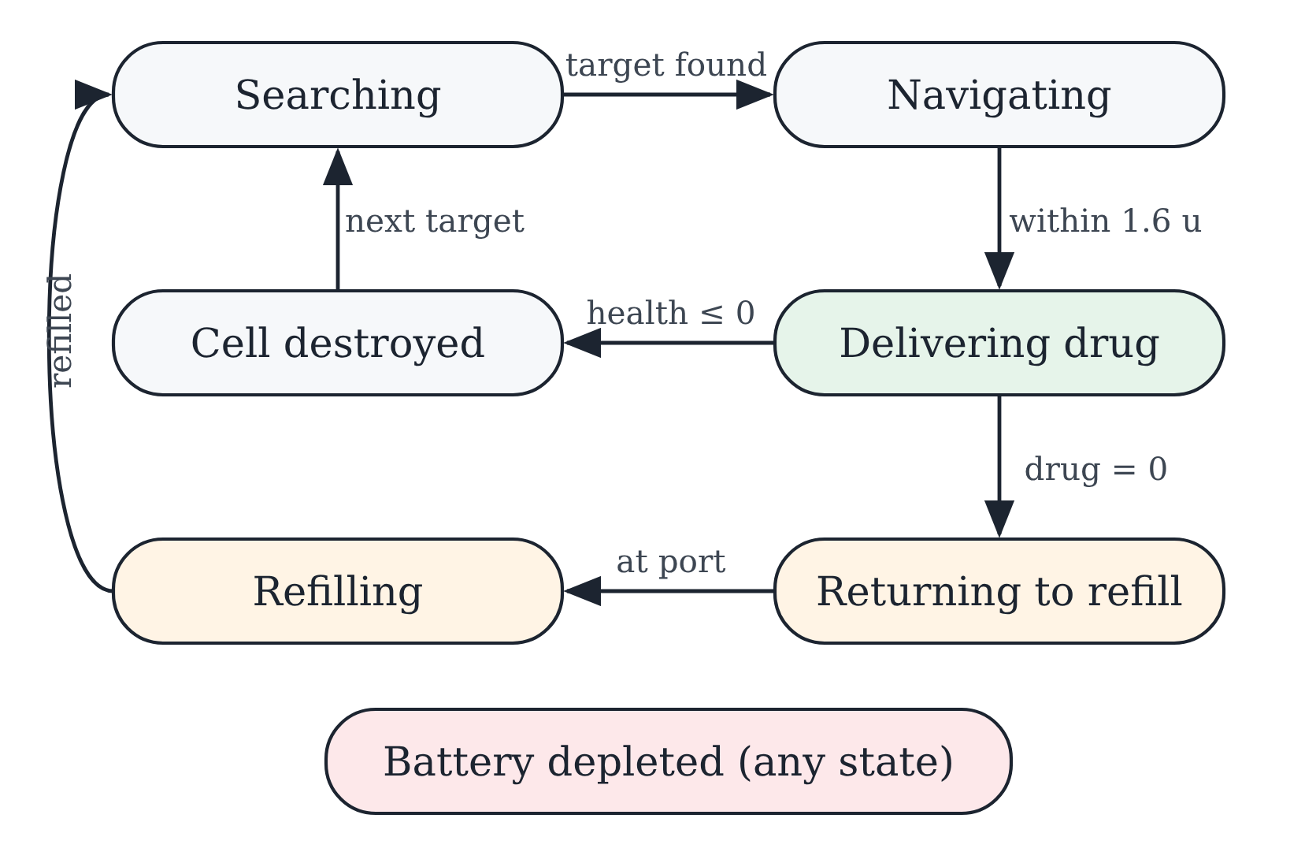
- Finite-state model of each nanobot in the 3D treatment simulation.
- Treatment Simulation Parameters
Parameter | Value
Nanobots, release interval | 50, 0.35 s
Speed | 5.2 to 6.8 u/s (random per bot)
Detection radius | 18 u
Drug capacity, dose | 100, 20 per release every 1.1 s
Cancer cell health | 70 + 70·(r/3), r = cell radius
Battery drain | 0.32 %/s moving, 0.22 %/s delivering
Refill at port | 45 drug/s, 25 %/s battery
Healthy-cell avoidance | repulsion within 6 u of a cell surface
Collateral damage | bot passes through a healthy cell; 18% chance per dose for cells near the target when avoidance is off
Time step | 1/30 s

Evaluation metrics
Segmentation is evaluated with the per-slice mean Dice and IoU over all validation slices, the per-patient detection rate, and pooled pixel metrics. Per-slice precision and recall are undefined on tumor-free slices where the model correctly predicts nothing (0/0), so pooled true positives (TP), false positives (FP) and false negatives (FN) over every validation pixel are used instead:
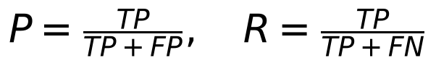 (5)
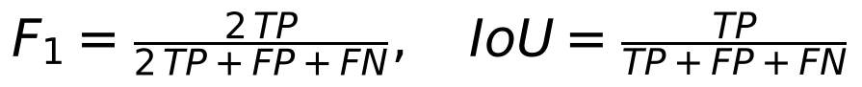 (6)
Navigation is evaluated with the path length, the number of steps, the final distance to the nearest true centroid, the number of tumor slices visited and the minimum clearance to a critical structure’s surface (negative when a path enters it):
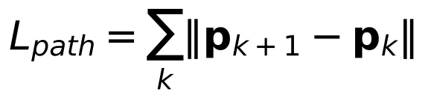 (7)
The treatment simulation reports the simulated time to destroy 50%, 90% and 100% of cancer cells and the number of healthy cells affected, as the mean and standard deviation over three random seeds.

Implementation
The model, training and evaluation are implemented in Python with PyTorch, OpenCV, NumPy, pandas and scikit-learn in a Kaggle notebook with a Tesla T4 GPU. The notebook trains the U-Net, saves the weights, computes all metrics, and exports one JSON file per validation patient holding each tumor slice’s index, centroid and area. Both simulators are single HTML files built with Three.js that run in any browser without installation: the targeting simulator re-implements the notebook’s pursuit rules in JavaScript and adds the obstacle-aware strategy, and the treatment simulator implements the agent model of Section IV-G. Both load the exported JSON files. Appendix A gives screenshots of the main code. Appendix C gives additional screenshots of both simulators and Appendix D shows dataset and prediction examples.

Results

Training
Training loss fell from 1.264 at epoch 1 to 0.174 at epoch 20 (lowest 0.139 at epoch 19). Validation loss fell from 1.188 to 0.584 and stayed between 0.58 and 0.63 after epoch 9 while training loss kept falling, a sign of overfitting (Fig. 4). The weights saved after epoch 20 are therefore not the best validation epoch.
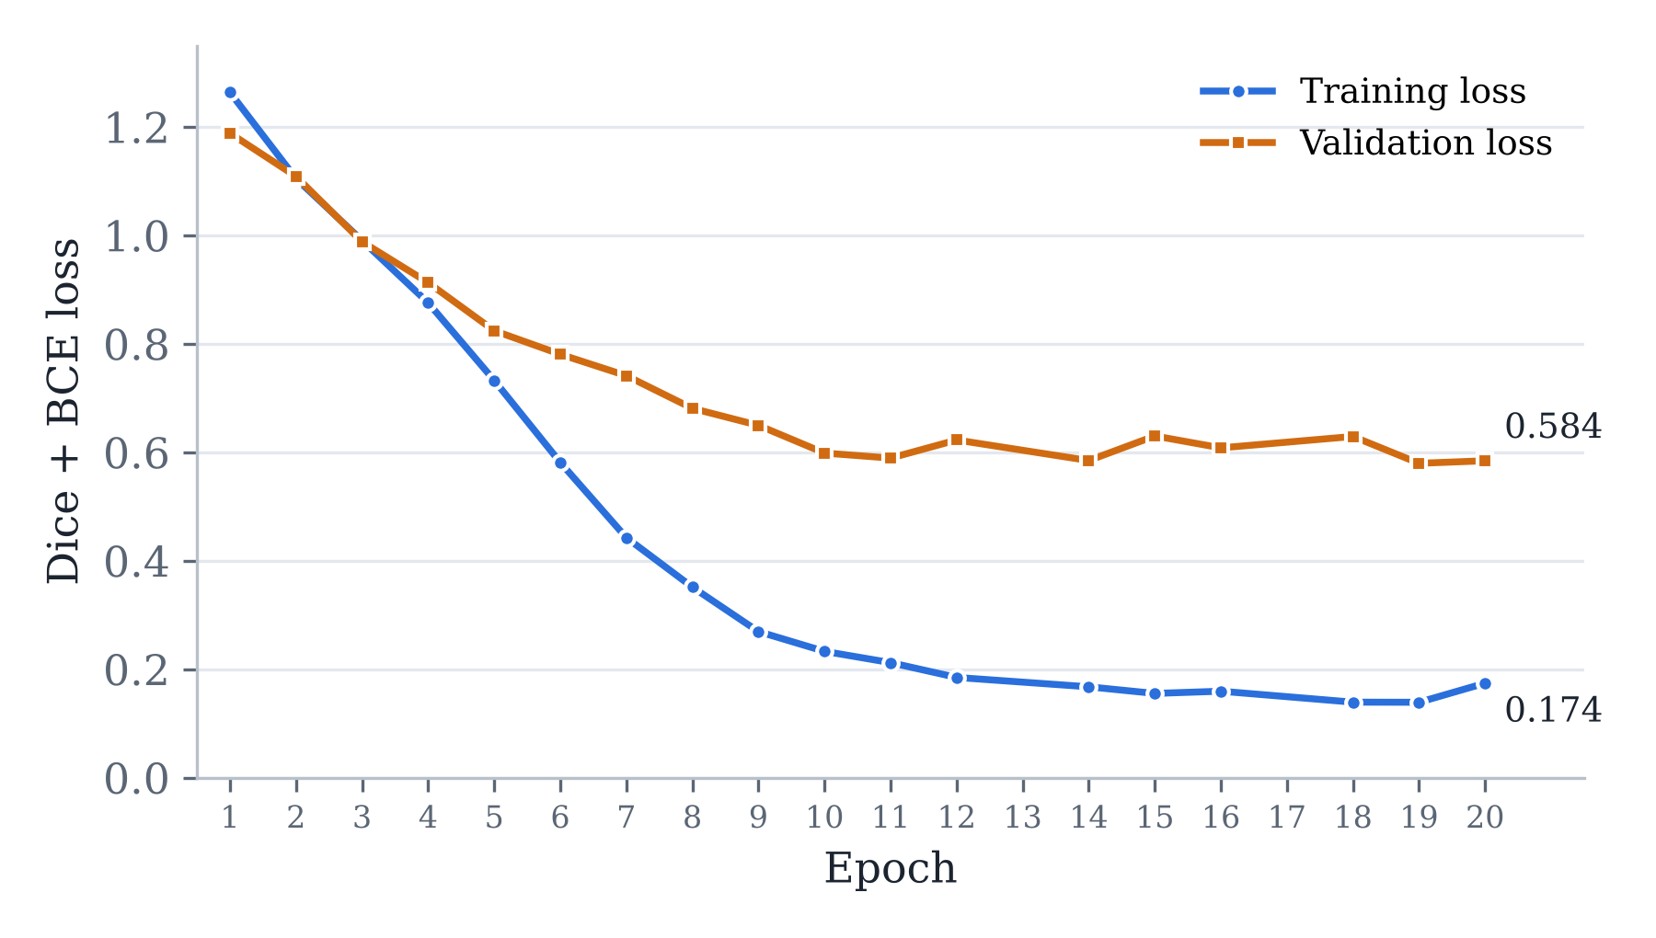
- Training and validation loss (Dice + BCE). Epochs 13 and 17 were not captured in the saved notebook log.

Segmentation
- Segmentation Results on the Validation Set (22 Patients, 778 Slices)
Metric | Value
Mean Dice (per slice) | 0.7732
Mean IoU (per slice) | 0.7459
Patients with tumor detected | 20 of 22 (90.9%)
Pooled precision | 0.8764
Pooled recall | 0.5789
Pooled F1 (pixel Dice) | 0.6973
Pooled IoU | 0.5352
Pixel accuracy | 0.9940
Specificity | 0.9990

Pooled over all 778 validation slices (50,987,008 pixels) the counts are TP = 351,552, FP = 49,579, FN = 255,679 and TN = 50,330,198. The model is precise (88% of predicted tumor pixels are tumor) but conservative (it finds 58% of tumor pixels). The per-slice mean Dice (0.773) is higher than the pooled F1 (0.697) because tumor-free slices that the model correctly leaves empty score a Dice of 1. An earlier per-slice implementation reported precision 0.238 and recall 0.193 by counting 0/0 as 0 on those slices; the pooled values replace it. Two validation patients (TCGA_DU_7306 and TCGA_HT_A61A) had no tumor detected on any slice. Fig. 5 shows a typical prediction.
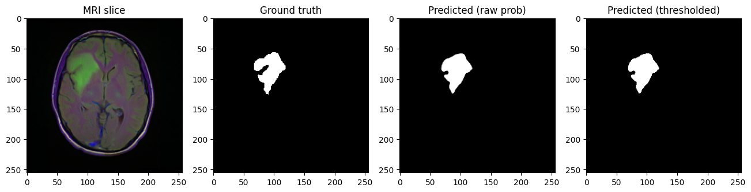
- Validation slice, ground-truth mask, raw prediction and thresholded prediction.

Centroids and 3D target
For validation patient TCGA_HT_7602 the model found tumor on 9 slices, the first at slice 4. Consecutive centroids move by a few pixels, for example (96.2, 91.9) on slice 4 and (94.6, 96.3) on slice 5, and the mean target is slice 8.56, x 100.8, y 94.0 (Fig. 6).
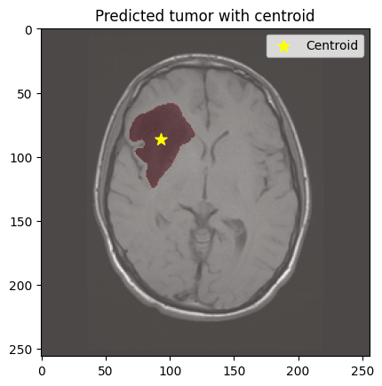
- Predicted tumor (red) and its centroid (star) on one validation slice.

Navigation on validation patients
Table IV summarises both strategies on the 20 patients with a detected tumor. Static targeting is never longer than dynamic tracking and is about 4 times shorter on average, but it stops at the tumor’s mean position, which can lie outside segmented tissue: its worst case, TCGA_FG_6688, ends 27.17 voxels from any tumor point. Dynamic tracking ends on a tumor centroid for every patient. Fig. 7 shows the per-patient spread and Fig. 8 the two paths for TCGA_HT_7602, where the static path is 44.4 voxels long and ends 3.65 voxels from the nearest centroid, and the dynamic path is 145.9 voxels long (106 steps). Appendix B lists every patient.
- Navigation Results over 20 Validation Patients (Voxels)
Measure | Static | Dynamic
Mean path length | 46.4 | 186.3
Median path length | 43.1 | 143.5
Path length range | 21.5–69.7 | 66.6–394.2
Mean final distance | 5.98 | 0.00
Worst final distance | 27.17 | 0.00

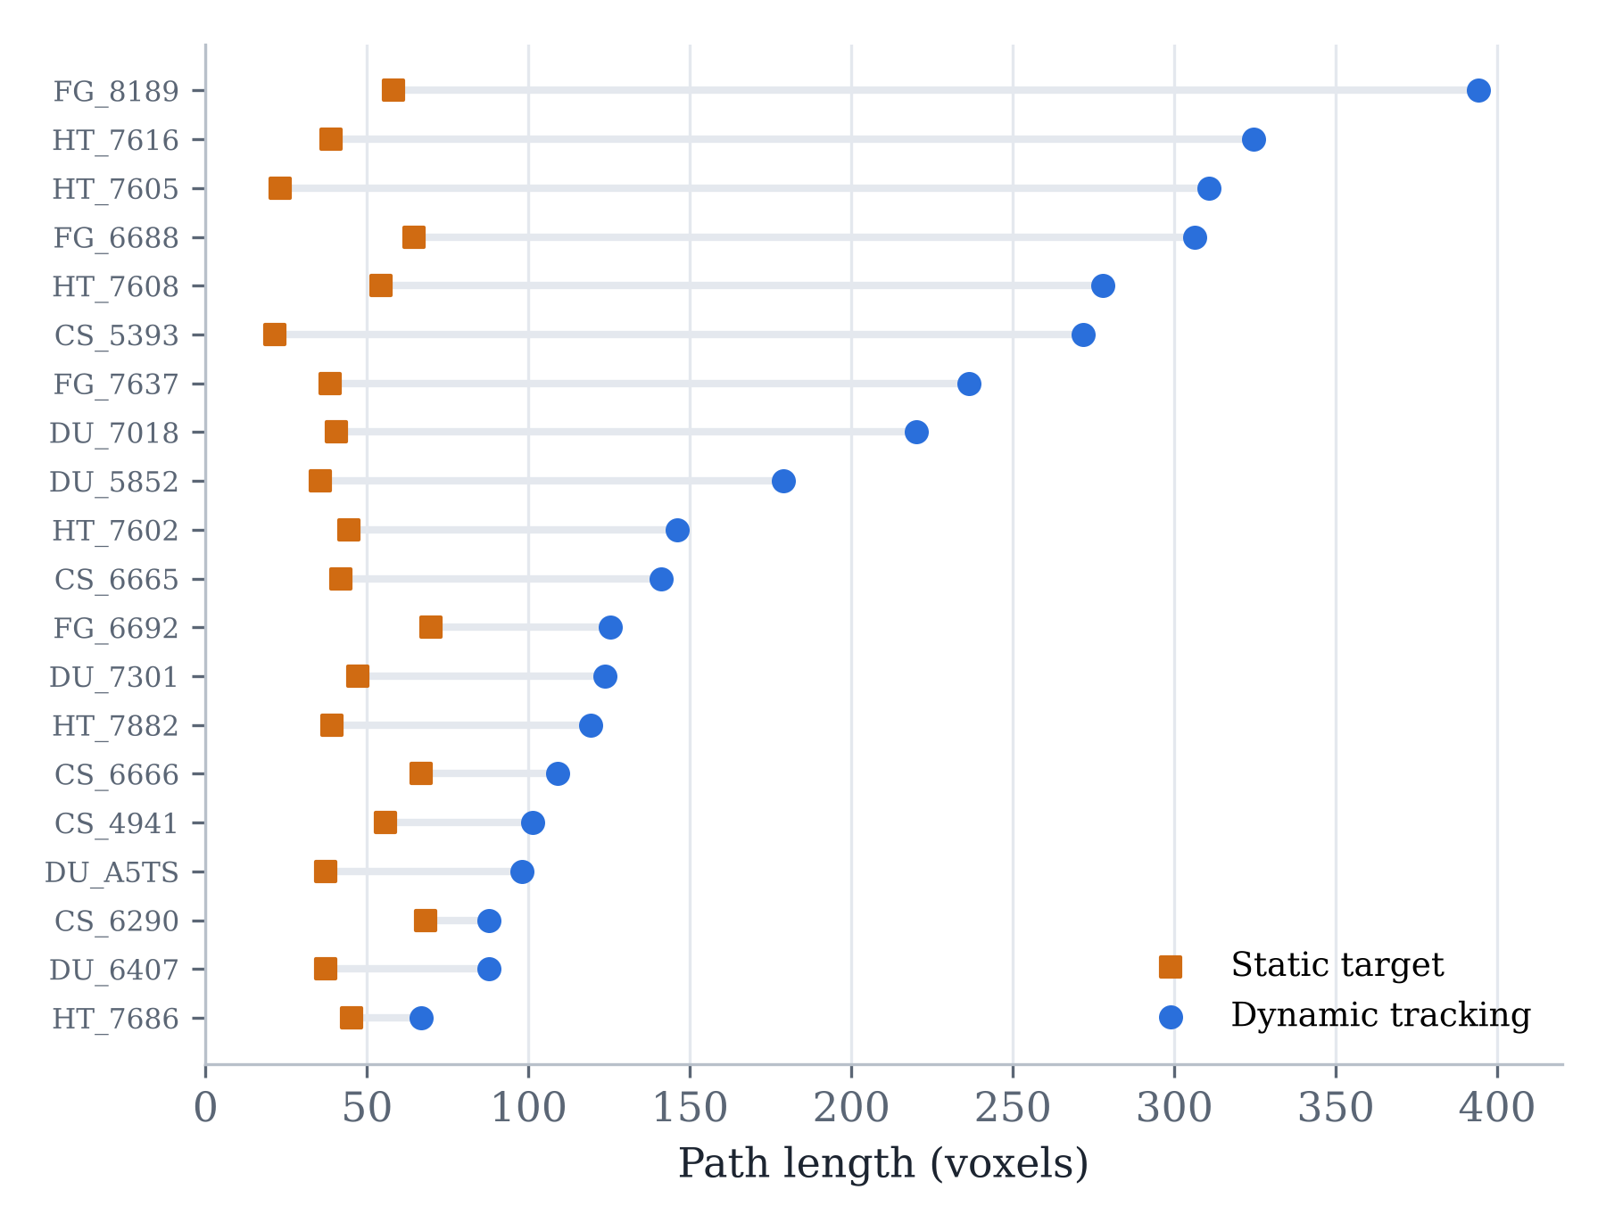
- Path length per validation patient for static and dynamic strategies, sorted by dynamic path length.
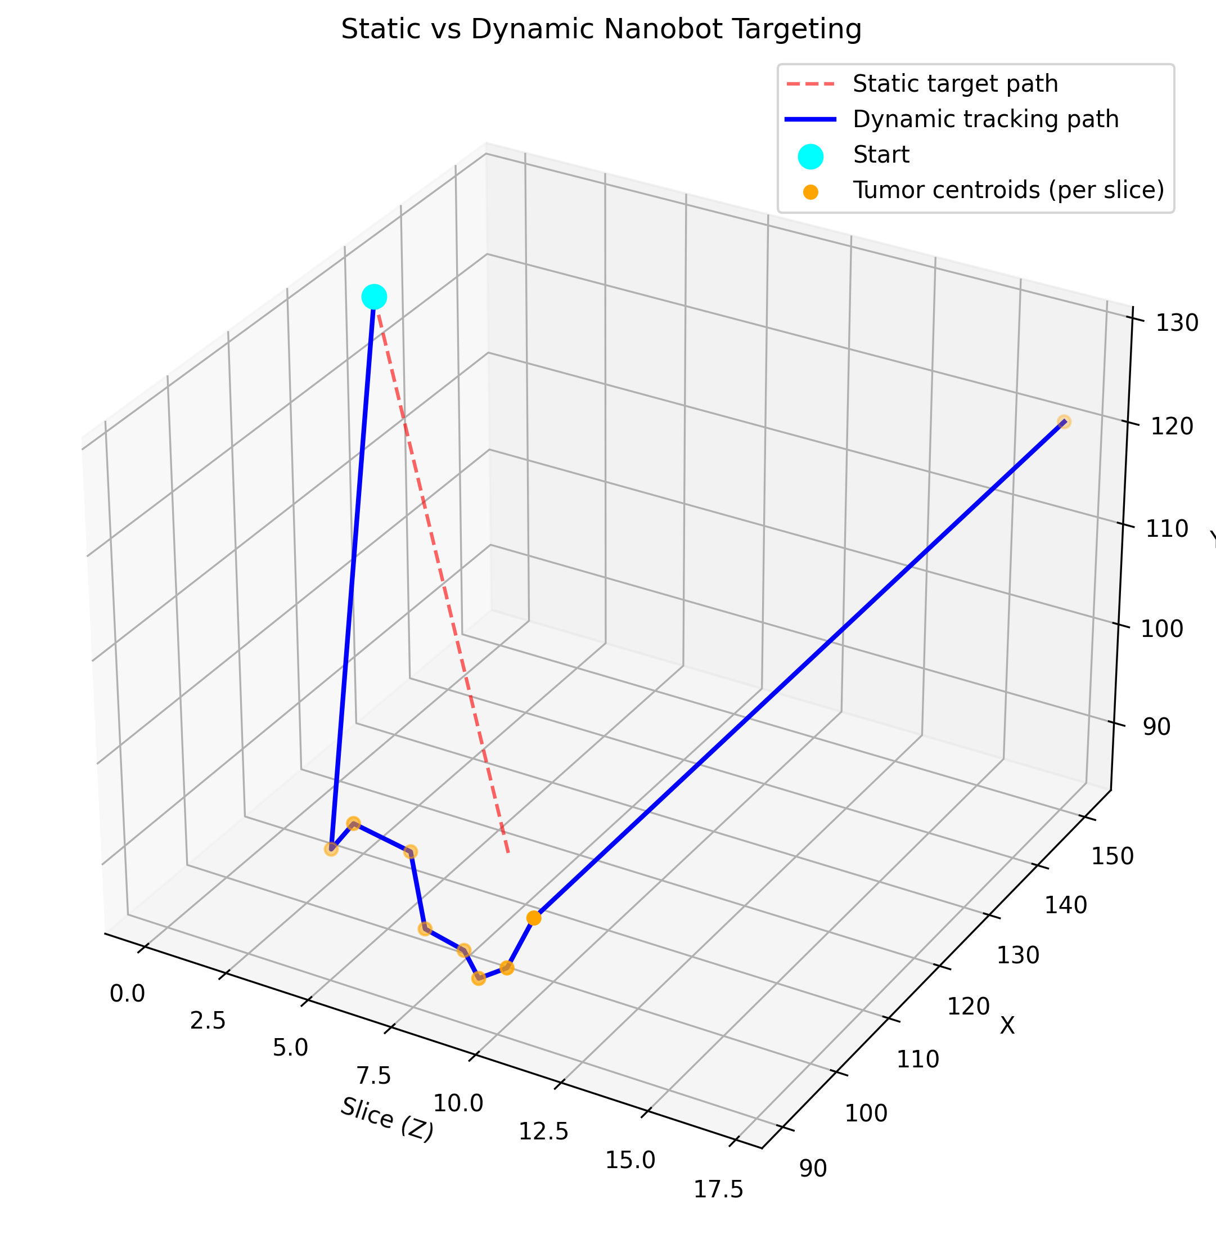
- 3D static (dashed) and dynamic (solid) paths for patient TCGA_HT_7602, from the entry point (cyan) to the per-slice tumor centroids (orange).

Obstacle-aware navigation (targeting simulator)
The obstacle-aware strategy was evaluated in the targeting simulator on five synthetic sample patients with 6 to 16 tumor slices, because the simulator’s obstacles are placed relative to each patient’s path (Table V, Fig. 9). Both static and dynamic paths entered a critical structure on every sample (minimum clearance −4.8 to −3.2 voxels), while the obstacle-aware path kept a clearance of 5.1 to 5.2 voxels and still reached every tumor slice, at a cost of 14.6 to 17.8 voxels of extra path over dynamic tracking. These samples test the method; they are not patient results.
- Targeting Simulator on Five Synthetic Samples (Mean)
Measure | Static | Dynamic | Obstacle-aware
Path length (voxels) | 57.6 | 79.1 | 95.1
Steps | 39.2 | 62.6 | 69.4
Final distance (voxels) | 1.08 | 0.00 | 0.00
Tumor slices visited | 3 of 58 | 58 of 58 | 58 of 58
Min. clearance (voxels) | −4.08 | −4.00 | +5.16

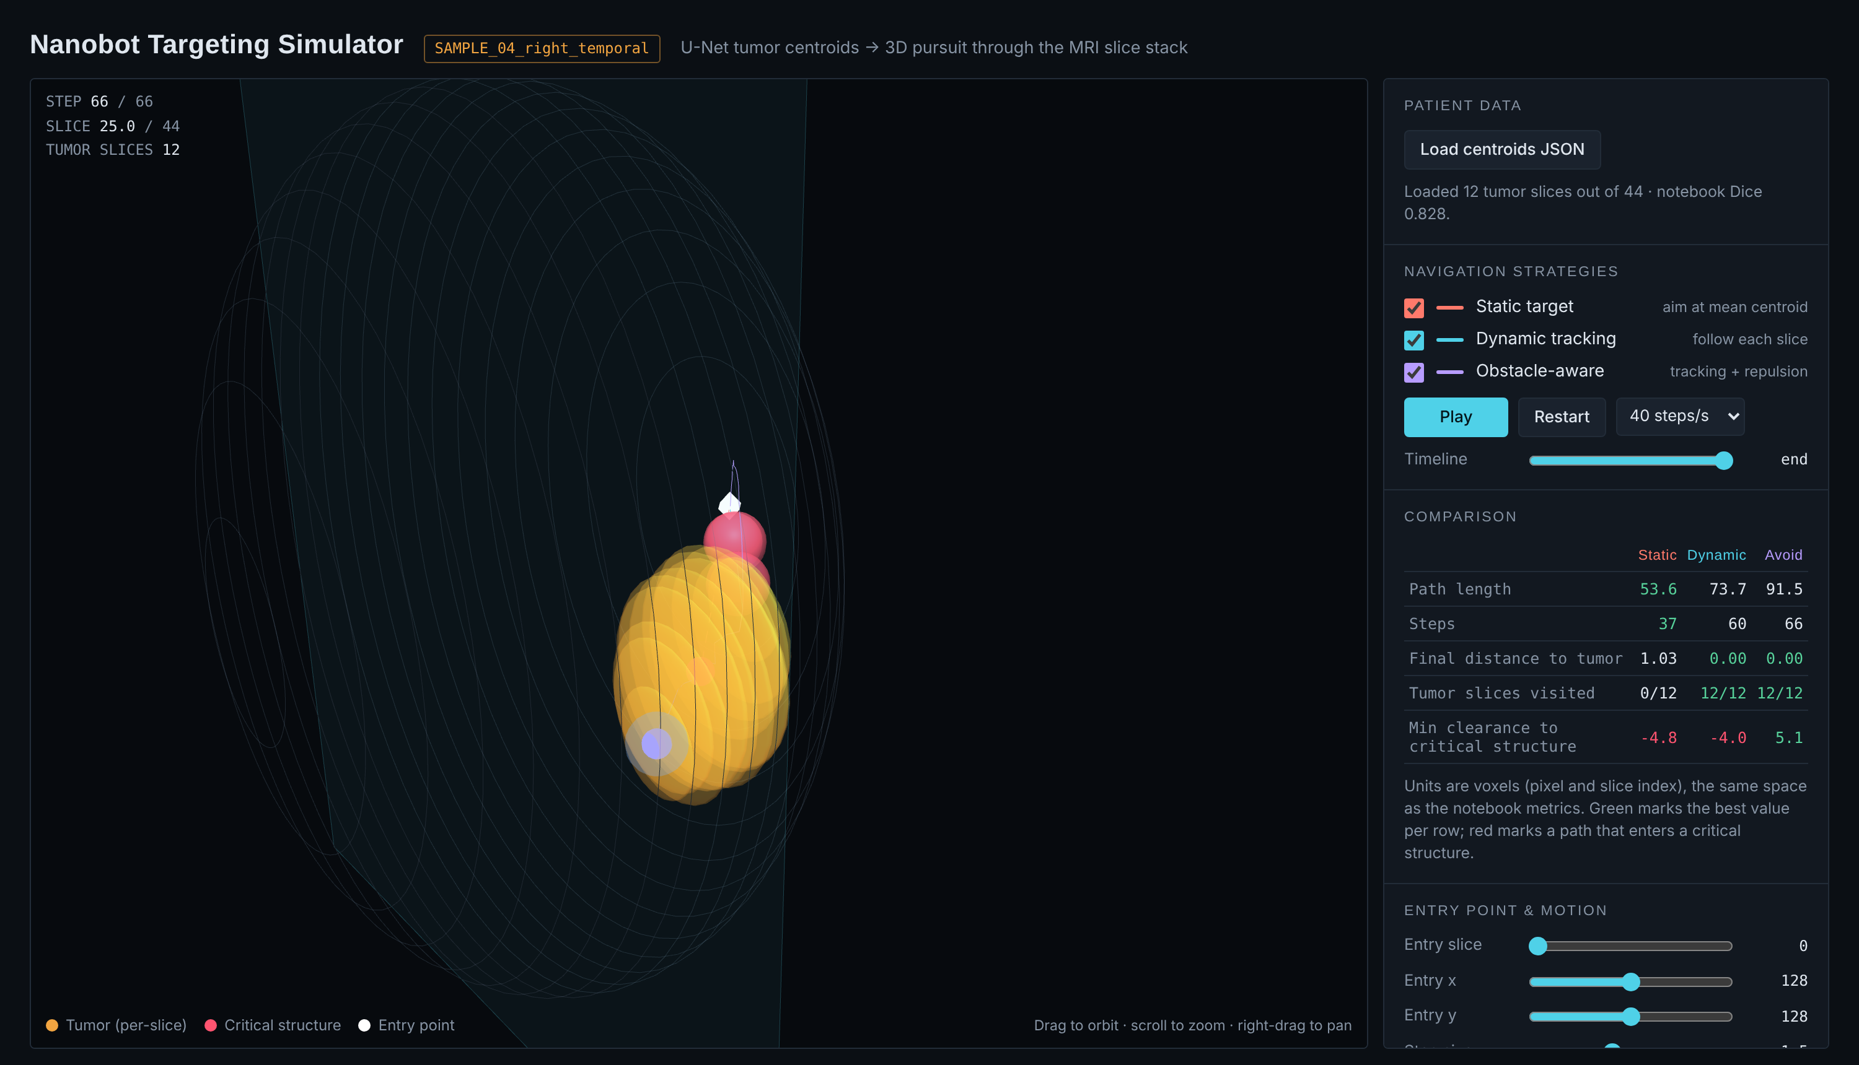
- Targeting simulator: static (coral), dynamic (cyan) and obstacle-aware (violet) paths around three simulated critical structures (red).

Multi-agent treatment simulation
Table VI gives the treatment simulation results over three seeds. With 50 nanobots and a 140-cell procedural tumor, all cancer cells were destroyed in every run. Healthy-cell avoidance removed collateral damage entirely (0 of 55 healthy cells affected, against about 6 without avoidance) at a cost of 1.8 to 8.8 s in clearance time (Fig. 10). Targeting the nearest cell directly or flying to the tumor centre first made little difference, because the centre-first stage only affects each bot’s first approach. Swarm size dominated: 20 bots needed about 302 s and 80 bots about 117 s (Fig. 11). A tumor built from the centroids of a sample patient (188 cells) was cleared in about 204 s (Fig. 24 in Appendix A). Fig. 12 shows the simulator during a run.
- Treatment Simulation: Time to Destroy Cancer Cells (s) and Healthy Cells Affected (Mean ± SD, 3 Seeds)
Configuration | 50% | 90% | 100% | Healthy hit
Nearest + avoid | 82.6 ± 1.5 | 145.2 ± 2.7 | 170.4 ± 3.6 | 0.0 of 55
Nearest, no avoid | 81.3 ± 1.8 | 143.8 ± 2.0 | 161.6 ± 1.2 | 6.0 of 55
Centre + avoid | 84.0 ± 4.2 | 147.7 ± 4.2 | 165.8 ± 0.5 | 0.0 of 55
Centre, no avoid | 78.7 ± 0.9 | 143.1 ± 1.1 | 164.0 ± 2.6 | 5.7 of 55
Nearest + avoid, 20 bots | 151.9 ± 2.4 | 269.3 ± 7.0 | 302.1 ± 10.2 | 0.0 of 55
Nearest + avoid, 80 bots | 60.4 ± 1.2 | 100.1 ± 1.2 | 117.2 ± 1.6 | 0.0 of 55
Patient-shaped, 188 cells | 102.4 ± 3.8 | 180.4 ± 9.0 | 203.5 ± 8.6 | 0.0 of 55

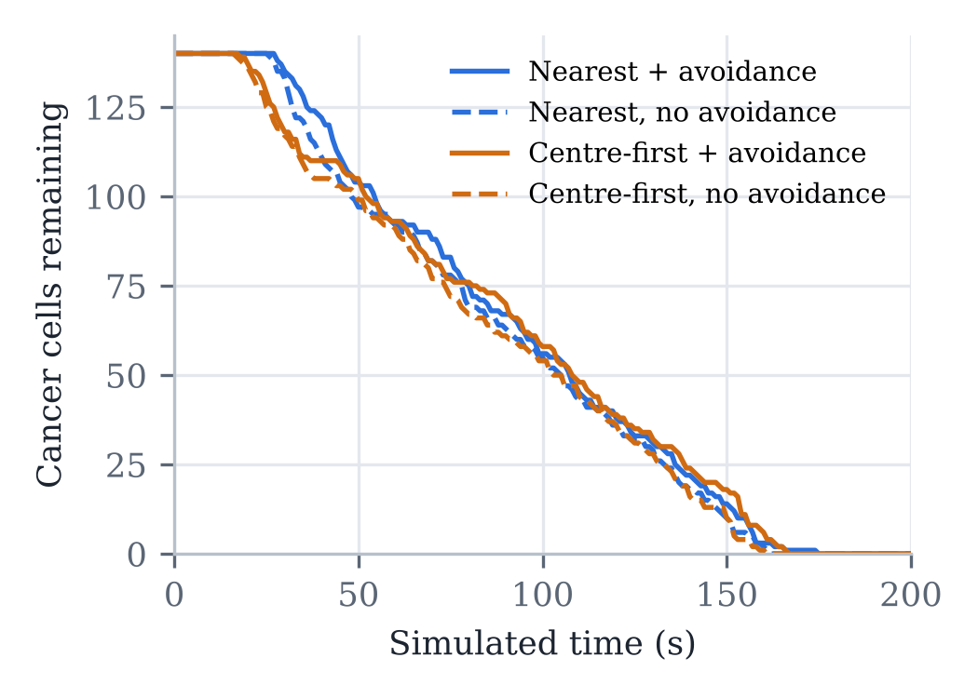
- Cancer cells remaining over time for the four targeting and avoidance settings (50 nanobots, seed 7).
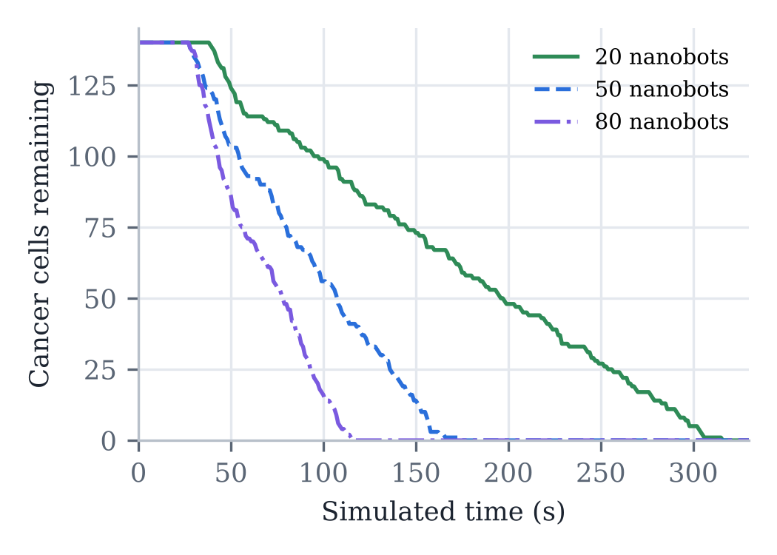
- Effect of swarm size on treatment time (nearest targeting with avoidance, seed 7).
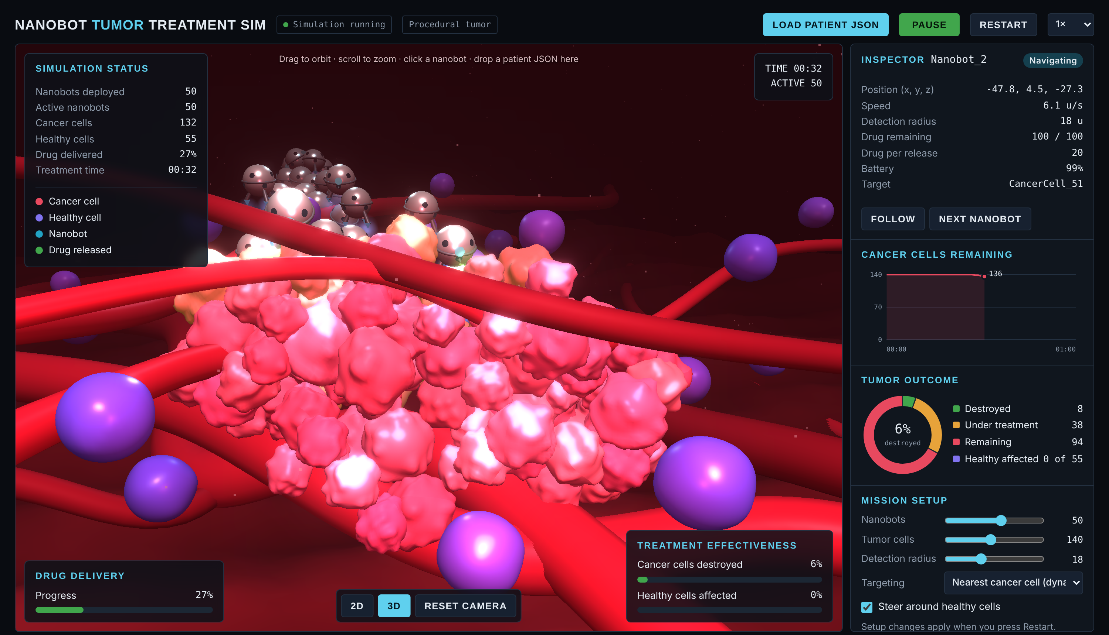
- 3D treatment simulator: nanobots release drug (green) at the tumor while live panels track deployment, drug delivery and treatment effectiveness.

Reproducibility across two training runs
The same notebook was run twice. The patient split depends on the order in which the file system lists patient folders, so the two runs used different validation patients (Table VII). The earlier run reached a higher Dice on its split, which shows that results on 22 patients vary noticeably with the split. All other results in this paper come from the second run, for which every metric, including the pooled ones, was measured.
- Two Training Runs on Different Patient Splits
Measure | Run 1 | Run 2
Train / validation slices | 3,202 / 727 | 3,151 / 778
Mean Dice | 0.8275 | 0.7732
Mean IoU | 0.7894 | 0.7459
Patients with tumor detected | 22 of 22 | 20 of 22
Mean static / dynamic path | 45.7 / 148.8 | 46.4 / 186.3
Mean static final distance | 6.19 | 5.98

Discussion and Limitations
The results show a consistent trade-off between efficiency and precision. Aiming at the mean centroid gives short paths, but the mean of a curved or scattered tumor can lie outside it, so a static strategy can deliver to healthy tissue next to the tumor. Following the segmented tumor slice by slice guarantees that the robot ends on tumor tissue at roughly four times the path length, and adding a potential field keeps it clear of known obstacles for a modest extra distance. In the treatment simulation, avoidance had almost no cost in time, while the number of nanobots set the treatment time.
The study has clear limits:
- The 2D U-Net sees one slice at a time and has no 3D context; validation loss plateaued after epoch 9, and the final weights are not the best epoch.
- With 22 validation patients and no separate test set, results vary with the split (Table VII); the split also depends on file-system order.
- Every detected slice becomes a waypoint, so a stray detection can lengthen the dynamic path (TCGA_HT_7605 has 13 tumor slices but a 310.7-voxel path).
- Critical structures are simulated spheres, and obstacle-aware results come from synthetic samples.
- Motion is straight-line pursuit in voxel units, ignoring slice thickness, blood flow, tissue drag and propulsion physics; the treatment simulation’s drug, health and battery values are modelling choices, not measurements.

Conclusion
This paper connected deep-learning tumor segmentation to nanobot navigation in one reproducible pipeline. A U-Net trained on 88 patients segments low-grade gliomas with a mean Dice of 0.773 and a pooled F1 of 0.697 on 22 unseen patients, and its per-slice centroids form a usable 3D target for 20 of them. Dynamic tracking always ends on tumor tissue, at about four times the path length of static targeting; potential-field avoidance keeps a 5 voxel clearance from critical structures; and in a multi-agent simulation, healthy-cell avoidance removes collateral damage at almost no cost in treatment time.

Future Work
- Train a 3D or multi-slice U-Net with augmentation, early stopping and a pretrained encoder, and evaluate with patient-level cross-validation.
- Keep only the largest connected tumor region per slice to filter stray detections before building waypoints.
- Segment real anatomy (vessels, ventricles) as obstacles and use millimetre spacing from scan metadata.
- Tune navigation parameters with a metaheuristic such as particle swarm optimisation [21], and replace hand-written rules with reinforcement learning as in recent microrobot work [11], [12].
- Add propulsion, flow and drag models so that simulated paths can be compared with physical microrobot experiments.

References
- D. Zhang, S. Liu, J. Guan, and F. Mou, “‘Motile-targeting’ drug delivery platforms based on micro/nanorobots for tumor therapy,” Frontiers in Bioengineering and Biotechnology, vol. 10, Art. no. 1002171, 2022, doi: 10.3389/fbioe.2022.1002171.
- B. Fu, D. Luo, C. Li, Y. Feng, and W. Liang, “Advances in micro-/nanorobots for cancer diagnosis and treatment: Propulsion mechanisms, early detection, and cancer therapy,” Frontiers in Chemistry, vol. 13, Art. no. 1537917, 2025, doi: 10.3389/fchem.2025.1537917.
- C. Simó et al., “Urease-powered nanobots for radionuclide bladder cancer therapy,” Nature Nanotechnology, vol. 19, no. 4, pp. 554–564, 2024, doi: 10.1038/s41565-023-01577-y.
- Y. Wang et al., “A DNA robotic switch with regulated autonomous display of cytotoxic ligand nanopatterns,” Nature Nanotechnology, 2024, doi: 10.1038/s41565-024-01676-4.
- X. Wang et al., “Mechanical nanosurgery of chemoresistant glioblastoma using magnetically controlled carbon nanotubes,” Science Advances, vol. 9, Art. no. eade5321, 2023, doi: 10.1126/sciadv.ade5321.
- F. Liu et al., “Allosteric DNA nanorobots for targeted glioma therapy: Acid-triggered doxorubicin delivery,” Advanced Functional Materials, vol. 36, no. 36, Art. no. e27455, 2026, doi: 10.1002/adfm.202527455.
- S. Rajendran, P. Sundararajan, A. Awasthi, and S. Rajendran, “Nanorobotics in medicine: A systematic review of advances, challenges, and future prospects,” arXiv:2309.10881, 2023.
- L. Xie et al., “Microrobotic swarms for cancer therapy,” Research, vol. 8, Art. no. 0686, 2025, doi: 10.34133/research.0686.
- Z. Huan, W. Ma, J. Wang, and F. Wu, “Path planning and optimization for micro-robot in a vessel-mimic environment,” Frontiers in Neurorobotics, vol. 16, Art. no. 923348, 2022, doi: 10.3389/fnbot.2022.923348.
- Y. Yang, M. Sokolich, F. C. Kirmizitas, S. Das, and A. A. Malikopoulos, “Microrobot vascular parkour: Analytic geometry-based path planning with real-time dynamic obstacle avoidance,” arXiv:2509.05500, 2025.
- T. Xiong, Z. Liu, C. J. Ong, and L. Zhu, “Enabling microrobotic chemotaxis via reset-free hierarchical reinforcement learning,” arXiv:2408.07346, 2024.
- M. Medany, L. Piglia, L. Achenbach, S. K. Mukkavilli, and D. Ahmed, “Model-based reinforcement learning for ultrasound-driven autonomous microrobots,” Nature Machine Intelligence, 2025, doi: 10.1038/s42256-025-01054-2.
- O. Khatib, “Real-time obstacle avoidance for manipulators and mobile robots,” The International Journal of Robotics Research, vol. 5, no. 1, pp. 90–98, 1986.
- O. Ronneberger, P. Fischer, and T. Brox, “U-Net: Convolutional networks for biomedical image segmentation,” in Proc. Medical Image Computing and Computer-Assisted Intervention (MICCAI), LNCS vol. 9351, 2015, pp. 234–241.
- M. A.-A. Al-Murshidawy and O. Al-Shamma, “A review of deep learning models (U-Net architectures) for segmenting brain tumors,” Bulletin of Electrical Engineering and Informatics, vol. 13, no. 2, pp. 1015–1030, 2024, doi: 10.11591/eei.v13i2.6015.
- M. Buda, A. Saha, and M. A. Mazurowski, “Association of genomic subtypes of lower-grade gliomas with shape features automatically extracted by a deep learning algorithm,” Computers in Biology and Medicine, vol. 109, pp. 218–225, 2019.
- K. Clark et al., “The Cancer Imaging Archive (TCIA): Maintaining and operating a public information repository,” Journal of Digital Imaging, vol. 26, no. 6, pp. 1045–1057, 2013.
- F. Milletari, N. Navab, and S.-A. Ahmadi, “V-Net: Fully convolutional neural networks for volumetric medical image segmentation,” in Proc. 4th Int. Conf. 3D Vision (3DV), 2016, pp. 565–571.
- M. Buda, “LGG segmentation dataset,” Kaggle. [Online]. Available: https://www.kaggle.com/datasets/mateuszbuda/lgg-mri-segmentation
- D. P. Kingma and J. Ba, “Adam: A method for stochastic optimization,” in Proc. Int. Conf. Learning Representations (ICLR), 2015.
- J. Kennedy and R. Eberhart, “Particle swarm optimization,” in Proc. IEEE Int. Conf. Neural Networks (ICNN’95), 1995, pp. 1942–1948.

Appendix A. Implementation Code
The screenshots below show the main code of the notebook (Python) and the two browser simulators (JavaScript), in the order the pipeline runs.
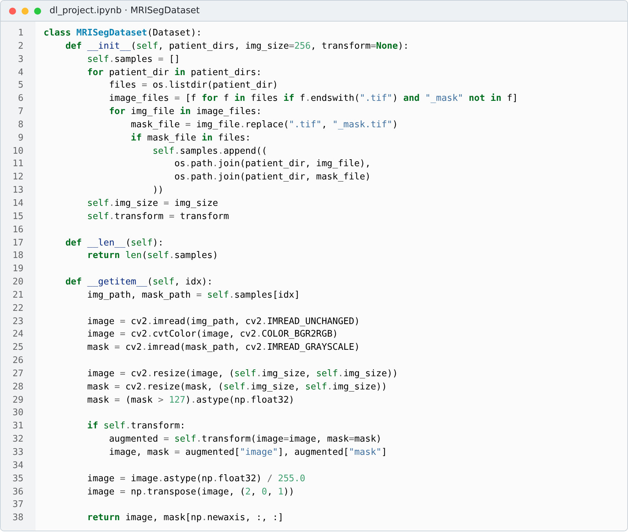
- Code: dataset class that pairs each MRI slice with its mask, resizes to 256 × 256 and normalises.
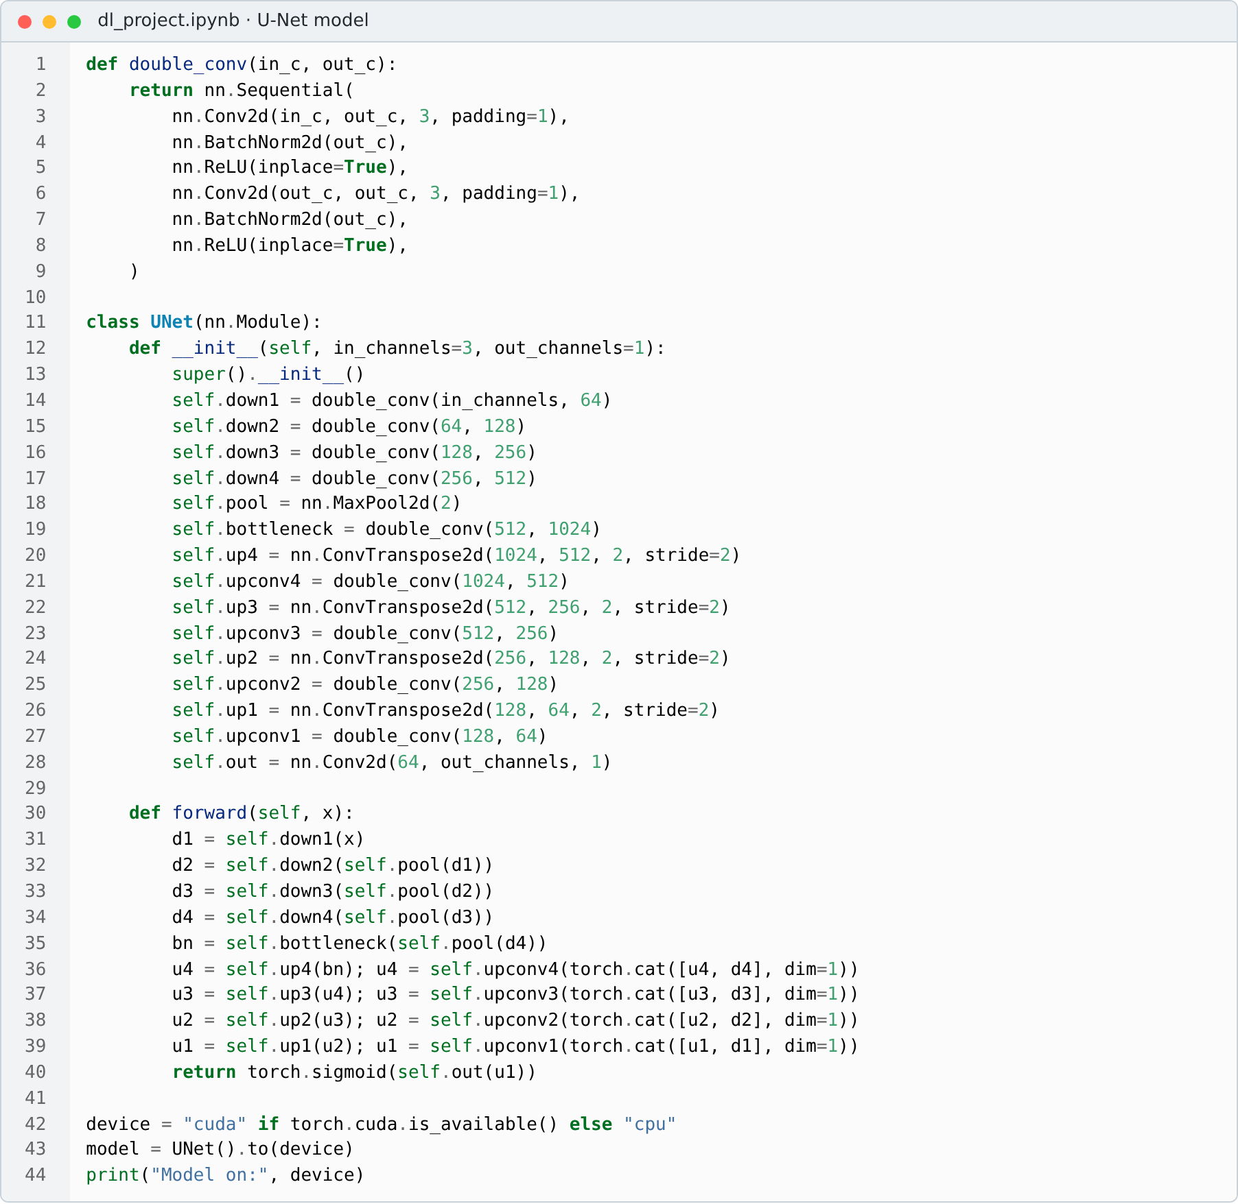
- Code: U-Net with four encoder levels, a 1,024-channel bottleneck, skip connections and a sigmoid output.
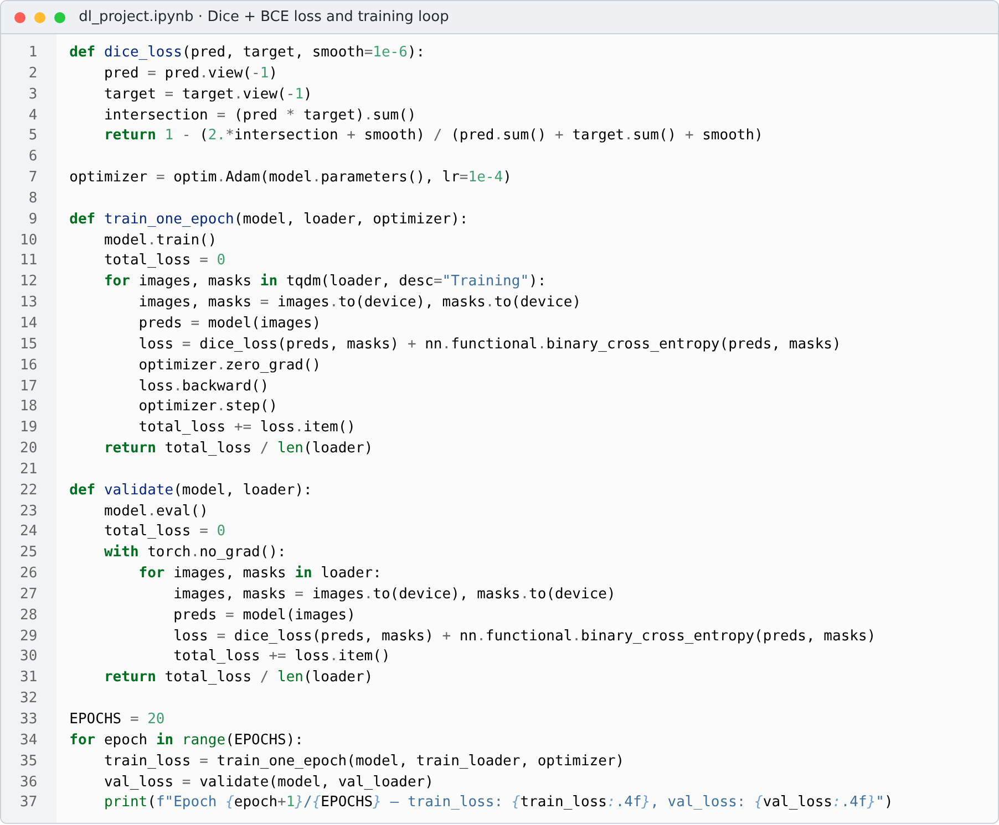
- Code: Dice loss and the training and validation loops (Dice + BCE, Adam).
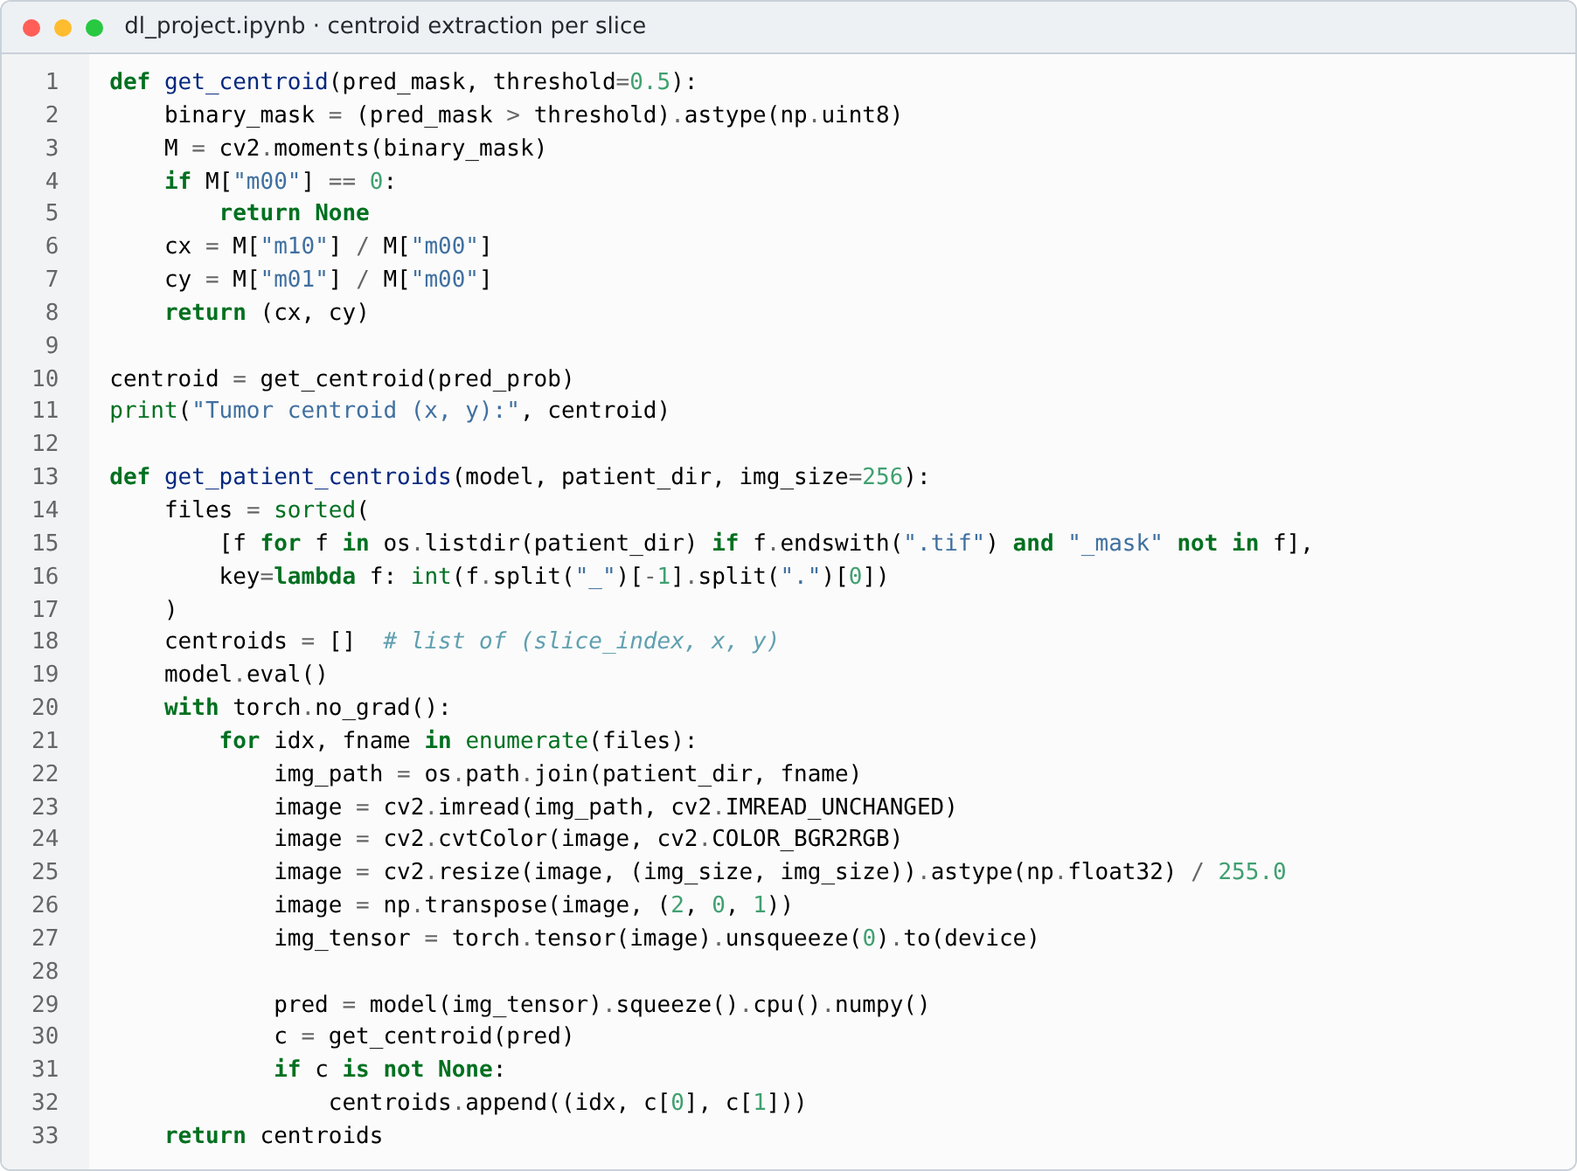
- Code: centroid of the predicted mask from image moments, and the per-patient waypoint list.
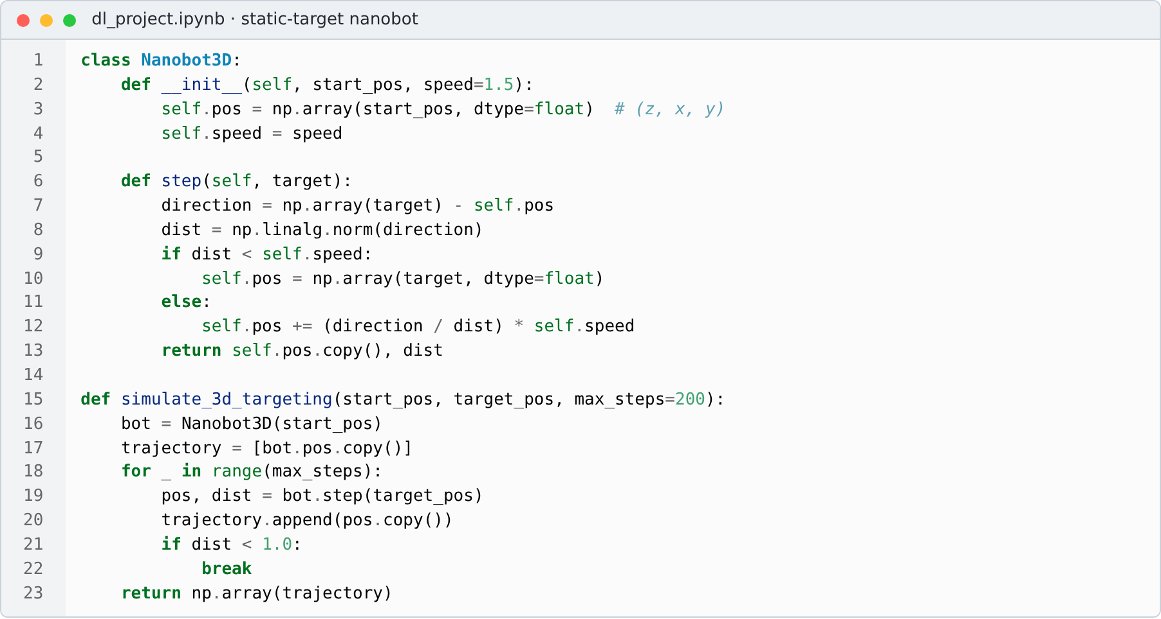
- Code: static-target nanobot that pursues the mean centroid.
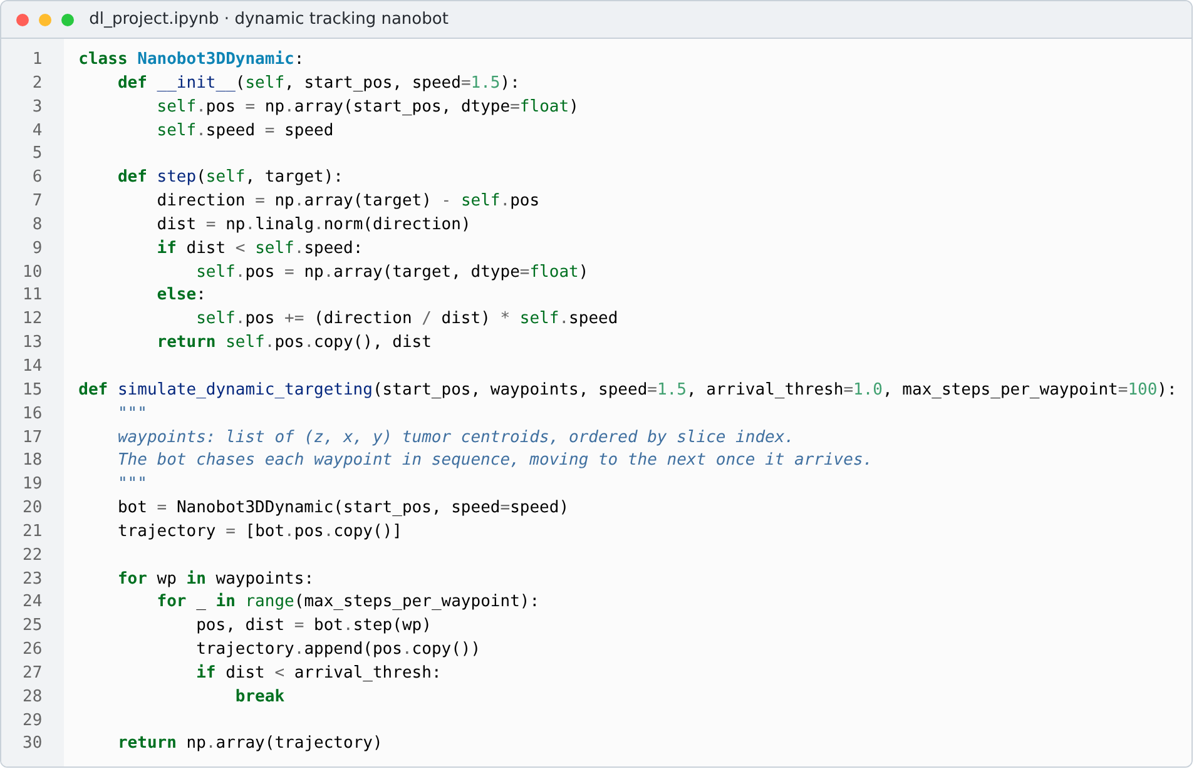
- Code: dynamic tracking nanobot that visits each slice’s centroid in turn.
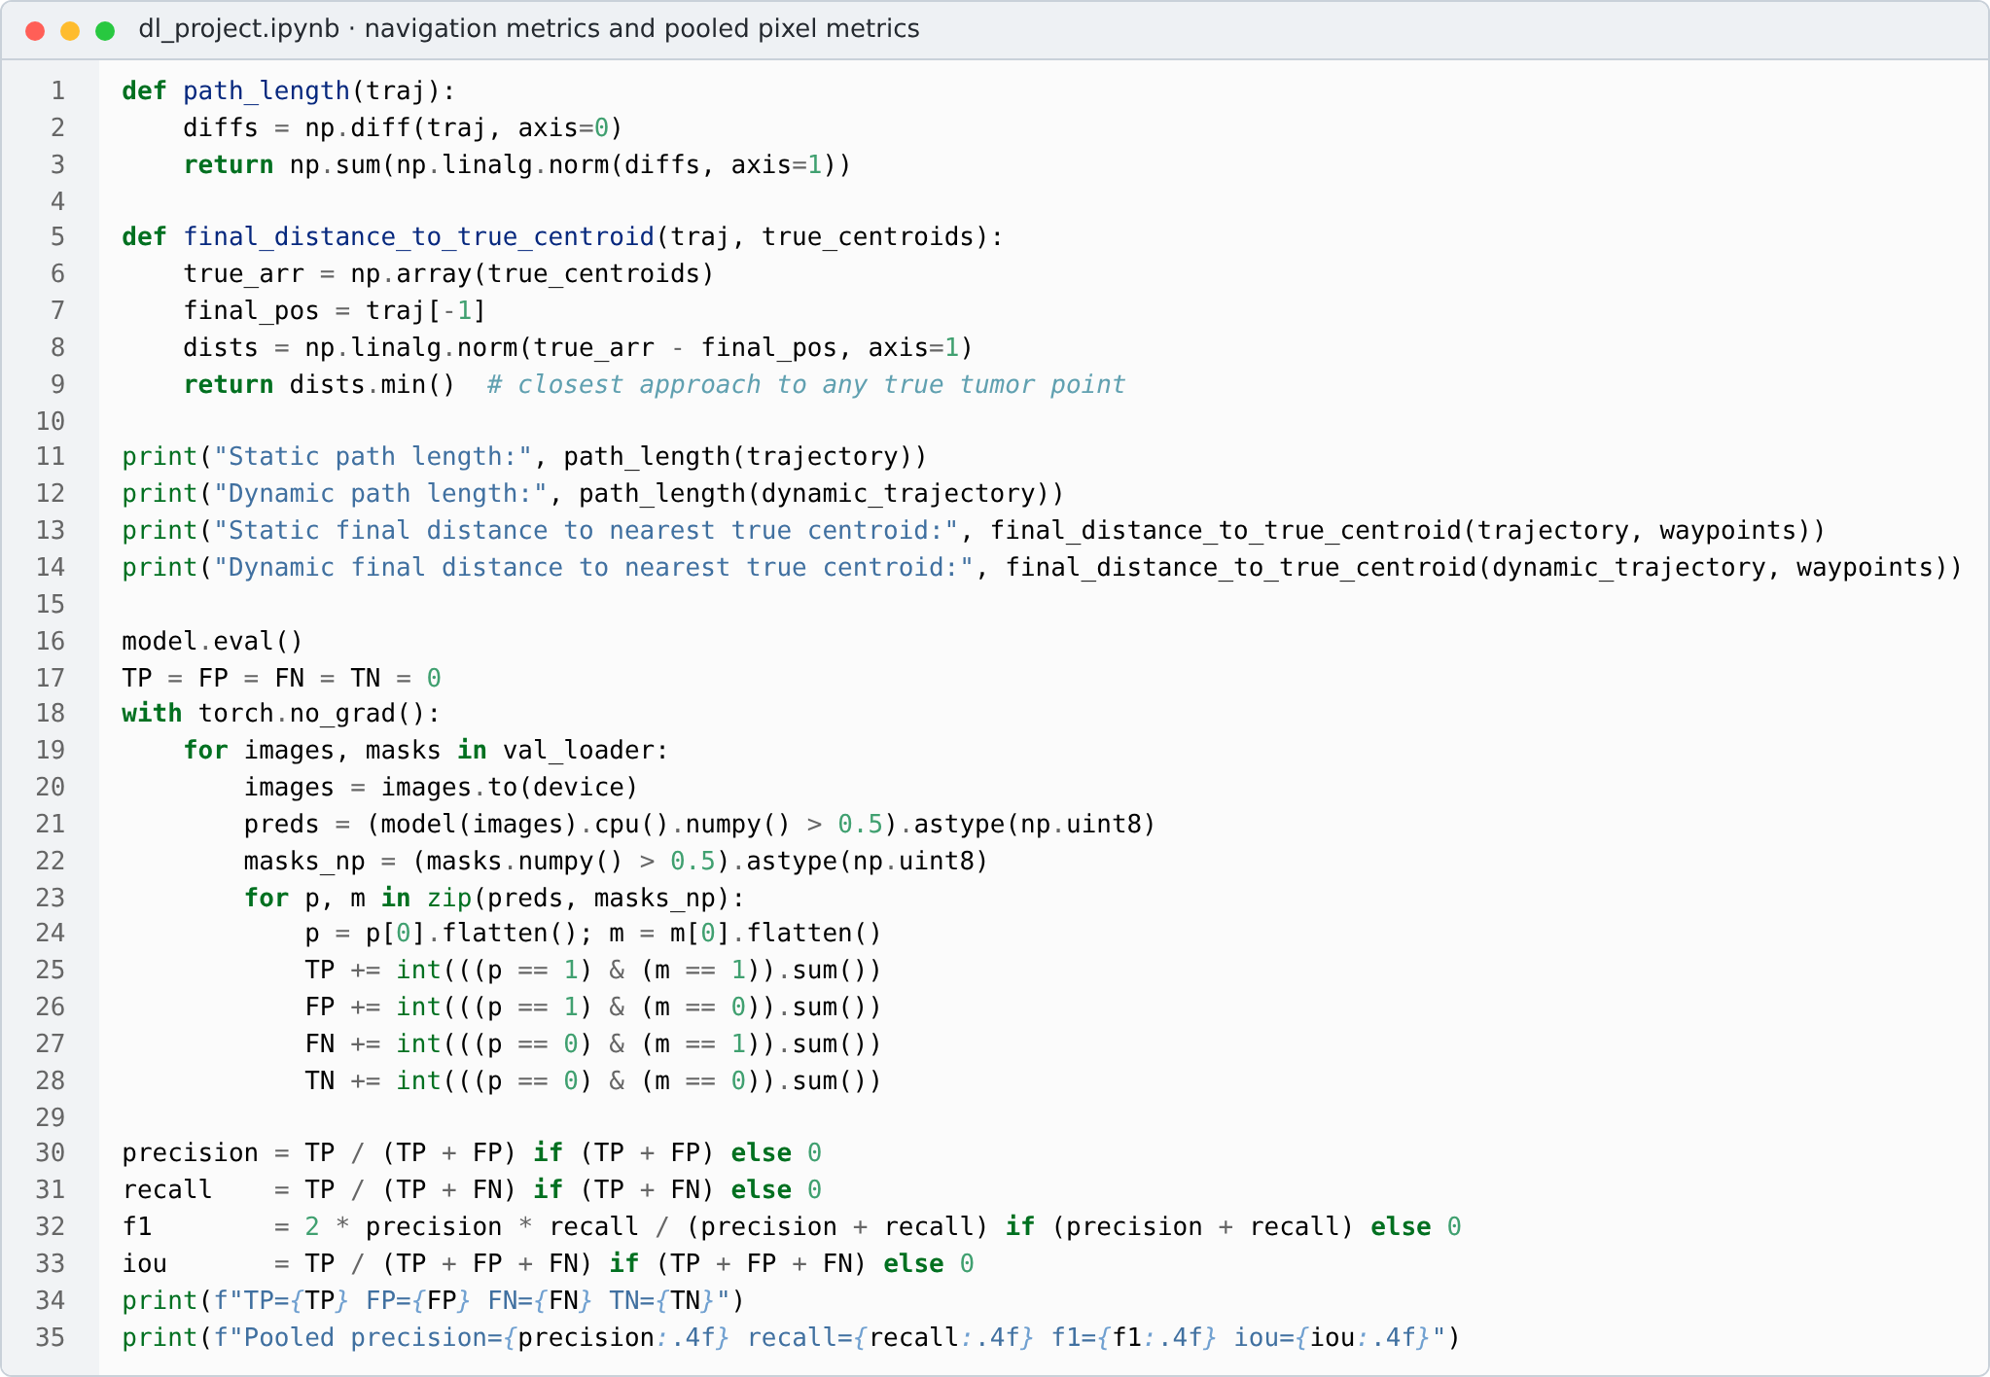
- Code: navigation metrics (path length, final distance) and pooled pixel precision, recall, F1 and IoU.
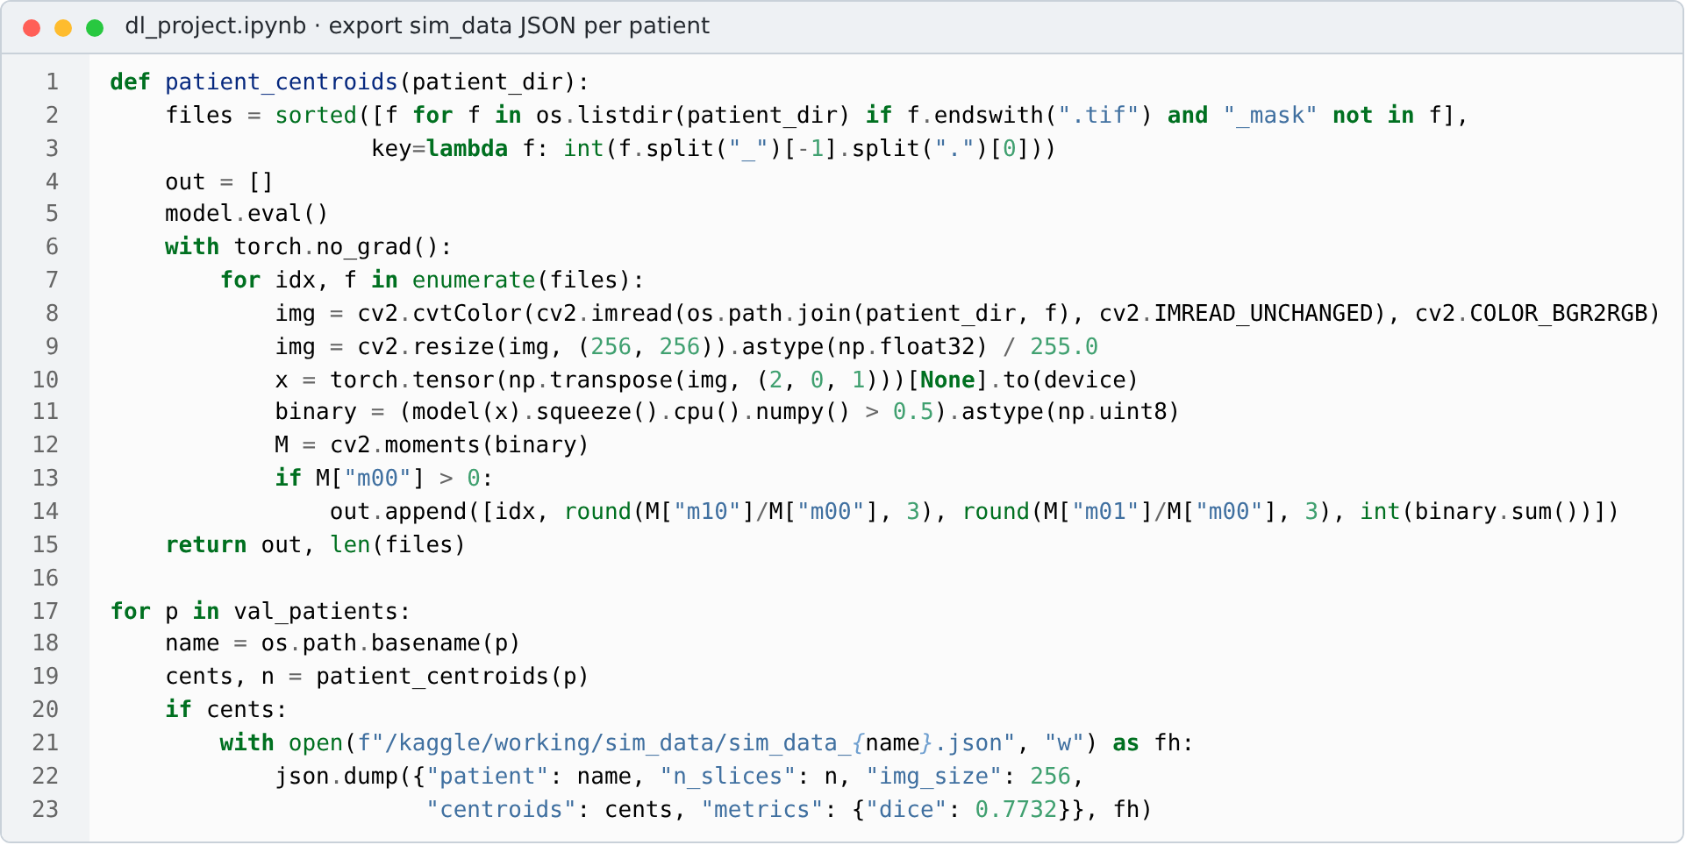
- Code: export of each validation patient’s centroids to JSON for the simulators.
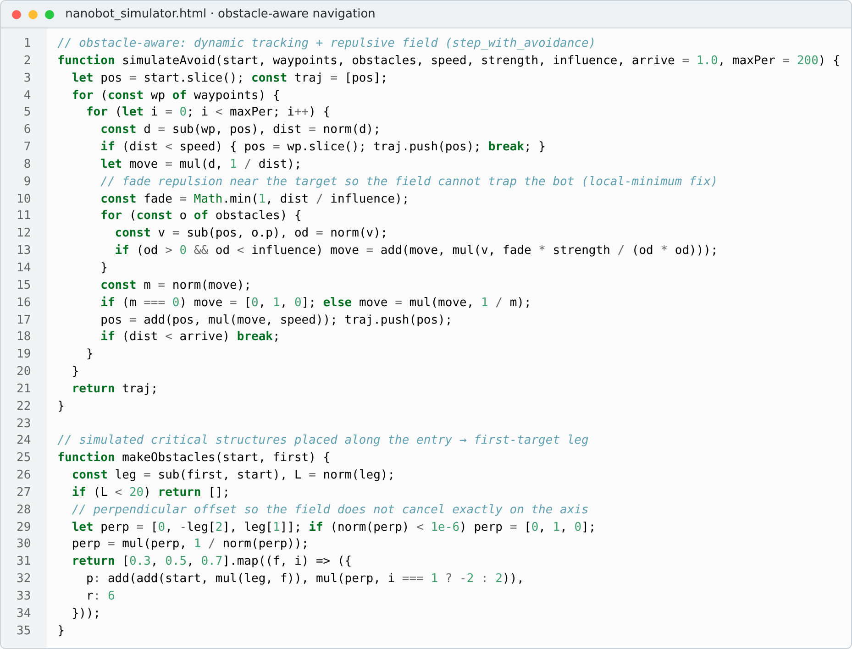
- Code: obstacle-aware navigation with a faded potential field, and placement of the simulated critical structures (targeting simulator).
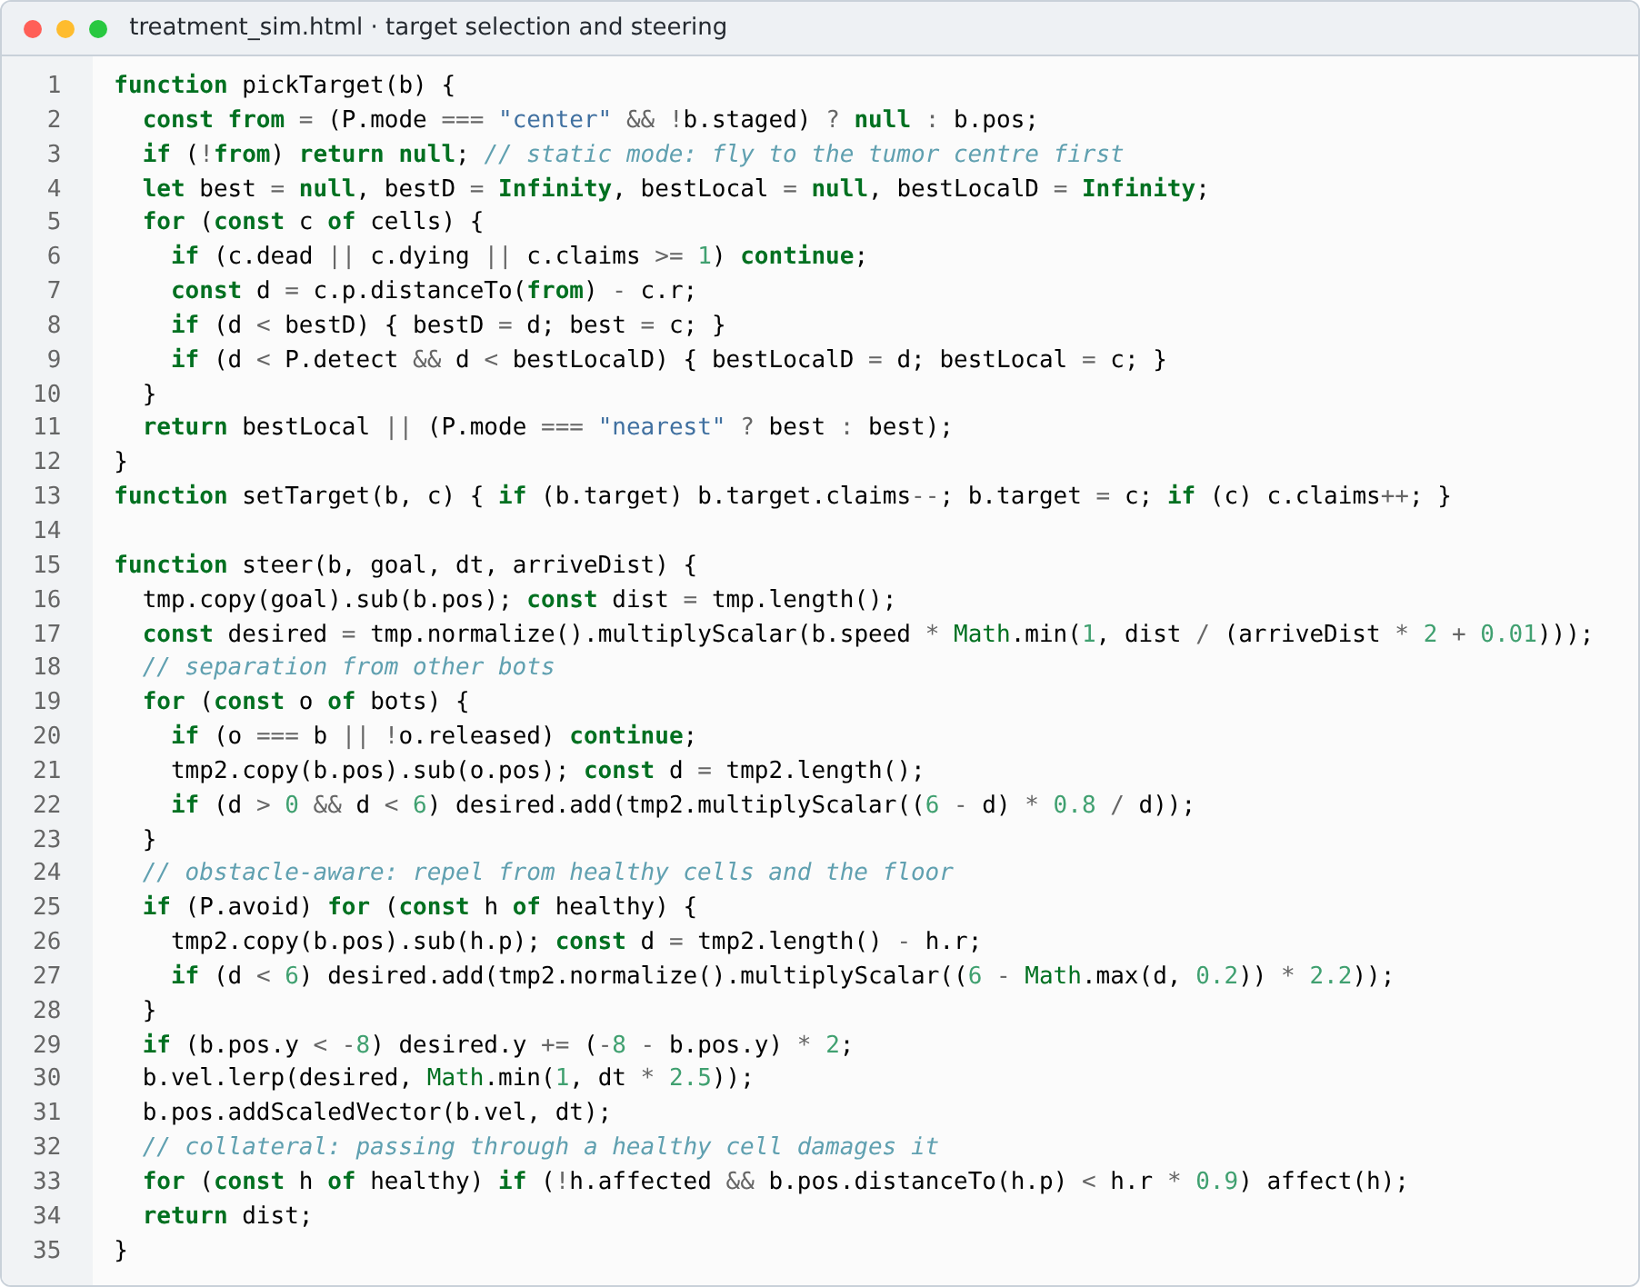
- Code: target selection and steering with bot separation and healthy-cell avoidance (treatment simulator).
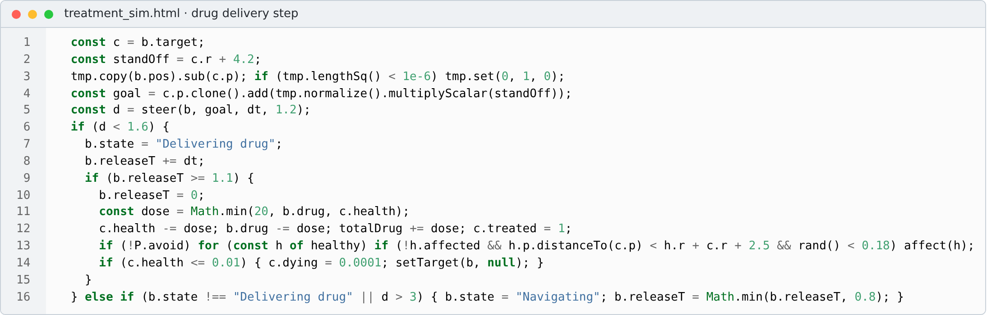
- Code: drug delivery step that applies doses, records collateral damage and marks cells destroyed (treatment simulator).
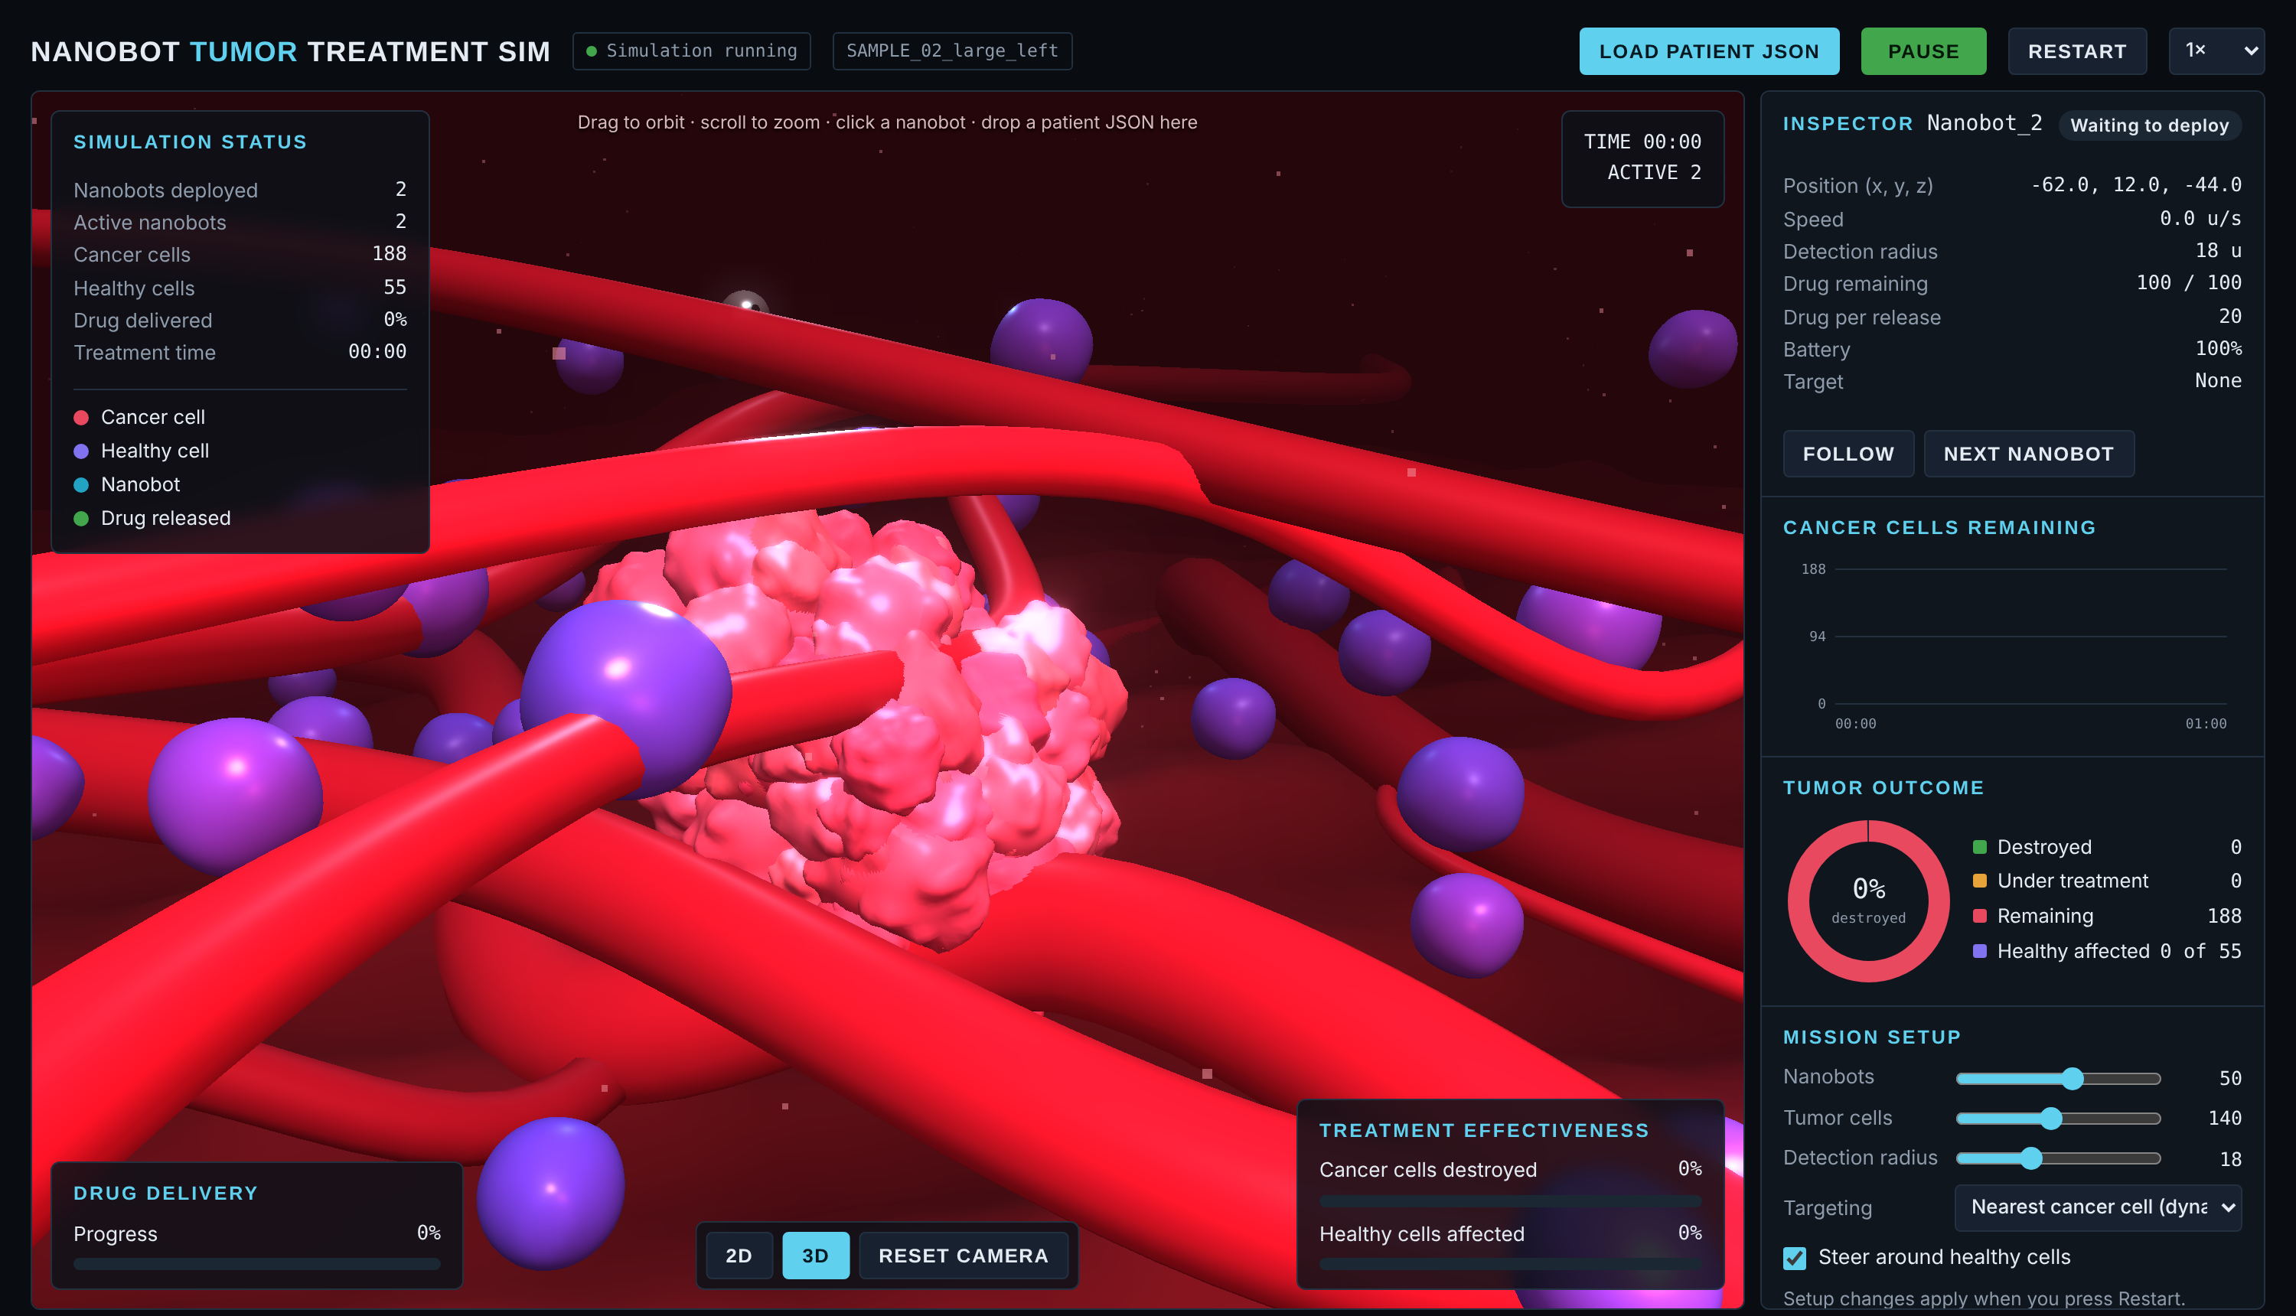
- Treatment simulator with a tumor built from a sample patient’s exported centroids (one cell cluster per MRI slice).

Appendix B. Per-Patient Navigation Results
- Per-Patient Navigation Results on Validation Patients With a Detected Tumor (Voxels)
Patient | Tumor slices | Static path | Dynamic path | Static final distance
TCGA_HT_7686_19950629 | 9 | 45.2 | 66.6 | 2.24
TCGA_DU_6407_19860514 | 16 | 37.1 | 87.8 | 3.68
TCGA_CS_6290_20000917 | 5 | 68.1 | 87.9 | 3.04
TCGA_DU_A5TS_19970726 | 13 | 37.2 | 98.0 | 2.95
TCGA_CS_4941_19960909 | 8 | 55.8 | 101.2 | 6.82
TCGA_CS_6666_20011109 | 9 | 66.6 | 109.1 | 1.38
TCGA_HT_7882_19970125 | 16 | 39.1 | 119.2 | 3.05
TCGA_DU_7301_19911112 | 13 | 47.2 | 123.6 | 3.41
TCGA_FG_6692_20020606 | 9 | 69.7 | 125.2 | 2.42
TCGA_CS_6665_20010817 | 12 | 41.8 | 141.1 | 6.26
TCGA_HT_7602_19951103 | 9 | 44.4 | 145.9 | 3.65
TCGA_DU_5852_19950709 | 8 | 35.7 | 178.8 | 5.77
TCGA_DU_7018_19911220 | 17 | 40.5 | 220.2 | 5.25
TCGA_FG_7637_20000922 | 17 | 38.6 | 236.3 | 9.27
TCGA_CS_5393_19990606 | 13 | 21.5 | 271.8 | 13.39
TCGA_HT_7608_19940304 | 14 | 54.4 | 277.9 | 1.90
TCGA_FG_6688_20020215 | 5 | 64.4 | 306.4 | 27.17
TCGA_HT_7605_19950916 | 13 | 23.0 | 310.7 | 10.65
TCGA_HT_7616_19940813 | 18 | 39.0 | 324.5 | 5.38
TCGA_FG_8189_20030516 | 27 | 58.3 | 394.2 | 1.90

Dynamic tracking ends on a tumor centroid (final distance 0.00) for every patient. TCGA_DU_7306 and TCGA_HT_A61A had no detected tumor and have no navigation result.

Appendix C. Additional Simulator Screenshots
The screenshots below were captured from the two simulators with the exported validation patients. The path lengths, steps and final distances in Figs. 25–27 match Tables IV and V and Appendix B.
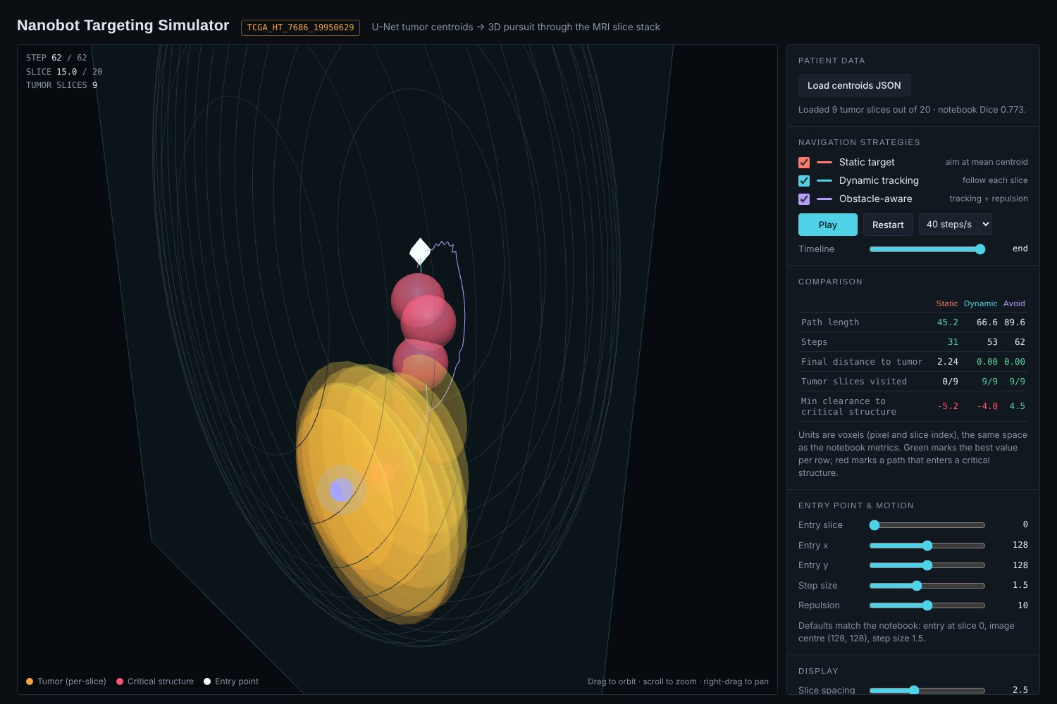
- Targeting simulator on validation patient TCGA_HT_7686 (9 tumor slices), all three strategies after the run. Static: 45.2 voxels, 31 steps, ends 2.24 from the tumor. Dynamic: 66.6 voxels, 53 steps, ends at 0.00. Obstacle-aware: 89.6 voxels, 62 steps, ends at 0.00 and stays clear of the simulated spheres (clearance 4.5 versus −5.2 and −4.0).
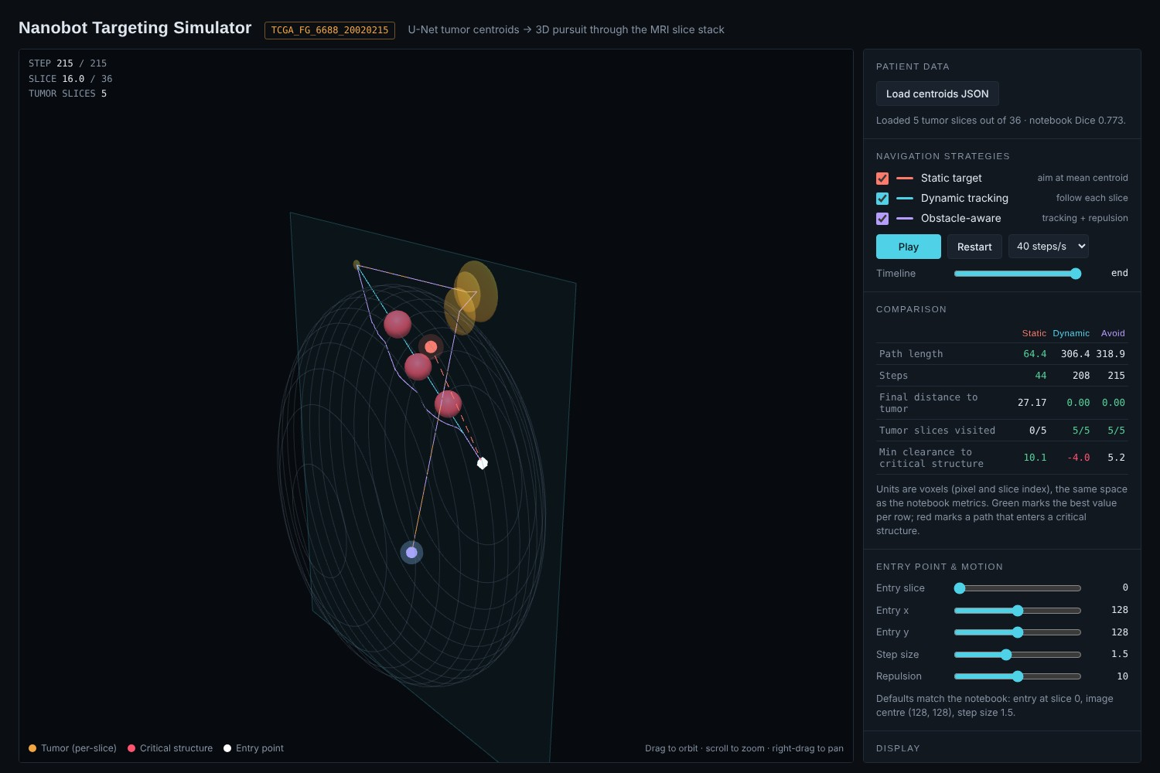
- Targeting simulator on TCGA_FG_6688 (5 tumor slices), the patient with the largest static error. Static: 64.4 voxels, 44 steps, ends 27.17 voxels from the tumor. Dynamic: 306.4 voxels, 208 steps. Obstacle-aware: 318.9 voxels, 215 steps.
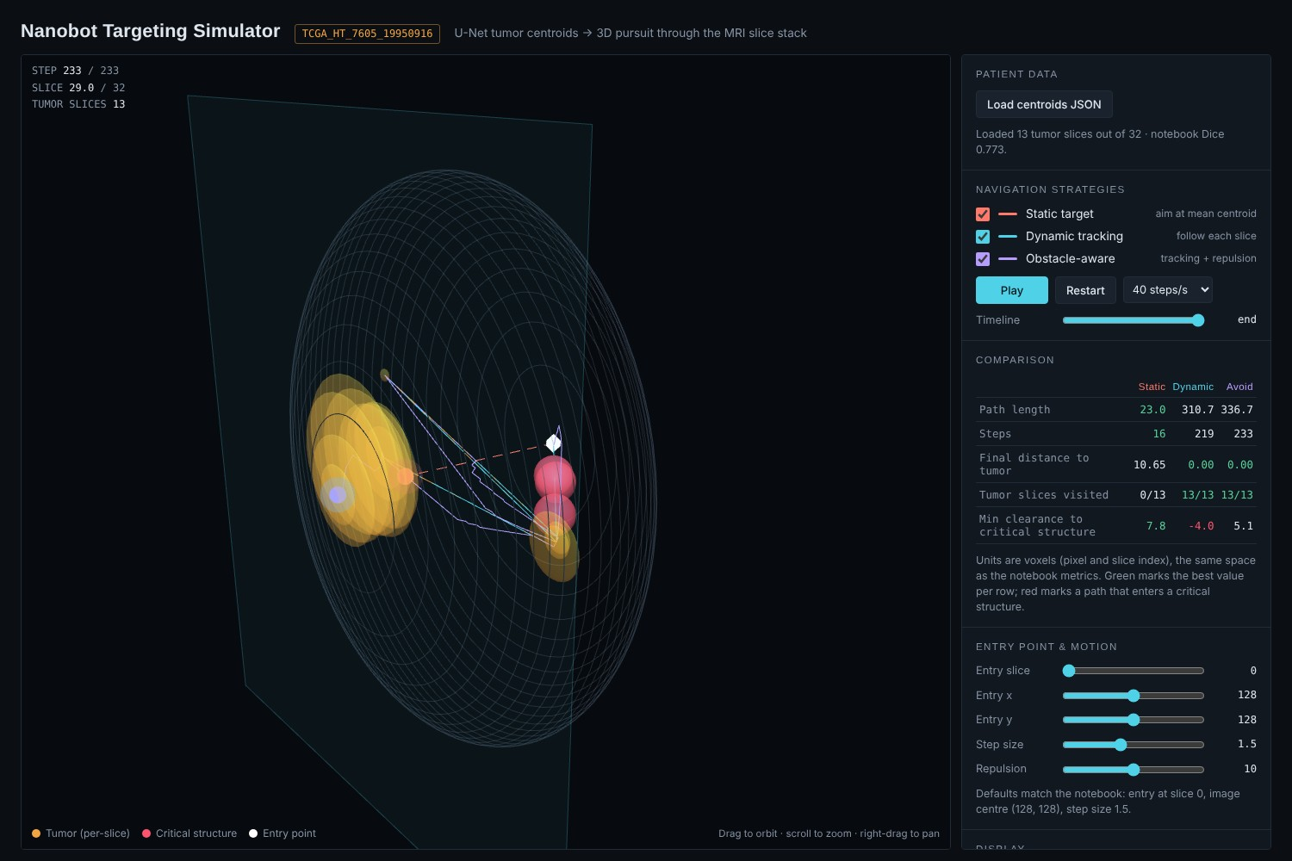
- Targeting simulator on TCGA_HT_7605 (13 tumor slices). Static: 23.0 voxels, ends 10.65 away. Dynamic: 310.7 voxels, 219 steps. Obstacle-aware: 336.7 voxels, 233 steps. The long dynamic path comes from stray detections on distant slices.
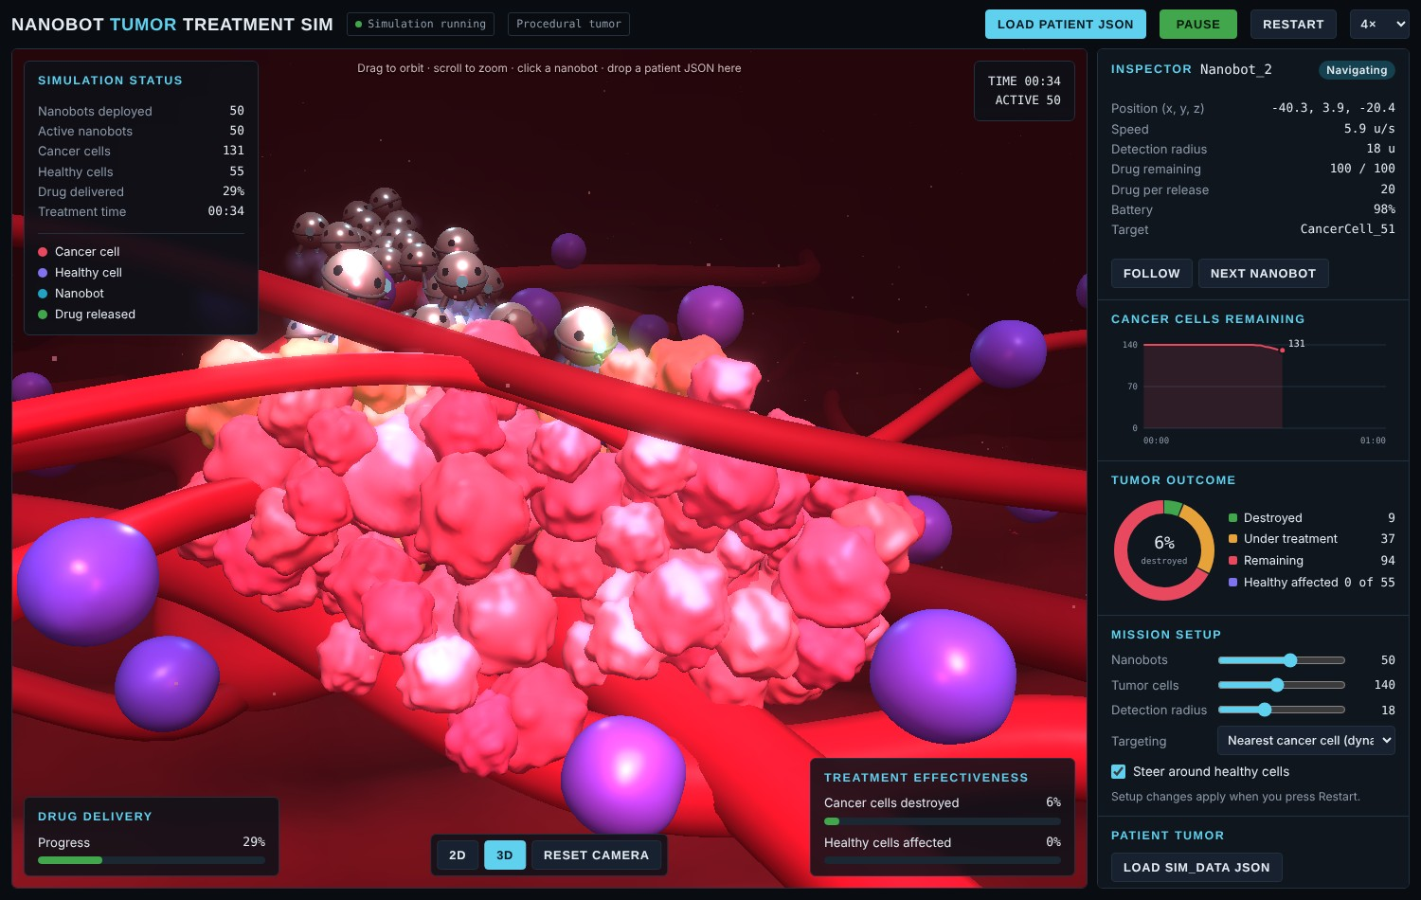
- Treatment simulator (3D view) with the procedural tumor: 50 nanobots, 140 cancer cells and 55 healthy cells. At 00:34 the nanobots have reached the tumor and 6% of cancer cells are destroyed with no healthy cell affected.
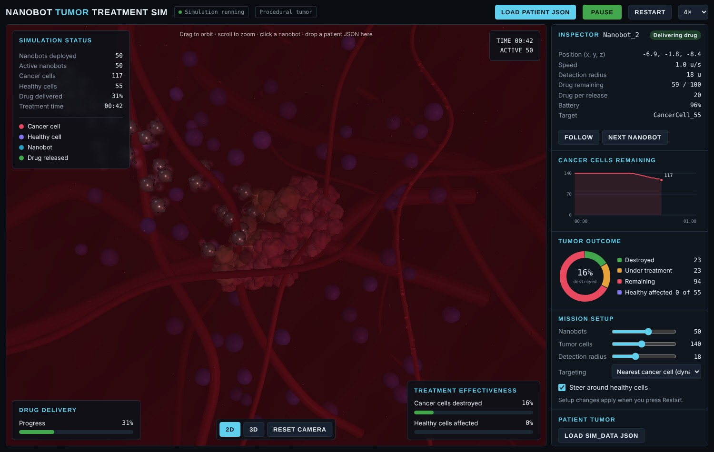
- Treatment simulator in 2D view at 00:42. Nanobots have spread over the tumor, 31% of the drug has been delivered and 16% of cancer cells are destroyed.
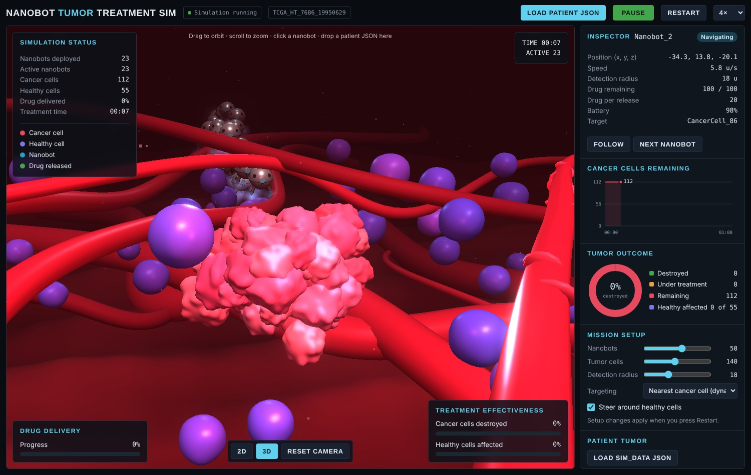
- Treatment simulator started from the exported centroids of TCGA_HT_7686 (23 nanobots, 112 cancer cells, 55 healthy cells). The tumor shape follows the patient’s slice centroids instead of the procedural cluster.

Appendix D. Dataset and Prediction Examples
The images below come from the training notebook and show the input slices, the ground-truth masks and the model output.
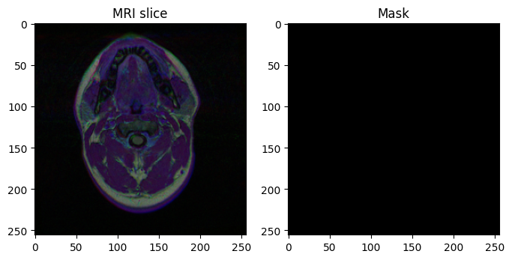
- Dataset example without tumor: an MRI slice (left) and its empty ground-truth mask (right). Most slices in the dataset look like this.
- Dataset example with tumor: an MRI slice (left) and its ground-truth tumor mask (right).
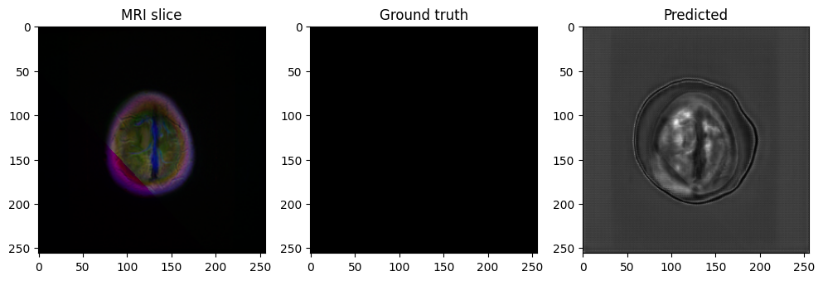
- Tumor-free validation slice: MRI slice, empty ground truth and the raw model output.
- Validation slice with tumor: MRI slice, ground truth, raw probability map and thresholded prediction.

