PROJECT REPORT
Deep Learning-Guided Nanorobotic Targeting
U-Net Brain Tumor Segmentation and 3D Navigation Simulation
Ojaswi Gondalia
B.Tech Artificial Intelligence
SVKM’s NMIMS Mukesh Patel School of Technology Management & Engineering, Mumbai
October 2026

Contents

Abstract
A 2D U-Net trained on the LGG brain MRI dataset segments tumors with a mean Dice coefficient of 0.773 and mean IoU of 0.746 on 22 held-out patients, and detects tumor in 20 of those 22. The centroid of each slice's predicted tumor is stacked into a 3D target path. Two navigation strategies are compared on every validation patient with a detected tumor: aiming at the mean centroid (static) and visiting each slice's centroid in turn (dynamic). Static targeting gives paths about 4× shorter (mean 46.4 against 186.3 voxels) but ends on average 5.98 voxels from any segmented tumor point, while dynamic tracking always ends on tumor tissue. A browser simulator adds a third, obstacle-aware strategy and lets the comparison be explored interactively.

1. Introduction
Nanorobotic drug delivery needs a target position, and this project supplies one from MRI automatically. Nanorobots are proposed as a way to concentrate treatment on tumor tissue and spare healthy tissue. Steering one requires coordinates, not only a diagnosis.
Brain MRI already shows where a tumor is, slice by slice. Outlining it by hand is slow, so that information is rarely turned into coordinates a navigation system could use.
This project builds and tests that link in three steps:
- A U-Net segments the tumor on every MRI slice.
- The centroid of each slice’s segmented tumor becomes a waypoint, and the waypoints stacked by slice index form a 3D target path.
- Simulated nanobots navigate from a fixed entry point to that target using three strategies, which are compared on path length, accuracy and clearance from critical structures.
The work is a simulation. It does not model a physical nanorobot, blood flow or tissue mechanics.

2. Dataset
The model is trained on the LGG MRI Segmentation dataset: 110 low-grade glioma patients and 3,929 slices with tumor masks. The scans come from The Cancer Genome Atlas via The Cancer Imaging Archive, and the dataset was assembled by Buda et al. and published on Kaggle.
Each slice is a .tif image whose three channels hold three MRI sequences (pre-contrast, FLAIR and post-contrast). Each has a matching single-channel binary mask, where white marks the FLAIR abnormality. A tumor spans only a range of slices per patient, so most masks are empty.
The data is split by patient rather than by slice, because neighbouring slices from one patient are nearly identical and would leak between the sets.
Table 1. Patient-level data split
Split | Patients | Slices
Training | 88 | 3,202
Validation | 22 | 727
Total | 110 | 3,929

The split is 80/20 with a fixed random seed (42), so it can be reproduced exactly.
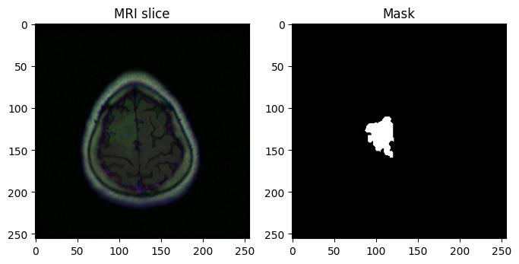
Figure 1. A training slice and its ground-truth tumor mask.

3. Methodology
The pipeline has five stages: preprocess each slice, segment it with a U-Net, extract the tumor centroid, stack centroids into a 3D path, and navigate to it.

3.1 Preprocessing
Each slice is read with all three channels, converted from BGR to RGB, resized to 256 × 256 and scaled to [0, 1]. Masks are resized to the same size and binarised at a value of 127.

3.2 U-Net architecture
The U-Net has a four-level encoder and a matching decoder. Each level applies two 3 × 3 convolutions with batch normalisation and ReLU. The encoder halves resolution with max pooling while channels grow from 64 to 512, with a 1,024-channel bottleneck. The decoder upsamples with transposed convolutions.
Skip connections concatenate each encoder level’s features onto the matching decoder level, which preserves the fine spatial detail needed for tumor boundaries. A final 1 × 1 convolution and a sigmoid give a per-pixel tumor probability.

3.3 Training
Table 2. Training configuration
Setting | Value
Input | 3 × 256 × 256
Loss | Dice loss + binary cross-entropy, equally weighted
Optimizer | Adam, learning rate 1 × 10⁻⁴
Batch size | 16
Epochs | 20
Hardware | Kaggle, NVIDIA Tesla T4, about 3 minutes per epoch
Prediction threshold | 0.5

Tumor pixels are a small fraction of each slice. BCE alone is dominated by background, so the Dice term is added to reward overlap with the tumor directly:
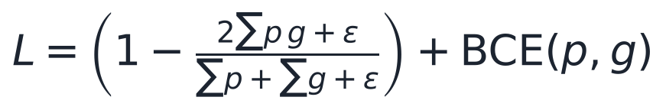
Here p is the predicted probability, g the ground-truth mask and ε = 10⁻⁶. No data augmentation or pretrained weights were used.

3.4 Centroid extraction and the 3D target
The predicted mask is thresholded at 0.5, and its image moments give the tumor centre on each slice:
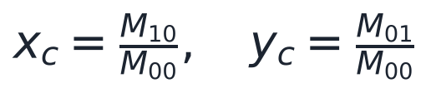
A slice with an empty mask (M₀₀ = 0) gives no waypoint. Slices are sorted by their numeric index, and each detected slice contributes a waypoint (z, x, y), where z is the slice index. The ordered waypoints form the tumor’s path through the volume, and their mean is the static target.

3.5 Navigation strategies
Every bot starts at slice 0, image centre (128, 128), and moves s = 1.5 voxels per step. All distances are in voxels, treating one pixel and one slice as one unit.
- Static target: moves straight to the mean centroid t and stops within 1 voxel, with at most 200 steps.
- Dynamic tracking: pursues each waypoint cᵢ in slice order and moves on once within 1 voxel, with at most 100 steps per waypoint.
- Obstacle-aware (simulator only): dynamic tracking plus a repulsive field from simulated critical structures, faded near each waypoint so the bot cannot be trapped beside an obstacle.
The pursuit step shared by all three:
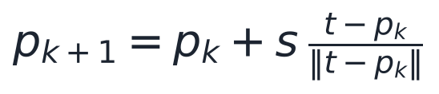
For the obstacle-aware bot, the step direction is the normalised sum of the goal direction and the repulsion from each obstacle o within an influence radius of 16 voxels, with strength k = 10 and fade f = min(1, distance to waypoint / 16):
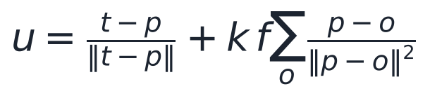

3.6 Evaluation metrics
- Segmentation: Dice coefficient and IoU per slice, averaged over the 727 validation slices; tumor detection rate per patient.
- Navigation: path length (sum of step lengths), steps taken, final distance to the nearest true centroid, and minimum clearance to a critical structure’s surface in the simulator.

4. Results
The U-Net reaches a mean Dice of 0.773 on held-out patients, and dynamic tracking always ends on tumor tissue at about 4× the path length of static targeting.

4.1 Training
Training loss fell from 1.264 at epoch 1 to 0.174 at epoch 20 (lowest at epoch 19, 0.139), and validation loss fell from 1.188 to between 0.58 and 0.63. Validation loss levelled off after epoch 9 while training loss kept falling, which is an early sign of overfitting; it ends at 0.584, slightly above epoch 19's 0.580, so the final saved weights are not the run's best epoch — the notebook keeps whichever epoch finishes last rather than the best-scoring one.
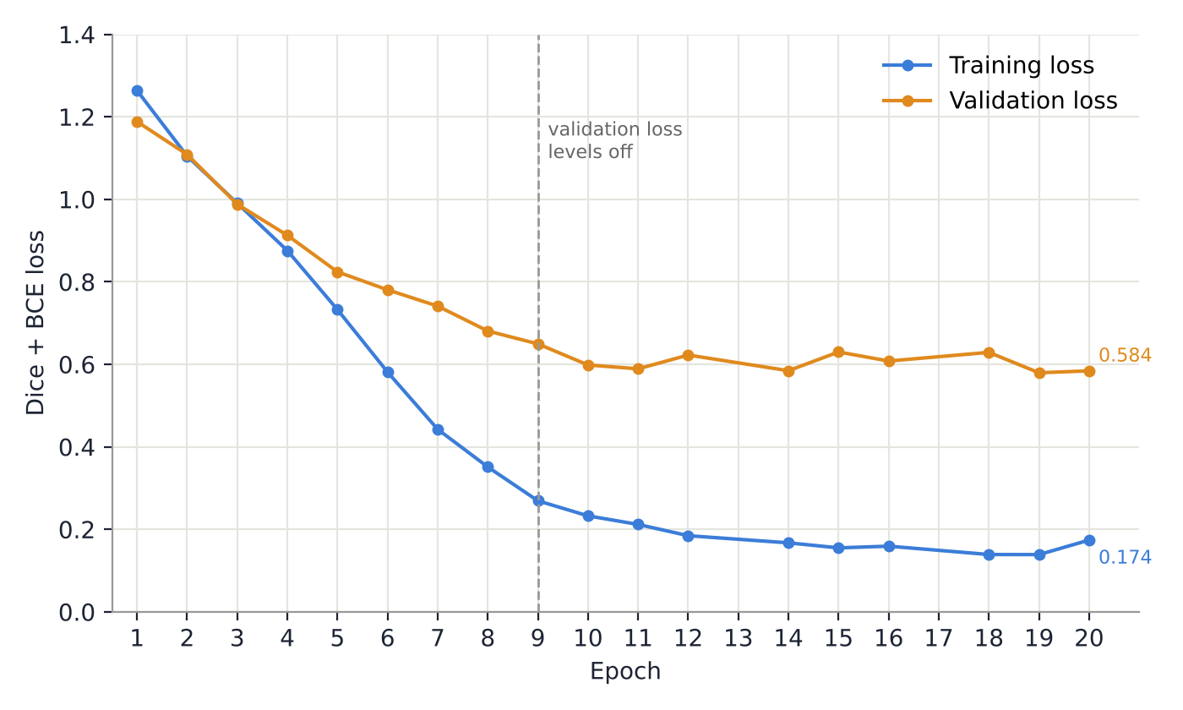
Figure 2. Training and validation loss (Dice + BCE). Epochs 13 and 17 were not captured in the saved notebook log, so only logged epochs are plotted.

4.2 Segmentation
Table 3. Segmentation results on 22 validation patients (727 slices)
Metric | Value
Mean Dice coefficient | 0.7732
Mean IoU | 0.7459
Patients with tumor detected | 20 of 22 (90.9%)
Pixel accuracy | 0.9940
Specificity | 0.9990

Pixel accuracy and specificity are high mainly because background dominates every slice, so Dice and IoU are the informative measures. Precision and recall are discussed in Section 5.
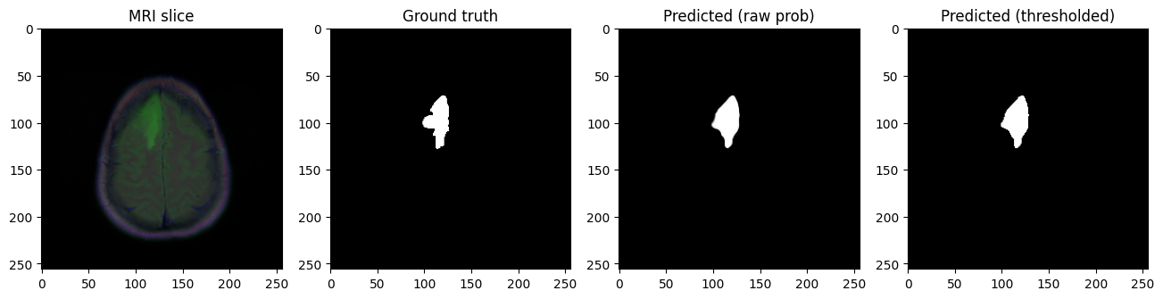
Figure 3. A validation slice: the predicted tumor matches the ground-truth mask closely in shape, size and position.

4.3 Centroids and the 3D target
For validation patient TCGA_HT_7686, the model found tumor on 9 slices (7 to 15). Centroids shift smoothly between neighbouring slices, for example (x 147.1, y 168.9) on slice 10 and (x 147.4, y 171.1) on slice 11, which shows the segmentation is spatially consistent for this patient. The mean target is slice 11.0, x 148.6, y 166.7. Not every patient is this clean: TCGA_FG_6688 (Section 4.4) has only 5 detected slices whose centroids jump between unrelated locations rather than tracing one tumor, which is why its static path ends so far from any real tumor point.
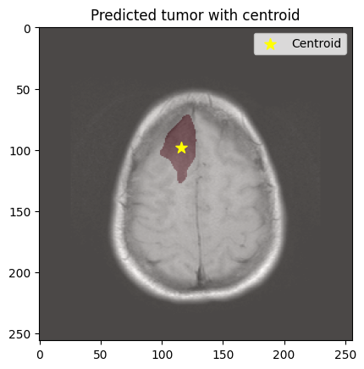
Figure 4. Predicted tumor (red) and its centroid (star) on one validation slice.

4.4 Navigation
Table 4. Navigation results over the 20 validation patients with a detected tumor (voxels)
Measure | Static target | Dynamic tracking
Mean path length | 46.4 | 186.3
Median path length | 43.1 | 143.5
Path length range | 21.5 to 69.7 | 66.6 to 394.2
Mean final distance to tumor | 5.98 | 0.00
Worst final distance | 27.17 | 0.00

Static targeting is never longer than dynamic tracking, but it stops at the tumor's average position, which can lie outside segmented tissue. The worst case, TCGA_FG_6688, has tumor detected on only 5 slices whose centroids are scattered rather than contiguous, so its static path ends 27.17 voxels from any tumor point. TCGA_CS_6290 has tumor on only 5 slices as well but a tighter cluster, so its static path ends only 3.04 voxels away.
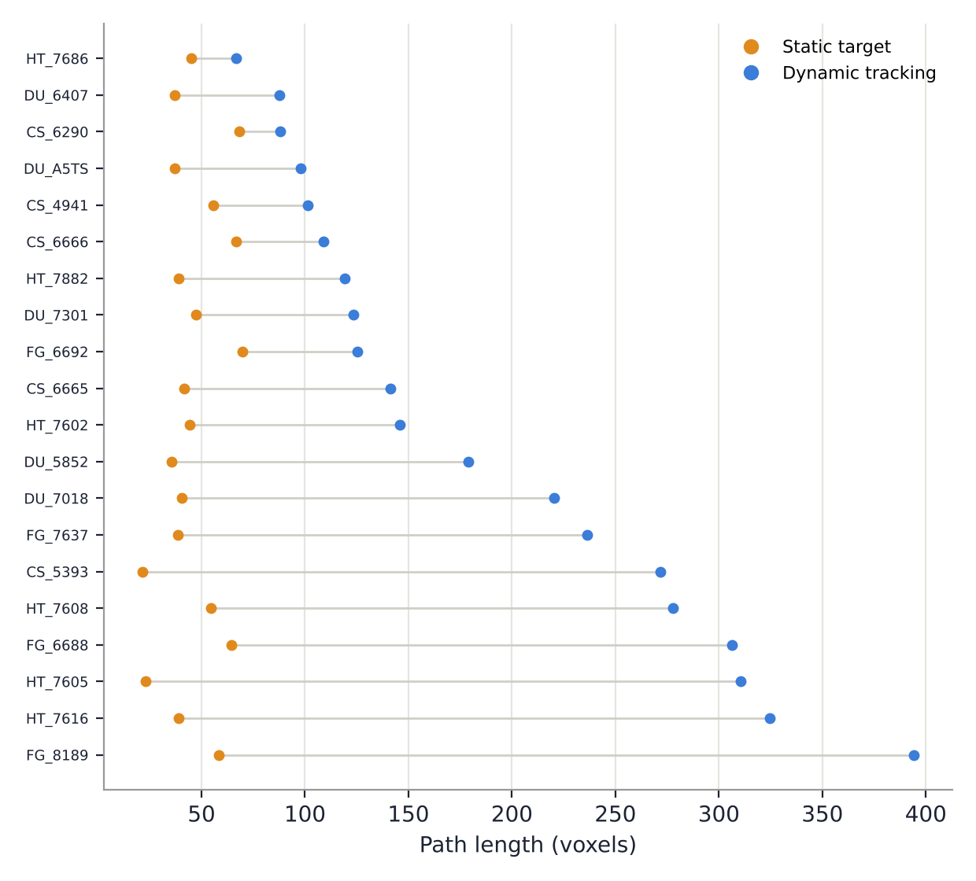
Figure 5. Path length per validation patient, sorted by dynamic path length.
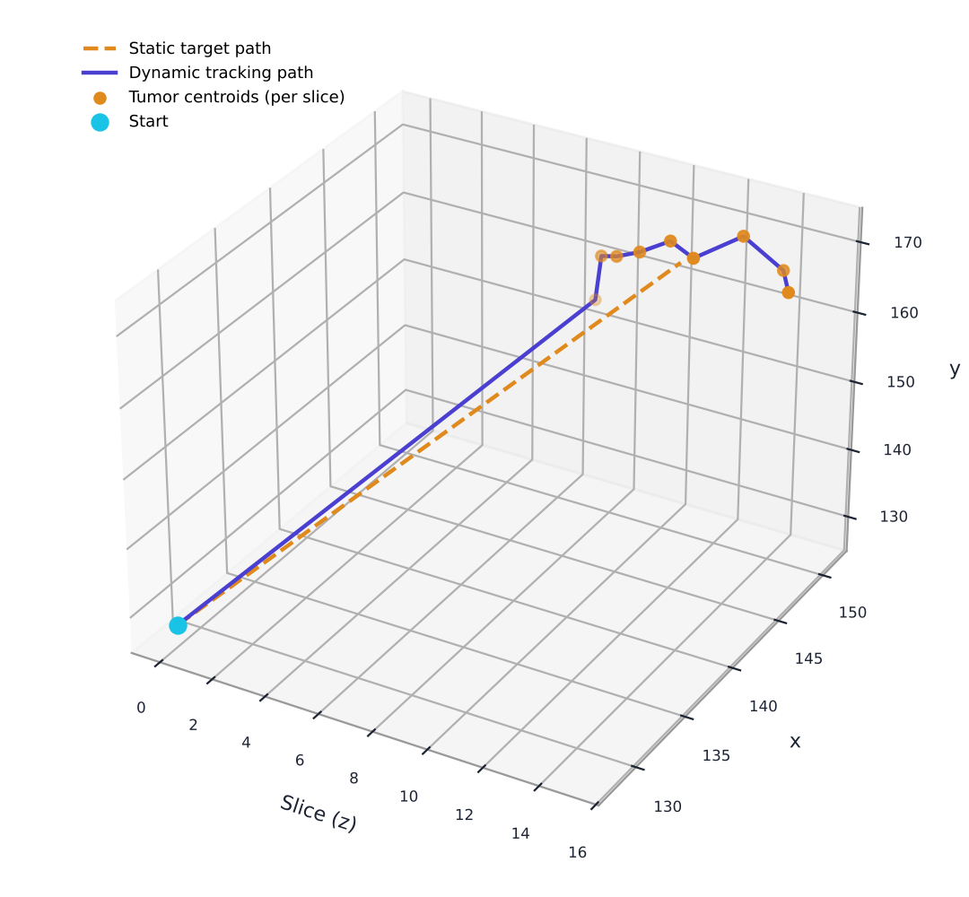
Figure 6. Patient TCGA_HT_7686: the static path (dashed) runs 45.2 voxels and ends 2.24 voxels from the nearest centroid; the dynamic path runs 66.6 voxels in 53 steps and visits all 9 tumor slices.

5. Correcting the precision and recall metrics
The first version of the evaluation reported precision 0.238, recall 0.193 and F1 0.204, which cannot be reconciled with a Dice of 0.773. Those values come from how the metrics were averaged, not from the model.
The metrics were computed per slice and then averaged. On a tumor-free slice where the model correctly predicts nothing, true positives, false positives and false negatives are all zero, so precision and recall are 0 ÷ 0. The code counted these as 0. Most of the 727 validation slices have no tumor, so these zeros pulled the averages far down. Dice did not suffer this, because its smoothing term scores an empty prediction on an empty mask as 1.
The corrected evaluation pools true positives, false positives and false negatives over every validation pixel, then computes each metric once:
Table 5. Pooled pixel metrics on the validation set
Metric | Value
Precision | 0.8764
Recall | 0.5789
F1 | 0.6973
IoU | 0.5352

Pooled over all 727 validation slices: TP = 351,552, FP = 49,579, FN = 255,679, TN = 50,330,198 pixels. These corrected values replace the per-slice precision and recall reported above, and come from the same evaluation run as the Dice, IoU and navigation figures in this report.

6. Web simulator
A browser-based simulator runs all three navigation strategies on any patient exported from the notebook, so the comparison can be explored interactively. It is built with Three.js and runs without installation.
- Input: one JSON file per patient, exported by the notebook, holding each tumor slice’s index, centroid and tumor area, plus the patient’s slice count.
- Scene: the brain volume drawn as stacked axial contours, the tumor as one disc per slice sized by its segmented area, and a plane marking the slice the lead bot is passing through.
- Simulation: the same pursuit rules, step size, stopping distance and step limits as the notebook, rewritten in JavaScript.
- Controls: entry point, step size, repulsion strength, slice spacing for display, and a playback timeline.
- Comparison table: path length, steps, final distance to the tumor, tumor slices visited and minimum clearance to a critical structure.
The critical structures are three simulated spheres placed along the route from the entry point to the first tumor slice. They are not segmented from the MRI.
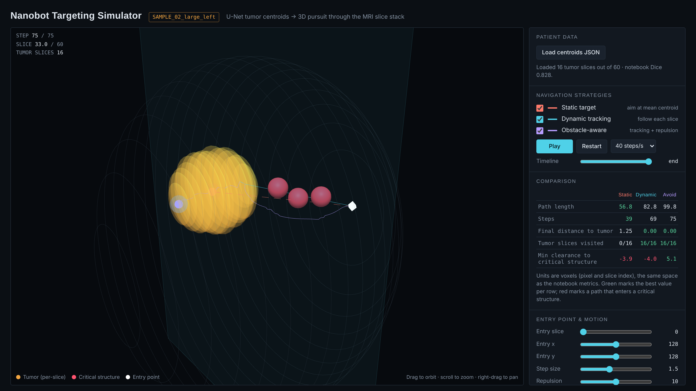
Figure 7. The simulator with a synthetic sample patient loaded.
On five synthetic sample patients, the static and dynamic bots both entered a critical structure (minimum clearance between −4.8 and −3.2 voxels), while the obstacle-aware bot cleared them by 5.1 to 5.2 voxels. Its paths were 15 to 18 voxels longer than dynamic tracking. These samples demonstrate the method only; they are not patient results.

7. Limitations and future work
The results show a working pipeline from imaging to navigation in simulation; they do not show clinical or physical feasibility.
Table 6. Limitations and next steps
Limitation | Effect | Next step
2D U-Net, one slice at a time | No 3D context between slices | A 3D U-Net, or several neighbouring slices as input
Validation loss plateaus after epoch 9 | Signs of overfitting | Augmentation, early stopping, a pretrained encoder
Every detected slice becomes a waypoint | A stray scattered-slice detection can pull the dynamic path far off; TCGA_HT_7605 has 13 tumor slices but a 310.7-voxel path | Keep only the largest connected tumor region and drop very small detections
22 validation patients and no separate test set | Results may not generalise | Patient-level cross-validation and a held-out test split
Per-slice precision and recall (Section 5) | Reported values understated the model | Pooled metrics, now added to the evaluation
Critical structures are simulated spheres | Clearance results are illustrative only | Segment real anatomy, such as the ventricles, as obstacles
Straight-line motion in voxel units | Ignores slice thickness, blood flow and tissue | Millimetre spacing from scan metadata, plus drag and flow in the motion model

8. Conclusion
A U-Net trained on 88 patients segments low-grade gliomas with a mean Dice of 0.773 on 22 unseen patients, detecting tumor on 20 of them, and its per-slice centroids form a usable 3D target wherever a tumor is detected. Comparing navigation strategies on that target shows a clear trade-off. Aiming at the mean centroid is roughly 4× shorter but misses segmented tissue by 5.98 voxels on average, while tracking each slice always ends on the tumor. Pooling the evaluation over every validation pixel (Section 5) gives a precision of 0.876 and a recall of 0.579: the model is conservative, under-flagging tumor more often than it over-flags healthy tissue. The browser simulator makes the static-versus-dynamic comparison available for any exported patient, and the obstacle-aware strategy adds a third option on synthetic sample data.

References
- Ronneberger, O., Fischer, P. and Brox, T. (2015). U-Net: Convolutional networks for biomedical image segmentation. MICCAI 2015, LNCS 9351, pp. 234–241.
- Buda, M., Saha, A. and Mazurowski, M. A. (2019). Association of genomic subtypes of lower-grade gliomas with shape features automatically extracted by a deep learning algorithm. Computers in Biology and Medicine, 109, pp. 218–225.
- Clark, K. et al. (2013). The Cancer Imaging Archive (TCIA): maintaining and operating a public information repository. Journal of Digital Imaging, 26(6), pp. 1045–1057.
- Milletari, F., Navab, N. and Ahmadi, S.-A. (2016). V-Net: Fully convolutional neural networks for volumetric medical image segmentation. Fourth International Conference on 3D Vision (3DV), pp. 565–571.
- Kingma, D. P. and Ba, J. (2015). Adam: A method for stochastic optimization. ICLR 2015.
- Khatib, O. (1986). Real-time obstacle avoidance for manipulators and mobile robots. The International Journal of Robotics Research, 5(1), pp. 90–98.
- Buda, M. LGG Segmentation Dataset. Kaggle. https://www.kaggle.com/datasets/mateuszbuda/lgg-mri-segmentation

Appendix A. Per-patient navigation results
All 20 validation patients with a detected tumor, sorted by dynamic path length. Dynamic tracking ends on a tumor centroid (final distance 0.00) for every patient, so that column is omitted. The 2 validation patients with no detected tumor (and so no navigation result) are not listed.
Table 7. Per-patient navigation results (voxels)
Patient | Tumor slices detected | Static path | Dynamic path | Static final distance
TCGA_HT_7686_19950629 | 9 | 45.2 | 66.6 | 2.24
TCGA_DU_6407_19860514 | 16 | 37.1 | 87.8 | 3.68
TCGA_CS_6290_20000917 | 5 | 68.1 | 87.9 | 3.04
TCGA_DU_A5TS_19970726 | 13 | 37.2 | 98.0 | 2.95
TCGA_CS_4941_19960909 | 8 | 55.8 | 101.2 | 6.82
TCGA_CS_6666_20011109 | 9 | 66.6 | 109.1 | 1.38
TCGA_HT_7882_19970125 | 16 | 39.1 | 119.2 | 3.05
TCGA_DU_7301_19911112 | 13 | 47.2 | 123.6 | 3.41
TCGA_FG_6692_20020606 | 9 | 69.7 | 125.2 | 2.42
TCGA_CS_6665_20010817 | 12 | 41.8 | 141.1 | 6.26
TCGA_HT_7602_19951103 | 9 | 44.4 | 145.9 | 3.65
TCGA_DU_5852_19950709 | 8 | 35.7 | 178.8 | 5.77
TCGA_DU_7018_19911220 | 17 | 40.5 | 220.2 | 5.25
TCGA_FG_7637_20000922 | 17 | 38.6 | 236.3 | 9.27
TCGA_CS_5393_19990606 | 13 | 21.5 | 271.8 | 13.39
TCGA_HT_7608_19940304 | 14 | 54.4 | 277.9 | 1.90
TCGA_FG_6688_20020215 | 5 | 64.4 | 306.4 | 27.17
TCGA_HT_7605_19950916 | 13 | 23.0 | 310.7 | 10.65
TCGA_HT_7616_19940813 | 18 | 39.0 | 324.5 | 5.38
TCGA_FG_8189_20030516 | 27 | 58.3 | 394.2 | 1.90

