

Cairo University -Faculty of Engineering

Project graphics

Names: bassant hisham 1190018

Sohad hossam 1190019

Mahinour alaa 1190339

Yasmin hashem 4200013

**Contributions:**

|  |  |  |
| --- | --- | --- |
| **Names:** | **Phase1** | **Phase2** |
| **Bassant hisham** | Checker board  chromatic abbrivation texture-utils.cpp  pipeline-state  world.cpp  world.hpp | Post process effect  Collision  Lighting in forward renderer |
| **Yasmin Hashem** | Transform  Mesh.hpp  Mesh renderer.hpp  Mesh renderer.cpp  Component desacralizer.hpp | Play state  Scene Deserialization  Game logic  3D motion  Win state  App.jsonc |
| **Sohad hossam** | Entity.cpp  Entity.hpp  Shader.cpp  Shader.hpp  Sampler  Triangle.vert  Color-mixer.frag  Texture-test.frag  Texture2d.hpp  Entity-test-state.hpp  Vignette.frag  Sky rendering  Forward-renderer (req 11) | Lighting in forward renderer  Multiple lights in the scene  Sky  Texture mapping  App.JSON |
| **Mahinour** | Camera.cpp  Material.cpp  Tinted.frag  Textured.frag  Forward rendering (Req 10) | Lighting in shaders  Lit material class  Collision |

**Win State:**

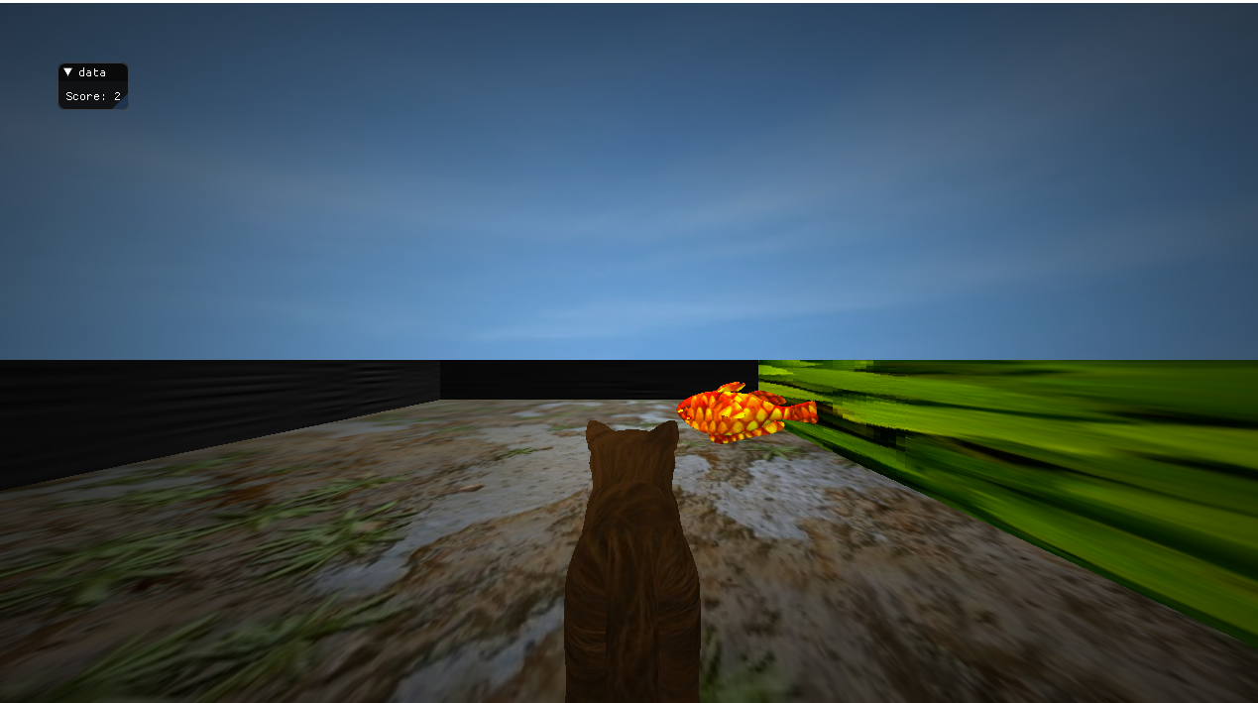

**Coin Collecting:**

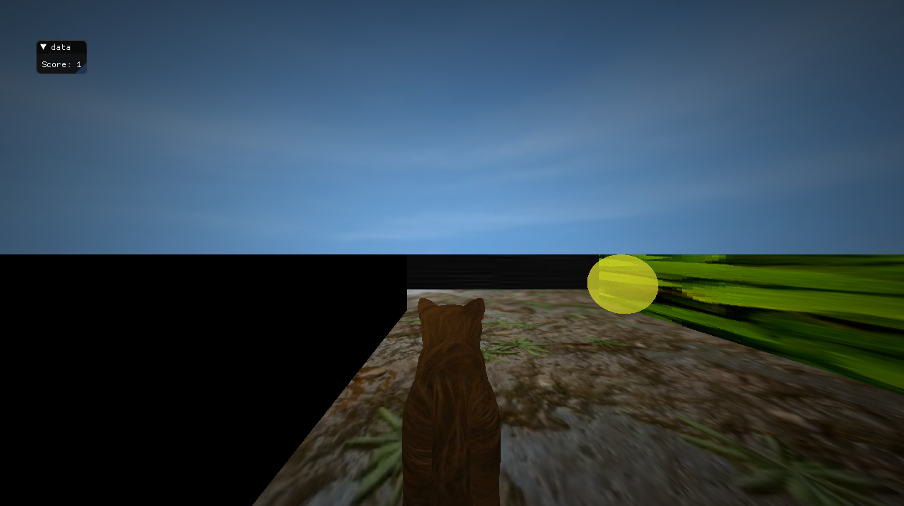

**Light state:**

