**ANNUAL REPORT**

**of**

**Social Upliftment Society (SUS)**

**FY: 2019-2020**

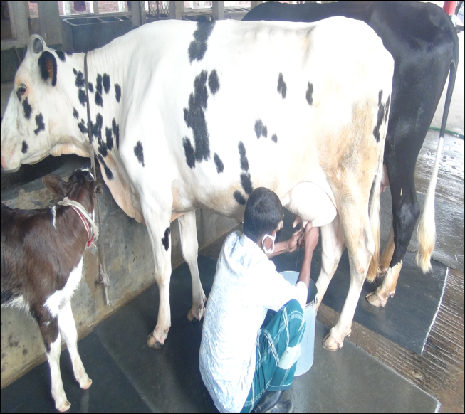

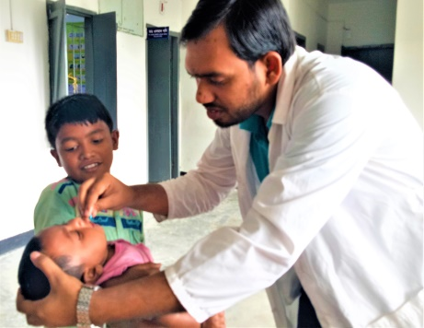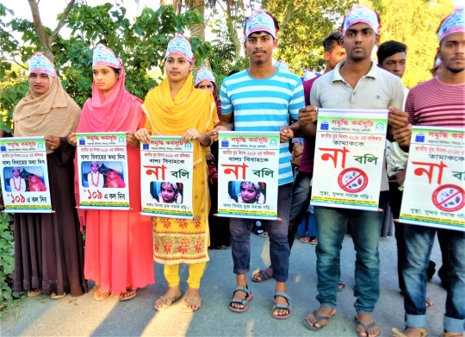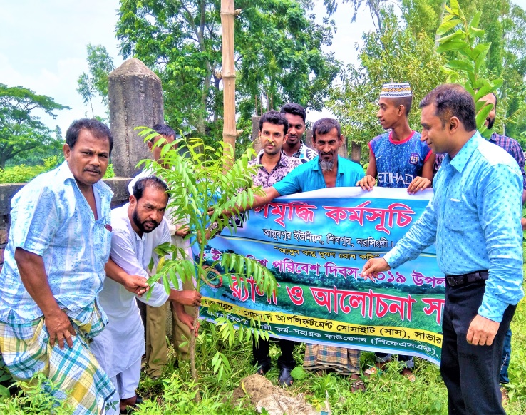

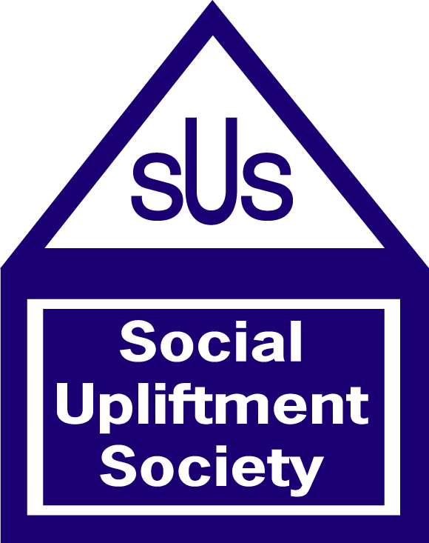

**Social Upliftment Society (SUS)**

**C-25, Jaleswar, Shimultala, Savar**

**Dhaka-1340**

**Phone: 88-02-77446229, 88-02-7742403**

**E-mail:sushelp360@gmail.com**

**Advisor:**

Hamida Begum, Executive Director

Social Upliftment Society (SUS)

Savar, Dhaka

**Editor:**

Dr. Kbd. Md. Rafiqul Islam Mollah, Director

Social Upliftment Society (SUS)

Savar, Dhaka

**Co-Editors:**

1. Md. Saidul Islam, Joint Director

2. Monjur Morshed, Deputy Director

3. Mridul Chakraborty, Deputy Director

Social Upliftment Society (SUS), Savar, Dhaka

**Report Preparation:**

Kamal Kumar Saha, Deputy Director

Social Upliftment Society (SUS)

Savar, Dhaka

**Data Compilation:**

Muhammad Nobe Alam, Program Officer (Development)

Social Upliftment Society (SUS)

Savar, Dhaka

**Data Collection:**

1. Md. Aminul Islam, Credit Coordinator

2. Muhammad Ali Hossan, Credit Coordinator

3. Md. Nazrul Islam, Area Coordinator

4. Emrul Kayes Chowdhury, Area Coordinator

5. Faruk Ahmed, Area Coordinator

6. Bishnu Pada Chakravartee, MIS Officer

Social Upliftment Society (SUS), Savar, Dhaka

**Design:**

Md. Nurul Alam Siddiquee

IT Officer, SUS

Savar, Dhaka

**Printing:**

Md. Shahidul Islam Sohel

Manikganj Printing Press

Savar, Dhaka

**Published by:**

Social Upliftment Society (SUS)

Savar, Dhaka

**June 2020**

**Abbreviation Acronyms**

CSO Civil Society Organization

DAE Department of Agricultural Extension

DLS [Department of Livestock Services](https://www.facebook.com/dls.gov.bd/)

DRR&CC Disaster Risk Reduction and Climate Change

EC Executive Committee

FY Financial Year

GC General Committee

ICT Information and Communication Technology

LGI Local Government Institution

MFP Microfinance Program

### MoWCA Ministry of Women and Children Affairs

MRA Microcredit Regulatory Authority

NGO Non-Governmental Organization

SMT Senior Management Team

SUS Social Upliftment Society

PKSF Palli Karma Sahayak Foundation

VGD Vulnerable Group Development

VGF Vulnerable Group Feeding

**Table of Contents**

**Contents Page #**

Message from the Chairman of the SUS Executive Committee ............................................... 05

Message from the Executive Director ........................................................................................ 06

COVID-19 Crisis and SUS Initiatives to face the situation ……………………………………….. 07

**Chapter-I: Organizational Overview**

1.1. Development Journey of SUS ………………………………………………………………… 09

1.2. General Information about SUS …………………………………………………………….. 09

1.3. Vision, Mission and Goal…………………………………………………………….……….... 11

1.4. Core Values ………………………………………………………………….….…………….... 11

1.5. Governance and Management Structure…………………………………..…….…….……. 12

1.6. Stakeholders of SUS …………………………………………………………………………… 12

1.7. Program Design and Implementation Strategies ……………………………..…………..… 13

**Chapter-II: Activities and Achievements during the FY: 2019-2020**

2.1. Summary of Project and program wise Activities and Achievements during the Financial Year: 2019-2020 ……………………………………………………………………….……….. 14

2.2. Detailed activities and achievements under different projects and programs..……….….. 17

**Chapter-III: SUS Financial Reports**

3.1. Statement of Financial Position (Balance Sheet) …………………………………………... 30

3.2. Statement of Comprehensive Income (Income and Expenditure Statement) …………… 30

3.3. Statement of Cash Flows ……………………………………………………………………… 30

**Message from the Chairman of the SUS Executive Committee**

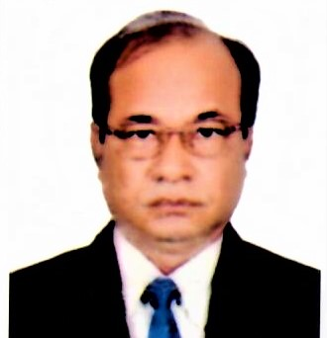

I, as the Chairman of the Executive Committee of Social Upliftment Society (SUS) am overwhelmingly delighted and feel honoured to present the Annual Report of the Social Upliftment Society (SUS) for the financial year 2019-2020. This report actually accounts in brief the activities and achievements that were accomplished during this said period.

In this reporting year, SUS was able to reach more than 40,000 Nos. of people living across its program implementation areas. It was also able to maintain its reputation as a national organization providing services to the targeted disadvantaged people including the excluded people living in its working areas. SUS has been particularly trying to expand its operations in poverty prone urban areas. Special emphasis is being given to social and economic empowerment of the poor women, livelihood and entrepreneurship development, the agricultural development and food security and child rights development.

We have been constantly growing and learning through our involvement with the development partners, donors and other groups like, the local level community groups, CSOs, NGOs and representatives of the society.

Our success is the success of the disadvantaged community people for whom we are working. With the ongoing support of our donors and other development partners, board and volunteers, Social Upliftment Society (SUS) will be ready to take and tackle any challenge ahead in 2021.



Mirza Tareq Md. Mamtazur Rahman

Chairman, Executive Committee

Social Upliftment Society (SUS)

*Note: On 27 June 2020 our honorable Chairman of the Executive Committee of SUS Mr. Mirza Tareq Md. Mamtazur Rahman passed away.*

**Message from the Executive Director of SUS**

We are going to start a new year with a dream of building a society where the people will able to overcome all of barriers in the path of leading a life of full enjoyment of rights recognized by the country.

During the last financial year, particularly in the later part of this reporting period ranging from March to June 2020, we came across some unexpected and deadly events like, COVID-19, Amphan, a super cyclone etc. that jeopardized the normal life of our people. Even today we are struggling for coping with the situation. Amid huge obstacles and barriers, we could not stop our journey and are constantly providing our support to the people in distress. We are continuing our field operation with our planned interventions among the targeted community people. This Annual Report has actually depicted the intervention package and achievements that we accomplished and attained with the fabulous support of all relevant stakeholders.

In fact, the end of one year is the beginning of another new year. So, it is our desire to have consistent supports and cooperation from our existing development partners and well-wishers in the journey towards our destination. So, we would like to welcome anyone or organizations to partner with us to collectively work for people who need an opportunity to change their situations.

Finally, I, on behalf of the SUS family, express my heart-felt gratitude to all stakeholders including our honorable board members who extended their supports and cooperation in successful accomplishment of all intervention packages and targets rightly set at the start of this reporting period.

Hamida Begum

Executive Director

Social Upliftment Society (SUS)

**COVID-19 Crisis and SUS Initiatives to face the situation**

Snapshot of COVID-19 Crisis: Mid-level and Small MFIs are severely affected by the COVID-19 situation which is briefly stated below.

🞄 Social Upliftment Society (SUS) along with other MFIs in Bangladesh could not collect loan instalments from their clients during April and May 2020 as the government halted nationwide operations. As a result, we faced cash flow crisis due to halted operations.

🞄 But after May 2020, MFIs has started its microfinance program on a limited scale.

🞄 As the majority of the MFI borrowers have already become vulnerable due to the pandemic, this has also created a serious threat to the day-to-day activities of the MFIs and also on their sustainability.

🞄 Further, on the health issue, some MFIs had to close their branches, change the way they work and reduce their physical contact with the program beneficiary groups.

🞄 The pandemic has affected the workplace and earnings of the borrowers which have seriously weakened their repayment capacity.

🞄 Loan defaults possibilities have become higher, administrative costs have risen and the MFIs' own debt obligations and liquidity have been facing challenges and concerns for the sustainability of their operations.

🞄 Most of the mid and small levels NGO-MFIs are already facing hardships and difficulties in paying full salaries to their staff last month.

SUS initiatives: Social Upliftment Society (SUS) has taken a number of initiatives to face the COVID-19 situation and also fight the battle accordingly. SUS initiatives are briefly described below.

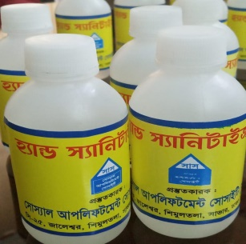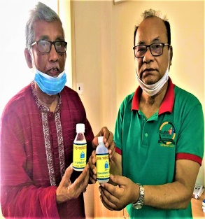◾ Sanitation services: At the very beginning of the COVID-19 crisis, Social Upliftment Society (SUS) provided sanitation services i.e. supply of hand sanitizers, soaps and surgical masks to all of its staff members so that they could protect themselves while discharging their duties in and outside the offices. Here, it is noted that SUS prepared these hand sanitizers using its own laboratory which is situated at Mushorikhola, Vakurta Union of Savar Upazila under Dhaka district. Apart from our staff members, we also supplied these SUS made hand sanitizers to the common people in our working areas in Savar, Dhaka. During this situation, around 2,000 Nos. of people came under the said sanitation services.

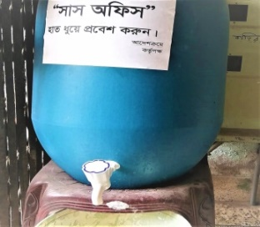◾ Setting hand washing corners: As a part of preventive measures for reducing the spread of the coronavirus, we have already set a number of hand washing corners with soaps in our project areas. Along with setting hand washing corners, all the concerned staff members working at the branch levels were advised to wash hands at different times such as: after blowing nose, coughing or sneezing; after visiting groups, markets and other public places; after touching money; before and after eating; when hands are visibly dirty etc.

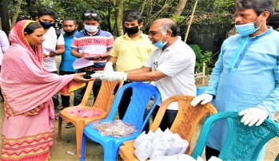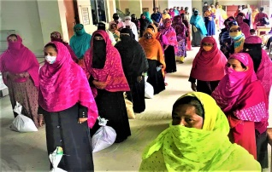◾ Distribution of Food Package and Seeds: During this COVID-19 situation, we distributed food package consisting of rice, pulses, oil, salt, potato, sugar, onion and vermicelli (Semai in Bengali) etc. among the 1,100 nos. of distressed people. We also distributed seeds of various vegetables, fruits and other food grains etc. among the 1,100 nos. of local farmers in the SUS working areas.

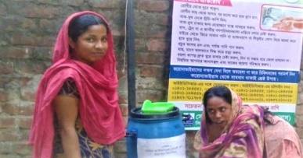◾ Sharing life-saving information: As a part of building mass awareness among the common people about fighting the COVID-19 crisis, life-saving information is being shared among the people in the SUS working areas. In this case, we prepared colourful, pictorial and message bearing leaflets designed by our own staff members and circulated accordingly among the mass people in the SUS working areas. We also hanged up banners containing precautionary message regarding COVID-19 at the crowded places.

◾ Dissemination of clear instruction to the field staff: Written instructions were passed to the field staff clearly specifying precautionary measures to be taken for the virus. In this case, we shared a complete guideline supplied by the PKSF among the SUS employees.

◾ Constant communication: From the senior members of the organization, constant communication is being done to keep staff motivated. Not only that our field staff members are also communicating with the beneficiary groups of SUS so that they do not feel isolated and think that SUS is with them. Further, the field situation is being continuously monitored by means of gathering all relevant information and using data software installed in each program office of the organization.

◾ Coordination with other projects: As per guidance of the SUS management, the field level staff members are playing an active role in coordinating with other projects of SUS to amplify and strengthen the organization’s drive towards overall response.

◾ Revision of action plans: Considering the situation, we have already brought some changes and adjustment to our work plans especially in the SUS Loan Program and have revised the plans accordingly to cope with the prevailing situation.

◾ Halting field operations: We also halted all field activities concerning loan and savings collection from 24 March 2020 to 30 April 2020, which was later extended up to 30 May 2020.

◾ Stoppage of loan classification: Immediately after receiving announcement / decree issued by the Microcredit Regulatory Authority (MRA) in Bangladesh, our organization has stopped classification of loans. This means that the default clients will not be classified as defaulters and their borrower status will not change. The borrowers will not have to pay any loan installment for the period up to September 2020. But they can pay installments only if they want and in that case, there will be no obligation and restriction.

◾ Opportunities for savings withdrawal: As our loan disbursement was temporarily closed for this situation, we kept our branches open so that clients could withdraw their savings.

◾ Donation from salary: The employees of Social Upliftment Society (SUS) have already donated their one-day salary for the people who have been suffering during the nationwide shutdown due to the coronavirus pandemic and to the fight against the COVID-19.

◾ Continuation of paying staff salaries: To keep the morale of all employees of the organization as strong as we expect, the organization could keep continuation of payment of staff salaries even in the condition of generating a low cash inflow in the program implementation.

In a nutshell, these are the initiatives taken by SUS to tackle the prevailing crisis.

**Chapter-I: Organizational Overview**

**1.1. Development Journey of SUS**: Social Upliftment Society (SUS) is a women-led Non-Political, Not-for-Profit and Non-Governmental Organization (NGO) which formally started its journey in the development sector of Bangladesh in the year of 1990 with an aim of improving the socio-economic condition of the disadvantaged and under privileged people with a clear focus on women empowerment. In 1988 Bangladesh faced a devastating flood that engulfed two thirds of the country and at that time, the surrounding Upazilas of Dhaka District went under flood water. In this situation, the Executive Director of Social Upliftment Society (SUS), Hamida Begum along with some local volunteers came forward with her generous heart to reduce the untold sufferings of the flood affected people and started for carrying out relief and rehabilitation activities among the distressed people. In 1989, SUS started its rehabilitation works with a support received from OXFAM-UK for the flood affected people. However, after successful completion of relief and rehabilitation works during 1988 and 1989, SUS finally got registered as an NGO with the Directorate of Social Services in 1990. This was the formal beginning of SUS in Bangladesh.

**1.2. General Information about SUS**:

|  |  |
| --- | --- |
| Name | Social Upliftment Society (SUS) |
| Address | Head Office: C-25, Jaleswar, Shimultala, Savar, Dhaka-1340 |
| Phone Number | 88-02-77446229, 88-02-7742403 |
| Email & Website | Email: sushelp360@gmail.com; www.sus-bd.org |
| Estd. Year | 1990 |
| Contact Person | Hamida Begum, Executive Director  Cell: 01678678888, 01715315026; Email: sushelp360@gmail.com |
| Legal Status | Social Upliftment Society (SUS) is registered as a Non-Governmental Organization (NGO). The particulars of registration are as below:  a. NGO Affairs Bureau: No. 1094; Date: 02/11/1996  b. Microcredit Regulatory Authority (MRA): No. 00161-00209-00014; Date: 05/09/2007  c. Department of Social Services: No. Dha-02411; Date: 09/05/1990  d. Directorate of Family Planning: No. 73/95; Date: 26/09/1995  e. Directorate of Women Affairs: No. 39/91; Date: 17/09/1991  f. Directorate of Youth Development: No. 97/94; Date: 21/07/1992 |
| Sources of Finance | a. Loan: Borrowings from the Palli Karma Sahayak Foundation (PKSF) at a concessional interest rate, Anukul Foundation, Bangladesh Bank and other Commercial Banks.  b. Clients Savings: Savings from clients of the microfinance program.  c. Equity: Use of equity (excess of income over expenditure).  d. Grants and Donation: Grants and donations from Government and Private institutions and individuals as well. |
| SUS working areas (as of 30th June 2020) | SUS is implementing its program and projects in six Districts and eleven Upazilas: Dhaka (Savar, Dhamrai, Keraniganj), Gazipur (Sadar, Kaliakoir), Manikganj (Singair), Narsingdi (Sadar, Shibpur), Mymensingh (Sadar) and Lakshmipur (Sadar, Kamolnagar). |
| No. of Branches | 25 (as of 30th June 2020) |
| No. of Staff | Total-252 (Regular Staff-231; Project Staff- 21) |
| No. of clients | 35,286 (as of 30th June 2020) |
| Loan disbursed | Tk. 1,069,44,21,000 (Since inception to 30th June 2020) |
| Loan Recovery | Tk. 972,06,17,079 (Since inception to 30th June 2020) |
| Loan Portfolio | Tk. 97,38,03,921 (as of 30th June 2020) |
| Own physical resources | Head Office at its own land, a pool of vehicles including car, micro bus and motor cycles, a Veterinary Laboratory, a Milk Chilling Plant, a well-equipped Training Centre, a Learning Centre for the distressed children in the name of DCTRC, Branch offices at its own land etc. |
| Departments and Units | SUS is running a number of departments and units assigned to perform in the areas of: (a) Microfinance Program (MFP), (b) Finance and Accounts, (c) Human Resource Management and Administration, (d) Information and Communication Technology (ICT), (e) Internal Audit and Monitoring, (f) Organizational Development, Research, Training and Fundraising and (g) Organizational Governance. |
| Policy and Plan | SUS is running with a number of policies. These are: Human Resource Management Policy Manual, Financial Policy, Administrative Policy, Procurement Policy, Internal Audit Management Policy Manual, Gender Policy, Vehicle Usage Policy, Child Protection Policy, Annual Budget, Long-term Financial Projection, Project Implementation Plan etc. |
| Key Programmatic focus | SUS is implementing its projects and programs in various programmatic areas such as:  🞄 Financial Services: Income Generating Activities (IGAs); Micro Enterprise (ME) and Small and Medium Enterprise (SME); Savings and insurance services; Asset Building including housing; Beggar Rehabilitation.  🞄 Health: Basic Health Care and Nutrition Education; Disability and Development; Free health camp.  🞄 Agriculture: Fisheries, Poultry and Livestock; Milk Production and Marketing; Tree Plantation, Horticulture, Nursery and Homestead Gardening; Integrated Agricultural Interventions; Action Research in Agricultural Fields.  🞄 Disaster and Relief: Disaster Risk Reduction and Climate Change (DRR&CC); Relief and Rehabilitation; Emergency Humanitarian Response.  🞄 Education: Non-Formal Primary Education (NFPE); Scholarship for the poor students  🞄 Women Empowerment: Social, Economic and Political Empowerment of Women; Improvement of Lives and Livelihood.  🞄 Social Safety Net Program (SSNP): Vulnerable Group Development (VGD); Vulnerable Group Feeding (VGF).  🞄 Water, Sanitation and Hygiene (WASH): Safe Water and Sanitation; Water Hygiene.  🞄 Environment: Environmental Protection; Conservation of Natural Resources.  🞄 Human Rights: Human Rights including child rights; Family Welfare & Child Care; Gender and Development; Senior Citizen Welfare Services; Legal Aid and Legal Education; Social Awareness.  🞄 Human Development: Training and Research; Life Skill Development; Communication and Leadership Skill Development. |
| Linkage and Network | a. Excellent working relationship/linkage has been developed with local level GoB service providers like DAE, DLS, and Department of Mass Education, Department of Health and Family Welfare, Department of Social welfare, Department of Woman affairs etc.  b. SUS Linkages and Network with other organizations are with: 🞄Micro-Credit, Summit, Washington; 🞄PKSF-Net Work; 🞄InM; 🞄ADAB; 🞄NGO-Forum; 🞄Anukul Foundation, MDF; 🞄Credit Development Forum (CDF); 🞄Traffic Watch Bangladesh(TWB); 🞄WBB Trust. |

**1.3. Vision-Mission-Goal**:

**Vision**

**Social Upliftment Society (SUS) seeks a country of social justice, where poverty has been overcome and people live in dignity and security.**

**Mission**

**SUS aims at building socially and economically empowered society where the people will be able to plan, prioritize and implement their own development programs.**

**1.4. Core Values**: Our works are guided by the following core values (beliefs and principles)

Belief: We hold some ideas and understanding about our action in our professional life.

🞄 Teamwork: We work together and believe that our combined efforts exceed what we can accomplish individually.

**Teamwork**

**Gender Equity & Equality**

**Professionalism**

**Community Empowerment**

**Sustained Relationship**

**Our Belief**

🞄 Sustained Relationship: We believe that a sound professional relationship can lead an organization towards building a healthy work atmosphere.

🞄 Professionalism: We believe in professionalism that can make us efficient, reliable, responsible and accountable.

🞄 Gender equity & equality: SUS believes in gender equity and equality both in personal and professional life.

🞄 Community empowerment: We believe that real development rests in community empowerment.

Principle: We abide by some accepted behavior in our professional life.

🞄 Spirit of liberation war: We wholeheartedly nurture the dream and spirit of liberation war in our development works for poverty eradication.

**Spirit of Liberation War**

**Inclusiveness**

**Excellence**

**Recognition**

**Our Principles**

**Respect**

🞄 Inclusiveness: We reasonably serve the people irrespective of gender, age, religion and ethnicity.

🞄 Respect: We encourage and appreciate people to share their different opinion and ideas.

🞄 Excellence: We always strive for excellence through continuous learning and improvement.

🞄 Recognition: We recognize and reward each other’s contributions and efforts.

**1.5. Governance and Management Structure of SUS**

**Governance Structure**

SUS Governance Structure consists of: a General Committee and an Executive Committee.

**General Committee**

SUS has a General Committee comprising twenty five members who elect the members of the Executive Committee for every three years. The members of the General Body meet twice a year to review the annual performance of the organization, approves annual budget and provide future directions.

**Executive Committee (EC)**

SUS has a seven member led Executive Committee consisting of Chairman-1, Vice-Chairman-1, General Secretary-1, Assistant General Secretary-1, Treasurer-1 and Executive Member-2 who meet on a quarterly basis to oversee the performance of the organizational management and provide necessary direction for proper functioning of all management units and departments of the organization. Apart from the scheduled meetings, the honorable members of the Executive Committee also meet in discussion as and when required by the organization.

**Management Structure**

SUS Management Structure consists of: a. Head of SUS Management, b. Senior Management Team (SMT) and c. Operational Staff Members.

**Head of SUS Management:** The Executive Director is appointed by the EC and is treated as the Head of the organizational management who shoulders the overall responsibility of efficient and effective management of the organization.

**Senior Management Team (SMT):** In order to increase coordination across various projects and programs, a committee comprising of all departmental heads is formed in the name of Senior Management Team (SMT).

**Staff Members:** SUS is implementing its projects and programs deploying a pool of human resources who are dedicated, committed and well experienced in their respective fields.

**1.6. Stakeholders of SUS**

❶ Primary Stakeholders: The primary stakeholders are those who directly benefit from or those people whose problems are addressed by the SUS’s development projects and programs. The primary stakeholders of SUS include (but not limited to): 🞄Vulnerable Community people, 🞄Slum/Squatter Dwellers, 🞄Disadvantaged women, children, elderly people, 🞄Youth & Adolescents, 🞄Physically challenged people etc.

❷ Secondary Stakeholders: The secondary stakeholders are the intermediary actors or target groups in the process of delivering aid to the primary stakeholders. These secondary stakeholders carry out project activities and provide project services to the primary stakeholders or direct beneficiaries. The secondary stakeholders of SUS include (but not limited to): 🞄Project staff, 🞄Professional Experts engaged in service delivery process: 🞄Community Leaders,🞄Community Volunteers both at the organizational and community levels,🞄Religious leaders (Imams), 🞄School teachers, etc.

❸ Tertiary Stakeholders: The tertiary Stakeholders are those external parties who are not directly engaged in aid delivery process, but can influence decisions for a project or program. The tertiary stakeholders of SUS include (but not limited to): 🞄Donors, 🞄Elected Representatives of LGIs, 🞄Representatives of Local Administration and other Govt. and Private officials, 🞄CSOs, Alliance & Networks, 🞄Representatives of NGOs etc.

**1.7. Program Design and Implementation Strategies of SUS**

**Community Mobilization**

Community mobilization is the back bone of all SUS programs where engagement and participation of the disadvantaged community people are ensured at all stages of the project cycle management.

**Community Empowerment**

All out efforts are made to capacitate the disadvantaged community people so that they can realize their problems, needs, rights and also can take control of their development journey.

**Knowledge Management**

SUS actually walks around knowledge generation, knowledge retention, knowledge dissemination and knowledge utilization for maximization of the results of its works.

**Partnership Building**

One of the program implementation strategies is building partnership with individuals and institutions for achieving a common goal of the projects and programs.

SUS is connected with different organizations for amplifying collective voices of NGOs against any injustice, enhancing negotiation skills and reinforcing the developmental role of CSOs.

**Networking**

To create opportunities for the poor to exercise their rights, SUS always undertakes advocacy program in line with the specific project goal and objectives.

**Advocacy**

SUS adopts a number of strategies for raising community awareness on rights, problems, practices etc. through organizing cultural events like drama and folk song, video shows, day observation etc.

**Awareness Building**

**Media Campaigning**

SUS uses electronic and print media to highlight the problems and views of the disadvantaged people at the national and international level.

**Performance Improvement**

SUS always strives for excellence through continuous improvement of staff skill.

**Chapter-II**

**Activities and Achievements during the FY: 2019-2020**

**2.1. Summary of Project and program wise Activities and Achievements during the Financial Year: 2019-2020**

| **SL** | **Titles of Projects & Programs** | **Implementation Period** | **Funded by:** | **Project Location** |
| --- | --- | --- | --- | --- |
| 01 | Credit Program / Projects | 1992 - On going | PKSF | SUS Working areas |
| 02 | Enhancing Resources and Increasing Capacities of Poor Households towards Elimination of their Poverty (ENRICH) | 2014 - On going | PKSF | Shibpur, Narsingdi |
| 03 | Promoting Agricultural Commercialization and Enterprises (PACE) | 2016 - Apr 2020 | PKSF | Savar, Singair & Dhamrai |
| 04 | Uplifting the Quality of the Lives of the Elderly People Program | 2018 - On going | PKSF | Shibpur, Narsingdi |
| 05 | Social Development Program under “Social Advocacy and Knowledge Dissemination Unit” of PKSF | 2018 - On going | PKSF | SUS Working areas |
| 06 | SUS Health Care Program | 2005 - On going | SUS Own Fund | Savar, Dhaka |
| 07 | Primary Health Care Support Project | 2011 - On going | Anukul Foundation | Mymensingh Sadar |
| 08 | Distressed Children Training & Rehabilitation Center (DCTRC) | 2004 - On going | SUS Own Fund | Savar |
| 09 | Save Urban Children from Hazardous Jobs and Links with Academy (SUCHALA) project | 2011- On going | Anukul Foundation | Savar & Mymensingh Sadar |
| 10 | Scholarship Program | 2011- On going | PKSF & SUS | SUS Working areas |
| 11 | Housing Loan Project | 2010 - On going | Bangladesh Bank | Dhaka, Manikgonj |
| 12 | Vulnerable Group Development (VGD) Project | 2019 - On going | SSNP of MoWCA | B.Baria |
| 13 | SUS Central Nursery Development | 2000 - On going | SUS Own Fund | Savar, Dhaka |
| 14 | Solid Paper Board Packaging Project | 1998- On going | SUS Own Fund | Savar, Dhaka |
| 15 | Other Projects and Activities | On going | Own Fund, PKSF | SUS Working areas |

**01. Credit Program / Projects**

Major Activities: Providing financial assistance (credit support and savings) to the poor, training support, awareness raising on different issues of social development.

Key Achievement:

🞄 Amount (Fg. in ‘000) of loan disbursed-BDT.13,81,268

🞄 No. of Branch opened - 02 (two)

**02. Enhancing Resources and Increasing Capacities of Poor Households towards Elimination of their Poverty (ENRICH) Program**

Major Activities:Organizing static clinics, satellite clinics, general health campaign, special eye camp and cataract surgery in special eye camp, providing health care services etc.; rehabilitating beggars with financial assistance; arranging education assistance centers (Boikalik Sikhkha Kendra); Providing training on ‘Self-realization and Leadership Development’ to the targeted youth; providing training on IGAs to the targeted beneficiaries

Key Achievement:

🞄 Recipients of services in special eye camps - 327;

🞄 Recipient of services in the General Health Campaign - 381

🞄 No. of Parents meeting organized - 473.

🞄 A total of 08 (Eight) Nos. of beggars were rehabilitated under this program.

🞄 36 No. of Youth Coordination Meeting was organized.

🞄 No. of Bandhu Chula’ (environment-friendly cooking stoves) provided to the project beneficiaries-02;

🞄 No. of Solar Home System provided to the project beneficiaries-01.

**03. Promoting Agricultural Commercialization and Enterprises (PACE) Project**

Major Activities: Formation of land less, marginal farmers & small farmers groups, imparting training to group members etc.

Key Achievement:

🞄 Increased average income per cow per annum (BDT) -21,909;

🞄 Increased number of cows (#) -285 increased;

🞄 Reduced Cow mortality rates (%)-8.26;

🞄 Decreased Calf mortality rates (%)-5.17;

🞄 Increased Daily Milk Production (in Metric Ton)- 2,400;

🞄 Increased Full-time employment opportunities (#)-90

**04. Uplifting the Quality of the Lives of the Elderly People Program**

Major Activities: Providing old age allowance, health care services and assistive materials.

Key Achievement:

🞄 Amount of old age allowance provided BDT 6,00,000 among 100 Elderly people;

🞄 Distribution of assistive materials to Elderly people i.e. Walking sticks-30; Wheel chairs-02 and Blankets-100

**05. Social Development Program under “Social Advocacy and Knowledge Dissemination Unit” of PKSF**

Major Activities: Training & workshop on “Social Development & Accountability”, “Prevention of Child Marriage & Child Abuse”, Advocacy Meeting etc.

Key Achievement:

🞄 Workshop on “Social Development and Accountability” among the UP Members -1 event with 35 participants

🞄 Workshop on “Prevention of Child Marriage and Child Abuse” - 1 event with 40 participants

🞄 Awareness Session on “Demerits of Child Marriage” - 20 events with 1000 participants

🞄 Operation of Adolescent Girls Club - 09

**06. SUS Health Care Program**

Major Activities: Providing reproductive health care, maternal health care, child health care, limited curative care, training on BCC and other reproductive health care services to the adolescent and women, encouraging mothers to get all the vaccines within a year after the baby is born; providing training on health awareness, Observance of National Immunization Day etc.

Key Achievement:

🞄 No. of general health care service recipients: F-3,460; M-577; Child and Adolescents-722

🞄 No. of Pre-Natal Health Care Services-148

🞄 No. of Post-Natal Health Care Services-73

**07. Primary Health Care Support Project**

Major Activities: Providing maternal and child health services; prenatal and antenatal health services; childbirth related health services; Distributing iron tablets & calcium tablets;

Key Achievement:

🞄 No. of the project beneficiary group receiving general health services: F-1,233; M-330; Boys & girls-419

🞄 No. of Non-beneficiary group receiving general health services: F-721; M-173; Boys & girls-215;

🞄 No. of the project beneficiary group receiving Pre-Natal Health Care Services: 211;

🞄 No. of the Non-beneficiary group receiving Pre-Natal Health Care Services: 178;

🞄 No. of the project beneficiary group receiving Post-Natal Health Care Services: 67;

🞄 No. of the Non-beneficiary group receiving Post-Natal Health Care Services: 54

**08. Distressed Children Training and Rehabilitation Center (DCTRC)**

Major Activities: Participation in the day observance, social activities, sports and other cultural functions; providing free school dress, warm cloths, blanket, educational materials, free morning snacks; participation in debating, recitation, storytelling; exchanging views among teachers and guardians.

Key Achievement:

🞄 No. of students get admitted into the DCTRC - 67 (Boys-21; Girls-46)

🞄 No. of students completed the primary education - 04 (All are Girls)

**09. Save Urban Children from Hazardous Jobs and Links with Academy (SUCHALA) project**

Major Activities: Providing allowance for school dress and education materials

Key Achievement:

🞄 No. of students receiving education materials and school dress - 32

🞄 No. of students successfully completed the Primary Education School Certificate - 09 including 1 student GPA 5

**10. SUS Scholarship Program**

Major Activities: Providing scholarship to the students of the poor families and the families of special profession.

Key Achievement:

🞄 A total of BDT. 5,65,000 was provided as scholarship among 48 students.

**11. Housing Loan Project under the Grihayan Tahobil (Fund Management Unit) of Bangladesh Bank**

Major Activities: Providing housing loan at lower interest rate and in easy terms among the poor community of the rural areas.

Key Achievement:

🞄 Loan disbursed - BDT. 33,60,000 among 48 Nos. of project beneficiaries.

**12. Vulnerable Group Development (VGD)**

Major Activities: Providing training on life skill development and IGA for the targeted beneficiaries

Key Achievement:

🞄 No. of VGD beneficiaries - 2,327

**13. SUS Central Nursery Development Project**

Major Activities:🞄Growing seasonal vegetable seedlings and selling at low price; 🞄Growing improved saplings of various fruit trees and selling at low price;🞄Growing saplings of various timber trees and selling at low price; 🞄Organizing training on vegetable growing, tree plantation and environment protection.

Key Achievement:

🞄 No. of HH farmers receiving services -1,575

**14. Solid Paper Board Packaging Project**

Major Activities: Making sweetmeat, sharees (women wear) and foot wear boxes by solid paperboard

Key Achievement:

🞄 No. of job created for the women groups under this project - 05

**15. Other Projects and Activities**

Day Observance: SUS observes National Days like Victory Day (16th December), Independence Day, (26th March), International Mother Language Day (21st February), 1st May international labour day, Bangali New Year’s Day (1st Baisakh) , International Women Day (8th March), National Children’s Day (17th March), Death Anniversary of the Father of the Nation Bangabandhu Sheikh Mujibur Rahman (15th August).

Organizing Cultural Events: SUS usually organizes a number of cultural events on different occasions and national days.

Printing & Publication: SUS publishes quarterly newsletter (SUS Kothokota), design and develop posters, banners, festoon etc.

Development of Training Modules: SUS develops training course curriculum and modules.

**2.2. Detailed activities and achievements under different projects and programs implemented during the FY: 2019-2020**

**01. SUS Microfinance Program:**

With a view to improving the quality of the lives of the poor and disadvantaged people with a clear focus on social and economic empowerment of women, Social Upliftment Society (SUS) has been implementing its microfinance program over last 30 years of its development journey in Bangladesh. SUS operates its Microfinance Program with different components, products and services that include: Jagoron/ Rural & Urban Micro-credit (RMC), Agrosor / Micro Enterprise (ME), Buniad/Ultra Poor Program (UPP), Sufolon/Seasonal Loan (SL), Income Generating Activities (IGA), ENRICH - Asset Creation, ENRICH-IGA, ENRICH - Livelihood, House Loan and Group members’ savings of microfinance program etc. Here, it is noted that SUS does not believe that provision of financial services to the poor is the only solution to poverty and hence SUS has brought diversity to the financial service provision as mentioned that include healthcare, education and legal aid and other services for its clients to strengthen the poverty eradication process.

**Loan Disbursement Process**

SUS follow the following loan disbursement process as depicted and explained in the following diagram and narratives.

① Client Orientation: At the start of the potential borrowers will be oriented on the key issues of the lending policy so that they remain well informed of the terms and conditions of getting loans and its investment criteria. There are two types of Client Orientation - the Group and Individual Client Orientation. Group Client Orientation is usually done particularly in the Group Meeting or in the MFI Office. On the other hand, Individual Client Orientations are conducted for prospective clients whose residence/business is located far from the organization. Loan applications will not be entertained if a client fails to attend an orientation.

② Application for Loan: The loan applicant fills out the loan application form and submits relevant documents upon submission of the loan application.

③ Verification of the loan application: Information supplied in the loan application is verified to test the accuracy and authentication of the information. In fact, at this verification stage, 5Cs (Character, Capacity, Capital, Collateral and Condition) are examined through document review, observation, discussion and spot visit. This verification is done to determine whether the applicant’s financial status qualifies for the loan criteria.

④ Recommendation for issuance of loan: Once the concerned authority confirms accuracy and authenticity of the information, meeting the eligibility criteria, agreement to other terms and condition, the concerned officials / authority recommends for approval of the loan application.

⑤ Approval of loan: Upon satisfactory assessment of the loan application and recommendation, the authority will approve the loan amount to disburse. But, in case of any clarification, the approval authority may consult with the individual who actually recommends for probable disbursement of loan.

⑥ Preparation of a Loan Agreement: A loan agreement, where applicable, will be prepared and signed by both the loan applicant and the concerned authority of the organization.

⑦ Disbursement of Loan: Immediately after getting approval on the loan application and receiving the signed loan agreement, the concerned authority will initiate the process of disbursement of the approved loan amount. In this case, the concerned authority responsible for disbursement of loan, will communicate with the successful loan applicant for receiving the approved money. All kinds of witness i.e. master roll, voucher and all other relevant documents will be maintained for giving money to the clients.

⑧ Recovery of Loan installment: As per terms and condition of the agreement, the field officers will start for collection of the loan installment.

⑨ Recording and reporting of recovery: All recovered money will be deposited, recorded and reported as per guiding policy and procedures.

**Uniqueness of the SUS Microfinance Program**: The SUS microfinance program is valued by its clients because of that SUS:

🞄 Targets and serves the people ignoring their own individual and collective identity and status in the society;

🞄 Has already demonstrated that the institution is a safe place to store deposits;

🞄 Provides its clients with quick access to financial services including their deposits;

🞄 Provides with demand driven products and services to its clients;

🞄 Provides a wide range of services (e.g. health, insurance and education etc. for its clients);

🞄 Has low transaction cost while dealing with its clients;

🞄 Provides a real interest rate on clients’ savings which is more than any other rates offered by commercial banks;

🞄 Provides door step technical supports to its clients so that they can manage their economic activities in an efficient and productive manner.

🞄 Adopts the Zero Tolerance policy to prevent any sort of injustice and corruption in the service delivery process and field operations.

**General Information about the SUS Credit Program**:

🞄 Area coverage of the SUS Credit Program: District - 06; Upazila - 17; Union - 102

🞄 No. of Branch - 25

🞄 No. of Samity - 1,851

🞄 No. of Members – 35,286

🞄 No. of Borrowers – 25,555

🞄 Client savings (as of 30th June 2020) – 431,223,261

🞄 Loan outstanding (as of 30th June 2020) – 973,803,920

🞄 Deployed staff members in credit program: Branch Manager-25, Accounts Officer-25 and Credit Officers (Collectors) - 126

🞄 The major sources of financing of the credit program are: Equity, Clients’ Savings, Funds from PKSF, ANUKUL Foundation and Commercial Banks etc.

Loan Products: To address the demand of different segments of the targeted people, SUS provides different financial services to its clients as below:

|  |  |  |  |  |  |
| --- | --- | --- | --- | --- | --- |
| **SL** | **Loan Program** | **Targeted Clients** | **Purpose** | **Loan Amount & Period** | **Recovery** |
| 1 | Jagoron | The rural and urban poor | HH based IGAs | Max. Tk. 99,000 for 1 year | Weekly in 46 weeks |
| 2 | Agrosor | The micro entrepreneurs | Wage based ME | Tk. 1 - 20 Lacs for Max. 2 years | Weekly or Monthly |
| 3 | Buniad | The ultra-poor | IGAs at individual level | Max. Tk. 10,000 for 1 year | Weekly in 46 weeks |
| 4 | Enrich | The micro entrepreneurs | Asset Creation | Max. Tk. 30,000 for 36 months | Weekly or Monthly |
| IGAs | Max. Tk. 10 Lacs for 24 months | Weekly or Monthly |
| Livelihood | Max. Tk. 10,000 for 24 months | Weekly or Monthly |
| 5 | House Loan | The Homeless People | Building houses | Max. Tk. 70,000 for 36 months | Weekly |
| 6 | Sufolon | Small & marginal farmers | Seasonal agricultural activities, cow rearing & beef fattening | Max. Tk. 40,000 for <1 year | A single installment |
| Note: Every borrower is eligible for receiving two loans for a period of less than one year. One is for seasonal agricultural activities at the start of a particular cropping season. This loan is recovered after the harvesting period in a single installment. Another loan is for cow rearing and beef fattening and is recovered after sale of the product. | | | |

Component wise Members and Borrowers (as of 30 June 2020**)**:

|  |  |  |  |
| --- | --- | --- | --- |
| **SL** | **Credit Components** | **No. of Members** | **No. of Borrowers** |
| 01 | Agrosor (Primary) | 6,089 | 4,601 |
| 02 | Agrosor (MDP) | 359 | 354 |
| 03 | Agrosor (SEP) | 275 | 271 |
| 04 | Buniad (Primary) | 751 | 542 |
| 05 | ENRICH - Asset Creation | 155 | 155 |
| 06 | ENRICH-IGA (Primary) | 808 | 660 |
| 07 | ENRICH – Livelihood | 109 | 109 |
| 08 | House Loan (Other) | 131 | 131 |
| 09 | Jagoron (Primary) | 26,979 | 18,561 |
| 10 | Sufolon (Other) | 2,209 | 2,209 |
| Note: A member can participate in different credit components at a time. | | | |

**Savings Products**

| **Savings Scheme** | **Amount & frequency of deposit** | **Interest payment** |
| --- | --- | --- |
| ❶ Mandatory Savings (MS) | Members have to deposit a particular amount of not less than Tk. 50 per week on regular basis. | The interest rate on this Mandatory Savings is 6% which is calculated two times (End of Jun & Dec) each year. |
| ❷ Monthly Savings Scheme (MSS) | Members can deposit a particular amount ranging from Tk. 100 to Max. Tk. 5,000 per month for 3 Yrs., 5 Yrs., 8 Yrs., and 10 years. | Interest rates are: 7% for 3 Yrs.; 8% for 5 Yrs.; 9% for 8 Yrs. and 10% for 10 Yrs. |
| ❸ Monthly Deposit Scheme (MDS) | Members may deposit a particular amount ranging from Tk. 50,000 to Max. Tk. 5,00,000 at one time for 6 months, 1 Yr., 2 Yrs., 3 Yrs., 4 Yrs., or 5 Yrs. | Interest is calculated on monthly basis and profit is paid accordingly. Interest rates are: 8.4% for 6 months, 9% for 1 Yr.; 9.6% for 2 Yrs.; 10.32% for 3 Yrs.; 11.04% for 4 Yrs. and 12% for 5 Yrs. |
| ❹ Term Deposit Scheme (TDS) | Members may deposit a particular amount ranging from Tk. 1,00,000 to Max. Tk. 10,00,000 at one time for 6 months, 1 Yr., 2 Yrs., 3 Yrs., 4 Yrs., or 5 Yrs. | Interest is calculated two times (End of Jun & Dec) each year. Interest rates are: 8.5% for 6 months; 9.2% for 1 Yr.; 9.8% for 2 Yrs.; 10.6% for 3 Yrs.; 11.5% for 4 Yrs.; and 12.5% for 5 Yrs. |
| Note: A depositor can withdraw his/her savings to meet emergency needs following the set rules & regulations. | | |

**Member Insurance Fund**: While disbursing loan to the clients, 1% of the principle amount is realized as insurance premium (at one time only during a particular loan period) and deposited to the “Insurance Fund-Members” Account which is shown in the liability side of the Balance Sheet of the organization. In case of death of any borrower, that deceased borrower is exempted from the obligation of repaying his/her unrealized loan after adjustment with this fund. In this case, entire savings amount is refunded to the successor of the deceased borrower. In addition to this arrangement, an amount of Taka 3,000/-is also provided as funeral costs. Here it is noted that no insurance premium is required for taking a “Sufolon-Agriculture” Loan.

**Performance of the SUS Microfinance Program**

**Period covered: July 2019 - June 2020**

BDT. In ‘000

|  |  |  |  |  |  |  |  |  |  |
| --- | --- | --- | --- | --- | --- | --- | --- | --- | --- |
| **FY:**  **2019-20** | **Disbursement Trend** | | **Recovery Trend** | | **Portfolio Growth** | | **OTR** | **PAR** | **OSS** |
| **BDT.** | **%** | **BDT.** | **%** | **BDT.** | **%** | **(%)** | **(%)** | **(%)** |
| Jun 2020 | 50 | 0.03 | 64,895 | 48 | 973,804 | 107 | 98.63 | 4.53 | 127.5 |
| May 2020 | 0 | 0 | 0 | 0 | 1,038,649 | 114 | 98.57 | 4.34 | 129.7 |
| Apr 2020 | 0 | 0 | 0 | 0 | 1,038,649 | 114 | 98.57 | 4.34 | 131.1 |
| Mar 2020 | 152,539 | 90 | 115,456 | 85 | 1,038,649 | 114 | 98.57 | 4.34 | 131.9 |
| Feb 2020 | 158,048 | 93 | 149,605 | 110 | 1,001,567 | 110 | 98.43 | 4.75 | 131.4 |
| Jan 2020 | 168,406 | 99 | 141,620 | 104 | 993,124 | 109 | 98.39 | 4.79 | 130.8 |
| Dec 2019 | 162,805 | 96 | 127,693 | 94 | 966,338 | 106 | 98.41 | 4.77 | 130.0 |
| Nov 2019 | 131,013 | 77 | 119,005 | 88 | 931,226 | 102 | 98.35 | 4.98 | 130.9 |
| Oct 2019 | 183,568 | 108 | 161,925 | 119 | 919,218 | 101 | 98.36 | 5.04 | 130.5 |
| Sep 2019 | 177,191 | 104 | 129,778 | 96 | 897,575 | 98 | 98.40 | 5.05 | 130.3 |
| Aug 2019 | 77,894 | 46 | 140,925 | 104 | 850,162 | 93 | 98.41 | 5.18 | 129.9 |
| Jul 2019 | 169,754 | 100 | 135,808 | 100 | 913,194 | 100 | 98.50 | 4.58 | 129.1 |

*Note: July 2019 has been taken as the “Base Month” for calculation of disbursement trend, recovery trend and also portfolio growth.*

**Loan Disbursement**: The data furnished in the above table shows that the trend of loan disbursement is uneven. The loan disbursement has increased from July 2019 to October 2019 and but after October disbursement has been significantly decreased. It is noted that in the month of August 2019 the loan disbursement was decreased because of Eid vacation and again in the subsequent months disbursement was considerably decreased because of COVID-19 situation. During April and May no disbursement was taken place and only BDT. 50,000 were disbursed in June 2020. During the financial year 2019-20, the loan disbursement has decreased from 100% in July 2019 to 0.03% in June 2020. Here it is noted that July has been taken as a base month for calculating the disbursement flow.

**Loan Recovery**: During the financial year 2019-20, the trend of loan recovery was not consistent. As mentioned above, the COVID-19 crisis tremendously hits the normal trend of loan recovery. Owing to this COVID-19 crisis, a large portion of our program beneficiaries especially who are not the permanent residents living in the urban program areas left their residences for their village homes. Besides this, carrying out economic activities of the program beneficiaries was also hampered by the COVID-19 and hence, we could not achieve the targeted recovery during the last five months of the financial year 2019-2020. The above table shows that no amount was recovered in April and May 2020 because of COVID-19 crisis. But, the trend is becoming gradually improving after May and it is seen that BDT. 6,48,95,000 was recovered in June 2020. Taking the base month - July 2019 as 100%, the overall recovery trend in terms of amount has gone down to 48% in June 2020 and hence the On-Time repayment Rate (OTR) has also gone down after the start of COVID-19 crisis.

**Portfolio Growth**: With the decreasing trend of loan disbursement and recovery, the portfolio growth has also been gone down. The above table shows that in the 1st half of the last financial year, the growth of portfolio was not as much as expected. Only 6% has increased from July 100% to December 106%. Again, in the 2nd half of the year, the growth reached at 107% in June 2020 from 109% in January 2020. Only 7% has increased from 100% in July 2019 to 107% in June 2020. As already mentioned, July 2019 has been taken as a base month (100%) for determining the growth of loan portfolio of the organization.

**Portfolio At Risk (PAR)**: At the end of the 1st half of the financial year, the Portfolio at Risk was 4.77% which was 4.53 at the end of the 2nd half of the year. The PAR has increased from 4.58% in July 2019 to 4.77% in December 2019. The table shows that the PAR was 5.18% in August which was the highest rate of the financial year. Here it is noted that classification of loans has been stopped immediately after publishing a circular from the end of MRA.

**Operational Self-Sufficiency**: Owing to COVID-19 crisis and also inadequacy of fund for disbursement, the trend of Operational Self-Sufficiency (OSS) during the financial year is found uneven. The table shows that OSS was gradually increasing from 129.1% in July to 130.9% in November 2019 which is slightly decreased to 130.0% in December 2019. Again it was gradually increased to 130.8%, 131.4% and 131.9% in January, February and March 2020 respectively. It is also found that the OSS is gradually decreasing to 131.1%, 129.7% and 127.5% in April, May and June 2020 respectively. In a word, the OSS has decreased from 129.1% in July 2019 to 127.5% in June 2020.

**Component wise Loan Portfolio**

|  |  |  |
| --- | --- | --- |
| **Component** | **Amount** | **%** |
| Agroshor | 454,489,913 | 46.7% |
| Agroshor-MDP | 40,625,153 | 4.2% |
| Buniad | 5,337,871 | 0.5% |
| Enrich | 30,365,614 | 3.1% |
| House Loan | 4,339,810 | 0.4% |
| Jagoron | 377,269,888 | 38.7% |
| Sufolon | 61,375,671 | 6.3% |
| **Total** | **973,803,920** | **100%** |

02. Enhancing Resources and Increasing Capacities of Poor Households towards Elimination of their Poverty (ENRICH): With the financial assistance of the Palli Karma-Sahayak Foundation (PKSF), SUS is implementing the ENRICH Project in Shibpur Upazila under Narsingdi district - Ayubpur Union among the ultra-poor and poor households, with monthly household incomes of up to BDT 5,000 and between BDT 5,000+ and BDT 5,800 respectively. The goal of this project is to ensure human dignity and freedom by gradually reducing poverty in a sustainable manner, towards total elimination of poverty and beyond poverty in a sustainable development at the household level. On the other hand, the Specific objectives are to: attain total development of each household as well as the whole community participating in ENRICH; empower the poor households through capacity building; ensure human dignity for all; facilitate the best utilization of the existing capabilities and resources of the poor households and to help enhance both their capabilities and resources in order to enable them to come out poverty and move ahead towards a life of human dignity.The activities of the ENRICH Project are categorically furnished under different components as below.

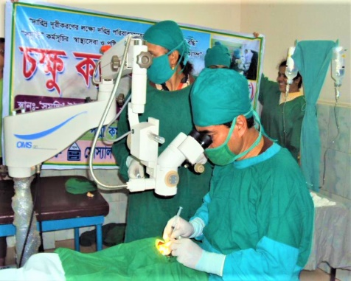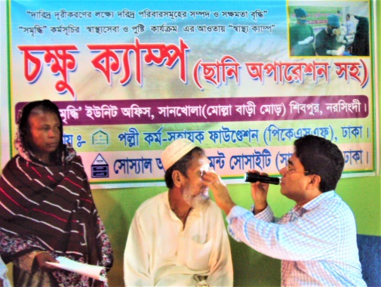Healthcare and Nutrition component: Health awareness meeting / Courtyard meeting; organizing static clinics; providing services at the static clinic; organizing satellite clinics; providing services at the satellite clinics; organizing general health campaign; providing services in the health campaign; organizing special eye camp; providing services in special eye camps; cataract surgery in special eye camp; distribution of worm medicine, nutrients, iron tablets, calcium tablets; providing services to pregnant mothers, maternity services, services to children under five; health care for the elderly people; distribution of health cards etc. The following table shows the progress against plan.

*Cataract Surgery in special eye camp under the ENRICH Program*

| **SL** | **Health Service Category** | **Plan** | **Actual** | |
| --- | --- | --- | --- | --- |
| **#** | **#** | **%** |
| 01 | Health awareness Courtyard meeting | 693 | 537 | 77 |
| 02 | Organizing static clinics | 384 | 342 | 89 |
| 03 | Organizing satellite clinics | 96 | 60 | 63 |
| 04 | Organizing general health campaign | 4 | 2 | 50 |
| 05 | Organizing special eye camp | 1 | 1 | 100 |
| 06 | Health card distribution | 4328 | 1886 | 44 |
| **SL** | **Health Service Recipients** | **Plan** | **Actual** | |
| **#** | **#** | **%** |
| 01 | Service Recipients at the static clinic | 3840 | 3460 | 90 |
| 02 | Service Recipient at the satellite clinics | 2400 | 1877 | 78 |
| 03 | Recipient of services in the health campaign | 600 | 381 | 64 |
| 04 | Services Recipients in special eye camps | 150 | 327 | 218 |
| 05 | Cataract surgery in special eye camp | 15 | 15 | 100 |

Graphical Presentation of Achievement

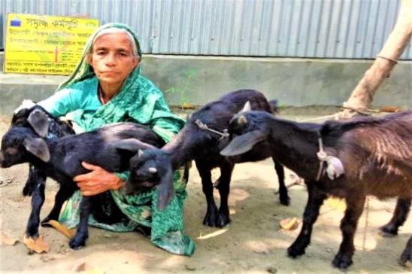Rehabilitation of Beggar: The identified and targeted beggars have been rehabilitated in the ENRICH Unions through providing financial assistance in the form of grants. During this financial year a total of 08 (Eight) Nos. of beggars were rehabilitated under this program. Earlier, the beggars were neglected in the society and after joining this program, they have transformed them into entrepreneurial members (“Uddami Sodasso” in Bengali term), become involved with different economic activities, have started earning income, meet their basic needs with their earnings and upgrade their living standard.

*Distribution of Goats as a part of rehabilitation of beggars under the “ENRICH” Program*

Education: Under this project, education assistance centers (Boikalik Sikhkha Kendra) are formed to prepare daily lessons of the students given by their schools. Students of class one and two are also given moral and co-curricular lessons. In this project, there are 30 on-going learning center where Boys-338 and Girls-430 are studying. During this financial year 473 No. of parents meeting were organized.

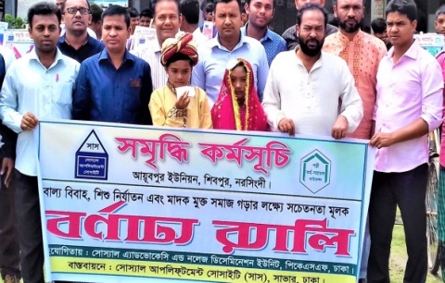Youth in Development: Under the ‘Youth in Development’ component, youths have already received training on ‘Self-realization and Leadership Development’. They are motivated to undertake various social activities such as the construction of roads, social awareness against child marriage, campaigns against drugs, tying pots on trees as accommodation for birds nest etc. During this year 36 No. of Youth Coordination Meeting was organized.

*Youths are participating in the campaign against child marriage and drugs under the ENRICH Program*

ENRICH center: Under this project, ENRICH centers were formed in the ENRICH Unions. During this financial year 45 coordination meeting was organized at ward level.

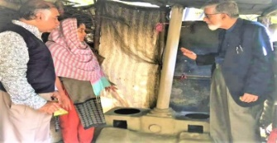Special Savings: The hardcore poor households (women headed household and disables) with a monthly income of less than taka 3,000 are in this component. They have their own personal savings bank account and deposit at least taka 100 per month for two years.

Loan Disbursement: There are three types of loans provided under ENRICH Program. These loans are for starting income generating activities, building assets and improving the quality of life.

Other activities are: Providing 02 ‘Bandhu Chula’ (environment-friendly cooking stoves) and 01 solar home system; Bashok Plantation by Bashok cultivators for earning handsome revenue by selling dry leaves of Bashok plants to pharmaceutical companies; providing training on IGAs to the targeted beneficiaries etc.

*Bandhu Chula (environment-friendly cooking stoves) distributed under the ENRICH Program*

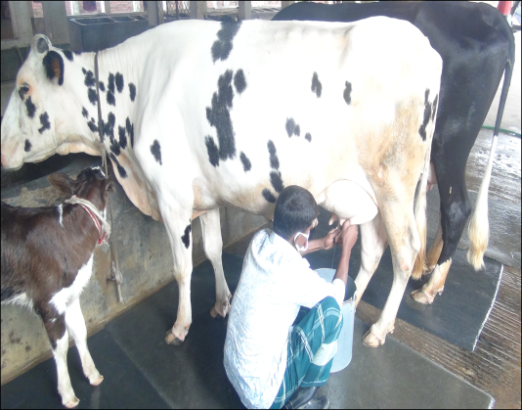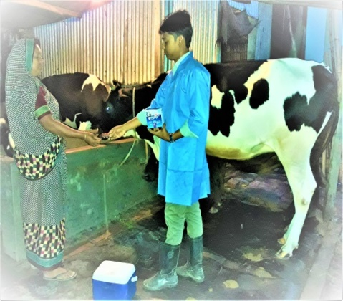03. Promoting Agricultural Commercialization and Enterprises (PACE) Project: SUS has implemented the project titled as “Promoting Agricultural Commercialization and Enterprises (PACE)” Project in Savar Upazila under Dhaka district, Singair Upazila under Manikganj district and Dhamrai Upazila under Dhaka district. The target beneficiaries under this project are: Micro entrepreneurs who are borrowers of ME loan program, moderately poor and extremely poor persons. The project targets the marginal and small farmers involved in livestock production and non-farm micro entrepreneurs. This project is implemented with financial assistance of International Fund for Agricultural Development (IFAD) through PKSF. The goal of this PACE project is to increase income and create employment opportunities among the dairy entrepreneurs through more milk production and marketing. Some specific objectives of this project are to: 🞄increase the number of cows in the project area and establish the area as a cluster of improved breeds of cows; 🞄enhance the skills of entrepreneurs in raising cows under improved management; 🞄develop deep breeds of improved breeds through expansion of artificial insemination services; 🞄commercialize medical services to maintain the sustainability and continuity of the project; 🞄raise the mortality rate of cattle; 🞄increase the average income of entrepreneurs; 🞄create employment opportunity. The key outputs are: 🞄Entrepreneurs will increase their skills in raising cows with improved management; 🞄the lactation period/milking period of cows will be increased; 🞄the propagation period / Calving interval will be decreased; 🞄the number of cross cows will be increased. Under this project some results indicators are: 🞄the family wealth of the project members will increase; 🞄the average income of entrepreneurs will increase; 🞄the number of cows will increase; 🞄very poor farmers will get worm medicine free of cost; 🞄cow mortality will be below 2% and calf mortality will be below 5%; 🞄the potential milk production will be 4500-6000 metric tons; 🞄60-70% of the members will have full-time employment opportunities and 🞄after three years, 30-40% wage based employment opportunities will be created. Some major activities are: formation of Land less, marginal farmers & small farmers groups, imparting training to all group members etc. The following table shows the comparative progress during the project period.

*Providing medicines to a dairy farm owner under the PACE Program*

*Milking cows by a dairy farmer under the PACE Program*

|  |  |  |  |  |  |
| --- | --- | --- | --- | --- | --- |
| **SL** | **Particulars** | **Base Line** | **End Line** | **Change during 4 Yrs. Of the Project Period** | |
| 01 | Average income of the Entrepreneurs per cow per annum (BDT.) | 28,530 | 50,439 | 21,909 | Increase |
| 02 | The number of cows (#) | 407 | 692 | 285 | Increase |
| 03 | Cow mortality rates (%) | 10.43 | 2.17 | 8.26 | Decrease |
| 04 | Calf mortality rates (%) | 10.19 | 5.02 | 5.17 | Decrease |
| 05 | Full-time employment opportunities (#) | 139 | 229 | 90 | Increase |
| 06 | Wage based employment opportunities (#) | 350 | 464 | 114 | Increase |
| 07 | Daily Milk Production (in Metric Ton) | 2,700 | 5,100 | 2,400 | Increase |

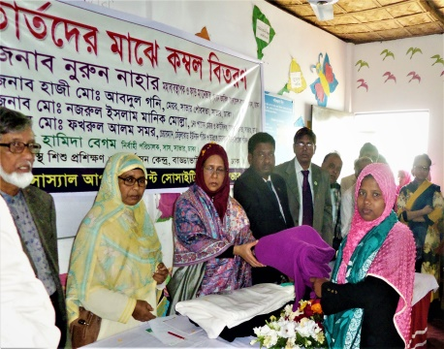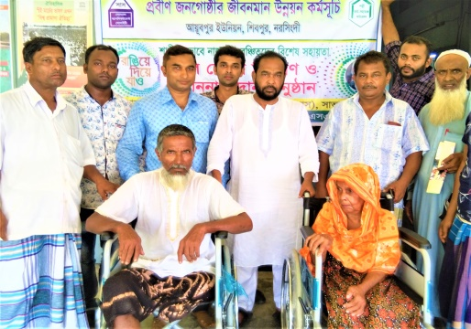04. Uplifting the Quality of the Lives of the Elderly People Program: Since 2018, with the financial assistance of Palli Karma-Sahayak Foundation (PKSF), SUS has been implementing the project titled as “Uplifting the Quality of the Lives of the Elderly People Program” among the elderly people in the Shibpur Upazila under Narsingdi District. The main objective of this project is to minimize miseries of the elderly people through providing them with social safety net services, financial benefits and primary health care services. Under this project, a number of activities are being implemented in the said working areas. These are: forming multi-tier committees at villages, ward and Union levels for operating the program; providing the elderly people with leadership and communication skill development training to increase their negotiation skills; providing old age allowance; providing health care services; providing assistive materials i.e. walking sticks, wheel chairs and blankets to the elderly people; bestowing awards to the best children for serving their parents; providing financial assistance to cover the funeral expenditure to the deceased; respecting and recognizing the contribution of the elderly people to the society; Celebrating Veterans Day etc.

*Distribution of Wheel Chairs and blankets among the elderly people under**the “Uplifting the Quality of the Lives of the Elderly People” Program*

|  |  |  |  |
| --- | --- | --- | --- |
| **SL** | **Distribution of assistive materials to Elderly people** | **Plan** | **Actual** |
| 01 | Walking sticks | 30 | 30 |
| 02 | Wheel chairs | 02 | 02 |
| 03 | Blankets | 80 | 100 |
| 04 | Old age Allowance (F-64; M-36) | 100 | 100 |

05. Social Development Program under “Social Advocacy and Knowledge Dissemination Unit” of PKSF: With the financial assistance from PKSF SUS is implementing a Social Development Program for making people aware on different issues of social development, awareness and social justice. Different activities under this program are: Workshop on “Social Development and Accountability” among the UP Members, Workshop on “Prevention of Child Marriage and Child Abuse”, Awareness Session on “Demerits of Child Marriage”, Advocacy Meeting i.e. day observance, meeting, Operation of Adolescent Girls Club etc. The table shows the plan and progress during this financial year: 2019-2020.

| **SL** | **Particulars** | **Target** | **Actual** |
| --- | --- | --- | --- |
| 1 | No. of Workshop on “Social Development and Accountability” among the UP Members (35 individuals participated) | 1 | 1 |
| 2 | No. of Workshop on “Prevention of Child Marriage and Child Abuse” (40 individuals participated) | 1 | 1 |
| 3 | No. of Awareness Session on “Demerits of Child Marriage” (1000 individuals participated) | 20 | 20 |
| 4 | No. of Advocacy Meeting i.e. day observance, meeting etc. | 5 | 5 |
| 5 | No. of Operation of Adolescent Girls Club | 9 | 9 |

06. SUS Health Care Program: Since 2004, SUS has been providing primary health care services under the banner “SUS Health Care Program” to the poor and disadvantaged people in its working areas with its own fund. The goal of this program is to provide sustainable health services by raising health awareness among the poor and disadvantaged people in the SUS working areas. On the other hand, the objectives of the SUS Health Care program are to: 🞄provide health care services at the lowest possible cost; 🞄improve and expand the quality of health care services; 🞄increase the use of essential health care services among the poor; 🞄strengthen the roles of the organization over the National Health Service delivery system through maintaining effective communication and coordination with the concerned public health service providers. The major activities of this SUS Health Care Program are: Distribution of health cards among the poor and disadvantaged people, providing reproductive health care, maternal health care, child health care, limited curative care, training on Behavioral Change Communication (BCC) and other reproductive health care services to the adolescent and women, counseling, encouraging the postnatal mothers to take vitamin A capsules; encouraging mothers to get all the vaccines within a year after the baby is born; participating in EPI campaigns, providing training on health awareness, Observance of National Immunization Day etc. The following table shows some achievement against plan.

*Vaccination for the under 5 child under the SUS Health Care Program*

|  |  |  |  |  |
| --- | --- | --- | --- | --- |
| **SL** | **Particulars** | Plan | Actual | |
| # | # | % |
| 01 | Female receiving general health care services | 4,500 | 3,460 | 77 |
| 02 | Male receiving general health care services | 700 | 577 | 82 |
| 03 | Child and Adolescents receiving health care services | 1,000 | 722 | 72 |
| 04 | Recipients of Pre-Natal Health Care Services | 200 | 148 | 74 |
| 05 | Recipients of Post-Natal Health Care Services | 100 | 73 | 73 |

07. Primary Health Care Support Project: SUS is implementing the Primary Health Care Support Project with the financial assistance of Anukul Foundation among the poor families in Mymensingh Sadar Upazila under Mymensingh district. The goal of this project is to ensure provision for primary health care services to the poor families at free of cost. The major activities of this project are to: provide maternal and child health services; prenatal and antenatal health services; childbirth related health services; distribute free iron tablets and calcium tablets to pregnant women; advise adolescent boy and girls about adolescence; organize courtyard meeting on community health awareness; test diabetes, urine and pregnancy etc. The progress against the plan during this financial year is shown in the table below.

| **SL** | **Particulars** | **Plan** | | | **Actual** | | |
| --- | --- | --- | --- | --- | --- | --- | --- |
| **Project beneficiary** | **Non beneficiary** | **Total** | **Project beneficiary** | **Non beneficiary** | **Total** |
| **a** | **b** | **c=(a+b)** | **d** | **e** | **f=(d+e)** |
| 01 | Recipients of Pre-Natal Health Care Services | 300 | 250 | 550 | 211 | 178 | 389 |
| 02 | Recipients of Post-Natal Health Care Services | 100 | 75 | 175 | 67 | 54 | 121 |
| 03 | Female receiving general health care services | 1500 | 1000 | 2500 | 1233 | 721 | 1954 |
| 04 | Male receiving general health care services | 500 | 300 | 800 | 330 | 173 | 503 |
| 05 | Child and Adolescents receiving health care services | 500 | 300 | 800 | 419 | 215 | 634 |
| 06 | Distribution of iron tablets | 300 | 250 | 550 | 211 | 178 | 389 |
| 07 | Distribution of calcium tablets | 300 | 250 | 550 | 211 | 178 | 389 |

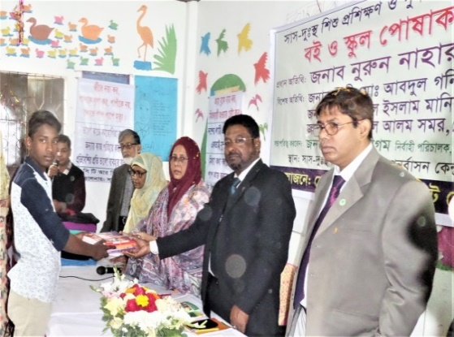08. Distressed Children Training and Rehabilitation Center (DCTRC): Since 2004, SUS is operating a DCTRC for rehabilitation of the distressed children with its own fund. The goal of establishing this DCTRC is to build children into good citizens providing them with education and training so that they can stand against any social injustice. On the other hand, the objectives are: 🞄Raising awareness about the hazards of child labor and the importance of education for all children; 🞄Moving of distressed children from DCTRC to another higher & next appropriate educational program; 🞄providing soft credit to the parents of these children. This DCTRC is standing on the SUS owned land at Badda, Vatpara, Savar, Dhaka. In this DCTRC, the disadvantaged, poor, helpless, orphans and street children are provided with formal education from the pre-primary to class five. The DCTRC is also providing pre-primary education for the enrolled infants. All of the students of this center are given free learning materials, school dress, winter clothes, free medical first aid and also breakfast. These children are provided with moral, cultural and environmental education. However, some key activities under this DCTRC are: enrollment of distressed floating children for education; participation in the day observance, social activities, sports and other cultural functions; participation in debating, recitation, storytelling, collecting different educational materials etc. under co-curriculum activities; exchanging views among teachers and guardians, where available; arrangement of higher education (secondary level) for them after completion of primary education etc. The following table shows some basic information regarding admission and passing of Class - V.

*Distribution of school books among the distressed children under the Distressed Children Training and Rehabilitation Center (DCTRC)*

| **Year** | **No. of students admitted into DCTRC** | | | **No. of students passed Class-V** | | |
| --- | --- | --- | --- | --- | --- | --- |
| **Boys** | **Girls** | **Total** | **Boys** | **Girls** | **Total** |
| 2019 | 21 | 46 | 67 | 0 | 4 | 4 |
| 2018 | 34 | 52 | 86 | 4 | 5 | 9 |
| 2017 | 50 | 48 | 98 | 9 | 4 | 13 |

09. Save Urban Children from Hazardous Jobs and Links with Academy (SUCHALA) project: With the financial assistance of Anukul Foundation, SUS is implementing the SUCHALA Project in Savar Upazila under Dhaka district and Mymensingh Sadar Upazila under Mymensingh district among the children in the categories as mentioned here. 🞄Children engaged in hazardous work; 🞄street children; 🞄orphan; 🞄children from families who are unable to earn money; 🞄Disabled child; 🞄Children of helpless families. The goal and objectives of this project are to: develop children as the role models and good citizens of the future; not to be deprived of primary education and prevent children from risky activities. The major activities of this SUCHALA project are: 🞄providing (a) one time yearly allowance for school dress and education materials of Taka 800/- for each student; 🞄providing monthly allowance once a month Taka 500/- for each Student.

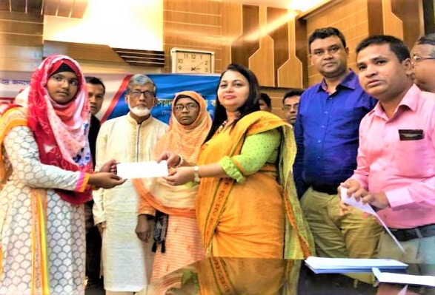10. Scholarship Program:As a part of development program, PKSF and also SUS provide financial supports in the form of scholarship to the students of some specific categories. During this financial year, 48 students were provided with scholarship of an amount of BDT. 5,65,000/- (Five lac and sixty five thousands only). The detailed particulars are as below:

A. Donor: PKSF

A.1. No. of students received scholarship: 44 (Forty Four)

*UNO distributing the amount of scholarship to the students of poor families & families of special profession under the SUS Scholarship Program*

A.2. Category of students receiving scholarship: 🞄Students who passed SSC for the 1st time; 🞄Students who passed XI for the 2nd time; 🞄These students are from the families of special profession and class in the society; 🞄These students are also from the core poor families.

A.3. Amount of scholarship (BDT.): 5,28,000/-

B. Donor: SUS own fund

B.1. No. of students received scholarship: 04 (Four)

B.2. Category of students receiving scholarship: 🞄These students are from the very poor families of the SUS MFP members; 🞄Disable students

B.3. Amount of scholarship (BDT.): 37,000/-

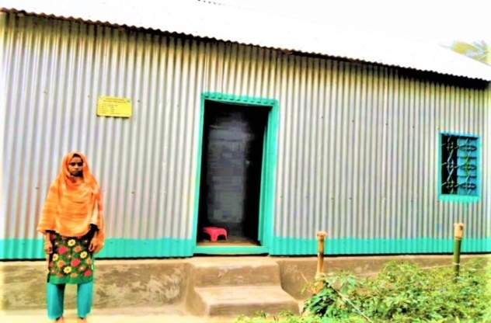11. Housing Loan Project: Since 2010, SUS has been implementing the housing project with the financial assistance of the Grihayan Tahobil – (Fund Management Unit) of Bangladesh Bank. Under this project SUS provides credit to its beneficiaries for making house and also loan to the beneficiaries which is repaid in 138 installments with the interest rate of 5.5%. The rural, low income and landless people are the beneficiaries of this project. The goal and objectives of the project are to: 🞄provide housing loan in easy terms among the poor community of rural area; 🞄create an opportunity for repayment installment within a maximum timeframe in order to easier the repayment schedule; 🞄provide credit support in various IGA / Productive activities for self-reliance and able the beneficiaries for refund housing loan installment. During the Financial Year 2019-20, SUS disbursed an amount of Tk 33,60,000 among 48 Nos. of Beneficiary for building houses as per standard specification of the Grihayon Tahobil - (Fund Management Unit) of Bangladesh Bank under this project.

*Building Houses Housing Loan Project under the Grihayqn Tahabil (Fund Management Unit) of Bangladesh Bank*

12. Vulnerable Group Development (VGD): Under the Govt. Social Safety Net Program (SSNP) of the Government of Bangladesh (GoB), SUS has implemented the Vulnerable Group Development Project, a largest social safety net program of GoB that includes the ultra-poor households. SUS has implemented this VGD project in in two Upazilas (Sub-District) - 09 Unions of Sarail and 03 Unions of Akhaura of Brahmanbaria District. The ultimate goal of the VGD program is to bring sustainable improvement to the lives of ultra-poor households. Further, the objective of the VGD program is to improve the nutritional status of women, children and adolescents through improved food consumption, education, skills development, livelihood diversification and risk mitigation. This VGD project was implemented among 2,327 VGD beneficiaries (Sarail-1659; Akhaura-668). To be eligible for the VGD project, all the beneficiaries had to fulfill the four basic selection criteria such as, 🞄widowed, separated/deserted/divorced or has a husband who is unable to work; 🞄has severe food insecurity; 🞄landless; 🞄has very low and irregular family income or works as casual labor; 🞄from a household headed by a woman. However, the development package includes life skill and income generating skill training as well as a personal savings program and access to the NGO operated micro-credit program that ultimately contribute to their social and economic empowerment in the society.

13. Central Nursery Development Project: With the financial support of the SUS own fund, SUS has developed a nursery at Savar Upazila of Dhaka district. The ultimate beneficiaries of this project are the rural farmers including the beneficiaries of the SUS credit program. The goal of this project is to encourage rural farm families to grow vegetables, fruits and timber trees and to make available vegetable seedlings, fruit and timber tree saplings at the doorstep of rural farm families. The objectives of this project are to: 🞄assist in balancing the ecological effect; 🞄improve the environment of the project area; 🞄supplement the nutritional food to the beneficiaries; 🞄help decrease diseases among the beneficiaries. The major activities of this nursery project are:🞄Growing seasonal vegetable seedlings and selling at low price; 🞄Growing improved saplings of various fruit trees and selling at low price;🞄Growing saplings of various timber trees and selling at low price; 🞄Organizing training on vegetable growing, tree plantation and environment protection.

14. Solid Paper Board Packaging Project: The Solid Paper Board Packaging is a project implemented by SUS own fund. Earlier it was funded by the Australian Agency for International Development (AUS/AID). This project is being implemented in Savar Upazila of Dhaka district with the profit earned through sale proceeds. The main objective of this project is to create a resource base of the organization for its sustainability and also create job opportunity for the poor and distressed women group members. The activities of this project are: making sweetmeat, sharees (women wear) and foot wear boxes by solid paperboard and selling these boxes to different shops at and around Savar and Dhaka City.