How in LinkedList data is stored:+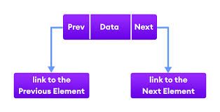

Linkedlist vs ArrayList data stores

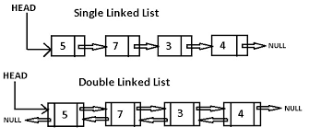

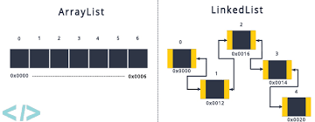

**Addition and Deletion in LinkedList**

