Using Data ICE

Accessing Data Within R (5 pts.)

Using the dataset car.test.frame.txt, please perform the following operations in order:

Open the file within R

Find out what the column header names are

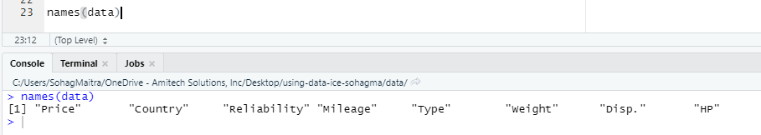

Determine the number of columns

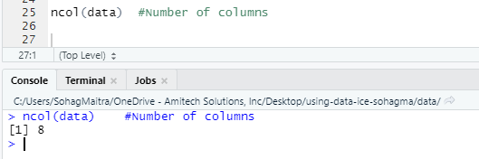

Determine the number of rows

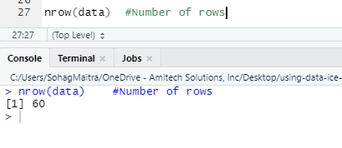

Test your dataframe to determine which columns are categorical

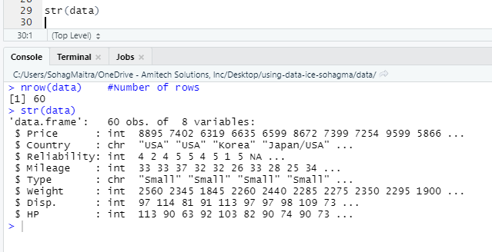

How many unique values does Type have?

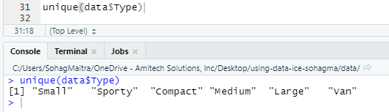

How many unique values does Country have?

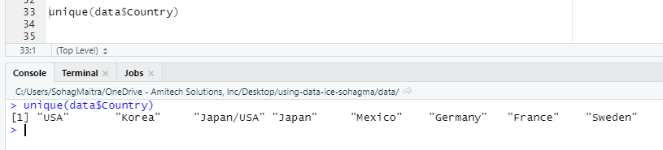

What is the value of row 57, column 3?

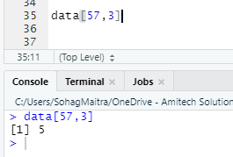

What are the values for row 24?

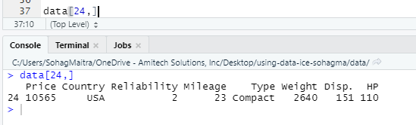

Using three different methods, select row 29 with columns 1, 2, 3

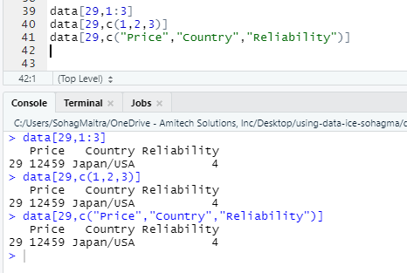

Using two different ways, select row 45 with columns 3 and 7

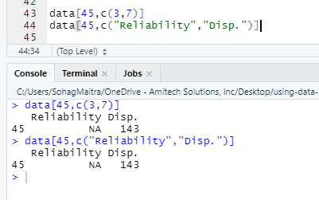

Create a new dataframe for the column HP using two different methods

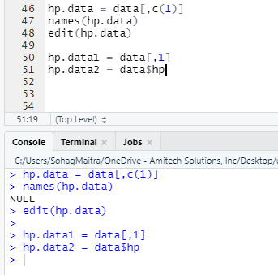

Sorting and Ordering Data (5 pts.)

Now that you have learned to subsample your data, it is your turn to try your new knowledge. Using the car.test.frame dataset, please perform the following operations in order:

Select compact cars that have a reliability greater than and equal to 4.

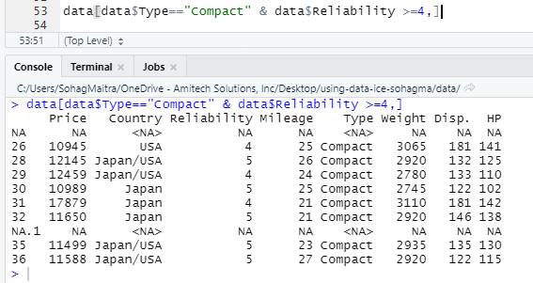

Find compact cars that have a reliability greater than and equal to 3 from Japan, but not from the US

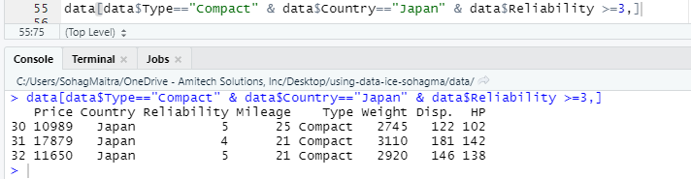

How many cars are manufactured in Japan/USA?

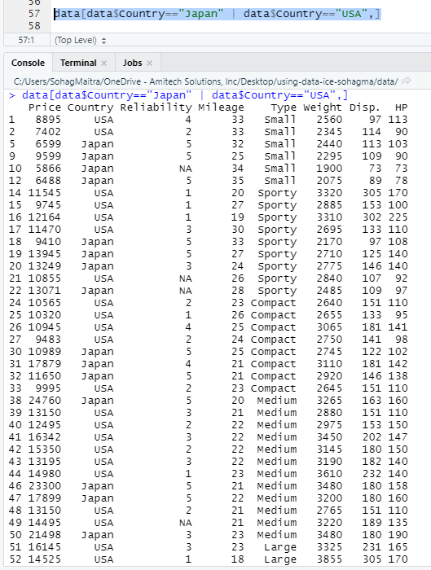

How many cars are manufactured in the US or Japan?

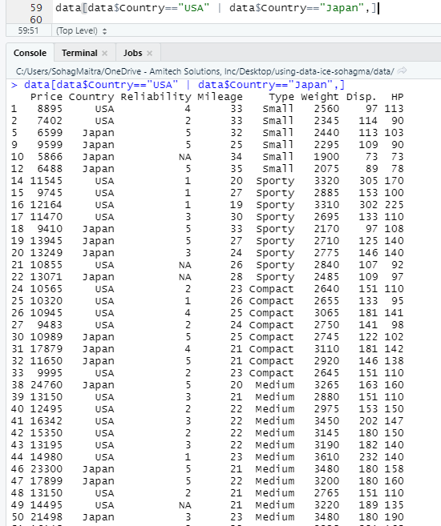

How many cars are manufactured in the US or Japan with a reliability greater than and equal to 4?

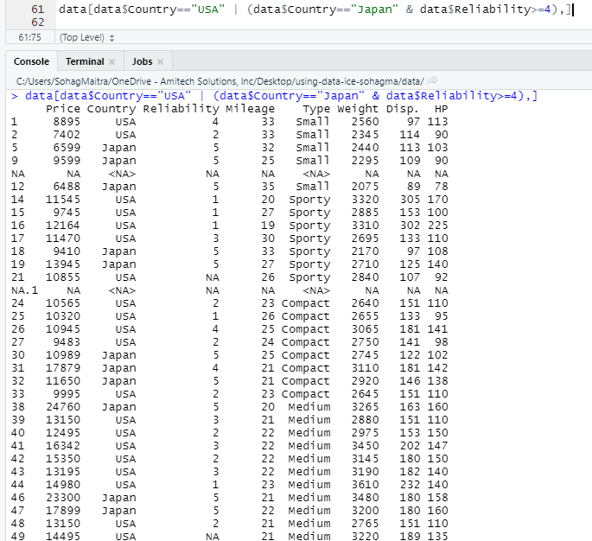

Create a subsample of 70% of your data

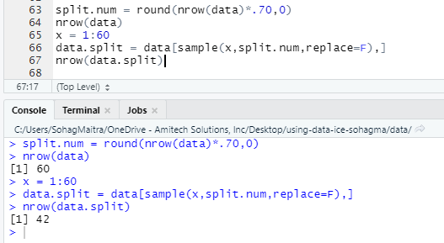

Create samples for a 8-fold cross validation test; save each subsample as a new dataframe

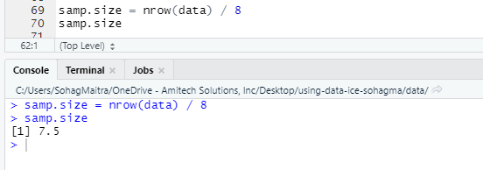

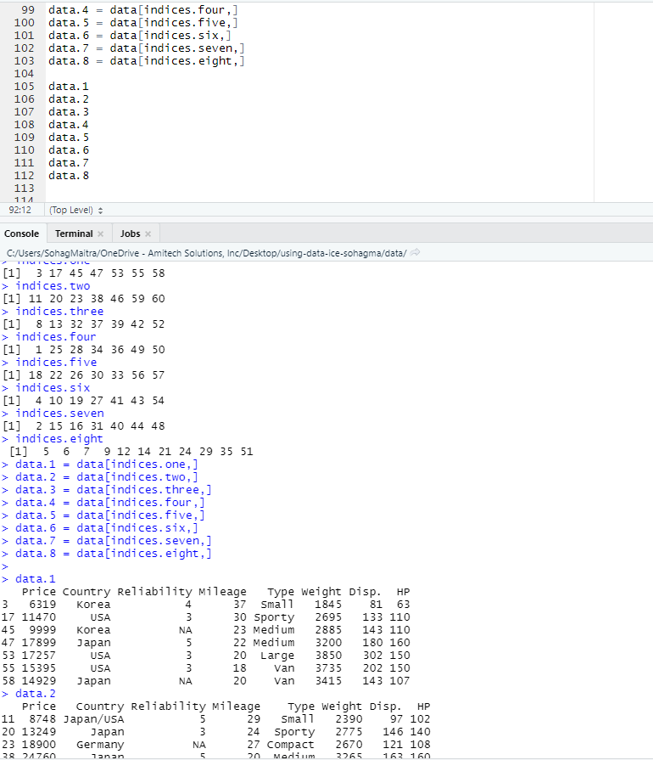

Select columns that are numeric and save it as a new dataframe

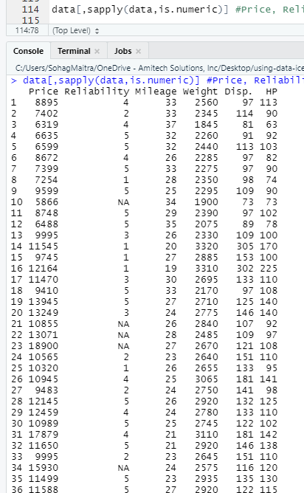

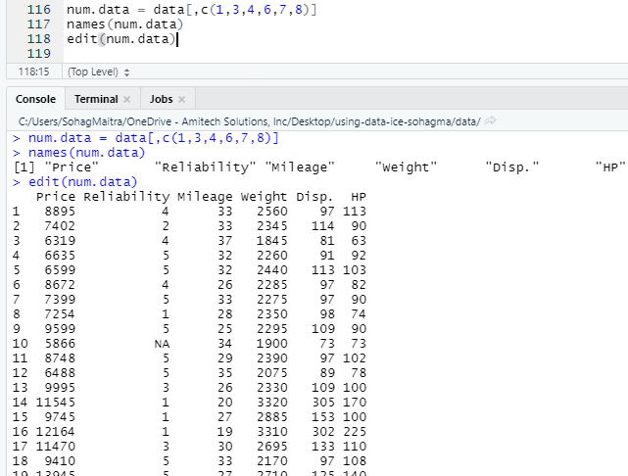

Remove the columns HP and Price from the dataframe

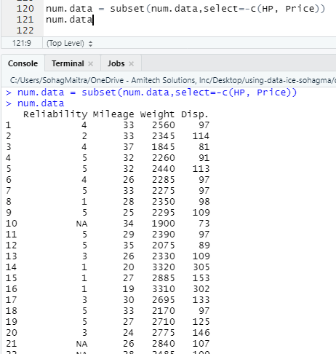

Save the columns Country and Weight as a new datafame

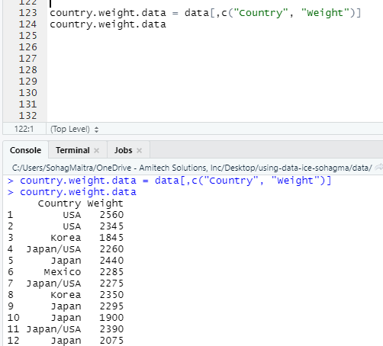

Rename these two columns in the new dataframe

