INSTRUCTION MANUAL FOR LABELING OF ROW-COLUMN DATA

Installing dependencies for the T-Truth labeling tool:
The T-Truth tool requires OpenJDK 11 for running. (It has not been tested with Oracle JDK 11, but it should work with that as well).
Ubuntu:
- Run $ java -version in ubuntu terminal to check which version of java (if any) is installed. Sample output:
- If the version is older than 11.0.4 uninstall it.
- Install OpenJDK 11 using the following command:
$ sudo apt install openjdk-11-jdk
- Ensure correct installation of the JDK by running:
$ java -version
Windows:
- Open command prompt.
- Run $ java -version to check which version of java (if any) is installed. Sample output:
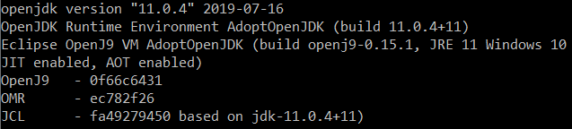
- If the version is older than 11.0.4 uninstall it.
- Download OpenJDK 11 installer from following link:
Download Link
- Run the downloaded file and follow onscreen instructions to install the JDK.
- Close command prompt and open it again. Run the following command to ensure correct installation:
$ java -version

Launching T-Truth labeling tool:
Ubuntu:
- Navigate to the directory containing the gtgui.jar and gtgui.sh files in terminal or command prompt for ubuntu and windows respectively. Afterwards run the following command:
Run in terminal - ./gtgui.sh

Windows:
Run the file gtgui.bat by double clicking it. It should launch the T-Truth software.

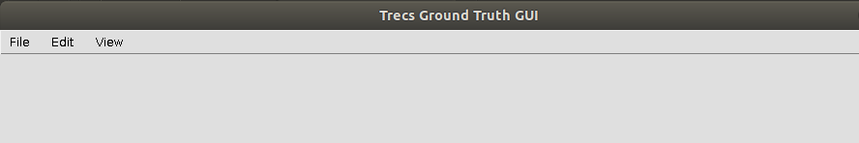

Conversion of original xml ground truth to T-Truth compatible xml files

usage: python xml_unlv_converter.py [-h] -i INPUT -o OUTPUT

optional arguments:
-h, --help show this help message and exit
-i INPUT, --input INPUT
path to containing input xml files.
-o OUTPUT, --output OUTPUT
path to store converted xml files.

Instructions for labelling images:
- Open the image directory:
  - File -> Open Image
or
  - Ctrl + O
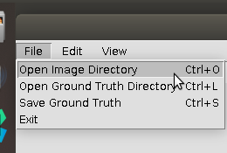
- Open the Ground Truth Directory:
  - File -> Open Ground Truth Directory
or
  - Ctrl + L
The selected directory must contain any pre-existing ground-truth XMLs to be loaded. The XML files edited using T-Truth will also be saved back to this directory and will overwrite the old XML files.

- Browsing the images:

  - RIGHT arrow key to Save & Move to next image.
  - LEFT arrow key to Save & Move to next image.
  - The XML file will be saved to the directory specified in Step 2.

- Using the labeling tools.

  - The tools can be selected either from the “Edit” menu as shown below or using the hotkeys shown in front of them.

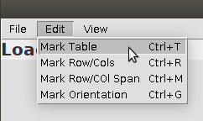
  - Further help will be shown on top of the window when the tool is selected, as shown below.
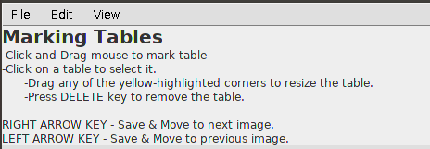
  - Note: A table can only be deleted while selecting the “Mark Table” tool.

