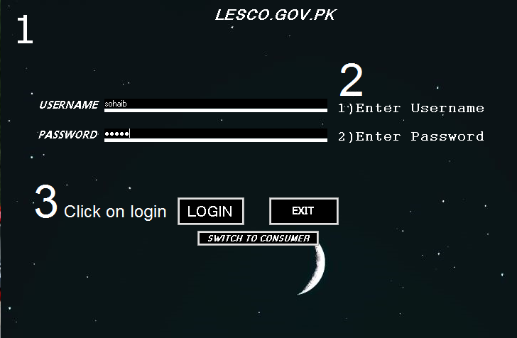

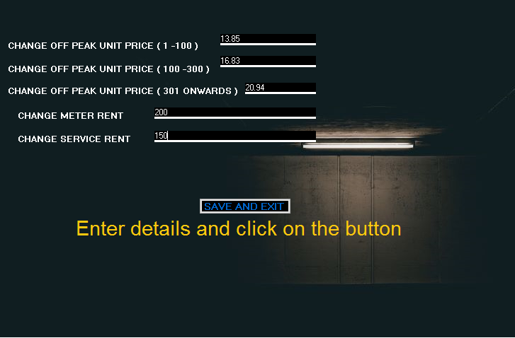

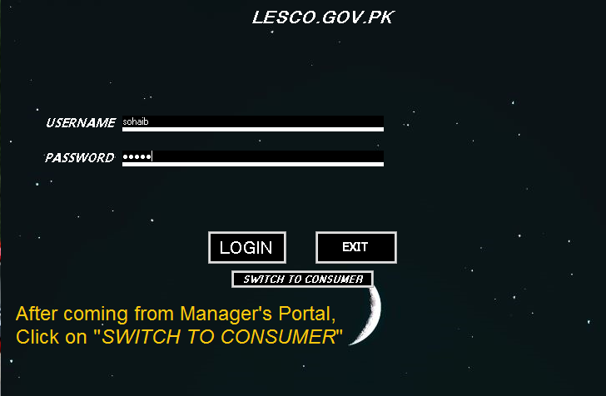

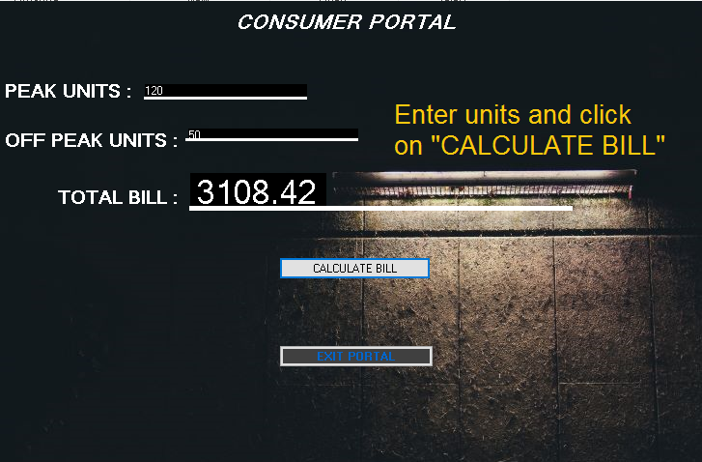

MADE BY:

--------------------FURRY & THE FURIOUS--------------------

1) MUHAMMAD SOHAIB ALI KHAN (20L-1268)

2) MUHAMMAD TAHIR (20L-1327)