Water Potability Prediction Using Machine Learning
Author: Sohaib Farooq
Email: sohaib.farooq@bigacademy.com
Date: January 2026

Abstract
This report presents a comprehensive machine learning approach to predict water potability based on physicochemical properties. We implement and compare four classification algorithms: Logistic Regression, Random Forest, XGBoost, and LightGBM. The study includes detailed exploratory data analysis, feature engineering, model training, evaluation, and deployment of a web application for real-time predictions.

Table of Contents
- Introduction
- Dataset Description
- Exploratory Data Analysis
- Data Preprocessing
- Machine Learning Algorithms
  - 5.1 Logistic Regression
  - 5.2 Random Forest
  - 5.3 XGBoost
  - 5.4 LightGBM
- Evaluation Metrics
- Results and Analysis
- Web Application Deployment
- Conclusions
- References

1. Introduction
Access to clean drinking water is essential for human health. The World Health Organization (WHO) estimates that contaminated water causes approximately 485,000 diarrheal deaths annually. This project aims to develop a machine learning model capable of predicting whether water is safe for human consumption based on measurable physicochemical parameters.
The objective is to build a classification system that can accurately determine water potability, enabling water quality monitoring systems to make rapid assessments without extensive laboratory testing.

2. Dataset Description
The dataset contains water quality metrics for 3,276 water samples with the following features:
Feature | Description | Unit
pH | Measure of acidity/alkalinity | 0-14 scale
Hardness | Capacity of water to precipitate soap | mg/L
Solids | Total dissolved solids (TDS) | ppm
Chloramines | Amount of chloramines | ppm
Sulfate | Amount of sulfate dissolved | mg/L
Conductivity | Electrical conductivity | μS/cm
Organic Carbon | Amount of organic carbon | ppm
Trihalomethanes | Amount of trihalomethanes | μg/L
Turbidity | Measure of light-emitting properties | NTU
Potability | Target variable (0: Not Potable, 1: Potable) | Binary

Missing Values Analysis
The dataset contains missing values that require handling before model training:
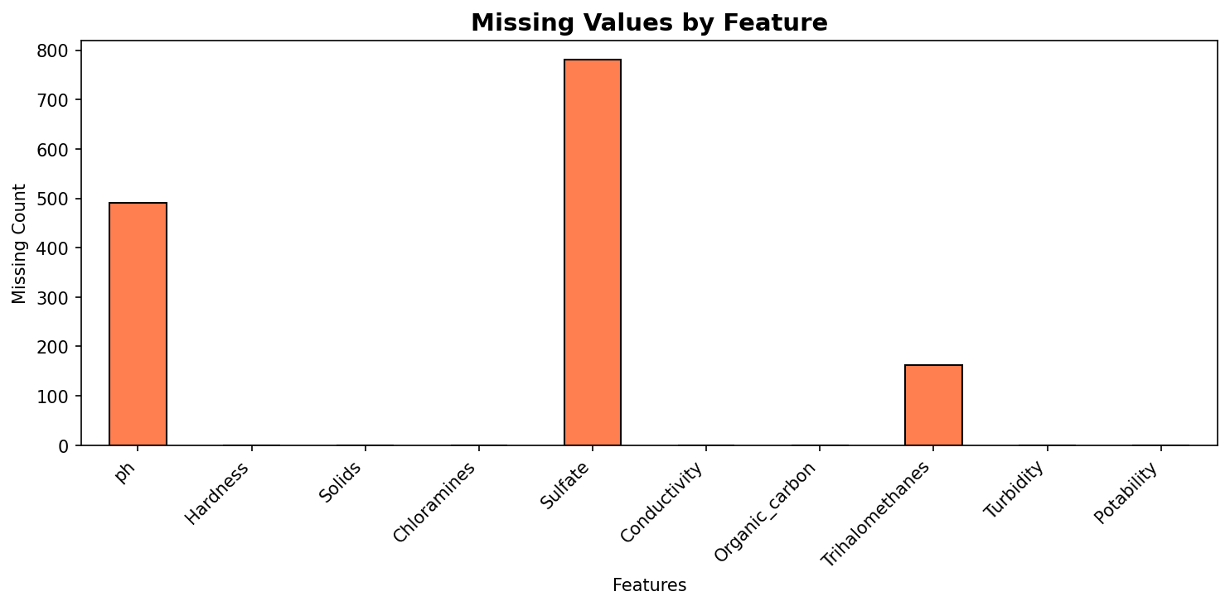
Missing Values by Feature
Figure 1: Distribution of missing values across features

3. Exploratory Data Analysis

3.1 Target Variable Distribution
The dataset exhibits class imbalance, with approximately 61% non-potable samples and 39% potable samples:
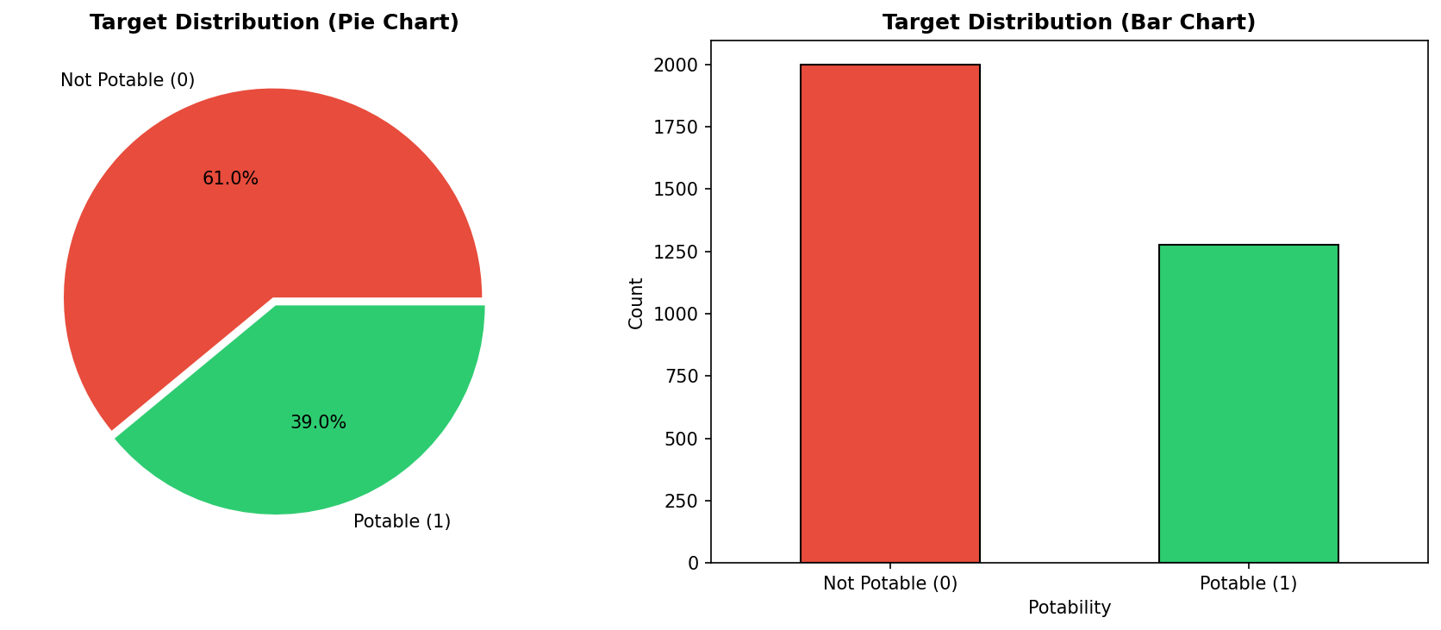
Target Distribution
Figure 2: Distribution of water potability classes

3.2 Feature Correlation Analysis
Understanding feature relationships is crucial for feature engineering and model interpretation:
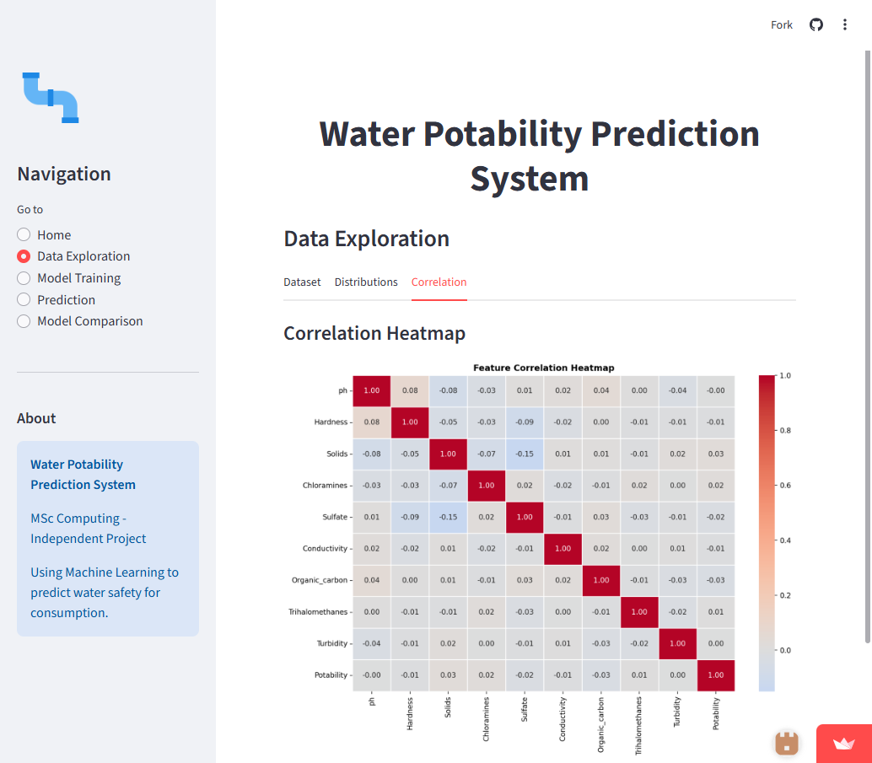
Correlation Heatmap
Figure 3: Correlation matrix heatmap showing relationships between features
Key observations: - Most features show weak correlation with each other - No strong multicollinearity issues detected - The target variable has weak correlations with all features, indicating classification complexity

3.3 Feature Distributions
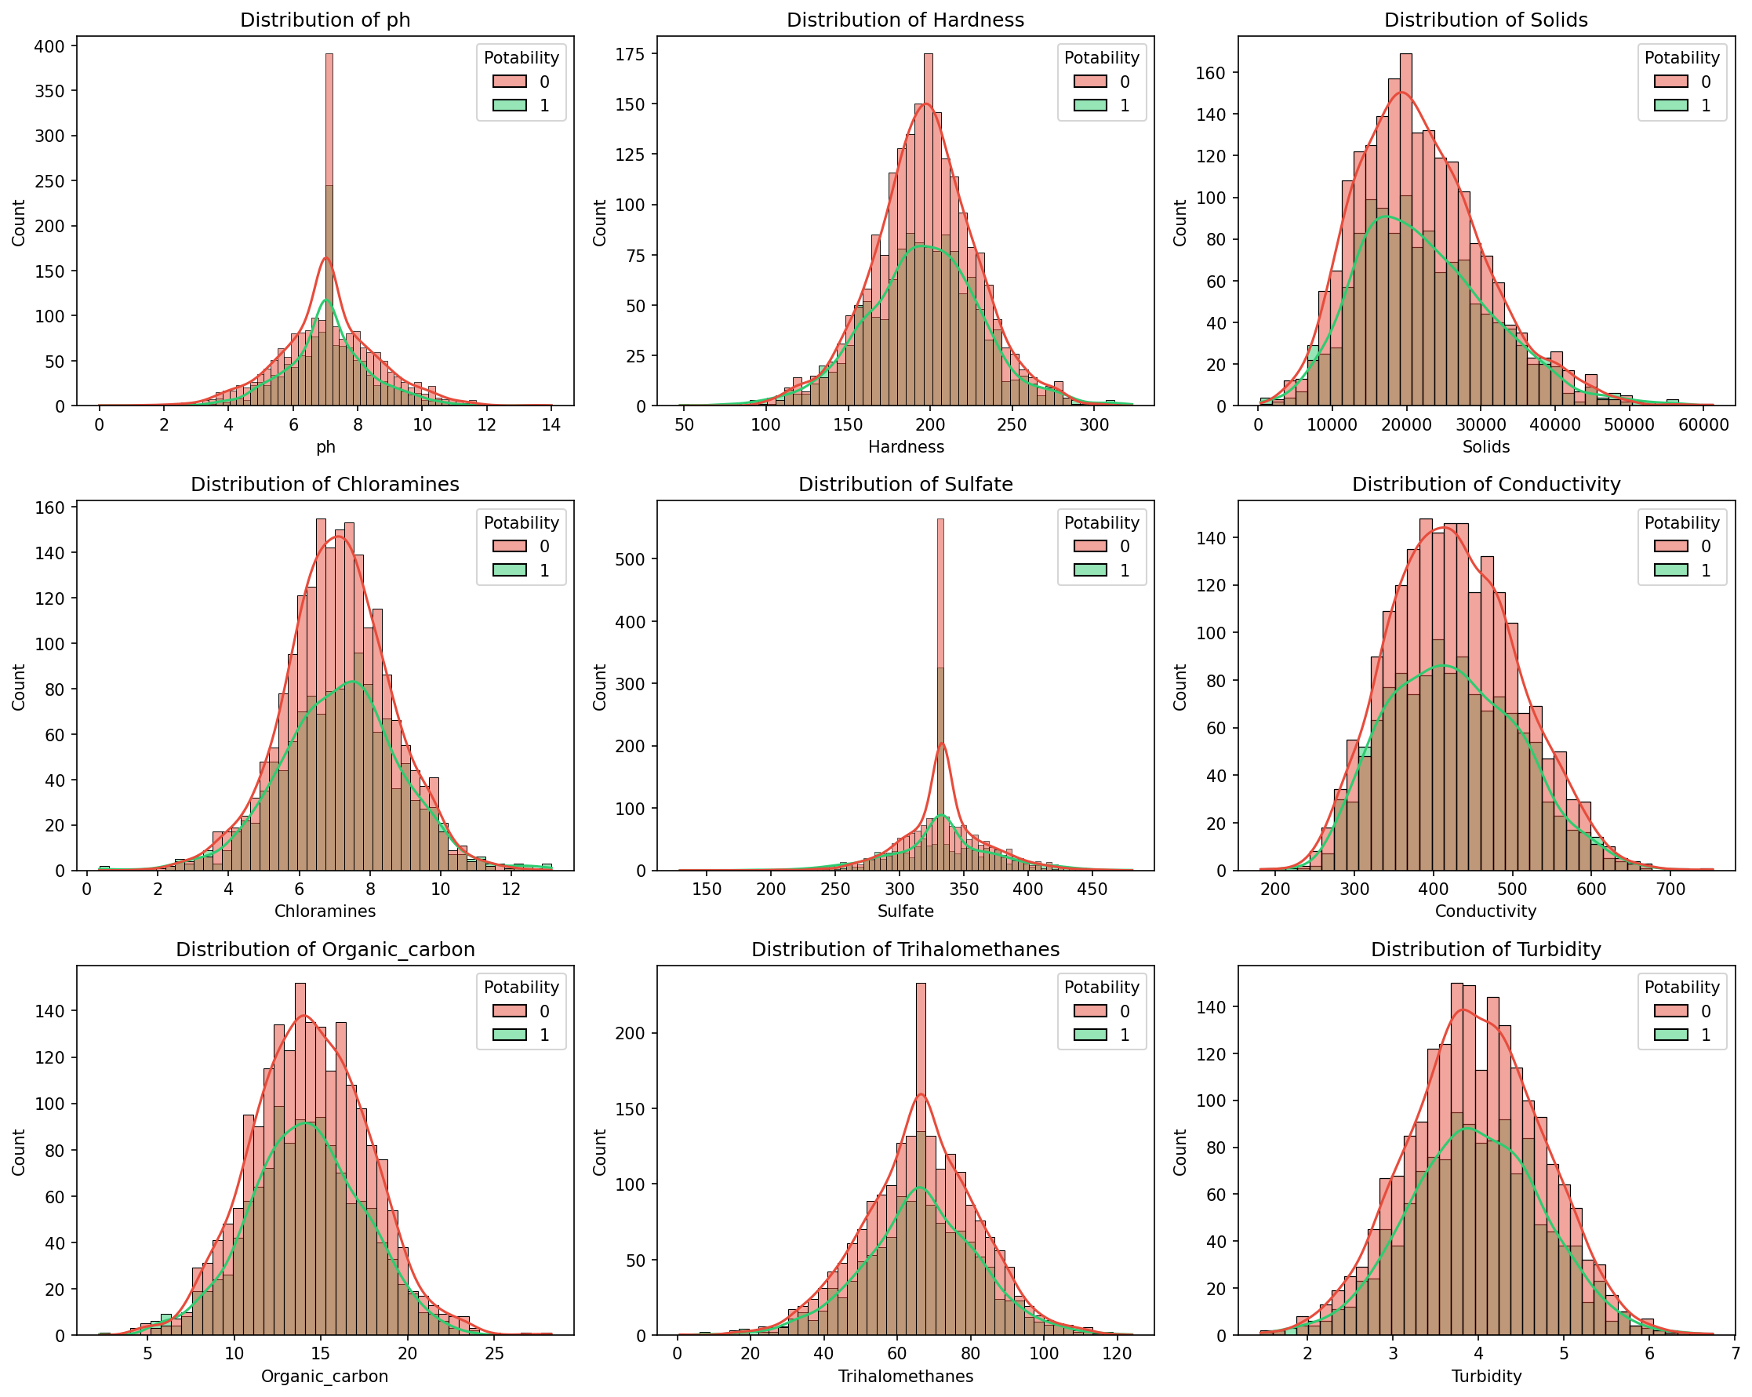
Feature Distributions
Figure 4: Histograms showing feature distributions by potability class

3.4 Box Plot Analysis
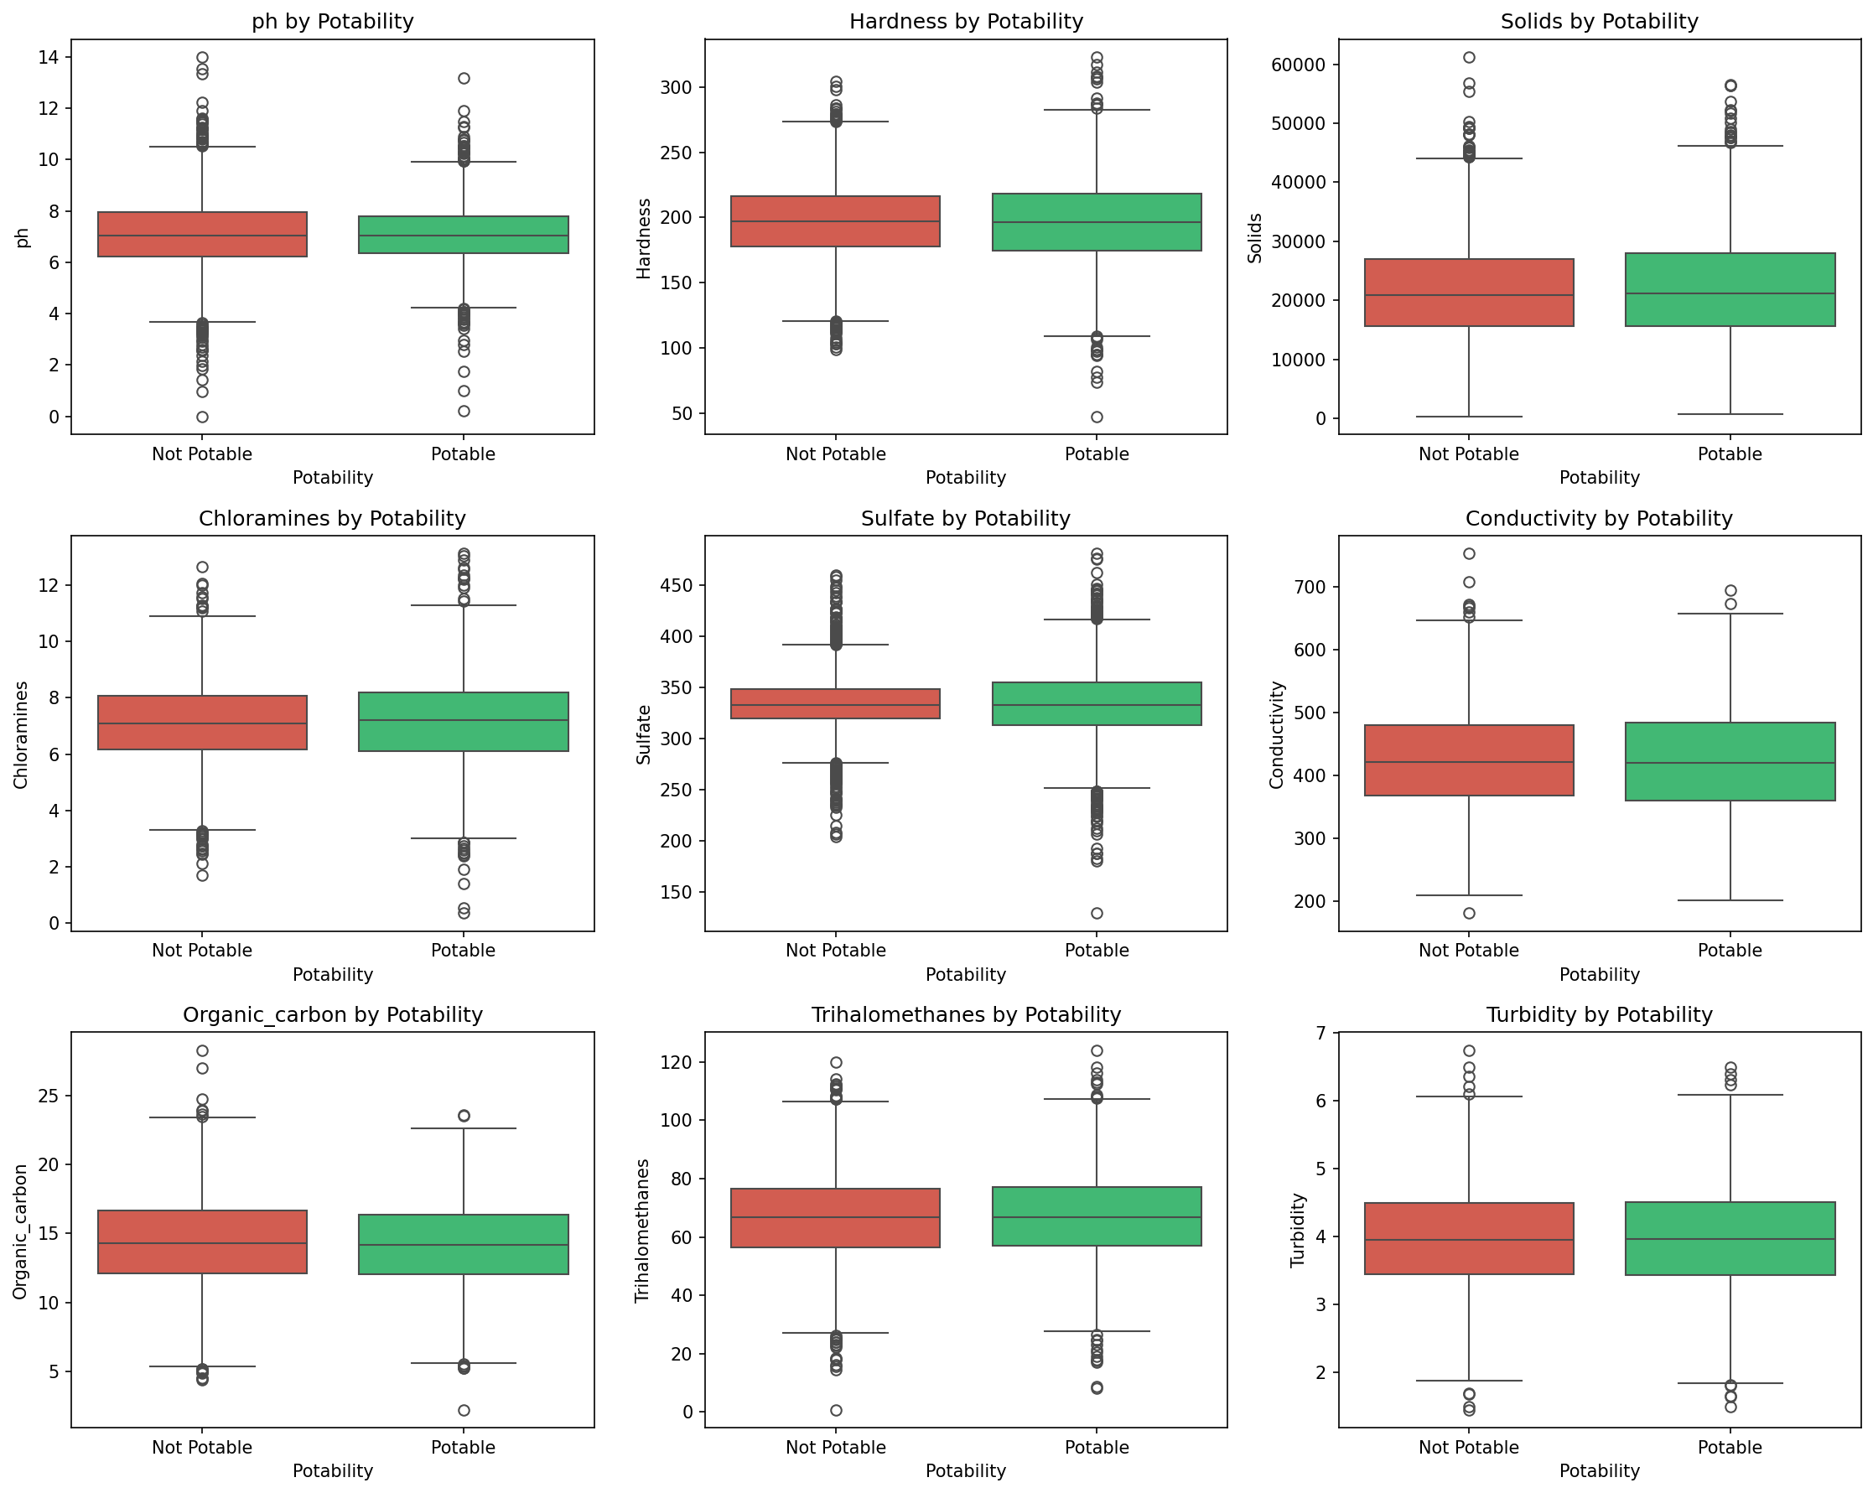
Box Plots
Figure 5: Box plots comparing feature distributions between potable and non-potable water

4. Data Preprocessing

4.1 Missing Value Imputation
Missing values were imputed using the median strategy, which is robust to outliers:
$${\tilde{x}}_{j}=\text{median}(x_{1j},x_{2j},…,x_{nj})$$
where ${\tilde{x}}_{j}$ is the median value for feature $j$.

4.2 Feature Scaling
Standard scaling was applied to normalize features:
$$z=\frac{x−μ}{σ}$$
where: - $x$ is the original feature value - $μ$ is the mean of the feature - $σ$ is the standard deviation - $z$ is the scaled value

4.3 Train-Test Split
The dataset was split using stratified sampling: - Training set: 80% (2,620 samples) - Test set: 20% (656 samples)

5. Machine Learning Algorithms

5.1 Logistic Regression
Logistic Regression is a linear classification algorithm that models the probability of binary outcomes using the logistic (sigmoid) function.

Mathematical Formulation
The hypothesis function:
$$h_{θ}(x)=σ(θ^{T}x)=\frac{1}{1+e^{−θ^{T}x}}$$
where: - $σ$ is the sigmoid function - $θ$ represents the model parameters - $x$ is the input feature vector

Cost Function (Cross-Entropy Loss)
$$J(θ)=−\frac{1}{m}\sum_{i=1}^{m}{\left[y^{(i)}log(h_{θ}(x^{(i)}))+(1−y^{(i)})log(1−h_{θ}(x^{(i)}))\right]}$$
where: - $m$ is the number of training examples - $y^{(i)}$ is the actual label for sample $i$ - $h_{θ}(x^{(i)})$ is the predicted probability

Gradient Descent Update
$$θ_{j}:=θ_{j}−α\frac{∂J(θ)}{∂θ_{j}}$$
where $α$ is the learning rate.

Class Weight Balancing
To address class imbalance, we apply balanced class weights:
$$w_{c}=\frac{n}{k⋅n_{c}}$$
where: - $n$ is the total number of samples - $k$ is the number of classes - $n_{c}$ is the number of samples in class $c$

5.2 Random Forest
Random Forest is an ensemble learning method that constructs multiple decision trees and aggregates their predictions.

Algorithm
For $b=1$ to $B$ (number of trees): 1. Draw a bootstrap sample $Z^{*}$ of size $n$ from training data 2. Grow a decision tree $T_{b}$ using recursive partitioning: - At each node, select $m≈\sqrt{p}$ features randomly - Find the best split among selected features using Gini impurity - Split the node into two child nodes

Gini Impurity
$$G=\sum_{c=1}^{C}{p_{c}}(1−p_{c})=1−\sum_{c=1}^{C}{p_{c}^{2}}$$
where $p_{c}$ is the proportion of samples belonging to class $c$ at the node.

Information Gain
The best split maximizes information gain:
IG(Dp,f)=G(Dp)−j∈{left,right}​njnpG(Dj)
where: - $D_{p}$ is the parent dataset - $n_{p}$ is the number of samples at parent node - $D_{j}$ is the child dataset after split

Final Prediction (Majority Voting)
$$\hat{y}=\text{mode}\{T_{1}(x),T_{2}(x),…,T_{B}(x)\}$$

Feature Importance
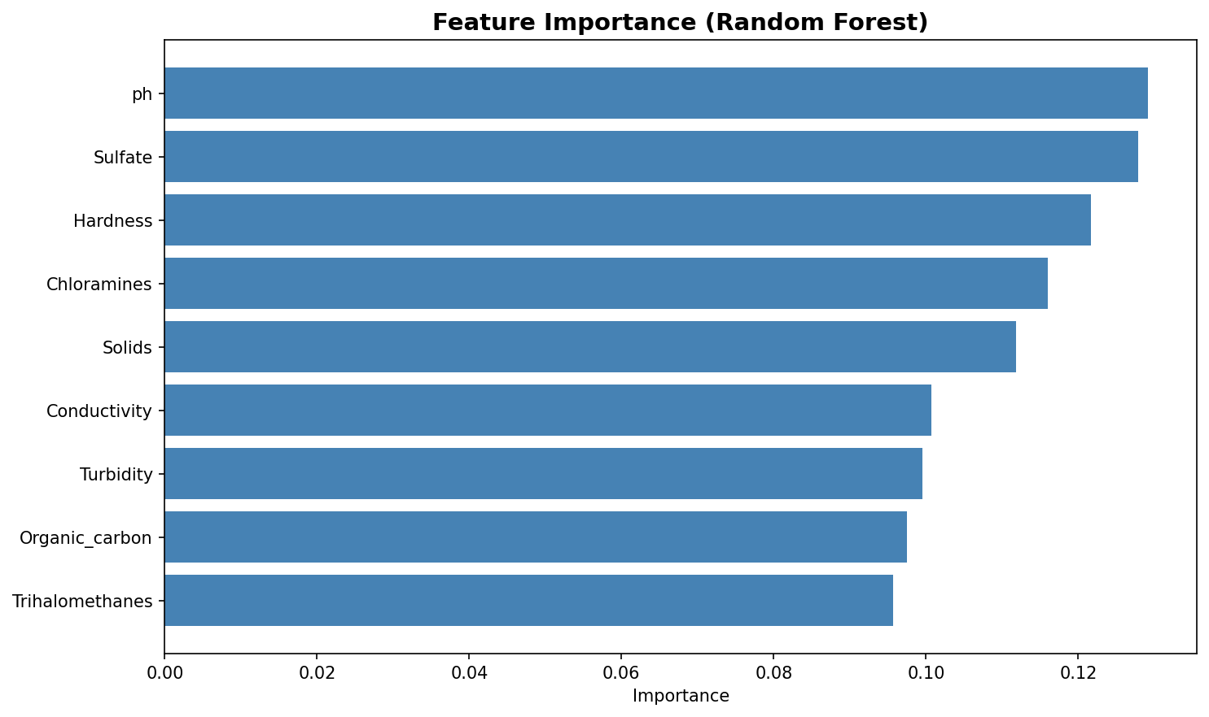
Feature Importance
Figure 6: Feature importance scores from Random Forest model

5.3 XGBoost
XGBoost (Extreme Gradient Boosting) is an optimized gradient boosting algorithm with regularization.

Objective Function
$$L(ϕ)=\sum_{i=1}^{n}{l}(y_{i},{\hat{y}}_{i})+\sum_{k=1}^{K}{Ω}(f_{k})$$
where: - $l$ is the loss function (logistic loss for classification) - $Ω$ is the regularization term - $K$ is the number of trees

Regularization Term
$$Ω(f)=γT+\frac{1}{2}λ\sum_{j=1}^{T}{w_{j}^{2}}$$
where: - $T$ is the number of leaves in the tree - $w_{j}$ is the weight of leaf $j$ - $γ$ and $λ$ are regularization parameters

Second-Order Taylor Expansion
For each iteration $t$:
$$L^{(t)}≈\sum_{i=1}^{n}{\left[g_{i}f_{t}(x_{i})+\frac{1}{2}h_{i}f_{t}^{2}(x_{i})\right]}+Ω(f_{t})$$
where: - $g_{i}=\frac{∂l(y_{i},{\hat{y}}^{(t−1)})}{∂{\hat{y}}^{(t−1)}}$ (gradient) - $h_{i}=\frac{∂^{2}l(y_{i},{\hat{y}}^{(t−1)})}{∂({\hat{y}}^{(t−1)})^{2}}$ (Hessian)

Optimal Leaf Weight
wj*=−i∈Ij​gii∈Ij​hi+λ

Split Gain
$$\text{Gain}=\frac{1}{2}\left[\frac{G_{L}^{2}}{H_{L}+λ}+\frac{G_{R}^{2}}{H_{R}+λ}−\frac{(G_{L}+G_{R})^{2}}{H_{L}+H_{R}+λ}\right]−γ$$

5.4 LightGBM
LightGBM is a gradient boosting framework that uses histogram-based algorithms for efficient training.

Gradient-based One-Side Sampling (GOSS)
GOSS keeps samples with large gradients and randomly samples from small gradient instances:
- Sort training instances by absolute gradient $|g_{i}|$
- Select top $a×100\%$ instances with largest gradients
- Randomly sample $b×100\%$ from remaining instances
- Amplify sampled small gradient data by factor $\frac{1−a}{b}$

Exclusive Feature Bundling (EFB)
EFB bundles mutually exclusive features to reduce dimensionality:
Conflict(fi,fj)=x∈D​1[fi(x)≠0∧fj(x)≠0]
Features are bundled if their conflict count is below a threshold.

Leaf-wise Tree Growth
Unlike level-wise growth, LightGBM grows trees leaf-wise: - Choose the leaf with maximum delta loss - Can lead to deeper trees and better accuracy - Uses max_depth to prevent overfitting

6. Evaluation Metrics

6.1 Confusion Matrix
The confusion matrix provides a complete picture of classification performance:
$$\text{Confusion Matrix}=\left[\begin{matrix}TN & FP \\ FN & TP\end{matrix}\right]$$
where: - $TN$ = True Negatives (correctly predicted non-potable) - $FP$ = False Positives (non-potable predicted as potable) - $FN$ = False Negatives (potable predicted as non-potable) - $TP$ = True Positives (correctly predicted potable)

6.2 Accuracy
$$\text{Accuracy}=\frac{TP+TN}{TP+TN+FP+FN}$$

6.3 Precision
$$\text{Precision}=\frac{TP}{TP+FP}$$
Precision measures the proportion of positive predictions that are actually correct.

6.4 Recall (Sensitivity)
$$\text{Recall}=\frac{TP}{TP+FN}$$
Recall measures the proportion of actual positives that are correctly identified.

6.5 F1-Score
The harmonic mean of precision and recall:
$$F_{1}=2⋅\frac{\text{Precision}⋅\text{Recall}}{\text{Precision}+\text{Recall}}$$

6.6 ROC-AUC
The Area Under the Receiver Operating Characteristic Curve:
$$\text{AUC}=\int_{0}^{1}{\text{TPR}}(t) d(\text{FPR}(t))$$
where: - $\text{TPR}=\frac{TP}{TP+FN}$ (True Positive Rate) - $\text{FPR}=\frac{FP}{FP+TN}$ (False Positive Rate)

6.7 Average Precision
AP=n​(Rn−Rn−1)Pn
where $P_{n}$ and $R_{n}$ are precision and recall at threshold $n$.

7. Results and Analysis

7.1 Model Performance Comparison
Model | Accuracy | Precision | Recall | F1-Score | AUC
Logistic Regression | 0.5259 | 0.4159 | 0.5312 | 0.4666 | 0.5475
Random Forest | 0.6585 | 0.6311 | 0.3008 | 0.4074 | 0.6407
XGBoost | 0.6418 | 0.5574 | 0.3984 | 0.4647 | 0.6256
LightGBM | 0.6540 | 0.6000 | 0.3398 | 0.4339 | 0.6512
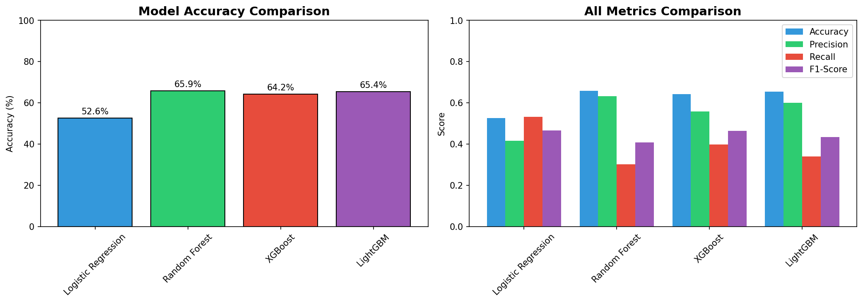
Model Comparison
Figure 7: Visual comparison of model performance metrics

7.2 Confusion Matrices
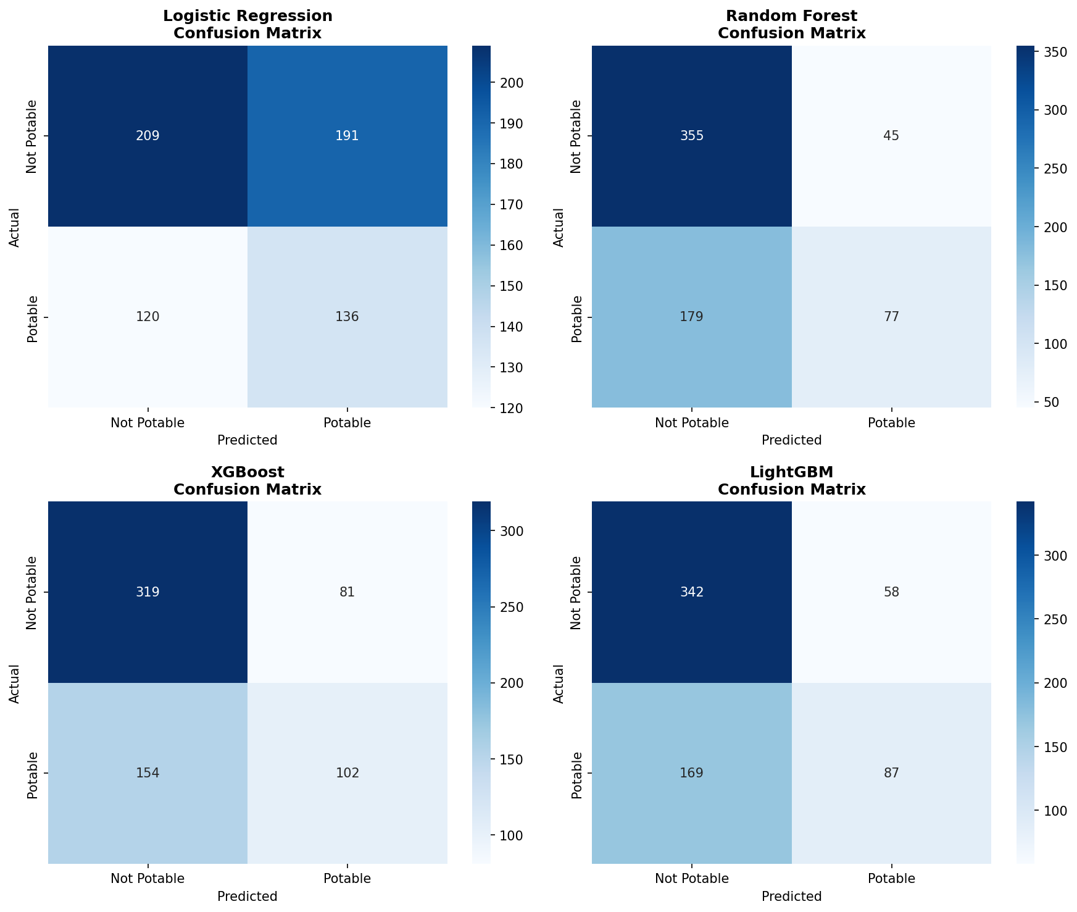
Confusion Matrices
Figure 8: Confusion matrices for all four models

7.3 ROC Curves
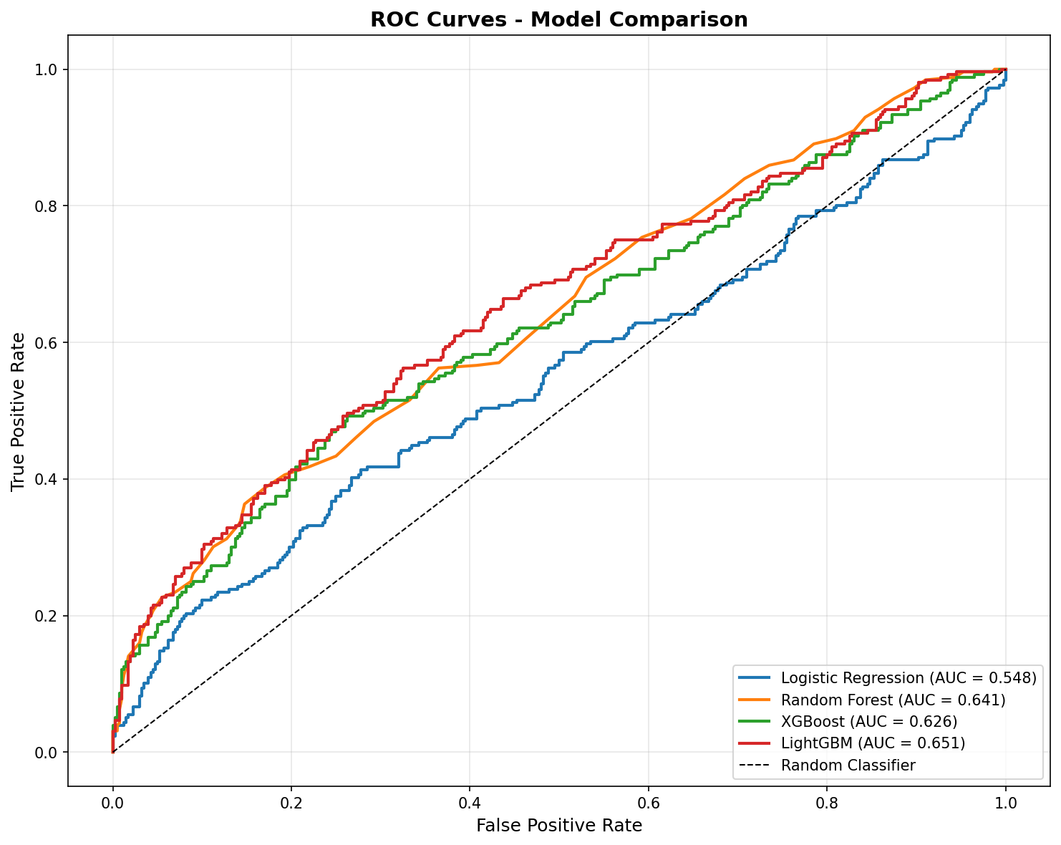
ROC Curves
Figure 9: ROC curves comparing model discrimination ability

7.4 Precision-Recall Curves
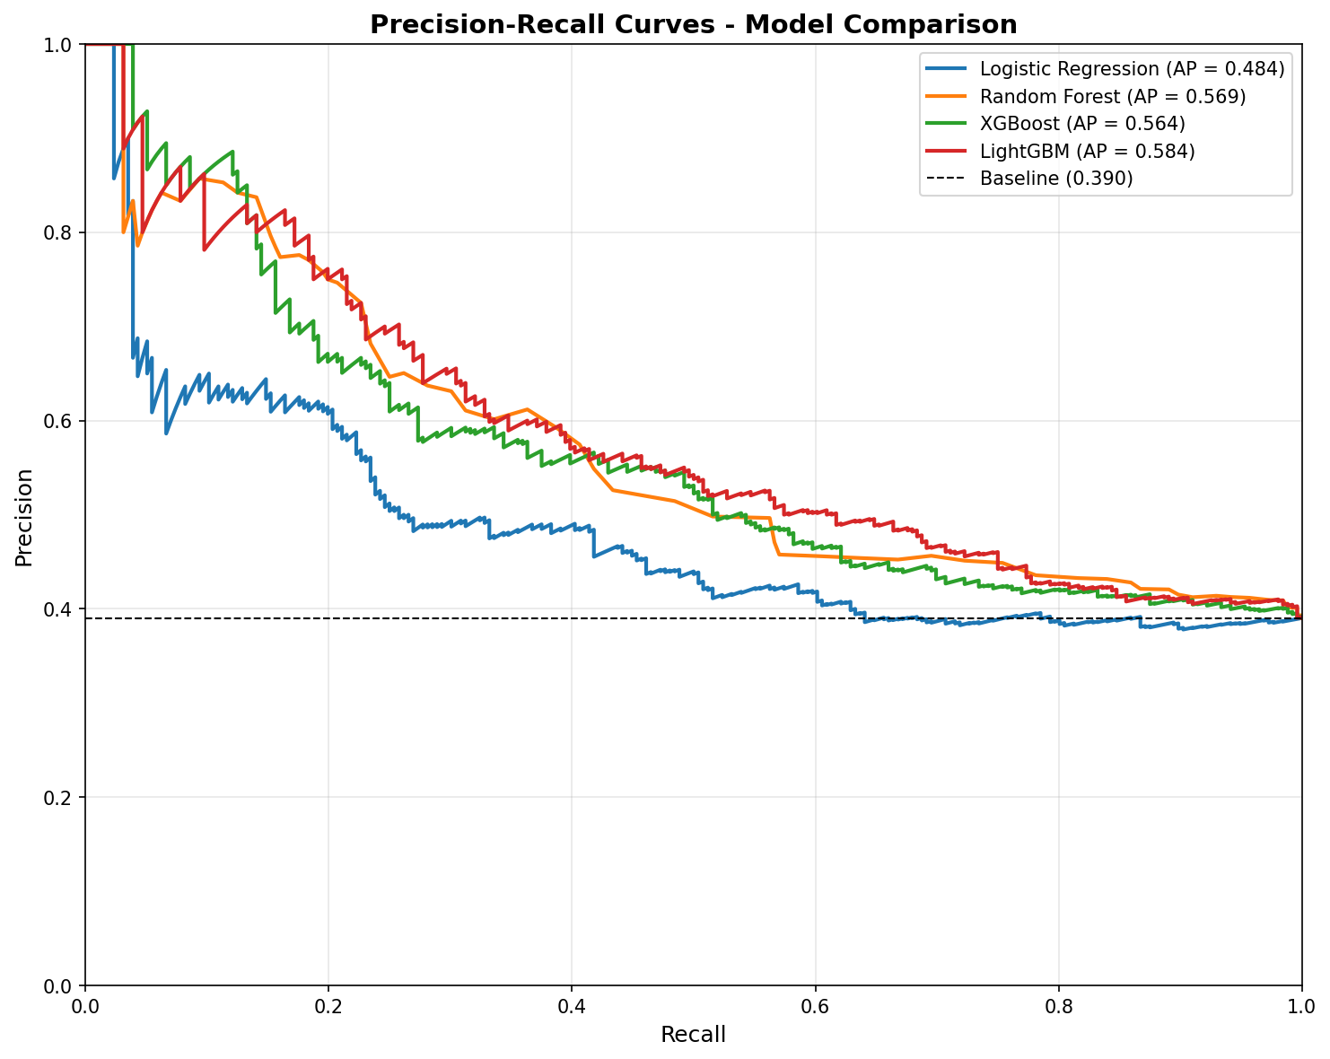
Precision-Recall Curves
Figure 10: Precision-Recall curves for model comparison

7.5 Key Findings
- Best Overall Accuracy: Random Forest (65.85%)
- Best AUC Score: LightGBM (0.6512)
- Best Recall: Logistic Regression (53.12%) - important for minimizing false negatives
- Best Precision: Random Forest (63.11%)
The class imbalance in the dataset (61% non-potable vs 39% potable) affects model performance. Using balanced class weights in Logistic Regression improved its recall significantly.

8. Web Application Deployment
A Streamlit web application was developed and deployed for real-time water potability predictions.
Live Application: https://water-potability-prediction-ip-assignment.streamlit.app/

8.1 Application Home Page
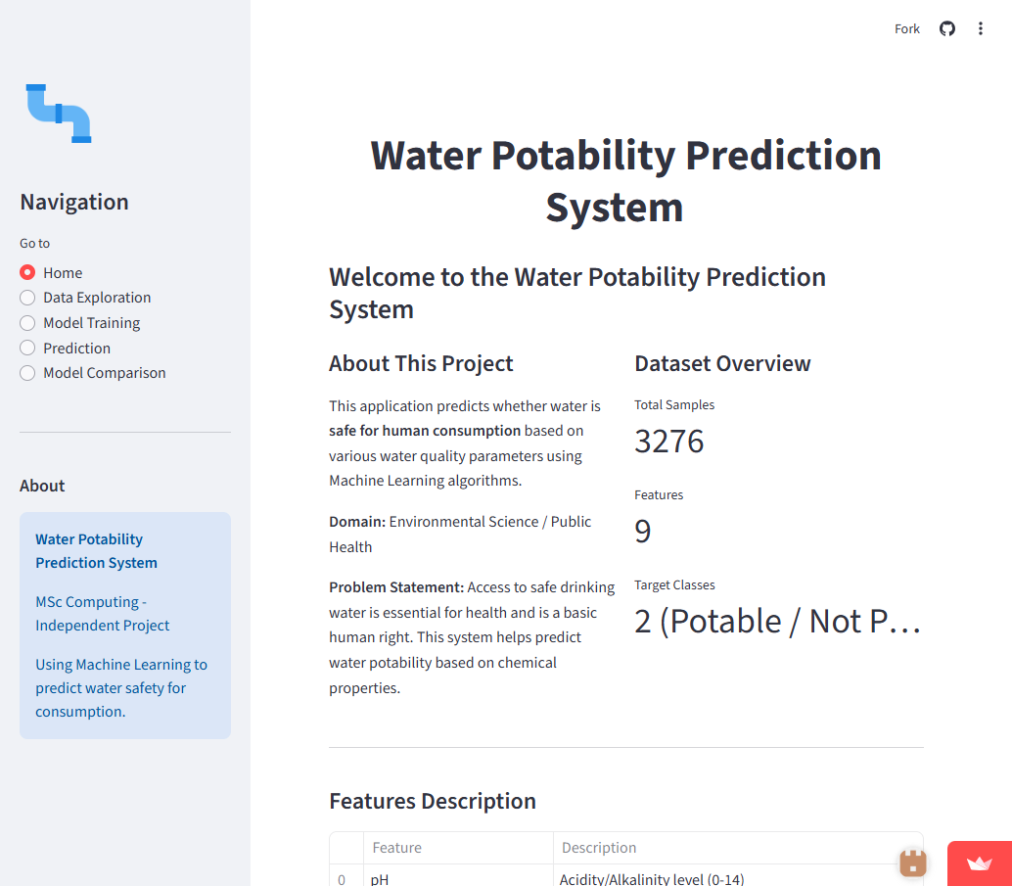
Streamlit Home Page
Figure 11: Home page of the Water Potability Prediction application

8.2 Data Exploration Features
The application provides interactive data exploration capabilities:
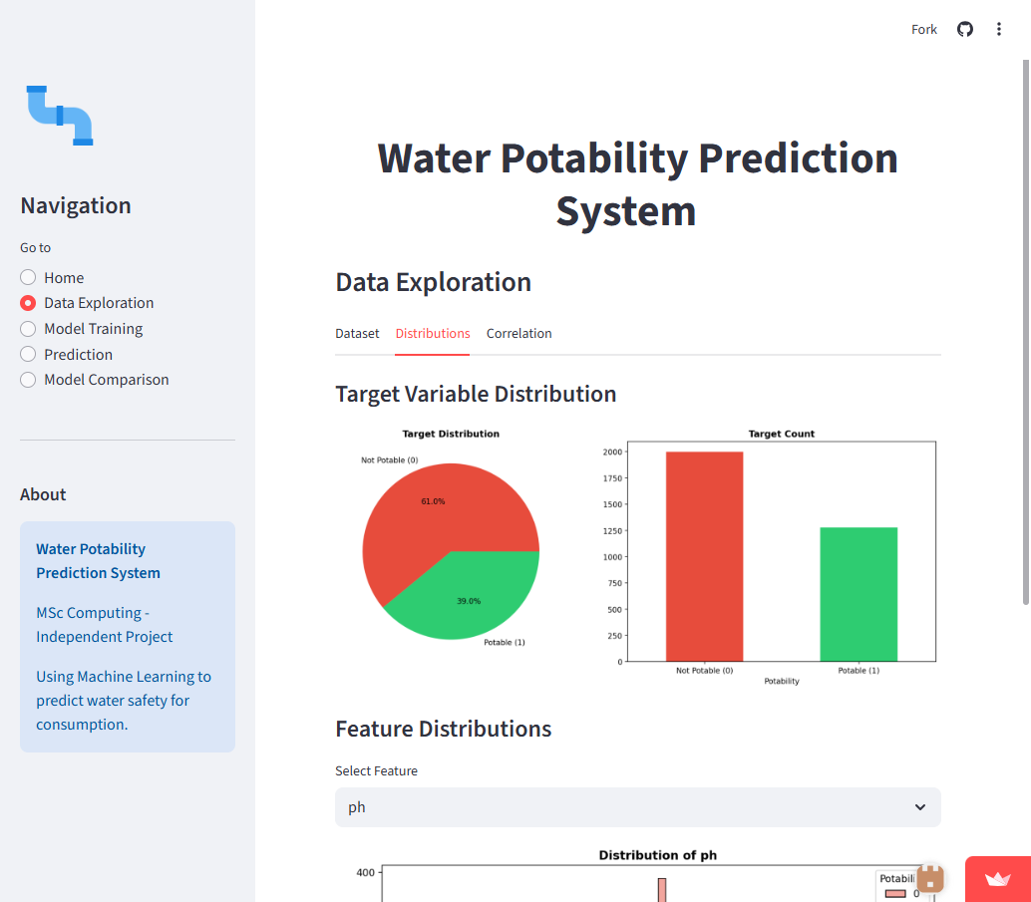
Data Distributions
Figure 12: Interactive data distribution visualizations

8.3 Model Training Interface
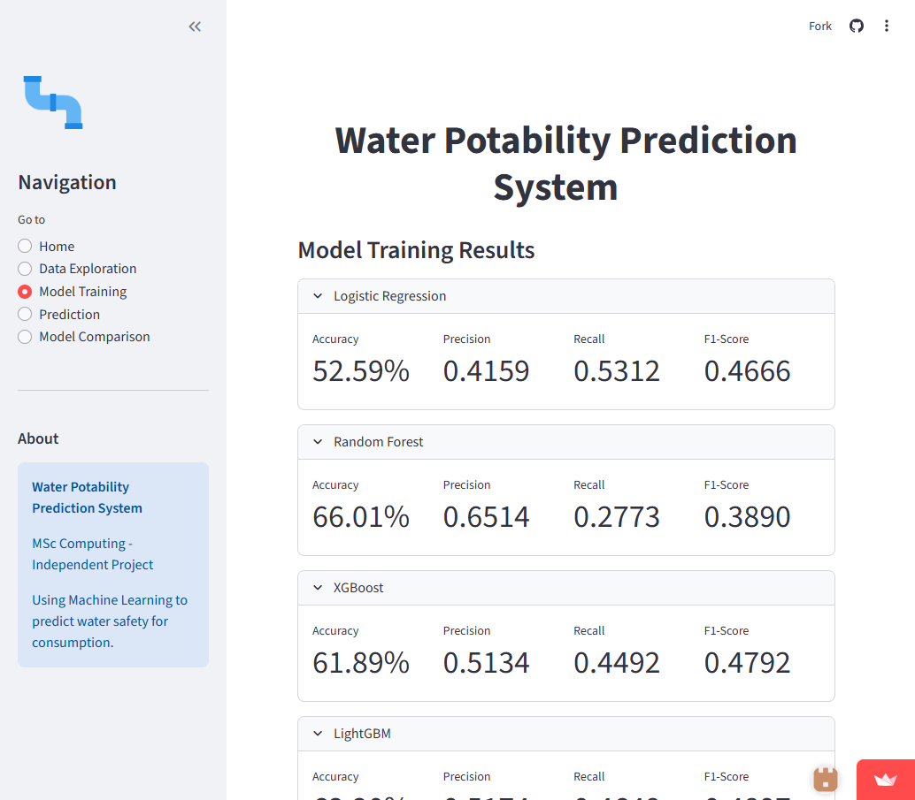
Model Training
Figure 13: Model training and evaluation interface

8.4 Model Comparison Dashboard
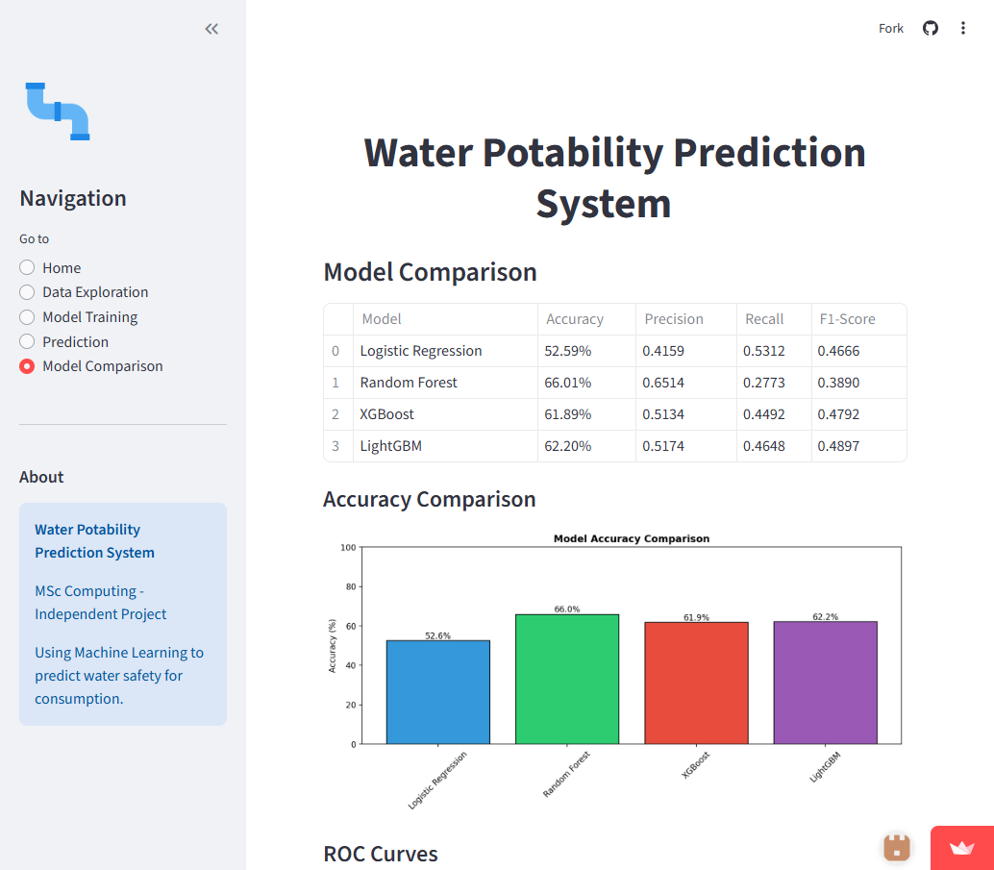
Model Comparison Dashboard
Figure 14: Dashboard comparing all trained models

8.5 Prediction Interface
Users can input water quality parameters to get predictions:
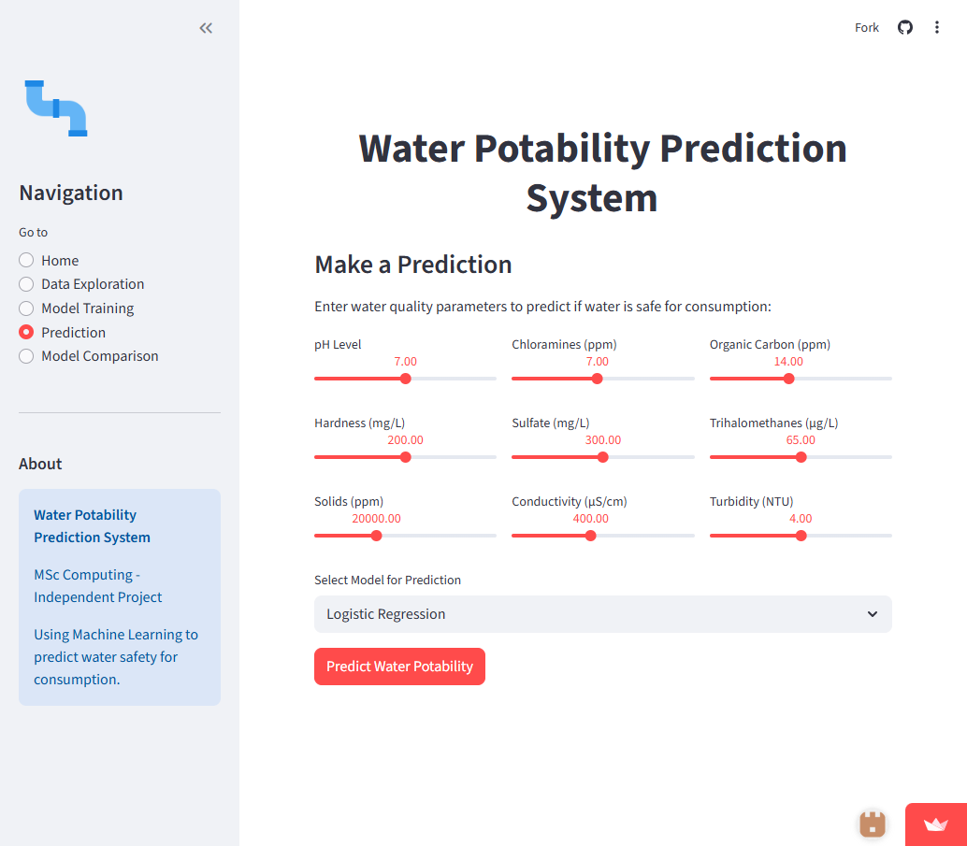
Prediction Page
Figure 15: Prediction input interface

8.6 Prediction Results
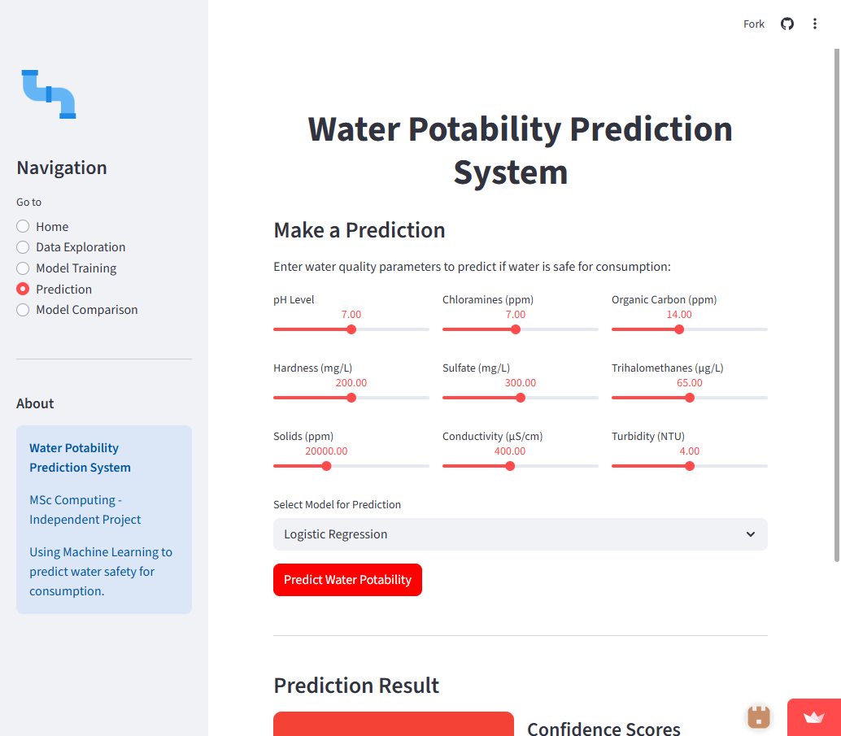
Prediction Result
Figure 16: Sample prediction result showing water potability assessment

9. Conclusions

9.1 Summary
This project successfully developed and deployed a machine learning system for water potability prediction. Key achievements include:
- Comprehensive EDA: Identified data patterns, missing values, and class imbalance issues
- Multiple Model Comparison: Evaluated four different classification algorithms
- Mathematical Foundation: Provided detailed mathematical formulations for each algorithm
- Web Deployment: Created an accessible web application for real-time predictions

9.2 Recommendations
- Collect More Data: Additional samples, especially potable water samples, would help address class imbalance
- Feature Engineering: Domain-specific features combining multiple water quality parameters
- Ensemble Methods: Combining multiple models could improve prediction accuracy
- Threshold Optimization: Adjusting classification thresholds based on cost-sensitivity analysis

9.3 Future Work
- Implement deep learning approaches (Neural Networks)
- Add time-series analysis for water quality monitoring
- Integrate IoT sensors for real-time data collection
- Develop a mobile application for field testing

10. References
- Breiman, L. (2001). Random Forests. Machine Learning, 45(1), 5-32.
- Chen, T., & Guestrin, C. (2016). XGBoost: A Scalable Tree Boosting System. KDD ’16.
- Ke, G., et al. (2017). LightGBM: A Highly Efficient Gradient Boosting Decision Tree. NIPS.
- World Health Organization. (2017). Guidelines for Drinking-water Quality.
- Hosmer, D. W., Lemeshow, S., & Sturdivant, R. X. (2013). Applied Logistic Regression.

GitHub Repository: https://github.com/sohaib3335/water-potability-prediction

Report generated as part of MSc Computing Independent Project
Author: Sohaib Farooq | Email: sohaib.farooq@bigacademy.com

