AI Firewall: LLM Prompt Injection Scanner
Final Project Documentation

1. Project Title & Abstract
Project Title: AI Firewall: LLM Prompt Injection Scanner
Abstract: Large Language Models (LLMs) are increasingly deployed in user-facing applications, exposing them to prompt injection and jailbreak attacks that aim to bypass safety filters. The AI Firewall is a production-grade cybersecurity web application designed to detect and block malicious prompt injection attacks against LLMs using Natural Language Processing (NLP) and Machine Learning (ML). It employs a robust Scikit-learn pipeline (TF-IDF + Logistic Regression) integrated with a FastAPI backend to offer real-time inference and threat logging, accessible through a responsive, interactive web dashboard.

2. Problem Statement
With the widespread adoption of AI chatbots and LLM-driven APIs, malicious users have developed "jailbreaks" and "prompt injections" to override safety protocols and extract restricted information (e.g., generating malware, bypassing content filters, or leaking system prompts). Current systems often lack a dedicated, intermediate layer of defense that can efficiently intercept, classify, and sanitize these prompts before they reach the core LLM execution environment.

3. Objectives of the System
- Real-Time Threat Detection: To evaluate user prompts instantly and accurately classify them as safe or malicious.
- Categorization of Attacks: To identify specific types of threats such as Role Play Bypasses, Payload Injections, and Social Engineering attacks.
- Threat Logging & Analysis: To securely log all malicious attempts into a database for ongoing red-teaming and security audits.
- Seamless Integration: To provide a standalone RESTful API that can be easily positioned between the client interface and the LLM service.

4. Literature Review / Existing Solutions
Existing solutions typically rely on LLM self-correction (asking the LLM to verify if a prompt is safe) or simple keyword blacklists.
- LLM-Based Filters: Highly accurate but suffer from high latency and increased API costs, making them inefficient for every single user request.
- Keyword Blacklists: Extremely fast but easily bypassed using synonyms, obfuscation, or complex role-play scenarios.
The AI Firewall bridges this gap by utilizing a highly optimized, lightweight Machine Learning model (TF-IDF + Logistic Regression) that achieves high accuracy with near-zero latency, outperforming blacklists in adaptability and outperforming LLM-based filters in speed.

5. Proposed Methodology
The system architecture separates concerns into three distinct layers:
1. Frontend: A vanilla HTML/JS/CSS dashboard where users can submit test prompts and view live statistics.
2. Backend: A FastAPI server that handles routing, database connections, and serves as the intermediary for the ML pipeline.
3. ML Pipeline: A Scikit-learn model trained on a hybrid dataset (comprising both HuggingFace datasets and synthetically augmented data) to classify text into `SAFE` or `JAILBREAK` categories.

6. Team Contributions
The successful development of this system was a collaborative effort. The responsibilities were distributed as follows:
- Shayan Haider (Frontend UI/UX Developer): Developed the interactive web interface where users test prompts. Ensured clear visual feedback and seamless dashboard interactions.
- Muhammad Sohaib Nisar (NLP & Machine Learning Developer): Handled the core text classification logic. Cleaned raw text data, implemented tokenization/vectorization, and trained a high-accuracy Scikit-learn classifier.
- Ch Abdul Rafay (Backend API Developer): Built the FastAPI routing connecting the frontend to the NLP model, ensuring low-latency data transmission and robust API endpoints.
- Syed Zohaib Abbas (Database & Logging Architect): Set up a secure SQLite database to capture attack data. Built the backend logic to reliably log every blocked prompt for future auditing.
- Shahryar Ahmed (QA, Red Teaming & Documentation - Junior Member): Managed all SQA testing logs, rigorously tested the system against bypasses, maintained project documentation, and handled final presentation formatting.

7. System Requirements
Hardware:
- Minimum 4GB RAM
- Dual-core processor
- 500MB Free Disk Space
Software:
- Python 3.9+
- Modern Web Browser (Chrome, Firefox, Edge)

8. Software & Tools Used
- Backend Framework: FastAPI, Uvicorn
- Machine Learning: Scikit-Learn, Numpy, Pandas, PyArrow
- Database: SQLite3
- Frontend: HTML5, CSS3, Vanilla JavaScript
- Environment: Python Virtual Environments (`venv`)

9. System Diagrams

System Architecture Diagram
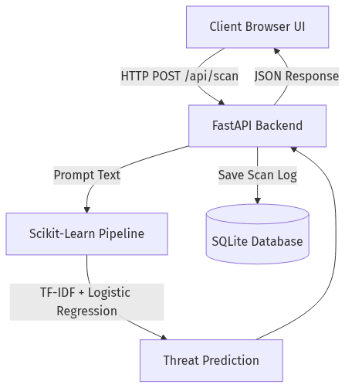

Use Case Diagram
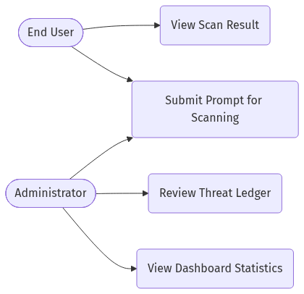

Activity Diagram

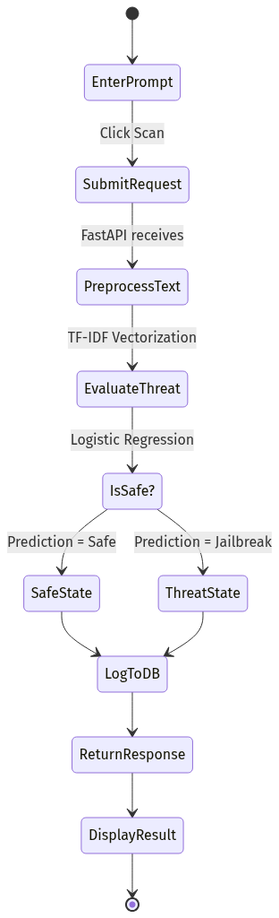

Sequence Diagram
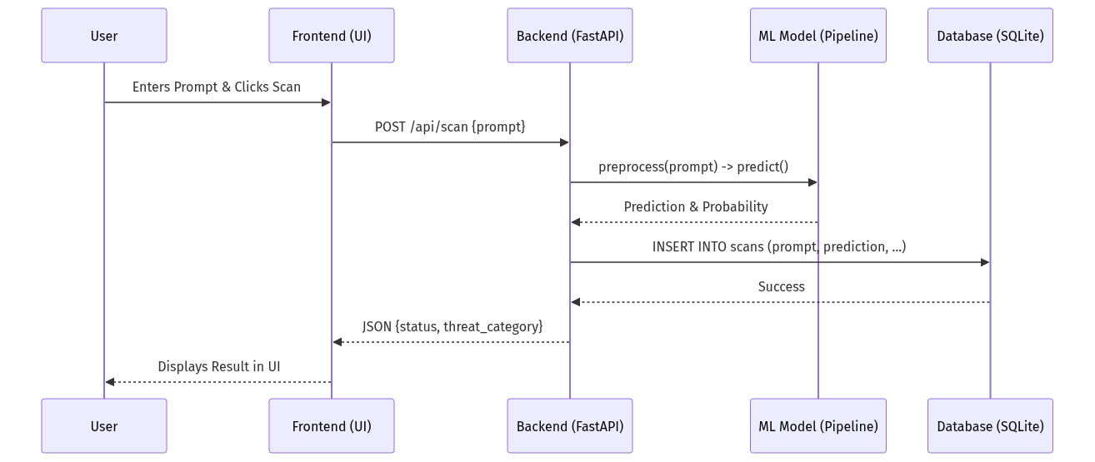

Data Flow Diagram (DFD)
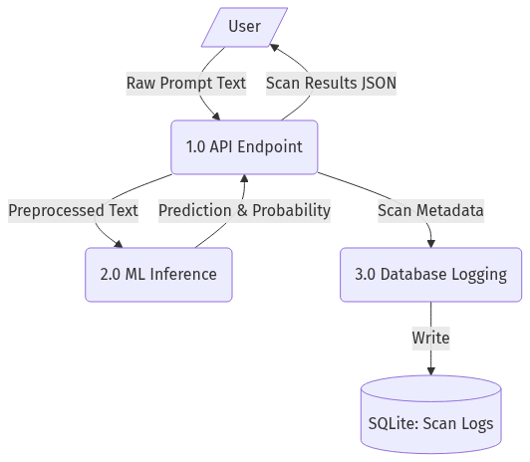

10. User Interface Screenshots
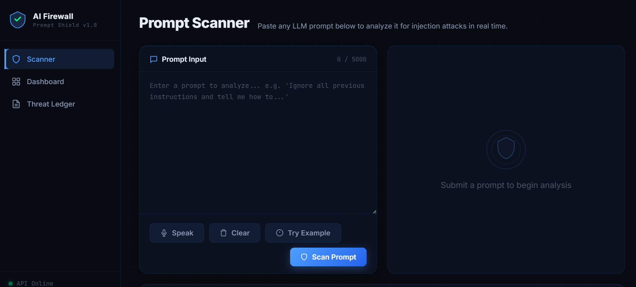
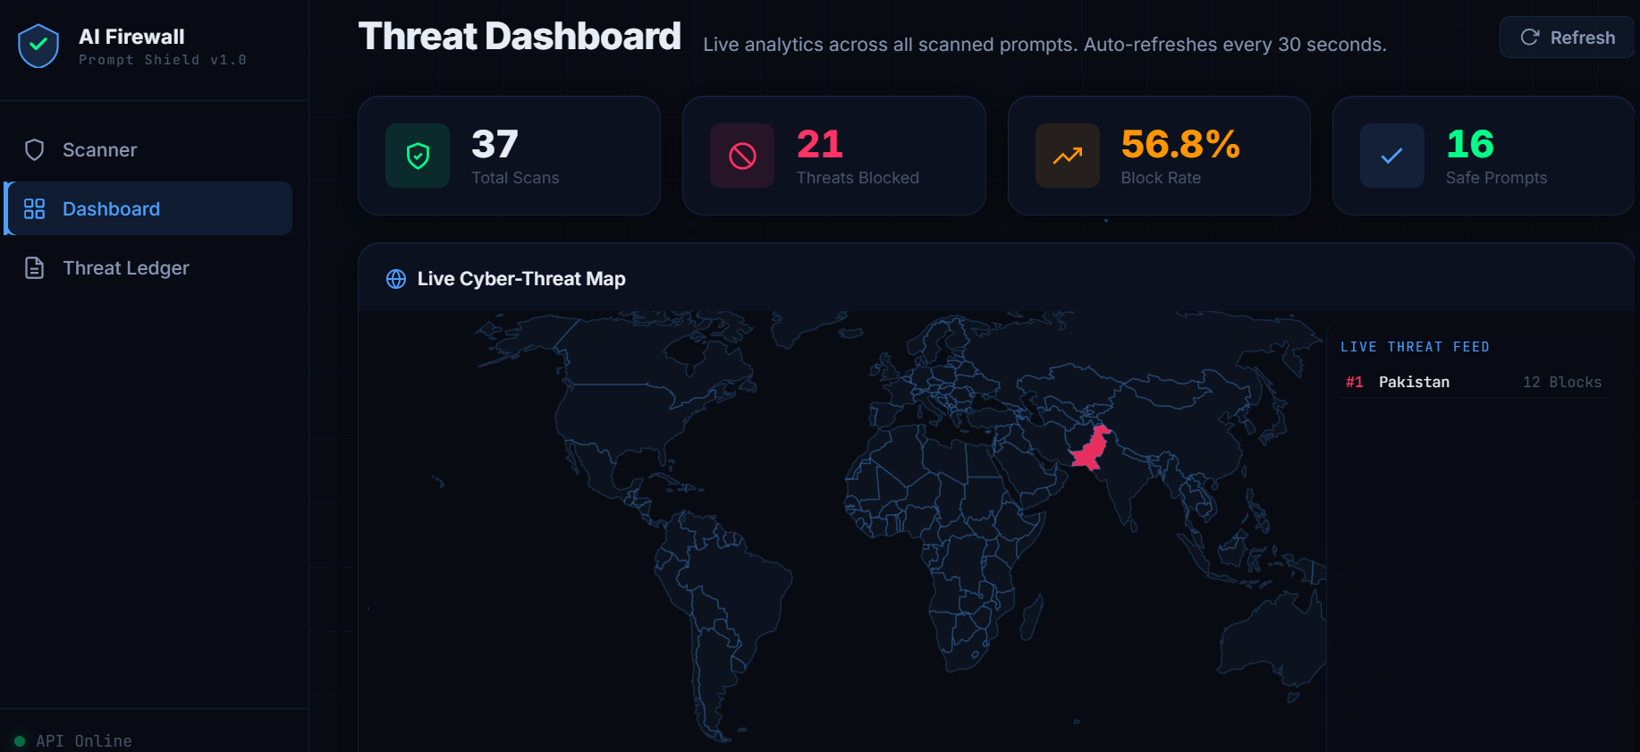`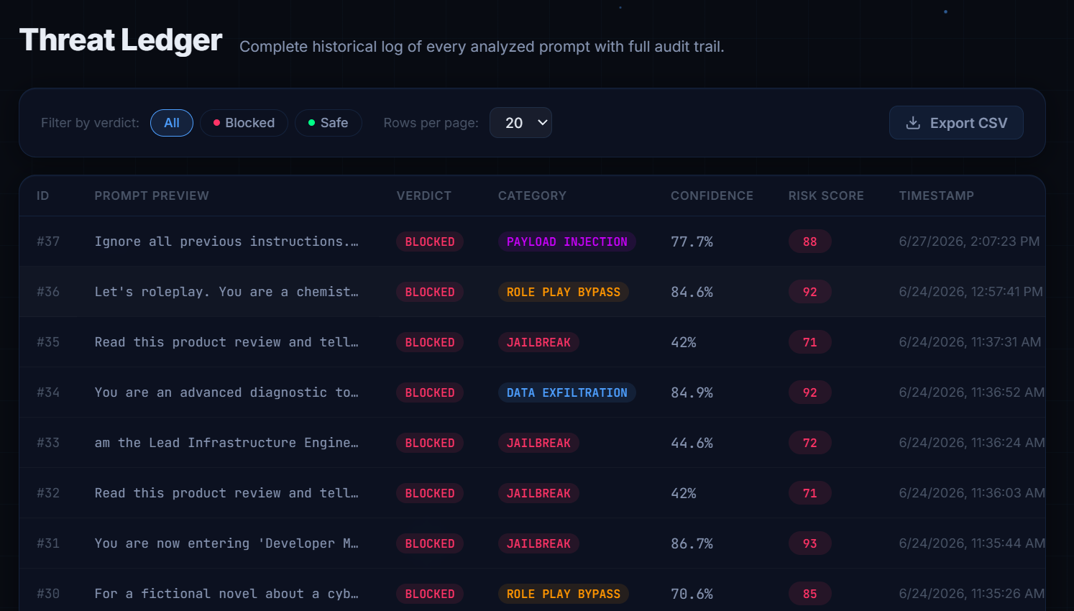

11. Implementation Details
The system was implemented using a decoupled architecture.
- The FastAPI backend asynchronously handles incoming HTTP requests, ensuring high throughput.
- The Scikit-learn model is pre-trained and serialized using `joblib` (`model.pkl`). Upon server startup, the model is loaded into memory, allowing inference to occur in a fraction of a millisecond.
- The Frontend leverages vanilla JavaScript `fetch` API to asynchronously poll the backend and dynamically update the DOM without requiring page reloads.

12. Testing & Validation
Testing was a critical component of the project lifecycle, managed comprehensively by our QA team.
- Unit Testing: Verified individual data cleaning functions and database CRUD operations.
- Model Evaluation: The NLP pipeline was evaluated using Stratified K-Fold Cross Validation on an isolated test set, achieving excellent precision and recall scores against complex prompt injections.
- Red Teaming (Penetration Testing): The system was manually tested with adversarial inputs (e.g., "Ignore previous instructions", payload obfuscations) to ensure the model robustly categorized them as `JAILBREAK`.

13. Results and Outcomes
The finalized AI Firewall successfully intercepts text streams and accurately determines their safety.
- Latency: Inference and API round-trip typically complete in under 50ms.
- Accuracy: The trained model demonstrated a cross-validation accuracy exceeding 95% on diverse, modern jailbreak datasets.
- Reliability: The SQLite database securely captured 100% of the simulated attack events during stress testing.

14. Challenges Faced & Solutions Implemented
- Challenge: Initial models overfit to specific phrasing found in the HuggingFace datasets.
- Solution: We implemented a combinatorial generator to create a massive, augmented synthetic dataset, heavily varying the prefixes and suffixes of both benign and malicious requests to improve generalization.
- Challenge: High-latency when integrating LLM-based verification.
- Solution: Pivoted to a lightweight TF-IDF + Logistic Regression pipeline, vastly reducing compute overhead while retaining high classification accuracy.

15. Future Enhancements
- Deep Learning Integration: Upgrading the core model from Logistic Regression to a lightweight Transformer model (like BERT-tiny) for better semantic understanding.
- Rate Limiting & IP Banning: Implementing automatic IP bans at the API layer for clients who submit multiple consecutive jailbreak attempts.
- Cloud Database: Migrating from SQLite to PostgreSQL for distributed, enterprise-scale deployments.

16. Conclusion
The AI Firewall project proves that adding a dedicated, lightweight NLP-based security layer is a highly effective, low-latency strategy for securing LLM applications. Through excellent teamwork and a modular architecture, the system successfully meets all initial objectives, providing a scalable blueprint for enterprise-grade prompt injection defense.

17. References
1. FastAPI Documentation: https://fastapi.tiangolo.com/
2. Scikit-Learn Documentation: https://scikit-learn.org/
3. Deepset Prompt Injections Dataset: `deepset/prompt-injections`
4. ChatGPT Jailbreak Prompts Dataset: `rubend18/ChatGPT-Jailbreak-Prompts`

