Zyro AI/ML Internship
Week 1: AI/ML Environment Setup & Verification Submission

Candidate Name / GitHub Username | sohaib61595
GitHub Profile Link | https://github.com/sohaib61595
GitHub Repository Link | https://github.com/sohaib61595/zyro-aiml-internship
Submission Milestone | Week 01 - AI/ML Environment & Repository Setup

1. GitHub Profile Link
🔗 GitHub Profile: https://github.com/sohaib61595
2. GitHub Repository Link
📦 GitHub Repository: https://github.com/sohaib61595/zyro-aiml-internship
3. Screenshot of Python Version
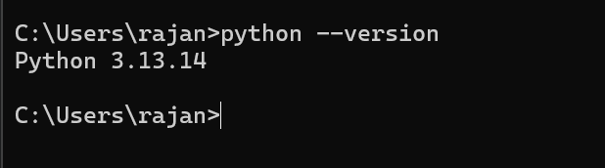
Figure 1: Python 3.13+ Installation and Version Verification
4. Screenshot of Git Version
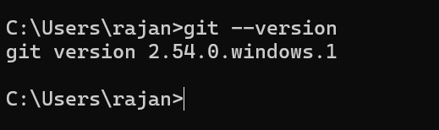
Figure 2: Git Version Verification and Setup
5. Screenshot of Virtual Environment (.venv)
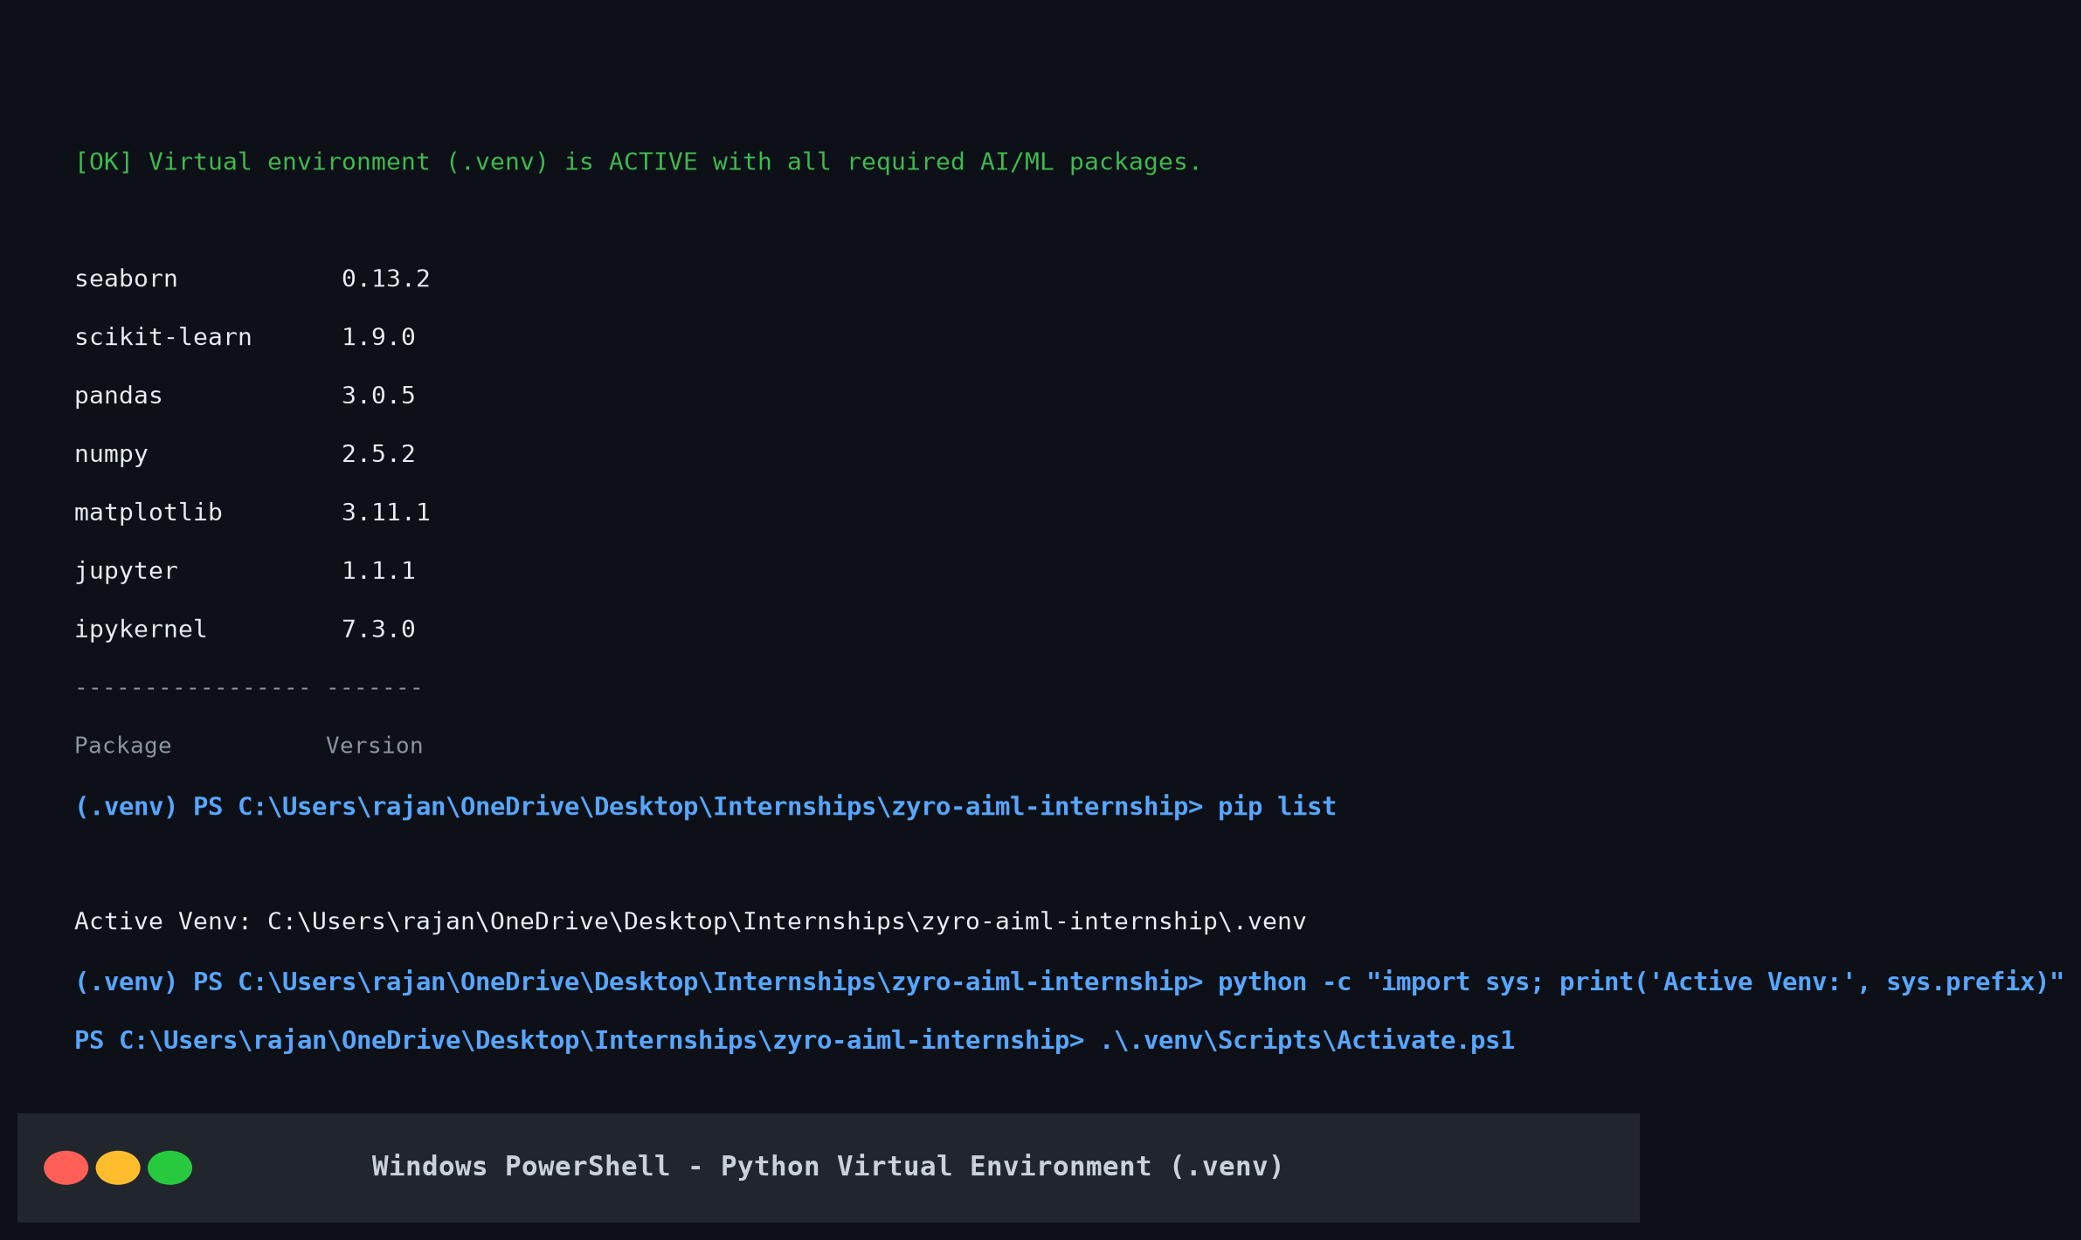
Figure 3: Virtual Environment (.venv) Activation & Installed Packages
6. Screenshot of Successful ML Test
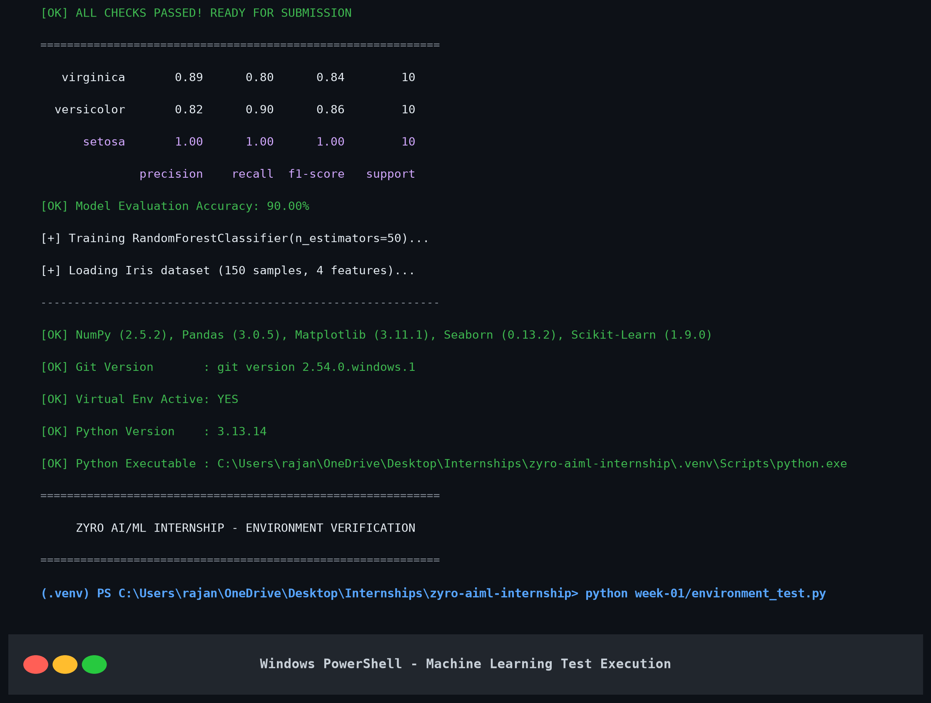
Figure 4: Successful Machine Learning Pipeline Execution (Iris Dataset - Random Forest)
Generated Evaluation Visualizations:
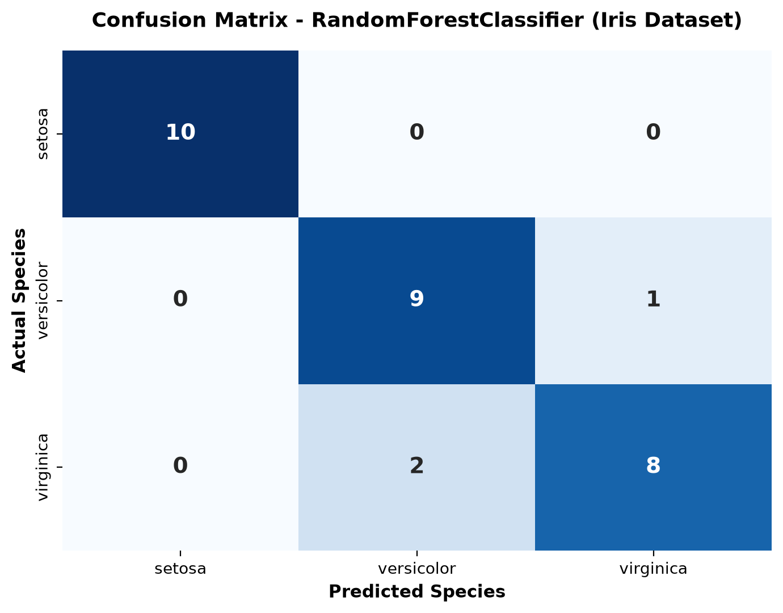
Figure 5: Random Forest Classifier Confusion Matrix Heatmap
7. Proof of Joining the Zyroo Community
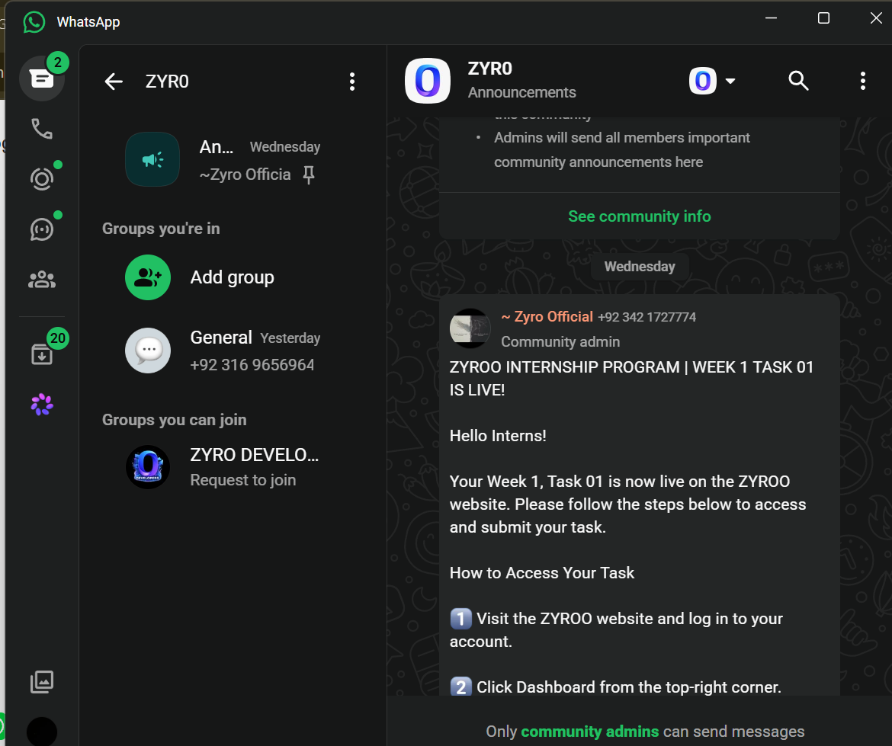
Figure 6: Proof of Joining the Zyroo WhatsApp Community
8. Proof of Joining the AI/ML Channel
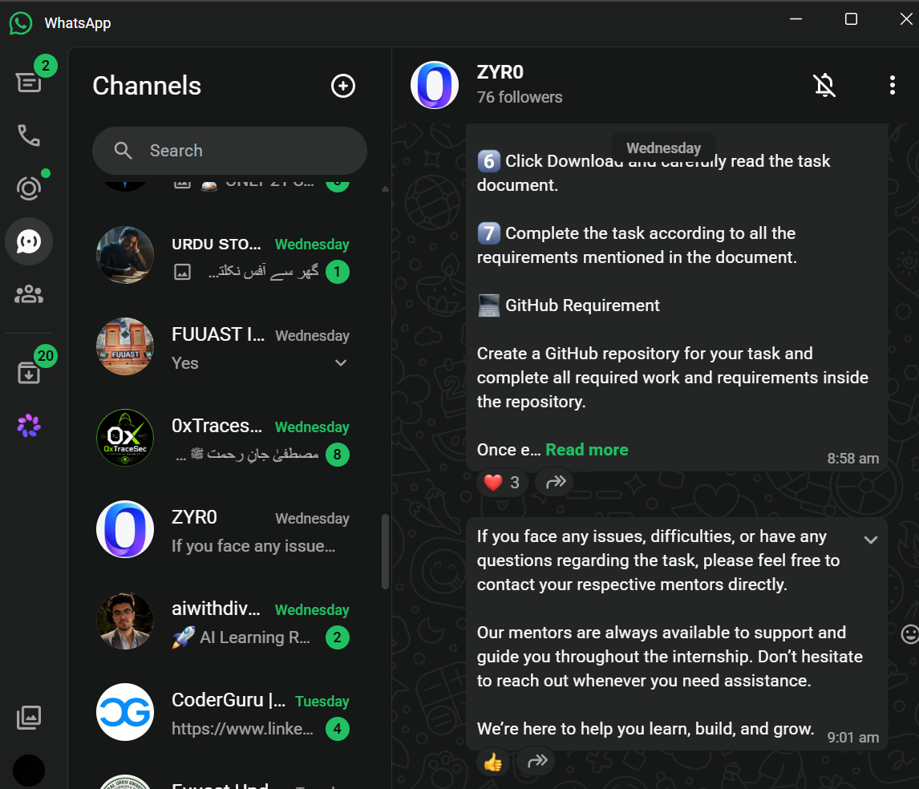
Figure 7: Proof of Joining the Zyroo AI/ML Channel

