ACKNOWLEDGEMENT

The first, we would like to express my special thanks of gratitude to my teacher <<Sir Wahab>>, who helped us a lot in finalizing this project within the limited time frame, valuable counselling and assistance for the accomplishment of this project.
Secondly we would also like to thank the EProject team at Aptech Head Office, who gave us the golden opportunity to do this wonderful project about Ingco tools.
Thirdly, we also thank the EProject team, some of the benefits are as under:
- Re-enforcement of skills happens in the experiential learning process. 
- A mentor, ensuring that we do not get drifted, constantly guides us. 
- It gives us a lot of confidence to face an interview as we have worked on a project. We can explain virtually everything on the subject we have learnt. 

1
eProject: specification-website-biography

SYNOPSIS

Follow the strong development of the internet, technology INGCO parts and the growing INGCO parts, every business needs a website design to display products on the internet.
The following INGCO product are designed with many different designs, suitable for all styles and preferences, which are the most special suggestions from INGCO parts.
Attached are the introductions hidden behind the watch gift from the gift you want to send to your lover, colleagues or loved ones.
So INGCO parts shares the best product images through the website for everyone to know.
However, purchases are not made directly on the website

2 eProject: specification-website-biography

PROBLEM DEFINITION

INGCO parts is into business of manufacturing and selling electronic parts . They have been advertising about their hammer and clawsthrough ,Portable highpressure washer, Generator 4m international. Now with changing tools, they have decided to go online as customers today use Internet extensively. They have planned for a website with complete details about their electronic tools and parts So, we solved many particular queries as followed:
- How the sitemap possibly looks alike?
- What information should be displayed on each page?
- How to put every comment is friendly?
- How to give users the best experience when using the website?
- How to let the website properly functioning along with the system requirement?
- Will the user be able to contact with INGCO parts company for advice?

3 eProject: specification – website biography

CUSTOMER REQUIREMENT SPECIFICATION (CRS)

After discussion, we are supposed to create a website for them with the below mentioned requirement specifications:
•The Home Page should have suitable logo, and decent colour combination. 

•The site should display a menu which will contain the options as Products,
Technology, Store Locator, Support etc. 
- Various pages having information about different types of tools and parts, Technology used in the electric etc. 
- The information should be categorized according to different Product Line-up e.g. “ELECTRONIC”etc. 
- When a user selects any product line-up, complete list of INGCO tools for that product line-up will be displayed. 
- Details of the watches should be displayed on the Web Page along with the title and it should be stored in Individual Word documents which can be downloaded or viewed by the User who wishes to see the same. 
- Price List for all watches should be available for download. 
- There should be a “Contact Us” page which will have the Address of the Stores selling watches and the mail address which when clicked will invoke the local mail client from where they can send an email. Address of the Company should be displayed using GeoLocation API (eg.GoogleMaps). 
eProject: specification – website- biography

SCOPE OF THE WORK (IN BRIEF)

The website is to be developed for the Windows Platform using HTML5, JavaScript and Geolocation. The site should work well in all leading browsers including Chrome, IE, Firefox etc..
Homepage show Top best sell items, big sale, collection, new shop...
Every content direct to relative content.

5

eProject: specification – website- biography

AGGREGATED SITEMAP

INGCO PARTS
(
0
.index.php
)

INGCO parts
(
.Index.html
1
)

Aura Watches
Vietnamese

(
1
-
VN.html
)

project: specification – website- biography
SITEMAP ENGLISH

1
eProjectspecification – website- biography

SHOP DETAIL
DETAIL.PHP

Footer
Shopping Cart
Slideshow

WIREFRAMES

1.ingco tools (1.Index.php)
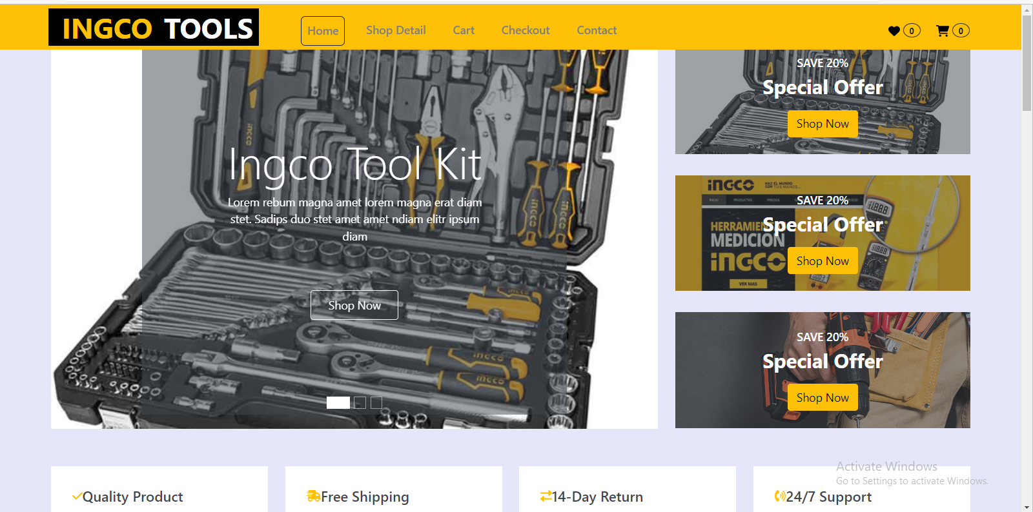

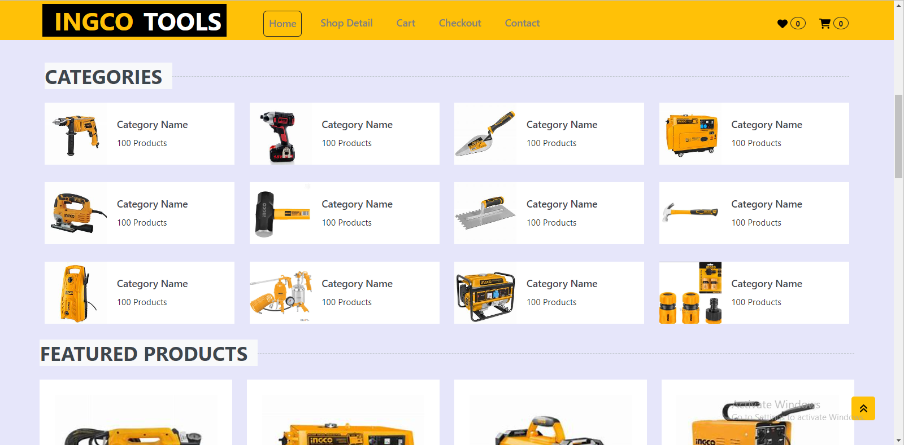

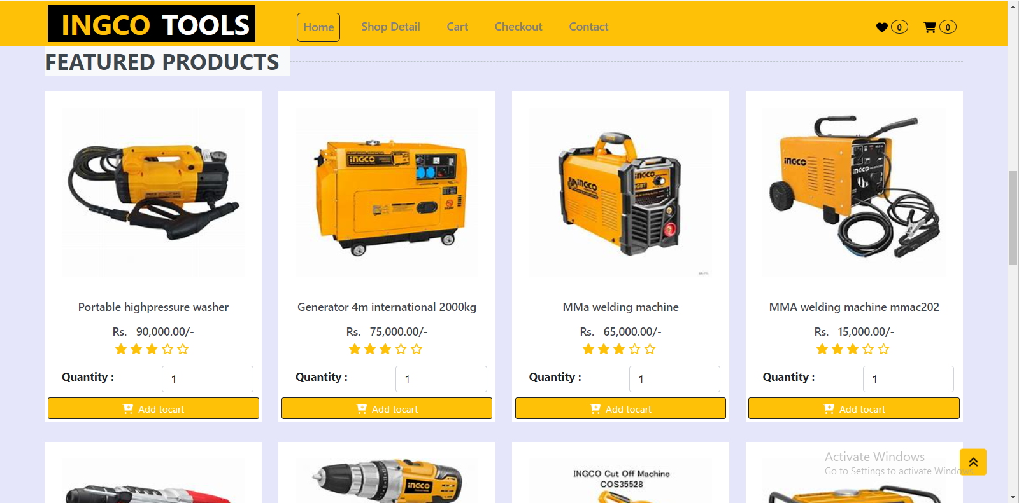
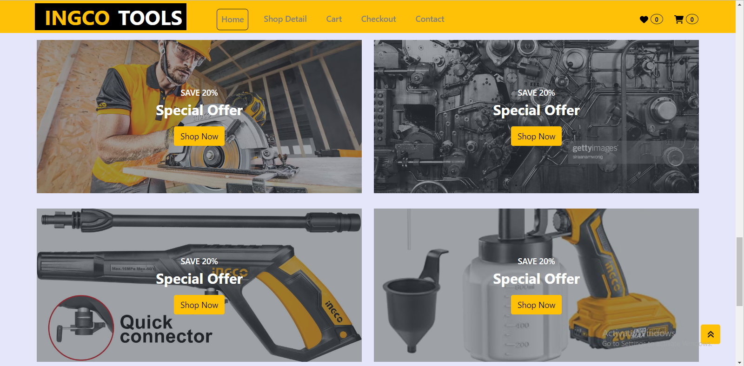

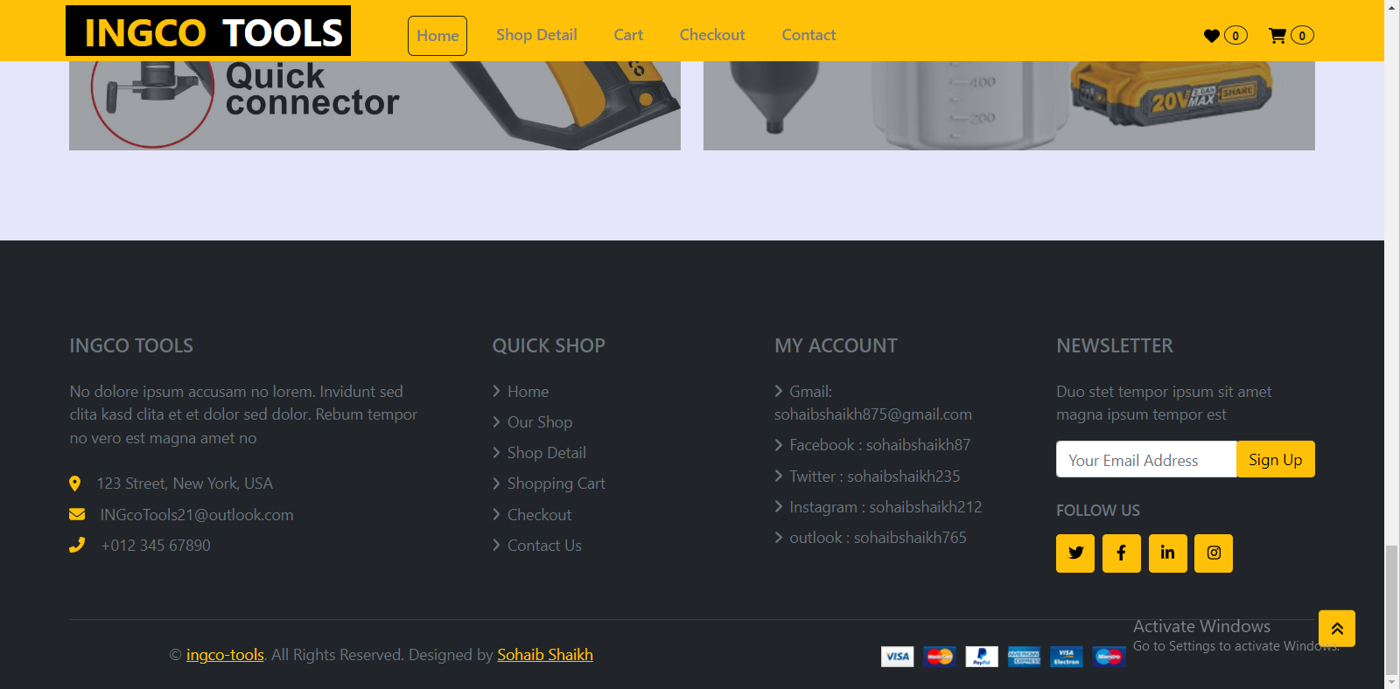
3

project: specification – website- biography

2.Cart detail (2.detail.php)

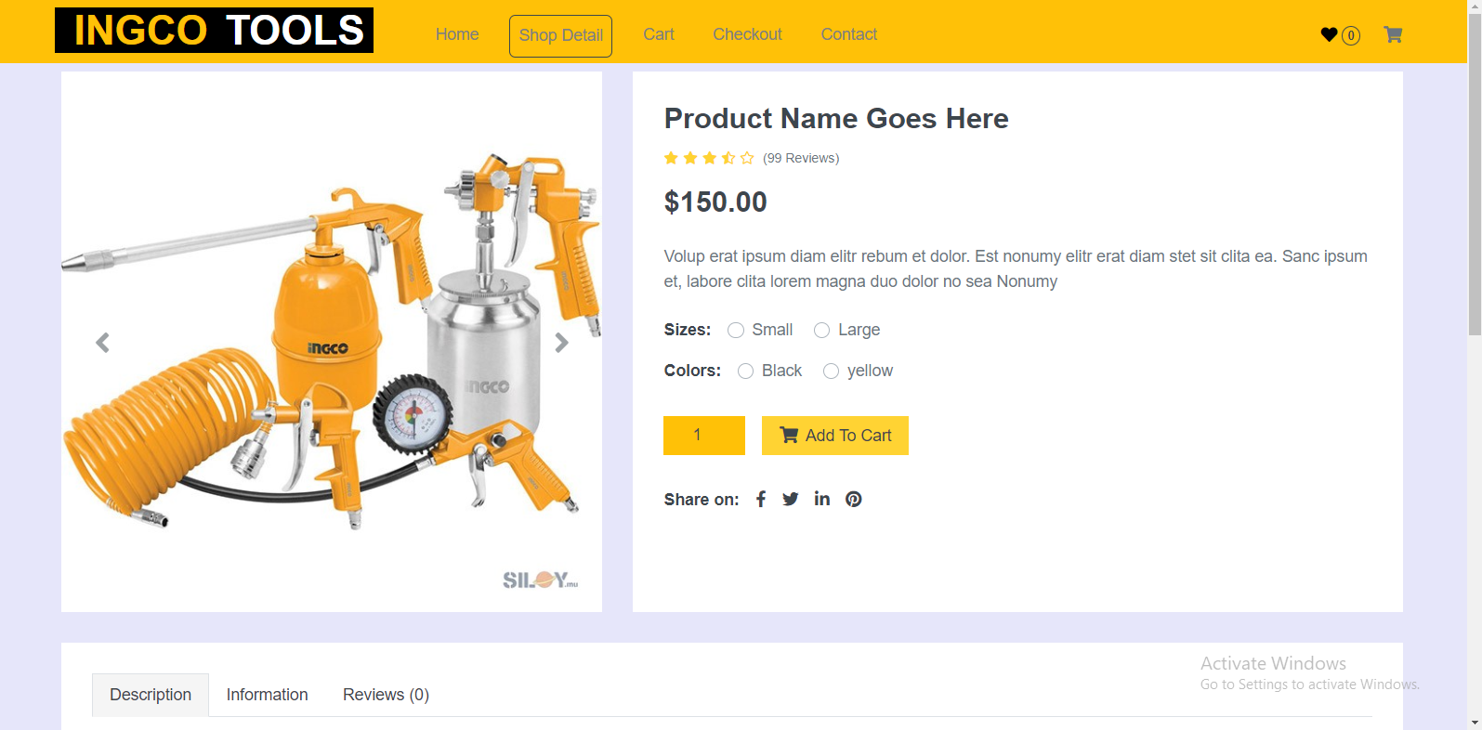

4
project: specification – website- biography

3.Cart page (2.cart.php)

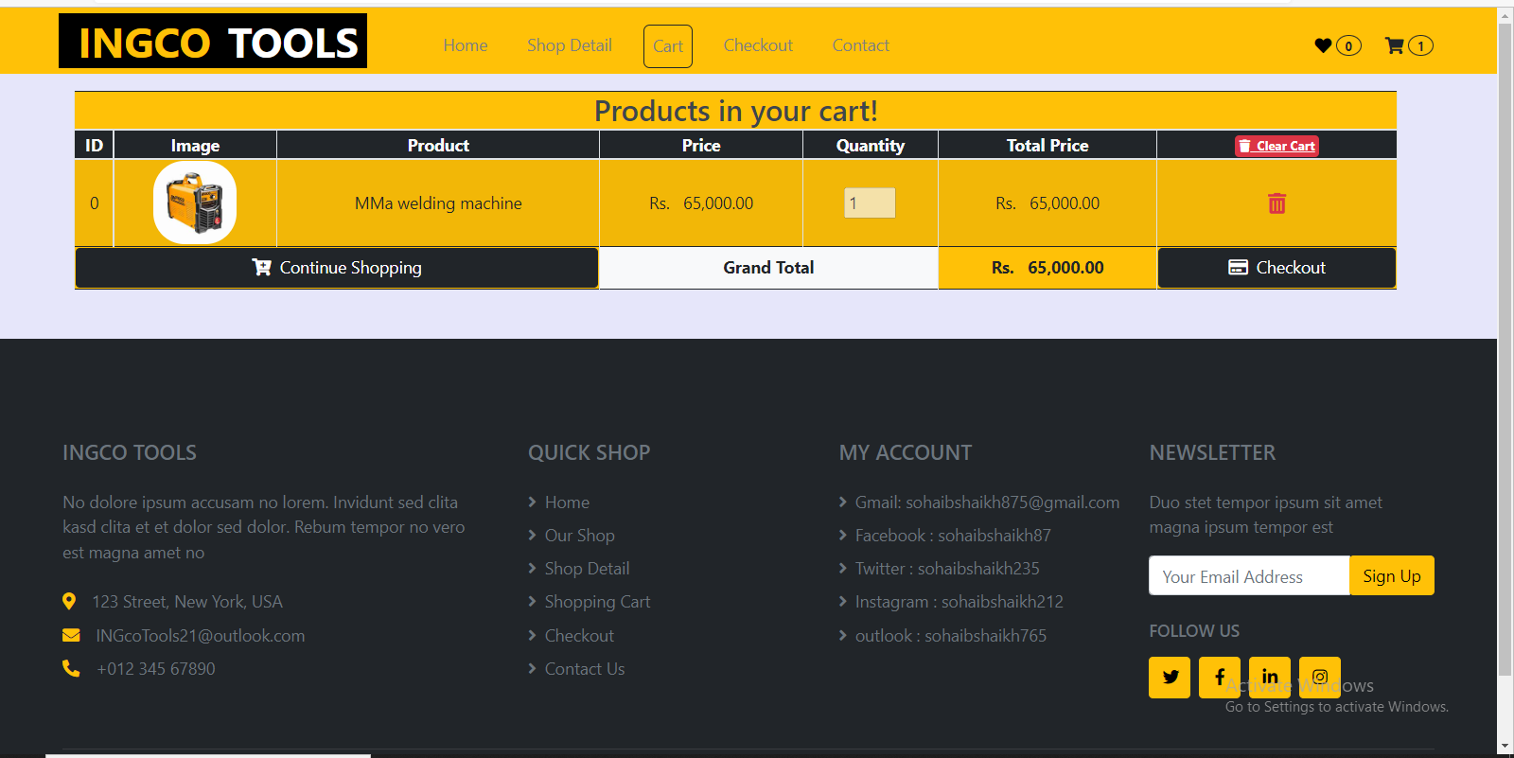

6

eProject: Aura Watches

4.Checkout page (2.Checkout.php)

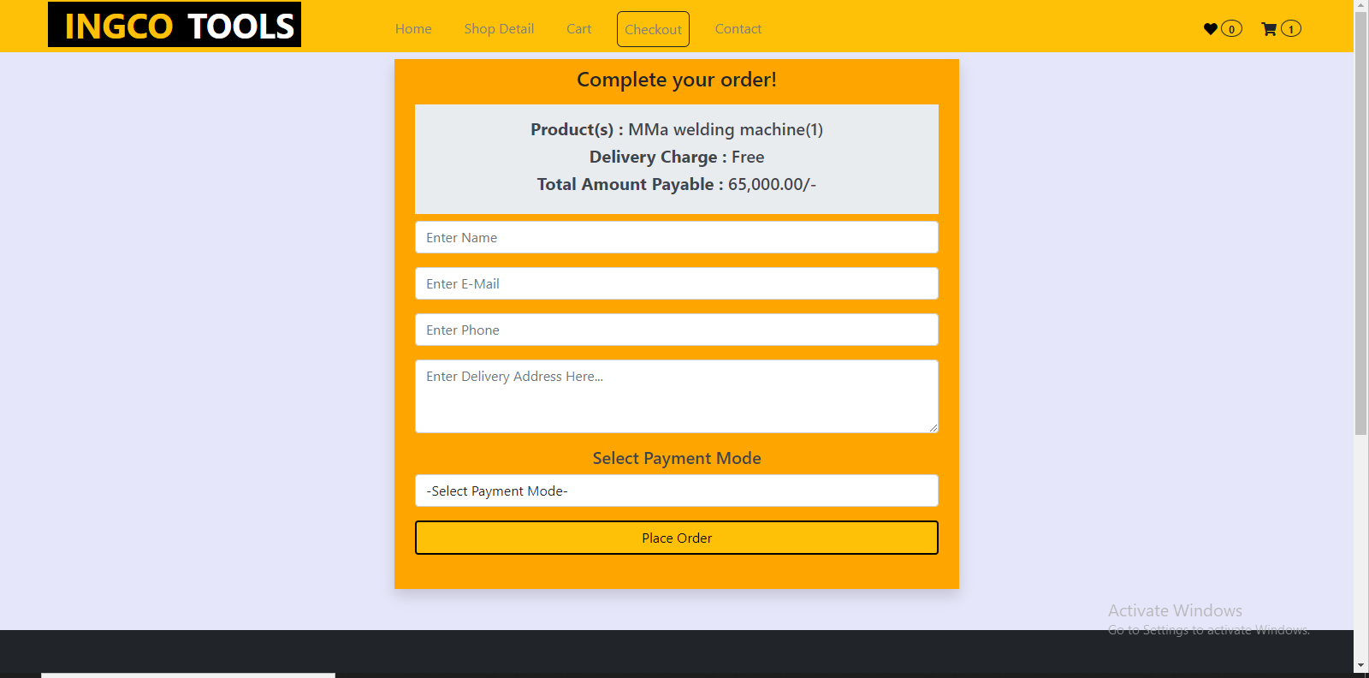

5.Contact page (2.contact.php)

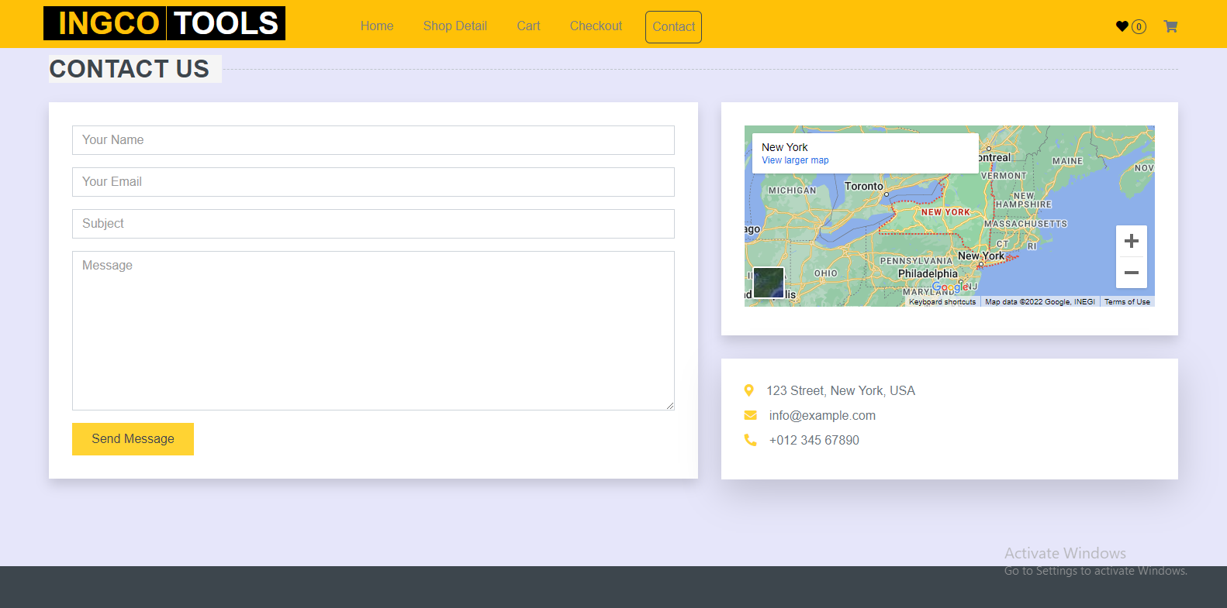

7

project: specification – website-

