Brain Buster (Style Guidelines for Final Year Project ReportsQuiz Game)

Final Year Project – Mid Report

Session 2016-2020

A 4th Year Student

A project submitted in partial fulfilment of the

COMSATS University Degree

of

BSc. (Hons.)BS in Computer Science / Software Engineering (CUI)



Department of Computer Science

COMSATS University Islamabad, Lahore Campus

24 December 2019

# Evaluation

|  |  |  |  |  |
| --- | --- | --- | --- | --- |
| **Project Group Members** (To be filled by students) | | | | (To be filled by supervisor) |
| Sr.# | Reg. # | Student Name | *Signature | Obtained Marks  (Total Marks: 10) |
| (i) | FA16-BCS-101 | Sohaib Ahmad |  |  |
| (ii) | FA16-BCS-249 | Muhammad Rizwan |  |  |
| (iii) | FA16-BCS-291 | Ali Ahmad |  |  |

*The candidates confirm that the work submitted is their own and appropriate credit has been given where reference has been made to work of others.

Supervisor Name: Ma’am Mamoona Tasadduq Supervisor Signature: ______________

Remarks (if any): ______________________________________________________________

______________________________________________________________

______________________________________________________________

# Abstract

Nowadays, e-learning and MOOCs (Massive Open Online Courses) are gaining a lot of attention. The students prefer to take online courses due to less cost, flexible learning schedule and instant view of lectures. It has been observed that many students drop out in the middle of the course. In literature, out of many reasons, lack of motivation is found to be a key factor that makes them leave the course. It is very important to keep students engaged so that they continue their learning process. A small prompt sometimes can re-engage the user. By keeping in view, we have proposed an e-learning project combining all the useful, interesting and motivating features of online learning through gaming process. It is an application of personalized based learning with gamification[1] strategies. Students take the quiz and the upcoming question is predicted while judging the student response on previous questions. The difficulty level increase as student progress through different stages and they are rewarded with badges. All track records are saved thus motivating the student to complete daily tasks. They can challenge their friends for interesting time-based quiz game. A discussion forum will be used for the discussion among students. They can also view their competitors and their standing among others using leader-board. Including some other gamified features, this quiz game will help students to improve their knowledge and get excellence in their domain. This project has the capability to master students on multiple subjects.

Table of Contents

Evaluation 2

Abstract 3

1 Introduction 11

1.1 Introduction 11

1.2 Objectives 13

1.3 Problem statement 13

1.4 Assumptions & constraints 13

1.4.1 Assumptions 13

1.4.2 Constraints 13

1.5 Project scope 13

2 Requirements Analysis 14

2.1 Literature review / Existing system study 14

2.2 Stakeholders list 14

2.3 Requirements elicitation 15

2.3.1 Functional requirements 15

2.3.2 Non-functional requirements 16

2.3.3 Requirements traceability matrix 18

2.4 Use case descriptions 20

2.4.1 Login 20

2.4.2 Signup 20

2.4.3 Take quiz 21

2.4.4 Challenge a Friend 22

2.4.5 Discussion board 23

2.4.6 Weekly quiz 24

2.5 Use case design 25

2.5.1 General 25

2.5.2 Login 26

2.5.3 Signup 26

2.5.4 Take Quiz 27

2.5.5 Challenge a Friend 27

2.5.6 Discussion Board 28

2.5.7 Upload Question 28

2.5.8 Weekly quiz 29

2.6 Software development life cycle model 30

3 System Design 31

3.1 Work breakdown structure (WBS) 31

3.2 Activity diagram 32

3.2.1 Login 32

3.2.2 Signup 33

3.2.3 Take Quiz 34

3.2.4 Challenge a friend 35

3.2.5 Discussion board 36

3.2.6 Take weekly quiz 37

3.2.7 Upload question 38

3.3 Sequence diagram 39

3.3.1 Login 39

3.3.2 Signup 40

3.3.3 Take quiz 41

3.3.4 Challenge a friend 42

3.3.5 Discussion board 43

3.3.6 Take weekly quiz 44

3.3.7 Upload question 45

3.4 Software architecture 46

3.5 Class diagram 46

3.6 Database diagram 47

3.7 Network diagram (Gantt chart) 47

3.8 Collaboration diagram 48

3.8.1 Login 48

3.8.2 Signup 49

3.8.3 Take quiz 49

3.8.4 Upload question 50

4 System Testing 50

4.1 Test cases 50

4.1.1 Login 50

4.1.2 Signup 51

4.1.3 Take Quiz 51

4.1.4 Challenge a Friend 52

4.1.5 Discussion board 53

4.1.6 Take weekly quiz 53

4.1.7 Upload question 54

4.2 Unit / integration / acceptance testing 54

4.2.1 Unit testing 54

4.2.2 Integration testing 54

4.2.3 System testing 54

4.2.4 Acceptance testing 55

5 Conclusion 55

5.1 Problems faced and lessons learned 55

5.2 Project summary 55

5.3 Future work 55

6 References 55

**List of Tables**

Table 1: Functional Requirement "Administrator" 15

Table 2: Functional requirements "Student Perspective" 16

Table 3: Non-functional requirements 18

Table 4: Requirements traceability matrix 19

Table 5:Use case description "Login." 20

Table 6: Use case description "Signup." 21

Table 7: Use case Description "Take quiz." 22

Table 8: Use case description "Challenge a friend" 23

Table 9: Use case description "Discussion board." 24

Table 10: Use case description "Weekly quiz." 25

Table 11: Test case "Login" 51

Table 12: Test case "Signup" 51

Table 13: Test case "Take quiz" 52

Table 14: Test case "Challenge a friend." 52

Table 15: Test case "Discussion board." 53

Table 16: Test case "Take weekly quiz" 53

Table 17: Test case "Upload question." 54

**List of Figures**

Figure 1: use case diagram "General." 25

Figure 2: use case diagram "Login." 26

Figure 3: use case diagram "Signup." 26

Figure 4: use case diagram "Take quiz." 27

Figure 5: use case diagram "Challenge a friend." 27

Figure 6: use case diagram "Discussion board." 28

Figure 7: use case diagram "Upload question." 28

Figure 8: use case diagram "Weekly quiz." 29

Figure 9: Software development life cycle 30

Figure 10: Work breakdown structure 31

Figure 11: Activity diagram "Login." 32

Figure 12: Activity diagram "Signup" 33

Figure 13: Activity diagram "Take quiz" 34

Figure 14: Activity diagram "Challenge a friend." 35

Figure 15: Activity diagram "Discussion board" 36

Figure 16:: Activity diagram "Weekly quiz." 37

Figure 17: Activity diagram "Upload question" 38

Figure 18: Sequence diagram "Login" 39

Figure 19: Sequence diagram "Signup" 40

Figure 20: Sequence diagram "Take quiz" 41

Figure 21: Sequence diagram "challenge a friend" 42

Figure 22: Sequence diagram "Discussion board" 43

Figure 23: Sequence diagram "Take weekly quiz" 44

Figure 24: Sequence diagram "Upload question" 45

Figure 25: Class Diagram 46

Figure 26: Database Diagram 47

Figure 27: Gantt chart details 47

Figure 28: Gantt chart 48

Figure 29: Collaboration diagram "Login" 48

Figure 30: Collaboration diagram "Signup" 49

Figure 31: Collaboration diagram "Take quiz" 49

Figure 32: Collaboration diagram "Upload question" 50

# Introduction

## Introduction

This project is a web-based application. The main goal of this project is to engage students while learning a particular course. The purpose of this project is to motivate them to learn the concepts of their core subjects. It is an application of personalized learning[2], in which the learning experience is different for every student enrolled in the same course. We have used gamification, which is the use of game design elements in a non-game context, to engage and motivate students.

This tool will not only help the students in practising the core concepts of the course but also provide them with the platform to participate in a challenge with their peers/competitors enrolled in the same course. It will in increasing the engagement with the tool.

The daily quiz challenges will motivate and engage the students to complete multiple challenges and earn rewards. If a student faces any difficulty in attempting a quiz, then he/she will be provided with video tutorials to enhance learning.

The features upholding our project are described as under.

* Students can take a quiz based on different difficulty levels and different stages within each level. The machine will decide whether a student qualifies for the next difficulty or not. After every level, a rapid-fire round start which will review most of the concepts learned by previous completed round.
* Students can upload queries with specific tags (e.g. if/else, for loop etc) in the discussion forum and they will be categorized in forum according to their tags. Students will collaborate to answer the queries which will improve their learning concept.
* Students’ progress through different levels which will increase in difficulty as their skills improve. Within each level, students will undergo different stages. Their track record, including earned points and number of days practised in a row, will be maintained to encourage students to return every day.
* A Feedback system is provided to students to take a review of the type of problems they are facing in the series of questions. The more students interact with the application, the more points they will earn.
* Every student will have a badge, representing his/her rank within the quiz game. They will earn rewards as they progress throughout the game with a minimum effort. This will motivate them to return and complete daily tasks.
* A leader board will be displayed to all students to view their standing, among others. The leader board will engage them in earning points to improve ranking.
* Weekly challenges can also be added depending on availability of time.
* Students can challenge their online friends for a rapid-fire challenge. There will be ten questions, and sixty seconds will be provided for each question to solve. The wrong answer will deduct one mark and the right answer will increase one mark. One who solves all questions first with a greater number of points wins.

During the project, the students will undergo such activities which will increase the motivation of students and engage them in interesting activities. It may help in the retention of students towards educational activities thus they will not drop out from the course.

## Objectives

* Our main objective is to keep motivation among students while learning online.
* Provide a platform for students to learn the concepts for a course.
* A user-friendly system where students can get straight to the course material without wasting any time on the internet.
* A platform where students can fast learn the concepts while going through the gamified quiz game.

## Problem statement

Everyone like online learning but the problem arises when they don’t get their desired course contents online. The biggest problem faced by the students is that they lack motivation during the course and drop out. Some of them find it much easier to solve, and some find it very difficult. While some find it extremely boring

Our proposed project is a solution to all these problems as it consists of different difficulty levels for different students while implementing personalized learning. The gamification process is used to engage students in different activities while performing the quiz. Students earn points, rewards and badges as they progress through the game.

## Assumptions & constraints

### Assumptions

* We assume that tools and technologies are present for students to operate this software.
* We assume that the students are well aware of using a web-based application.

### Constraints

* As this is web-based software, so it needs an active internet connection to operate.
* A student should be registered in a course to use the software.

## Project scope

The quiz game is a web-based application in which a system will be provided to students to learn new concepts by engaging in multiple activities of a gamified quiz. Students will take a quiz of their respective courses and it will be a personalized experience for them as everyone will attempt questions based on their previous experience.

They will be able to challenge their friends on multiple course stages, and a leader board will be provided to view their ranking among others. The variation in rankings will keep them motivated throughout the course.

# Requirements Analysis

## Literature review / Existing system study

‘Duolingo’[3] is a web application which works on the concept of personalized learning and gamification. This platform trains its user to learn multiple languages. It awards them with badges and reward and takes feedback, and a leader board is also present for user ranking within the game.

Another application is ‘Quizizz’[4]. In this application teacher from worldwide made quizzes related to many subjects and they are ready to play. Students can take a quiz to learn the concept of some topic. They can challenge their friends, and their game record is saved. But there is no classroom environment like in our project. We will provide class enrolment system which is monitored by the specific teacher, and class performance is recorded.

There is an application called ‘Khan Academy’[5]. It is free and provides video lectures for multiple concepts. The student learns one concept and moves on to the other. Not much gamification is found in it.

Our work is related to these applications, and we are using this process for learning the purpose of some academic syllabus of specific monitored class via a quiz.

The author in [1][6], discussed the connection between gamification and education. He collected and analyzed 120 papers published on gamification between 2011 and 2014. These originate from different countries from primary school to higher education. These papers were classified on the basis of the target population, kinds of educational content delivered, the tools installed and type of research (experimental vs theoretical).

The results showed widely accepting of the gamification process in education. The author also stated that from the past few years this process becomes clear in the minds of researchers. The term gamification was also used as a synonym for Game-Based Learning as an educational strategy treated globally as a game or competition.

## Stakeholders list

**Admin / Teachers:**

* Teachers can add or delete a course, delete any student if he/she violates any rules.

**Student:**

* Student can login/ signup.
* Can register in multiple courses.
* Can take a quiz.
* Can take video lectures.
* Can challenge a friend.
* Can discuss problems with the community.

## Requirements elicitation

### Functional requirements

#### Administrative Perspective

|  |  |
| --- | --- |
| **FR-01** | **Login** |
| FR-01-01 | Admin will enter email address and password to login the system. Only one admin can log in at a time. |
| **FR-02** | **Update Student** |
| FR-02-01 | Admin can update the info of any student and remove any student from the registered course. |
| **FR-03** | **Update course** |
| FR-03-01 | Admin can add/delete any course and add data in any course. |
| **FR-03** | **Sign-out** |
| FR-03-01 | Admin can log out at any time. |

Table 1: Functional Requirement "Administrator"

#### Student Perspective

|  |  |
| --- | --- |
| **FR-01** | **Login** |
| FR-01-01 | Students can log in by entering username and password |
| **FR-02** | **Signup** |
| FR-02-01 | Only one client can be registered under a unique email and contact number. |
| FR-02-02 | Every student needs a unique email address, username and contact number to register. |
| **FR-03** | **Take quiz** |
| FR-03-01 | Students can take a quiz based on specific course and levels. |
| FR-03-02 | Students can retake quiz of any course level. |
| **FR-04** | **Challenge a friend** |
| FR-04-01 | Students can challenge their friends registered in the same course. |
| **FR-05** | **Discussion board** |
| FR-05-01 | Students can add queries in a discussion board or ask for help related to course. |
| FR-05-02 | Students can answer related queries in the discussion board. |
| **FR-06** | **Weekly quiz** |
| FR-06-01 | Students can take a weekly quiz to improve the in-game score and improve learning. |
| **FR-07** | **Leader board** |
| FR-07-01 | Students can see their standings in the leader board. |
| **FR-08** | **Logout** |
| FR-08-01 | Students can logout the system at any time. |

Table 2: Functional requirements "Student Perspective"

### Non-functional requirements

|  |  |
| --- | --- |
| **NFR-01** | **Security** |
| NFR-01-01 | All of the data must be secured and should not be leaked. |
| NFR-01-02 | Only authorised users can access the Student’s data. |
| **NFR-02** | **Performance** |
| NFR-02-01 | User’s queries should be resolved quickly. |
| NFR-02-02 | The loading time of the system should be low. |
| NFR-02-03 | The system should be responsive on all devices. |
| **NFR-03** | **Reliability** |
| NFR-03-01 | The system should work in all states without crashing. |
| NFR-03-02 | The system should mention if any error occurs. |
| **NFR-04** | **Availability** |
| NFR-04-01 | The system should be accessible all the time without any downtime. |
| NFR-04-02 | Users can only be accessed the authorised features. |
| **NFR-05** | **Discoverability** |
| NFR-05-01 | The interface should be user-friendly, and all the necessary features should be available on the dashboard. |
| NFR-05-02 | Even novice users can use all the features. |
| NFR-05-03 | Newly added features should be easily accessible. |
| **NFR-06** | **Portability** |
| NFR-06-01 | The system should be working in all major browsers like Chrome, Firefox, Safari etc. |
| NFR-06-02 | The system should have cross-platform compatibility, should work on both windows and android devices. |
| **NFR-07** | **Maintainability** |
| NFR-07-01 | The system should be maintained at regular intervals. |
| NFR-07-02 | If any system breakdown occurs, it should be recoverable. |
| **NFR-08** | **Scalability** |
| NFR-08-01 | The system should be able to support new features in future. |
| **NFR-09** | **Data integrity** |
| NFR-09-01 | The data stored should be accurate and consistent. |

Table 3: Non-functional requirements

### Requirements traceability matrix

|  |  |  |  |  |  |  |
| --- | --- | --- | --- | --- | --- | --- |
| Requirement Id | Requirement Description | Test Case Id | Test Case  Scenario | Test Case | Status | Test Case Technique |
| FR-01 | Log in | TC-01 | Log in | Test whether a student can log in or not. | Pass | Use Case Testing |
| FR-02 | Signup | TC-02 | Signup | Test whether a student can register or not. | Pass | Use Case Testing |
| FR-03 | Take quiz | TC-03 | Take quiz | Test whether a student can attempt quiz or not. | Pass | Use Case Testing |
| FR-04 | Challenge a friend | TC-04 | Challenge a friend | Verify whether the student | Pass | Use Case Testing |
| FR-05 | Discussion board | TC-05 | Discussion board | Verify whether the student was able to post a question in a discussion board or not. | Pass | Use Case Testing |
| FR-06 | Weekly quiz | TC-06 | Weekly quiz | Test whether a student can attempt a weekly quiz or not. | Pass | Use Case Testing |
| FR-07 | Leader board | TC-07 | Leader board | Verify  whether the  the student was able to see the ranking in leader board or not. | Pass | Use Case Testing |
| FR-09 | Logout | TC-09 | Logout | Verify  whether the  the student was able to  Successfully logout or not. | Pass | Use Case Testing |

Table 4: Requirements traceability matrix

## Use case descriptions

### Login

|  |  |  |  |  |  |
| --- | --- | --- | --- | --- | --- |
| Use case ID: | | 001 | Use case Name: | | Login |
| Priority: | | High | | | |
| Actor: | | Admin, Student | | | |
| Use case Summary: | | This use case will allow the user to enter login credentials and access the dashboard. | | | |
| Pre-conditions: | | Student and admin must have an account to log in. | | | |
| **Normal Flow of Path** | | | | **Alternative Path** | |
| 1. The use case starts when the user accesses the login screen. | | | |  | |
| 1. The user will enter the username and password in the given fields. | | | |  | |
| 1. The user clicks on the login button. | | | | **3a:** If the username or password is incorrect, an error message will be displayed.  **3b**: The webpage will refresh with empty fields for the user to try again. | |
| 1. The dashboard will be displayed to the user to perform its authorised tasks. | | | |  | |
| 1. This use case ends. | | | |  | |
| Post-conditions: | | | | | |
| **Step no #** | **Description:** | | | | |
| **1.** | Now the user can perform authorized tasks. | | | | |
| Use case Cross References: | | | | | |
| **Includes** | Enter username, enter password. | | | | |
| **Extends** | Forget Password. | | | | |

Table 5:Use case description "Login."

### Signup

|  |  |  |  |  |  |
| --- | --- | --- | --- | --- | --- |
| Use case ID: | | 002 | Use case Name: | | Signup |
| Priority: | | Medium | | | |
| Actor: | | Student | | | |
| Use case Summary: | | This use case will allow the user to create an account. | | | |
| Pre-conditions: | | Username, email and contact must be unique. | | | |
| **Normal Flow of Path** | | | | **Alternative Path** | |
| 1. This use case will start when the user selects the signup button. | | | |  | |
| 1. The user will be displayed a username, email, contact number and password fields with a signup button. | | | |  | |
| 1. The user selects the signup button on the website after filling the fields. | | | | 3a: If the username already exists error message will be displayed.  3b: If the password is not following constraints, an error message will be displayed.  3c: The webpage will be reset with empty fields for the user to try again. | |
| 1. The login page will be displayed to the student to login to the application. | | | |  | |
| 1. This use case ends. | | | |  | |
| Post-conditions: | | | | | |
| **Step no #** | **Description:** | | | | |
| **1.** | Now the user can view the home page with the dashboard. | | | | |
| Use case Cross References: | | | | | |
| **Includes** | Create a username, Create password, Validation | | | | |
| **Extends** | Login | | | | |

Table 6: Use case description "Signup."

### Take quiz

|  |  |  |  |  |  |
| --- | --- | --- | --- | --- | --- |
| Use case ID: | | 003 | Use case Name: | | Take quiz |
| Priority: | | High | | | |
| Actor: | | Student | | | |
| Use case Summary: | | This use case will allow the user to take the quiz of the registered course. | | | |
| Pre-conditions: | | User must log in | | | |
| **Normal Flow of Path** | | | | **Alternative Path** | |
| 1. This use case will start when the user selects the quiz option from the dashboard. | | | |  | |
| 1. The user selects whether he/she wants to continue with quiz progress or retake any quiz. | | | |  | |
| 1. The user will start taking the quiz by clicking on start quiz button. | | | | 3a: If a user wants to leave the quiz, he/she will click on End Quiz button.  3b: If a user wants to logout, he/she can click on logout button in the sidebar to directly logout the application. | |
| 1. After completing all the questions student will return to the dashboard. | | | |  | |
| 1. This use case ends. | | | |  | |
| Post-conditions: | | | | | |
| **Step no #** | **Description:** | | | | |
| **1.** | Now the user can take another quiz. | | | | |
| Use case Cross References: | | | | | |
| **Includes** | Login, Select course | | | | |
| **Extends** | Sign-out | | | | |

Table 7: Use case Description "Take quiz."

### Challenge a Friend

|  |  |  |  |  |  |
| --- | --- | --- | --- | --- | --- |
| Use case ID: | | 004 | Use case Name: | | Challenge a friend |
| Priority: | | Medium | | | |
| Actor: | | Student | | | |
| Use case Summary: | | This use case will allow the user to challenge a friend registered in the same course. | | | |
| Pre-conditions: | | User must log in | | | |
| **Normal Flow of Path** | | | | **Alternative Path** | |
| 1. This use case will start when the user selects challenge a friend option from the dashboard. | | | |  | |
| 1. The user selects the course, stage and friend to whom he/she wants to challenge | | | |  | |
| 1. The user will start taking the challenge by clicking on start challenge button. | | | | 3a: If a user wants to leave the challenge, he/she will click on End Challenge button.  3b: If a user wants to logout, he/she can click on logout button in the sidebar to directly logout the application. | |
| 1. After completing all the questions in the challenge, a result will be shown and the student will return to the dashboard. | | | |  | |
| 1. This use case ends. | | | |  | |
| Post-conditions: | | | | | |
| **Step no #** | **Description:** | | | | |
| **1.** | Now the user can take a quiz or challenge another friend. | | | | |
| Use case Cross References: | | | | | |
| **Includes** | Login, select course, select Stage | | | | |
| **Extends** | Sign-out | | | | |

Table 8: Use case description "Challenge a friend"

### Discussion board

|  |  |  |  |  |  |
| --- | --- | --- | --- | --- | --- |
| Use case ID: | | 005 | Use case Name: | | Discussion board |
| Priority: | | Low | | | |
| Actor: | | Student | | | |
| Use case Summary: | | This use case will allow the user to ask a question in the discussion board. | | | |
| Pre-conditions: | | User must login | | | |
| **Normal Flow of Path** | | | | **Alternative Path** | |
| 1. This use case will start when the user selects the Discussion board option from the dashboard. | | | |  | |
| 1. The user selects the course for which he/she wants to add a question. | | | |  | |
| 1. The user will type the question and click on the submit button. | | | | 3a: If a user wants to logout, he/she can click on logout button in the sidebar to directly logout the application. | |
| 1. After submitting the question, the student will return to the dashboard. | | | |  | |
| 1. This use case ends. | | | |  | |
| Post-conditions: | | | | | |
| **Step no #** | **Description:** | | | | |
| **1.** | Now the user can take a quiz or ask another question in the discussion board. | | | | |
| Use case Cross References: | | | | | |
| **Includes** | Login | | | | |
| **Extends** | Sign-out | | | | |

Table 9: Use case description "Discussion board."

### Weekly quiz

|  |  |  |  |  |  |
| --- | --- | --- | --- | --- | --- |
| Use case ID: | | 006 | Use case Name: | | Take weekly quiz |
| Priority: | | medium | | | |
| Actor: | | Student | | | |
| Use case Summary: | | This use case will allow the user to take a weekly quiz of the registered course. | | | |
| Pre-conditions: | | User must log in | | | |
| **Normal Flow of Path** | | | | **Alternative Path** | |
| 1. This use case will start when the user selects the weekly quiz option from the dashboard. | | | |  | |
| 1. The user will start taking the quiz by clicking on start quiz button. | | | | 3a: If a user wants to leave the quiz, he/she will click on End Quiz button.  3b: If a user wants to logout, he/she can click on logout button in the sidebar to directly logout the application. | |
| 1. After completing all the questions student will return to the dashboard. | | | |  | |
| 1. This use case ends. | | | |  | |
| Post-conditions: | | | | | |
| **Step no #** | **Description:** | | | | |
| **1.** | Now the user can take a regular quiz. | | | | |
| Use case Cross References: | | | | | |
| **Includes** | Login | | | | |
| **Extends** | Sign-out | | | | |

Table 10: Use case description "Weekly quiz."

## Use case design

### General

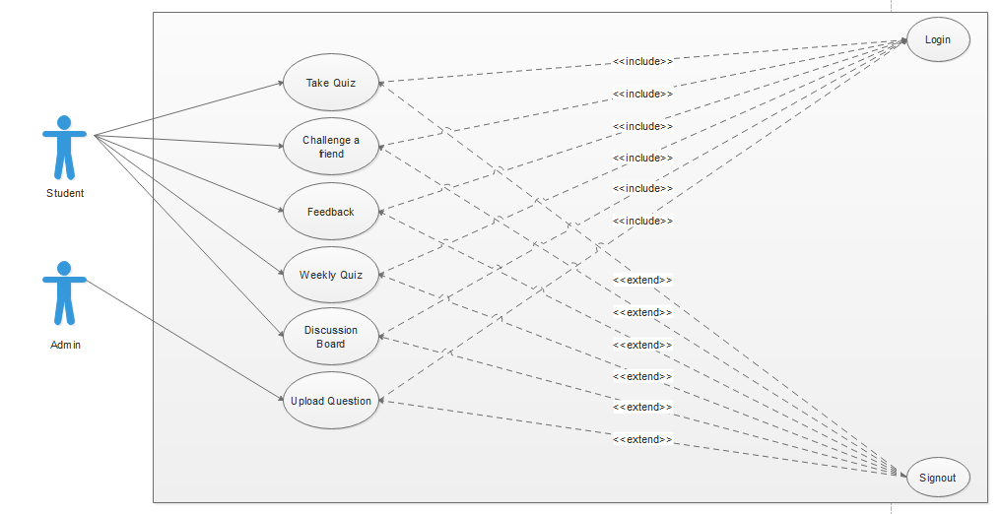

Figure 1: use case diagram "General."

### Login

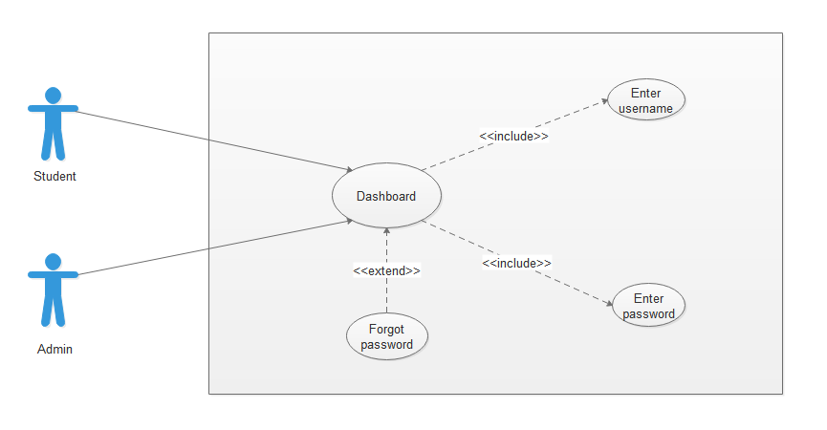

Figure 2: use case diagram "Login."

### Signup

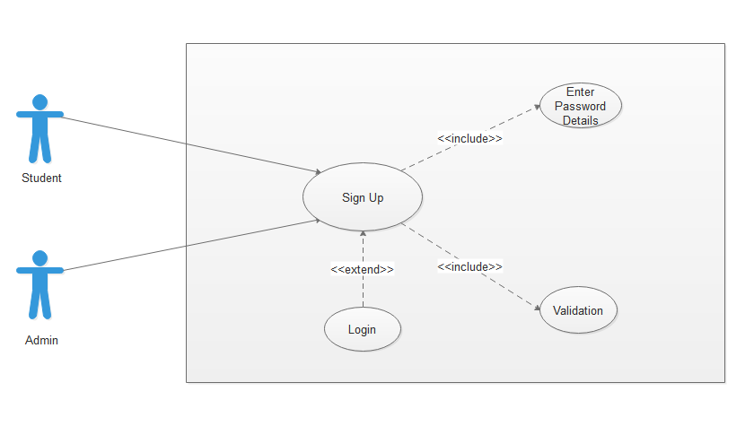

Figure 3: use case diagram "Signup."

### Take Quiz

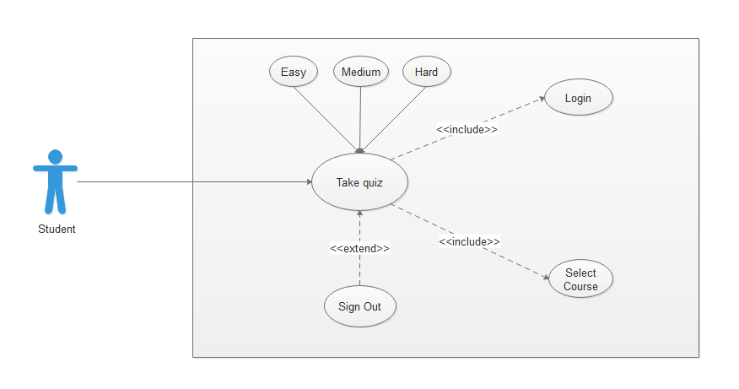

Figure 4: use case diagram "Take quiz."

### Challenge a Friend

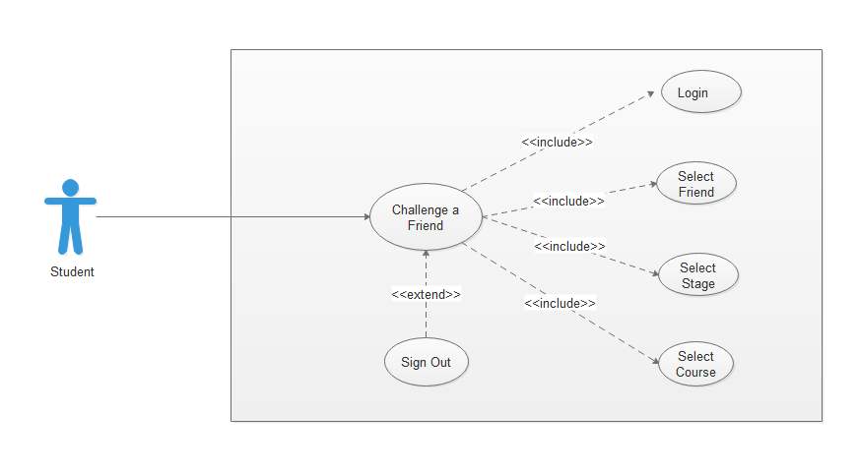

Figure 5: use case diagram "Challenge a friend."

### Discussion Board

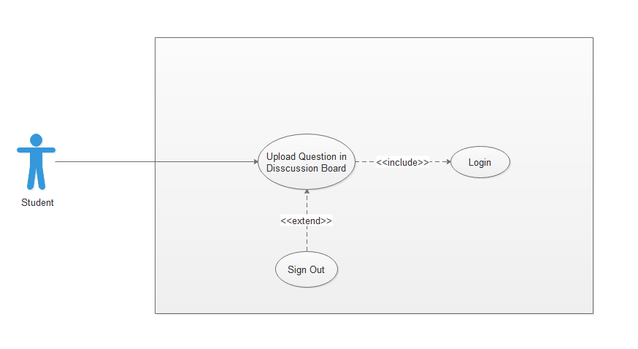

Figure 6: use case diagram "Discussion board."

### Upload Question

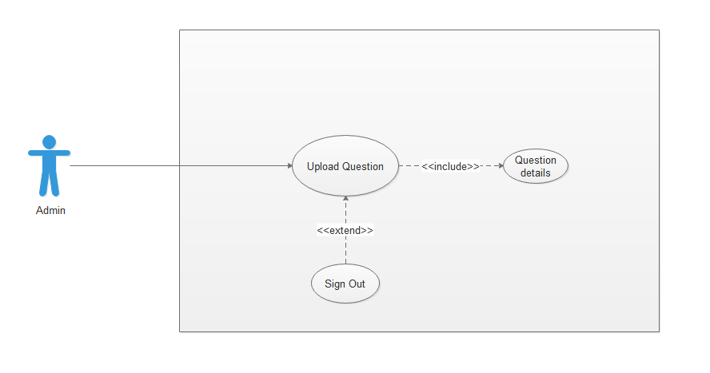

Figure 7: use case diagram "Upload question."

### Weekly quiz

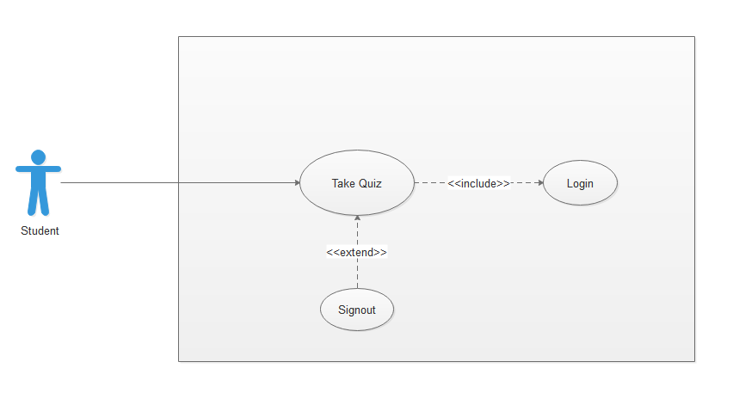

Figure 8: use case diagram "Weekly quiz."

## Software development life cycle model

For this project, we have chosen the **Agile Model.**

Agile Software Development Cycle modelis an iterative method of development**.** The user gives feedback at the end of each iteration. After the feedback, the next iteration starts and the process is repeated. So, it is an incremental process. We check after each increment that our goal is completed or not.

[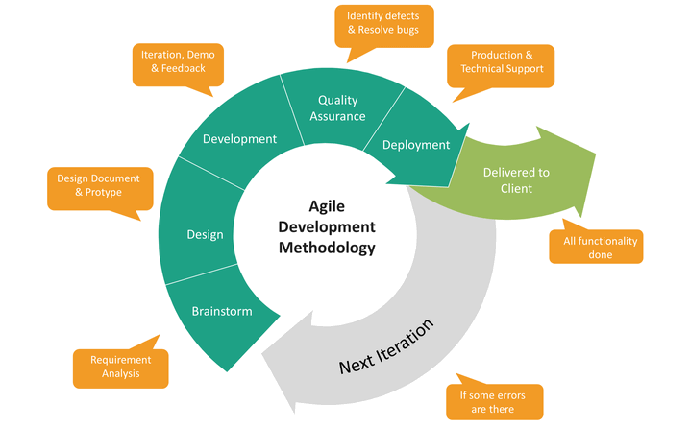](https://chercher.tech/images/jira/agile-development-chart.png)

Figure 9: Software development life cycle[7]

# System Design

## Work breakdown structure (WBS)

Figure 10: Work breakdown structure

## Activity diagram

### Login

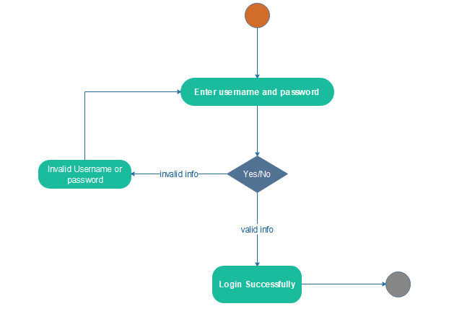

Figure 11: Activity diagram "Login."

### Signup

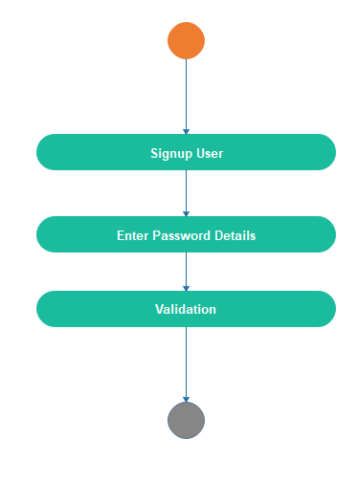

Figure 12: Activity diagram "Signup"

### Take Quiz

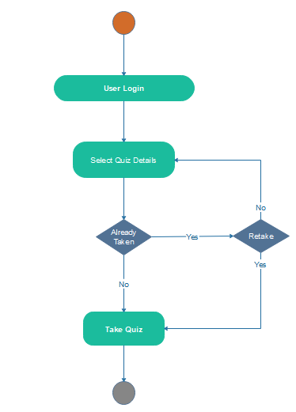

Figure 13: Activity diagram "Take quiz"

### Challenge a friend

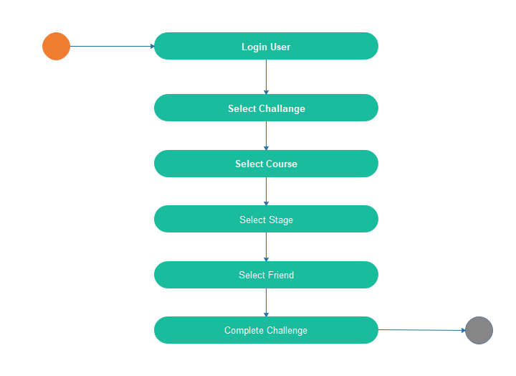

Figure 14: Activity diagram "Challenge a friend."

### Discussion board

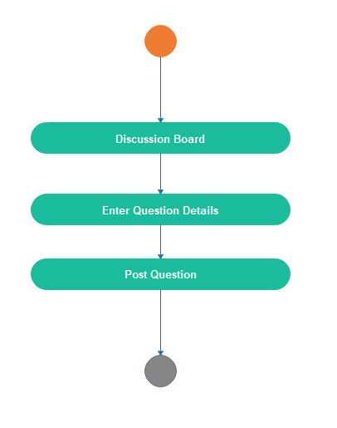

Figure 15: Activity diagram "Discussion board"

### Take weekly quiz

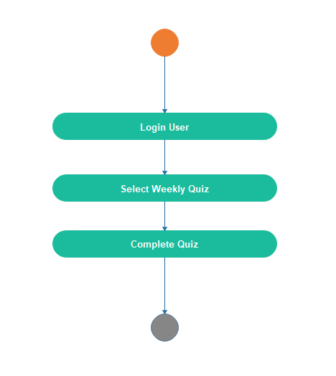

Figure 16:: Activity diagram "Weekly quiz."

### Upload question

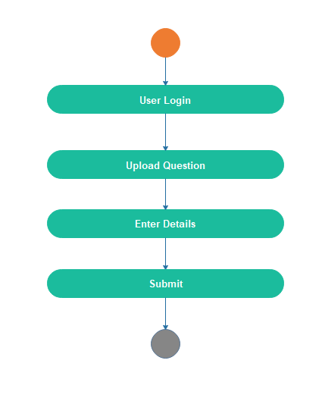

Figure 17: Activity diagram "Upload question"

## Sequence diagram

### Login

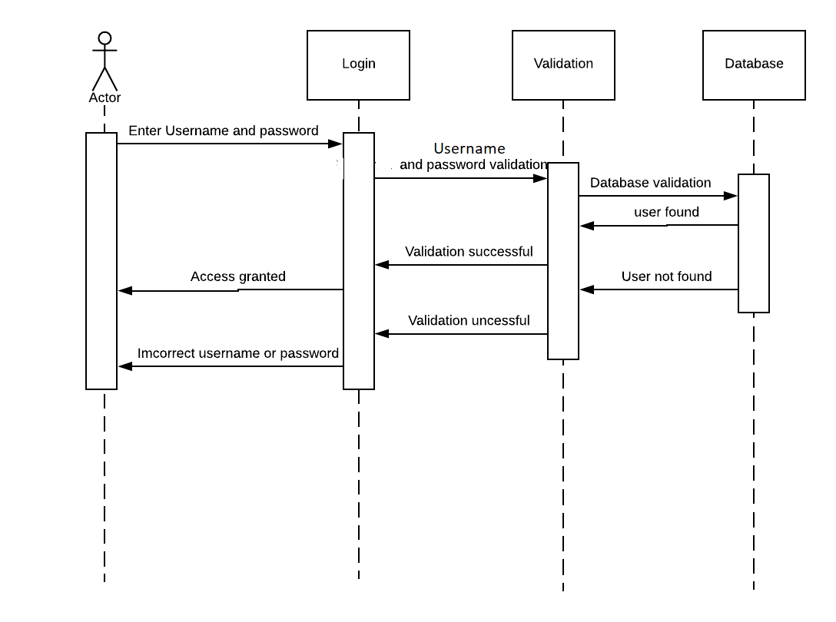

Figure 18: Sequence diagram "Login"

### Signup

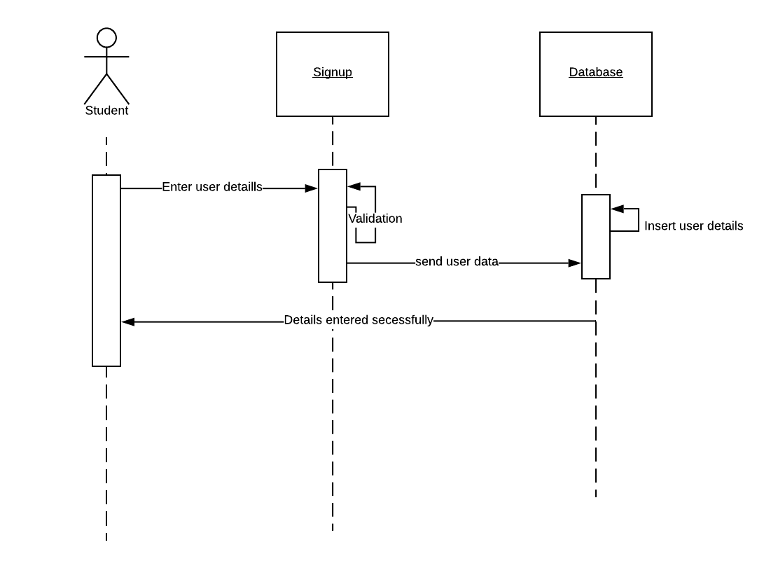

Figure 19: Sequence diagram "Signup"

### Take quiz

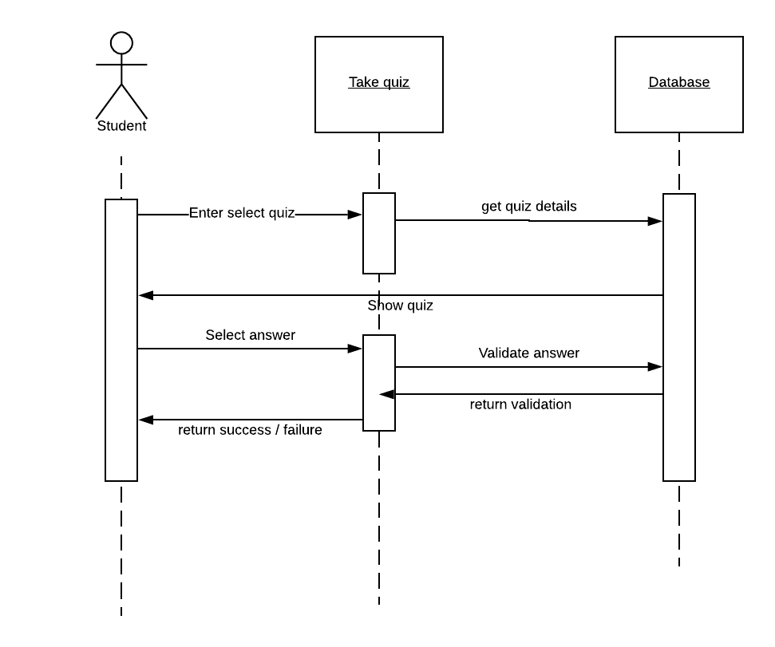

Figure 20: Sequence diagram "Take quiz"

### Challenge a friend

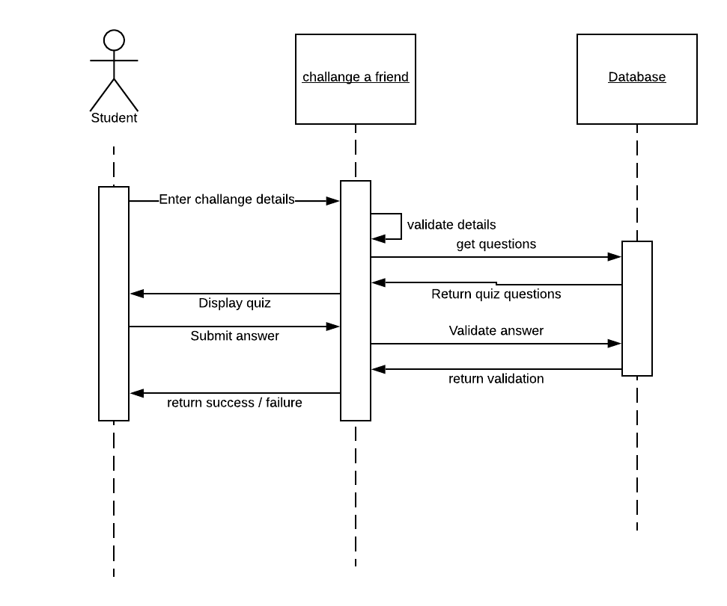

Figure 21: Sequence diagram "challenge a friend"

### Discussion board

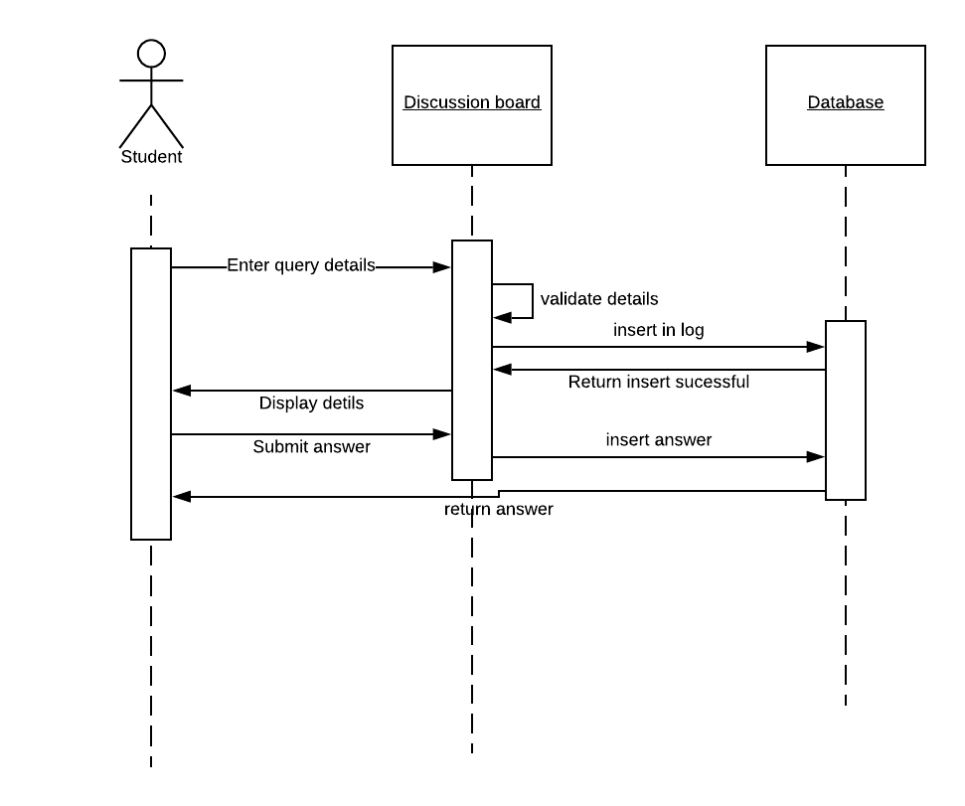

Figure 22: Sequence diagram "Discussion board"

### Take weekly quiz



Figure 23: Sequence diagram "Take weekly quiz"

### Upload question

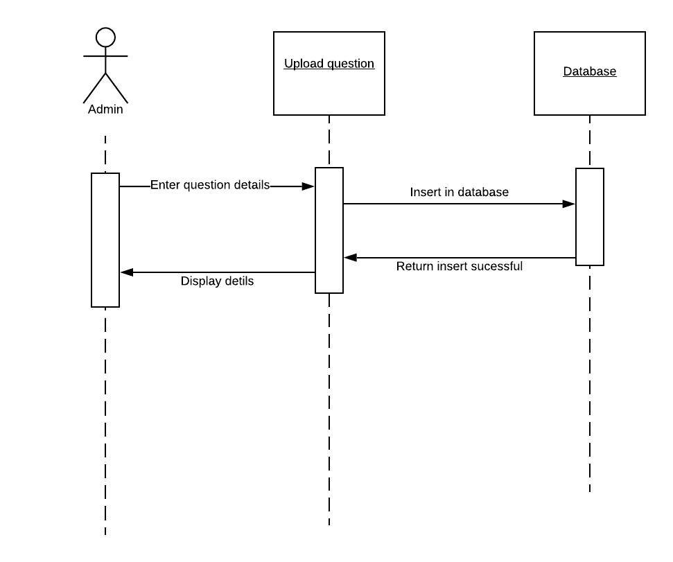

Figure 24: Sequence diagram "Upload question"

## Software architecture

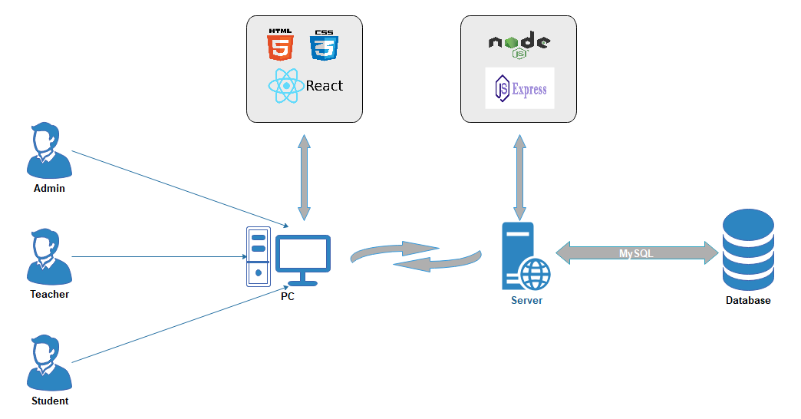

## Class diagram

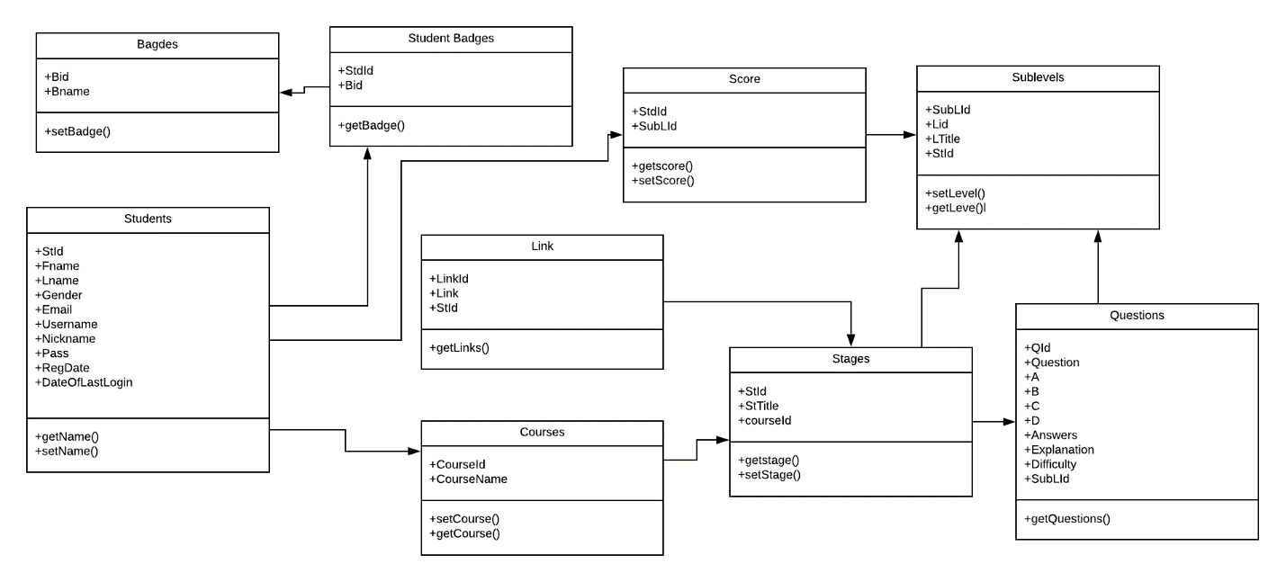

Figure 25: Class Diagram

## Database diagram

s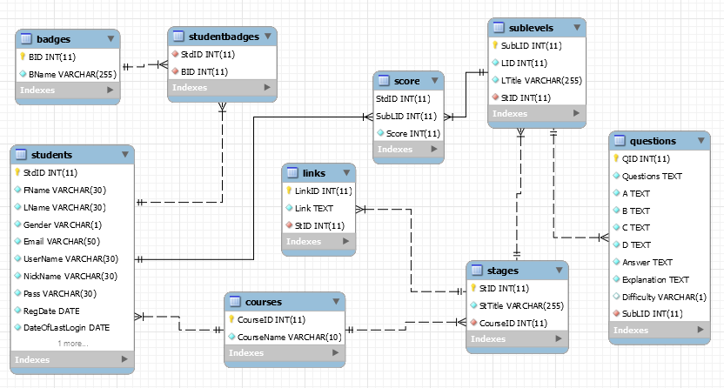

Figure 26: Database Diagram

## Network diagram (Gantt chart)

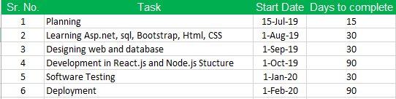

Figure 27: Gantt chart details

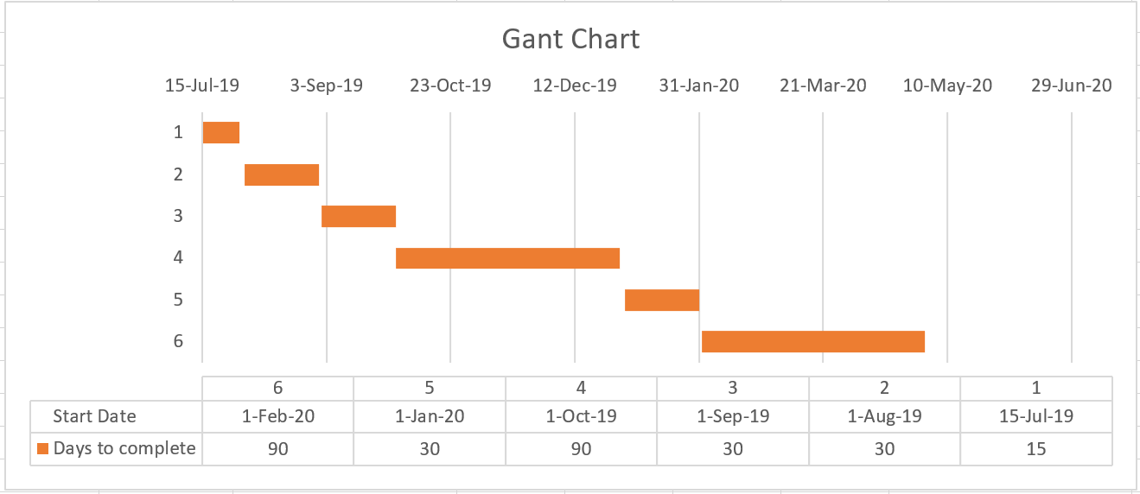

Figure 28: Gantt chart

## Collaboration diagram

### Login

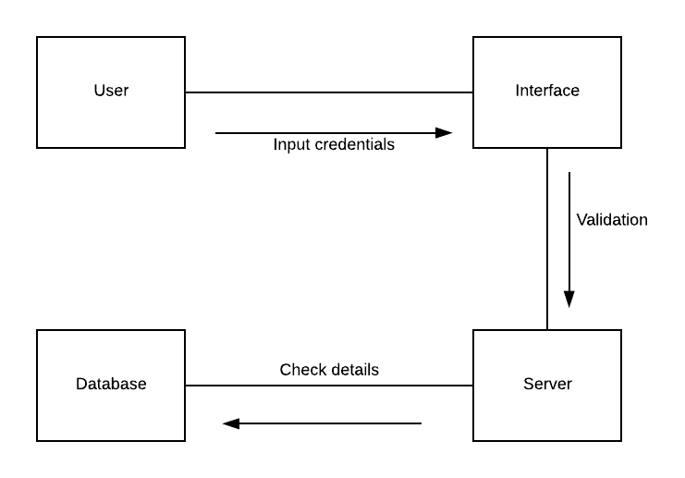

Figure 29: Collaboration diagram "Login"

### Signup

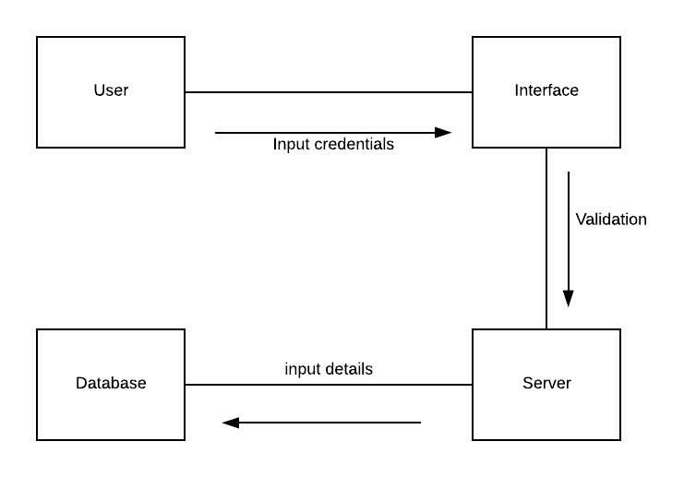

Figure 30: Collaboration diagram "Signup"

### Take quiz

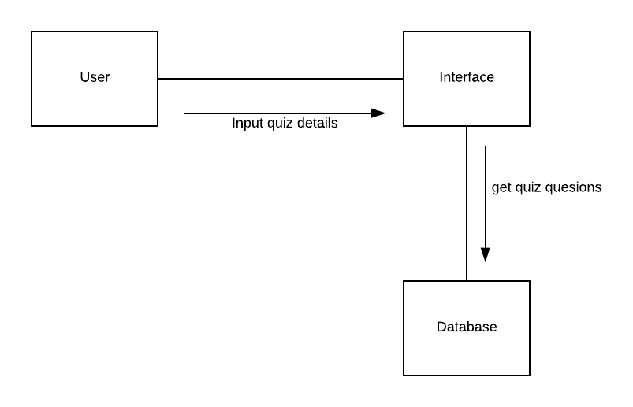

Figure 31: Collaboration diagram "Take quiz"

### Upload question

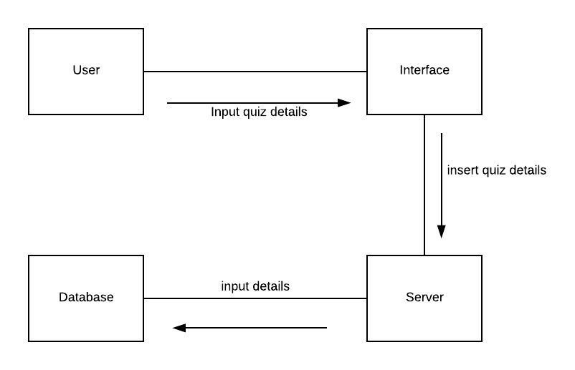

Figure 32: Collaboration diagram "Upload question"

# System Testing

## Test cases

### Login

|  |  |  |  |  |  |  |
| --- | --- | --- | --- | --- | --- | --- |
| **Test Case Id** | **Test Case**  **Scenario** | **Test Case** | **Pre-Condition** | **Test Steps** | **Post- Condition** | **Pass/Fail** |
| TC-01 | Login | To test that the user can log in or not. | The user wants to enter into the system. | 1.User visits homepage.  2. User fills the form by entering valid information.  2. User clicks on login button.  3. User will be logged in if the information provided is authenticated by the database.  4. The use case ends. | This user is successfully logged in. | Pass |

Table 11: Test case "Login"

### Signup

|  |  |  |  |  |  |  |
| --- | --- | --- | --- | --- | --- | --- |
| **Test Case Id** | **Test Case**  **Scenario** | **Test Case** | **Pre-Condition** | **Test Steps** | **Post- Condition** | **Pass/Fail** |
| TC-02 | User Signup | To test whether the user can create an account or not. | The user wants to enrol to explore the system. | 1. User visits the homepage of the site.  2. The user then clicks on the signup button.  3. User fills the form by entering valid information.  4. User press the submit button.  5. The use case ends. | The account of the user is created successfully. | Pass |

Table 12: Test case "Signup"

### Take Quiz

|  |  |  |  |  |  |  |
| --- | --- | --- | --- | --- | --- | --- |
| **Test Case Id** | **Test Case**  **Scenario** | **Test Case** | **Pre-Condition** | **Test Steps** | **Post- Condition** | **Pass/Fail** |
| TC-03 | Take quiz | To test whether the user can take a quiz or not. | The user wants to learn the course by taking the quiz. | 1.User visits dashboard.  2. User clicks on take quiz button.  3. User selects whether he/she wants to resume the quiz or retake any quiz.  4.User press the continue button.  5. The use case ends. | The user has taken the quiz successfully. | Pass |

Table 13: Test case "Take quiz"

### Challenge a Friend

|  |  |  |  |  |  |  |
| --- | --- | --- | --- | --- | --- | --- |
| **Test Case Id** | **Test Case**  **Scenario** | **Test Case** | **Pre-Condition** | **Test Steps** | **Post- Condition** | **Pass/Fail** |
| TC-04 | Challenge a friend | To test that the user can challenge friends or not. | User want to challenge a friend | 1.User visits dashboard.  2. User clicks on the challenge a friend button.  3. The user selects a course.  4. The user selects the stage.  5. The user selects a friend.  6.User press the start challenge button.  7. The use case ends. | User has successfully challenged his/her friend. | Pass |

Table 14: Test case "Challenge a friend."

### Discussion board

|  |  |  |  |  |  |  |
| --- | --- | --- | --- | --- | --- | --- |
| **Test Case Id** | **Test Case**  **Scenario** | **Test Case** | **Pre-Condition** | **Test Steps** | **Post- Condition** | **Pass/Fail** |
| TC-05 | Discussion board | To test whether the user can post queries in the discussion board. | The user wants to ask a question. | 1.User visits dashboard.  2. User clicks on the discussion board button.  3. The user selects the category for the question.  4. User post a question.  4. User press the submit button.  5. The use case ends. | User’s query was successfully posted. | Pass |

Table 15: Test case "Discussion board."

### Take weekly quiz

|  |  |  |  |  |  |  |
| --- | --- | --- | --- | --- | --- | --- |
| **Test Case Id** | **Test Case**  **Scenario** | **Test Case** | **Pre-Condition** | **Test Steps** | **Post- Condition** | **Pass/Fail** |
| TC-06 | Take weekly quiz | To test whether the user can take a weekly quiz or not. | The user wants to increase score while taking the quiz. | 1.User visits dashboard.  2. User clicks on take weekly quiz button.  3.User press the continue button.  4. The use case ends. | The user has taken the weekly quiz successfully. | Pass |

Table 16: Test case "Take weekly quiz"

### Upload question

|  |  |  |  |  |  |  |
| --- | --- | --- | --- | --- | --- | --- |
| **Test Case Id** | **Test Case**  **Scenario** | **Test Case** | **Pre-Condition** | **Test Steps** | **Post- Condition** | **Pass/Fail** |
| TC-07 | Upload question | To test that user can upload question or not. | The teacher/admin want to upload question in any course. | 1.User visits dashboard.  2. User clicks on upload question button.  3. The user selects a course.  4.User upload question details.  4. User press the submit button.  5. The use case ends. | The question was added successfully. | Pass |

Table 17: Test case "Upload question."

## Unit / integration / acceptance testing

### Unit testing

In unit testing, the components or units of a program are tested individually by testing tools. It is the first level of software testing and is performed before integration testing.

Units which we will test are:

* Quiz
* Discussion board
* Leader board

### Integration testing

After the completion of unit testing, the integration testing is done by combining one or more units as a group at a time and then applying testing tools. The purpose of this testing is to expose the faults in the interaction between the units.

### System testing

After integration testing, the system testing is done by combining all the units of a system and then testing them as a whole. This testing is done to analyse and test our system, so it meets all the requirements which were mentioned earlier in the requirements phase.

### Acceptance testing

The acceptance testing is done to check whether the system meets all the user requirements or not. It is usually done on the client’s premises. It checks whether the system is ready to be delivered or not.

# Conclusion

## Problems faced and lessons learned

* We faced connectivity issue while connecting MySQL with Node.js but eventually it was sorted out by using old mysql_native_password because caching_sha2_password is introduced in MySQL 8 but the node.js version is not implemented yet.
* We faced problem while connecting API with AXIOS request. It was solved by importing the CORS module.

## Project summary

It is a web-based project in which students take a quiz to learn course concepts. It works on the principle of personalized learning using gamification as a motivational factor. Each student has its credentials to log in to the system where they can enrol in a course and attempt quizzes. The difficulty level changes based on the performance of students. Students can earn points and badges as they progress. They can also see their ranking among other students on the leader board. The system will also provide them with a platform to challenge their friends for a quick quiz while competing with each other they will learn a lot.

Furthermore, if they have any query related to course, they can add it in the discussion board section. The main purpose of this project is to motivate and encourage students to learn and experience new concepts with a continuous entertaining and competing process.

## Future work

Our project is limited to a specific course, and it can be enhanced by adding different study programs and multiple courses maintained by multiple teachers. More gamification features can be added like goals to meet in a week, creating student avatars and catchy name which will build player engagement throughout.

# References

<https://en.wikipedia.org/wiki/Gamification>

<https://en.wikipedia.org/wiki/Personalized_learning>

<https://www.duolingo.com/>

<https://quizizz.com/>

<https://kahoot.com/>

<http://softwaretestingfundamentals.com/unit-testing/>

<https://dl.acm.org/citation.cfm?id=2554956>

<https://www.researchgate.net/institution/Carnegie_Mellon_University/department/Human-Computer_Interaction_Institute/publications?nav=overview>

<https://books.google.com.pk/books?hl=en&lr=&id=IedEBQAAQBAJ&oi=fnd&pg=PA50&dq=gamification+in+education&ots=bF-k2S-m02&sig=SxHJHDLRe7iJYl9JhXzDyCbK4CY&redir_esc=y#v=onepage&q=gamification%20in%20education&f=false>

<https://elucidlearning.co/11-must-have-gamification-features-to-train-new-age-workforce/>

1. <https://en.wikipedia.org/wiki/Gamification>
2. <https://en.wikipedia.org/wiki/Personalized_learning>
3. <https://www.duolingo.com/>
4. <https://quizizz.com/>
5. <https://www.khanacademy.org/>
6. <https://books.google.com.pk/books?id=IedEBQAAQBAJ&lpg=PA50&dq=gamification%20in%20education&lr&pg=PA50#v=onepage&q=gamification%20in%20education&f=false>
7. <https://chercher.tech/images/jira/agile-development-chart.png>