

Task 01

# Name:

M. Sohaib Javed

# Roll no:

075

# Section:

BSDS-3A

# Subject:

Artificial Intelligence (Lab)

# Lecturer:

Mr. Rasikh Ali

# Hangman Game Project

This project is a simple implementation of the classic Hangman game using Python. The game selects a random word from a given list, and the player has to guess the letters within a limited number of lives. Each incorrect guess results in a reduction of lives and a visual Hangman figure being displayed. The player wins if they correctly guess the entire word before losing all lives.

## Code

import random  
stages = ["""  
 -----  
 | |  
 O |  
 /|\ |  
 / \ |  
 |  
 =========  
 """,  
 """  
 -----  
 | |  
 O |  
 /|\ |  
 / |  
 |  
 =========  
 """,  
 """  
 -----  
 | |  
 O |  
 /|\ |  
 |  
 |  
 =========  
 """,  
 """  
 -----  
 | |  
 O |  
 /| |  
 |  
 |  
 =========  
 """,  
 """  
 -----  
 | |  
 O |  
 | |  
 |  
 |  
 =========  
 """,  
 """  
 -----  
 | |  
 O |  
 |  
 |  
 |  
 =========  
 """,  
 """  
 -----  
 | |  
 |  
 |  
 |  
 |  
 =========  
 """]  
word_list = ["superman", "spiderman", "aquaman"]  
lives = 6  
game_over = False  
Choice = random.choice(word_list)  
display = []  
for i in range(len(Choice)):  
 display += '_'  
print(display)  
while not game_over:  
 guess = input("Guess a letter").lower()  
 for position in range(len(Choice)):  
 letter = Choice[position]  
 if letter == guess:  
 display[position] = guess  
 print(display)  
 if guess not in Choice:  
 lives -= 1  
 print(stages[lives])  
 print(f"Lives left: {lives}")  
 if lives == 0:  
 game_over = True  
 print("You Lose! The word was:", Choice)  
  
 if '_' not in display:  
 game_over = True  
 print("You Win!")

## Explanation

1. The program uses the random module to randomly select a word from the word list.
2. A list of ASCII art strings represents the Hangman figure at different stages of the game. As lives decrease, the Hangman figure is drawn step by step.
3. Contains three superhero names ['superman', 'spiderman', 'aquaman']. A random word is selected.
4. The player starts with 6 lives.
5. An underscore '_' is used to represent each hidden letter in the word. As the player guesses correctly, underscores are replaced with the correct letters.
6. The loop continues until the player either guesses the full word or loses all lives.  
    - If the guessed letter is correct, it replaces the underscore in the correct position.  
    - If the guessed letter is wrong, one life is deducted and the Hangman stage is printed.
7. The player wins if no underscores are left (all letters guessed). The player loses if lives reach zero.

## Output

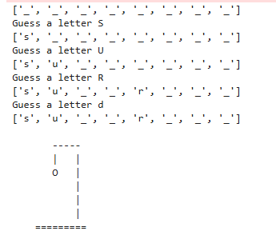

Figure 1: The first three letters are present in the underscore. As we guess the wrong letter, one life is deducted and handman is start printing.

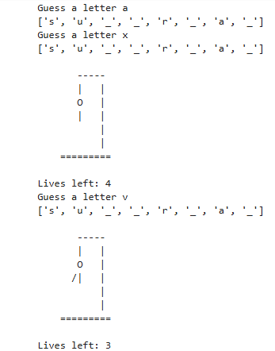

Figure 2

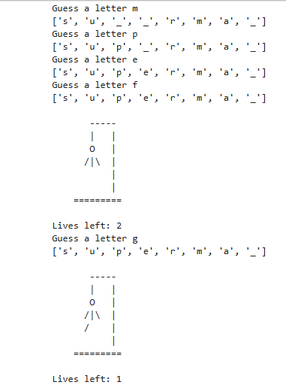

Figure 3

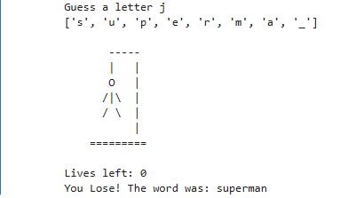

Figure 4: As we lose all our lives, the hangman is print completely, and the output is printed along with correct word.