COMM110J Software Development - Requirements Analysis and Use Case Model

1. Purpose and scope
This part records the user requirements for the Java multi-threaded card game. The system must read a valid pack, create n players and n decks, deal cards in the required order, run each player as a thread, detect the first winner, and write the required player/deck output files. The requirements come from the coursework specification, so the design is kept simple and close to the expected behaviour.

2. Actors and system boundary
Actor | Role in the system
Game User | Runs CardGame, enters the number of players, and gives the pack file path.
Pack File | External text file containing the card values used to initialise the game.
File System | Stores player output files and deck output files.
Developer / Tester | Runs the JUnit test suite and checks the implementation.

Players are not external actors in the use case model. They are internal Player objects created by the program and run as separate threads.

3. Functional requirements
ID | Functional requirement | Priority
FR1 | Provide an executable CardGame class and ask for the number of players n. | Must
FR2 | Accept n only as a positive integer and reject invalid input before the game starts. | Must
FR3 | Ask for a pack file and validate that it contains exactly 8n rows. | Must
FR4 | Accept only one non-negative integer per row; allow values greater than n. | Must
FR5 | Create n players and n decks, numbered 1 to n. | Must
FR6 | Deal four cards to each player first, then deal the remaining cards to decks, both round-robin. | Must
FR7 | Use ring topology: player i draws from deck i and discards to the next deck. | Must
FR8 | Run one thread per player and avoid a fixed sequential player loop. | Must
FR9 | Apply the preferred-denomination rule and discard a non-preferred card where possible. | Must
FR10 | Detect four equal cards, declare the first winner, and notify other players to exit. | Must
FR11 | Print the winner to the terminal and write one output file per player and deck. | Must
FR12 | Provide JUnit tests and a README explaining how to run them. | Must

4. Non-functional requirements
ID | Non-functional requirement | Priority
NFR1 | Use object-oriented design with small classes and clear responsibilities. | Must
NFR2 | Make Card, Player, decks, and shared game state safe for threaded use. | Must
NFR3 | Treat draw and discard as one atomic action so player hands stay consistent. | Must
NFR4 | Handle invalid input and invalid pack files without crashing. | Must
NFR5 | Keep output file names and wording exactly in the required format. | Must
NFR6 | Keep the code simple enough to explain in the report and discussion. | Should

ID | User story
US1 | As a game user, I want to enter n so the system creates the correct number of players and decks.
US2 | As a game user, I want to provide a pack file so the game can load the cards.
US3 | As a game user, I want invalid n and invalid packs rejected so the game starts only with valid data.
US4 | As a game user, I want round-robin dealing so the starting state follows the specification.
US5 | As a game user, I want each player to run in its own thread so the simulation is multi-threaded.
US6 | As a game user, I want players to draw, discard, and detect a winner according to the rules.
US7 | As a game user, I want separate player and deck files so I can inspect the result.
US8 | As a developer/tester, I want JUnit tests and a README so the implementation can be checked easily.
5. User stories
6. MoSCoW prioritisation

Priority | Requirements
Must have | Valid n, valid pack, 8n cards, non-negative card values, n players/decks, round-robin dealing, player threads, ring topology, winner detection, atomic draw/discard, player/deck files, JUnit tests, README.
Should have | Clear error messages, simple class responsibilities, deterministic discard strategy, useful comments.
Could have | Extra sample packs, report alignment notes, extra integration tests.
Won't have | GUI, database, networking, advanced concurrency framework, event/listener system, or features outside the brief.

7. Use case diagram
The diagram shows the system from the user point of view. Internal player turns are part of Run Simulation, not separate external use cases.
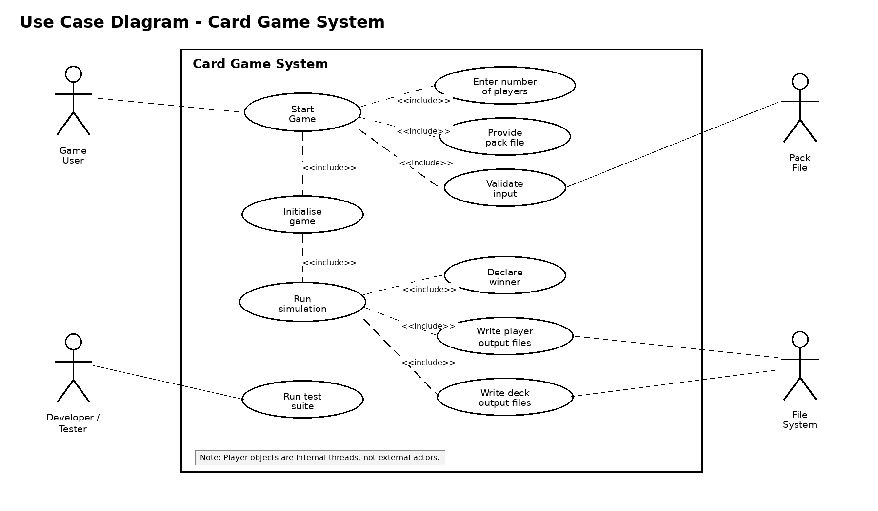
Figure 1. Use case diagram for the card game system.
8. Use case descriptions
Field | Start Game
Primary actor | Game User
Goal | Start the card game using a valid player number and valid pack file.
Preconditions | The program can be executed and the user has a pack file.
Main flow | User starts CardGame; system asks for n; user enters n; system validates n; system asks for pack path; system validates pack; system creates players/decks; system deals cards; system starts player threads.
Alternative flow | Invalid n or invalid pack is rejected and the system asks again.
Postconditions | The game has either ended immediately because of an initial winning hand or the threaded simulation has started.

Field | Run Simulation
Primary actor | Game User
Goal | Run the game until one player wins.
Preconditions | Players and decks exist, cards have been dealt, and the game has not already ended.
Main flow | Each player thread runs; a player draws from the left deck, discards to the right deck, writes its action, checks for a winning hand, and the first winner declares victory. Other players are informed and exit. Deck files are then written.
Alternative flow | If a player sees that another player has already won, it records this and exits.
Postconditions | One winner is stored, all players have exited, and all player/deck output files exist.

9. Reasoning behind the requirements
The requirements were kept close to the coursework brief because the marking depends on the exact behaviour, output files, and thread model. Input validation is needed before the game starts because the game cannot be dealt correctly without a positive n and a pack with exactly 8n valid card values. Round-robin dealing and ring topology define the starting state and how players interact with decks.
Thread-safety is treated as a requirement because the players share decks and a winner state. The implementation therefore needs synchronized shared objects and one atomic draw/discard action. This prevents inconsistent player hands and supports the rule that each player should hold four cards after a complete action.
Testing was also treated as part of the requirements. Unit tests check small classes such as Card, CardDeck, PackReader, GameState, and Player. Integration tests check dealing, full game runs, immediate wins, eventual wins, and output files. This links the requirements directly to verification.

