Assignment 2: HTTP APIs, gRPC, and Metrics
Gym Tracker: logging a set over HTTP and gRPC
Enterprise Software Development, Fall 2026
Sohaib Muhammad · sm09751
Individual assignment, extending the Assignment 1 project
Chosen user task: logging one set during a live workout. Over HTTP it is POST /api/sessions/{session_id}/sets; over gRPC it is gymtracker.v1.WorkoutService/LogSet, served by a second process (grpc_server.py, container gym-grpc). Both call sessions.log_set against the same Postgres database.
How to run and test: see the Assignment 2 section of README.md and the table in HOW_TO_RUN.md. The last section lists every submitted file.

Part A: Improving the HTTP API 3
A.1 REST constraints 3
A.2 Endpoint review 3
A.3 OpenAPI specification 4
A.4 Idempotency (safe repeats) 6
A.5 Rate limiting 6
A.6 Before and after: logging a set 7
A.7 The Python caller (timeout, retry, circuit breaker) 8
Part B: The gRPC service 11
B.1 The operation and where it runs 11
B.2 Contract and generated code 11
B.3 The gRPC client 11
B.4 Success and failure through both versions 12
B.5 Call paths 13
B.6 Logs and trace correlation across the gRPC boundary 13
Part C: Extending the metrics 15
C.1 Audit of the Assignment 1 metrics 15
C.2 New metrics 15
C.3 Prometheus and Grafana 16
Submission contents 19
References and reused work 19

Part A: Improving the HTTP API

A.1 REST constraints
The six constraints from the lecture, what each means, and where (or whether) this API shows it. Code on demand is the optional one.
Constraint | Plain-language meaning | In this API
Client–server | The user interface and the data/storage live in separate programs that only talk through the interface, so each can change on its own. | The live-workout PWA (static/app.js) and clients/http_caller.py are clients; FastAPI + Postgres is the server. They share nothing but the /api JSON contract in docs/openapi.json.
Stateless | Every request carries everything the server needs to handle it; the server does not remember the previous request of a conversation. | Each call sends its credential (session cookie or HTTP Basic) and names its resources in the path (/sessions/12/sets). No handler depends on an earlier request. The only stored state is the login session itself and the workout data, which is resource state in Postgres, not conversation state.
Cacheable | Responses say whether they may be reused, so clients and proxies can skip repeat requests. | Partly. Static files are sent with Cache-Control (app.py:1644, 1663) and the service worker caches the app shell. The JSON API responses are per-user and change on every set, so they are deliberately not marked cacheable.
Uniform interface | Resources are named by URLs and handled with the standard methods; messages describe themselves. | Plural nouns (/sessions, /routines, /sets), methods that mean what they say (GET reads, POST creates, PATCH partially updates, DELETE removes), real status codes, and one error body {"error": {code, message, request_id}} for every failure.
Layered system | A client cannot tell whether it is talking to the server directly or to something in between (proxy, load balancer, cache). | The client only knows a base URL. Deployed, the app runs behind the hosting platform's proxy (render.yaml); locally it is the container directly. Callers did not change between the two.
Code on demand (optional) | The server may send code for the client to run. | Shown: the server delivers static/app.js and the service worker static/sw.js, which the browser runs to provide the live-workout screen and its offline outbox.

A.2 Endpoint review
All application endpoints under /api were reviewed (health and metrics excluded). The changes applied across all of them:
- Clear paths and methods. Collections are plural nouns. The singular /session/... paths became /sessions/...; whole-object PUT on routines and sets became PATCH, because both only ever changed the fields sent. Two actions that are not CRUD keep a verb sub-path (/sessions/{id}/finish, /records/rebuild).
- Validated input. Request bodies were untyped dicts read with payload.get(...). They are now Pydantic models (for example LogSetIn in api.py), so a wrong type or an out-of-range id is refused before any database work.
- Meaningful status codes. Previously every data-layer error became 400, including "no such workout". Now: 400 bad input (FastAPI's 422 is folded into 400 so "your input is wrong" is one status), 401 not signed in, 404 not found (SessionNotFound), 409 conflict (SessionConflict, e.g. the workout is finished), 429 rate limited, 500 unexpected.
- Consistent error format. Every /api error has the same body, and request_id is the id in every log line for that request and in the X-Request-ID header:
{"error": {"code": "not_found", "message": "That workout does not exist.",
"request_id": "9f2c41d07ab3e811"}}
- Handlers are plain `def`. They were async def while calling the synchronous database driver, which blocked the event loop for every other request. FastAPI now runs them in its thread pool.

A.3 OpenAPI specification
What it is. The OpenAPI Specification is a standard, machine-readable format (JSON or YAML) for describing an HTTP API: its paths, methods, parameters, request bodies, responses and authentication. Tools read it to render interactive documentation, generate client and server code, validate requests, and test the API, so it works as the contract between the API and its callers.
This API's spec. docs/openapi.json (OpenAPI 3.1) is generated from the code by api.openapi_document() and scripts/export_openapi.py, so the routes, typed inputs and success/error responses cannot drift from the implementation. The generated document was corrected in three places: FastAPI's 422 entries are replaced by the real 400 ErrorBody, both security schemes (session cookie, HTTP Basic) are declared, and the old paths are marked deprecated. POST /sessions/{session_id}/sets documents the Idempotency-Key header and both 201 (written) and 200 (replay); POST /records/rebuild documents 429 and its Retry-After header.
How it was used.
- Swagger UI at http://localhost:8000/api/docs renders the spec. After Authorize (Basic, demo account), Try it out on POST /api/sessions/{session_id}/sets returns 201 with the set; sending the same Idempotency-Key again returns 200 with idempotent-replayed: true.
- A test (tests/test_api_v2.py::TestOpenApi) fails if the committed file and the code disagree, if any route is undocumented, or if the idempotency header, the replay response or the 429 are missing. python scripts/export_openapi.py --check does the same in CI.
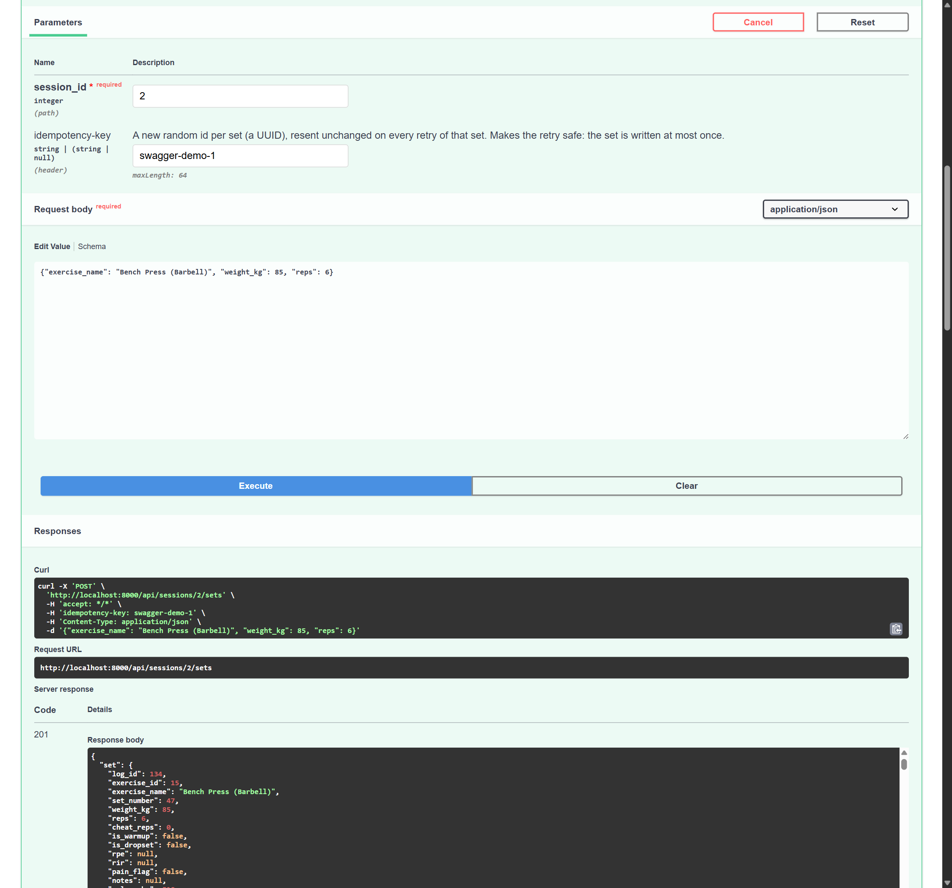
Figure A.1. Swagger UI, Try it out on POST /api/sessions/{session_id}/sets with Idempotency-Key swagger-demo-1: 201, set log_id 134. (Basic credentials for the demo account were sent by the browser, which is why the generated curl line has no Authorization header.)
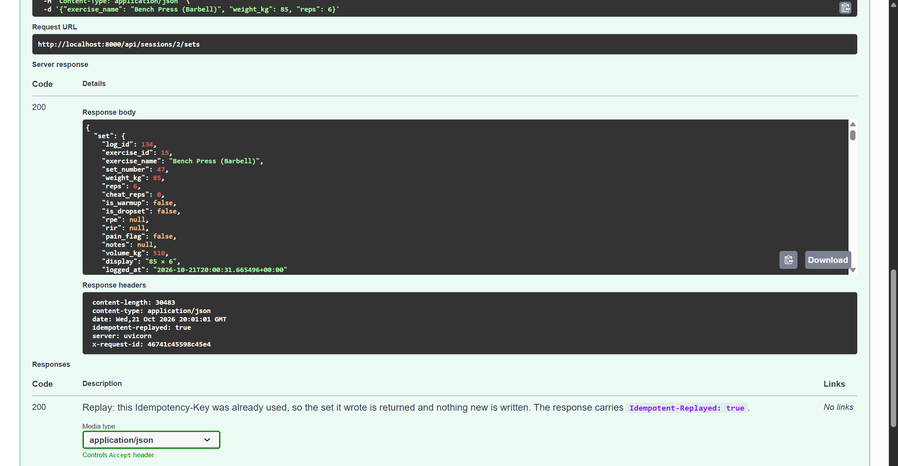
Figure A.2. The same request executed again with the same key: 200, the same log_id 134, and the response header idempotent-replayed: true. Nothing new was written.

A.4 Idempotency (safe repeats)
The operation that is retried: logging a set. A phone on gym wifi sends the POST, the server writes the set, and the response is lost on the way back. The client cannot tell that apart from "never arrived", so it retries, and before this change the retry wrote the set a second time.
The fix: the client generates one Idempotency-Key (a UUID) per set and resends it unchanged on every retry of that set.
- The key is stored with the set in workout_logs.client_set_id, with a unique partial index on (user_id, client_set_id) (migrations/004_idempotent_sets.sql).
- sessions.log_set looks the key up first. If this account already used it, the stored set is returned and nothing is written: HTTP 200 with Idempotent-Replayed: true instead of 201; gRPC OK with replayed = true.
- Two copies racing past the lookup are settled by the unique index: the loser's insert fails and it returns the winner's row (tested in TestIdempotencyAgainstPostgres).
- Keys are per account, so two users cannot collide. Without a key the old behaviour is kept (each request is a new set).
Other operations are safe to repeat by design: POST /sessions returns the workout already in progress instead of starting a second one; POST /records/rebuild recomputes from the logged sets, so twice gives the same result as once; GET is read-only.

A.5 Rate limiting
Item | Detail
Endpoint | POST /api/records/rebuild (recomputes every personal record: the most expensive call in the API)
Limit | 3 calls per 60 seconds, sliding window (RECORDS_REBUILD_LIMIT, RECORDS_REBUILD_WINDOW_SECONDS)
Who shares it | One account. The key is user:{user_id}, so all of one person's devices and sessions share the budget and other users are unaffected.
When calls are allowed again | Every attempt is counted, refused ones included, so a client that keeps calling stays refused. Retry-After is the number of whole seconds until enough attempts have left the 60 s window to bring the count under the limit, rounded up, so a client that stops and waits that long is accepted (auth.RateLimiter.retry_after). That is why the two refused calls below both say 60 s.
Scope | In memory, single process: fine for one instance as the assignment allows. Several replicas would need a shared store such as Redis.
Response | 429 Too Many Requests, Retry-After: <seconds>, the standard error body, and a rate_limited warning in the logs.

Result of python scripts/a2_traffic.py (from observability/results-a2/traffic.txt): three calls are accepted and the next two are refused with Retry-After.
rate limit: POST /api/records/rebuild x5
call 1: 200 {"rebuilt":15}
call 2: 200 {"rebuilt":15}
call 3: 200 {"rebuilt":15}
call 4: 429 Retry-After: 60s
call 5: 429 Retry-After: 60s
The 429s also appear on the Grafana dashboard panel POST /api/records/rebuild by status.

A.6 Before and after: logging a set
Aspect | Before (old endpoint) | Problem | Change | Reason
Path | POST /api/session/{id}/sets | Singular collection name, inconsistent with GET /api/sessions. | POST /api/sessions/{id}/sets; old path kept as a deprecated alias. | Uniform plural nouns. The alias lets an installed PWA with a cached app.js drain its offline queue instead of losing sets to a 404.
Input | Untyped dict, payload.get(...) | Wrong types reached the data layer; some became 500s. | Typed LogSetIn model. | Bad input is a 400 with a clear message, before any database work.
Status codes | Every data error → 400 | "No such workout" and "workout finished" looked like bad input. | 400 / 404 / 409, and 401 for no credentials. | Callers can react correctly (do not retry a 404; tell the user on a 409).
Error body | FastAPI default {"detail": ...}, 422 for validation | Two shapes, two statuses for bad input, no link to logs. | One ErrorBody with code, message, request_id. | One parser in every client; the id finds the request in Kibana.
Retries | No protection | A retried POST wrote the set twice. | Idempotency-Key header; 200 + Idempotent-Replayed on replay. | Makes the retry in the Python caller and the PWA outbox safe.
Concurrency | async def calling a blocking driver | One slow query stalled every request, /healthz included. | Plain def (thread pool). | Blocking is harmless off the event loop.

Other endpoints. Every endpoint now gets the typed input and the shared error format. Beyond that:
Endpoint | What happened
POST /session/start → POST /sessions | Changed: create a workout by POSTing to the collection. Repeat-safe (returns the one in progress).
GET /session/active, GET /session/{id}, DELETE /session/{id}, POST /session/{id}/finish | Changed to /sessions/.... Finish on an already-finished workout is 409.
PUT /sets/{id}, PUT /routines/{id} | Changed to PATCH: only the fields sent are changed; an empty body is 400.
POST /records/rebuild | Path unchanged; rate limit added (A.5).
GET /catalog, POST /exercises, GET/POST /routines, GET /routines/{id}, DELETE /routines/{id}, POST /routines/reorder, DELETE /sets/{id}, GET /sessions, GET /exercises/{id}/previous, GET /records, GET/POST /measurements, DELETE /measurements/{id} | Paths and methods left alone: they were already clear. All old paths still answer, marked deprecated in the OpenAPI document.

Callers updated. static/app.js uses the new paths and methods, sends an Idempotency-Key with every set (kept with the set in its offline outbox, so a resend after reconnecting is a replay), and reads the new error body. static/sw.js bumps its cache name (gym-shell-v3) so phones fetch the new app.js.
Tests: valid, invalid, repeated. In tests/test_api_v2.py:
Case | Test | Expected
Valid request | test_a_valid_set_is_written | 201 and the set
Invalid input | test_invalid_input_is_400_in_the_shared_error_shape, test_a_business_rule_violation_is_also_400 | 400 and ErrorBody
Repeated request | test_a_repeated_request_writes_the_set_once, test_two_copies_racing_past_the_lookup_still_write_once | 201 then 200 replayed; one row
Also | 404 unknown workout, 409 finished workout, 401 signed out, old path still works, malformed key refused, keys per account

The same three cases against the running stack (from traffic.txt, round 1):
HTTP valid 201 written
HTTP repeat same key 200 replayed
HTTP reps = 0 400 Reps must be between 1 and 500.
HTTP no such workout 404 That workout does not exist.

A.7 The Python caller (timeout, retry, circuit breaker)
clients/http_caller.py acts like another service (say, a watch app's sync job). In one run it starts a workout and logs several sets through POST /api/sessions/{id}/sets.
Setting | Value | Notes
Timeout | 2.0 s per attempt (connect + response) | --timeout
Retry limit | 2 retries, so at most 3 attempts per call | --retries
Backoff | 0.5 s, doubling (0.5 s, 1 s), plus up to 25 % jitter | --backoff
What is retried | Timeouts, refused/dropped connections, 500/502/503/504 | Never a 4xx: the server understood and said no.
Why the retry is safe | Each set has one Idempotency-Key, resent on every attempt | A timed-out attempt may have been written; the retry gets it back as a replay.
Breaker opens | After 3 consecutive failed attempts | --failures. While OPEN, calls fail at once without touching the network.
Recovery period | 10 s, then HALF_OPEN: one trial call | --recovery. Success → CLOSED; failure → OPEN for another 10 s.

The test (./scripts/demo_reliability.sh) uses a timeout and a server failure, not the rate limit:
- The app is restarted with fault injection: every 4th request under /api/sessions/ is held for 3 s, longer than the 2 s timeout, so those attempts time out and are retried.
- After 9 s the app container is stopped: connections are refused, three attempts fail in a row, the breaker opens, and the next sets are blocked without a request.
- The container is started again; after the recovery period the breaker goes HALF_OPEN, the trial call succeeds and it closes: the caller has recovered.
The unit tests in tests/test_http_caller.py check the same behaviour with a fake clock and transport: retry with the same key, no retry on 4xx, the breaker opening, blocking, the half-open trial and closing.
Output of ./scripts/demo_reliability.sh (saved as observability/results-a2/reliability.txt; the >>> lines are the script stopping and starting the app container):
[00:55:31.484] settings: timeout 2.0s, 2 retries (backoff 0.5s doubling, +25% jitter), breaker opens after 3 consecutive failures and tries again after 10.0s
[00:55:31.645] start workout attempt 1 -> 201 (161 ms, request id fa6b4c9dc67c4a7d)
[00:55:31.645] workout 2 is live
[00:55:31.747] set 1 attempt 1 -> 201 (102 ms, request id be9e94c3a61f40a6)
[00:55:31.747] set 1 written: log_id 87, 62.5 × 8
[00:55:32.836] set 2 attempt 1 -> 201 (90 ms, request id 03afdf751e6e4b27)
[00:55:32.836] set 2 written: log_id 88, 65 × 8
[00:55:33.931] set 3 attempt 1 -> 201 (94 ms, request id db72f05f1d944e8d)
[00:55:33.931] set 3 written: log_id 89, 67.5 × 8
[00:55:36.940] set 4 attempt 1 -> timed out after 2.0s; retrying in 0.57s
[00:55:37.611] set 4 attempt 2 -> 201 (96 ms, request id 6dd04b09e38c4095)
[00:55:37.611] set 4 written: log_id 90, 70 × 8
[00:55:38.702] set 5 attempt 1 -> 201 (90 ms, request id 551e9345ae354467)
[00:55:38.702] set 5 written: log_id 91, 72.5 × 8
>>> stopping the app container
[00:55:39.803] set 6 attempt 1 -> 201 (101 ms, request id f2c0645dd14d40ed)
[00:55:39.803] set 6 written: log_id 92, 75 × 8
[00:55:40.826] set 7 attempt 1 -> ReadError: [WinError 10053] An established connection was aborted by the software in your host machine; retrying in 0.59s
[00:55:45.436] set 7 attempt 2 -> timed out after 2.0s; retrying in 1.25s
[00:55:50.705] breaker OPEN after 3 consecutive failure(s): blocking calls for 10s
[00:55:50.705] set 7 attempt 3 -> timed out after 2.0s; no retries left
[00:55:50.705] set 7 failed: timed out after 2.0s
[00:55:51.706] set 8 blocked: circuit open, 9.0s until a trial call
[00:55:52.706] set 9 blocked: circuit open, 8.0s until a trial call
>>> starting the app container
[00:55:53.707] set 10 blocked: circuit open, 7.0s until a trial call
[00:55:54.707] set 11 blocked: circuit open, 6.0s until a trial call
[00:55:55.708] set 12 blocked: circuit open, 5.0s until a trial call
[00:55:56.708] set 13 blocked: circuit open, 4.0s until a trial call
[00:55:57.709] set 14 blocked: circuit open, 3.0s until a trial call
[00:55:58.709] set 15 blocked: circuit open, 2.0s until a trial call
[00:55:59.709] set 16 blocked: circuit open, 1.0s until a trial call
[00:56:00.710] breaker HALF_OPEN: letting one trial call through
[00:56:00.891] breaker CLOSED: trial call succeeded, normal service resumed
[00:56:00.891] set 17 attempt 1 -> 201 (181 ms, request id ddf808658c8e49ff)
[00:56:00.891] set 17 written: log_id 93, 102.5 × 8
[00:56:01.975] set 18 attempt 1 -> 201 (84 ms, request id d88def3fb6c8421e)
[00:56:01.975] set 18 written: log_id 94, 105 × 8
[00:56:03.059] set 19 attempt 1 -> 201 (83 ms, request id 641c4badb23e4098)
[00:56:03.059] set 19 written: log_id 95, 107.5 × 8
[00:56:06.074] set 20 attempt 1 -> timed out after 2.0s; retrying in 0.58s
[00:56:06.768] set 20 attempt 2 -> 201 (110 ms, request id 9f522282a7044194)
[00:56:06.768] set 20 written: log_id 96, 110 × 8
[00:56:07.860] set 21 attempt 1 -> 201 (91 ms, request id 1a2619e1a12e42d8)
[00:56:07.860] set 21 written: log_id 97, 112.5 × 8
[00:56:08.975] set 22 attempt 1 -> 201 (114 ms, request id 12eff2adfcb14049)
[00:56:08.975] set 22 written: log_id 98, 115 × 8
[00:56:11.992] set 23 attempt 1 -> timed out after 2.0s; retrying in 0.60s
[00:56:12.701] set 23 attempt 2 -> 201 (111 ms, request id 28b419b6ec3344e7)
[00:56:12.701] set 23 written: log_id 99, 117.5 × 8
[00:56:13.782] set 24 attempt 1 -> 201 (81 ms, request id f535baf2f3834b5f)
[00:56:13.782] set 24 written: log_id 100, 120 × 8
[00:56:14.871] set 25 attempt 1 -> 201 (88 ms, request id d34a9e579d3b4f6a)
[00:56:14.871] set 25 written: log_id 101, 122.5 × 8
[00:56:17.875] set 26 attempt 1 -> timed out after 2.0s; retrying in 0.55s
[00:56:20.441] set 26 attempt 2 -> timed out after 2.0s; retrying in 1.13s
[00:56:23.573] breaker OPEN after 3 consecutive failure(s): blocking calls for 10s
[00:56:23.573] set 26 attempt 3 -> timed out after 2.0s; no retries left
[00:56:23.573] set 26 failed: timed out after 2.0s
[00:56:24.574] set 27 blocked: circuit open, 9.0s until a trial call
[00:56:25.574] set 28 blocked: circuit open, 8.0s until a trial call
[00:56:26.575] set 29 blocked: circuit open, 7.0s until a trial call
[00:56:27.575] set 30 blocked: circuit open, 6.0s until a trial call
[00:56:27.575] summary: written 15, replayed 0, blocked 13, failed 2, refused 0
What the run shows:
- Success: sets 1–6 and 17–25 are all written (201, about 80–110 ms), all but 4, 20 and 23 on the first attempt.
- Retrying a failure: sets 4, 20 and 23 hit the injected 3 s delay, time out at 2 s, and succeed on the retry 0.5–0.6 s later.
- Breaker open, calls blocked: with the container stopped, set 7 fails three attempts in a row (connection aborted, then two timeouts), the breaker opens, and sets 8–16 are blocked immediately without a request, counting down to the trial call.
- Recovery: 10 s later the breaker goes HALF_OPEN, the trial call (set 17) returns 201, and it closes. Normal service resumes.
- A second opening, from a slow server rather than a dead one: set 26's first attempt was delayed by the fault, and its two retries also took longer than 2 s. The server logs show both retries arriving late and being handled about 6 s later: one wrote the set (201) and the other was answered as a replay (200). So the set was written once even though the caller reported it as failed. The run ended while the breaker was still open. The cause of that 6 s server-side delay was not investigated further.
No duplicates. After the run, workout 2 held 16 rows with 16 distinct Idempotency-Keys: the 15 sets the caller saw written, plus set 26, which the server wrote once. The retries did not duplicate any set.
Two fixes to the demo script were needed on Windows, both in scripts/demo_reliability.sh. Git Bash rewrote FAULT_PATH_PREFIX=/api/sessions/ into a Windows path before it reached docker.exe, so no fault fired; MSYS2_ENV_CONV_EXCL now stops that. The run was also lengthened from 18 to 30 calls, so it outlasts the outage and the recovery period.

Part B: The gRPC service

B.1 The operation and where it runs
The operation taken from the user task is logging a set: WorkoutService.LogSet, a unary RPC (one set in, one result out: nothing to stream).
- Its own process and container. grpc_server.py runs as the gym-grpc service in docker-compose.yml, on port 50051, with Prometheus metrics on 9102. The HTTP version stays in the gym-tracker app container.
- Same business rules, same source of truth. Both the HTTP handler (api.log_set) and the gRPC handler (WorkoutService._log_set) call sessions.log_set with a connection to the same Postgres database. Validation, ownership checks, record detection and idempotency are one piece of code reached two ways. The gRPC server never calls the HTTP API.
- Same accounts. Credentials go in the authorization metadata as HTTP Basic and are checked with auth.authenticate against the same accounts table.

B.2 Contract and generated code
proto/workout.proto defines the service and its messages (shortened here; the file documents every field):
syntax = "proto3";
package gymtracker.v1;

service WorkoutService {
rpc LogSet(LogSetRequest) returns (LogSetResponse);
}

message LogSetRequest {
int64 session_id = 1;
oneof exercise { int64 exercise_id = 2; string exercise_name = 3; }
optional double weight_kg = 4; // optional: 'not sent' differs from 0
optional int32 reps = 5;
int32 cheat_reps = 6; bool is_warmup = 7;
optional double rpe = 8; optional int32 rir = 9;
string idempotency_key = 10; // same rule as the HTTP header
}

message LogSetResponse {
LoggedSet set = 1;
repeated RecordBreak records = 2;
bool replayed = 3;
}
Generation command (output committed in grpc_gen/):
python -m grpc_tools.protoc -I proto --python_out=grpc_gen \
--pyi_out=grpc_gen --grpc_python_out=grpc_gen proto/workout.proto
This produces workout_pb2.py (messages), workout_pb2.pyi (type hints) and workout_pb2_grpc.py (the client stub WorkoutServiceStub and the server base class WorkoutServiceServicer). The handler is WorkoutService(WorkoutServiceServicer).LogSet in grpc_server.py.

B.3 The gRPC client
clients/grpc_client.py calls the service directly through the generated stub; no browser and no HTTP. It takes its input from flags, sets a deadline (default 2 s, --deadline), sends x-request-id metadata, and prints the result or the status code and message, plus the request id the server logged under.
python clients/grpc_client.py --session-id 12 --exercise "Bench Press (Barbell)" --weight 80 --reps 8
python clients/grpc_client.py --session-id 12 --exercise-id 3 --reps 0 # fails
Past the deadline the client stops waiting and gets DEADLINE_EXCEEDED; gRPC also sends the deadline to the server, so it knows the caller has gone.

B.4 Success and failure through both versions
python scripts/a2_traffic.py sends the same four calls over both transports (round 1 of observability/results-a2/traffic.txt):
Call | HTTP | gRPC | Message
Valid set | 201 Created | OK | written
Same Idempotency-Key again | 200 OK + Idempotent-Replayed: true | OK, replayed = true | replayed, nothing new written
reps = 0 | 400 Bad Request | INVALID_ARGUMENT | Reps must be between 1 and 500.
Workout that does not exist | 404 Not Found | NOT_FOUND | That workout does not exist.

How the statuses are chosen. Both transports map the same data-layer exceptions, so a given input fails the same way over both:
Situation | HTTP | gRPC | Why
Written / replayed | 201 / 200 | OK (replayed flag) | HTTP separates "created" from "already there" by status; gRPC has one OK and says it in the message.
Bad field (ValueError) | 400 | INVALID_ARGUMENT | The caller's input is wrong; retrying the same input cannot help.
SessionNotFound | 404 | NOT_FOUND | No such workout for this account (another user's workout is also "not found", so ids leak nothing).
SessionConflict | 409 | FAILED_PRECONDITION | The input is fine but the workout is in the wrong state (already finished).
No / wrong credentials | 401 | UNAUTHENTICATED | Identity is missing or wrong.
Unexpected error | 500 | INTERNAL | Detail goes to the logs, not to the caller.
Caller stopped waiting | client timeout (no status) | DEADLINE_EXCEEDED | Set by the client; gRPC also propagates the deadline to the server.

The gRPC client on its own, one success and one failure (observability/results-a2/grpc-client.txt):
$ python clients/grpc_client.py --session-id 1 --exercise "Bench Press (Barbell)" --weight 82.5 --reps 8 --request-id a2-grpc-ok
status: OK (133 ms, deadline 2.0s)
request id: a2-grpc-ok
written: log_id 48, Bench Press (Barbell) set 12: 82.5 × 8
record: Heaviest weight 82.5
record: Best estimated 1RM 104.5
(exit 0)

$ python clients/grpc_client.py --session-id 1 --exercise "Bench Press (Barbell)" --weight 82.5 --reps 0 --request-id a2-grpc-fail
status: INVALID_ARGUMENT (123 ms, deadline 2.0s)
request id: a2-grpc-fail
error: Reps must be between 1 and 500.
(exit 1)

B.5 Call paths
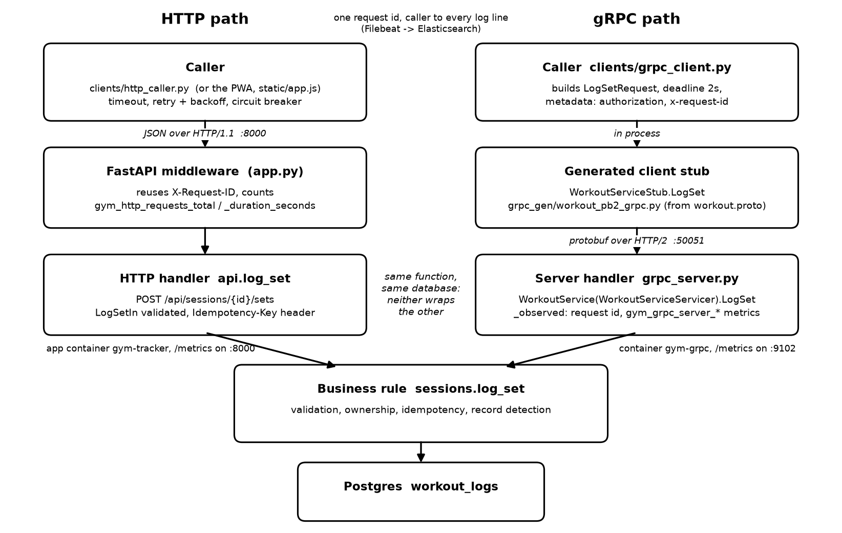
Figure B.1. HTTP and gRPC call paths for logging a set. The gRPC path goes through the generated client stub and the generated servicer base class; both paths end in the same function and database. Source: docs/a2-call-paths.png.

B.6 Logs and trace correlation across the gRPC boundary
The Assignment 1 logging (ECS JSON on stdout → Filebeat → Elasticsearch, correlated by http.request.id) carries over unchanged:
- The client sends x-request-id in the call metadata.
- WorkoutService._observed (grpc_server.py) reuses it as the log correlation id through logging_setup.set_request_id, exactly as the HTTP middleware reuses an inbound X-Request-ID, and returns it in the trailing metadata. Malformed or over-long ids are replaced, as on HTTP. The id is cleared after each call so a reused worker thread cannot inherit it.
- Every line the call produces (rpc served, set logged, any error) carries the id, with service.name = gym-tracker-grpc. The gym-grpc container has the same co.elastic.logs/enabled label as the app, so Filebeat ships its logs to the same index.
- So one Kibana search on http.request.id finds a gRPC call made with --request-id, just as it finds an HTTP request. Figure B.2 uses the two calls from B.4 (a2-grpc-ok, a2-grpc-fail).
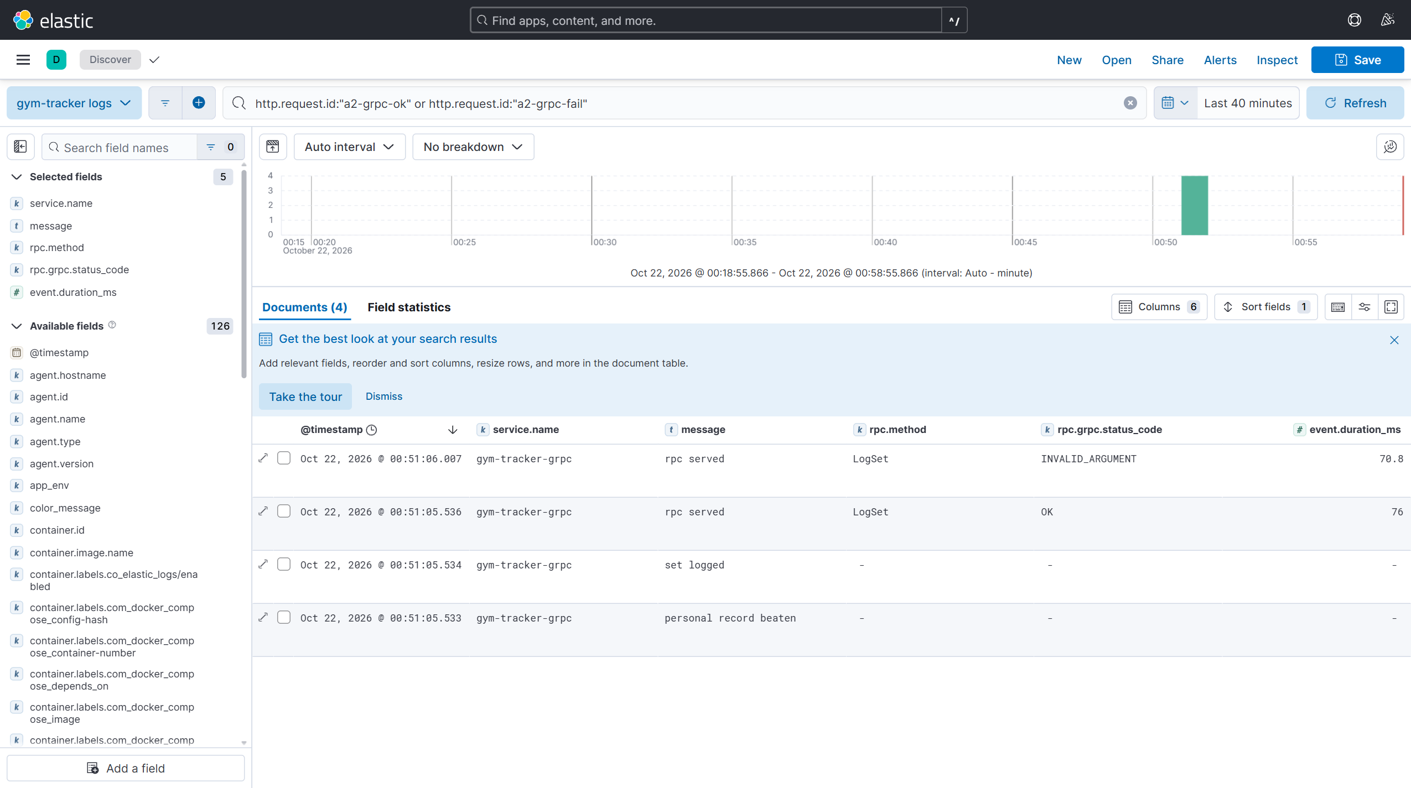
Figure B.2. Kibana Discover, http.request.id: "a2-grpc-ok" or "a2-grpc-fail". All four lines come from service gym-tracker-grpc: for the success, personal record beaten, set logged and rpc served (OK, 76 ms); for the failure, rpc served (INVALID_ARGUMENT, 70.8 ms).

Part C: Extending the metrics

C.1 Audit of the Assignment 1 metrics
A1 metric(s) | Useful? | Gap | Action
gym_http_requests_total, _request_duration_seconds, _requests_in_flight | Yes: rate, errors and latency per route, with a bounded route template label. | None for HTTP. They already cover the HTTP version of LogSet. | Kept; used as the HTTP side of the new dashboard. 429s are visible through the existing status label, so the rate limit needed no new metric.
gym_grpc_* | n/a | The new gRPC service had no metrics at all. | Added calls by status, a duration histogram and in-flight calls (C.2).
gym_sets_written_total | Yes, for sets saved from journal entries. | Sets logged from the live-workout screen were not counted: the A1 report listed this as the one thing missing. | Added gym_live_sets_total{transport, outcome}.
(none) | n/a | No way to see that idempotency is doing its job (retries replayed instead of written twice). | outcome="replayed" on the same counter, and a "Duplicate sets prevented" stat.
gym_build_info, gym_llm_extractions_in_flight | Yes, for debugging; not charted. | None. | Left as they are.

C.2 New metrics
All new metrics are measured at the server: for gRPC inside _observed, around the handler; for HTTP by the existing middleware. Network time and the client's deadline handling are not included, so the two transports are compared like for like. Labels are bounded: every label value comes from a fixed list in metrics.py (GRPC_CODES, GRPC_METHODS, LIVE_SET_TRANSPORTS, LIVE_SET_OUTCOMES) and all series are created at zero on start-up. No user, request, session or trace ids are used as labels.
Metric | Purpose | Type / unit | Labels | Code location
gym_grpc_server_handled_total | gRPC calls and error rate by method and status | Counter / calls | grpc_service, grpc_method, grpc_code (6 values) | defined metrics.py:441; .inc() in grpc_server.py:131
gym_grpc_server_handling_seconds | Server-side duration; source of p50 / p95 | Histogram / seconds | grpc_service, grpc_method | defined metrics.py:449; .observe() in grpc_server.py:130
gym_grpc_server_in_flight | Calls being handled now (saturation) | Gauge / calls | grpc_method | defined metrics.py:461; .inc() / .dec() in grpc_server.py:116, 129
gym_live_sets_total | Live-workout sets written vs replayed, per transport (the missing A1 business metric) | Counter / sets | transport (http, grpc), outcome (written, replayed) | defined metrics.py:152; .inc() in api.py:731, grpc_server.py:190

Queries (as on the dashboard; where the dashboard also filters on the one grpc_service value, that filter is left out here for space):
Panel | PromQL
gRPC: calls by status code | sum by (grpc_code) (rate(gym_grpc_server_handled_total{grpc_service="gymtracker.v1.WorkoutService",grpc_method="LogSet"}[1m])) > 0
gRPC error ratio | sum(rate(gym_grpc_server_handled_total{grpc_method="LogSet",grpc_code!="OK"}[5m])) / sum(rate(gym_grpc_server_handled_total{grpc_method="LogSet"}[5m]))
gRPC p50 / p95 (5m) | histogram_quantile(0.50, sum by (le) (rate(gym_grpc_server_handling_seconds_bucket{grpc_method="LogSet"}[5m]))) and the same with 0.95
In-flight calls | sum(gym_grpc_server_in_flight{grpc_method="LogSet"}) beside sum(gym_http_requests_in_flight)
Live sets by transport and outcome | sum by (transport, outcome) (rate(gym_live_sets_total[5m]))
Duplicate sets prevented | sum(increase(gym_live_sets_total{outcome="replayed"}[$__range]))
HTTP side (same panels) | gym_http_requests_total / gym_http_request_duration_seconds_bucket filtered on route=~"/api/sessions?/.session_id./sets", method="POST" (the regex also matches the deprecated singular path)

Buckets. The gRPC histogram uses the same buckets as HTTP: 5, 10, 25, 50, 75, 100, 250, 500, 750 ms, 1, 2.5, 5, 10 s. A LogSet is one small Postgres transaction, so most calls fall between 5 and 100 ms, where the buckets are dense; the upper buckets catch a slow database. Identical boundaries let the HTTP and gRPC p50/p95 sit on one panel and be compared honestly.
p50 and p95 are shown over a 5-minute window (rate(...[5m])) for both transports on the Duration (server-side, 5m window) row.
In-flight rather than message size. A LogSetRequest is a few scalar fields, tens of bytes whatever the input, so a size histogram would be a flat line that never tells us anything. Concurrency is what runs out first: the server has a fixed pool of 8 worker threads. In-flight calls is also the gRPC twin of gym_http_requests_in_flight, so both are on one panel.
Other missing metric: gym_live_sets_total, above, fills the business-metric gap from Assignment 1 and also shows idempotency working.

C.3 Prometheus and Grafana
Prometheus scrapes the gRPC service as its own job (observability/prometheus/prometheus.yml), so if it goes down up{job="gym-tracker-grpc"} drops to 0 while the app's stays at 1:
- job_name: gym-tracker-grpc
static_configs:
- targets: ["grpc:9102"]
labels:
service: gym-tracker-grpc
The dashboard Gym Tracker - HTTP vs gRPC (log a set) (observability/grafana/dashboards/04-http-vs-grpc.json, provisioned automatically) puts each gRPC panel beside its HTTP counterpart:
Row | Panels
Overview (5m) | HTTP calls/s, gRPC calls/s, HTTP error ratio, gRPC error ratio, targets up, duplicate sets prevented
Calls and errors by status | HTTP: calls by status; gRPC: calls by status code
Duration (server-side, 5m window) | HTTP p50 / p95; gRPC p50 / p95
Concurrency and business outcome | In-flight calls (HTTP and gRPC); live sets by transport and outcome
Rate limiting | POST /api/records/rebuild by status (the 200s and 429s)

Populating the panels. python scripts/a2_traffic.py repeats a fixed set of calls (valid, replay, invalid, not found) over both transports, then the rate-limit burst. Running it a few times fills every panel with both successes and failures.
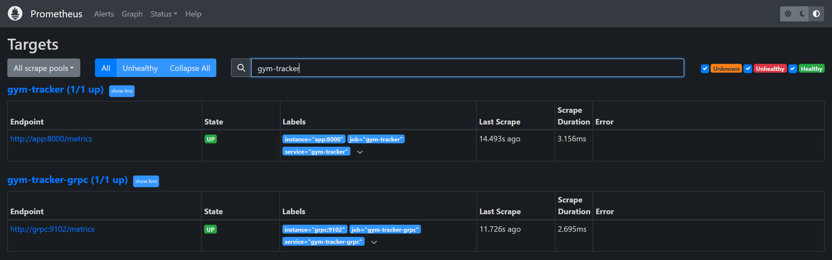
Figure C.1. Prometheus Status → Targets: the gym-tracker-grpc job (grpc:9102) is UP beside the HTTP app.
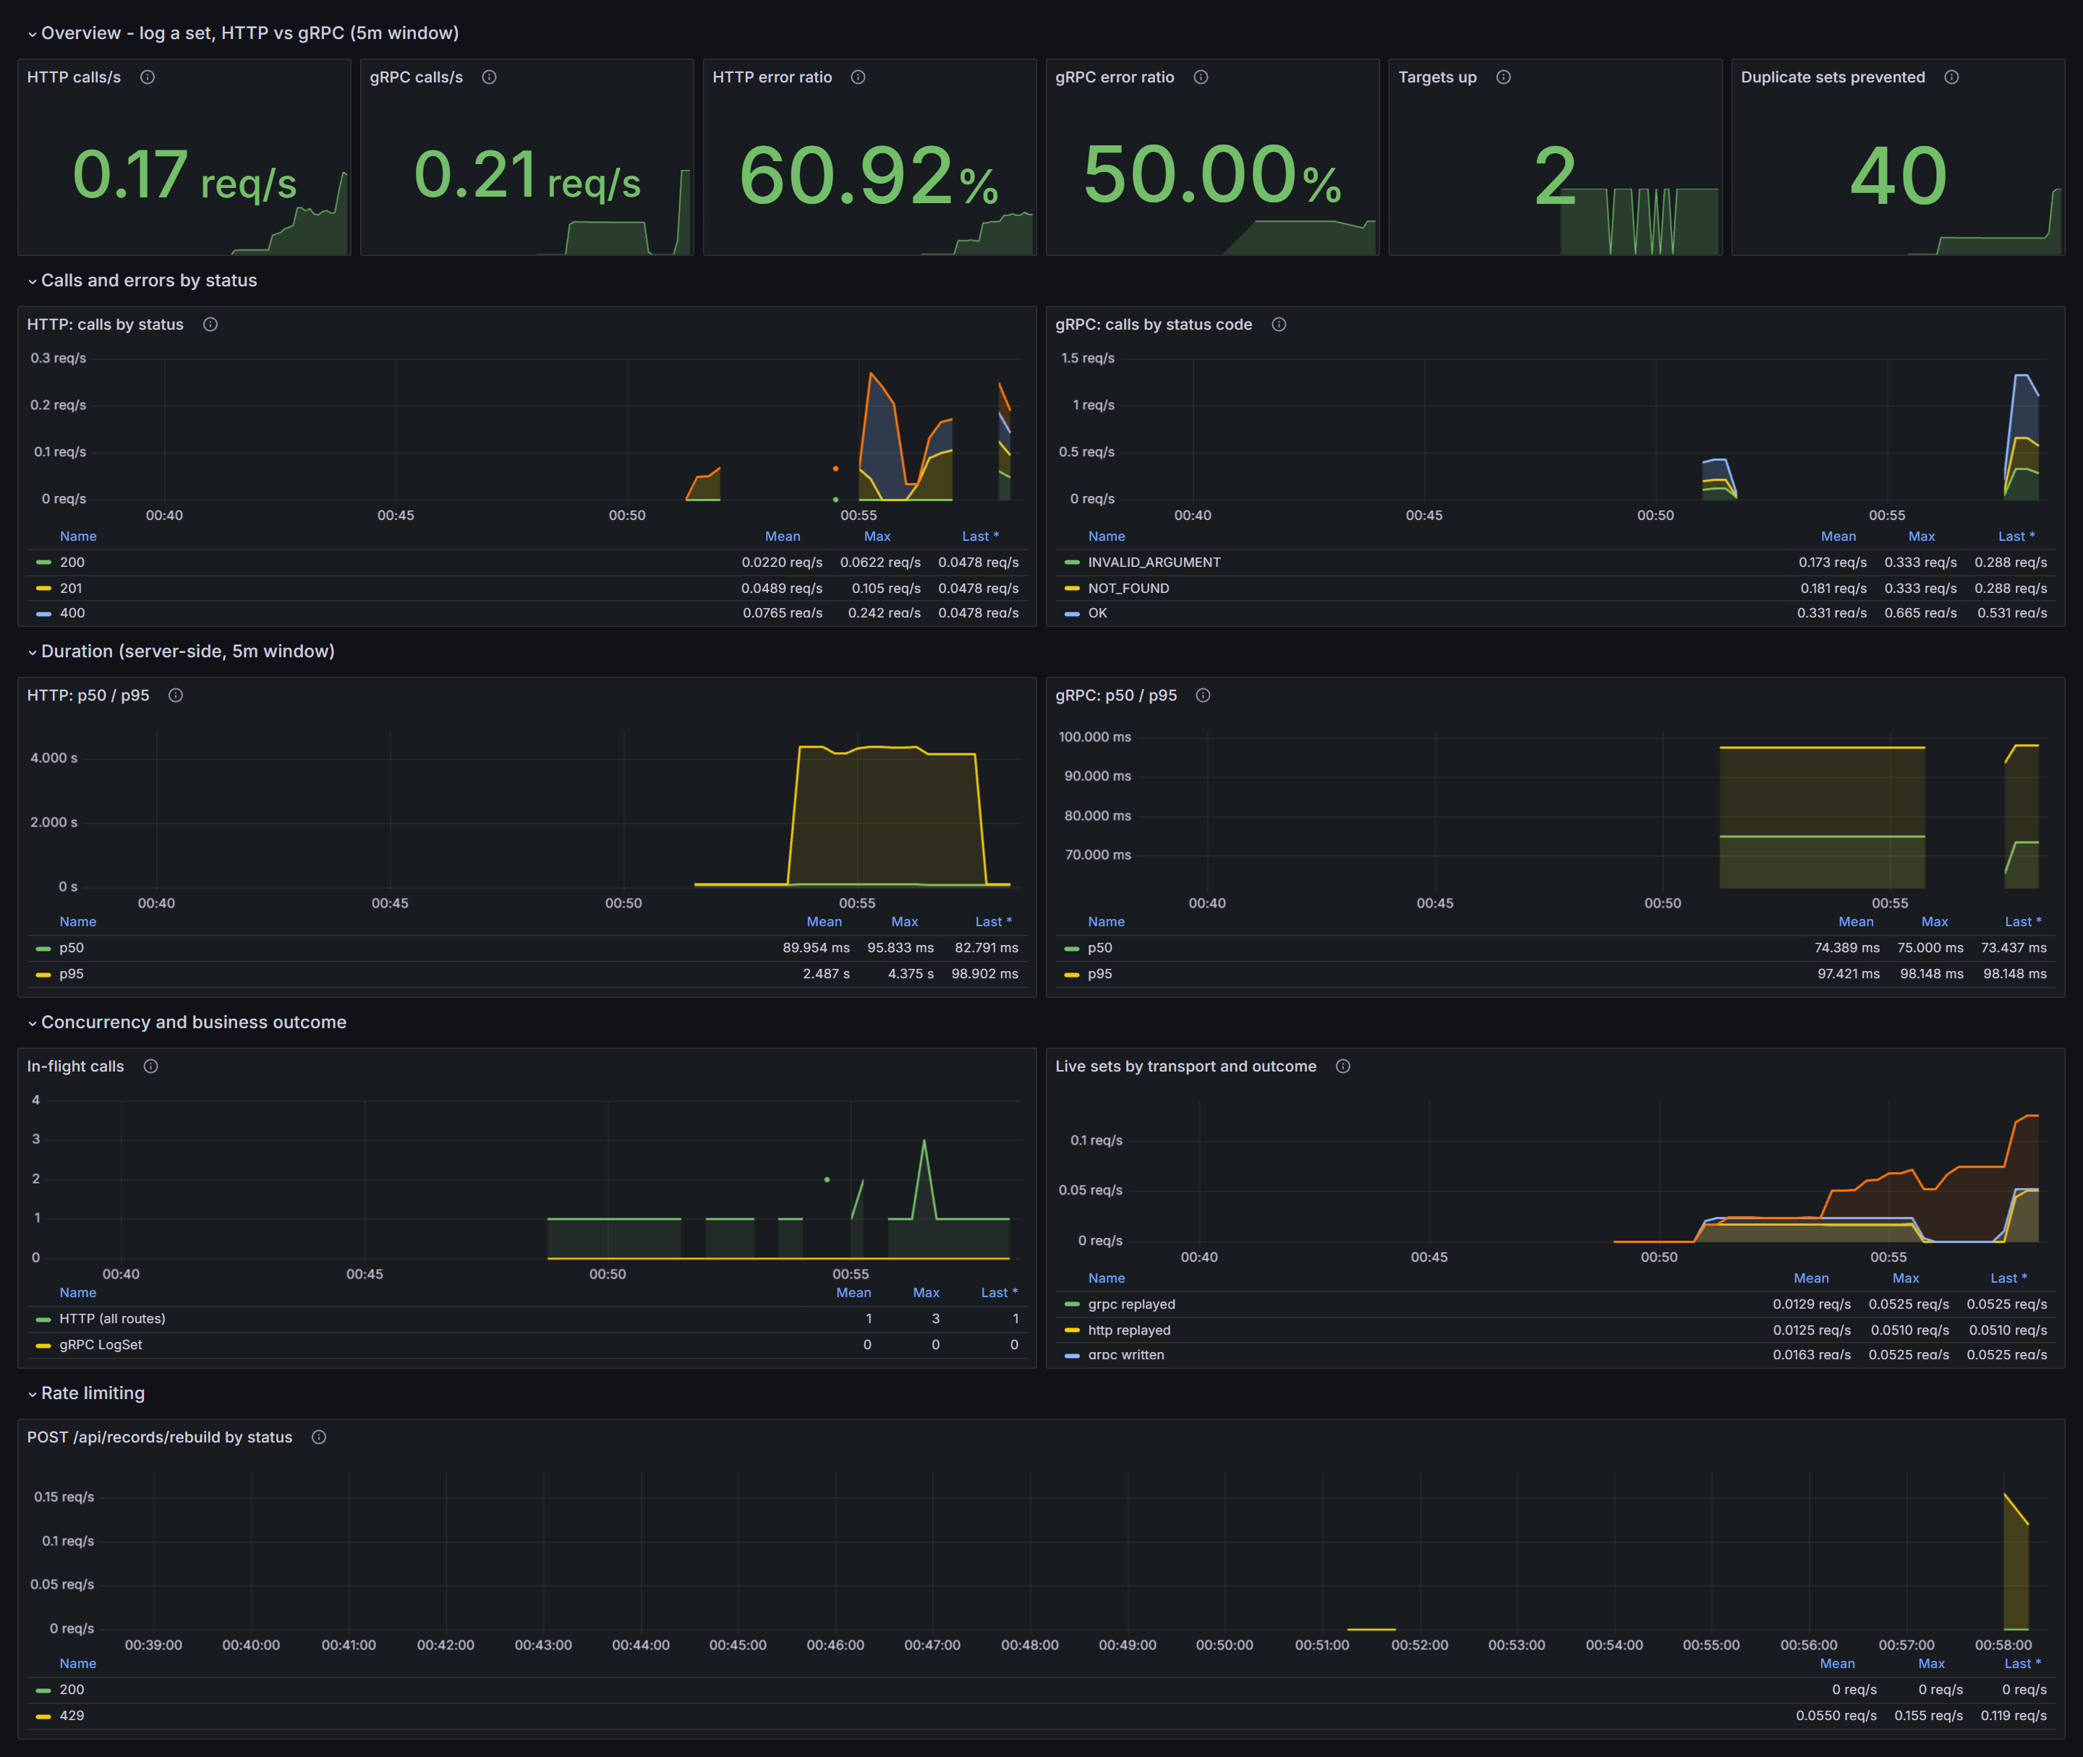
Figure C.2. The HTTP vs gRPC dashboard over 20 minutes, after several runs of scripts/a2_traffic.py and the reliability demo.
Reading the dashboard:
- Error ratios of 50–61 % are by design: each round of the traffic script sends one valid call, one replay, one invalid and one not-found call, so half the gRPC calls are failures (INVALID_ARGUMENT, NOT_FOUND). HTTP is higher because the reliability demo's refused and aborted calls are counted there as well.
- Duration: gRPC LogSet p50 is about 74 ms and p95 about 98 ms. HTTP p50 is about 90 ms, but HTTP p95 reaches about 4.4 s while the reliability demo was running, because of its injected 3 s delay on every 4th request. It falls back to about 99 ms once the fault is removed. This is the latency fault showing up in the histogram's upper buckets, as intended.
- Duplicate sets prevented: 40. Each replayed request (same Idempotency-Key) over either transport is counted by gym_live_sets_total{outcome="replayed"}.
- Rate limiting: the bottom panel shows the 200s, and then the 429s from repeated POST /api/records/rebuild bursts.

Submission contents
Item | Location
Code | api.py, sessions.py, grpc_server.py, metrics.py, static/app.js
OpenAPI document | docs/openapi.json (generated by scripts/export_openapi.py)
.proto and generated code | proto/workout.proto, grpc_gen/
Generation command | Section B.2 and README.md
Python clients | clients/http_caller.py, clients/grpc_client.py
Tests | tests/test_api_v2.py, tests/test_http_caller.py, tests/test_grpc_service.py
Prometheus configuration | observability/prometheus/prometheus.yml
Grafana dashboard | observability/grafana/dashboards/04-http-vs-grpc.json
Migration | migrations/004_idempotent_sets.sql
Traffic and demo scripts | scripts/a2_traffic.py, scripts/demo_reliability.sh
Results | observability/results-a2/
Run and test commands | README.md (Assignment 2 section), HOW_TO_RUN.md

Test commands:
pip install -r requirements-dev.txt
python -m pytest -q tests/test_api_v2.py tests/test_http_caller.py tests/test_grpc_service.py
python scripts/export_openapi.py --check

References and reused work
- gRPC Python documentation and grpcio-tools (code generation); Protocol Buffers proto3 language guide.
- OpenAPI Specification 3.1; FastAPI's OpenAPI generation and Swagger UI.
- Prometheus client for Python; metric naming follows the conventions of the gRPC ecosystem's Prometheus middleware (grpc_server_handled_total, grpc_server_handling_seconds).
- The course gRPC workshop was available as a reference. [Confirm and cite here if any of its code or structure was reused.]
- Data volumes are excluded from the submission.

