Assignment 1
Observability
Gym Tracker — a journal-first training log, instrumented end to end
Field | Value
Student Name | [PLACEHOLDER]
Student ID | [PLACEHOLDER]
Course | Enterprise Software Development
Semester | Fall 2026
Assignment | Assignment 1 — Observability
Project | Gym Tracker (FastAPI + Postgres), repository root of this submission
Report source | docs/REPORT.md — this document is the submission copy
Stack verified | 19–20 September 2026, Docker Desktop for Windows (WSL2 backend)

Submission contents. Code and configuration — the repository, including observability/prometheus/, observability/grafana/dashboards/ (3 dashboards), observability/filebeat/, observability/elasticsearch/ and observability/kibana/saved-objects.ndjson (9 saved objects).
README — README.md, with start / use / test / clean-up instructions.
Short report — this document, covering Parts A to E.

Contents

Right-click the table above and choose "Update Field" in Word to populate page numbers.

Part A — Project

A.1 Problem
People who lift weights keep a training journal, and almost nobody keeps it in a form a computer can read. A real entry looks like this:
Mon - chest
bench 60x8, 70x6, 70x5 (last one was a grind)
incline db press 22.5s x10 x10 x9
cable fly 3x12 light
bw 78.4
That is enough for the person who wrote it and useless to everything else. Answering "is my bench press actually going up?" means reading back through months of it by hand. The structured alternatives — apps that make you tap through exercise → sets → reps → weight for every set — are accurate and so tedious that people stop using them mid-session.
The tension the project resolves. The journal wins because it costs nothing to write; it loses because nothing can read it.

A.2 Intended Users
One person's own training log, with accounts so several people can share a single deployment. Each account sees only its own training: every query is scoped by user_id, and ownership always comes from the session cookie, never from anything the browser posted.
It is not a social app, a coaching platform, or a gym's membership system.

A.3 Solution
A small FastAPI web application. Paste the journal entry exactly as written; a language model extracts the structured rows; you review every row before anything is saved; the saved data feeds progress charts and a weekly report.
The design decision the whole thing rests on: the language model never produces a number that reaches the database unseen.
The pipeline scores how well each proposed row is grounded in the source text, and the review screen shows every prospective row with anything missing or implausible marked in red. The weekly report works the same way — every figure is computed in code, and the model only writes prose around figures it did not calculate.
journal text ──▶ extract (LLM) ──▶ score & validate ──▶ REVIEW SCREEN ──▶ database
(code) (a human) │
▼
progress charts, weekly report

A.4 What Works
The right-hand column distinguishes functionality that pre-dates this assignment from the observability layer added for it.
Capability | State
Paste a messy journal entry, get structured sets | Works
Review-before-save, with per-row confidence | Works
Bodyweight picked out of the same entry | Works
Fuzzy matching so "bench" / "Bench Press" stay one exercise | Works
Duplicate-submission guard that asks rather than refuses | Works
Per-user accounts, timezones, sessions | Works
Progress charts and a weekly report | Works
Prometheus metrics — four types, application + business | Added for this assignment
Structured JSON logs → Filebeat → Elasticsearch → Kibana | Added for this assignment
Grafana dashboards, Node Exporter, alert rules | Added for this assignment
Fault injection and the cardinality demo | Added for this assignment
Live set-by-set logging, routines, PRs, measurements (installable PWA) | Added after this assignment
Known coverage gap, stated plainly. The live set-by-set workout app was added after this assignment was written. Its API routes run through the same middleware and are labelled by route template, so the application metrics and request logs cover it. The business metrics do not: gym_sets_written_total is incremented in the journal save path only, so a set logged through the workout app does not increment it. That is a real gap in coverage rather than a design choice.
Without a Groq API key. Pasting an entry needs GROQ_API_KEY; everything else works without one. POST /log now shows "Parsing is unavailable because this server has no GROQ_API_KEY configured. Nothing was saved." with a warning-level log line (event.action: extraction_unavailable), instead of the unhandled 500 it returned until 20 September. The check is a MissingApiKeyError raised inside extract_entities, a subclass of the existing ExtractionError, so every caller that already handled a failed extraction handles this too.

A.5 How to Run the Project

Prerequisites
Docker and Docker Compose. Around 4 GB of free RAM (Elasticsearch takes a 512 MB heap and Kibana is not small). No Groq API key is needed for any of the observability work.

Start the application, monitoring and logging
One command brings up all eight services — app, Postgres, Prometheus, Node Exporter, Grafana, Elasticsearch, Kibana and Filebeat:
docker compose up -d --build
./scripts/stack.sh status # every service healthy, every Prometheus target up
./scripts/setup_kibana.sh # imports the data view and 8 saved searches

Access the interfaces
Interface | URL | Credentials
Gym Tracker (the app) | http://localhost:8000 | —
Prometheus | http://localhost:9090 | —
Grafana | http://localhost:3000 | admin / admin on first login
Kibana | http://localhost:5601 | —
Elasticsearch | http://localhost:9200 | —
Node Exporter | http://localhost:9100/metrics | —
Cardinality demo (Part E2) | http://localhost:8001 | profile "experiment" only

Generate traffic
python scripts/load_generator.py --duration 120 --rps 5

# to populate the BUSINESS dashboard without a Groq key:
python scripts/submit_reviewed_entries.py

Run the experiments
./scripts/experiment_anomaly.sh # Part E1: baseline → fault → recovery
./scripts/experiment_cardinality.sh # Part E2: in-process
./scripts/experiment_cardinality.sh --stack # Part E2: through Prometheus

Run the tests
docker compose exec app python -m pytest -q
Note: the suite runs inside the container image, which is where the application actually runs. On a host Python without rapidfuzz installed, collection fails before any test executes.

Shut down safely
./scripts/stack.sh down # stop, KEEP all data
./scripts/stack.sh destroy # stop and DELETE every volume (asks to confirm)

# confirm nothing is left behind:
docker compose ps -a && docker volume ls | grep gym-tracker
Why down and destroy are separate. Losing an experiment's data to the habit of typing "down -v" is a bad afternoon. destroy requires typing the word destroy.

My Comments

Part B — Metrics

B.1 Metrics Architecture
Prometheus pulls. Nothing in this stack pushes a metric anywhere: each target exposes a /metrics endpoint and Prometheus fetches it on a timer.
Application (metrics.py) Prometheus Grafana
counters / gauges :9090 :3000
histograms / summaries │ │
│ │ │
└── GET /metrics ◀───── scrape every 15s │
(exposition text) │ │
TSDB, 15d retention ──── PromQL ┘

node-exporter :9100 ────── GET /metrics ──▶ Prometheus
Why pull rather than push: a target going down is itself visible — the synthetic up series drops to 0 — where a push-based system simply stops receiving and cannot tell silence from health. This is the one failure the application cannot report about itself.
Setting | Value | Why
scrape_interval | 15s | The resolution of every chart downstream. A spike shorter than one scrape is not in the data at all, however it is queried.
scrape_timeout | 10s | Below the interval, so a slow target cannot overlap its own next scrape.
evaluation_interval | 15s | How often alerting rules are re-run.
retention.time | 15d | Prometheus is a recent-history store, deliberately not an archive.
external_labels | monitor=gym-tracker-local, environment=development | Attached to every series, so these metrics are distinguishable from another environment's.
Table B.1 — Global scrape configuration. Source: observability/prometheus/prometheus.yml

B.2 Metric Inventory
19 metrics, declared in exactly one place — metrics.py — so this table has a single source of truth to be checked against. Call sites import a name from that module; they never build a metric inline. Unit "1" means a dimensionless count.

Counters — monotonic totals, always queried through rate()
Metric | Purpose | Unit | Labels | Code Location | Grafana Query
gym_http_requests_total | Every response served. Numerator and denominator of the error rate. | 1 | method, route, status | app.py:419 (exception path), app.py:459 (success path) | sum by (route) (rate(gym_http_requests_total[1m]))
gym_http_exceptions_total | Requests that raised out of the handler. Distinguishes a crash from a deliberate 500. | 1 | route, exception | app.py:422 | sum by (route, exception) (rate(gym_http_exceptions_total[5m]))
gym_workout_entries_total | BUSINESS. Journal entries reaching a terminal state at save. | 1 | outcome = saved / blocked / duplicate_held | app.py:1332, 1374, 1397 | sum by (outcome) (increase(gym_workout_entries_total[5m]))
gym_sets_written_total | BUSINESS. Individual sets inserted — the product's unit of value. | 1 | — | app.py:1400 | increase(gym_sets_written_total[24h])
gym_bodyweight_entries_written_total | BUSINESS. Bodyweight readings inserted. | 1 | — | app.py:1401 | sum(rate(gym_bodyweight_entries_written_total[5m])) * 60
gym_duplicate_decisions_total | BUSINESS. How the duplicate prompt was answered. | 1 | decision = held / overridden | app.py:1349, 1375 | sum by (decision) (increase(gym_duplicate_decisions_total[10m]))
gym_llm_extractions_total | BUSINESS. Groq extraction calls by outcome. | 1 | outcome = success / rate_limited / error | pipeline.py:1050 | sum by (outcome) (increase(gym_llm_extractions_total[5m]))
gym_weekly_reports_total | BUSINESS. Reports generated, by narration success. | 1 | narration = ok / failed | app.py:1509 | sum by (narration) (increase(gym_weekly_reports_total[1h]))
gym_logins_total | Authentication outcomes. Failures without successes is the shape of credential stuffing. | 1 | result = success / failure / rate_limited | app.py:851, 874, 889 | sum by (result) (increase(gym_logins_total[5m]))
gym_faults_injected_total | Part E only. Proves from metrics alone when a fault was live. | 1 | kind = latency / error | faults.py:138 | sum by (kind) (increase(gym_faults_injected_total[1m]))

Gauges — a value that goes up and down
Metric | Purpose | Unit | Labels | Code Location | Grafana Query
gym_http_requests_in_flight | Concurrent requests. The saturation signal on a single worker. | 1 | — | app.py:377 (inc) / app.py:447 (dec, in finally) | gym_http_requests_in_flight
gym_llm_extractions_in_flight | Extractions waiting on Groq right now. | 1 | — | pipeline.py:1187 (inc) / pipeline.py:1224 (dec) | gym_llm_extractions_in_flight
gym_review_drafts_open | BUSINESS. Entries parsed but not yet confirmed. | 1 | — | metrics.py:269 (DraftTracker); driven from app.py:1272 / 1406 | gym_review_drafts_open
gym_build_info | Always 1; labels carry the build identity. | 1 | version, commit | metrics.py:277 / 359 | gym_build_info

Histograms — bucketed, so percentiles can be computed
Metric | Purpose | Unit | Labels | Code Location | Grafana Query
gym_http_request_duration_seconds | The headline latency metric. | seconds | method, route | app.py:416 (exception path) / app.py:456 (success path) | histogram_quantile(0.95, sum by (le) (rate(gym_http_request_duration_seconds_bucket[5m])))
gym_llm_extraction_duration_seconds | BUSINESS. One Groq extraction, retries included. | seconds | — | pipeline.py:1051 | histogram_quantile(0.95, sum by (le) (rate(gym_llm_extraction_duration_seconds_bucket[10m])))
gym_db_commit_duration_seconds | Time inside the committing transaction. | seconds | — | app.py:1356 | histogram_quantile(0.95, sum by (le) (rate(gym_db_commit_duration_seconds_bucket[5m])))
Bucket boundaries are chosen per metric, because the three live on different scales: HTTP latency keeps resolution from 5 ms to 10 s, the LLM from 0.25 s to 60 s, the database from 5 ms to 5 s. Buckets are the resolution limit of every percentile computed from them — Part E shows exactly this in the numbers.

Summaries — client-side sum and count only
Metric | Purpose | Unit | Labels | Code Location | Grafana Query
gym_entry_text_bytes | BUSINESS. Size of a pasted entry. Drives the token budget, so it is a cost metric too. | bytes | — | app.py:1264 | rate(gym_entry_text_bytes_sum[30m]) / rate(gym_entry_text_bytes_count[30m])
gym_sets_per_entry | BUSINESS. Sets written per saved entry. | 1 | — | app.py:1402 | rate(gym_sets_per_entry_sum[30m]) / rate(gym_sets_per_entry_count[30m])
On Python summaries. The brief notes that Python summaries lack percentiles, and they do: prometheus_client implements no streaming quantiles, so a Summary exposes only _sum and _count. The average is therefore the only question it can answer — which is why every p95 in this project comes from a Histogram.
This is asserted in the test suite (test_summary_exposes_sum_and_count_but_no_quantiles) rather than merely stated.

My Comments

B.3 Application Metrics
These measure the machinery — whether the service is fast, up and correct. The application dashboard is laid out on the RED method (Rate, Errors, Duration).
Metric | What it answers | Why it matters here
gym_http_requests_total | How much traffic, split by route and status? | Both halves of the error rate come from one counter, so the numerator and denominator can never disagree about what counts as a request.
gym_http_request_duration_seconds | How long does a request take, and how is that spread? | The headline latency metric. Bucketed rather than a Summary so percentiles can be taken over any window and aggregated across processes in PromQL.
gym_http_exceptions_total | Which routes are raising, and with what exception class? | A deliberate 500 and a crash need telling apart. This counts the unhandled ones specifically.
gym_http_requests_in_flight | How many requests are being served right now? | On a single free-tier worker this is the saturation signal — it climbs while latency climbs. Part E1 shows both moving together.
gym_logins_total | Are authentication attempts succeeding? | A spike in failure without a matching spike in success is the shape of credential stuffing. No username label — that would be both unbounded and a disclosure of who has an account.
gym_db_commit_duration_seconds | How long is the committing transaction? | Separates "the database is slow" from "the model is slow" when POST /save gets slow.

B.4 Business Metrics
These measure the thing the product is actually for. Nothing here is a technical signal; each one can move while every application metric stays perfectly healthy — which is exactly why they are separate.
Metric | What it answers | Why it matters here
gym_sets_written_total | How much training is actually being recorded? | Entries vary wildly in size, so counting entries is misleading. Sets is the honest unit of value the product delivers.
gym_workout_entries_total | Are entries reaching a terminal state, and which one? | outcome=blocked rising while saved falls means extraction quality regressed. Nothing is down; the product has stopped doing its job.
gym_review_drafts_open | How many parsed entries are waiting for a person to confirm? | This project's version of the brief's "orders waiting to be prepared" — see B.4.1 below.
gym_llm_extractions_total | Is the one external dependency healthy, and how does it fail? | The LLM is the dependency that fails in interesting ways; outcome says which way (success / rate_limited / error).
gym_llm_extraction_duration_seconds | How slow is extraction? | Dominates the latency of POST /log, so a slow /log is diagnosed by comparing this histogram against the HTTP one.
gym_weekly_reports_total | Are weekly reports being produced, and is narration working? | A failed narration still produces a correct report — every number is computed in code — so this is a quality signal, not an error rate.
gym_duplicate_decisions_total | How is the duplicate prompt being answered? | Re-pasting a corrected entry looks identical to a double-tapped submit. This counts which one it actually was.
gym_entry_text_bytes | How much text do people paste? | Average entry size drives the token budget, which is what the Groq rate limit is spent on. A cost metric as much as a product one.
gym_sets_per_entry | How full are the sessions being logged? | A sudden fall alongside steady entry volume means extraction started dropping rows — a data-quality alarm no HTTP metric would raise.

B.4.1 The gauge that can come back down
gym_review_drafts_open rises when an entry is parsed at POST /log and falls when it is saved at POST /save. The interesting part is what happens when somebody parses an entry and closes the tab.
A gauge that can only rise is worse than no gauge at all. A naive counter would drift upward until the process restarted, and a dashboard would read that as a real and growing backlog. So an open draft carries a timestamp and is aged out after 30 minutes, and the whole map is capped so a burst cannot grow memory without bound (metrics.py, DraftTracker). Neither the user id nor the session date ever becomes a metric label — they are dict keys inside the process, and the gauge publishes only the count.

B.4.2 The metric I explored myself
gym_sets_per_entry — a Summary, not in any tutorial for this stack, added because it answers a question the obvious metrics cannot. Entries saved and sets written both look healthy if extraction silently starts dropping rows: the same number of people save the same number of entries. The ratio is what moves. Average sets per saved entry rising means people are logging fuller sessions; a sudden fall alongside steady entry volume means the pipeline is losing data.

My Comments

B.5 Percentiles and the Time Window
Every percentile in this project is over a sliding 5-minute window (10 minutes for the LLM, which is rarer and would otherwise have too few samples to interpolate from).

Query
histogram_quantile(
0.95,
sum by (le) (rate(gym_http_request_duration_seconds_bucket[5m]))
)

What the query means, read outward
Step | Reads as
rate(..._bucket[5m]) | the per-second rate of each cumulative bucket over the last 5 minutes
sum by (le) (...) | summed across every label combination, keeping only the bucket boundary le
histogram_quantile(0.95, ...) | interpolate the value below which 95% of observations fall

What the percentile means, and why it matters
"95% of requests completed in this time or less, measured over the last 5 minutes." Part E1 is the argument for using it: during the fault, server-side p95 rose from 4.8 ms to 687.1 ms while p50 moved only from 2.5 ms to 3.1 ms. A dashboard showing only the median would have reported a perfectly healthy service while one request in five took half a second.
Two constraints, both easy to get wrong. The window must hold at least four scrapes. At a 15-second scrape interval, nothing below [1m] is trustworthy — rate() needs several points to fit.
A percentile cannot be averaged. avg(p95) across instances is not the p95 of the whole. Summing the buckets first and taking the quantile of the sum, as above, is correct; taking quantiles per instance and averaging them is not.

B.6 Grafana Dashboards
Three dashboards, 41 panels, 52 queries — all provisioned from version-controlled JSON in observability/grafana/dashboards/, not clicked together in the UI. A dashboard that only exists in Grafana's database is lost with the volume and cannot be reviewed in a diff.

B.6.1 Application performance (uid: gym-app-perf)
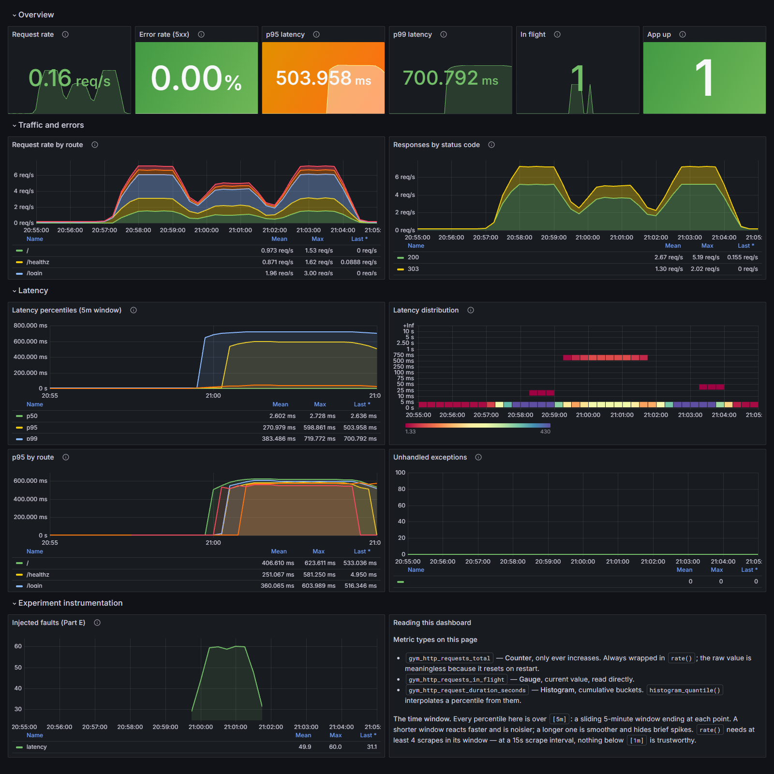
Screenshot 1 — Grafana "Application performance" dashboard, captured live across the Part E1 experiment window. Proves: Part B (Prometheus + Grafana, application metrics, Counter/Gauge/Histogram in one view, p95 and p99) and Part E1 (the fault is visible).
What the chart shows. The overview row reads left to right as the RED method: rate, errors, duration. The latency panels show the injected fault clearly — a flat baseline until 21:00, then p95 and p99 stepping up to ~504 ms and ~701 ms and holding, while p50 stays at 2.6 ms throughout. The heatmap makes the bimodality literal: two separate bands, one at 5–10 ms and one at 500–750 ms, with nothing in between.
Key queries on this dashboard:
# Request rate sum(rate(gym_http_requests_total[1m]))
# Error rate (5xx) (sum(rate(gym_http_requests_total{status=~"5.."}[5m])) or vector(0))
# / clamp_min(sum(rate(gym_http_requests_total[5m])), 0.0001)
# p95 latency histogram_quantile(0.95, sum by (le) (rate(gym_http_request_duration_seconds_bucket[5m])))
# p99 latency histogram_quantile(0.99, sum by (le) (rate(gym_http_request_duration_seconds_bucket[5m])))
# In flight (Gauge) gym_http_requests_in_flight
# App up up{job="gym-tracker"}
# p95 by route histogram_quantile(0.95, sum by (le, route) (rate(gym_http_request_duration_seconds_bucket[5m])))
# Latency heatmap sum by (le) (increase(gym_http_request_duration_seconds_bucket[1m]))
# Injected faults sum by (kind) (increase(gym_faults_injected_total[1m]))
Interpretation. Error rate stayed at 0.00% for the whole window — every request returned 200. A monitoring setup watching only errors and uptime would have seen nothing at all. The clamp_min in the error-rate query prevents a division by zero when there is no traffic, which would otherwise render as NaN rather than 0.

My Comments

B.6.2 Business metrics (uid: gym-business)
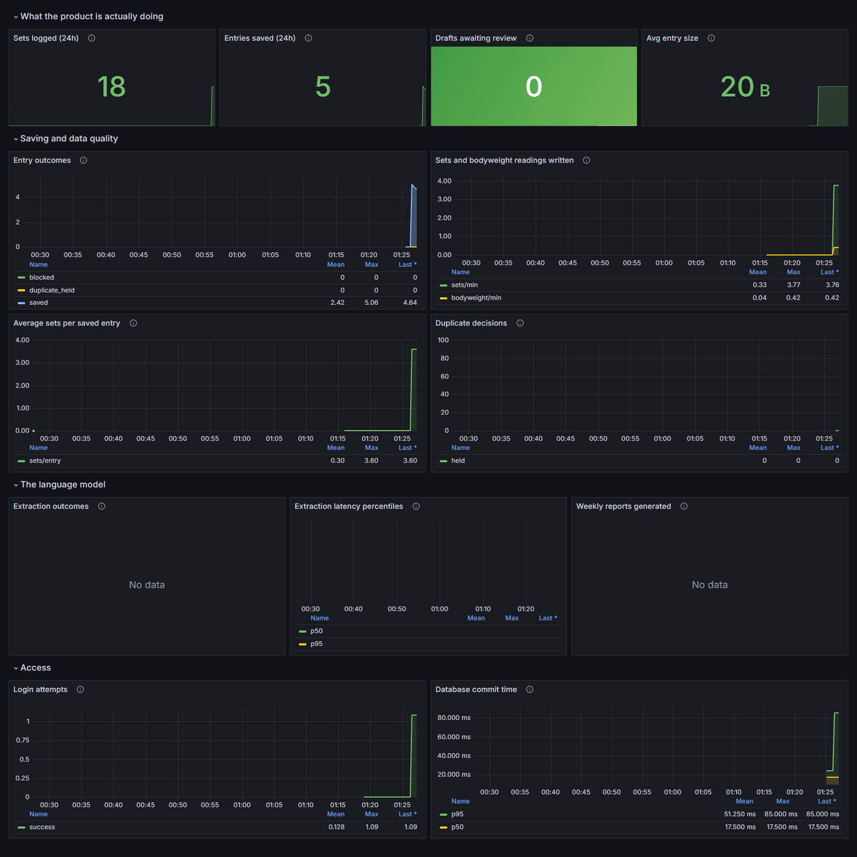
Screenshot 2 — Grafana "Business metrics" dashboard with real data written through the review form. Proves: Part B business metrics, Counter / Gauge / Summary / Histogram all present on one page.
What the chart shows. 18 sets logged and 5 entries saved in the last 24 hours, 0 drafts awaiting review, and an average entry size of 20 B. "Entry outcomes" shows all five entries landing on outcome="saved" with zero blocked and zero duplicate_held. "Average sets per saved entry" reaches 3.60, and database commit p95 is 85 ms against a p50 of 17.5 ms.
Key queries:
# Sets logged (24h) increase(gym_sets_written_total[24h])
# Entries saved (24h) increase(gym_workout_entries_total{outcome="saved"}[24h])
# Drafts awaiting review gym_review_drafts_open
# Avg entry size rate(gym_entry_text_bytes_sum[30m]) / clamp_min(rate(gym_entry_text_bytes_count[30m]), 0.0001)
# Entry outcomes sum by (outcome) (increase(gym_workout_entries_total[5m]))
# Avg sets per entry rate(gym_sets_per_entry_sum[30m]) / clamp_min(rate(gym_sets_per_entry_count[30m]), 0.0001)
# DB commit percentiles histogram_quantile(0.95, sum by (le) (rate(gym_db_commit_duration_seconds_bucket[5m])))
Three panels read "No data", and that is disclosed rather than hidden. The machine this was captured on has no GROQ_API_KEY, so the LLM extraction path was never exercised. "Extraction outcomes", "Extraction latency percentiles" and "Weekly reports generated" therefore have no series. The instrumentation exists and is unit-tested; it has no production data behind it in this capture.

My Comments

B.7 Node Exporter — the machine
prom/node-exporter:v1.8.2 reports CPU, memory, disk and network for the Docker host — the machine running the stack.

The machine being measured
Property | Value
Prometheus label | machine="docker-host", job="node-exporter", service="node-exporter"
Scrape target | 172.28.77.1:9100 (the pinned gym-net bridge gateway)
What it actually is | On Docker Desktop for Windows, the WSL2 Linux VM that runs every container — not the Windows PC itself. On a Linux host it is simply the host.
Observed hardware | 12 cores, 7.56 GiB total memory, root volume /mnt/docker-desktop-disk at 944 GiB
Namespaces | network_mode: host and pid: host, with /proc, /sys and / bind-mounted read-only
Why not host.docker.internal? On Docker Desktop, host.docker.internal resolves to Windows, not to the Linux VM the exporter is running in. The bridge gateway 172.28.77.1 is the VM itself, so the subnet is pinned in docker-compose.yml and prometheus.yml scrapes that address. Every container in the stack is a process on this one kernel, so their CPU and memory use is included in these totals.
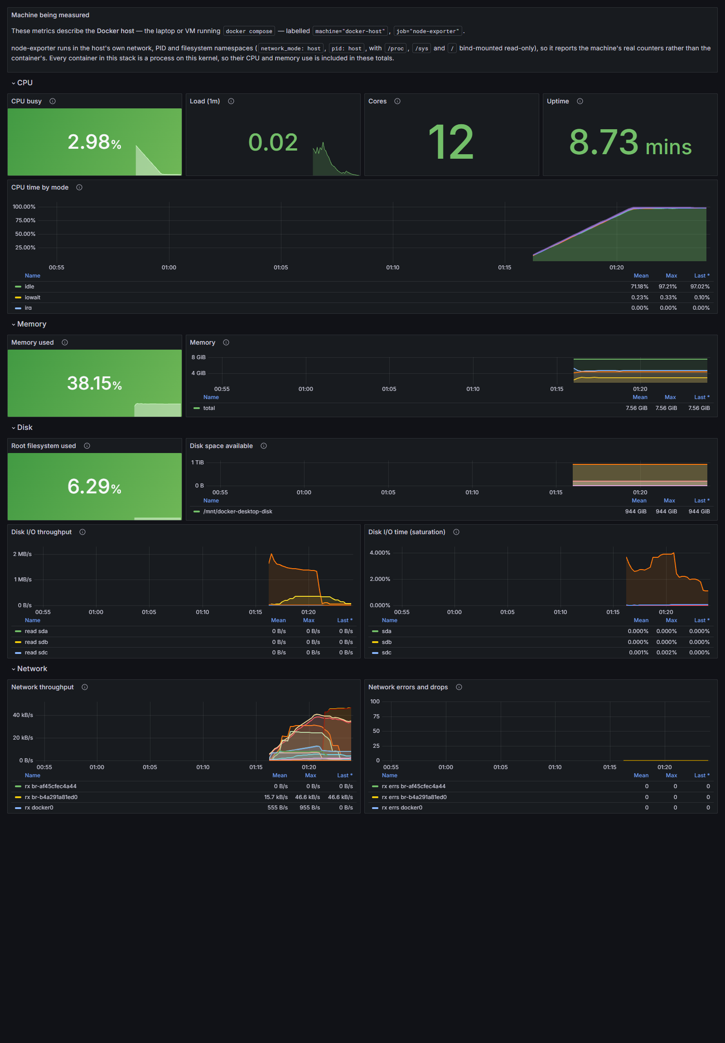
Screenshot 3 — Grafana "Host (node-exporter)" dashboard. Proves: Part B Node Exporter requirement — CPU, memory, disk and network, collected by Prometheus, displayed in Grafana, with the machine named in the header panel.

CPU
CPU busy 2.98%, load (1m) 0.02, 12 cores, uptime 8.73 minutes. "CPU time by mode" breaks the total into idle (71.18% mean, 97.02% last), iowait and irq — the shape that tells a CPU-bound process from an I/O-bound one.
# CPU busy 1 - avg(rate(node_cpu_seconds_total{mode="idle"}[5m]))
# Cores count(count by (cpu) (node_cpu_seconds_total{mode="idle"}))
# By mode avg by (mode) (rate(node_cpu_seconds_total[5m]))
# Uptime node_time_seconds - node_boot_time_seconds

Memory
38.15% used of 7.56 GiB total. The time series plots total, used (total minus available) and cached separately, because "used" on Linux is meaningless without knowing how much is reclaimable cache.
# Memory used 1 - (node_memory_MemAvailable_bytes / node_memory_MemTotal_bytes)
# Series node_memory_MemTotal_bytes
# node_memory_MemTotal_bytes - node_memory_MemAvailable_bytes
# node_memory_MemAvailable_bytes
# node_memory_Cached_bytes

Disk
Root filesystem 6.29% used; 944 GiB available on /mnt/docker-desktop-disk. Throughput and I/O time are plotted per device (sda, sdb, sdc) — I/O time is the saturation signal, distinct from throughput.
# Root used 1 - (node_filesystem_avail_bytes{mountpoint=~"/|/var/lib"}
# / node_filesystem_size_bytes{mountpoint=~"/|/var/lib"})
# Available node_filesystem_avail_bytes{fstype!~"tmpfs|overlay|squashfs"}
# Throughput sum by (device) (rate(node_disk_read_bytes_total[5m]))
# sum by (device) (rate(node_disk_written_bytes_total[5m]))
# Saturation sum by (device) (rate(node_disk_io_time_seconds_total[5m]))
The mountpoint matcher is =~"/|/var/lib" rather than a plain "/" because mountpoint="/" does not exist on the Docker Desktop VM — the data disk is mounted at /var/lib. This panel was silently empty until that was found by running it.

Network
Throughput per interface peaks at 46.6 kB/s on the bridge carrying the stack's traffic; docker0 shows 555 B/s mean. Errors and drops are flat at zero across every interface for the whole window.
# Throughput sum by (device) (rate(node_network_receive_bytes_total{device!="lo"}[5m]))
# sum by (device) (rate(node_network_transmit_bytes_total{device!="lo"}[5m]))
# Errors/drops sum by (device) (rate(node_network_receive_errs_total{device!="lo"}[5m]))
# sum by (device) (rate(node_network_receive_drop_total{device!="lo"}[5m]))
device!="lo" excludes loopback, which would otherwise dominate every chart with traffic that never left the machine.

My Comments

B.8 Alert rules
Nine alerting rules in observability/prometheus/alerts.yml. No Alertmanager is wired in, so they surface at Prometheus /alerts and as Grafana annotations. They are here because writing the alert is what forces a number onto the word "slow".
Alert | Expression (abbreviated) | For | Severity
TargetDown | up == 0 | 1m | critical
HighErrorRate | sum(rate(gym_http_requests_total{status=~"5.."}[5m])) / sum(rate(gym_http_requests_total[5m])) > 0.05 | 2m | critical
SlowRequests | histogram_quantile(0.95, sum by (le, route) (rate(gym_http_request_duration_seconds_bucket[5m]))) > 1 | 2m | warning
SlowExtraction | histogram_quantile(0.95, sum by (le) (rate(gym_llm_extraction_duration_seconds_bucket[5m]))) > 15 | 5m | warning
SavesFailingReview | blocked share of gym_workout_entries_total over 15m > 0.5 | 10m | warning
FaultInjectionActive | increase(gym_faults_injected_total[5m]) > 0 | 1m | warning
HostLowDisk | node_filesystem_avail_bytes{mountpoint="/"} / node_filesystem_size_bytes{mountpoint="/"} < 0.10 | 5m | critical
HostHighCpu | 1 - avg(rate(node_cpu_seconds_total{mode="idle"}[5m])) > 0.90 | 10m | warning
Every rule uses for:, so a condition has to persist before it fires. Without it a single slow scrape raises an alert, people learn the alerts are noise, and the next real one is ignored.

My Comments

Part C — Logs

C.1 Logging Architecture
Application Docker Filebeat Elasticsearch Kibana
─────────── ────── ──────── ───────────── ──────
logging_setup.py json-file driver autodiscover index Discover
EcsJsonFormatter ──▶ /var/lib/docker/ ─▶ container input ─▶ filebeat-gym- ─▶ 8 saved
one JSON object containers/<id>/ strips envelope tracker-logs searches
per line to stdout <id>-json.log decode_json_fields ILM: 7 days
10MB x 3 add_docker_metadata
Stage | What happens | Configured in
1. App writes | One JSON object per line to stdout, in ECS field names. | logging_setup.py — EcsJsonFormatter
2. Docker saves | The json-file driver wraps each line in its own envelope and appends to /var/lib/docker/containers/<id>/<id>-json.log, capped at 10 MB × 3. | docker-compose.yml — logging: driver: json-file
3. Filebeat reads | Autodiscover watches the Docker API and starts a harvester for any container carrying co.elastic.logs/enabled: "true". The container input strips Docker's envelope. | observability/filebeat/filebeat.yml
4. Filebeat parses | decode_json_fields parses the app's JSON string and promotes its keys to the root of the event. | filebeat.yml — processors
5. ES stores | Bulk-indexed into filebeat-gym-tracker-logs, with the ILM policy attached. | filebeat.yml output + observability/elasticsearch/ilm-policy.json
6. Kibana searches | Data view gym-tracker-logs over filebeat-gym-tracker-*, plus 8 saved searches. | observability/kibana/saved-objects.ndjson
Step 4 is the one that turns text into data. Without decode_json_fields a Kibana search for a request id is a full-text match against a blob; with it, it is a term query against an indexed keyword field.

C.2 What Is Logged
Elastic Common Schema (ECS) field names, so Kibana's built-in columns and the http.*, url.* and event.* field groups work without custom mappings.
Field | Meaning | Brief's requirement
@timestamp | ISO-8601, UTC, milliseconds — the moment the event happened | Time
service.name | gym-tracker | Service
service.version | Build identity | —
log.level | debug | info | warning | error | critical | Severity
message | A short human sentence, not a key=value blob | Message
http.request.id | The correlation id — one per HTTP request | Request ID
event.dataset / log.logger | Which logger produced it | —
http.request.method | GET / POST | —
url.path | Route template where known, raw path otherwise | —
http.response.status_code | Integer, so numeric range queries work | —
event.duration_ms | Float milliseconds | —
event.action | What happened, e.g. entry_saved, extraction_unavailable | —
error.type / error.message / error.stack_trace | On exceptions, all three scrubbed | —
log.origin.file.name / .line / .function | Where in the code it came from | —
container.name / container.image.name / host.name | Added by Filebeat from the Docker API | —

C.2.1 Secrets and personal data are never logged
This application handles a person's training journal, which is health data, plus passwords and API keys.
The filter is a backstop, not the policy. The policy is that call sites log ids and counts, never content. SensitiveDataFilter is installed on the handler rather than a logger, so it applies to library output too — a dependency that helpfully logs the request it just made with the Authorization header attached is exactly the case this catches.
Redaction path | What it catches | Verified by
Key name | password, new_password, token, session, cookie, authorization, api_key, groq_api_key, secret, database_url, raw_text, raw_source — matched case-insensitively on the whole key or its last dotted segment, recursing into dicts and lists | test_sensitive_keys_are_replaced, test_redaction_recurses_into_nested_values
Groq key shape | Regex \bgsk_[A-Za-z0-9]{8,}\b anywhere in free text | test_secret_shaped_values_are_scrubbed_from_free_text
Authorization header | Bearer / Basic followed by 8+ credential characters | test_secret_shaped_values_are_scrubbed_from_free_text
URL userinfo | user:password@ inside a DSN or connection string | test_secret_shaped_values_are_scrubbed_from_free_text
Exception text | error.message and error.stack_trace both pass through the scrubber, because a client library can echo a key back inside an exception | test_exception_text_is_scrubbed_too
raw_text — the journal entry itself — is never logged at any level. Its length and the number of rows extracted from it are what the pipeline records instead (test_journal_text_is_never_logged).

C.3 Logging Code

The formatter
One JSON object per line matters: Filebeat reads newline-delimited records, and a pretty-printed object would arrive as N unparseable lines. json.dumps with default separators never emits a newline inside the object, and ensure_ascii=False keeps non-ASCII characters readable in Kibana rather than escaped.
# logging_setup.py — EcsJsonFormatter.format()
document: dict[str, Any] = {
"@timestamp": datetime.fromtimestamp(record.created, tz=timezone.utc)
.isoformat(timespec="milliseconds").replace("+00:00", "Z"),
"log.level": record.levelname.lower(),
"message": record.getMessage(),
"service.name": self.service,
"service.version": self.version,
"event.dataset": record.name,
...
}

request_id = request_id_var.get()
if request_id:
document["http.request.id"] = request_id

# Everything a call site attached with extra={...}, scrubbed on the way in.
for key, value in record.__dict__.items():
if key in _RESERVED or key.startswith("_"):
continue
document[key] = scrub_value(key, value)

return json.dumps(document, ensure_ascii=False, default=str)
default=str so a date, a Decimal or a model object degrades to its string form instead of killing the log call it appeared in. A logging failure must never be able to take a request down with it.

Request correlation
request_id_var is a contextvar set once per request by the middleware. Every log line emitted while handling that request — from any module, at any depth — picks it up automatically, so one Kibana search on http.request.id returns the whole story of a single click.
Why a contextvar and not a thread-local. The app is async: several requests share a thread, and a thread-local would cross their ids over. The call site never has to mention the request id, which is what makes correlation complete rather than best-effort.

Where logs are generated
Location | Event | Why it is logged there
app.py — log_requests middleware | One "request served" line per response, with method, route, status and duration | The single place every request passes through, so coverage cannot drift as routes are added
app.py — POST /log | entry_drafted, or extraction_unavailable at warning | The parse step is where the external dependency can fail
app.py — POST /save | entry_saved with inserted_sets and session date | The terminal business event; pairs with gym_sets_written_total
app.py — POST /login | Authentication outcome, without the username | Security signal; the username would be a disclosure
pipeline.py | Extraction attempts, token budget, rate-limit waits | Diagnosing a slow or failing LLM needs the retry structure, not just the outcome
faults.py | One warning per injected fault, with fault.kind and fault.sequence | It should be impossible to read a log stream from a degraded process and not notice why

My Comments

C.4 Filebeat — collection and parsing

1. How it reads the logs
Autodiscover rather than a static path: containers get new ids every time they are recreated, so a hardcoded path breaks on the first docker compose up --build. Autodiscover watches the Docker API and starts a harvester when a matching container appears.
filebeat.autodiscover:
providers:
- type: docker
templates:
- condition:
contains:
docker.container.labels.co.elastic.logs/enabled: "true"
config:
- type: container
paths:
- /var/lib/docker/containers/${data.docker.container.id}/*.log
close_removed: true
clean_removed: true
Only containers carrying that label are collected. Elasticsearch and Kibana are themselves chatty, and indexing their logs into the same cluster is a feedback loop: an Elasticsearch error produces a log line, which is indexed by Elasticsearch, which can produce another error. Filebeat's own container is deliberately not labelled either.

2. How it parses them into searchable fields
processors:
- decode_json_fields:
fields: ["message"]
target: "" # root of the event, not a nested prefix
overwrite_keys: true # the app's @timestamp wins over Filebeat's
add_error_key: true # a malformed line gets error.message, not silence
expand_keys: true # "http.request.id" becomes {"http":{"request":{"id":...}}}

- add_docker_metadata:
host: "unix:///var/run/docker.sock"
- add_host_metadata:
when.not.contains.tags: forwarded
- drop_fields:
fields: ["agent.ephemeral_id", "ecs.version", "input.type", "log.offset"]
ignore_missing: true
Option | Effect | Why it is set this way
target: "" | Promotes the app's keys to the document root | log.level in the app's JSON lands as the document's log.level, not under a nested prefix
overwrite_keys: true | The app's values win over Filebeat's defaults | Lets the app's @timestamp — the moment the event happened — replace Filebeat's, which is the moment the line was read. The two differ by the shipping delay, which is exactly the error you do not want when correlating a log against a metric spike
add_error_key: true | A non-JSON line gets an error.message field | Losing a malformed log is how a parsing bug hides for months
expand_keys: true | Dotted keys become nested objects | What Elasticsearch's mapping expects

3. Explaining the parsing (the brief asks for this explicitly)
The app emits JSON rather than plain text, which moves the parsing to the producer — the only place that still knows the types. The application used to log event=request method=POST path=/save status=200. That is readable in a terminal and miserable downstream: every consumer has to re-parse it with a grok pattern, and one unescaped space inside a value breaks the pattern silently.
The payoff is typed fields. Because status code and duration arrive as numbers rather than strings, Kibana can answer url.path: "/save" and http.response.status_code >= 500 and event.duration_ms > 1000 — a question you simply cannot ask of a plain-text log without a grok pattern that someone has to maintain.

4. How it ships them
output.elasticsearch:
hosts: ["http://elasticsearch:9200"]
index: "filebeat-gym-tracker-logs"

setup.template.name: "filebeat-gym-tracker-logs"
setup.template.pattern: "filebeat-gym-tracker-*"
setup.template.overwrite: true
Filebeat 8.x writes to a data stream named filebeat-<version> by default. Without the explicit index, events go there, bypassing both the template and the ILM policy. The index name, the template name and the ILM rollover alias must all agree — a defect found only by running the stack (see the Verification section).

C.5 Elasticsearch — a stored document
The same event, at each stage of the journey. This is a real line from the live run.

1. The original line, as the app writes it to stdout
{"@timestamp": "2026-09-15T06:07:28.710Z", "log.level": "info",
"message": "request served", "service.name": "gym-tracker",
"service.version": "1.0.0", "event.dataset": "gym_tracker.app",
"log.logger": "gym_tracker.app", "log.origin.file.name": "app.py",
"log.origin.file.line": 429, "log.origin.function": "log_requests",
"process.pid": 3124, "http.request.id": "f1d4bb6745b64b3d",
"http.request.method": "GET", "url.path": "/healthz",
"http.route": "/healthz", "http.response.status_code": 200,
"event.duration_ms": 4.1}

2. As Docker stores it — wrapped in the driver's envelope
{"log":"{\"@timestamp\": \"2026-09-15T06:07:28.710Z\", ...
\"event.duration_ms\": 4.1}\n",
"stream":"stdout",
"time":"2026-09-15T06:07:28.710Z"}

3. As Elasticsearch indexes it — envelope stripped, JSON parsed, metadata attached
Field | Value | Type
@timestamp | 2026-09-15T06:07:28.710Z | date
log.level | info | keyword
message | request served | text
service.name | gym-tracker | keyword
http.request.id | f1d4bb6745b64b3d | keyword
http.request.method | GET | keyword
url.path | /healthz | keyword
http.response.status_code | 200 | long
event.duration_ms | 4.1 | float
container.name | gym-tracker | keyword (added by Filebeat)
container.image.name | gym-tracker-observability-app | keyword (added by Filebeat)
host.name | the Docker host | keyword (added by Filebeat)
Table C.5 — The stored document. The two bold rows are the point: numbers arrive as numbers, so range queries work.

My Comments

C.6 Kibana — a working search
Data view gym-tracker-logs over filebeat-gym-tracker-*, plus eight saved searches shipped in observability/kibana/saved-objects.ndjson and imported by scripts/setup_kibana.sh.
Saved search | Query
01 — All gym-tracker logs | service.name: "gym-tracker"
02 — Errors and warnings | log.level: ("error" or "warning" or "critical")
03 — Slow requests (over 500ms) | event.duration_ms > 500
04 — Trace one request by id | http.request.id: "<paste an id>"
05 — Workout entry events | event.action: ("entry_drafted" or "entry_saved")
06 — Authentication failures | event.action: "login" and log.level: "warning"
07 — Injected faults (Part E) | fault.kind: *
08 — LLM extraction failures | event.dataset: "gym_tracker.pipeline" and log.level: ("warning" or "error")

How to search for one request
Copy the x-request-id response header (or an id from any log line), then in Kibana Discover:
http.request.id: "8d59a31cdc6f454c"
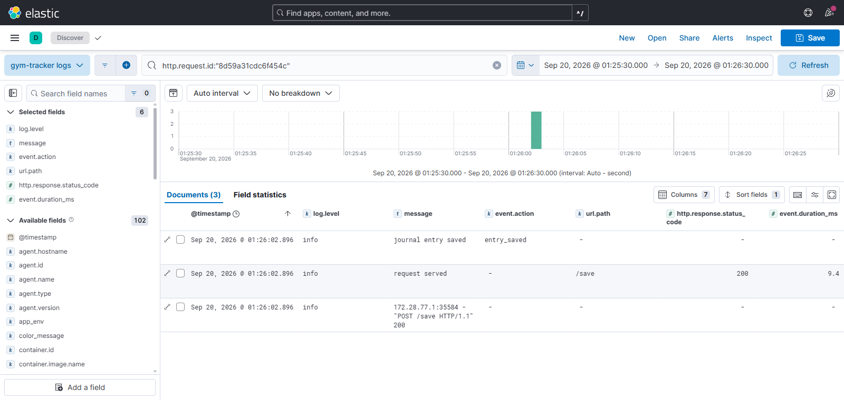
Screenshot 4 — Kibana Discover tracing one POST /save by request id. Proves: Part C (working Kibana search, parsed searchable fields, time/service/severity/message/request-id) and Part D.3 (the log journey, end to end).
What this proves, field by field. Three documents share the id 8d59a31cdc6f454c and the same millisecond (01:26:02.896): the business event (journal entry saved, event.action: entry_saved), the middleware's own line (request served, url.path: /save, status 200, event.duration_ms 9.4), and uvicorn's access line — all three in the same JSON shape because uvicorn's handlers were cleared and its records propagate to the root handler.
The left rail shows 102 available fields discovered from the index, with type icons: k for keyword on log.level, event.action and url.path; t for text on message; # for number on http.response.status_code and event.duration_ms. Those type icons are the direct visual evidence that decode_json_fields worked — an unparsed pipeline would show one text blob and nothing else.

My Comments

C.7 Persistence and Retention
Three separate lifetimes, routinely confused.
Stage | Lives in | Bounded by | Survives restart?
The file | /var/lib/docker/containers/<id>/ on the host | json-file driver: max-size 10m, max-file 3 (30 MB per container) | Yes, until the container is removed
Filebeat's position | filebeat-data named volume | — | Yes — this is why a restart resumes instead of re-indexing everything
The document | elasticsearch-data named volume | ILM policy: deleted 7 days after rollover | Yes

When old logs are deleted
Phase | Action | Trigger
hot | rollover | 1 GB primary shard size, 10,000,000 documents, or 1 day — whichever comes first
hot | set_priority | 100
delete | delete | 7 days after rollover
Writes always go to the newest index, so deleting an old one never interrupts ingestion. Deleting by whole index is also far cheaper than deleting individual documents, which in Lucene only marks them and reclaims nothing until a merge.
The real data-loss window in this design. Docker deletes the oldest log file whether or not Filebeat has read it. If Elasticsearch is down long enough that Docker rotates a file away before Filebeat catches up, those lines are gone. That is why Filebeat needs a persistent registry and a cluster that stays up.
Seven days suits a course project. Production retention is a legal and financial question, not a technical one: long enough to investigate an incident nobody noticed for a week, short enough that the storage bill and the personal-data exposure stay bounded. docker compose down keeps all of it; docker compose down -v deletes it.
Not verified by observation. The ILM policy is attached to the write index and reports phase: hot. Rollover needs 1 GB or 1 day and deletion needs 7 more, so neither transition has actually been watched happening. What is verified is that the policy exists, is valid, and is bound to the index. Docker's 10 MB × 3 rotation has likewise not been reached in practice.

My Comments

Part D — System Design

D.1 Architecture Diagram
┌──────────────────────────┐
│ Person with a phone │
│ and a journal entry │
└────────────┬─────────────┘
│ HTTPS
┌───────────────────────────────────▼──────────────────────────────┐
│ APPLICATION │
│ ┌────────────────────────────┐ ┌──────────────────────┐ │
│ │ gym-tracker │ SQL │ Postgres 16 :5432 │ │
│ │ FastAPI / uvicorn :8000 │───────▶│ [STORE] workouts, │ │
│ │ ────────────────────────── │ │ users, reports │ │
│ │ /metrics exposition │ │ volume postgres-data │ │
│ │ JSON logs to stdout │ └──────────────────────┘ │
│ └──────┬──────────────┬──────┘ │
└─────────│──────────────│─────────────────────────────────────────┘
│ HTTPS │ stdout
▼ ▼
┌──────────────────┐ ┌──────────────────────────────────────────┐
│ Groq API │ │ LOGS — push │
│ [EXTERNAL] │ │ Docker json-file driver │
│ LLM extraction │ │ /var/lib/docker/containers/ 10MB x 3 │
└──────────────────┘ │ │ reads file │
│ ▼ │
┌──────────────────┐ │ Filebeat — tails, strips envelope, │
│ METRICS — pull │ │ decode_json_fields │
│ │ │ │ bulk index │
│ Prometheus │ │ ▼ │
│ :9090 │ │ Elasticsearch :9200 [STORE] │
│ scrape /15s │ │ indexed documents, ILM delete after 7d │
│ TSDB 15d │ │ volume elasticsearch-data │
│ [STORE] │ │ │ queries │
│ ▲ ▲ │ │ ▼ │
│ │ │ │ │ Kibana :5601 — Discover + 8 searches │
│ GET /metrics │ └──────────────────┬───────────────────────┘
│ (Prometheus │ │ log panels
│ INITIATES) │ │
│ │ │ │
│ node-exporter │ ┌──────────────────▼───────────────────────┐
│ :9100 │ │ Grafana :3000 │
│ host CPU/mem/ │──▶│ 3 provisioned dashboards, 41 panels │
│ disk/net │ │ PromQL + ES query DSL │
└──────────────────┘ └──────────────────────────────────────────┘
Figure D.1 — Full architecture. Solid arrows are push; the Prometheus arrows are pull (Prometheus initiates every metrics connection). [STORE] marks a persistent volume. A Mermaid source version is at docs/architecture.mmd.

What each component does, and how they communicate
Component | Does | Talks to | How
gym-tracker | Serves the app; exposes /metrics; writes JSON to stdout | Postgres, Groq | SQL over TCP; HTTPS
Postgres | Stores workouts, users, reports | — | Receives SQL
Groq | LLM extraction. The one external dependency | — | HTTPS, called by the app
Prometheus | Scrapes /metrics every 15s, stores in its TSDB, evaluates alert rules | app, node-exporter, itself | HTTP GET — it initiates
node-exporter | Reads /proc and /sys, exposes host metrics | — | Scraped by Prometheus
Grafana | Queries Prometheus and Elasticsearch, draws dashboards | Prometheus, Elasticsearch | PromQL over HTTP; ES query DSL
Docker json-file | Captures stdout to disk, rotates it | — | Writes files
Filebeat | Tails container logs, parses, ships | Docker API, Elasticsearch | Reads socket + files; bulk HTTP
Elasticsearch | Indexes and stores documents, enforces ILM | — | Receives bulk writes
Kibana | Search UI | Elasticsearch | HTTP queries

Where data is stored, and why this design
Data | Stored in | Why there
Workouts, users, reports | Postgres (postgres-data) | Relational, needs transactions, foreign keys and exact answers. This is the system of record.
Metrics | Prometheus TSDB (prometheus-data), 15 days | Numeric time series compress enormously as delta-of-delta. Prometheus is a recent-history store, deliberately not an archive — this is why it is not a database you query for business facts.
Logs | Elasticsearch (elasticsearch-data), 7 days | An inverted index is what makes arbitrary field search fast. Storage cost per event is far higher than a metric sample, which is exactly why identifiers belong here and not in a metric label.
Dashboards, datasources, alert rules | Files in the repository | Reviewable in a diff, recreatable on any machine, not lost with a volume.
The load-bearing design decision. Metrics answer "how many, how fast, right now" cheaply for unlimited events but only across a few bounded dimensions. Logs answer "what exactly happened to this one request" at a cost per event. Trying to use one for the other's job is how both bills get large: putting a request id in a metric label is a cardinality explosion (Part E2), and computing a request rate by counting log documents is expensive and imprecise.

What happens if a component stops working
Fails | Immediate effect | Still works | Recovery
Postgres | Saving and charts fail. The app serves errors, correctly | /healthz, /metrics, logs. pool_pre_ping avoids handing out dead connections | Restart; the volume persists. Errors visible as gym_http_exceptions_total
Groq | Parsing fails at POST /log. No data is lost — nothing was saved yet | Everything else. Weekly reports still work: narration degrades, every number is computed in code | Retry. Visible as gym_llm_extractions_total{outcome="error"}
Prometheus | No new metrics, dashboards go blank. The app is unaffected | Everything. The app does not know it is being scraped | Restart. The gap in history is permanent — scrapes missed are missed
node-exporter | No host metrics; up{job="node-exporter"} == 0 fires TargetDown | Everything | Restart
Grafana | No dashboards | Prometheus still collects and still alerts; data is not lost, only the view | Restart. Dashboards are re-provisioned from files
Elasticsearch | Filebeat cannot ship and backs off, retrying | The app logs normally to stdout; Docker keeps the files | Restart. Filebeat resumes from its registry — as long as Docker has not rotated the files away first. This is the real data-loss window
Kibana | No log UI | Ingestion continues; nothing is lost | Restart
Filebeat | No new documents | Files keep accumulating on the host | Restart; resumes from the registry
The app | Total outage | up{job="gym-tracker"} == 0 fires TargetDown within a minute | The one failure the app cannot report itself — which is precisely why up is synthesised by the scraper
The pattern worth naming. Observability failures degrade observability, not the application. The app does not know whether Prometheus is scraping it, and writes to stdout whether or not anything is reading. That is deliberate, and it is why /metrics is a plain endpoint and logging is a stdout write — the two cheapest, least coupled things they could be.

Things not yet fully understood (the brief asks these be noted)
Area | What is understood | What is not
Lucene segment merging | That ILM deletes whole indices because deleting documents only marks them until a merge reclaims the space | The merge policy's scheduling, or how to tune it
Prometheus TSDB internals | The head block, the WAL and compaction into 2-hour blocks, at the level of "why a restart does not lose recent data" | Predicting memory use from a series count with any precision. The Part E2 reasoning is about growth shape, not bytes
histogram_quantile interpolation | That it interpolates linearly within a bucket and that the result is bounded by bucket width — the Part E numbers show this | Its behaviour when observations cluster exactly at a bucket boundary or fall in +Inf
Filebeat back-pressure | That it retries and backs off when Elasticsearch rejects a bulk request | How the queue interacts with file rotation to decide exactly when a log is lost rather than delayed

My Comments

D.2 Metric Journey — gym_sets_written_total

Step 1 — code updates the metric
Someone saves an entry with 5 sets. In app.py, inside POST /save:
METRICS.sets_written_total.inc(result.inserted_sets) # app.py:1400
The counter is a float in the process's memory. Nothing is sent anywhere.

Step 2 — the app exposes it
On the next scrape, GET /metrics renders it in Prometheus text exposition format:
# HELP gym_sets_written_total Individual workout sets inserted into the database.
# TYPE gym_sets_written_total counter
gym_sets_written_total 5.0

Step 3 — Prometheus collects and stores it
Every 15 seconds Prometheus fetches that endpoint and appends a sample to the series, attaching the labels from the scrape config:
gym_sets_written_total{job="gym-tracker", instance="app:8000",
service="gym-tracker",
monitor="gym-tracker-local",
environment="development"}
@ 1789451340 → 5
@ 1789451355 → 5
@ 1789451370 → 12 # two more entries saved

Step 4 — Grafana queries it
The "Sets logged (24h)" stat panel on the business dashboard asks:
increase(gym_sets_written_total[24h])
Why increase() and not the raw value. A counter resets to 0 when the process restarts. increase() and rate() detect the reset and account for it; reading the raw value would show the total dropping to zero on every deploy.

Step 5 — Grafana displays it
A stat panel, last value, 0 decimal places. In Screenshot 2 it reads 18.

Observed values from the live run
From observability/results-live/02-fault-metrics.txt — the scrape taken at the end of the fault stage:
gym_http_requests_total{method="GET",route="/healthz",status="200"} 142.0
gym_http_request_duration_seconds_count{method="GET",route="/healthz"} 142.0
gym_http_request_duration_seconds_sum{method="GET",route="/healthz"} 12.55208804299673
gym_faults_injected_total{kind="latency"} 121.0
142 requests to /healthz taking 12.55 seconds in total — a mean of 88.4 ms, from a route whose real cost is under 3 ms, because 25 of those 142 were delayed by half a second each. The same arithmetic in PromQL, which is what the panel actually runs:
rate(gym_http_request_duration_seconds_sum{route="/healthz"}[2m])
/ rate(gym_http_request_duration_seconds_count{route="/healthz"}[2m])

My Comments

D.3 Log Journey — one POST /save

Step 1 — the application creates the log
# app.py, in POST /save
logger.info("journal entry saved", extra={
"event.action": "entry_saved",
"user.id": user.user_id,
"session.date": str(draft.session_date),
"entry.inserted_sets": result.inserted_sets,
...
})
The formatter adds @timestamp, service.name, log.level, and — from the contextvar — http.request.id, without the call site mentioning it.

Step 2 — it reaches stdout, as one line
{"@timestamp":"2026-09-15T06:07:29.210Z","log.level":"info",
"message":"journal entry saved","service.name":"gym-tracker",
"event.dataset":"gym_tracker.app","http.request.id":"959d6bccd86742ab",
"event.action":"entry_saved","user.id":1,"session.date":"2026-09-15",
"entry.inserted_sets":5}

Step 3 — Docker stores it, wrapped
{"log":"{\"@timestamp\":\"2026-09-15T06:07:29.210Z\",...}\n",
"stream":"stdout",
"time":"2026-09-15T06:07:29.210Z"}

Step 4 — Filebeat collects and parses it
The container input strips the envelope; decode_json_fields promotes the app's keys to the root; add_docker_metadata attaches container.name.
The format changes twice on this journey. flat JSON → wrapped in Docker's envelope → unwrapped and expanded into a nested document, with http.request.id becoming {"http": {"request": {"id": ...}}} via expand_keys.

Step 5 — Elasticsearch stores it
Indexed into filebeat-gym-tracker-*, with entry.inserted_sets mapped as a long and http.request.id as a keyword. See Table C.5 for the full stored document.

Step 6 — Kibana searches and displays it
event.action: "entry_saved" and entry.inserted_sets > 3

# or, for that one request:
http.request.id: "959d6bccd86742ab"
Screenshot 4 (Part C.6) is exactly this search executed against the live stack, returning all three documents for one POST /save.
The two paths meeting. The metric says 12 sets were written in the last hour. The log says which entries, by whom, at what time, in which request. Neither answers the other's question, and the http.request.id is what lets you walk from a spike on a chart to the specific clicks that caused it.

My Comments

Part E — Experiments

E.1 Experiment 1 — Reproducing a Problem
Injected latency: a 500 ms delay on every 5th request — 20% of traffic. Three stages of two minutes each, which at a 15-second scrape interval is eight scrapes per stage.

The repeatable test
./scripts/experiment_anomaly.sh

# which runs, per stage:
python scripts/load_generator.py --duration 120 --rps 5 --label <stage>
The load generator is deterministic and closed-loop: a fixed request mix at a fixed target rate, waiting for each response. The fault sampling is deterministic too — every 5th request, not randomly — so a run injects a known number of faults and the numbers are reproducible rather than merely probable.

Normal behaviour — the baseline
Measure | Value
Requests | 599
Achieved rate | 4.99 rps
p50 latency (client) | 6.3 ms
p95 latency (client) | 29.1 ms
p99 latency (client) | 38.9 ms
Mean latency | 12.2 ms
Error rate | 0.00% (599 × HTTP 200)
Server-side p95 (Prometheus) | 4.8 ms
Time window (UTC) | 2026-09-19T15:56:52Z .. 15:58:53Z
Table E.1a — Baseline. Source: observability/results-live/01-baseline.json and prometheus-percentiles.json
Per-route p95 at baseline: / 35.0 ms, /healthz 26.2 ms, /login 25.1 ms, /metrics 26.3 ms, /progress 37.1 ms.
Screenshot 5 — The baseline is the flat left-hand portion of this dashboard (before 21:00). Proves: Part E1 step 1, normal behaviour on a repeatable test.

My Comments

Prediction — written before the fault stage ran
Recorded in observability/results-live/predictions.md before the fault was armed. Writing the prediction down first is the point of the exercise: an explanation that only arrives after the data is not an explanation.
Metric | Prediction | Reasoning
gym_http_request_duration_seconds p95 | rises to ~500 ms | 20% of requests are delayed, so the 95th percentile lands inside the delayed group
gym_http_request_duration_seconds p50 | barely moves | the median request is not one of the delayed ones
mean latency | rises by ~500/5 ms | the delay averaged over all requests
gym_http_requests_in_flight | rises slightly | delayed requests overlap with new arrivals
gym_http_requests_total rate | falls, or holds | a closed-loop client issues fewer requests when each takes longer
gym_faults_injected_total{kind="latency"} | 0 → non-zero | proves the fault was actually live
error rate | unchanged at 0 | a delay is not a failure; every request still returns 200
Logs predicted to change: event.duration_ms above 500 on the delayed requests only; one warning line per delayed request ("injected fault: delaying this request deliberately") carrying fault.sequence and fault.latency_ms; and no error lines, because this fault degrades rather than breaks.

The problem introduced
The fault is a piece of configuration, not a code edit. Nothing in the request path changes; the only difference between a healthy run and a degraded one is an environment variable, and reverting means unsetting it and restarting.
FAULT_INJECTION_ENABLED=true \
FAULT_LATENCY_MS=500 \
FAULT_LATENCY_EVERY_N=5 \
docker compose up -d --force-recreate app
Safety property | How it is enforced
Off unless explicitly armed | FAULT_INJECTION_ENABLED must be true. A latency value on its own does nothing — two variables have to agree before a request is ever delayed
Cannot degrade production | Refuses to arm when APP_ENV is production, whatever else is set. A copied .env cannot degrade a real deployment
Cannot hide | Logs a loud warning at startup, once, naming exactly what is armed
Provable from metrics | Every injected fault increments gym_faults_injected_total, so the experiment does not rest on trusting that a variable was set
Bounded | The delay is clamped to MAX_LATENCY_MS = 10,000, so a mistyped 5000-for-500 cannot pin a worker for a minute
Does not stall the event loop | asyncio.sleep, never time.sleep. The app is async on one worker; time.sleep would block every concurrent request and make the experiment measure queueing instead of latency
Table E.1b — The undo is safe by construction. Source: faults.py

During the problem
Measure | Baseline | During fault | Change
Requests | 599 | 415 | −31%
Achieved rate | 4.99 rps | 3.45 rps | −31%
p50 (client) | 6.3 ms | 20.2 ms | ×3.2
p95 (client) | 29.1 ms | 524.3 ms | ×18
p99 (client) | 38.9 ms | 531.2 ms | ×13.7
Mean | 12.2 ms | 156.1 ms | ×12.8
Max | 64.2 ms | 551.3 ms | ×8.6
Error rate | 0.00% | 0.00% | unchanged
Server-side p50 | 2.5 ms | 3.1 ms | ×1.2
Server-side p95 | 4.8 ms | 687.1 ms | ×143
gym_faults_injected_total{kind="latency"} | absent | 121 | proves the fault was live
Table E.1c — Before and during. Time window of the fault stage: 2026-09-19T15:59:16Z .. 16:01:17Z (UTC).
Per-route p95 during the fault, showing the delay applied uniformly across every route: / 530.7 ms, /healthz 517.9 ms, /login 518.9 ms, /metrics 517.0 ms, /progress 517.9 ms.
Queries used to read the server side:
histogram_quantile(0.95, sum by (le) (rate(gym_http_request_duration_seconds_bucket[2m])))
histogram_quantile(0.50, sum by (le) (rate(gym_http_request_duration_seconds_bucket[2m])))
sum(rate(gym_http_request_duration_seconds_sum[2m]))
/ sum(rate(gym_http_request_duration_seconds_count[2m]))
increase(gym_faults_injected_total[2m])

What the logs showed
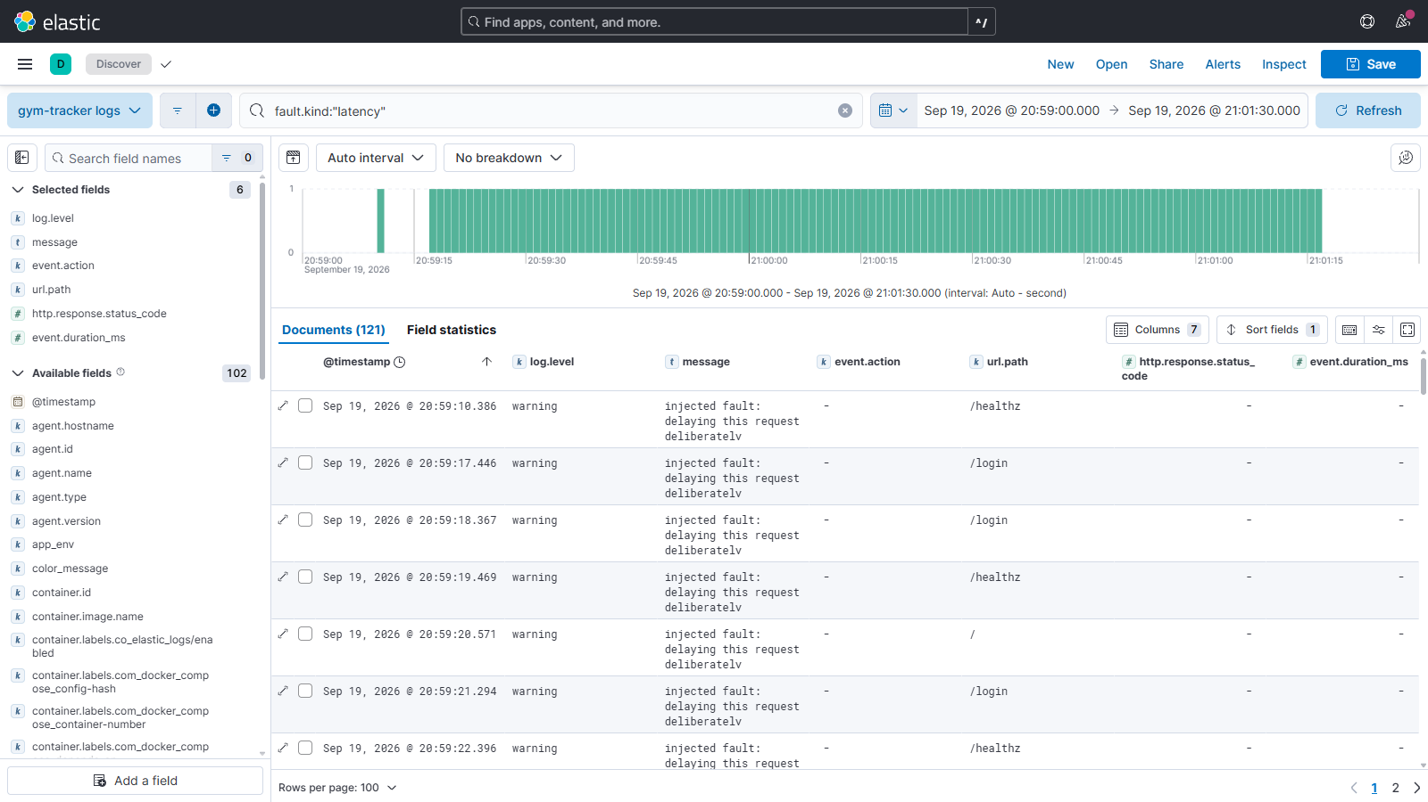
Screenshot 6 — Kibana Discover, query fault.kind: "latency", time range 20:59:00–21:01:30 local. 121 documents, all at warning level, each naming the delayed route. Proves: Part E1 step 3 (evidence in logs) and Part C (severity field, working search).
Signal | Baseline | During fault | After recovery
fault.kind: "latency" documents | 0 | 120 (121 in the wider capture window) | 0
log.level: warning from the app | 0 | 120 | 0
event.duration_ms > 500 | 0 | 120 | 0
log.level: error | 0 | 0 | 0
The metric and the log agree to within one event. gym_faults_injected_total reports 121 while the stage window holds 120 — the extra one is the first request the newly recreated process served, which drew the first delay at 15:59:10.386 and really was held 500 ms (→ 10.887). I first assumed that extra event came from the script's readiness probe, and wrote that down. Following the request id showed otherwise. It is a small case, but it is the pattern this assignment is about: the guess was plausible, and the log settled it in one query.

Cause
faults.py delays every 5th request by 500 ms inside the timed region. fault.sequence in the logs confirms the sampling was exactly deterministic: 5, 10, 15, 20, 25 …

Effect on users
One request in five takes half a second longer. But a page load involves several requests, so in practice most page loads feel slow rather than one in five — which is why p95 predicts how an app feels far better than an average does.
The mean is the worst of both. 156.1 ms describes no actual request. No request took 156 ms; they took either ~6 ms or ~520 ms. An average over a bimodal distribution is a number with no referent — the latency heatmap in Screenshot 1 shows the two bands with nothing between them.

Recovery
FAULT_INJECTION_ENABLED=false docker compose up -d --force-recreate app
Configuration is read once at construction, not per request, so settings cannot drift mid-experiment and a run is described by one set of values. Changing a fault means restarting the process — which is also what makes "remove the problem and repeat the test" an honest step rather than a mutation of live state.

After recovery — the three-stage comparison
Stage | Requests | Rate | p50 | p95 | p99 | Mean | Errors
Normal (01-baseline) | 599 | 4.99 rps | 6.3 ms | 29.1 ms | 38.9 ms | 12.2 ms | 0.00%
During fault (02-fault) | 415 | 3.45 rps | 20.2 ms | 524.3 ms | 531.2 ms | 156.1 ms | 0.00%
After recovery (03-recovery) | 599 | 4.99 rps | 6.2 ms | 31.8 ms | 41.0 ms | 12.9 ms | 0.00%
Table E.1d — Client-side, all three stages. Source: observability/results-live/summary.md
Stage | Server p50 | Server p95 | Server p99 | Server mean | Faults/min | Time window (UTC)
01-baseline | 2.50 ms | 4.76 ms | 4.96 ms | 0.53 ms | none | 15:56:52 – 15:58:53
02-fault | 3.12 ms | 687.1 ms | 737.4 ms | 98.7 ms | 119.9 | 15:59:16 – 16:01:17
03-recovery | 2.50 ms | 4.76 ms | 4.96 ms | 0.53 ms | none | 16:01:40 – 16:03:40
Table E.1e — Server-side, queried from Prometheus with histogram_quantile. Source: observability/results-live/prometheus-percentiles.json
Recovery is verified, not assumed. Server-side p95 is 4.76 ms in both the baseline and the recovery stages — identical to three significant figures — and /healthz returns {"status": "ok"}.

Conclusion — did the monitoring detect the problem?
Signal | Detected? | Evidence
Latency percentiles | Yes | p95 rose 143× server-side; the SlowRequests alert (p95 > 1s for 2m) is the rule this fault was designed to approach
Error rate / uptime | No | 0.00% throughout, up == 1 throughout. A setup watching only errors and uptime would have seen nothing at all
Median latency | Barely | 6.3 → 20.2 ms client-side, 2.5 → 3.1 ms server-side
Throughput | Yes | −31% with offered load unchanged. On a real service this is how a latency problem becomes a capacity problem
Logs | Yes | 120 warning-level documents, searchable by fault.kind, correlatable by request id
Fault counter | Yes | absent → 121 → absent, which is what makes this evidence rather than an assertion

Two things this experiment taught me that I did not plan
1. The instrumentation was wrong, and the experiment caught it. The first run produced a contradiction: the client measured a p95 of 506 ms while the server-side histogram showed every request in the fastest bucket. The cause was ordering in my own middleware — the fault was applied before started = time.perf_counter(), so the delay fell outside the timed region. Prometheus was reporting a perfectly healthy service while every client waited half a second.
The general lesson. Instrumentation that does not span the whole path is worse than none, because it produces confident wrong answers. It was only found by comparing two independent measurements.
2. Server-side p95 (687.1 ms) and client-side p95 (524.3 ms) disagree by 163 ms. Not an error — a property of histograms. The real observations cluster just above 0.5 s, but the surrounding buckets are le="0.5" and le="0.75", so histogram_quantile interpolates linearly across that 250 ms gap and lands near 687 ms. The raw buckets show why the interpolation has nothing better to go on: 117 observations at le="0.25", still 117 at le="0.5", then 142 at le="0.75". Every delayed request is somewhere in that one 250 ms-wide bucket and the histogram cannot say where.
A histogram's percentile is only as precise as its bucket boundaries. The client, holding every raw sample, can report the true value; Prometheus trades that precision for the ability to aggregate across instances and any time window. Knowing which number is which matters before anyone sets an SLO on it — an SLO of "p95 under 600 ms" would be reported as breached by Prometheus and as met by the client, on the same requests. That this reproduced to within 1 ms across two runs on different days and different infrastructure (direct uvicorn, then the full container stack) is the strongest evidence it is a systematic property of the bucket layout rather than noise.

My Comments

E.2 Experiment 2 — Cardinality Explosion

Objective — why high-cardinality labels are dangerous
Prometheus stores one time series per unique combination of label values. A label drawn from a small fixed set (an HTTP method, a status code) adds a handful of series. A label carrying an identifier — a request id, a user id, an email — adds one series for every distinct value ever seen. Each series carries its own samples, index entries and memory in the head block.

Initial setup — the counter without a request id
observability/cardinality_demo.py exposes the same event as two counters, in its own registry on its own port, so the real app's metrics are never polluted:
# THE RIGHT ONE — one series per endpoint, no matter the load.
SAFE = Counter(
"demo_requests_safe",
"Requests, labelled only by bounded dimensions.",
["endpoint"],
registry=REGISTRY,
)

Request ID label added
# THE BAD ONE. `request_id` is unbounded: every distinct value is a new
# series, each with its own samples, index entries and memory in the
# Prometheus head block. Never do this in real code.
UNSAFE = Counter(
"demo_requests",
"Requests, labelled by request id. DELIBERATELY WRONG.",
["endpoint", "request_id"],
registry=REGISTRY,
)
Bounded by design, as the brief requires. MAX_UNIQUE_IDS caps the labelled counter at 100 distinct ids. Past the cap the script re-uses an id already seen rather than minting new series, and --max-ids above 100 is refused outright rather than quietly obeyed. 100 series is nothing to a Prometheus server — the lesson is the shape of the growth curve, not the damage. This project does not attempt to crash Prometheus.

Generating 100 unique IDs
./scripts/experiment_cardinality.sh # in-process
./scripts/experiment_cardinality.sh --stack # through Prometheus

# or directly:
python observability/cardinality_demo.py --drive 100
python observability/cardinality_demo.py --drive 100 --safe-only

Series growth
Growth measured at five points, each an independent process:
Requests | count(demo_requests_total) | count(demo_requests_safe_total)
1 | 1 | 1
10 | 10 | 1
25 | 25 | 1
50 | 50 | 1
100 | 100 | 1
Table E.2a — Series growth is exactly linear in the number of requests. The safe counter is flat at 1.
Through Prometheus (--stack) — the same comparison measured end to end against the running server rather than by counting lines of exposition text:
Configuration | Unique IDs | count(demo_requests_total) | count(demo_requests_safe_total)
Without request_id (safe only) | 100 minted, 0 labelled | no series | 1
With request_id | 100 | 100 | 1
After removing the label + restart | 100 | no data (instant query) | 1
Table E.2b — The comparison the brief asks for. Source: observability/results-live/cardinality-stack.md
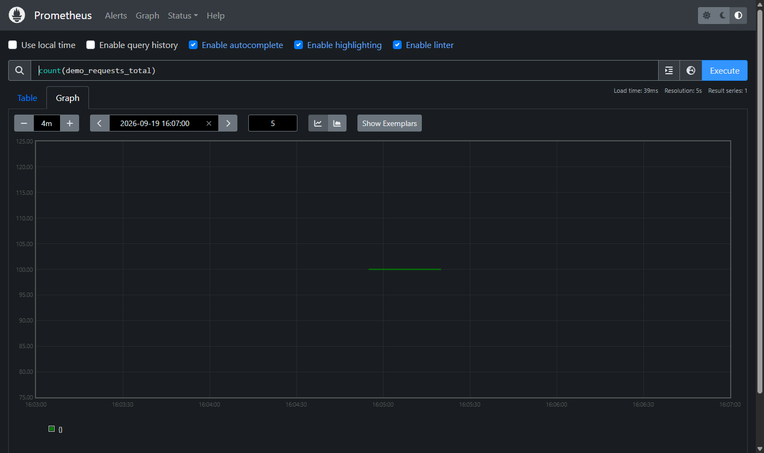
Screenshot 7 — count(demo_requests_total) in Prometheus's own graph view, 16:03–16:07 UTC. Proves: Part E2 steps 2–3 — series growth shown through the exact query the brief names, and the effect of removing the label.
The line sits at exactly 100 from about 16:04:55 to 16:05:20 and does not exist either side of it: nothing before the demo was first scraped, and nothing after the restart without the label. No slow fade over the 5-minute lookback — the cut is at a single scrape.

Remove the request ID and restart
# The label is removed by switching the demo into safe-only mode,
# then recreating the container so the process starts clean.
CARDINALITY_SAFE_ONLY=true \
docker compose --profile experiment up -d --force-recreate cardinality-demo

# then repeat the same 100 requests and re-query after another scrape:
curl -s "http://localhost:9090/api/v1/query?query=count(demo_requests_total)"
In-process, the same 100 requests with the label removed produce:
[cardinality-demo] requests=100 mode=safe demo_requests_total series=0 demo_requests_safe_total series=1

What I expected here, and what actually happened
I expected the second row to still read 100 — that removing a label stops new series being created but leaves the existing ones in place until retention expires. That is the usual way this is explained, and it is what an earlier draft of this report asserted. The measurement contradicted it, and the reason is worth more than the original point.
count(demo_requests_total) as an instant query returns no data once the label is removed. But the same query evaluated at a past timestamp still returns 100. Running it at a series of time= values maps the boundary exactly:
Query time (UTC) | count(demo_requests_total)
16:04:30 | no data (demo not yet scraped)
16:04:59 | 100
16:05:10 | 100
16:05:30 | no data (label removed, app restarted)
16:09:00 | no data
Both results are true and they are not in conflict. The history is intact — every one of those 100 series is still on disk and still queryable at any timestamp where it was live, until the 15-day retention window drops it. What changed is only what a query evaluated now can see.
Why the cutoff is sharper than the 5-minute lookback. An instant query normally carries the last sample forward for up to 5 minutes, so the series was predicted to linger until ~16:10. It does not: it disappears between 16:05:10 and 16:05:30, at the first scrape after the restart. When a target stops exporting a series, Prometheus writes an explicit stale marker, and that marker terminates the series immediately rather than letting the lookback window carry it. The 5-minute lookback applies when a target goes missing unexpectedly, not when it is scraped successfully and simply no longer reports that series.

Removing the label does not delete the stored history
This is the part the brief specifically warns about, and it is worth stating precisely because the measurement above makes it easy to draw the wrong conclusion.
What happens to it | Detail
Disappears quickly | The series from current dashboards and alerts — an instant query stops returning it at the first scrape after the restart
Does not disappear | The stored samples, the index entries, and the disk they occupy — for the full 15-day retention period. Any range query over a past window still returns all 100 series
Never un-happens | The memory pressure while those series were active. If a cardinality explosion kills a Prometheus server, removing the label brings the next one back up; it does not recover the data lost while it was down
The practical lesson, and it is stronger than the one I started with. You cannot verify a cardinality fix by watching count() go down, because it goes down either way — whether you fixed the label or merely stopped the app. The timeline of a real incident is: deploy the bad label, memory climbs, notice, ship a fix, and then wait days for the server to recover. There is no command that undoes it. Cardinality is a code-review question, not an incident-response one.

The cost at larger scale
Extrapolating the measured 1-series-per-request rate:
Traffic | New series per day with a request_id label
10 req/s | 864,000
100 req/s | 8,640,000
1,000 req/s | 86,400,000
A single Prometheus server is generally comfortable into the low millions of active series. At 100 req/s this design exceeds that in one day, and the failure is not graceful: memory climbs until the process is killed, taking with it the monitoring for everything else — at precisely the moment you most need it.
And the cost is not only Prometheus's. Every one of those series is stored, indexed and replicated for the whole retention window, while being queried exactly never: nobody asks "how many requests had id a3f9c2?" The series answers a question no one has.

Why request IDs belong in logs
The request id is genuinely useful — it is what made the Part D.3 trace possible. The question is which store it goes in.
 | Metric label | Log field
Cost model | One series, forever, per distinct value | One field on one event
Growth | Multiplies with every other label | Linear in events
Good at | "how many, how fast" across bounded dimensions | "what happened to this one"
Retention | Full resolution for the whole window | Age out cheaply by index
So this app puts the request id in every log line and in no metric label. gym_http_requests_total is labelled by route template ("/weekly-report"), never the raw path — which is also why an unmatched path collapses to a single route="unmatched" series, so a scanner probing /wp-login.php and /.env cannot mint series on this server from outside.
Enforced in the test suite, not just documented. test_labels_are_bounded_dimensions_only fails if anyone ever adds user_id, request_id, session_date, username or similar as a metric label. The cheapest moment to catch a cardinality mistake is before it merges, which is exactly what that test is for.

My Comments

Verification Status
Stated plainly, because a report that quietly implies more testing than actually happened is worse than one that draws the line.

Verified by running it
Claim | How it was verified
1038 automated tests pass (18 skipped), 63 covering the observability layer | pytest inside the container image
The app serves /metrics in valid Prometheus exposition format, all four types present | test_metrics_endpoint_serves_exposition_format, test_metrics_reports_all_four_types
JSON logging works, including request-id correlation and all four redaction paths | tests/test_observability.py — 17 tests across formatter and redaction
Fault injection works end to end; every number in the Part E1 tables is measured | scripts/experiment_anomaly.sh, three stages, results in observability/results-live/
The cardinality demo works and the growth table is measured output | scripts/experiment_cardinality.sh, both modes
The cardinality cap holds at 100, and --max-ids above it is refused | test_unique_ids_are_capped_at_one_hundred; reproduced at the command line
Config files are valid; dashboards have no duplicate panel ids or refIds | docker compose config; every YAML/JSON parses; all shell scripts pass bash -n

The full stack, verified on 19–20 September 2026
Run end to end on Docker Desktop for Windows (WSL2 backend).
Component | Observed
Prometheus | Scraping the app and node-exporter. All targets up
Grafana | Rendering all three provisioned dashboards; both datasources healthy
Filebeat | Tailing Docker logs, with decode_json_fields producing real queryable fields
Elasticsearch | Indexing, with the ILM policy attached to the write index
Kibana | Importing all nine saved objects ("successCount":9)
Part E1 | Re-run against the live stack, with server-side percentiles queried from Prometheus via histogram_quantile rather than replicated in Python
Part E2 | Re-run through Prometheus with count(demo_requests_total) against a running server — which is what disproved this report's own earlier claim about what happens after a label is removed
Screenshots | All six in docs/screenshots/ are from this live stack. Every panel shown was checked to return data; two that read "No data" when the app was healthy were fixed
Business dashboard | Real data: entries submitted through the review form, recorded by the app's own save path

What had to be fixed to get there
Five configuration defects, none of which any amount of file-level validation would have caught, because every one of these files was syntactically valid.
# | Symptom | Cause | Fix
1 | docker compose up aborts: "path / is mounted on / but it is not a shared or slave mount" | The rslave mount propagation flag on node-exporter's /:/host/root mount is not supported on Docker Desktop's VM | Dropped the flag
2 | Filebeat starts, finds the container, harvests nothing | Autodiscover condition written as docker.container.labels.co_elastic_logs/enabled. Filebeat's event fields de-dot label names, but the autodiscover condition matches the original dotted form | docker.container.labels.co.elastic.logs/enabled
3 | "lifecycle policy gym-tracker-logs creation failed: unknown field [_comment]" | A JSON file cannot hold comments, and Elasticsearch rejects unknown top-level fields | Removed the _comment key
4 | "no matching index template found for data stream [filebeat-gym-tracker]" | Filebeat 8.x writes to a data stream, and the template name, the index: target and the ILM rollover alias must all agree. They did not | All three renamed to filebeat-gym-tracker-logs
5 | Host dashboard's root-disk panel silently empty | mountpoint="/" does not exist on the Docker Desktop VM; the data disk is /var/lib | Matcher widened to mountpoint=~"/|/var/lib"
Plus one environment-specific change that is not a defect in the original config: the node-exporter scrape target moved from host.docker.internal:9100 to the pinned bridge gateway 172.28.77.1:9100, for the WSL2 reason explained in Part B.7.
What I take from this. Every one of these files parsed. docker compose config validated the compose file. Four of the five defects were semantic agreements between two different systems — a label spelling shared between Docker and Filebeat, three names that Filebeat and Elasticsearch both have to agree on, a mountpoint that exists on one kernel and not another. Validation checks a file against a grammar; only running the thing checks it against reality. The single most misleading failure was #2, because Filebeat reported no error at all: it started cleanly, connected to Elasticsearch successfully, and quietly collected nothing. A pipeline that is silently empty looks exactly like a pipeline with nothing to report.

Still not verified
Item | What is and is not known
ILM rollover and deletion | The policy is attached to the write index and reports phase: hot, but rollover needs 1 GB or 1 day and deletion needs 7 more. Verified: the policy exists, is valid, and is bound to the index. Not verified: that Elasticsearch has executed either transition
Docker json-file log rotation | 10 MB × 3 has not been reached in practice
The LLM extraction path | This machine has no GROQ_API_KEY, so gym_llm_extraction_duration_seconds, the extraction counters and the weekly-report counter have no data, and three panels on the business dashboard are empty. What is verified is that the app behaves correctly without a key
Host-Python test run | The tests do not run in the host Python on this machine — rapidfuzz is absent from it, and collection fails before any test executes. They pass in the container image, which is where the application actually runs. An environment gap, not a code defect

My Comments

Final Verification Checklist
Every requirement in the assignment specification. Tick each column as you confirm it on your own machine before submitting.

Part A — Working project and clear problem
Requirement | Implemented | Tested | Screenshot | Documented
A working project | ☑ | ☑ | ☑ | ☑
Clearly stated problem | ☑ | ☐ | ☐ | ☑
Intended users | ☑ | ☐ | ☐ | ☑
Solution explanation | ☑ | ☐ | ☐ | ☑
What works | ☑ | ☑ | ☐ | ☑
Instructions for trying the application | ☑ | ☑ | ☐ | ☑

Part B — Metrics and dashboards
Requirement | Implemented | Tested | Screenshot | Documented
Prometheus set up and scraping | ☑ | ☑ | ☐ | ☑
Grafana set up and rendering | ☑ | ☑ | ☑ | ☑
Application metrics | ☑ | ☑ | ☑ | ☑
Business metrics | ☑ | ☑ | ☑ | ☑
Counter | ☑ | ☑ | ☑ | ☑
Gauge | ☑ | ☑ | ☑ | ☑
Histogram | ☑ | ☑ | ☑ | ☑
Summary | ☑ | ☑ | ☑ | ☑
p95 or p99 shown | ☑ | ☑ | ☑ | ☑
Explanation of the time window | ☑ | ☐ | ☐ | ☑
Metric table: name, purpose, type, unit, labels, code location | ☑ | ☐ | ☐ | ☑
Grafana queries listed | ☑ | ☐ | ☐ | ☑
Explanation of each chart | ☑ | ☐ | ☐ | ☑
Important app/business metrics, not only trivial examples | ☑ | ☑ | ☑ | ☑
At least one metric/chart explored myself (gym_sets_per_entry) | ☑ | ☑ | ☑ | ☑
Node Exporter installed | ☑ | ☑ | ☑ | ☑
CPU monitoring | ☑ | ☑ | ☑ | ☑
Memory monitoring | ☑ | ☑ | ☑ | ☑
Disk monitoring | ☑ | ☑ | ☑ | ☑
Network monitoring | ☑ | ☑ | ☑ | ☑
Prometheus collects Node Exporter metrics | ☑ | ☑ | ☐ | ☑
Grafana visualises them | ☑ | ☑ | ☑ | ☑
Machine being monitored is named | ☑ | ☑ | ☑ | ☑

Part C — Logging pipeline
Requirement | Implemented | Tested | Screenshot | Documented
Application JSON logging | ☑ | ☑ | ☐ | ☑
Docker log handling (json-file driver) | ☑ | ☑ | ☐ | ☑
Filebeat collecting | ☑ | ☑ | ☐ | ☑
Elasticsearch storing | ☑ | ☑ | ☐ | ☑
Kibana searching | ☑ | ☑ | ☑ | ☑
Correct pipeline: App → Docker → Filebeat → Elasticsearch → Kibana | ☑ | ☑ | ☑ | ☑
Parsing into searchable fields | ☑ | ☑ | ☑ | ☑
Persistence / storage behaviour explained | ☑ | ☐ | ☐ | ☑
What survives container/application restarts | ☑ | ☐ | ☐ | ☑
Log deletion / retention behaviour (ILM) | ☑ | ☐ | ☐ | ☑
Kibana search process explained | ☑ | ☑ | ☑ | ☑
Time field | ☑ | ☑ | ☑ | ☑
Service field | ☑ | ☑ | ☐ | ☑
Severity field | ☑ | ☑ | ☑ | ☑
Message field | ☑ | ☑ | ☑ | ☑
Request ID where relevant | ☑ | ☑ | ☑ | ☑
No secrets or personal information in logs | ☑ | ☑ | ☐ | ☑
One original application log shown | ☑ | ☐ | ☐ | ☑
The corresponding stored Elasticsearch fields | ☑ | ☐ | ☑ | ☑
A working Kibana search | ☑ | ☑ | ☑ | ☑
Explanation of parsing | ☑ | ☐ | ☐ | ☑

Part D — System design and explanation
Requirement | Implemented | Tested | Screenshot | Documented
Architecture diagram | ☑ | ☐ | ☐ | ☑
Diagram shows the application | ☑ | ☐ | ☐ | ☑
Diagram shows dependencies | ☑ | ☐ | ☐ | ☑
Diagram shows monitoring tools | ☑ | ☐ | ☐ | ☑
Connections / arrows | ☑ | ☐ | ☐ | ☑
What each component does | ☑ | ☐ | ☐ | ☑
How components communicate | ☑ | ☐ | ☐ | ☑
Where data is stored | ☑ | ☐ | ☐ | ☑
Why the storage/design was chosen | ☑ | ☐ | ☐ | ☑
What happens if a component stops working | ☑ | ☐ | ☐ | ☑
Anything not yet understood, noted | ☑ | ☐ | ☐ | ☑
Metric trace: code → Prometheus → Grafana | ☑ | ☑ | ☑ | ☑
Metric trace shows actual values | ☑ | ☑ | ☐ | ☑
Metric trace shows queries | ☑ | ☐ | ☐ | ☑
Log trace: code → Filebeat → Elasticsearch → Kibana | ☑ | ☑ | ☑ | ☑
Log trace shows actual values | ☑ | ☑ | ☑ | ☑
Log trace shows changes in log format | ☑ | ☐ | ☐ | ☑

Part E1 — Reproduce a problem
Requirement | Implemented | Tested | Screenshot | Documented
1. Normal behaviour shown | ☑ | ☑ | ☑ | ☑
2. A repeatable test | ☑ | ☑ | ☐ | ☑
3. Prediction of which metrics/logs will change | ☑ | ☑ | ☐ | ☑
4. An actual problem introduced | ☑ | ☑ | ☑ | ☑
5. Evidence of what changed | ☑ | ☑ | ☑ | ☑
6. Explanation of the cause | ☑ | ☐ | ☐ | ☑
7. Explanation of the effect on users | ☑ | ☐ | ☐ | ☑
8. Removal/fixing of the problem | ☑ | ☑ | ☐ | ☑
9. Repeated test after recovery | ☑ | ☑ | ☐ | ☑
10. Comparison of before / during / after | ☑ | ☑ | ☑ | ☑
11. Commands used | ☑ | ☐ | ☐ | ☑
12. Time ranges | ☑ | ☑ | ☐ | ☑
13. Queries | ☑ | ☐ | ☐ | ☑
14. Results | ☑ | ☑ | ☑ | ☑
15. Enough runtime for several Prometheus scrapes (8 per stage) | ☑ | ☑ | ☐ | ☑
16. Locally reproducible | ☑ | ☑ | ☐ | ☑
17. A safe way to undo the fault | ☑ | ☑ | ☐ | ☑

Part E2 — Cardinality explosion
Requirement | Implemented | Tested | Screenshot | Documented
1. A request_id label added to a local test counter | ☑ | ☑ | ☐ | ☑
2. The test stops at 100 unique IDs | ☑ | ☑ | ☐ | ☑
3. Series growth demonstrated | ☑ | ☑ | ☑ | ☑
4. count(demo_requests_total) shown | ☑ | ☑ | ☑ | ☑
5. The request ID label removed | ☑ | ☑ | ☐ | ☑
6. The application restarted | ☑ | ☑ | ☐ | ☑
7. The experiment repeated | ☑ | ☑ | ☐ | ☑
8. Results compared | ☑ | ☑ | ☑ | ☑
9. The cost at larger scale explained | ☑ | ☐ | ☐ | ☑
10. Why request IDs belong in logs, not Prometheus labels | ☑ | ☑ | ☐ | ☑
11. No attempt to crash Prometheus | ☑ | ☑ | ☐ | ☑
12. Acknowledges that removing labels does not delete history | ☑ | ☑ | ☐ | ☑

Submission requirements
Requirement | Implemented | Tested | Screenshot | Documented
Code and configuration | ☑ | ☑ | ☐ | ☑
Grafana dashboards included | ☑ | ☑ | ☑ | ☑
Kibana queries included | ☑ | ☑ | ☑ | ☑
README with start / use / test / clean-up instructions | ☑ | ☑ | ☐ | ☑
Short report with sections A–E | ☑ | ☐ | ☐ | ☑
Metric list | ☑ | ☐ | ☐ | ☑
Diagrams | ☑ | ☐ | ☐ | ☑
Explanations and results | ☑ | ☑ | ☑ | ☑
Reused code, sources and assistance credited | ☑ | ☐ | ☐ | ☑
Dependencies and data volumes excluded | ☑ | ☐ | ☐ | ☑

My Comments

Credits
Item | Attribution
Existing application | FastAPI app, extraction pipeline, review flow, insights, accounts — my own prior work in this repository
Added for this assignment | metrics.py, logging_setup.py, faults.py, observability/, scripts/, Dockerfile, docker-compose.yml, tests/test_observability.py, and the instrumentation call sites in app.py and pipeline.py
AI assistance | Claude (Anthropic) was used to implement the observability layer, the compose stack, the dashboards and this report, working from the assignment brief and the existing codebase. All of it was reviewed, and the experiments were run and their results recorded
Documentation consulted | Prometheus docs (metric types, naming, and the label cardinality guidance the brief links), Grafana provisioning docs, Elastic's Filebeat / ECS / ILM docs, prometheus_client source for the Summary quantile question
Method | The RED method (Rate, Errors, Duration) for the application dashboard, after Tom Wilkie; the USE method (Utilisation, Saturation, Errors) informed the host dashboard
Course materials | Lab 1 — Midnight Launch, used as a reference for the stack layout

Security note on this compose file
This is a local lab, not a production deployment. Elasticsearch runs with security disabled and Grafana with a default password, because requiring a TLS handshake and a credential rotation to look at a chart on localhost teaches nothing about observability. Both would be wrong on any network anyone else can reach. The app's /metrics endpoint does support a bearer token (METRICS_TOKEN, compared with hmac.compare_digest) for a deployment where that matters.

