# Compile/ West Build

For Compile and West Build, install docker desktop and run below command in project directory

*docker run --rm -v d:/GitHub_Repo/button:/project public.ecr.aws/tuoaccessories/build-nrf-matter:20230207 west build -b tuo_button -- -DBOARD_ROOT=/project –p*



Or if you want to select NRF52-840 DK board, use below command

*docker run --rm -v d:/GitHub_Repo/button:/project public.ecr.aws/tuoaccessories/build-nrf-matter:20230207 west build -b nrf52840dk_nrf52840*

# Programming Board

Install nrfjprog tools

Go to directory of zephyr.hex file

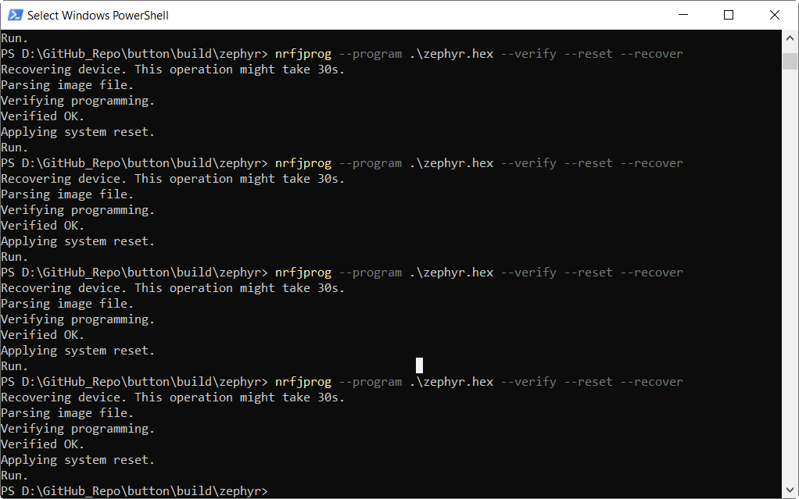

# Debugging

For watching the logs using JLink RTT

Open JLink RTT Viewer

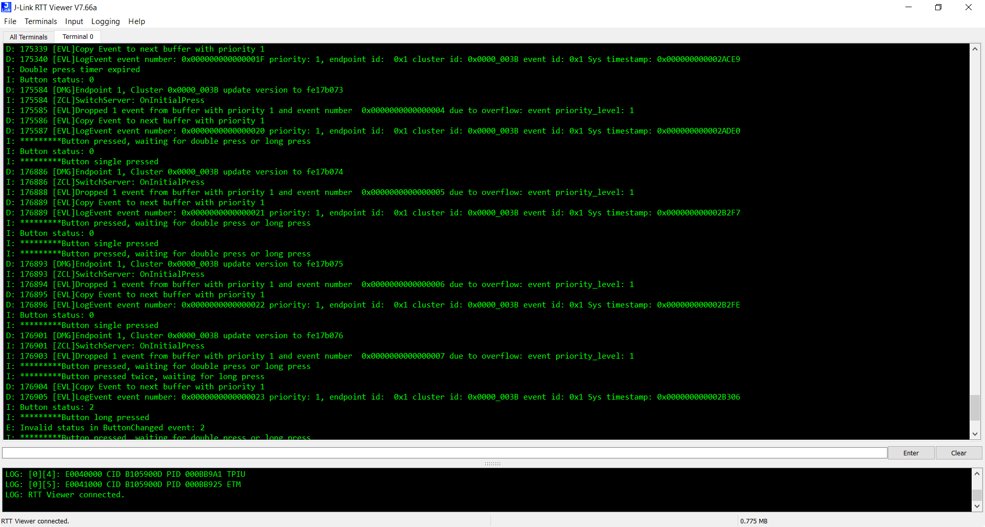

# Functionality

Button is connected at P0.06 and can be used for Single press, double press and long press. Double press functionality is not tested enough.