The Bookstore Intelligence Mission
Business Data and Text Mining | Web Scraping
Name: Sohaib Roll No: 23i5030 Assignment 3

Mission 1: Reconnaissance
I inspected a product card on https://books.toscrape.com/ using the browser Inspect tool. Each book sits inside an <li> in the grid, and the card itself is an <article class="product_pod"> element. At the top of the card, a <div class="image_container"> holds a link (<a href="catalogue/.../index.html">) wrapping the thumbnail <img class="thumbnail" alt="...">.
Data Needed | HTML Tag / Class Found | Your Notes
Book Title | <a title="..."> inside <h3> (also <img class="thumbnail" alt="..."> inside div.image_container) | The title attribute holds the full title, e.g. "Scott Pilgrim's Precious Little Life (Scott Pilgrim #1)"; the visible h3 text is often cut short with "...". The thumbnail alt text carries the same full title.
Price | <p class="price_color"> | Text includes the £ sign, so I strip it and convert to float.
Rating | <p class="star-rating Three"> | Rating is a word in the second class name; I map One to Five onto 1 to 5.
Availability | <p class="instock availability"> | Text needs .strip() because it has extra whitespace.
Product URL (Bonus 2) | <a href="catalogue/.../index.html"> inside div.image_container | The href is a relative link (e.g. catalogue/scott-pilgrims-precious-little-life-scott-pilgrim-1_987/index.html), so I join it with the base URL using urljoin.

Missions 2 and 3: Capture and Scale the Data
I wrote a scrape_page() function that takes a page number, requests the page with requests, parses it with BeautifulSoup and returns one record per book. A for loop calls this function for pages 1 to 50, so the scraping code is written once and reused. All records go into a Pandas DataFrame, which is saved as competitor_books.csv.
Result: 50 pages scraped, 20 books per page, giving a dataset of 1,000 rows and 5 columns (Title, Price, Rating, Availability, URL). This covers Bonus 1 (5 pages), Bonus 2 (product URL column) and the Boss Level (all catalogue pages).
First rows of the dataset:
Title | Price | Rating | Availability | Page URL
A Light in the Attic | 51.77 | 3 | In stock | on file
Tipping the Velvet | 53.74 | 1 | In stock | on file
Soumission | 50.10 | 1 | In stock | on file
Sharp Objects | 47.82 | 4 | In stock | on file
Sapiens: A Brief History of Humankind | 54.23 | 5 | In stock | on file

Mission 4: Intelligence Analysis
- Most expensive book: The Perfect Play (Play by Play #1), £59.99.
- Cheapest book: An Abundance of Katherines, £10.00.
- Average book price: £35.07.
- Books with a 5-star rating: 196.
- Percentage in stock: 100%. Every scraped book is available.
- Top 5 highest-rated books: Many books share 5 stars, so I broke ties by lower price: An Abundance of Katherines (£10.00), Greek Mythic History (£10.23), The Power Greens Cookbook (£11.05), Dear Mr. Knightley (£11.21) and The Darkest Corners (£11.33).
- Cheapest 5-star book: An Abundance of Katherines, £10.00.

Bonus: Books per Rating Level
Star Rating | Number of Books
1 star | 226
2 stars | 196
3 stars | 203
4 stars | 179
5 stars | 196

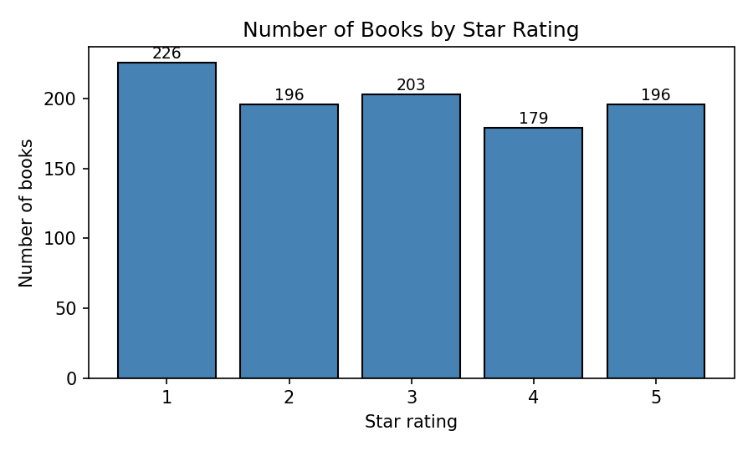

Final Challenge: The CEO Has £100
Goal: choose books that maximise the total star rating without spending more than £100. This is a knapsack problem, so I solved it with dynamic programming over prices in pence instead of just picking the cheapest books. If two baskets had the same total stars, the cheaper one wins.
Selected Title | Price (£) | Rating
Fruits Basket, Vol. 2 (Fruits Basket #2) | 11.64 | 5
An Abundance of Katherines | 10.00 | 5
The Darkest Corners | 11.33 | 5
The Power Greens Cookbook: 140 Delicious Superfood Recipes | 11.05 | 5
Naturally Lean: 125 Nourishing Gluten-Free, Plant-Based Recipes | 11.38 | 5
The Origin of Species | 10.01 | 4
Dear Mr. Knightley | 11.21 | 5
Greek Mythic History | 10.23 | 5
Old School (Diary of a Wimpy Kid #10) | 11.83 | 5

Total books: 9 | Total cost: £98.68 | Total rating score: 44

Business Recommendation
I would prioritise the 5-star books, especially the cheaper ones, because only 196 of the 1,000 books (19.6%) earn the top rating, so they are the strongest proven sellers on offer. Our £100 test basket shows the value: 9 books costing £98.68 delivered 44 stars, with eight 5-star titles priced under £12 each. Since 5-star books cost about the same on average (£35.37) as the whole catalogue (£35.07), we can stock quality without paying a premium.

Submission Links
GitHub repository: [paste your GitHub link here]
LinkedIn post: [paste your LinkedIn post link here]

