Assignment 3

Sohaib Syed

2022-10-02

Table of Contents

# Problem 1

## a

sales_data<-read.table('CH03PR17.txt',col.names = c('y','x'))  
par(mfrow=c(1,1))  
plot(sales_data$x,sales_data$y,xlab = 'Year',ylab='Sales (in thousands)')  
f<-lm(sales_data$y~sales_data$x)  
abline(f)

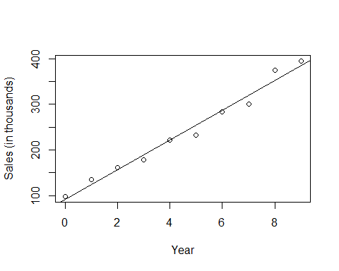

summary(f)

##   
## Call:  
## lm(formula = sales_data$y ~ sales_data$x)  
##   
## Residuals:  
## Min 1Q Median 3Q Max   
## -22.049 -9.177 2.446 9.814 22.461   
##   
## Coefficients:  
## Estimate Std. Error t value Pr(>|t|)   
## (Intercept) 91.564 8.814 10.39 6.38e-06 ***  
## sales_data$x 32.497 1.651 19.68 4.62e-08 ***  
## ---  
## Signif. codes: 0 '***' 0.001 '**' 0.01 '*' 0.05 '.' 0.1 ' ' 1  
##   
## Residual standard error: 15 on 8 degrees of freedom  
## Multiple R-squared: 0.9798, Adjusted R-squared: 0.9772   
## F-statistic: 387.4 on 1 and 8 DF, p-value: 4.62e-08

A linear function may not be adequate here because as year increase the rate of sales increases non-linearly.

## b

par(mfrow=c(1,2))  
boxcox(y~x,data=sales_data)  
boxcox.sse(sales_data$x,sales_data$y,l=seq(.3,.7,.1))

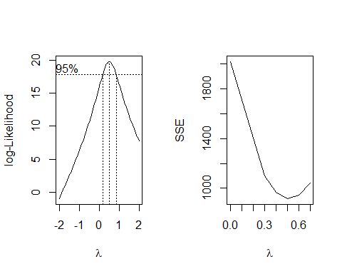

## lambda SSE  
## 6 0.0 2019.8767  
## 1 0.3 1099.7093  
## 2 0.4 967.9088  
## 3 0.5 916.4048  
## 4 0.6 942.4498  
## 5 0.7 1044.2384

It is suggested to use Y^.5 aka sqrt(Y)

## c

f1<-lm(sqrt(sales_data$y)~sales_data$x)  
  
summary(f1)

##   
## Call:  
## lm(formula = sqrt(sales_data$y) ~ sales_data$x)  
##   
## Residuals:  
## Min 1Q Median 3Q Max   
## -0.47447 -0.30811 0.01549 0.29541 0.46781   
##   
## Coefficients:  
## Estimate Std. Error t value Pr(>|t|)   
## (Intercept) 10.26093 0.21290 48.20 3.80e-11 ***  
## sales_data$x 1.07629 0.03988 26.99 3.83e-09 ***  
## ---  
## Signif. codes: 0 '***' 0.001 '**' 0.01 '*' 0.05 '.' 0.1 ' ' 1  
##   
## Residual standard error: 0.3622 on 8 degrees of freedom  
## Multiple R-squared: 0.9891, Adjusted R-squared: 0.9878   
## F-statistic: 728.4 on 1 and 8 DF, p-value: 3.826e-09

sqrt(Y)=10.26093+1.07626x

## d

plot(sales_data$x,sqrt(sales_data$y))  
abline(f1)

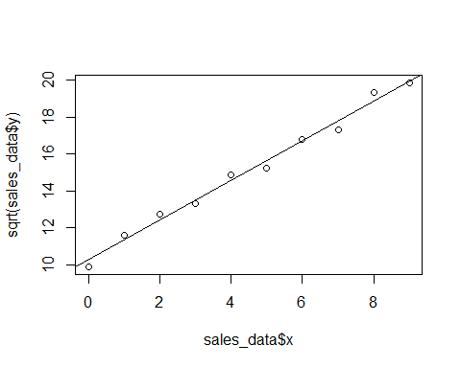

Yes the line is a great fit on the data.

## e

ei<-f1$residuals  
yhat<-f1$fitted.values  
par(mfcol=c(1,2))  
plot(yhat,ei,xlab='Residuals',ylab='Fitted Values')  
abline(0,0)  
qqnorm(residuals(f1))  
qqline(residuals(f1))

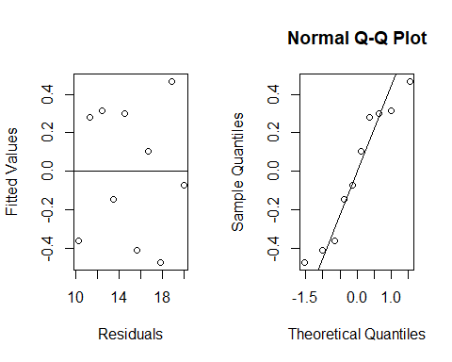

Plots show errors are there are no pattern to residuals and the residuals are approximately normally distributed as they are close to the line

## f

sqrt(Sales in thousands)=10.26093+1.07626(coded year)

# Problem 2

##a

mass_data<-read.table('CH01PR27.txt',col.names = c('y','x'))  
xh<-c(45,55,65)  
f2<-lm(y~x,data=mass_data)  
f2_sum<-summary(f2)  
anova(f2)

## Analysis of Variance Table  
##   
## Response: y  
## Df Sum Sq Mean Sq F value Pr(>F)   
## x 1 11627.5 11627.5 174.06 < 2.2e-16 ***  
## Residuals 58 3874.4 66.8   
## ---  
## Signif. codes: 0 '***' 0.001 '**' 0.01 '*' 0.05 '.' 0.1 ' ' 1

pred<-predict(f2,newdata = data.frame(x=xh),se.fit = T,level=.95)  
W <-sqrt( 2 * qf(0.95, 2, 58) )  
f2_sum

##   
## Call:  
## lm(formula = y ~ x, data = mass_data)  
##   
## Residuals:  
## Min 1Q Median 3Q Max   
## -16.1368 -6.1968 -0.5969 6.7607 23.4731   
##   
## Coefficients:  
## Estimate Std. Error t value Pr(>|t|)   
## (Intercept) 156.3466 5.5123 28.36 <2e-16 ***  
## x -1.1900 0.0902 -13.19 <2e-16 ***  
## ---  
## Signif. codes: 0 '***' 0.001 '**' 0.01 '*' 0.05 '.' 0.1 ' ' 1  
##   
## Residual standard error: 8.173 on 58 degrees of freedom  
## Multiple R-squared: 0.7501, Adjusted R-squared: 0.7458   
## F-statistic: 174.1 on 1 and 58 DF, p-value: < 2.2e-16

lower<-pred$fit-W * pred$se.fit  
upper<-pred$fit+W * pred$se.fit  
lower

## 1 2 3   
## 98.48916 88.01540 76.11248

upper

## 1 2 3   
## 107.10437 93.77822 81.88123

Xh=45; 98.489 <=E{yh}<= 107.104

Xh=55; 88.015 <=E{yh}<= 93.778

Xh=65; 76.113 <=E{yh}<= 81.881

## b

The WH procedure is better for larger g, so no, not for this problem. It’s not the most efficient.

## c

xhbef=c(48,59,74)  
Wbef<-qt(1-.05/6,58)  
pred2<-predict(f2,newdata = data.frame(x=xhbef),se.fit = T,level=.95)  
Sxx <- sum( mass_data$x * mass_data$x) - length(mass_data$x) * (mean(mass_data$x))^2  
varR <- (f2_sum$sigma)^2  
SE <- sqrt(varR*((1/length(mass_data$x) + (xhbef - mean(mass_data$x))^2/Sxx) + 1))  
pred2$fit+Wbef*SE

## 1 2 3   
## 119.71815 106.45537 88.84195

pred2$fit-Wbef*SE

## 1 2 3   
## 78.73541 65.81829 47.73184

Xh=48; 78.73541 <=E{yh}<= 119.71815

Xh=59; 65.81829 <=E{yh}<= 106.45537

Xh=74; 47.73184 <=E{yh}<= 88.84195

## d

Yes, the three prediction intervals will need to be recalculated. Same for the Scheffe Procedure.

# Problem 3

## a

brand_data<-read.table('CH06PR05.txt',col.names = c('y','x1','x2'))  
pairs(~y+x1+x2,data=brand_data)

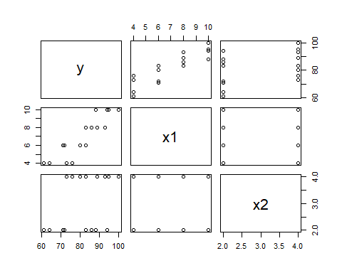

cor(brand_data)

## y x1 x2  
## y 1.0000000 0.8923929 0.3945807  
## x1 0.8923929 1.0000000 0.0000000  
## x2 0.3945807 0.0000000 1.0000000

The scatter plot shows general relationship between Y and input variables and the correlation matrix shows that moisture(x1) has a very strong positive correlation with brand liking(y).

## b

fit3<-lm(y~x1+x2,data = brand_data)  
summary(fit3)

##   
## Call:  
## lm(formula = y ~ x1 + x2, data = brand_data)  
##   
## Residuals:  
## Min 1Q Median 3Q Max   
## -4.400 -1.762 0.025 1.587 4.200   
##   
## Coefficients:  
## Estimate Std. Error t value Pr(>|t|)   
## (Intercept) 37.6500 2.9961 12.566 1.20e-08 ***  
## x1 4.4250 0.3011 14.695 1.78e-09 ***  
## x2 4.3750 0.6733 6.498 2.01e-05 ***  
## ---  
## Signif. codes: 0 '***' 0.001 '**' 0.01 '*' 0.05 '.' 0.1 ' ' 1  
##   
## Residual standard error: 2.693 on 13 degrees of freedom  
## Multiple R-squared: 0.9521, Adjusted R-squared: 0.9447   
## F-statistic: 129.1 on 2 and 13 DF, p-value: 2.658e-09

Y= 4.425x1+4.375x2+37.65 is the regression function.

B1 is how much the moisture content affects the brand liking.

## c

res_fit3<-residuals(fit3)  
boxplot(res_fit3)

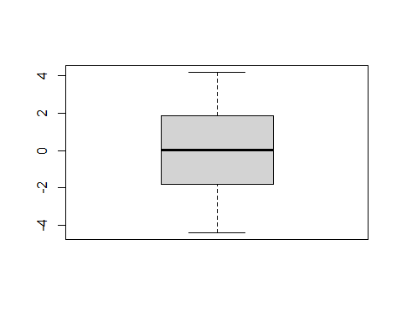

The boxplot shows the spread of the residuals and their quantiles. There seems to be no outliers and the boxplot is symmetrical.

## d

plot(fit3$fitted.values,res_fit3)  
abline(0,0)

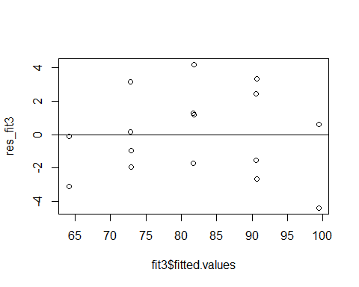

plot(brand_data$x1,res_fit3)  
abline(0,0)

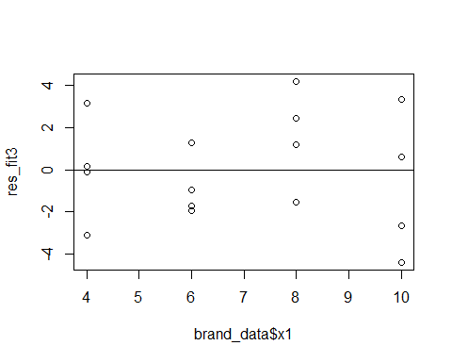

plot(brand_data$x2,res_fit3)  
abline(0,0)

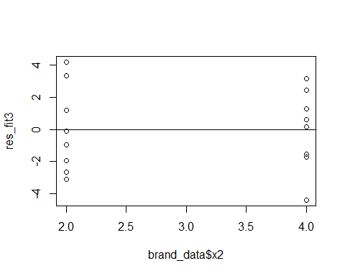

plot((brand_data$x1*brand_data$x2),res_fit3)  
abline(0,0)

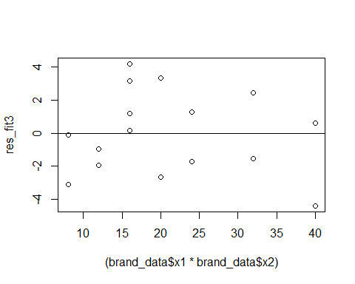

qqnorm(res_fit3)  
qqline(res_fit3)

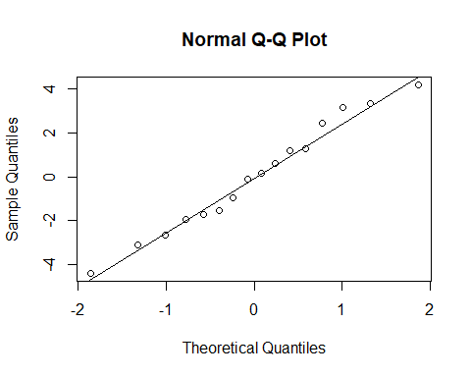

The residuals do not seem random and there are repeated values. The normal plot however shows the residuals follow close to linear line.

## e

library(lmtest)

## Loading required package: zoo

##   
## Attaching package: 'zoo'

## The following objects are masked from 'package:base':  
##   
## as.Date, as.Date.numeric

lm(res_fit3~brand_data$x1)

##   
## Call:  
## lm(formula = res_fit3 ~ brand_data$x1)  
##   
## Coefficients:  
## (Intercept) brand_data$x1   
## -3.014e-16 3.413e-17

bptest(fit3)

##   
## studentized Breusch-Pagan test  
##   
## data: fit3  
## BP = 2.0441, df = 2, p-value = 0.3599

chi_val=qchisq(.99, df=2)  
chi_val

## [1] 9.21034

# Alternatives  
# H0:y1=0 and Ha:y1 != 0  
  
# Decision Rule: if X^2BP < chi-square distribution

Conclude that y1=0 since 2.0441< 9.21

## f

alpha=.01  
fit_lack<-lm(y~as.factor(x1)+as.factor(x2),data = brand_data)  
lackfit<-anova(fit3,fit_lack)  
#Alternatives: H0:E{Y} = b0 + b1x1 + b1x2 and Ha: E{Y} != b0 + b1x1 + b1x2  
# Reject H0 if F-ratio > F a,m-p,n-m  
(lackfit$F)<qf(1-alpha,5,8)

## [1] NA TRUE

Conclude: accept H0 since Fratio not bigger than F distribution

# Problem 4

## a

commercial_data<-read.table("CH06PR18.txt",col.names = c('y','x1','x2','x3','x4'))  
stem(commercial_data$x1)

##   
## The decimal point is at the |  
##   
## 0 | 0000000000000000  
## 2 | 00000000000000000000000  
## 4 | 00000  
## 6 | 0  
## 8 | 0  
## 10 | 00  
## 12 | 00000  
## 14 | 0000000000000  
## 16 | 0000000000  
## 18 | 000  
## 20 | 00

stem(commercial_data$x2)

##   
## The decimal point is at the |  
##   
## 2 | 0  
## 4 | 080003358  
## 6 | 012613  
## 8 | 00001223456001555689  
## 10 | 013344566677778123344666668  
## 12 | 00011115777889002  
## 14 | 6

stem(commercial_data$x3)

##   
## The decimal point is 1 digit(s) to the left of the |  
##   
## 0 | 0000000000000000000000000000002333333333334444445555556678889  
## 1 | 023444469  
## 2 | 1223477  
## 3 | 3  
## 4 |   
## 5 | 7  
## 6 | 0  
## 7 | 3

stem(commercial_data$x4)

##   
## The decimal point is 5 digit(s) to the right of the |  
##   
## 0 | 333333444444  
## 0 | 555666667778899  
## 1 | 000001111222333334  
## 1 | 578889  
## 2 | 011122334444  
## 2 | 555788899  
## 3 | 002  
## 3 | 567  
## 4 | 23  
## 4 | 8

The stem and leaf plots shows the frequency at which certain classes of values occur

## b

pairs(~y+.,data=commercial_data)

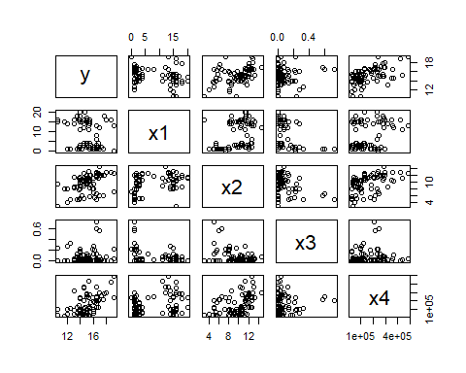

cor(commercial_data)

## y x1 x2 x3 x4  
## y 1.00000000 -0.2502846 0.4137872 0.06652647 0.53526237  
## x1 -0.25028456 1.0000000 0.3888264 -0.25266347 0.28858350  
## x2 0.41378716 0.3888264 1.0000000 -0.37976174 0.44069713  
## x3 0.06652647 -0.2526635 -0.3797617 1.00000000 0.08061073  
## x4 0.53526237 0.2885835 0.4406971 0.08061073 1.00000000

The rate(y) is strongly correlated to two predictors: first square footage(x4) and then expenses(x2). expenses(x2) and square footage(x4) is are also correlated which explains why both of those predictors also have strong correlation with rate(y). It also makes sense to see expenses(x2) and vacancy(x3) have strong negative correlation, as if more places are vacant there are less expenses.

## c

commercialfit<-lm(y~.,data=commercial_data)  
sum_comm<-summary(commercialfit)  
sum_comm

##   
## Call:  
## lm(formula = y ~ ., data = commercial_data)  
##   
## Residuals:  
## Min 1Q Median 3Q Max   
## -3.1872 -0.5911 -0.0910 0.5579 2.9441   
##   
## Coefficients:  
## Estimate Std. Error t value Pr(>|t|)   
## (Intercept) 1.220e+01 5.780e-01 21.110 < 2e-16 ***  
## x1 -1.420e-01 2.134e-02 -6.655 3.89e-09 ***  
## x2 2.820e-01 6.317e-02 4.464 2.75e-05 ***  
## x3 6.193e-01 1.087e+00 0.570 0.57   
## x4 7.924e-06 1.385e-06 5.722 1.98e-07 ***  
## ---  
## Signif. codes: 0 '***' 0.001 '**' 0.01 '*' 0.05 '.' 0.1 ' ' 1  
##   
## Residual standard error: 1.137 on 76 degrees of freedom  
## Multiple R-squared: 0.5847, Adjusted R-squared: 0.5629   
## F-statistic: 26.76 on 4 and 76 DF, p-value: 7.272e-14

anova(commercialfit)

## Analysis of Variance Table  
##   
## Response: y  
## Df Sum Sq Mean Sq F value Pr(>F)   
## x1 1 14.819 14.819 11.4649 0.001125 **   
## x2 1 72.802 72.802 56.3262 9.699e-11 ***  
## x3 1 8.381 8.381 6.4846 0.012904 *   
## x4 1 42.325 42.325 32.7464 1.976e-07 ***  
## Residuals 76 98.231 1.293   
## ---  
## Signif. codes: 0 '***' 0.001 '**' 0.01 '*' 0.05 '.' 0.1 ' ' 1

Y=12.2-.1420x1+.2820x2+.6193x3+.000007924x4

## d

boxplot(resid(commercialfit))

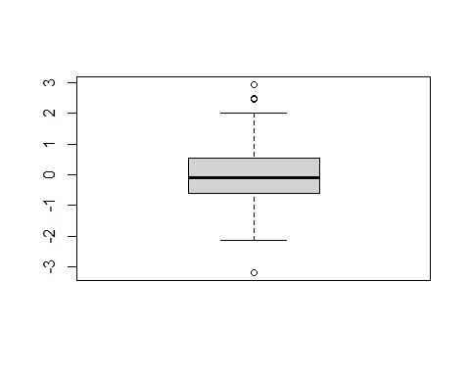 No. it seems like there are a number of outliers outside of the boxplot, especially at the top. If there were no outliers however the boxplot would be symmetrical.

## e

plot(commercialfit$fitted.values,residuals(commercialfit))  
abline(0,0)

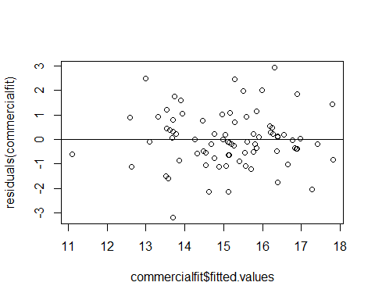

plot(commercial_data$x1,residuals(commercialfit))  
abline(0,0)

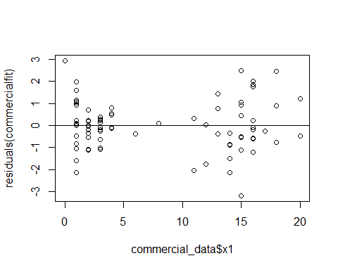

plot(commercial_data$x2,residuals(commercialfit))  
abline(0,0)

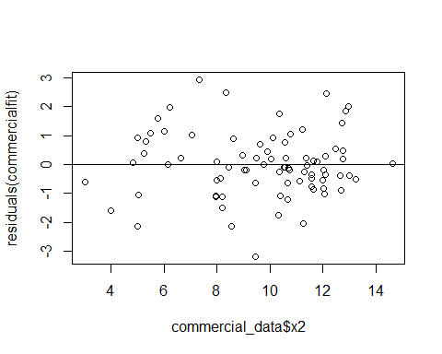

plot(commercial_data$x3,residuals(commercialfit))  
abline(0,0)

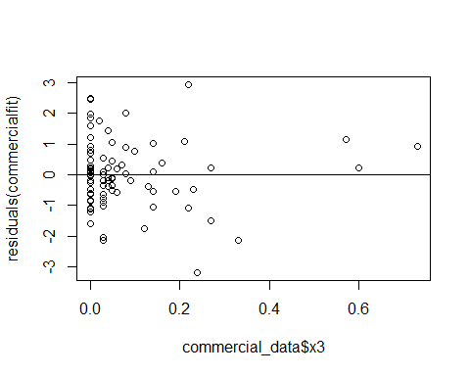

plot(commercial_data$x4,residuals(commercialfit))  
abline(0,0)

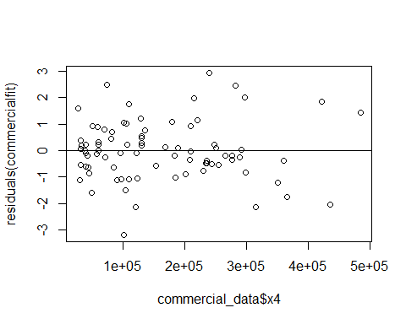

plot(commercial_data$x1*commercial_data$x2,residuals(commercialfit))  
abline(0,0)

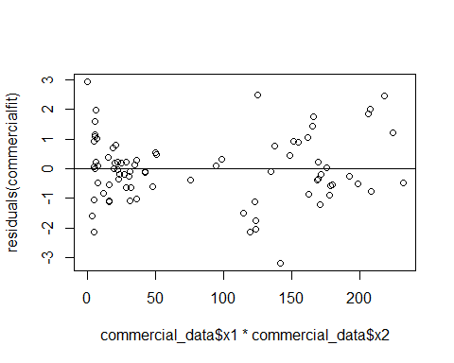

plot(commercial_data$x1*commercial_data$x3,residuals(commercialfit))  
abline(0,0)

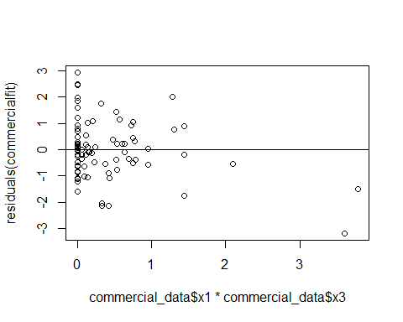

plot(commercial_data$x1*commercial_data$x4,residuals(commercialfit))  
abline(0,0)

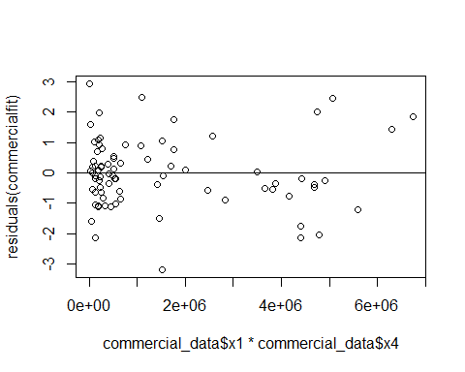

plot(commercial_data$x2*commercial_data$x3,residuals(commercialfit))  
abline(0,0)

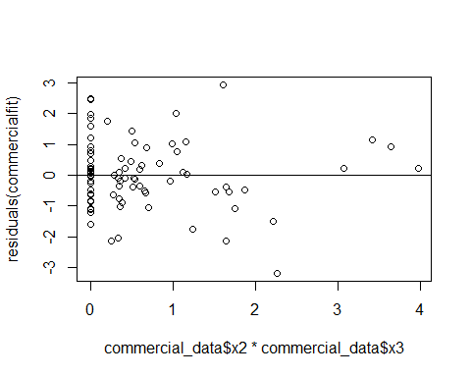

plot(commercial_data$x2*commercial_data$x4,residuals(commercialfit))  
abline(0,0)

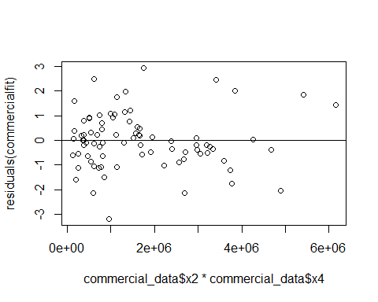

plot(commercial_data$x3*commercial_data$x4,residuals(commercialfit))  
abline(0,0)

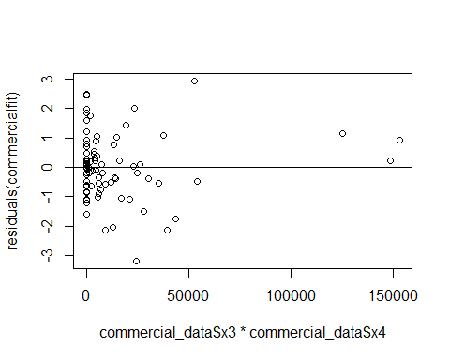

qqnorm(residuals(commercialfit))  
qqline(residuals(commercialfit))

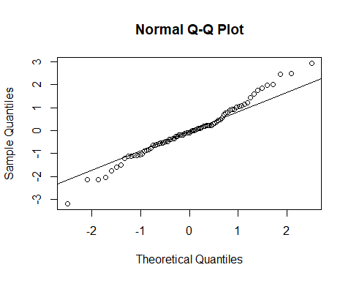

The residual plots show that the fitted values are apprpriate for a linear fit, also the x2,x4 and x2*x4, terms are also good terms to be used in a linear model since the residual points are mostly random. The rest of the plots show some pattern or at least they aren’t showing randomness. The normal plot also seems to not completely follow a linear line as the points at the ends start to increase their distance from the line. the outliers may be occuring because of the non-randomness of x1 and x3.

## f

No, because each xi would need to have repeating Y values which doesn’t occur with the given data.

## g

### Decision rule with alpha=0.5, if |t*BF| <= t alpha/2,n-2 then error variance is constant

rownum_of_ordered_fitted<-order(commercialfit$fitted.values)  
fortysmallest_fitted<-commercial_data[rownum_of_ordered_fitted[1:40],]  
restof_fitted<-commercial_data[rownum_of_ordered_fitted[41:81],]  
  
group1_fitted<-lm(y~.,data=fortysmallest_fitted)  
group2_fitted<-lm(y~.,data=restof_fitted)  
  
d1<-abs(residuals(group1_fitted)-median(residuals(group1_fitted)))  
mean(d1)

## [1] 0.6963691

d2<-abs(residuals(group2_fitted)-median(residuals(group2_fitted)))  
mean(d2)

## [1] 0.7492604

sdd1<-sum((d1-mean(d1))^2)  
sdd2<-sum((d2-mean(d2))^2)  
s_for_comm<-sqrt((sdd1+sdd2)/79)  
  
t_star_comm<-(mean(d1)-mean(d2))/(s_for_comm*sqrt((1/40)+(1/41)))  
  
t_star_comm<qt(1-.05/2,79)

## [1] TRUE

### conclusion: Error variance is constant

# Problem 5

## a

### alternatives

H0: b1 = b2 = b3 = b4 = 0, Ha: not all bk in H0 equal 0

### Decision rule:

using F-Ratio; if F*>F a,p-q,n-p then reject H0

comm_anova<-anova(commercialfit)  
sum_comm

##   
## Call:  
## lm(formula = y ~ ., data = commercial_data)  
##   
## Residuals:  
## Min 1Q Median 3Q Max   
## -3.1872 -0.5911 -0.0910 0.5579 2.9441   
##   
## Coefficients:  
## Estimate Std. Error t value Pr(>|t|)   
## (Intercept) 1.220e+01 5.780e-01 21.110 < 2e-16 ***  
## x1 -1.420e-01 2.134e-02 -6.655 3.89e-09 ***  
## x2 2.820e-01 6.317e-02 4.464 2.75e-05 ***  
## x3 6.193e-01 1.087e+00 0.570 0.57   
## x4 7.924e-06 1.385e-06 5.722 1.98e-07 ***  
## ---  
## Signif. codes: 0 '***' 0.001 '**' 0.01 '*' 0.05 '.' 0.1 ' ' 1  
##   
## Residual standard error: 1.137 on 76 degrees of freedom  
## Multiple R-squared: 0.5847, Adjusted R-squared: 0.5629   
## F-statistic: 26.76 on 4 and 76 DF, p-value: 7.272e-14

comm_MSR<-mean(comm_anova$`Mean Sq`[1:4])  
comm_MSE<-comm_anova$`Mean Sq`[5]  
F_star_comm<-comm_MSR/comm_MSE  
comm_F_score<-qf(1-.05,4,76)  
F_star_comm>comm_F_score

## [1] TRUE

### Conclusion

Reject H0. This means that there is atleast one Bk that is influencial to the data. The p-value of the test is 2.272e-14, almost 0.

## b

commercial_upperbounds_betas<-sum_comm$coefficients[2:5,'Estimate']+qt(1-0.05/8,76)*sum_comm$coefficients[2:5,'Std. Error']  
commercial_lowerbounds_betas<-sum_comm$coefficients[2:5,'Estimate']-qt(1-0.05/8,76)*sum_comm$coefficients[2:5,'Std. Error']  
commercial_upperbounds_betas

## x1 x2 x3 x4   
## -8.742769e-02 4.436456e-01 3.399999e+00 1.146731e-05

commercial_lowerbounds_betas

## x1 x2 x3 x4   
## -1.966396e-01 1.203875e-01 -2.161312e+00 4.381297e-06

-.1966 <= B1 <= -.0874 .1204 <= B2 <= .4436 -2.1613 <= B3 <= 3.3999 .00000438 <= B4 <= .0000114

With 95% confidence th coefficients for the data will be between the calculated ranges.

## c

sum_comm$r.squared

## [1] 0.5847496

R^2 shows that approx. 58.5% of the variation in the data is being explained by the model. This isn’t a great result.

# Problem 6

commercial_xh<-read.table("CH06PR20.txt", col.names=c('x1','x2','x3','x4'))  
Wbef_2<-qt(1-.05/8,76)  
predcom<-predict(commercialfit,newdata=commercial_xh,se.fit = T,level=.95)  
varR_2 <- (sum_comm$sigma)^2  
  
Sxx_2_x1 <- sum( commercial_data$x1 * commercial_data$x1) - length(commercial_data$x1) * (mean(commercial_data$x1))^2  
SE_x1 <- sqrt(varR_2*((1/length(commercial_data$x1) + (commercial_xh$x1 - mean(commercial_data$x1))^2/Sxx_2_x1) + 1))  
  
Sxx_2_x2 <- sum( commercial_data$x2 * commercial_data$x2) - length(commercial_data$x2) * (mean(commercial_data$x2))^2  
SE_x2 <- sqrt(varR_2*((1/length(commercial_data$x2) + (commercial_xh$x2 - mean(commercial_data$x2))^2/Sxx_2_x2) + 1))  
  
Sxx_2_x3 <- sum( commercial_data$x3 * commercial_data$x3) - length(commercial_data$x3) * (mean(commercial_data$x3))^2  
SE_x3 <- sqrt(varR_2*((1/length(commercial_data$x3) + (commercial_xh$x3 - mean(commercial_data$x3))^2/Sxx_2_x3) + 1))  
  
Sxx_2_x4 <- sum( (commercial_data$x4) * (commercial_data$x4)) - length(commercial_data$x4) * (mean((commercial_data$x4)))^2

## Warning in (commercial_data$x4) * (commercial_data$x4): NAs produced by integer  
## overflow

SE_x4 <- (varR_2*((1/length(commercial_data$x4) + ((commercial_xh$x4) - mean((commercial_data$x4)))^2/Sxx_2_x4) + 1))  
  
  
predcom$fit[1]-Wbef_2*SE_x1

## [1] 12.86809 12.87003 12.85604 12.86444

predcom$fit[1]+Wbef_2*SE_x1

## [1] 18.72816 18.72622 18.74022 18.73181

predcom$fit[2]-Wbef_2*SE_x2

## [1] 13.09527 13.09705 13.09199 13.10001

predcom$fit[2]+Wbef_2*SE_x2

## [1] 18.95980 18.95802 18.96308 18.95506

predcom$fit[3]-Wbef_2*SE_x3

## [1] 12.96752 12.95198 12.97322 12.96752

predcom$fit[3]+Wbef_2*SE_x3

## [1] 18.83393 18.84947 18.82823 18.83393

predcom$fit[4]-Wbef_2*SE_x4

## [1] NA NA NA NA

predcom$fit[4]+Wbef_2*SE_x4

## [1] NA NA NA NA

# Problem 7

## a

sy<-sqrt(sum((commercial_data$y-mean(commercial_data$y))^2)/ (length(commercial_data$y)-1))  
y_star<-data.frame(y=(1/(sqrt(length(commercial_data$y)-1)))*((commercial_data$y-mean(commercial_data$y))/sy))  
  
s1=sqrt(sum((commercial_data$x1-mean(commercial_data$x1))^2)/ (length(commercial_data$x1)-1))  
x1_star<-data.frame(x1=(1/(sqrt(length(commercial_data$x1)-1)))*((commercial_data$x1-mean(commercial_data$x1))/s1))  
  
s2=sqrt(sum((commercial_data$x2-mean(commercial_data$x2))^2)/ (length(commercial_data$x2)-1))  
x2_star<-data.frame(x2=(1/(sqrt(length(commercial_data$x2)-1)))*((commercial_data$x2-mean(commercial_data$x2))/s2))  
  
s3=sqrt(sum((commercial_data$x3-mean(commercial_data$x3))^2)/ (length(commercial_data$x3)-1))  
x3_star<-data.frame(x3=(1/(sqrt(length(commercial_data$x3)-1)))*((commercial_data$x3-mean(commercial_data$x3))/s3))  
  
s4=sqrt(sum((commercial_data$x4-mean(commercial_data$x4))^2)/ (length(commercial_data$x4)-1))  
x4_star<-data.frame(x4=(1/(sqrt(length(commercial_data$x4)-1)))*((commercial_data$x4-mean(commercial_data$x4))/s4))  
transformed_commercial_data<-data.frame(y=y_star,x1=x1_star,x2=x2_star,x3=x3_star,x4=x4_star)  
fitted_transformed<-lm(y~., data=transformed_commercial_data)

Y*=-.5479x1+.423ex2+.04846x3+.5028x4 standardized regression model

## b

The scaled coeffiecient for x2 is .423 and this means this shows that even after scaling the increasing expenses(x2) would increase rates(y)

## c

b1=(sy/s1)*-.5479  
b2=(sy/s2)*.423  
b3=(sy/s3)*.04846  
b4=(sy/s4)*.5028  
b0=mean(commercial_data$y)-b1*(mean(commercial_data$x1))-b2*(mean(commercial_data$x2))-b3*(mean(commercial_data$x3))-b4*(mean(commercial_data$x4))  
b0

## [1] 12.20475

b1

## [1] -0.1420459

b2

## [1] 0.2815859

b3

## [1] 0.6193261

b4

## [1] 7.924977e-06

Yes, the coefficient are the same

# Problem 8

## a

first_order_brandfit<-lm(y~x1,data=brand_data)  
first_order_brandfit

##   
## Call:  
## lm(formula = y ~ x1, data = brand_data)  
##   
## Coefficients:  
## (Intercept) x1   
## 50.775 4.425

Y=50.775+4.425x1

## b

They have the same coefficient

## c

anova(first_order_brandfit)

## Analysis of Variance Table  
##   
## Response: y  
## Df Sum Sq Mean Sq F value Pr(>F)   
## x1 1 1566.45 1566.45 54.751 3.356e-06 ***  
## Residuals 14 400.55 28.61   
## ---  
## Signif. codes: 0 '***' 0.001 '**' 0.01 '*' 0.05 '.' 0.1 ' ' 1

summary(first_order_brandfit)

##   
## Call:  
## lm(formula = y ~ x1, data = brand_data)  
##   
## Residuals:  
## Min 1Q Median 3Q Max   
## -7.475 -4.688 -0.100 4.638 7.525   
##   
## Coefficients:  
## Estimate Std. Error t value Pr(>|t|)   
## (Intercept) 50.775 4.395 11.554 1.52e-08 ***  
## x1 4.425 0.598 7.399 3.36e-06 ***  
## ---  
## Signif. codes: 0 '***' 0.001 '**' 0.01 '*' 0.05 '.' 0.1 ' ' 1  
##   
## Residual standard error: 5.349 on 14 degrees of freedom  
## Multiple R-squared: 0.7964, Adjusted R-squared: 0.7818   
## F-statistic: 54.75 on 1 and 14 DF, p-value: 3.356e-06

1566.45 for both so yes they are equal.

## d

The matrix confirms findings in part b and part c because the matrix shows the correlation between x1 and x2 is 0

# Problem 9

## a

valuations_data<-read.table("CH08PR24.txt",col.names = c('y','x1','x2'))  
group <- as.factor(ifelse(valuations_data$x2==T, "Group 1", "Group 2"))  
plot(valuations_data$x1,valuations_data$y,pch = as.numeric(group), col = group)  
legend('bottomright',legend=c('Corner','Non-Corner'), pch=c(1,2), col=c("Black",'Red'))

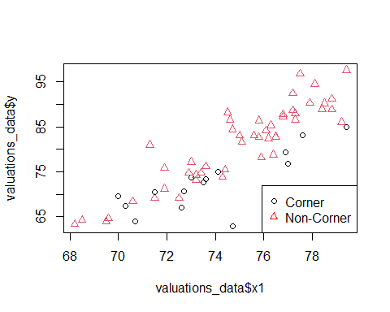

The relation does not appear the same. The non-corner houses look to have a bigger slope.

## b

### alternatives

H0:B2=B3=0; Ha: not all of the Bk in H0 equal zero.

### Decison rule

Partial F test: Reject H0 if F*> F alpha,p-q,n-p (SSR(x2,x3|x1)/(p-q))/MSE(x1,x2,x3)

### Conclusion

valuationfit<-lm(y~x1+x2+(x1*x2),data=valuations_data)  
  
summary(valuationfit)

##   
## Call:  
## lm(formula = y ~ x1 + x2 + (x1 * x2), data = valuations_data)  
##   
## Residuals:  
## Min 1Q Median 3Q Max   
## -10.8470 -2.1639 0.0913 1.9348 9.9836   
##   
## Coefficients:  
## Estimate Std. Error t value Pr(>|t|)   
## (Intercept) -126.9052 14.7225 -8.620 4.33e-12 ***  
## x1 2.7759 0.1963 14.142 < 2e-16 ***  
## x2 76.0215 30.1314 2.523 0.01430 *   
## x1:x2 -1.1075 0.4055 -2.731 0.00828 **   
## ---  
## Signif. codes: 0 '***' 0.001 '**' 0.01 '*' 0.05 '.' 0.1 ' ' 1  
##   
## Residual standard error: 3.893 on 60 degrees of freedom  
## Multiple R-squared: 0.8233, Adjusted R-squared: 0.8145   
## F-statistic: 93.21 on 3 and 60 DF, p-value: < 2.2e-16

anova(valuationfit)

## Analysis of Variance Table  
##   
## Response: y  
## Df Sum Sq Mean Sq F value Pr(>F)   
## x1 1 3670.9 3670.9 242.2760 < 2.2e-16 ***  
## x2 1 453.1 453.1 29.9073 9.282e-07 ***  
## x1:x2 1 113.0 113.0 7.4578 0.008281 **   
## Residuals 60 909.1 15.2   
## ---  
## Signif. codes: 0 '***' 0.001 '**' 0.01 '*' 0.05 '.' 0.1 ' ' 1

sum(anova(valuationfit)[2:3,"Sum Sq"])/(4-2)/anova(valuationfit)[4,"Mean Sq"] > qf(1-.05,2,60)

## [1] TRUE

Conclude reject H0.

## c

pop1_fit<-lm(y~x1,data=valuations_data[valuations_data$x2==T,])  
pop2_fit<-lm(y~x1,data = valuations_data[!valuations_data$x2,])  
  
summary(pop1_fit)

##   
## Call:  
## lm(formula = y ~ x1, data = valuations_data[valuations_data$x2 ==   
## T, ])  
##   
## Residuals:  
## Min 1Q Median 3Q Max   
## -10.847 -1.382 1.191 2.388 4.615   
##   
## Coefficients:  
## Estimate Std. Error t value Pr(>|t|)   
## (Intercept) -50.8836 28.4687 -1.787 0.095541 .   
## x1 1.6684 0.3843 4.342 0.000677 ***  
## ---  
## Signif. codes: 0 '***' 0.001 '**' 0.01 '*' 0.05 '.' 0.1 ' ' 1  
##   
## Residual standard error: 4.215 on 14 degrees of freedom  
## Multiple R-squared: 0.5738, Adjusted R-squared: 0.5434   
## F-statistic: 18.85 on 1 and 14 DF, p-value: 0.0006769

summary(pop2_fit)

##   
## Call:  
## lm(formula = y ~ x1, data = valuations_data[!valuations_data$x2,   
## ])  
##   
## Residuals:  
## Min 1Q Median 3Q Max   
## -6.9460 -2.1639 -0.6544 1.4775 9.9836   
##   
## Coefficients:  
## Estimate Std. Error t value Pr(>|t|)   
## (Intercept) -126.9052 14.3305 -8.856 1.68e-11 ***  
## x1 2.7759 0.1911 14.529 < 2e-16 ***  
## ---  
## Signif. codes: 0 '***' 0.001 '**' 0.01 '*' 0.05 '.' 0.1 ' ' 1  
##   
## Residual standard error: 3.789 on 46 degrees of freedom  
## Multiple R-squared: 0.8211, Adjusted R-squared: 0.8172   
## F-statistic: 211.1 on 1 and 46 DF, p-value: < 2.2e-16

valuations_data<-read.table("CH08PR24.txt",col.names = c('y','x1','x2'))  
group <- as.factor(ifelse(valuations_data$x2==T, "Group 1", "Group 2"))  
plot(valuations_data$x1,valuations_data$y,pch = as.numeric(group), col = group)  
legend('bottomright',legend=c('Corner','Non-Corner'), pch=c(1,2), col=c("Black",'Red'))  
abline(pop1_fit)  
abline(pop2_fit,col='red')

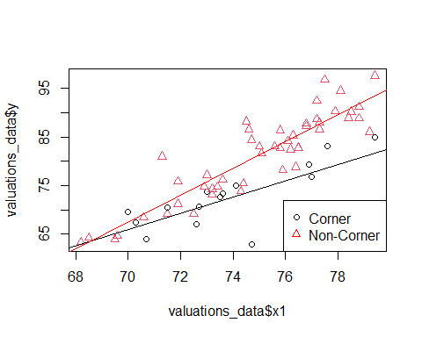 Y=-50.8836+1.6684x1 (Corner) Y=-126.9052+2.7759x2 (Non-Corner)