ASSIGNMENT 2

MUHAMMAD SOHAIB TARIQ

BSCS -4B rEG# 33584

This project implements the following smart pointers:

* Copied pointers
* Owned pointers
* COW with Reference Counting
* COW with Reference linking

**Github**: <https://github.com/sohaibtariq/smart-pointers>

The project contains the following files:

* Copied_ptr.h
* Copied_ptr.cpp
* Copied_string.h
* Copied_string.cpp

( *The copied_ptr files contain the implementation of the copied pointer whereas the copied_string is the implementation of the string that the copied pointer points to.*)

* Owned_ptr.h
* Owned_ptr.cpp
* Owned_string.h
* Owned_string.cpp

(*The owned_ptr files contain the implementation of the owned pointer whereas the owned_string is the implementation of the string that the owned pointer pointer points to.*)

* Refcount.h
* Refcount.cpp
* String_refcount.h
* String_refcount.cpp

(*The refcount files contain the implementation of the COW reference counted pointer whereas the string_refcount is the implementation of the string that the pointer points to.*)

* Reflink_ptr.h
* Reflink_ptr.cpp

(*The reflink files contain the implementation of COW with reference linking. The string used in this instance is the owned_string.*)

**Implemented functions:**

**Pointer classes:**

* Constructors ( no argument, pass string object by reference, pass pointer object by reference, pass character array and length)
* Destructors
* Operator overloading for the member access operator ( -> ) so that the pointer objects can be used like pointers.
* get_length : get the length of the string
* get_str: get a reference to the character array

**String classes:**

* Constructors ( no argument, pass string object by reference, pass character and length)
* get_length : get the length of the string
* get_str: get a reference to the character array
* ***This list only includes functions that are present in all classes. Functions unique to each class are not mentioned here.***

**Profiling:**

***(Profiling has been done for CPU usage only since my Visual studio installation is not able to perform memory profiling for some reason.)***

* CPU usage for large string:

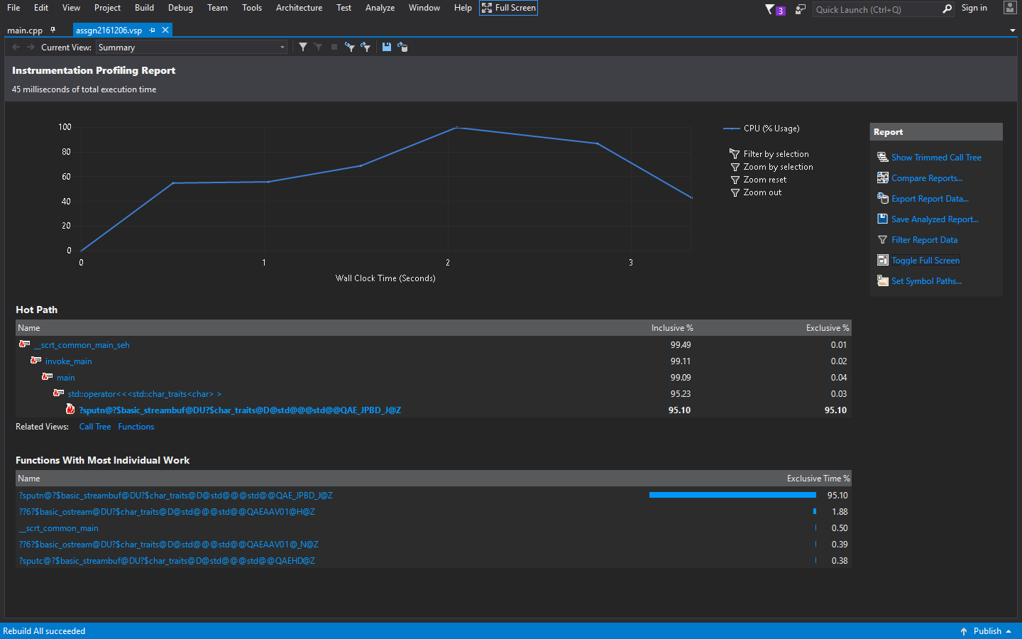

* CPU usage for small string

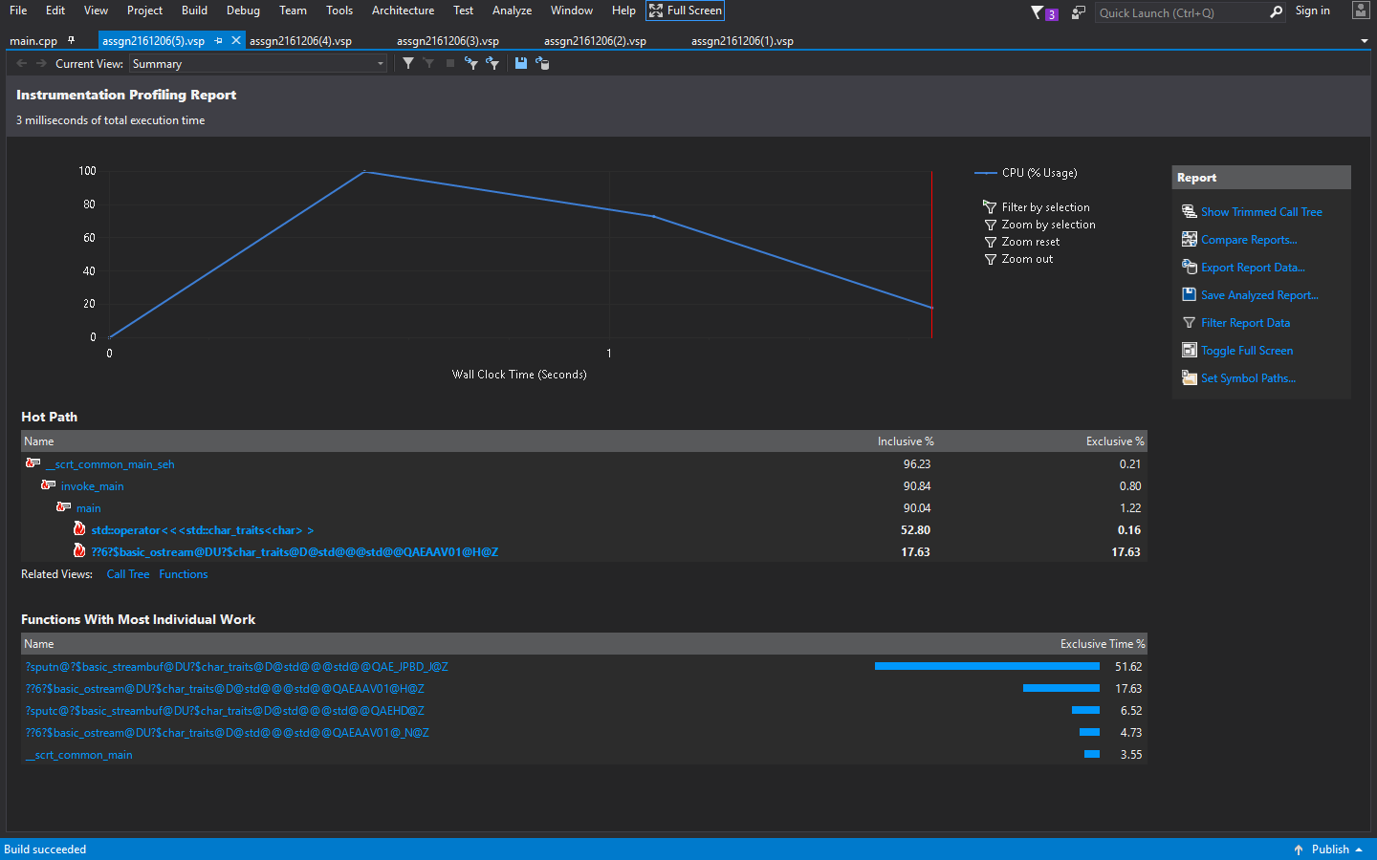

* CPU usage form medium string:

