1. When Submit button is clicked without entering any data then it should throw validation and blank table should not be loaded.

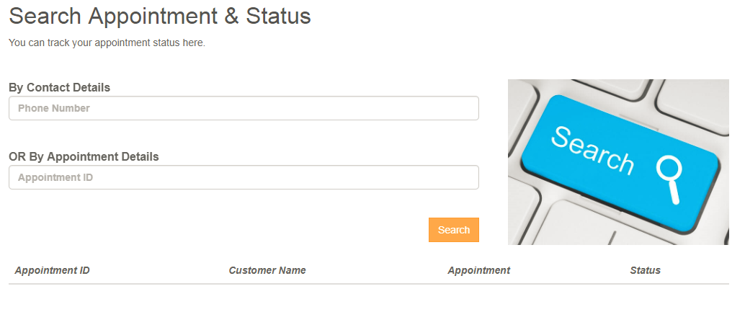

1. Input that doesn’t have any data in database should display message as “No Record or Appointment found” and blank table should not be loaded.

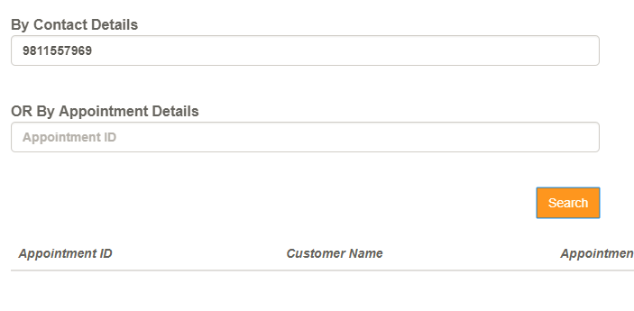

1. Spaces only should not be considered as message.

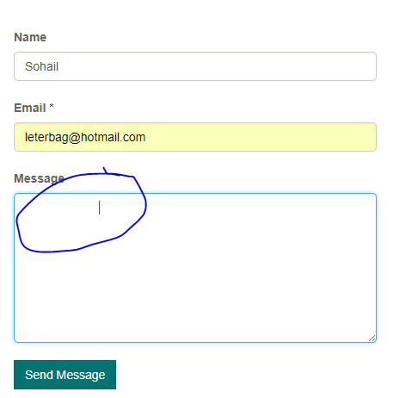

1. Cursor after login on left panel of sorting should be changed, it should be mouse pointer and not curson.
2. Search filter is not working after login, it works only after 5 character.

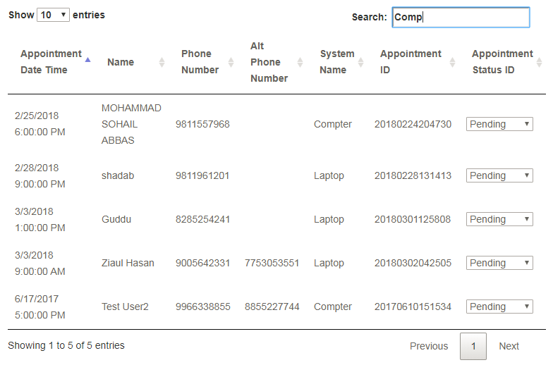

1. Update Appointment status link is not working

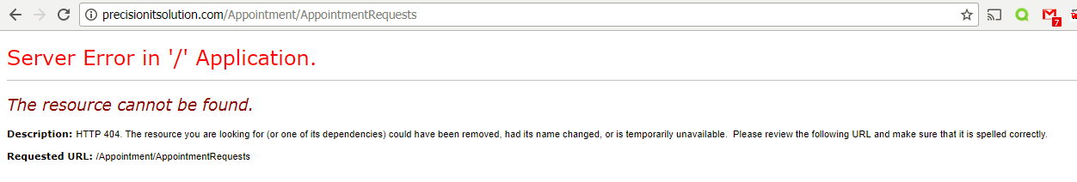

To correct this, the url should be corrected to **“http://precisionitsolution.com/Admin/AppointmentRequests”**

1. After login Put Company name is displayed which should not be displayed.

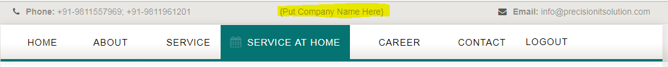

1. After admin login if I navigate from appointment detail table then I can’t come back to that table. Hence, there should be an option where we can come to that table.
2. To logout you have to hit twice “Logout” button to log out else you won’t be able to log out.
3. Login button should be changed to Admin Login as we will allow only Admin to Login

or if it is login and a normal user login and user is routed to Book Appointment window then user detail should be auto loaded.