LAB-2
AIM :
To perform exploratory data analysis (EDA) on a student performance dataset using Pandas and Matplotlib.
DATASET:
Create a CSV file named student_data.csv with the following data:
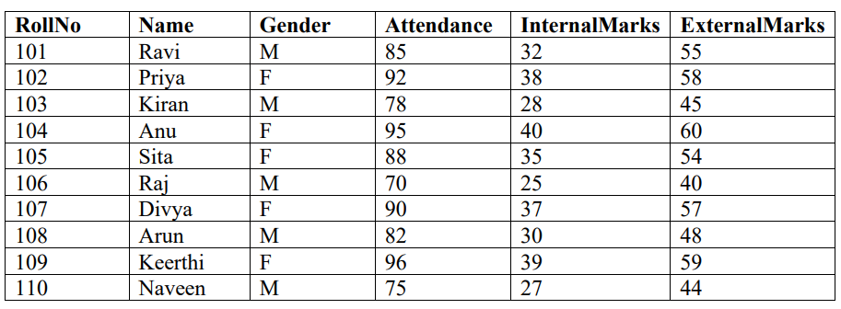
TASKS
Task A: Dataset Loading and Inspection
• Import the necessary Python libraries.
• Load the dataset into a Pandas DataFrame.
• Display the first five records.
• Display the last five records.
• Find the total number of rows and columns.
• Display the names of all columns.
• Display the data type of each column.
• Generate dataset information using info().
Task B: Statistical Analysis
• Calculate the mean attendance of all students.
• Calculate the average Internal Marks.
• Calculate the average External Marks.
• Find the maximum Internal Marks.
• Find the minimum Internal Marks.
• Find the maximum External Marks.
• Find the minimum External Marks.
• Calculate the standard deviation of Internal Marks.
• Generate summary statistics using describe().
Task C: Data Manipulation
• Create a new column named TotalMarks.
• TotalMarks=InternalMarks+ExternalMarks
• Create a new column named Percentage. 1. Percentage=TotalMarks/100×100
• Display the updated DataFrame.
Task D: Filtering and Searching
• Display the details of students whose attendance is greater than 90%.
• Display the details of students whose TotalMarks exceed 90.
• Display the details of female students.
• Display the details of male students.
• Display students whose ExternalMarks are less than 50.
Task E: Ranking and Comparison
• Identify the student with the highest TotalMarks.
• Identify the student with the lowest TotalMarks.
• Display the top three performers based on TotalMarks.
• Display the bottom three performers based on TotalMarks.
• Determine how many students scored above the class average.
Task F: Group-wise Analysis
• Calculate the average TotalMarks of male students.
• Calculate the average TotalMarks of female students.
• Compare the average attendance of male and female students.
Task G: Data Visualization
• Plot a bar chart showing TotalMarks of all students.
• Plot a histogram of Attendance.
• Plot a pie chart showing the distribution of male and female students.
• Plot a scatter plot between Attendance and TotalMarks.
• Interpret the relationship between Attendance and TotalMarks.
Task H: Observations
• Write any three observations based on the analysis performed.
• State whether higher attendance appears to be associated with better academic performance.

Code:
import pandas as pd
import numpy as np
print("\n-----Task_A------\n")
df=pd.read_csv('student_data.csv', encoding='latin1')
print(df.head(),"\n")
print(df.tail(),"\n")
rows=df.shape[0]
print("No.of Rows=",rows)
colums=df.shape[1]
print("No.of columns=",colums,"\n")
if "Name" in df.columns:
for names in df["Name"]:
print(names)
print("\ncolumn datatypes:\n",df.dtypes)
print("\nDetailed info:",df.info())
#partB
print("\n-----Task_B------\n")
mean_att=df["Attendance"].mean()
print("\n averagr attendence of class:",mean_att)
print("\n average internal marks of class:",df["InternalMarks"].mean())
print("\n average external marks of class:",df["ExternalMarks"].mean())
print("\n Maximum internal marks:",df["InternalMarks"].max())
print("\n Minimum internal marks:",df["InternalMarks"].min())
print("\n Maximum external marks:",df["ExternalMarks"].max())
print("\n Minimum external marks:",df["ExternalMarks"].min())
print("\n Standard dev of internal marks:",df["InternalMarks"].std())
print("\n Summary Statistic:\n", df.describe())
#taskC
print("\n-----Task_c------\n")
df["TotalMarks"]=df[["InternalMarks","ExternalMarks"]].sum(axis=1)
df["Percentage"]=(df["TotalMarks"]/100)*100
print(df)
#taskD
print("\n-----Task_D------\n")
print("Students with the attendance greater than 90:\n")
print(df.loc[df["Attendance"] >= 90, "Name"])
print(df.loc[df["Attendance"] >= 90, "Name"])
print(df.loc[df["Gender"] == "F", "Name"])
print(df.loc[df["Gender"] == "M", "Name"])
print(df.loc[df["ExternalMarks"] <= 50, "Name"])
#paet e
print("\n-----Task_E------\n")

print(df.loc[df["TotalMarks"] == df["TotalMarks"].max(), "Name"])
print(df.loc[df["TotalMarks"] == df["TotalMarks"].min(), "Name"])
df.sort_values(by="TotalMarks", ascending=False, inplace=True)
print(df.head(3),"Name")
print(df.tail(3),"Name")
classavg=df["TotalMarks"].mean()
count=(df["TotalMarks"]>classavg).sum()
print("No of students scored above class avg:",count)
#Tasj=k f\
print("\n-----Task_F------\n")
print("Class average of males:", df.loc[df["Gender"] == "M", "TotalMarks"].mean())
print("Class average of females:", df.loc[df["Gender"] == "F", "TotalMarks"].mean())
M_att=df.loc[df["Gender"] == "M", "Attendance"].mean()
F_att=df.loc[df["Gender"] == "F", "Attendance"].mean()
if F_att>M_att:
print("female have more attendence")
else:
print("male have more attendence")
print("\n-----Task_G------\n")
import matplotlib.pyplot as plt
plt.bar(df["Name"], df["TotalMarks"], color="skyblue")
plt.xlabel("Students")
plt.ylabel("Total Marks")
plt.title("Total Marks of Students")
plt.xticks(rotation=45)
plt.tight_layout()
plt.show()
print("\n")
plt.hist(df["Attendance"], bins=10, color="lightgreen", edgecolor="black")
plt.xlabel("Attendance")
plt.ylabel("Number of Students")
plt.title("Distribution of Attendance")
plt.show()
print("\n")
gender_counts = df['Gender'].value_counts()
plt.figure(figsize=(6, 6))
plt.pie(gender_counts, labels=gender_counts.index, autopct='%1.1f%%', startangle=90, colors=['lightcoral', 'lightskyblue'])
plt.title('Gender Distribution of Students')
plt.axis('equal') # Equal aspect ratio ensures that pie is drawn as a circle.
plt.show()
print("\n")
plt.scatter(df["Attendance"], df["TotalMarks"], color="purple")
plt.xlabel("Attendance (%)")
plt.ylabel("Total Marks")
plt.title("Relationship between Attendance and Total Marks")
plt.show()
print("\n")
correlation = df["Attendance"].corr(df["TotalMarks"])
print("Correlation between Attendance and Total Marks:", correlation)

OUTPUT:
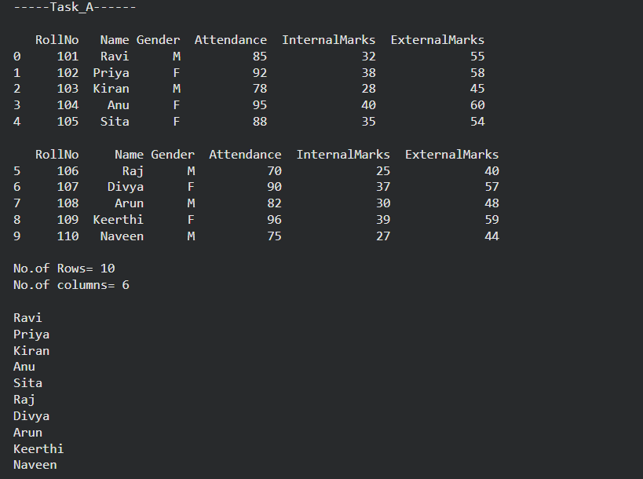
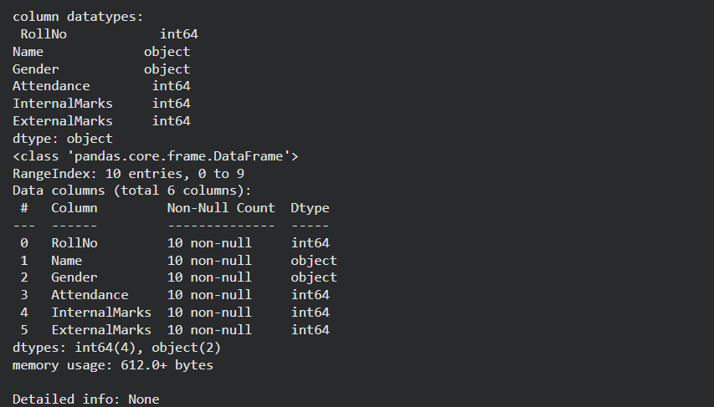
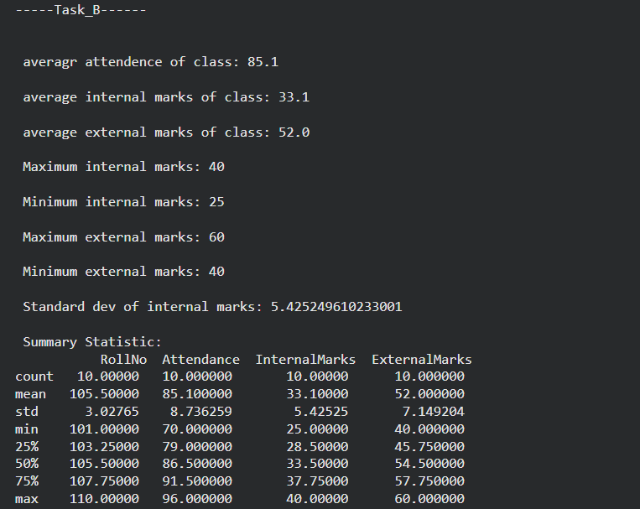
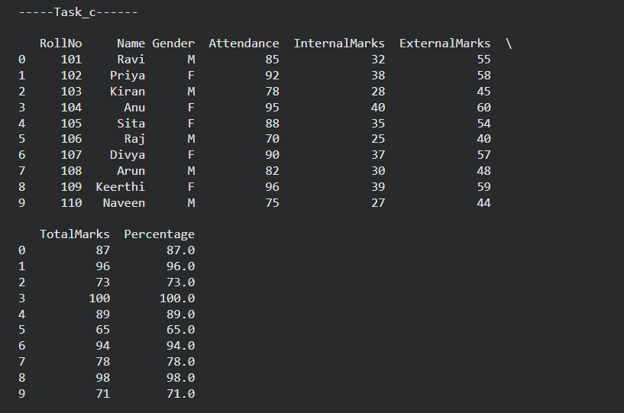
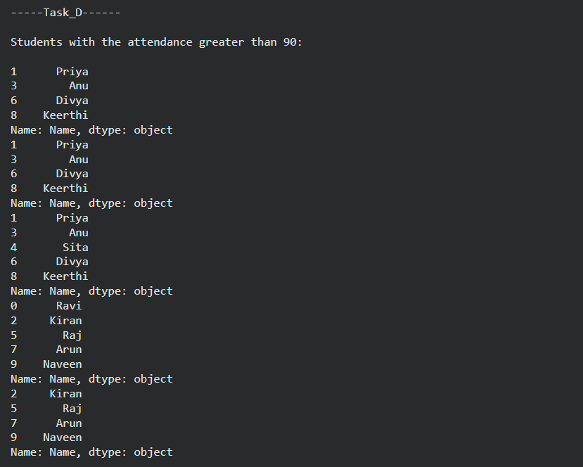
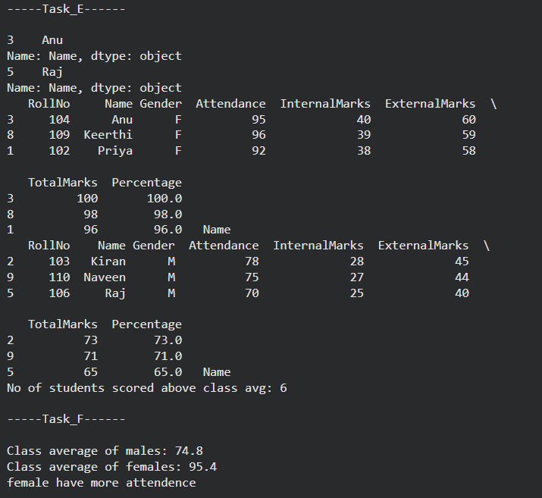
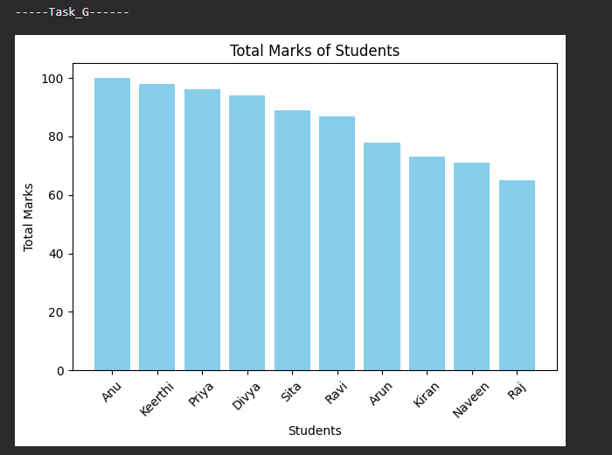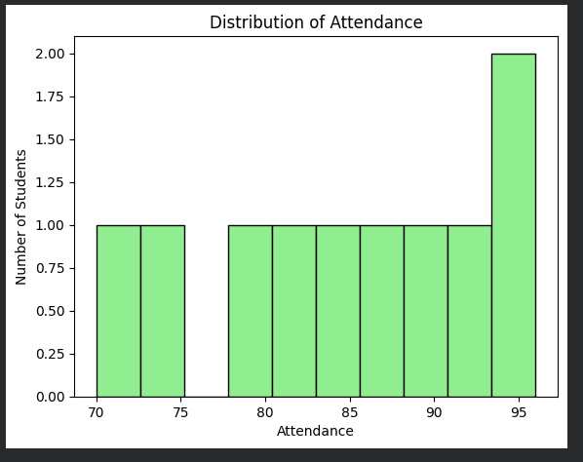
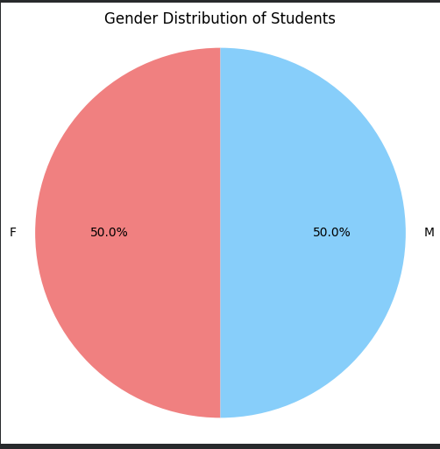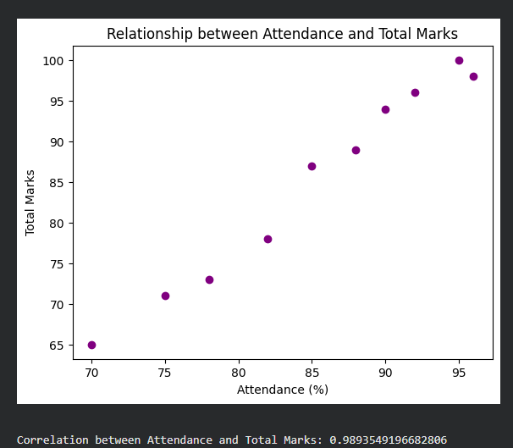
Task H
Observations:
- There are equal male and female
- Females are having higher score compared to male
- Female have higher attendance percentage
- Almost all the students with higher attendance have good score
Yes, based on the given data higher attendance appears strongly associated with the better academic performance. The corelation between the academic performance and attendance is 0.989 then is nearly 99%. Which states that the 99% of students having higher attendance are performing better in academics.
- There are equal male and female
- Females are having higher score compared to male
- Female have higher attendance percentage
- Almost all the students with higher attendance have good score

