Install Ubuntu Alongside With Windows 10 or 8 in Dual-Boot

This tutorial will guide you on how you can perform the installation of Ubuntu 20.04**,** Ubuntu 19.04**,** Ubuntu 18.10**,** or Ubuntu 18.04 in dual-boot with a Microsoft Operating System on machines that come pre-installed with Windows 10.

In case your hardware uses UEFI then you should modify the EFI settings and disable Secure Boot feature.

If your computer has no other Operating System already installed and you plan to use a Windows variant alongside Ubuntu, you should first install Microsoft Windows and then proceed with Ubuntu installation.

1. 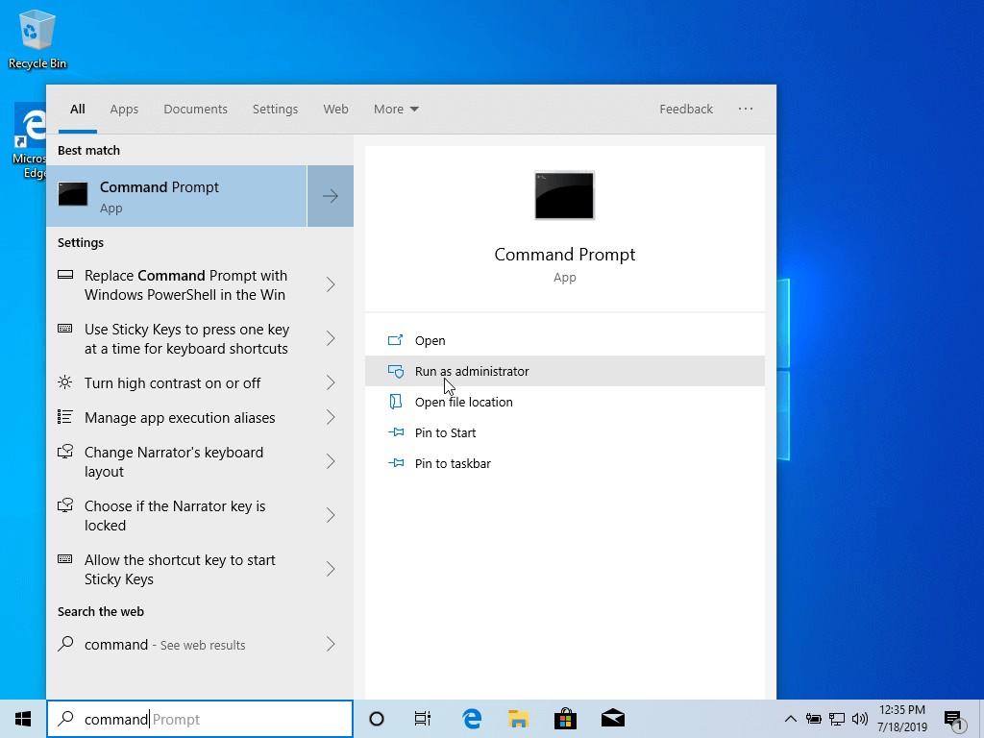The first thing you need to take care of is to create free space on the computer hard disk in case the system is installed on a single partition.
2. Once in **CLI**, type **diskmgmt.msc** on prompt and the **Disk Management** utility should open. From here, right-click on **drive** the partition and select **Shrink Volume** in order to resize the partition.

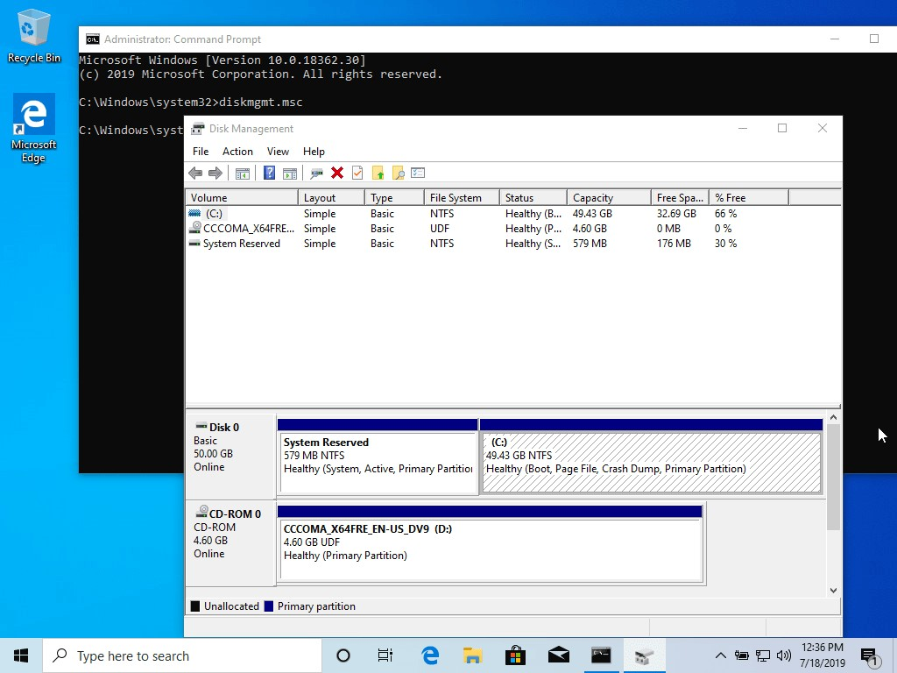

1. On Shrink of selected drive enter a value on space to shrink in MB (use at least **20000 MB** depending on the **drive** partition size) and hit **Shrink** to start partition resize as illustrated below (the value of space shrink from below image is lower and only used for demonstration purposes).Once space has been resized you will see a new unallocated space on the hard drive. Leave it as default and reboot the computer in order to proceed with the Ubuntu insta

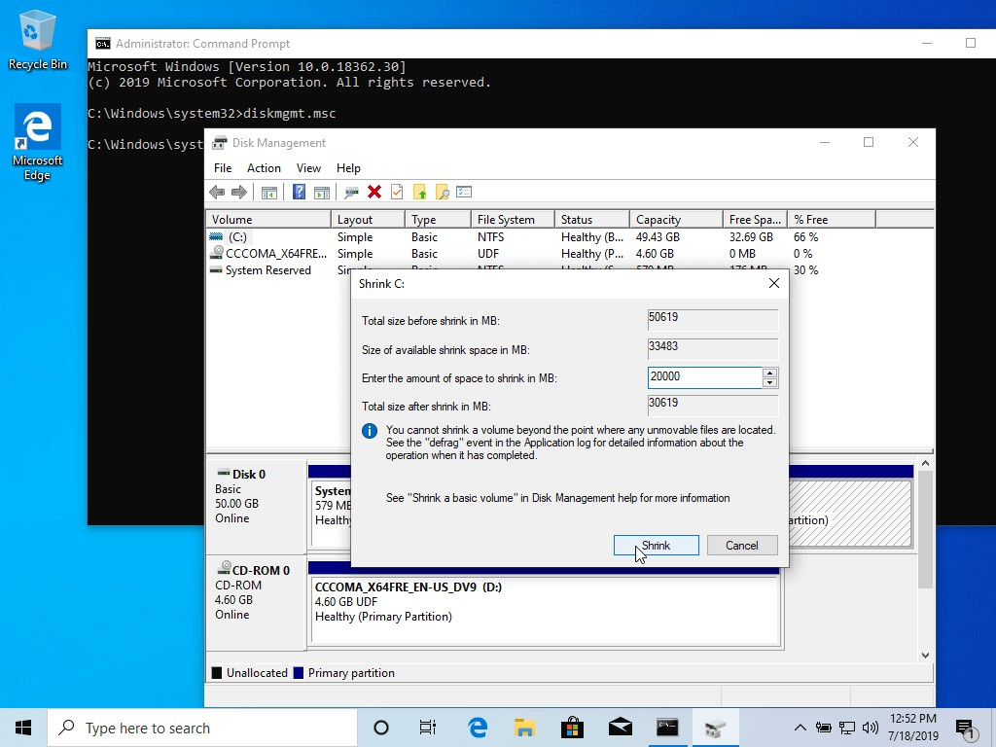

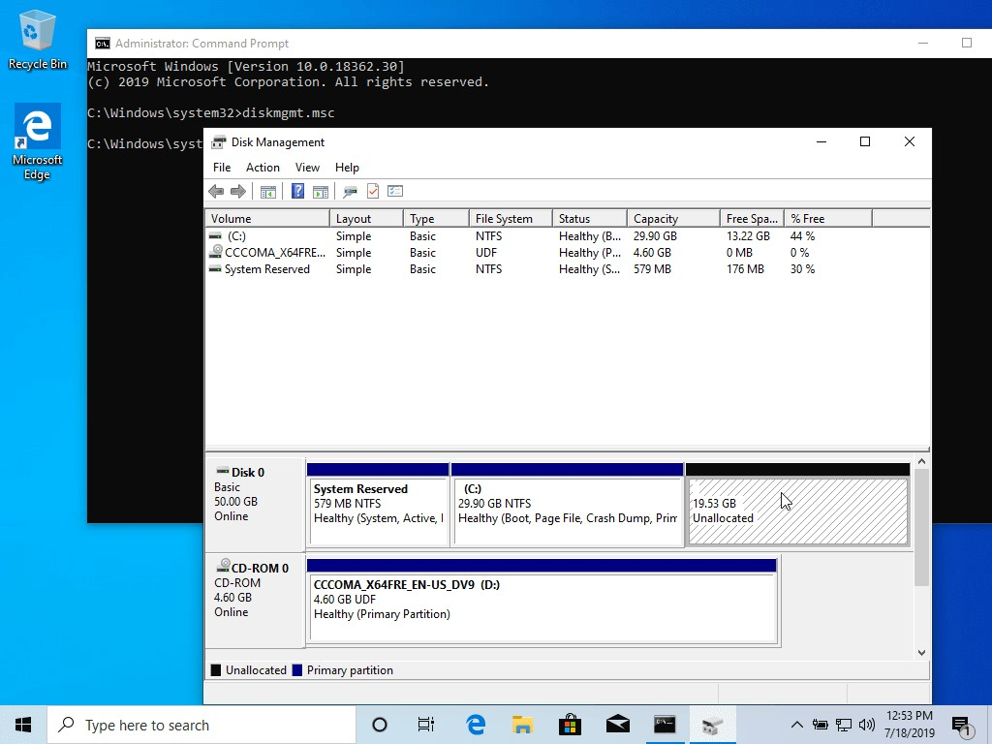

**Install Ubuntu with window Dual-Boot**

1. For the purpose of this article, we will be installing Ubuntu 19.04 alongside with Windows dual boot (you can use any Ubuntu release for installation). Go the download link from the topic description and grab Ubuntu Desktop 19.04 ISO image.
   1. Burn the image to a DVD or create a bootable USB stick using a utility such as Universal USB Installer (BIOS compatible)[**http**[**s://www**](http://www.pendrivelinux.com/universal-usb-installer-easy-as-)**.pen**[**drivelinux.com/universal-usb-installer-easy-as-**](http://www.pendrivelinux.com/universal-usb-installer-easy-as-) **1-2-3/**] or Rufus (UEFI compatible).
   2. Place the USB stick or DVD in the appropriate drive, reboot the machine and instruct the BIOS/UEFI to boot-up from the DVD/USB by pressing a special function key (usually **F12**, **F10** or **F2** depending on the laptop/pc specifications).
   3. Once the media boot-up a new grub screen should appear on your monitor. From the menu select Install Ubuntu and hit **Enter** to continue.

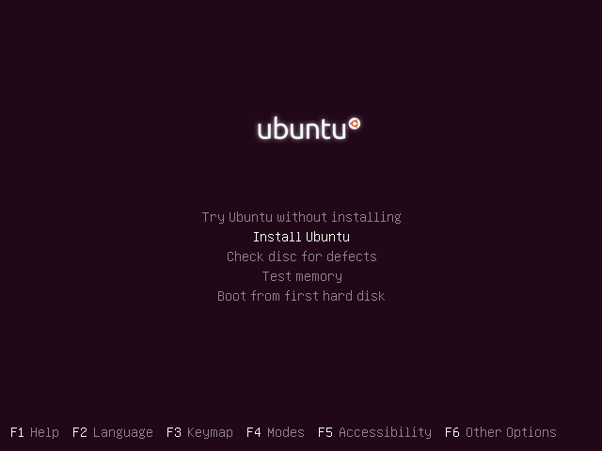

1. Choose the language you wish to perform the installation and click on the **Continue** button to proceed further.
2. Next, choose the first option “**Normal Installation**” and hit on the **Continue** button again.

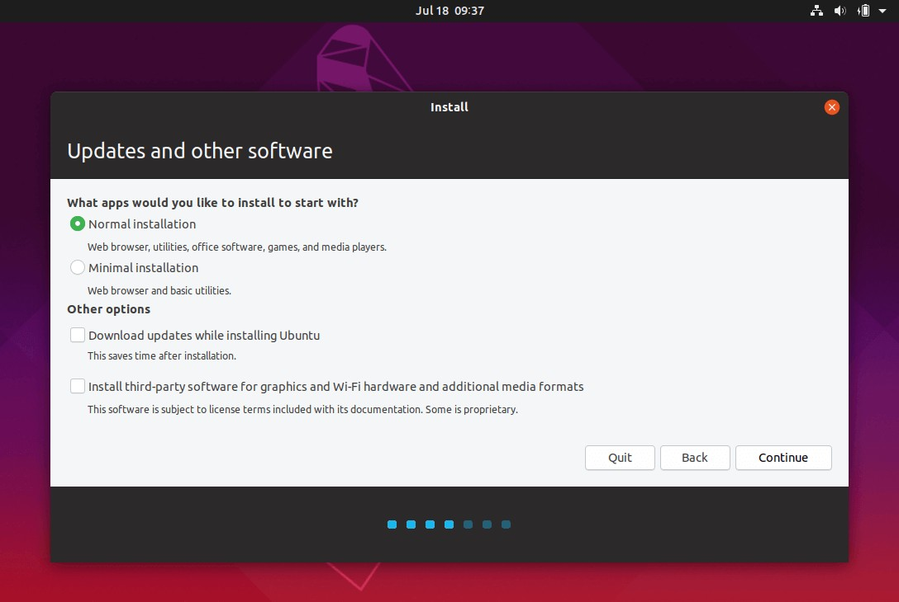

1. Now it’s time to select an Installation Type. You can choose to **Install Ubuntu** alongside **Windows Boot Manager**, an option that will automatically take care of all the partition steps.Use this option if you don’t require a personalized partition scheme.
   1. In case you want a custom partition layout, check the **something else** option and hit on the **Continue** button to proceed further.

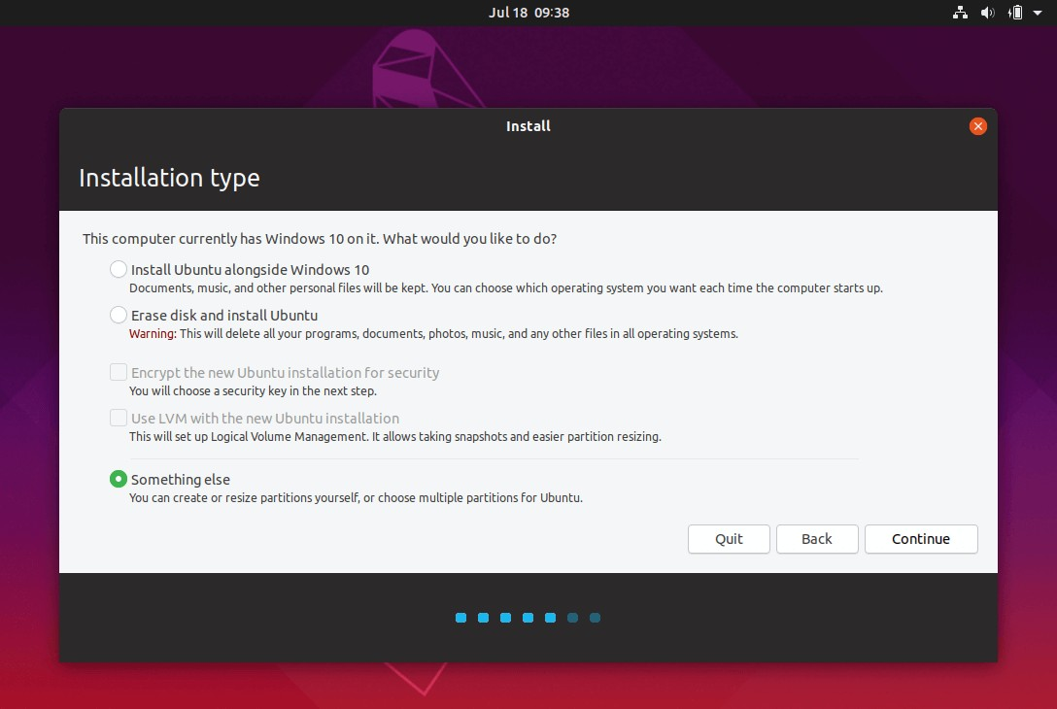**Note**: The option **Erase disk** and install Ubuntu should be avoided on dual-boot because is potentially dangerous and will wipe out your disk.

1. On this step, we’ll create our custom partition layout for **Ubuntu**. This guide will recommend that you create two partitions, one for **root** and the other for **home** accounts data and no partition for **swap** (use a swap partition only if you have limited RAM resources or you use a fast SSD).

To create the first partition, the **root** partition, select the free space (the shrinking space from Windows created earlier) and hit on the + icon below. On partition settings use the following configurations and hit **OK** to apply changes:

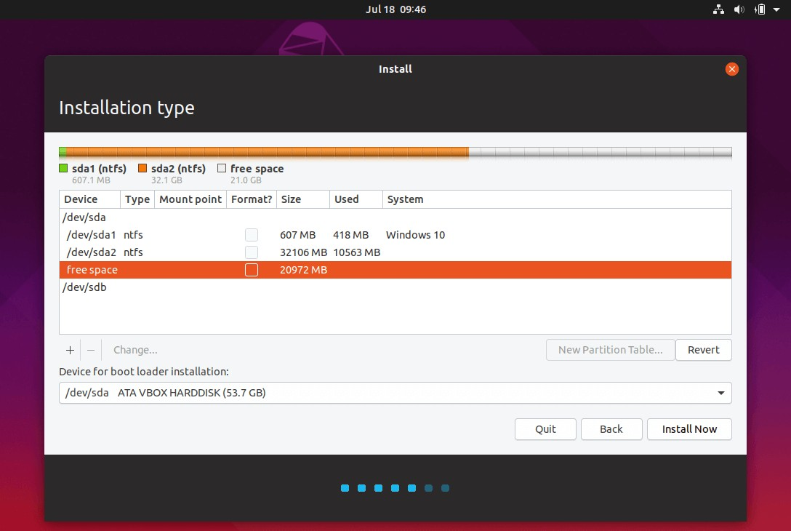

1. Size = at least **20000** MB
2. Type for the new partition = **Primary**
3. Location for the new partition = **Beginning**
4. Use as = **EXT4** journaling file system
5. Mount point = **/**

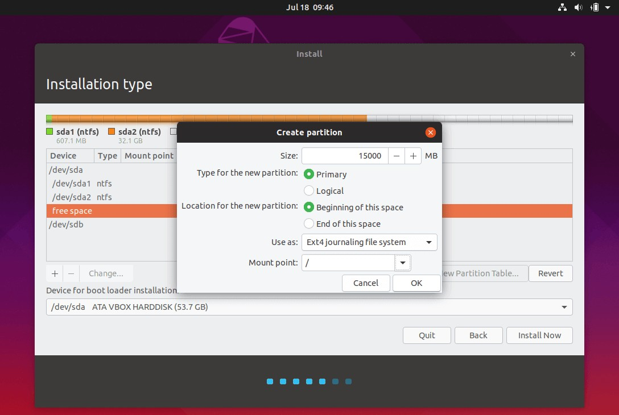

Create the **home** partition using the same steps as above. Use all the available free space left for the home partition size. The partition settings should look like this:

1. Size = all remaining free space
2. Type for the new partition = **Primary**
3. Location for the new partition = **Beginning**
4. Use as = **EXT4** journaling file system
5. Mount point = **/home**
6. When finished, hit the **Install Now** button in order to apply changes to disk and start the installation process.
   1. A pop-up window should appear to inform you about **swap** space. Ignore the alert by pressing on the **Continue** button.
   2. Next, a new pop-up window will ask you if you agree with committing changes to disk. Hit **Continue** to write changes to disk and the installation process will now start.

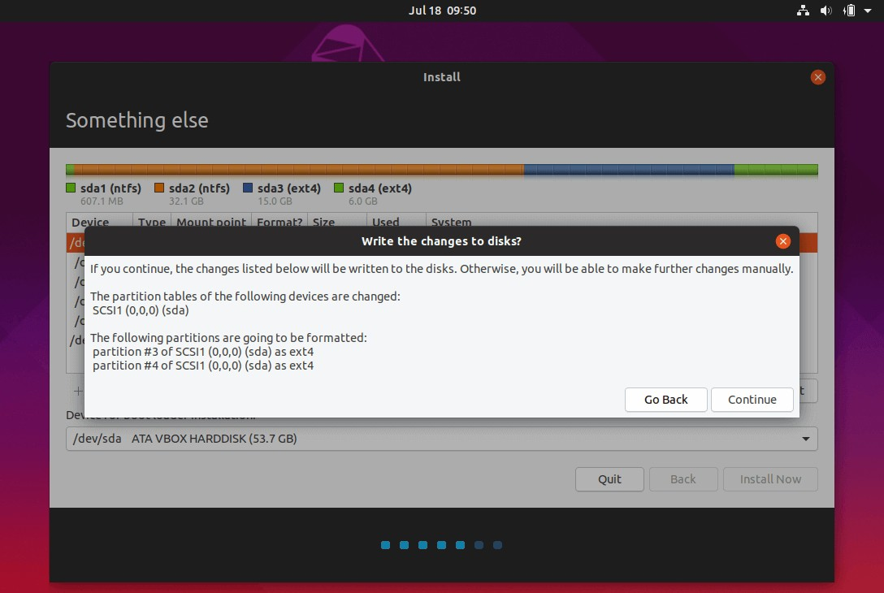

1. On the next screen adjust your machine physical location by selecting a city nearby from the map. When done hit **Continue** to move ahead.
2. Pick up a username and password for your administrative **sudo** account, enter a descriptive name for your computer and hit **Continue** to finalize the installation.These are all the settings required for customizing the **Ubuntu** installation. From here on the installation process will run automatically until it reaches the end.
3. After the installation process reaches its end hit on the **Restart Now** button in order to complete the installation.
   1. The machine will reboot into the **Grub** menu, where for ten seconds, you will be presented to choose what OS you wish to use further: **Ubuntu 19.04** or **Microsoft Windows**.
   2. Ubuntu is designated as default OS to boot from. Thus, just press **Enter** key or wait for those **10** seconds timeout to drain.

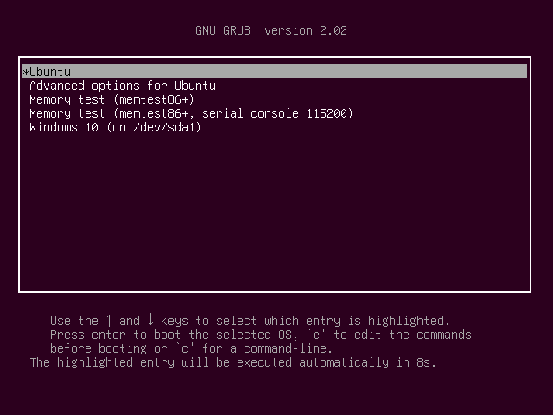

1. After Ubuntu finishes loading, login with the credentials created during the installation process. **Ubuntu** provides **NTFS** file system support automatically so you can access the files from Windows partitions just by clicking on the **Windows** volume.