# Chapter 4: Implementation

For the development of my system blood donor registration system I have chosen core PHP as my programing language with html and JavaScript, also OOP Pattern of code architecture was use for the fast programing of the system. These frameworks provide built in fictionality and secure authentication process.

## 4.1 UI-Modelling

User Interface Modelling is a visual user interface designing used by application developer to develop front end design for various software. For my project UI design is important because it helps to make design more user-friendly and shows how my project design will look. I have used an interface designing tool called Balsamiq to design the UI of my project.

## 4.1.1 Prototype:

UI model of login page:

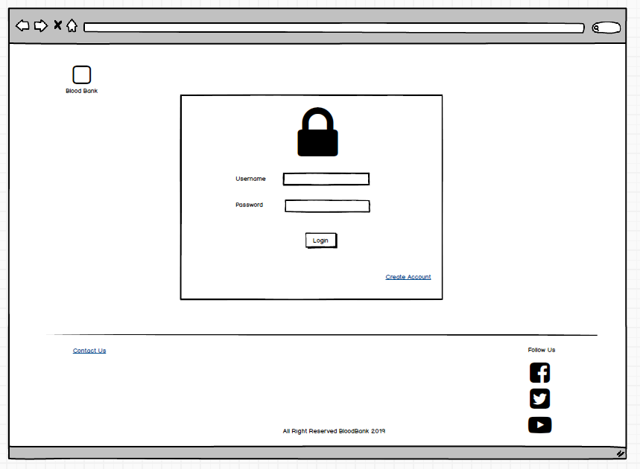

Figure 5 for login page

UI model of registration page:

Figure 6 registration model

UI modeling of dashboard:

Figure 7 dashboard model

# Chapter 5 Testing

## 5.1 Blackbox Testing:

Blackbox is the testing methodology where the software's functionality is evaluated without much understanding of the tester implementation or internal structure.

## 5.1.1 Benefits of black box testing:

1. The developer doesn’t need not have technical background to conduct this testing.
2. Analysis is carried out from a tester perspective.
3. Cases may be designed immediately after completion of functional specification test cases.
4. A proof of the functional requirement

|  |  |  |  |  |  |
| --- | --- | --- | --- | --- | --- |
| **Test Name:** | | Donor CRUD functionality test | | | |
| **Test By:** | | Sohail maharjan | **Test Location:** | Ravibhawan | |
| **Approved By:** | | Sudeep Bajimaya | **Test Time:** | 15:35, Monday, 2020-01-25 | |
| **Case ID** | **Description** | **Data** | **Expected Results** | **Actual Results** | **Remark** |
| DCF03 | Add donor information | Name: sohail  Gender: male  Date: 02/31/0190  Weight:44  Contact:9812376  Blood type: AB | Added successfully. | The field is incorrect, invalid date | Failed |
| DCF04 | Add donor information | Name: sohail  Gender: male  Date: 01/31/0190  Weight:44  Contact:9812376  Blood type: AB | Added successfully. | Added successfully | Success |
| DCF05 | View donor information | Click on view donor | Donor list is displayed | Donor list is displayed | Success |
| DCF06 | Edit donor | Click on view edit donor | Edit donor is opened | Edit donor is opened | Success |
| DCF07 | Edit donor | Name: sam  Gender: female  Date: 02/31/0190  Weight:44  Contact:9812376  Blood type: AB | Update successful | Update successful | success |
| DCF08 | Remove donor | Click on remove donor | Donor list remove successfully | Donor list remove successfully | success |

|  |  |  |  |  |  |
| --- | --- | --- | --- | --- | --- |
| **Test Name:** | | Blood CRUD functionality test | | | |
| **Test By:** | | Sohail maharjan | **Test Location:** | Ravibhawan | |
| **Approved By:** | | Sudeep Bajimaya | **Test Time:** | 15:35, Monday, 2020-01-25 | |
| **Case ID** | **Description** | **Data** | **Expected Results** | **Actual Results** | **Remark** |
| BCF03 | Create Campaign information | Campaign Name: Blood notaion nepal  Organization name: Who  Date: 02/31/2020  Location: Ravhibhawan  Description: test | Campaign created. | The field is incorrect, invalid date | Failed |
| BCF04 | Create Campaign information | Campaign Name: Blood notaion nepal  Organization name :Who  Date: 06/08/2020  Location: Ravhibhawan  Description: test | Campaign created. | Campaign created. | Success |
| BCF05 | View Campaign information | Click on view Campaign | Campaign list is displayed | Campaign list is displayed | Success |
| BCF06 | Edit Campaign | Click on view edit Campaign | Edit Campaign is opened | Edit Campaign is opened | Success |
| BCF07 | Edit Campaign | Campaign Name: Nepal Who  Organization name: Who  Date: 06/08/2020  Location: tesr  Description: test | Update successful | Update successful | success |
| BCF08 | Remove Campaign | Click on remove Campaign | Campaign list remove successfully | Campaign list remove successfully | success |

Results:

|  |  |  |  |  |  |
| --- | --- | --- | --- | --- | --- |
| DCF03 | Add donor information | Name: sohail  Gender: male  Date: 02/31/0190  Weight:44  Contact:9812376  Blood type: AB | Added successfully. | The field is incorrect, invalid date | Failed |

Screenshot:

Figure 8 DCF03

|  |  |  |  |  |  |
| --- | --- | --- | --- | --- | --- |
| DCF04 | Add donor information | Name: sohail  Gender: male  Date: 01/31/0190  Weight:44  Contact:9812376  Blood type: AB | Added successfully. | Added successfully | Success |

Screenshot of the test:

Figure 9 DCF04

|  |  |  |  |  |  |
| --- | --- | --- | --- | --- | --- |
| DCF05 | View donor information | Click on view donor | Donor list is displayed | Donor list is displayed | Success |

Screenshot of the test:

Figure 10 DCF05

|  |  |  |  |  |  |
| --- | --- | --- | --- | --- | --- |
| DCF06 | Edit donor | Click on edit. | Edit donor is opened | Edit donor is opened | Success |

Figure 11 DCF06

|  |  |  |  |  |  |
| --- | --- | --- | --- | --- | --- |
| DCF07 | Edit donor | Name: sam  Gender: female  Date: 02/31/0190  Weight:44  Contact:9812376  Blood type: AB | Update successful | Update successful | success |

Figure 12 DCF07

|  |  |  |  |  |  |
| --- | --- | --- | --- | --- | --- |
| DCF08 | Remove donor | Click on remove donor | Donor list remove successfully | Donor list remove successfully | success |

Figure 13 DCF08

Figure 14 DCF08

|  |  |  |  |  |  |
| --- | --- | --- | --- | --- | --- |
| BCF03 | Create Campaign information | Campaign Name: Blood notaion nepal  Organization name: WholDate: 02/31/2020  Location: Ravhibhawan  Description: test | Campaign created. | The field is incorrect, invalid date | Failed |

Figure 15 BCF03

|  |  |  |  |  |  |
| --- | --- | --- | --- | --- | --- |
| BCF04 | Create Campaign information | Campaign Name: Blood notaion nepal  Organization name :Who  Date: 06/08/2020  Location: Ravhibhawan  Description: test | Campaign created. | Campaign created. | Success |

Figure 16 BCF04

|  |  |  |  |  |  |
| --- | --- | --- | --- | --- | --- |
| BCF05 | View Campaign information | Click on view Campaign | Campaign list is displayed | Campaign list is displayed | Success |

Figure 17 BCF05

|  |  |  |  |  |  |
| --- | --- | --- | --- | --- | --- |
| BCF06 | Edit Campaign | Click on view edit Campaign | Edit Campaign is opened | Edit Campaign is opened | Success |

Figure 18 BCF06

|  |  |  |  |  |  |
| --- | --- | --- | --- | --- | --- |
| BCF07 | Edit Campaign | Campaign Name: Nepal Who  Organization name: Who  Date: 06/08/2020  Location: tesr  Description: test | Update successful | Update successful | Success |

Figure 19 BCF07A screenshot of a cell phone

Description automatically generated

Figure 20 BCF08

|  |  |  |  |  |  |
| --- | --- | --- | --- | --- | --- |
| BCF08 | Remove Campaign | Click on remove Campaign | Campaign list remove successfully | Campaign list remove successfully | success |

Figure 21 BCF08

# 

# 6.User manual:

It is a practical interaction report which provides the device user with assistance on how to navigate and use the system. It includes both images and text guide associated with system. It is common to find screenshots of the computer applications in User manual.

User dashboard:

Step1: Click on create account to register and fill it with valid credentials.

Step 2: Login with the registration credential

Step 3: Click on donor to add, edit, view and delete donor:

Step 4: Click on campaign to add, edit, view and delete.

Step 6: Click of view donor to view donor info:

Step 7: Click on edit donor to update the Donor info:

Step 8: Click of Remove donor to delete the donor info:

Step 9: Click on campaign create campaign to add campaign info:

Step 12: Click on View campaign to View Campaign info:

Step 13: Click on delete to delete campaign information:

