 **Proposal Blood donation registration system**

Contents

OVERVIEW 2

1.1 Introduction 2

1.2 Justification for The Project 2

1.2.1 Background of the project 2

1.2.2 Problem Statement 2

1.3 Description of The Proposed System 3

1.3.1 Features of The Project 3

2) PROJECT SCOPE 4

2.1 Scope and Limitation of project 4

2.2 Aim 4

2.3 Objective 4

3) DEVELOPMENT METHODOLOGY 4

3.1 Methodology used 4

3.2 Design Pattern 6

3.3 System Architecture 6

4) PROJECT PLAN 7

4.1 Work Breakdown Structure 7

4.2 Milestones: 8

4.3 Scheduling/ Gantt Chart 9

5.Risk management 10

6. Configuration management 12

Conclusion: 13

# 1. OVERVIEW

## 1.1 Introduction

Blood Donor Online Registration System is a web base application where any individual or staff of any hospital or blood bank can keep an online record of donors with blood types and keep record of campaigns done by their organization with their location. The aim main of this system is create an online record of blood donors and make the record available online so that various blood banks/hospital can share each other’s record of donors and blood type, so that they can find proper blood donor for an immediate patient. The motto of this system is to help patients in need and save lives. This system is not developed for any business propose, it goal is to save people life by providing a platform for faster communication.

## 1.2 Justification for The Project

### 1.2.1 Background of the project

We are living in the age of internet and technology. Using our technological advancement, a lot of good can be done in this world. My system is one those technological advancement intended to save life ad make people life easier. Blood Donor Online Registration System is a web base application where any individual or staff of any hospital or blood bank can keep a online record of donors with blood types and also keep record of campaigns done by their organization with their location.

### 1.2.2 Problem Statement

In the current time hospitals and blood banks in use old paper-based document system, where documents often get misplaced and damage. Also, the record kept are rarely shared with other organization. My system enables these organization to keep a digital record of the donor with their blood type and enable them to share this information with other organization for the immediate help of any patient.

Many people die every day because suitable blood type cannot be found on time. The blood donor registration system helps to reduce the time of finding the suitable donors with a old paper base documentation system and helping organization share their information of various donor so that a suitable donor could be contacted to save a patient life.

## 1.3 Description of The Proposed System

The system will be developed for registering donor details with blood type, viewing the donor information with a click of button, also deleting and updating donor information. Also, similar functions might be added for campaigns for adding, viewing, updating and deleting. The aim main of this system is create an online record of blood donors and make the record available online so that various blood banks/hospital can share each other’s record of donors and blood type, so that they can find proper blood donor for an immediate patient.

### 1.3.1 Features of The Project

Features of this system are given below,

1. Login and sign-up: User can register using organization registration number and login to the system.
2. Add Donors: User can add donor information with blood type
3. View Donors: User can view the detail of all donors with a click of a button.
4. Edit Donors: the user can update the donor information.
5. Delete Donor: User can delete the donor if necessary.
6. Create campaign: Campaigns can be added with their location.
7. View campaign: User can view the detail of all Campaigns with a click of a button.
8. Edit campaign: the user can update the campaign information at any time.
9. Delete campaign: User can delete the campaign if necessary.
10. Log out: user can logout of the system at any time.

# 2) PROJECT SCOPE

## 2.1 Scope and Limitation of project

Scope of this project is limited to only valid organization staff, any user not part of a blood collecting organization such as blank banks or hospital, cannot access the system. Because this is a web base application, it requires internet to operate at any level so, without it; it's basically useless. To use this application client needs to have some degree of formal educational background. Illiterate people might have difficulties operating in this system. This project is limited to serve in a limited geographical area like a town or a city.

## 2.2 Aim

The main aim of this project is to develop a web-based application that can keep digital record of the donors or campaigns online and make the record accessible to various certified organization.

To design a user-friendly application that provides easy and convenient experience.

To save time of the user and expose the system to a wider audience.

## Objective

1. Creating and designing a functional website.
2. To create a secure database and login system.
3. To provide easy access of donor information.
4. To provide means to add, view and delete donor information.
5. Create fast and friend User interface.
6. Perform proper testing and debug any issues.

# 3) DEVELOPMENT METHODOLOGY

## 3.1 Methodology used

Since this project will have a single person in charge of evaluating, designing, developing, implementing and testing and no other team mates are to be involved, so waterfall methodology will be the best to use in this project. The project size is also tiny, so it is unlikely that project demands will alter. Methodology of waterfalls has some of these benefits over others such as agile. Some of the reason for choosing this methodology are as follow;

* Non-repetitive stages unlike agile.
* Easy and uncomplicated steps, beneficial for short project.
* Next stage only begins when the requirement of last stage is completed.
* Saves time and energy.
* Uncomplicates the project

This methodology isn’t without shortcomings some of them are as follow,

* Less room for errors.
* Going back to the previous stage is not possible
* If the requirement changes then you will have to run the stages all over again.
* No guarantee of user satisfaction as stockholders are not involved.

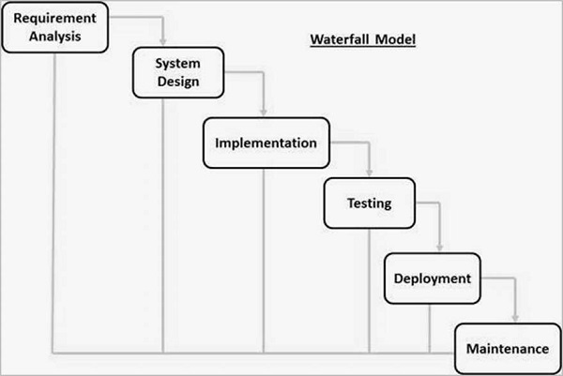

Figure 1 Waterfall Model

## 3.2 Design Pattern

In software engineering, a design pattern is a general repeatable solution to a commonly occurring problem in software design. A design pattern isn't a finished design that can be transformed directly into code. It is a description or template for how to solve a problem that can be used in many different situations.

I have decided to use OOP framework for the development of my system. Object-oriented programming (OOP) refers to a type of computer programming in which programmers define the data type of a data structure, and the types of operations that can be applied to the data structure. In this way, the data structure becomes an object that includes both data and functions. In addition, programmers can create relationships between one object and another. For example, objects can inherit characteristics from other objects. One of the principal advantages of object-oriented programming techniques over procedural programming techniques is that they enable programmers to create modules that do not need to be changed when a new type of object is added. A programmer can simply create a new object that inherits many of its features from existing objects. This makes object-oriented programs easier to modify.

## 3.3 System Architecture

This is a client-server system project, so I'm using three-tiered database system architecture. Three-tier architecture is an architecture for the growth of a database in which functional procedures, data access system and logical data storage system are established and maintained separately, resulting in rapid alteration and growth.

Presentation Tier: You can view multiple views of database information in this level. This is the user interface from which the user is able to view data and information from the application level. Because of this layer, they understand nothing of any database presence.

Application Tier: This is a middle layer tier containing business logic that generates an abstract perspective of the database to the layer of presentation. It monitors the features of the implementation and opinions of information for the layer of presentation. It functions as an intermediate between the database and the presentation.

Data Tier: Database level is a layer that stores data and information. This layer also contains relationship tables. The database is developed using the languages of query processing. Data, information indexing, limitation and relationships are described in this layer.

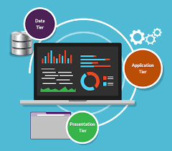

Fig: Three-tier architecture

# 4) PROJECT PLAN

## 4.1 Work Breakdown Structure

WBS is the method of breaking down large project into hierarchical tree framework with tiny achievable milestones so that tasks are easier and more manageable and can be accomplished more quickly and more effectively. WBS ' main goal is to allow distinct team members to carry out the project concurrently, leading in better productivity and easier project management. A project management WBS is a deliverable-oriented breakdown into smaller parts of a project.

FIG: projects WBS

The project is divided into smaller, more manageable parts that can be reasonably evaluated and worked on. In the figure above, in order to be able to comprehend obviously, I split my job into 5 significant stages that are again granulated into other sub-phases.

## 4.2 Milestones:

A milestone finished is a noticeable indicator of advancement towards its goal. A failure to reach a milestone is the project indicator that does not follow the plan and needs corrective action.

Description of milestones;

Analysis (13 days)

* Requirement analysis
* Feasibility study
* Use cases
* SRS

Design (10 days)

* structural Mode
* behavior model

Implementation (30 days)

* database designing
* coding

Testing (7 days)

* Nonfunctional testing
* Unit testing

Documentation (9 days)

* Presentation
* Final report

## 4.3 Scheduling/ Gantt Chart

Gantt chart is a graphical depiction of the duties and activities to be conducted against time. It offers a visual representation of a project where these operations are broken down and presented in a graph that facilitates understanding and interpretation.

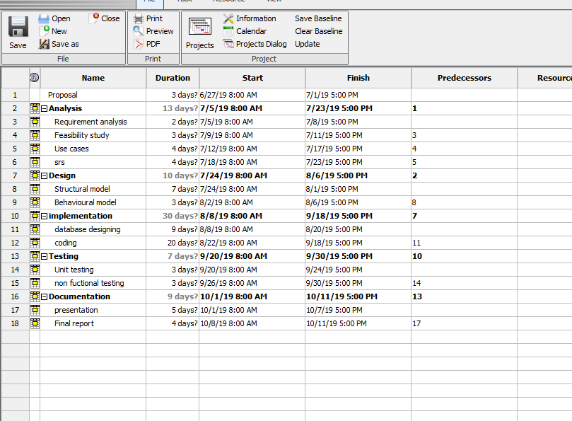

Fig; grand chart

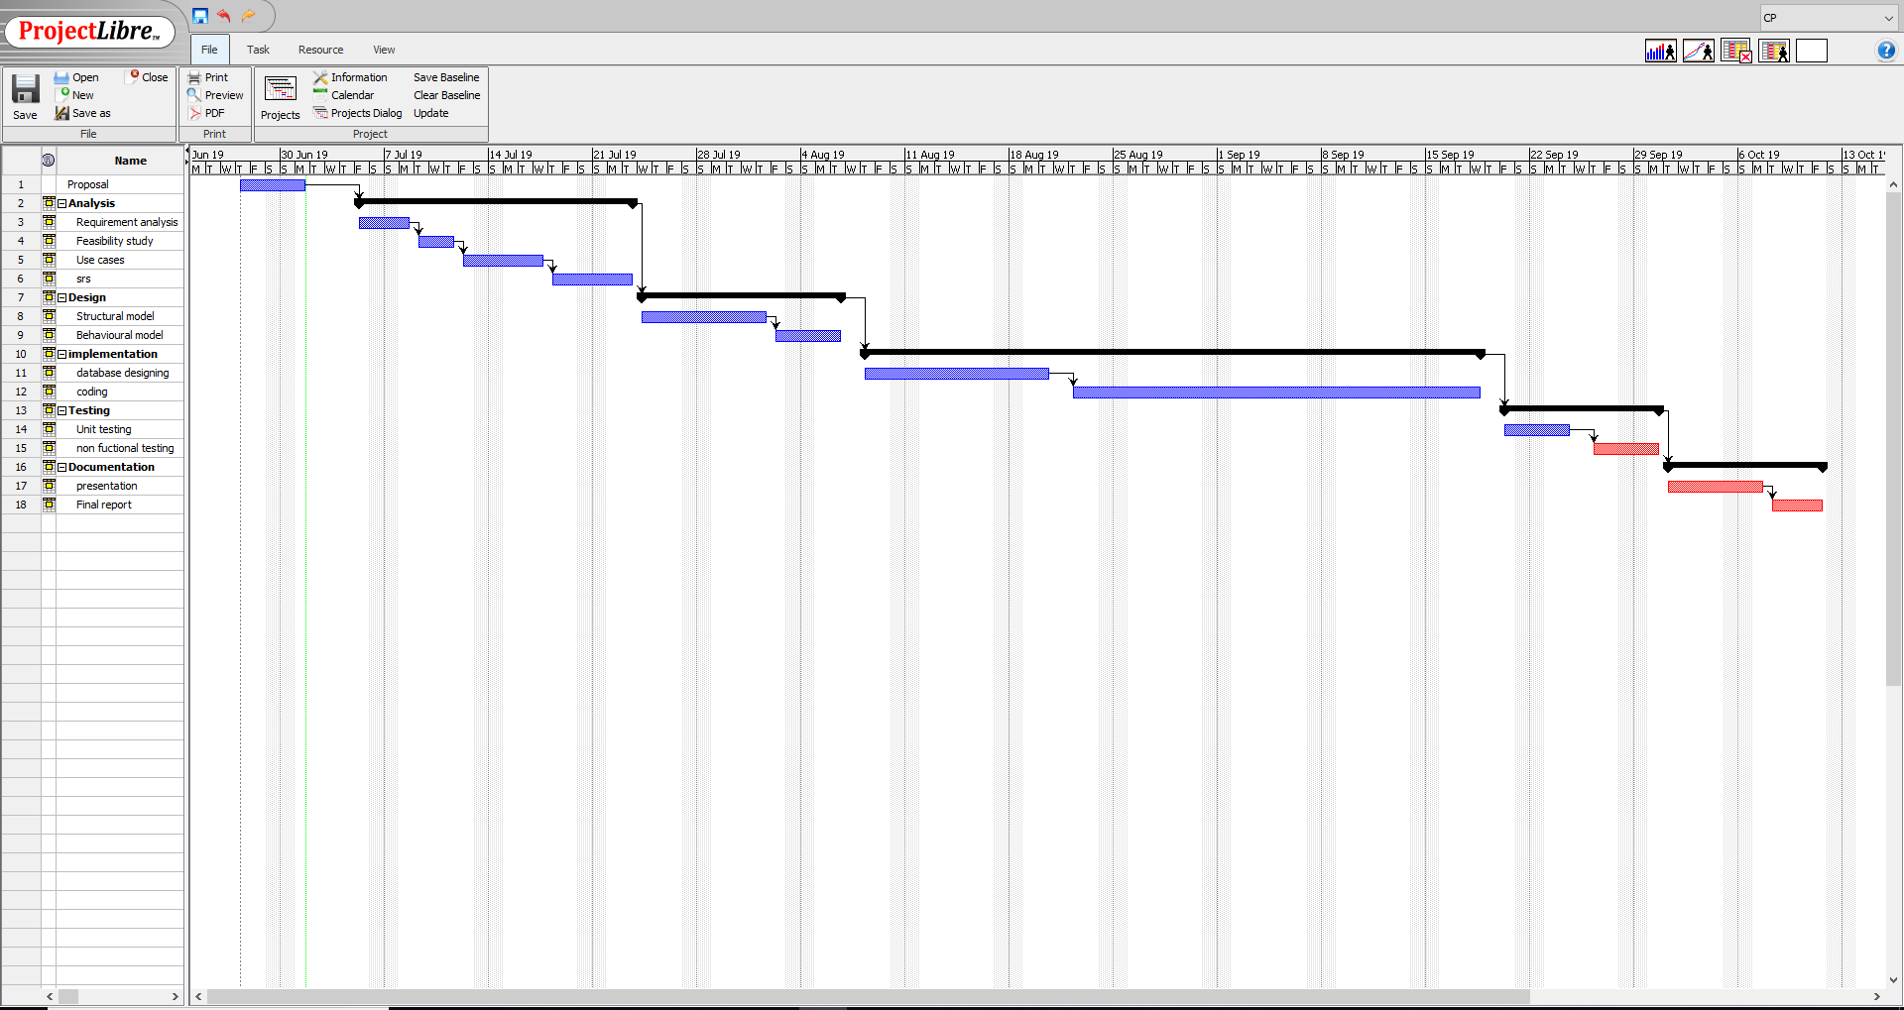

Fig: grand chart data

# 5.Risk management

Risk management is basically risk identification, assessment and prioritization followed by coordinated and cost-effective use of resources to minimize, monitor and control the likelihood or effect of unfortunate events or to maximize opportunities realization. Programmatic, electrical and process risks are types of hazards faced by each software engineering project during their growth. The process of defining these hazards, lowering the likelihood or probability of their occurrence, and decreasing the effect of these threats if a project is successful. These threats or hazards could stem from a broad range of sources, including economic uncertainty, legal liabilities, mistakes in strategic management, accidents, and natural disasters. The dangers and governance for this project will follow. After a risk is detected an effective plan is deployed within the system to cancel or minimize the risk factor.

Likelihood table:

|  |  |
| --- | --- |
| Likelihood | Value |
| Low | 1 |
| Medium | 2 |
| High | 3 |

Risk consequences table:

|  |  |
| --- | --- |
| Consequences | Values |
| Very low | 1 |
| Low | 2 |
| Medium | 3 |
| High | 4 |
| Extreme | 5 |

|  |  |  |  |  |
| --- | --- | --- | --- | --- |
| SN | Risk | Likelihood | Consequence | Actions |
| 1 | Time shortage | 2 | 5 | Proper project management should be done with proper time allocation |
| 2 | Equipment failure | 1 | 5 | All the data should be backed up in more than one device |
| 3 | Server failure | 1 | 4 | Data should be backed up on a daily basis |
| 4 | Viruses | 3 | 3 | Antivirus software should be used |
| 5 | Over budget | 1 | 3 | Budget should be properly allocated and spend on the task rather than personal gains |

Table: Risk analysis

# 6. Configuration management

Mechanism to cope with a project plan's various technical problems. Effective software configuration management can be improved in a software organization productivity through enhanced coordination between a team's programmers. Configuration management is the collective project of process activities, methods and tools where items are managed by practitioners throughout the life cycle of the project.

The activities of configuration management are given below;

**Change management**Systematic method that addresses change in the process or goals of the organization. These management's main aim is to implement policies to control change, effect change, and help individuals accommodate change.

**Release management**

Method that is responsible for planning and controlling construction as well as testing release and release deployment. Its goal is to safeguard the integrity of the living setting and release precise components.

**Version control**

It could be a framework that keeps records of a collection of records that have been changed over a period of time so that you just can keep in mind particular forms afterward. The most reason for actualizing usually to promptly recuperate from blunders made, survey past alterations, participation with designers, and reinforcement of code. We have proposed to utilize GitHub as version control for this project.

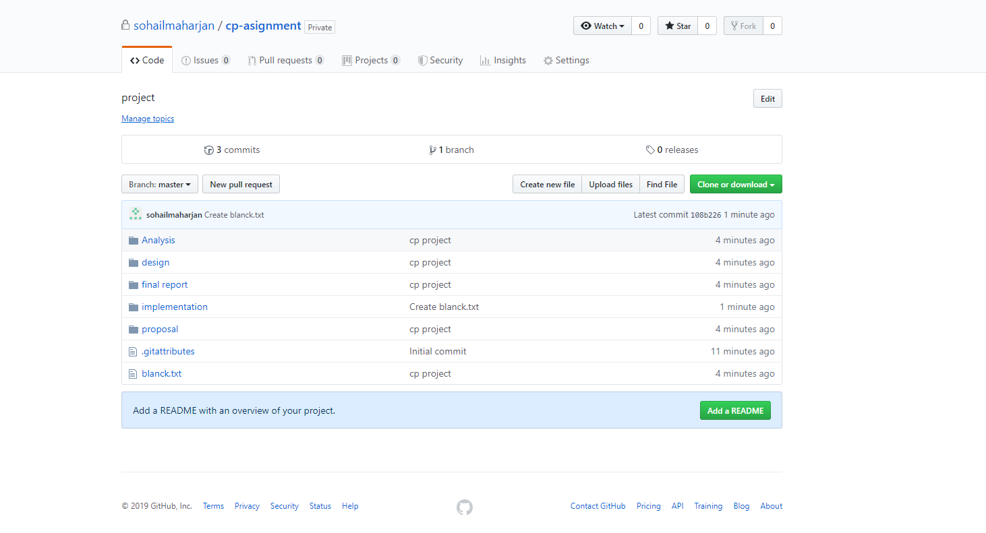

Fig: Git directory

Link: https://github.com/sohail-maharjan/cp_project.git

# Conclusion:

To complete this task, I have performed number of analysis, designing, implementation, risk management and various other researchers. Hence looking at this project I see great potentially in this system, I believe it will be of great use for hospitals and blood banks of Nepal. I designed this system with a noble cause of helping people and saving life, and I have full confidence that it will fulfill that cause.