A

PROJECT REPORT

ON

ELITEGYMBOOK

Submitted in partial fulfillment for the award of

Post Graduate Diploma in Advance Computing

(PG-DAC) from

INSTITUTE OF EMERGING TECHNOLOGIES

Authorized Training Centre


Under the Guidance of
Name of the Guide
BY
Nikhil Kadam 240345920047
Supriya Motipawale 240345920091

Nisha Mourya 240345920051
Ravindra Patil 240345920054
Sohail Shaikh 240345920086



CERTIFICATE

This is to certify that the project report entitled EliteGymBook is a bonfire work carried out by NIKHIL KADAM, SUPRIYA MOTIPAWALE, NISHA MOURYA, RAVINDRA PATIL, SOHAIL SHAIKH and submitted in partial fulfilment of the requirement for the C-DAC ACTS, DAC course in Institute of Emerging Technology in the batch of Aug 2024.

Course Coordinator External Examiner

ACKNOWLEDGEMENT

This project EliteGymBook was a great learning experience for us and we are submitting this work to Advanced Computing Training School (CDAC).

We are very glad to mention the Name of the Guid for her valuable guidance to work on this project. Her guidance and support helped us to overcome various obstacles and intricacies during the course of project work.

Our most heart full thanks goes to Mr. Sangram Patil (Director ,IET)who gave all the required support and kind coordination to provide all the necessities like required hardware , internet facility and extra lab hours to complete the project and throughout the course up to the last day here in C-DAC ACTS, Pune.

Sign of student

Nikhil Kadam 240345920047
Supriya Motipawale 240345920091
Nisha Mourya 240345920051
Ravindra Patil 240345920054
Sohail Shaikh 240345920086

Abstract

The Gym Management and Services system is a comprehensive, web-based platform designed to streamline the operations of fitness centers and gyms. This system integrates multiple functionalities to enhance operational efficiency, improve user experience, and facilitate effective management of gym activities.
The primary objective of the system is to provide a unified solution for managing memberships, scheduling classes, processing payments, and tracking equipment. By consolidating these functions into a single platform, the system aims to automate routine tasks, reduce administrative overhead, and offer a seamless experience for both gym staff and members.

Index

Sr. No. | Title | Page No.
1 | Introduction
2 | Problem Definition & Scope
2.1 | Problem Definition
2.2 | Goals & Objectives
2.3 | Major Constraints& Outcomes
3 | Software Requirement Specification
3.1 | Purposed System
3.2 | Scope
4 | System Modules
5 | Performance-Requirements
5.1 | H/W Requirements & S/W Requirements
6 | UML Diagram
6.1 | DFD
6.2 | ERD
6.3 | Use case diagram
6.4 | Class Diagram
6.5 | Sequence diagram
6.6 | Activity Diagram
6.7 | Deployment diagram
6.8 | System Architecture
7 | Test Cases
8 | Screenshots
9 | References

Introduction

This document communicates the business requirements and scope for developing Gym Service for a company. The scope of this document is to define the functional and non- functional requirements, business rules and other constraints requirements.
Now a day’s online service is the best competitive edge for any organization. Our fitness management website provides best platform for ease of access to the gym managers, trainers and also for customers. User can check his updates online anytime about his/her fitness, diet plan etc. There is a need for online healthcare maintenance online. This project provides user friendly customer and trainer interaction.

Problem Definition

Existing Gyms works without any website for providing services to their customers. Managers have to keep records on papers and registers. There is no any way for trainers and customers to manage their workout progress. Customers need to visit gym for checking facilities and packages provided by different gyms.
Fitness club-Gym Services is intended to provide complete solution for Gym owner, trainers & customers through a single gateway using internet. It allows owners to manage their gym, customers to view packages provided by gym ,search and choose trainers and get information about gym equipments and purchase the convenient package to get membership. It allows gym trainers to evaluate workout and diet report of gym members. Gym managers can manage their daily gym schedule and send notifications to customers about same. The administrator module will be able to manage branch activity, trainer activity and payments.

Scope

The scope of a project defines the boundaries, deliverables, and the extent of work involved. It outlines what is included in the project and what is not, helping to set expectations and guide the development process.

User Management
- Member Registration and Profiles: Allow users to register, create, and manage their profiles.
- Role-Based Access Control: Implement different roles (Admin, Trainer, Member) with specific permissions.

Membership Management
- Membership Plans: Offer various plans (e.g., monthly, quarterly, annual) with the option to upgrade or downgrade.
- Payment Tracking: Record payments, send reminders for renewals, and handle payment history.
- Attendance Tracking: Monitor member attendance and generate reports

Trainer Management
- Trainer Profiles: Create and manage trainer profiles, including qualifications and schedules.
- Scheduling: Allow trainers to set availability, and manage class bookings and one-on-one sessions.

Class and Session Management
- Class Scheduling: Schedule classes with defined capacities and timing (e.g., yoga, Zumba, strength training).
- Booking System: Enable members to book or cancel class slots.
- Class Management: Track attendance and generate reports on class popularity.

Equipment Management
- Inventory Tracking: Keep an updated record of gym equipment, its usage status, and maintenance schedules.
- Booking Equipment: Allow members to book specific equipment if applicable

Payment Processing
- Online Payments: Integrate with payment gateways for secure online transactions.
- Invoice Management: Generate and send invoices for memberships and other services.

Communication and Notifications
- Automated Notifications: Send SMS or email reminders for class bookings, payments, and upcoming events.
- Feedback Mechanism: Allow members to provide feedback on trainers, classes, and overall gym experience.

Reporting and Analytics
- Membership Reports: Generate reports on active, expired, and pending memberships.
- Revenue Reports: Provide detailed insights into revenue streams, including membership fees and additional services.
- Class/Trainer Performance: Analyze the performance and popularity of classes and trainers.
User Interface
- Responsive Web Interface: Ensure the platform is accessible on various devices, including desktops, tablets, and smartphones.
- Dashboard: Provide personalized dashboards for members, trainers, and administrators.

Security
- Data Protection: Implement security measures to protect user data, including encryption, secure login, and data privacy policies.
- Access Control: Restrict access to sensitive information based on user roles.

Goals

• Optimize Gym Management Efficiency
- Implement a centralized platform to automate and streamline daily gym operations, including membership tracking, class scheduling, and trainer management.
• Enhance Member Engagement and Satisfaction
- Develop features that improve member interaction with the gym, such as an intuitive booking system, personalized notifications, and a feedback mechanism.
• Improve Financial Oversight and Accuracy
- Integrate secure payment processing and financial reporting tools to manage transactions effectively, track revenue, and reduce errors.
• Maximize Resource Utilization
- Ensure optimal use of gym resources, including class capacities, trainer schedules, and equipment, to avoid conflicts and improve overall service delivery.
• Ensure Robust Data Security and Compliance
- Implement security measures to protect user data and financial information, ensuring compliance with data protection regulations.
• Support Scalability and Future Growth
- Design the system to accommodate future enhancements and growth, allowing for easy integration of new features and expansion to additional locations if needed.

Objectives

This product aimed toward a person who don’t want to visit the gym to see functionalities and packages provided by that gym to get membership, he/she can use the web application for ease.

In other words, our Gym Management portal has, following objectives:
- Simple database is maintained.
- Easy operations for the user and the admin of the system.
- User interfaces are user accommodating and attractive; it takes very less time for the operator to use the system.
- This system will provide complete solution for Gym owners to take their business online.

Major Constraints

• Budget Limistations:
- Constraint: The project must be developed within a fixed budget, which may limit the scope and features.
- Impact: Potential trade-offs in features or technology used to stay within budget.
• Time Constraints:
- Constraint: The project must be completed within a specific timeline.
- Impact: May require prioritization of core features and phased implementation of additional functionalities.
• Resource Availability:
- Constraint: Limited team size or expertise may affect the development process.
- Impact: Could lead to limitations in the complexity of features or extended development time.
• Technical Constraints:
- Constraint: Compatibility with existing systems or limitations of the chosen technology stack.
- Impact: May restrict the integration of certain features or necessitate additional development work.
• Regulatory Compliance:
- Constraint: Adherence to data protection regulations and industry standards.
- Impact: Requires careful implementation of security measures and data handling practices.
• Scalability Issues:
- Constraint: Designing the system to scale with future growth.
- Impact: Initial design decisions may need to balance current needs with future expansion potential.

Outcomes

• Increased Operational Efficiency:
- Outcome: Automation of membership management, scheduling, and payment processing will streamline gym operations and reduce administrative workload.
• Enhanced Member Experience:
- Outcome: A user-friendly interface and personalized features will improve member satisfaction and engagement, leading to higher retention rates.
• Accurate Financial Management:
- Outcome: Integrated payment processing and financial reporting will ensure accurate tracking of revenue, minimize errors, and support financial planning.
• Optimized Resource Utilization:
- Outcome: Efficient management of trainers, classes, and equipment will maximize resource use, reduce conflicts, and improve service delivery.
• Strong Data Security and Compliance:
- Outcome: Implementing robust security measures will protect user data and ensure compliance with data protection regulations, safeguarding the gym’s reputation.
• Future Growth Support:
- Outcome: A scalable system design will accommodate future enhancements and expansion, allowing the gym to grow and adapt to new needs over time.

Software Requirement Specification

External Interface Requirements:

User Interfaces:
- All the users will see the same page when they enter in this website. This page asks the users a username and a password.
- After being authenticated by correct username and password, user will be redirect to their corresponding profile where they can do various activities.
- The user interface will be simple and consistence, using terminology commonly understood by intended users of the system. The system will have simple interface, consistence with standard interface, to eliminate need for user training of infrequent users.
Hardware Interfaces:
- No extra hardware interfaces are needed.
- The system will use the standard hardware and data communication resources.
This includes, but not limited to, general network connection at the server/hosting site, network server and network management tools.

Application Interfaces:

Web Browser:
The system is a web-based application; clients need a modern web browser such as Mozilla Firebox, Internet Explorer, Opera, and Chrome. The computer must have an Internet connection in order to be able to access the system.
Communications Interfaces:
- This system uses communication resources which includes but not limited to, HTTP protocol for communication with the web browser and web server and TCP/IP network protocol with HTTP protocol.
- This application will communicate with the database that holds all the booking information. Users can contact with server side through HTTP protocol by means of a function that is called HTTP Service. This function allows the application to use the data retrieved by server to fulfil the request fired by the us.

HARDWARE REQUIREMENT
Hardware requirements for insurance on internet will be same for both parties which are as follows:
RAM | 4 GB
Hard disk | 320 GB
Processor | Dual Core

Software Requirements
Client side:
Web Browser | Google Chrome or any compatible browser
Operating System | Windows 8 or above

Server side:
Web Server | To-be-decided
Server-side Language | J2EE(Spring, Hibernate)
Database Server | MYSQL
Web Browser | Google Chrome or any  compatible browser
Operating System | Windows 8 or above

OPERATING ENVIRONMENT:

Server Side:

Processor: Intel® Xeon® processor 3500 series
HDD: Minimum 500GB Disk Space
RAM: Minimum 4GB
OS: Windows 10
Database: MySQL

Client Side (minimum requirement):
Processor: Intel Dual Core
HDD: Minimum 80GB Disk Space
RAM: Minimum 4GB
OS: Windows 7 or above

Design and Implementation Constraints:

- The application will use ReactJS, Axios and CSS as main web technologies.
- HTTP protocol is used as communication protocol. FTP is used to upload the web application in live domain and the client can access it via HTTP protocol.
- SMTP protocol is used for Email communication
- Several types of validations make this web application a secured one and SQL Injections can also be prevented.
- Since Fitness Club is a web-based application, internet connection must be established.

User Characteristics:
User should be familiar with the terms like login, register etc.
Principle Actors:
Super admin, Gym Owners, Trainer, Members
General Constraints:
A full internet connection is required.
Functional Requirements:
This section provides requirement overview of the system. Various functional modules that can be implemented by the system will be –

1.Registration

If customer wants to take the membership, then he/she must be registered, unregistered user can’t have access to packages. They can view the gym.
The Super admin must be able to Register new gym branch details as well as the Branch manager details.
The local gym branch owners can register new trainers for the gym.

2.Login

Each system user including Admin, Branch owners, Trainers and Customers/ Members must be able to login to application by entering valid user id and password.

3.Pakages

Branch owners can provide different packages for customers.
Customer can view and packages, trainers and choose one as per their requirements.

4.Membership

After choosing one of packages & making successful payment customer can avail the services provided by gym.

5.Gym Shifts
Branch owners can schedule different shifts for group of customers and trainers.

6.Workout plan
Trainers can add workout plans and diet suggestions to their respective members.

7.LogOut

Application user redirected to home page after surfing the application or whenever they wanted.

Non-Functional Requirements:
Security:
System will assign different roles to users for authentication. Users will be allowed
to access application only after authentication by entering login id and password.
Reliability & Maintainability:
FCS will backup the users data after every activity using database.
Availability:
24X7 availability.
Modularity:
FCS will be designed and developed using independent or dependent business scenarios in the form of modules. It will contain modules such as Authentication, Package information, Branch Information, Trainers and customers data, Payment processing and Membership
Reusability:
The different modules of system will be reusable and can be modified independently.
Scalability:
System will be able to provide consistent user experience to users.

Scope

The scope section of the SRS document defines the boundaries and specific functionalities of the system. It clearly outlines what the system will include and what will be excluded to manage expectations and focus the development efforts.

Scope of Gym Management and Services System
1. Introduction
1.1 Purpose
- This section describes the purpose of the Gym Management and Services system, which is to streamline and automate various aspects of gym operations, including membership management, class scheduling, payment processing, and communication.
1.2 Scope
- The scope outlines the specific features and functionalities of the system, as well as the limitations and boundaries of the project.
2. In-Scope
2.1 Membership Management
- Features:
  - Creation, modification, and deletion of membership plans by gym administrators.
  - Member registration, profile management, and subscription handling.
  - Tracking of membership status, renewals, and cancellations.
  - Reporting on membership statistics and usage.
2.2 Class and Trainer Scheduling
- Features:
  - Trainers can create, update, and manage class schedules.
  - Members can view, book, and cancel classes.
  - Conflict detection to prevent double bookings.
  - Integration with calendar systems for real-time updates.
2.3 Payment Processing
- Features:
  - Secure integration with payment gateways for online transactions.
  - Automated invoicing, receipt generation, and payment tracking.
  - Management of financial records and transaction history.

2.4 Equipment Management
- Features:
  - Inventory tracking of gym equipment, including maintenance schedules.
  - Booking system for equipment use, if applicable.
  - Reporting on equipment availability and usage.
2.5 Communication and Notifications
- Features:
  - Automated notifications and reminders for class schedules, membership renewals, and payment deadlines.
  - Email and SMS communication for operational updates and alerts.
  - Feedback system for collecting member reviews and suggestions.
2.6 Reporting and Analytics
- Features:
  - Generation of reports on membership trends, class attendance, and financial performance.
  - Data analytics for operational insights and decision-making.
2.7 System Administration
- Features:
  - Role-based access control for administrators, trainers, and members.
  - System configuration and management tools for administrative tasks.
3. Out-of-Scope
3.1 Mobile Application Development
- Development of native mobile applications for iOS and Android platforms is not included.
3.2 Integration with Third-Party Fitness Apps
- Integration with external fitness or health tracking applications is not part of this project.

3.3 Custom Hardware Integration
- The project does not include integration with gym hardware or IoT devices for automated equipment management.
3.4 Advanced AI Features
- Implementation of advanced AI functionalities, such as personalized recommendations or predictive analytics, is excluded.
3.5 Multi-Language Support
- The system will not support multiple languages beyond the initial language (English) in the first release.
3.6 Physical Infrastructure Changes
- The project does not cover changes or upgrades to physical gym infrastructure or equipment.
3.7 Non-Web-Based Interfaces
- The system will not include non-web-based interfaces, such as desktop applications or kiosks.
4. Assumptions
4.1 Technology Stack
- The system will use the specified technologies, including web frameworks, databases, and payment processors.
4.2 User Access
- Users will have access to modern web browsers and reliable internet connections.
4.3 Compliance
- The system will adhere to relevant data protection regulations as per current standards.

4.4 External Dependencies
- Integration with external services (e.g., payment gateways) depends on the availability and functionality of those services.
5. Constraints
5.1 Budget Constraints
- Development will be constrained by the allocated budget, potentially limiting feature sets or technologies.

5.2 Time Constraints
- The project must be completed within a specified timeline, possibly impacting feature prioritization.
5.3 Technical Constraints
- The system will be designed within the limitations of selected technologies and integration capabilities.

System Modules

The Gym Management and Services system will be organized into several key modules, each responsible for specific functionalities. These modules work together to provide a comprehensive solution for managing gym operations.

1. Membership Management Module
1.1 Features:
- Membership Plan Management: Create, update, and delete membership plans.
- Member Registration and Profile Management: Allow members to register, manage their profiles, and view their membership details.
- Subscription Handling: Manage membership subscriptions, renewals, and cancellations.
- Membership Status Tracking: Track membership status, including active, expired, or canceled.
- Reporting: Generate reports on membership statistics and usage.
1.2 Interfaces:
- Admin Interface: For managing membership plans and viewing membership reports.
- Member Interface: For registering, managing profiles, and viewing subscription details.

2. Class and Trainer Scheduling Module
2.1 Features:
- Class Scheduling: Trainers can create, update, and manage class schedules.
- Class Booking: Members can view, book, and cancel class slots.
- Trainer Availability: Manage and display trainer availability.
- Conflict Detection: Prevent double bookings and scheduling conflicts.
- Calendar Integration: Sync with external calendar systems for real-time updates.
2.2 Interfaces:
- Trainer Interface: For scheduling classes and managing availability.
- Member Interface: For booking and managing class reservations.

3. Payment Processing Module
3.1 Features:
- Payment Gateway Integration: Securely process online payments through external payment gateways.
- Invoice and Receipt Management: Generate and send invoices and receipts for transactions.
- Payment Tracking: Track payment history and status.
- Financial Reporting: Provide reports on financial transactions and revenue.

3.2 Interfaces:
- Admin Interface: For managing payment settings and viewing financial reports.
- Member Interface: For making payments and viewing payment history.

4. Equipment Management Module
4.1 Features:
- Equipment Inventory Tracking: Manage and track gym equipment and inventory.
- Maintenance Scheduling: Schedule and track equipment maintenance.
- Equipment Booking: Allow members to book equipment if applicable.
- Equipment Reporting: Generate reports on equipment usage and availability.
4.2 Interfaces:
- Admin Interface: For managing equipment inventory and maintenance schedules.
- Member Interface: For booking and viewing equipment availability.

5. Communication and Notifications Module
5.1 Features:
- Automated Notifications: Send reminders for class bookings, membership renewals, and payment due dates.
- Email and SMS Communication: Provide notifications and updates via email and SMS.
- Feedback System: Collect and manage member feedback and reviews.
5.2 Interfaces:
- Admin Interface: For managing communication settings and viewing feedback.
- Member Interface: For receiving notifications and providing feedback.

6. Reporting and Analytics Module
6.1 Features:
- Membership Reports: Generate reports on membership trends and statistics.
- Class Attendance Reports: Track and report on class attendance.
- Financial Reports: Provide insights into financial performance and revenue.
- Data Analytics: Analyze data for operational insights and decision-making.

6.2 Interfaces:
- Admin Interface: For generating and viewing various reports and analytics.

7. System Administration Module
7.1 Features:
- User Role Management: Define and manage roles and permissions for Admins, Trainers, and Members.
- System Configuration: Configure system settings, such as payment gateways and notification preferences.
- Audit and Monitoring: Monitor system performance and user activities.

7.2 Interfaces:
- Admin Interface: For managing system settings, roles, and monitoring system activities.

Integration Points
- Payment Gateway Integration: For processing online transactions.
- Calendar Systems: For syncing class schedules and trainer availability.
- Email/SMS Services: For sending notifications and communication.

Dependencies
- External Services: Payment gateways, email/SMS service providers.
- Technologies: Web frameworks, databases, and server infrastructure.

Performance-Requriments

Performance requirements define the expected performance standards for the system, including responsiveness, scalability, and reliability. These requirements ensure that the system meets user expectations and performs efficiently under various conditions.

1. Response Time
1.1 User Actions
- Login/Logout: The system should authenticate and log in users within 2 seconds.
- Page Load: Web pages should load within 3 seconds for a standard user interface on average network conditions.
- Search Queries: Search results (e.g., class schedules, member profiles) should be displayed within 2 seconds.
- Form Submissions: Forms (e.g., membership registration, class booking) should be processed and confirmed within 3 seconds.
1.2 Real-Time Updates
- Class Availability: Class schedules and availability updates should be reflected in real-time, with a delay of no more than 2 seconds.
- Notifications: Automated notifications (e.g., booking confirmations, reminders) should be sent within 5 seconds of the triggering event.

2. Throughput
2.1 Concurrent Users
- System Load: The system should support up to 500 concurrent users without a significant decrease in performance.
- Class Bookings: The system should handle up to 1000 simultaneous class bookings during peak hours.
2.2 Data Processing
- Transactions: The system should process financial transactions and update records in real-time with minimal latency.

3. Scalability
3.1 Horizontal Scaling
- Server Load: The system architecture should support horizontal scaling, allowing additional servers to be added as the number of users or data volume increases.
- Database Scaling: The database should support scaling solutions, such as sharding or replication, to handle increased data loads.

3.2 Future Growth
- User Base: The system should be designed to accommodate a growing user base, with provisions for scaling up to 1000 concurrent users in the future.
- Data Volume: The system should handle growing data volumes, such as increased membership records and class schedules, without performance degradation.

4. Reliability and Availability
4.1 Uptime
- System Availability: The system should achieve 99.9% uptime, with minimal downtime for maintenance and unexpected issues.
- Backup: Regular backups should be performed daily, with backup storage maintained for a minimum of 30 days.

4.2 Fault Tolerance
- Redundancy: The system should include redundant components (e.g., servers, databases) to ensure continued operation in case of hardware or software failures.
- Disaster Recovery: A disaster recovery plan should be in place to restore system functionality within 4 hours in the event of a major failure.

5. Load Handling
5.1 Peak Usage
- Load Testing: The system should be tested under peak load conditions (e.g., during membership renewal periods or special events) to ensure it can handle expected traffic without performance issues.

5.2 Performance Monitoring
- Real-Time Monitoring: Implement performance monitoring tools to track system performance in real-time and identify potential bottlenecks or issues.
- Alerts: Configure alerts to notify administrators of performance degradation or system failures.

6. Security Performance
6.1 Encryption Overhead
- Performance Impact: The encryption of sensitive data (e.g., payment information, personal details) should not significantly impact system performance.

6.2 Secure Access
- Access Control: Access control mechanisms should provide secure authentication and authorization without introducing significant delays.

Data Flow Diagrams

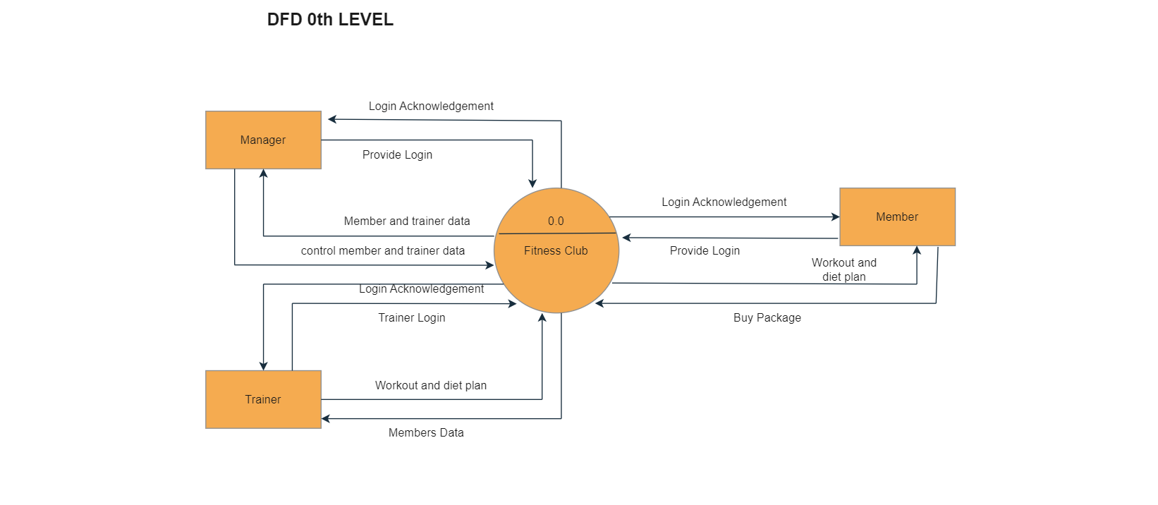
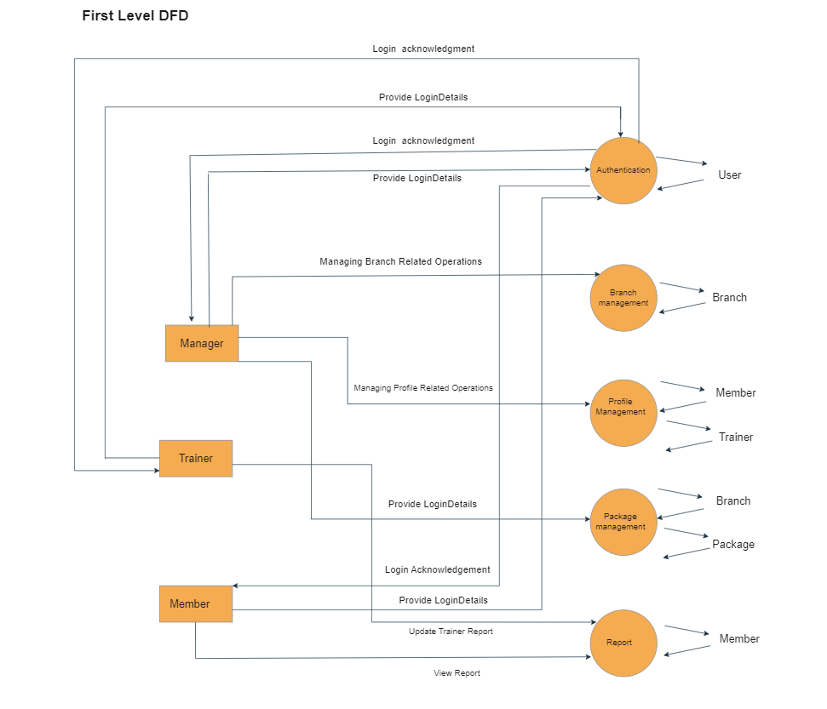

ER Diagrams

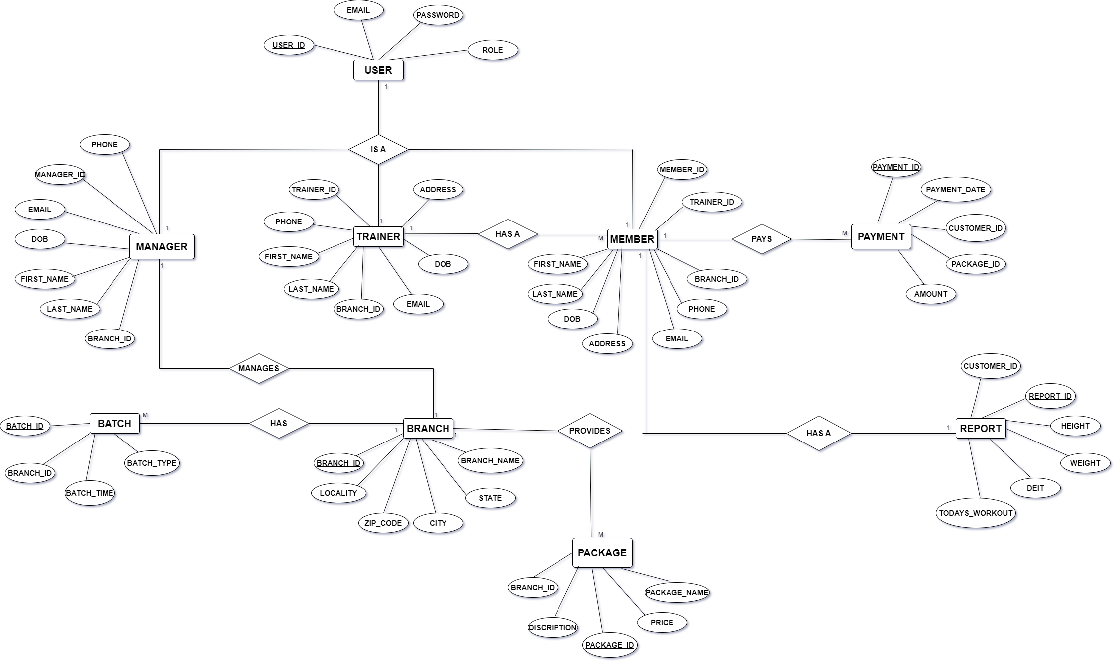

Use Case Diagrams

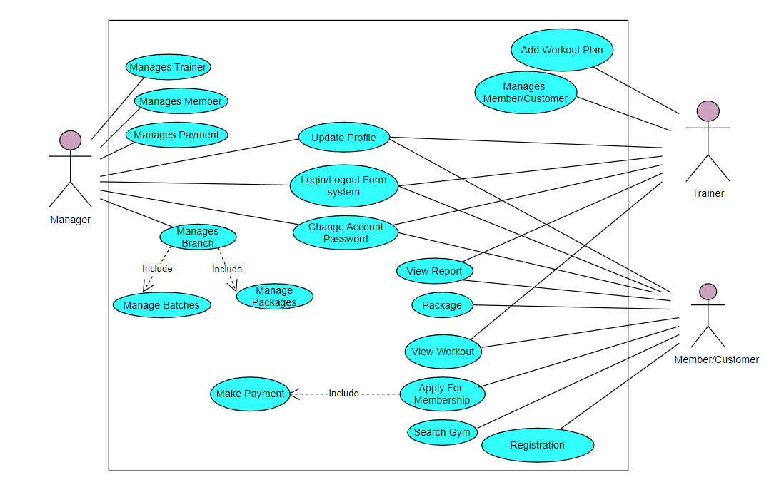

Class Diagrams

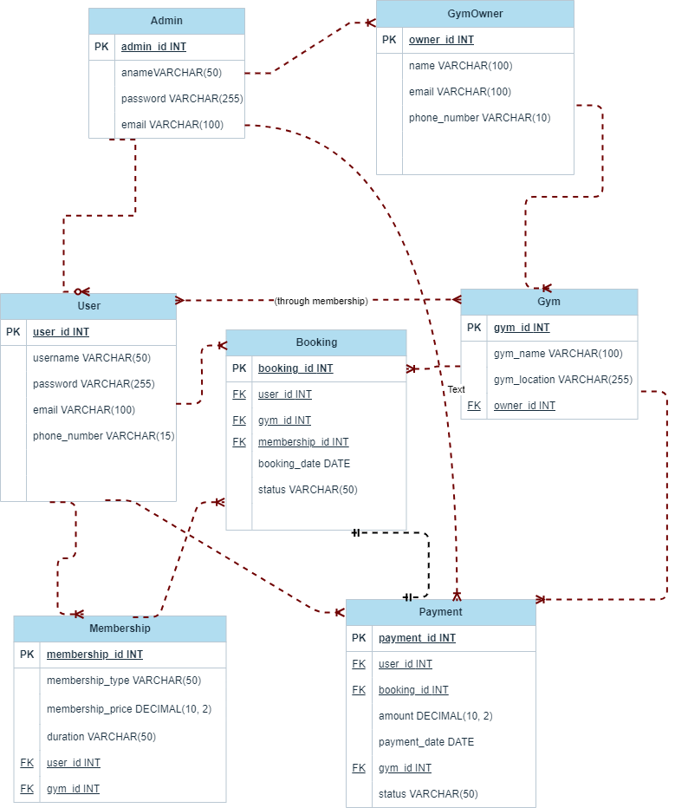

REFERENCES

References:

React – A JavaScript library for building user interfaces (reactjs.org)

Bootstrap · The most popular HTML, CSS, and JS library in the world. (getbootstrap.com)

React Tutorial (w3schools.com)

Learn Spring Boot | Baeldung

Java 11 api docs

Spring Data JPA - Reference Documentation

cult.fit - Bring gym home

Gym Management-UML

