Smart City Traffic Management and Route Optimization System
Capstone Project Report
Vansh | Roll No. 2401201123
BCA (AI & DS)

1. Problem Statement
Urban roads suffer from congestion, incidents and poorly planned infrastructure. Commuters need fast and reliable routes, and city administrators need to know which roads and intersections matter most. This project models a city's transportation network as a graph and applies graph traversal, shortest-path and minimum spanning tree algorithms to support routing, traffic evaluation and infrastructure planning.

Objectives
- Represent intersections as nodes and roads as weighted edges (distance or congestion-adjusted travel time).
- Implement BFS, DFS, Dijkstra, A*, Kruskal and Prim from scratch and verify them against each other.
- Provide commuter features: fastest route, shortest route, alternative route, incident re-routing.
- Provide administrator features: congestion hotspots, critical intersections and roads, backbone planning.
- Provide an interactive dashboard and a measured performance analysis.

2. System Design

2.1 Graph model
The network is an undirected weighted graph G = (V, E) stored as an adjacency list. Each road stores length (km), speed limit (km/h) and a congestion level in [0, 1]. Travel time in minutes is free-flow time multiplied by (1 + 2c^2), where c is congestion, so a fully jammed road takes three times as long as an empty one. Users can switch the optimisation metric between distance and time.

2.2 Architecture
Layer | Module | Responsibility
Data | data/*.csv, generate_sample.py | Reproducible synthetic city (seed 42)
Model | smartcity/graph.py | Graph, edges, congestion updates, road closure, CSV loading
Algorithms | smartcity/algorithms.py | Traversal, shortest path, MST, network analysis
Visualisation | smartcity/viz.py | Congestion maps, routes, MST, heat map, benchmark charts
Interface | app.py (Streamlit) | Four-tab interactive dashboard
Evaluation | tests/, benchmark.py, make_figures.py | Correctness tests and performance study

2.3 Algorithm selection
Algorithm | Complexity | Purpose
BFS / DFS | O(V+E) | Reachability, hop distance, connected components
Dijkstra (binary heap) | O((V+E) log V) | Fastest or shortest route; single-source costs
A* | O((V+E) log V) worst case | Faster point-to-point routing with a straight-line heuristic
Kruskal (union-find) | O(E log E) | Minimum spanning tree: cheapest connected backbone
Prim (heap) | O(E log V) | MST, used to cross-check Kruskal
Tarjan low-link | O(V+E) | Critical intersections (articulation points) and bridge roads

The A* heuristic is the straight-line distance, divided by the network's maximum speed limit when optimising time. It never overestimates the true cost, so A* returns the same optimal answer as Dijkstra.

3. Implementation
- Language and libraries: Python 3, matplotlib (maps and charts), Streamlit (dashboard), pytest (tests), python-docx (this report).
- Alternative routing: the busiest (most congested) road on the primary route is removed from a copy of the graph and Dijkstra is re-run.
- Incident handling: a road can be closed or its congestion changed at runtime; all routes are recomputed on the updated graph.
- Hotspot analysis: shortest paths are computed for many random origin-destination pairs and the number of trips through each intersection is counted.
- Critical infrastructure: Tarjan's low-link method finds intersections and roads whose failure would disconnect the network.

Sample dataset
Network: 120 intersections, 216 roads, 1 component(s). The city is a 12 x 10 grid with faster, busier arterial roads, a few missing links and diagonal shortcuts, so it contains realistic bottlenecks. Data is stored in nodes.csv and edges.csv and can be replaced with any real network in the same format.

Dashboard features
- Commuter routing: origin, destination, metric (time or distance), algorithm (Dijkstra or A*), route and alternative, nodes expanded, compute time.
- Network and incidents: edit congestion, close roads, simulate rush hour, live map with critical intersections.
- Infrastructure planning: MST backbone (Kruskal or Prim) and trip-load hotspot map.
- Performance: benchmark charts and complexity table.
The dashboard (app.py) draws its maps with the same plotting module (smartcity/viz.py) that produced the figures in Section 4, so the route, MST, congestion and hotspot views in this report are exactly what the Commuter routing, Network, Infrastructure planning and Performance tabs display.

3.1 Implementation evidence
Project structure: source package, data, tests, results and entry-point scripts.
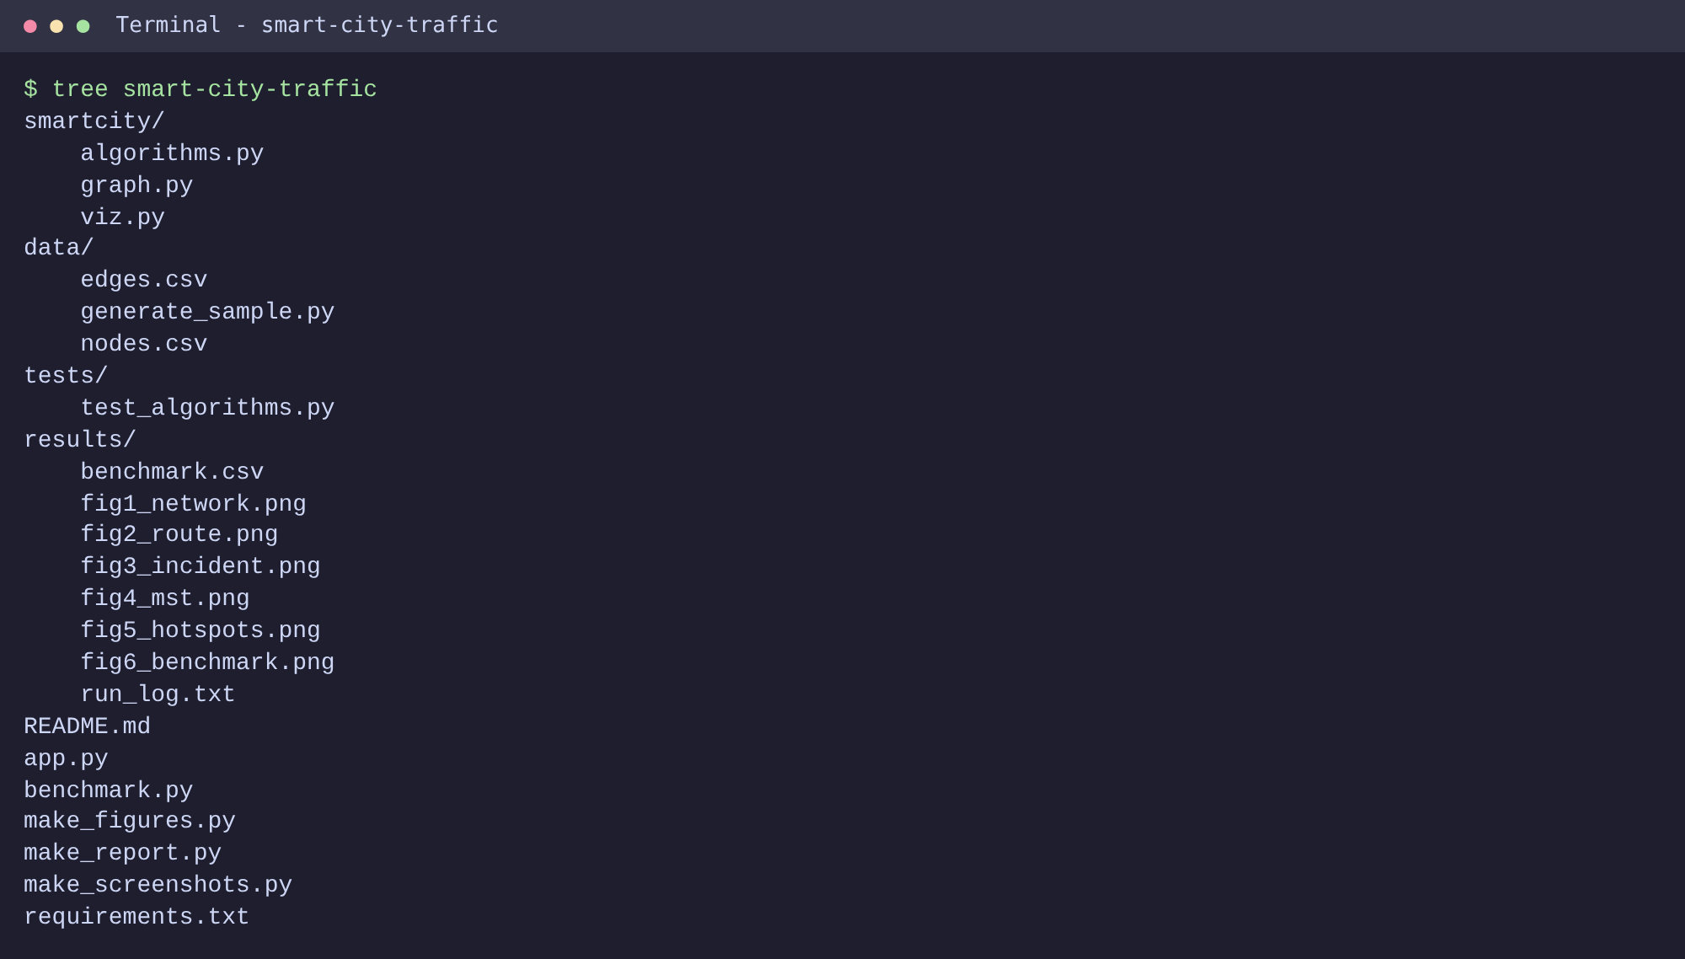
Screenshot 1. Project folder structure.
Sample dataset: the first rows of the node and edge files and their sizes (120 intersections, 216 roads).
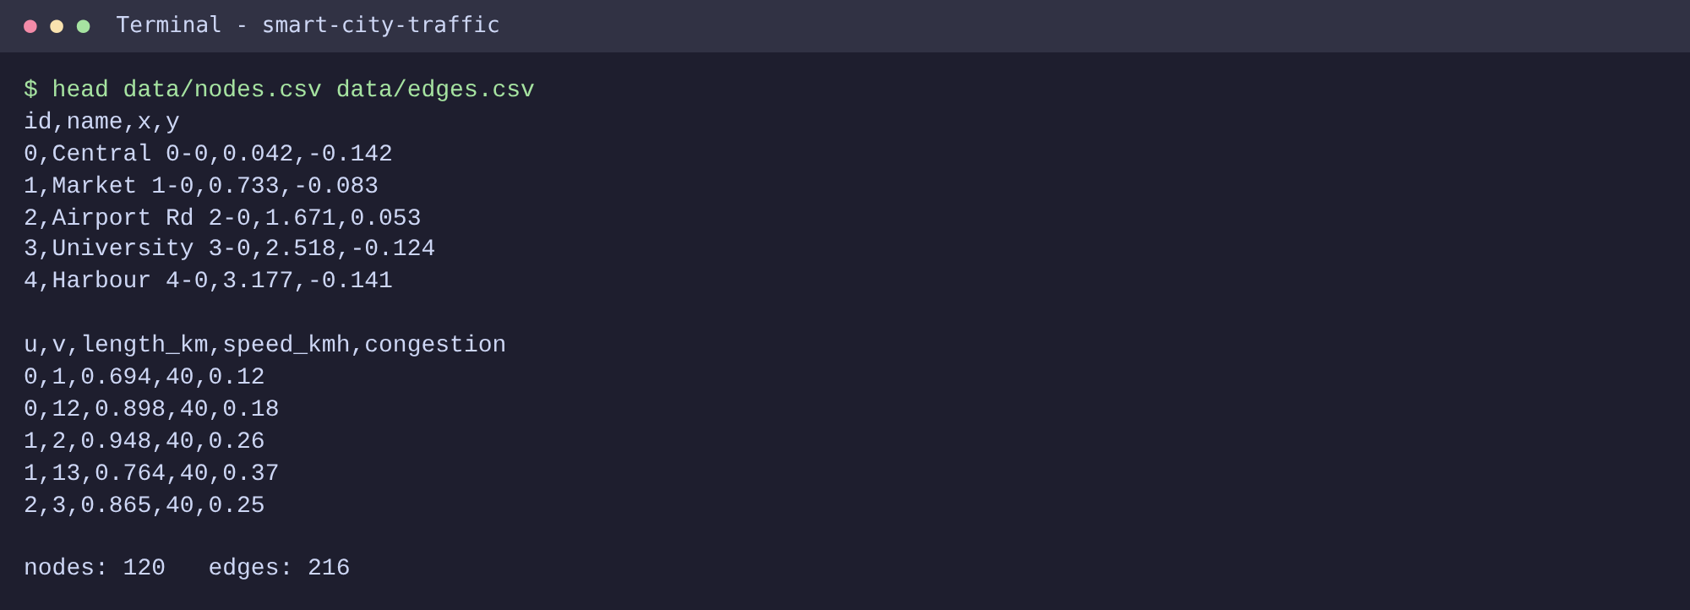
Screenshot 2. Sample data files (nodes.csv and edges.csv).

4. Results

4.1 Network and congestion
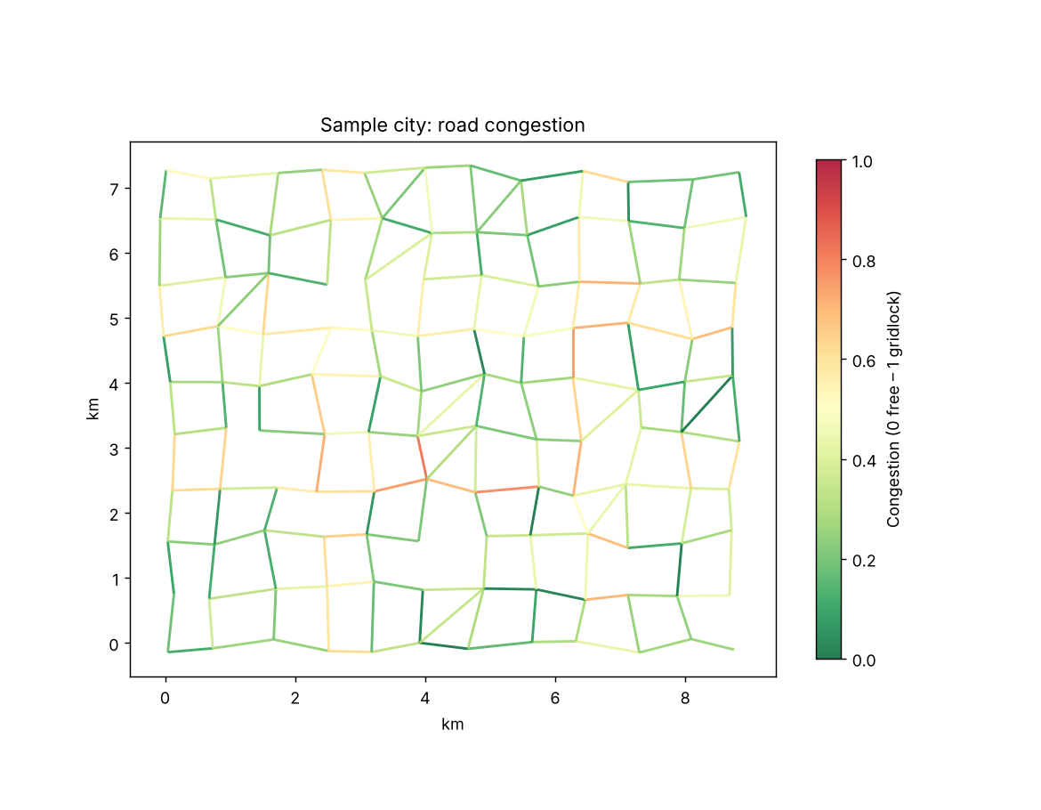
Figure 1. Sample city coloured by congestion level.

4.2 Route optimisation
Route 0->119: fastest 23.2 min over 17 segments; shortest 14.37 km over 17 segments. Alternative avoiding the busiest road: 23.4 min (+0.3 min).
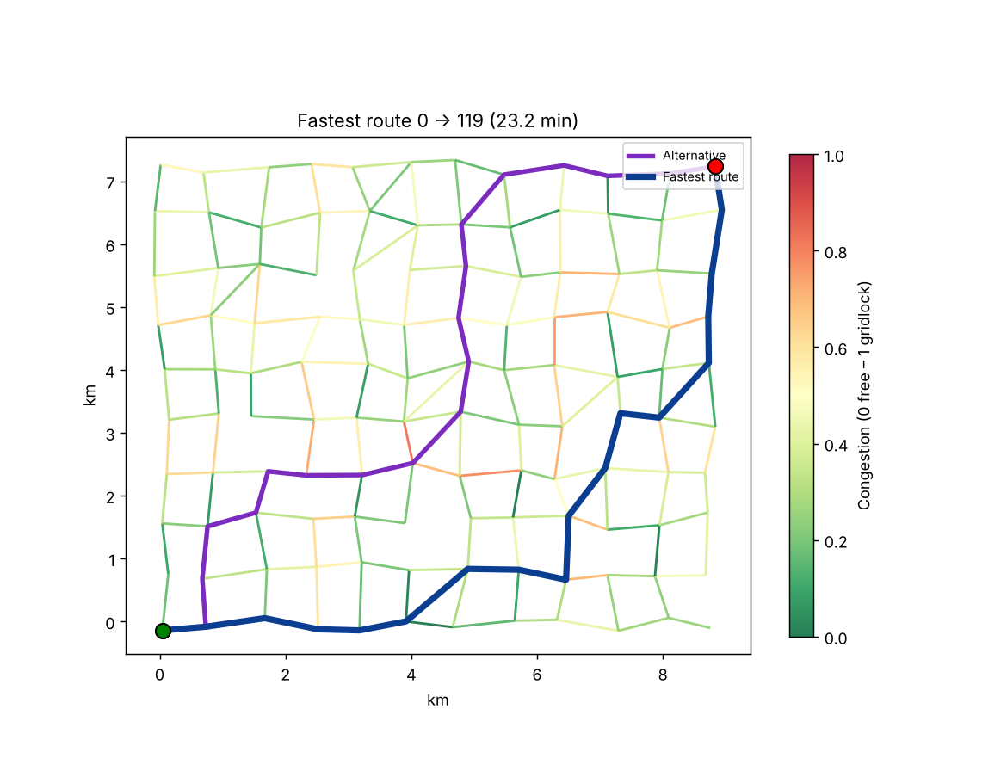
Figure 2. Fastest route (blue) and alternative avoiding the busiest road (purple).

4.3 Incident re-routing
Incident: road 32-45 closed -> new fastest route 23.4 min (+0.2 min).
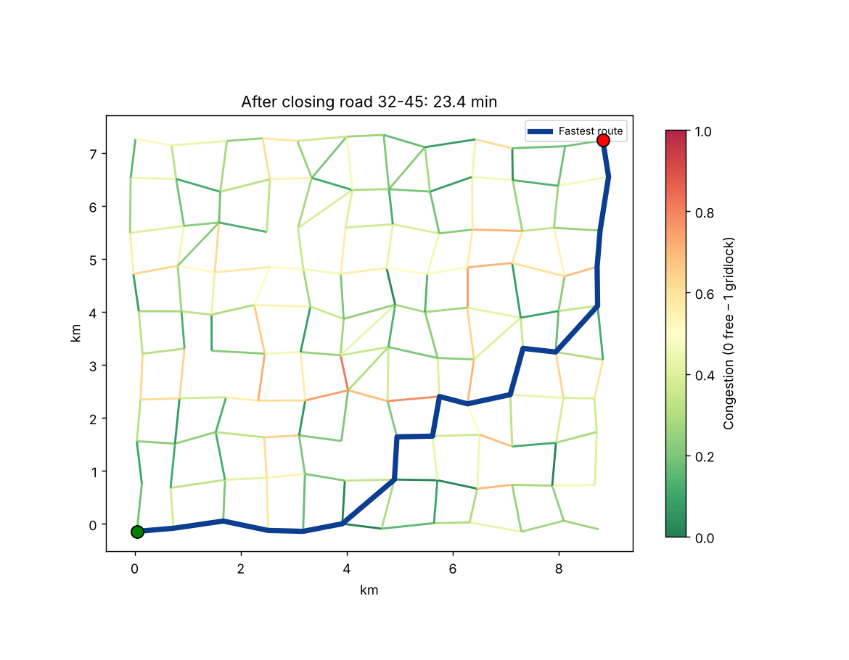
Figure 3. Route recomputed after a road on the original route is closed.

4.4 Infrastructure planning with minimum spanning trees
MST (distance): Kruskal 86.71 km, Prim 86.71 km, 119 roads kept of 216 (48% of total road length). Kruskal and Prim produce the same total weight, as expected.
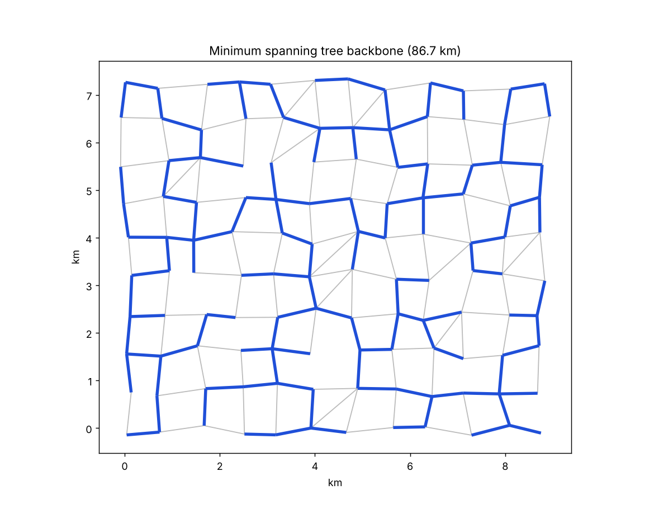
Figure 4. Minimum spanning tree (blue) showing the cheapest connected road backbone.

4.5 Critical infrastructure and hotspots
Critical intersections (articulation points): 1; bridge roads: 1.
Roads with congestion >= 0.7: 9.
Top 5 busiest intersections: Station 6-5 (69 trips), Stadium 7-4 (66 trips), Lakeside 7-5 (65 trips), Harbour 7-3 (62 trips), Central 6-6 (57 trips).
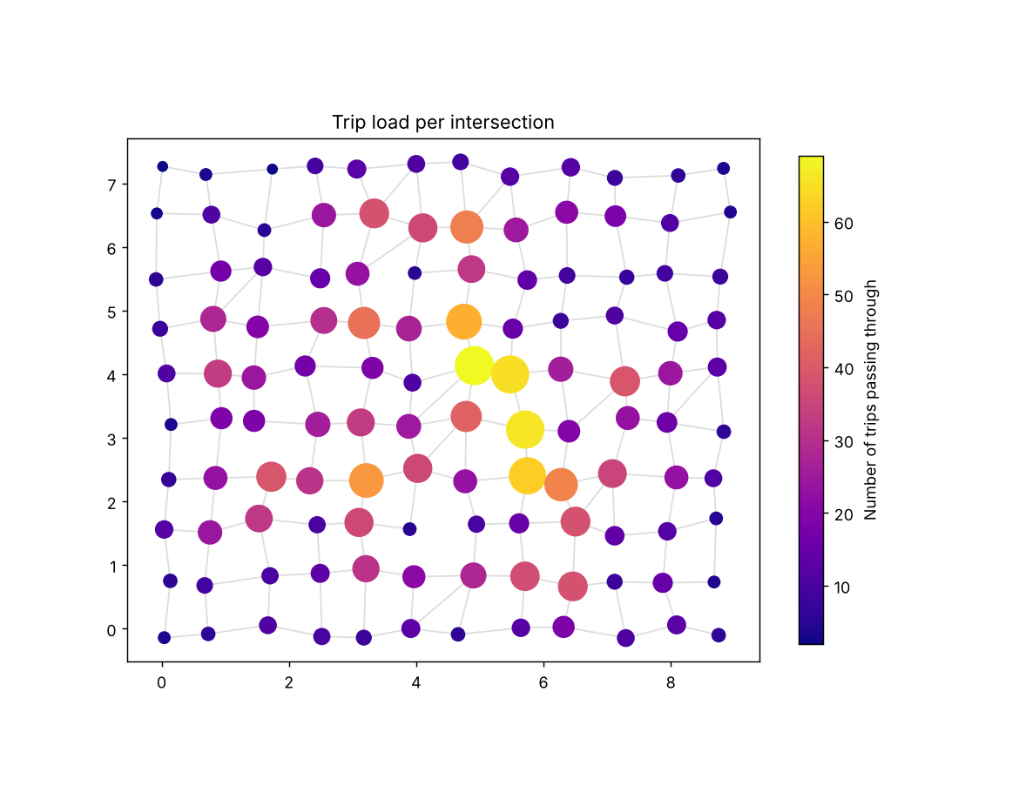
Figure 5. Number of simulated trips passing through each intersection.
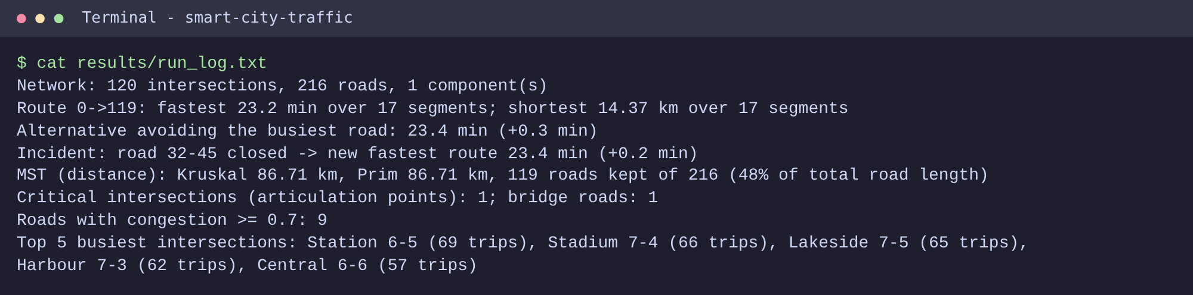
Screenshot 3. Analysis output (results/run_log.txt) from running the full pipeline.

5. Performance Analysis
Algorithms were timed on grid cities from 100 to 6,400 intersections. Query times are medians of 5 repeats, averaged over 20 random origin-destination pairs.
Nodes | Edges | BFS ms | DFS ms | Dijkstra ms | A* ms | Dijkstra expanded | A* expanded | Kruskal ms | Prim ms
100 | 180 | 0.071 | 0.082 | 0.08 | 0.088 | 55.0 | 25.3 | 0.107 | 0.081
400 | 760 | 0.413 | 0.554 | 0.303 | 0.204 | 188.3 | 85.2 | 0.288 | 0.265
1600 | 3120 | 1.266 | 1.255 | 1.574 | 1.271 | 948.8 | 508.8 | 1.342 | 1.187
3600 | 7080 | 2.904 | 2.92 | 3.501 | 2.906 | 1747.7 | 938.0 | 3.134 | 3.555
6400 | 12640 | 6.304 | 5.195 | 5.893 | 3.689 | 2759.6 | 1051.8 | 5.854 | 8.044

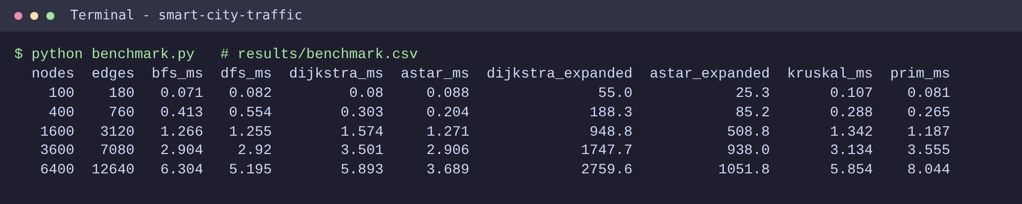
Screenshot 4. Benchmark output (results/benchmark.csv).
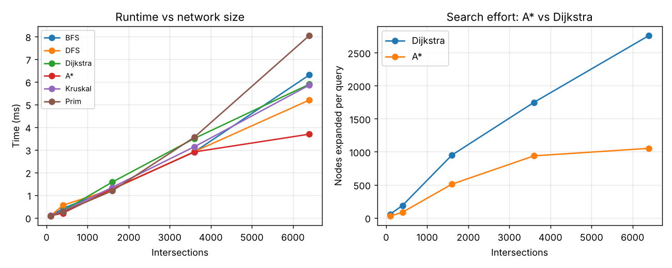
Figure 6. Runtime growth and search effort of A* versus Dijkstra.
All algorithms grow roughly linearly (with a log factor for the heap-based ones) in network size. On the largest network A* expanded 1051.8 nodes per query against 2759.6 for Dijkstra, about 2.6 times fewer, because the heuristic steers the search toward the destination. Kruskal and Prim perform similarly; Prim's heap-based version is slightly slower here because the grid is sparse.

6. Testing
Testing uses pytest (40 tests, all passing).
Test | What it checks
BFS/DFS coverage, hop counts, components | Traversals visit exactly the reachable nodes; isolated node forms its own component
Dijkstra on hand-checked graph | Path [0,1,2,5] with cost 3 km
Unreachable destination | Dijkstra and A* return None
Congestion and closure | Higher congestion raises travel time; closed road never appears in a route
MST on small graph | Kruskal and Prim both give weight 5 with 5 edges
Bridges and articulation points | Detected after deleting edges to create a weak link
A* vs Dijkstra (20 random graphs x 10 queries) | Identical optimal cost for both metrics
Kruskal vs Prim (10 random graphs) | Identical MST weight

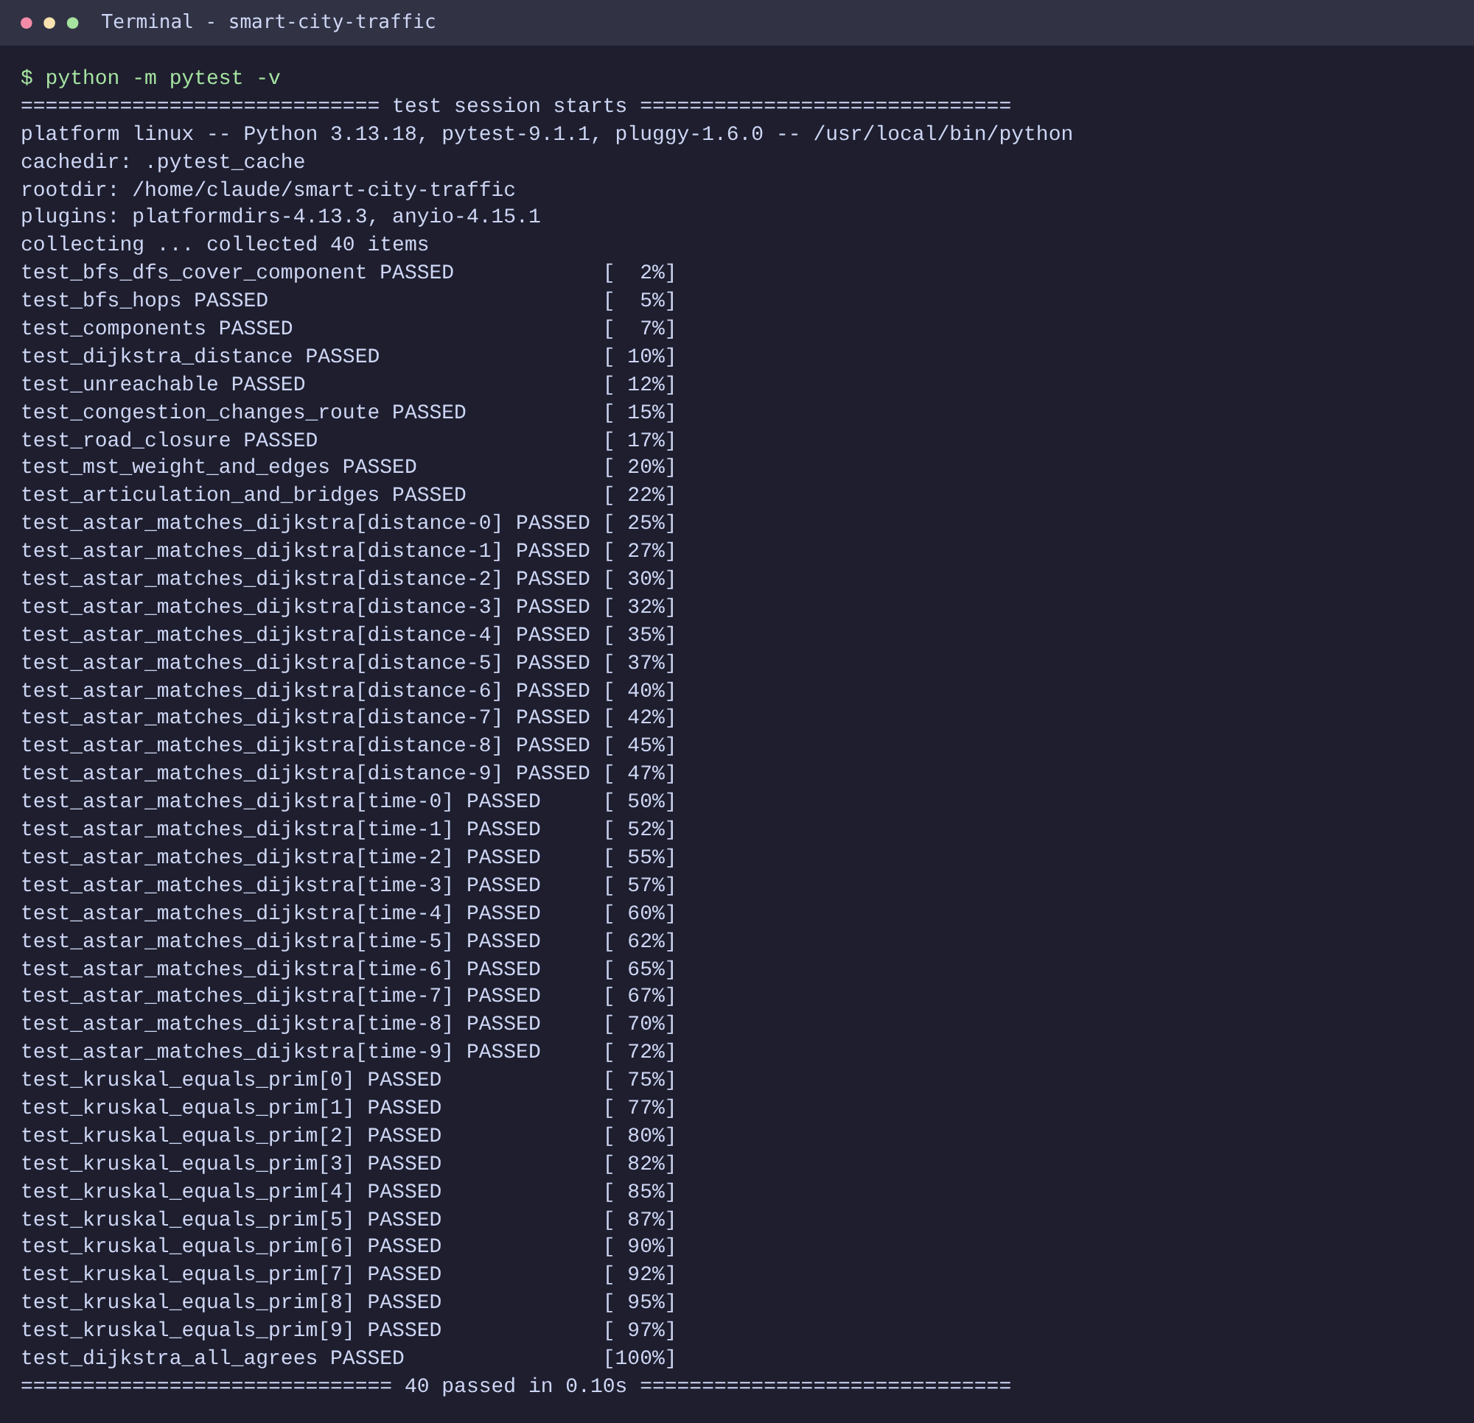
Screenshot 5. pytest run: all 40 tests passed.
During development the tests caught a defect in Prim's priority queue (ties in edge weight caused the heap to compare Edge objects); it was fixed by adding a tie-breaker counter.

7. Conclusion and Future Work
The system shows that classic graph algorithms can power a practical traffic decision-support tool: Dijkstra and A* give commuters fast routes and re-routes after incidents, BFS/DFS and Tarjan analysis reveal connectivity and fragile points, and minimum spanning trees and hotspot counts guide infrastructure investment. Randomised cross-checks and benchmarks give confidence in both correctness and scalability.

Limitations and future work
- Roads are undirected and congestion is static between user edits; real data would need one-way streets and time-of-day profiles.
- The sample city is synthetic; importing OpenStreetMap data would test the system on a real network.
- Possible extensions: live traffic feeds, turn penalties, multi-stop routing (travelling salesman heuristics), and Bellman-Ford for negative incentives such as toll rebates.

Appendix: Execution log
- Network: 120 intersections, 216 roads, 1 component(s)
- Route 0->119: fastest 23.2 min over 17 segments; shortest 14.37 km over 17 segments
- Alternative avoiding the busiest road: 23.4 min (+0.3 min)
- Incident: road 32-45 closed -> new fastest route 23.4 min (+0.2 min)
- MST (distance): Kruskal 86.71 km, Prim 86.71 km, 119 roads kept of 216 (48% of total road length)
- Critical intersections (articulation points): 1; bridge roads: 1
- Roads with congestion >= 0.7: 9
- Top 5 busiest intersections: Station 6-5 (69 trips), Stadium 7-4 (66 trips), Lakeside 7-5 (65 trips), Harbour 7-3 (62 trips), Central 6-6 (57 trips)

